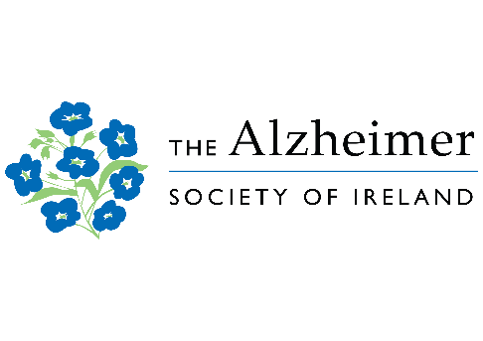
FAMILY CARER TRAINING –
Positive and Practical Training
for Family Carers only
APPLICATION FORM
(please write carefully using block capitals if possible)
Name:

Address:

Eircode:

Phone: | Mobile:
Email:

I am currently a family carer Yes No
(by family carer, we mean do you provide regular unpaid care / support to someone who is impacted by dementia)

Relationship – the person with dementia is my: _______________________________
- The age of the person with dementia is: _______________________________
- Approximate date my relative was diagnosed: _______________________________

My relative with dementia lives: Alone With me

With other relative Other care arrangements

In nursing home

Have you used any services of The Alzheimer Society before? Yes No

Signed: …………………………………………………………………………………… Date: ……………………………….

I want to attend the Face to Face course only | Preferred County: ..…………………………………………
I want to attend the Online course only

I can attend either the Face to Face or Online  course (next available) | Preferred County: ..…………………………………………

How did you hear about Family Carer Training?

From a friend Newspaper Advert Website Other (please state) _______________

Do you have any special requirements for your attendance at the training course e.g. access, communication, print size etc. Yes No

If yes, please give details:

Please provide the name of an emergency contact:

__________________________________________________________

Please provide the contact number of your emergency contact:

__________________________________________________________

Please forward as soon as possible:
The Alzheimer Society of Ireland, Insights into Dementia, The Alzheimer Society of Ireland, National Office, Temple Road, Blackrock, Co. Dublin.
Email: familycarertraining@alzheimer.ie

We will be in contact with you about this course. From time to time, we may wish to contact you in relation to other related courses or events of interest to family carers of people with Dementia that ASI are running. We will never share your personal details with any third party.

Please tick the box if you agree to being contacted for these reasons.

I agree to being contacted by email

I agree to being contacted by post

I agree to being contacted by phone

Thank you, we will contact you as soon as possible with the offer of a place on the next available course.

