July
Activity Pack

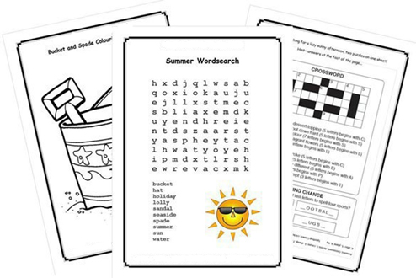

Dear Friends,

We are now in the month of July, the birds are singing and the sun is shining (some of the time!)

We want you to know that we continue to think about you all and wish to offer support in any way we can, even if we cannot see you in person.

We have a number of resources that we have listed on the next page that we hope you may be able to access for support, including our new Virtual Cafes. These cafes are run by hosts from all around Ireland featuring fantastic guest speakers such as: occupational therapists, naturopaths, solicitors, singers and members of our community. And don’t let the name fool you - people from all over are welcome at each cafe –
the more the merrier!

We hope you all enjoy this month’s pack…

The greatest gift you can give is your time.
Not money, not items, not food, not pretty cards
with the handwritten sentiment, but time.
People need your presence.
The way you can help a soul the most is to simply be there.”
Richelle E. Goodrich

Useful Resources:

- Our Free Helpline and Dementia Nurse Support Line are available at:
Phone: 1800 341 341 and Email: helpline@alzheimer.ie

- We are hosting a number of Virtual Cafes. They are a place to come together, share a cuppa and listen to our amazing guest speakers. For information on how to attend visit: https://alzheimer.ie/service/alzheimer-cafe/

- The ASI also have a huge library of factsheets and resources available on: https://alzheimer.ie/get-support/resources-and-factsheets/

- Engaging Dementia are running an online café each Friday and several webinars. For more information : https://engagingdementia.ie/

- For musical videos and resources, Music For Dementia are a wonderful resource: https://musicfordementia.org.uk/

- The Irish Museum of Modern Art (IMMA) have a huge collection available to view online at: https://imma.ie/collection/

- Vocalist Liz Ryan runs a weekly online Tea Dance from the National Concert Hall. Tickets are free and available from the “What’s On” section of: https://www.nch.ie/Online/default.asp

- Emergency Response Numbers: 999 or 112

- HSE 24/7 Your Mental Health Information Helpline: 1800 111 888

Table of Contents

Activity | Pages
Summertime Quiz | 5, 6
Elvis Presley Crossword | 7 - 9
Soccer Scramble Quiz | 10
Sweet Tooth Teaser | 11
Sing The Next Line | 12, 13
Gone Fishing Wordsearch | 14
Birds Wordsearch | 15
Pictures to Colour | 16 - 18
Flower Fun | 19
Chocolate Pudding Recipe | 20
Remembering the Clothesline | 21, 22
“The Pub” | 23, 24
On this Day In History | 25 - 28
The Four Farrellys Poem | 29 -31
Mindfulness Session | 32

Summertime Quiz
Pit your wits against our holiday-themed quiz.

1. Television comedy ‘Hi-de-Hi’ was set in which fictional holiday camp?
a) Butlers b) Maplins c) Dixons

2. Which well known pop singer starred in 60’s film ‘Summer Holiday’?
a) Cliff Richard b) Elvis Presley c) Bill Haley

3. The ‘Seven Sisters’ is the name of which landmark in East Sussex?
a) Lakes b) Standing Stones c) Chalk Cliffs

4. ‘Only Fools and Horses’ TV comedy filmed at which popular seaside resort?
a) Clacton b) Margate c) Southend

5. Where did Billy Butlin open his first holiday camp in 1936?
a) Skegness b) Minehead c) Bognor Regis

6. Which pop act sang the 1970’s hit ‘In The Summertime’?
a) T-Rex b) Mungo Jerry c) Black Lace

7. Name of the first roller coaster ride at Blackpool?
a) Big Dipper b) Runaway Train c) Revolution

8. Which was the earliest king to enjoy ice cream in the UK?
a) Charles l b) Henry ll c) Edward V

Answers:
1. Maplins
2. Cliff Richard
3. Chalk Cliffs
4. Margate
5. Skegness
6. Mungo Jerry
7. Big Dipper
8. Charles 1
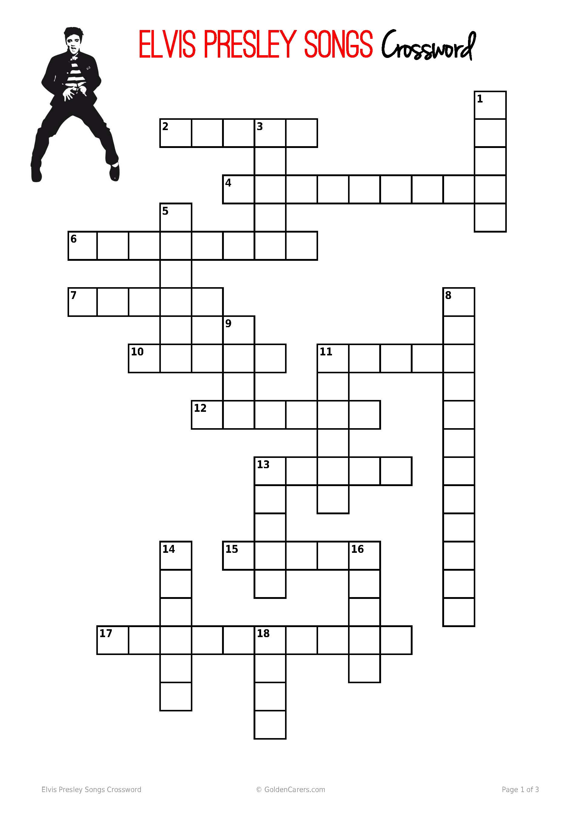
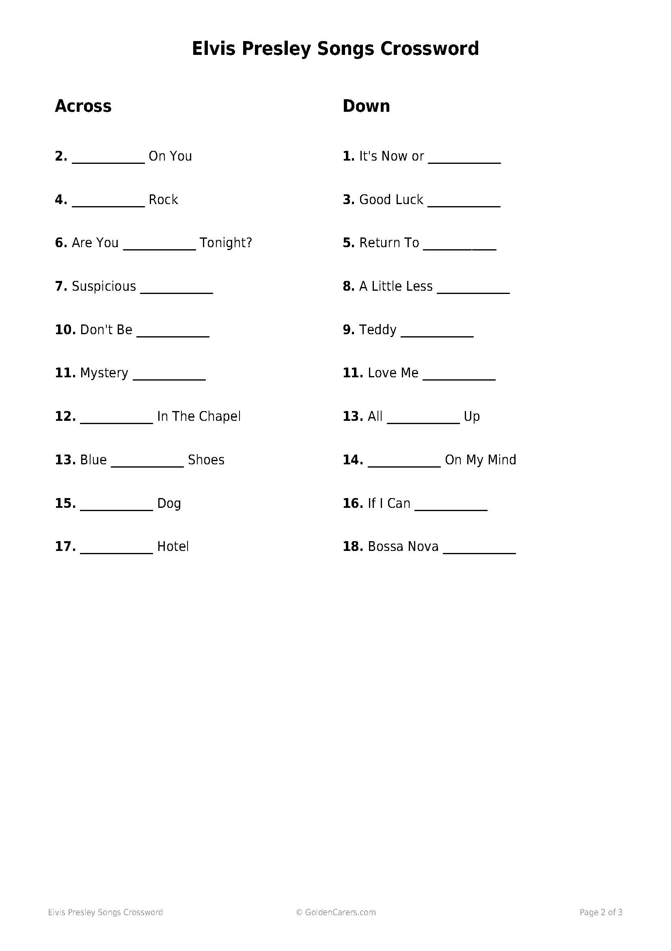

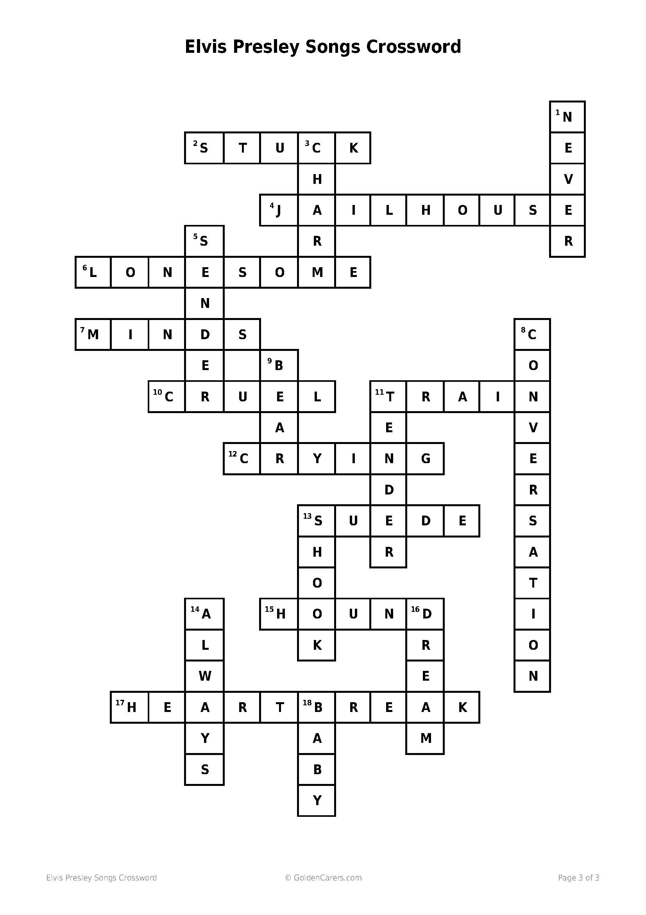

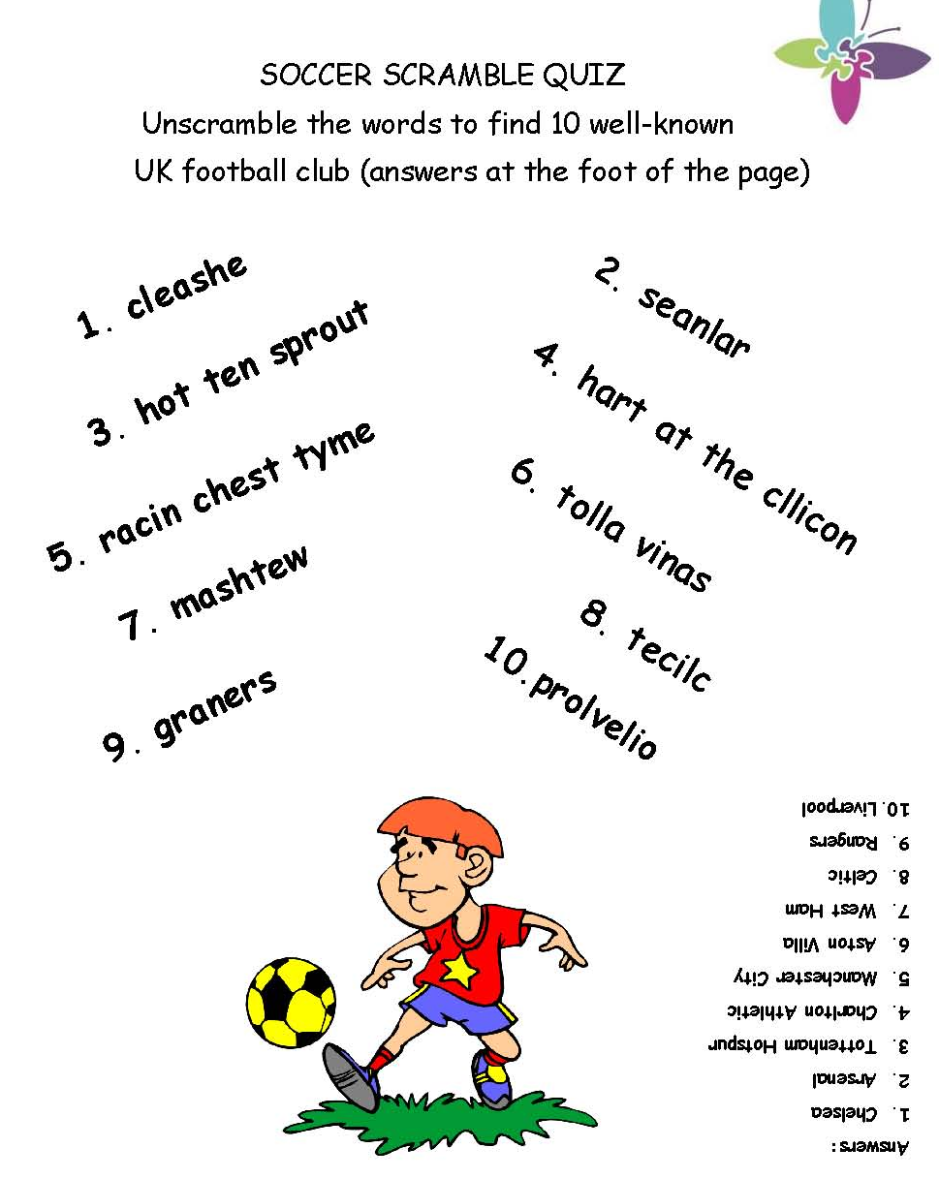

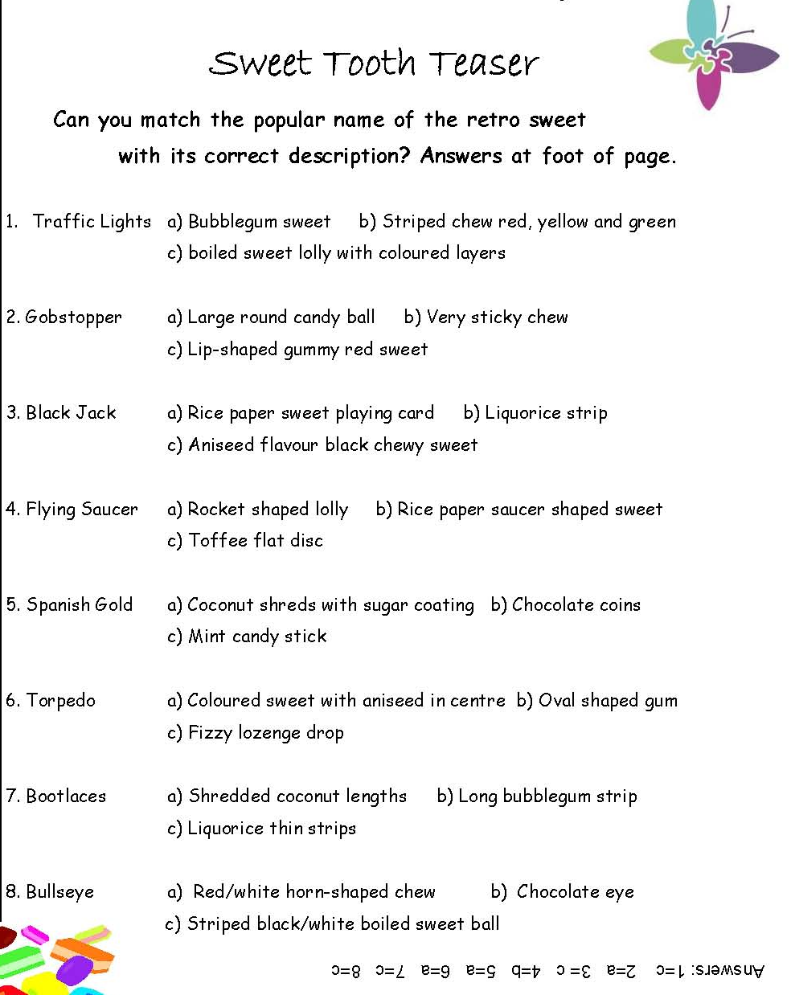

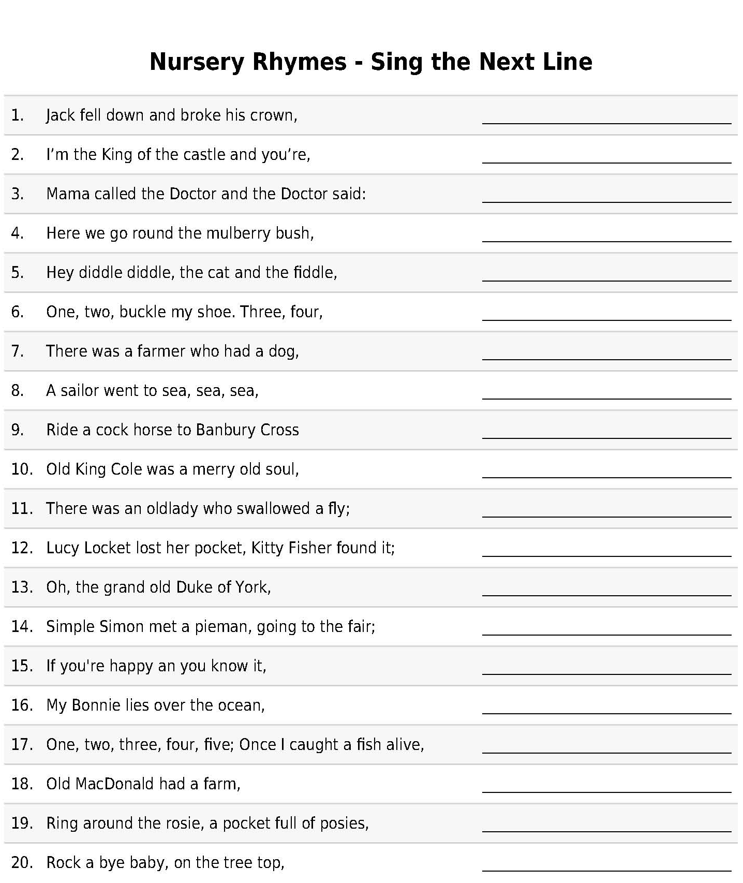

Answers:
1 - and Jill came tumbling after
2 - the dirty rascal
3 - No more monkeys jumping on the bed!
4 - on a cold and frosty morning
5 - the cow jumped over the moon
6 - knock at the door
7 - And Bingo was his name-O
8 - To see what he could see, see, see
9 - To see a fine lady upon a white horse
10 - and a merry old soul was he
11 - I don't know why she swallowed a fly – perhaps she'll die!
12 - Not a penny was there in it, Only ribbon round it.
13 - He had ten thousand men; he marched them up to the top of the hill and he marched them down again.
14 - Says Simple Simon to the pieman, let me taste your ware.
15 - clap your hands
16 - Oh, bring back my Bonnie to me
17- Six, seven, eight, nine, ten; Then I let them go again.
18 - E I E I O
19 - Atishoo, atishoo, we all fall down!
20 - When the wind blows the cradle will rock
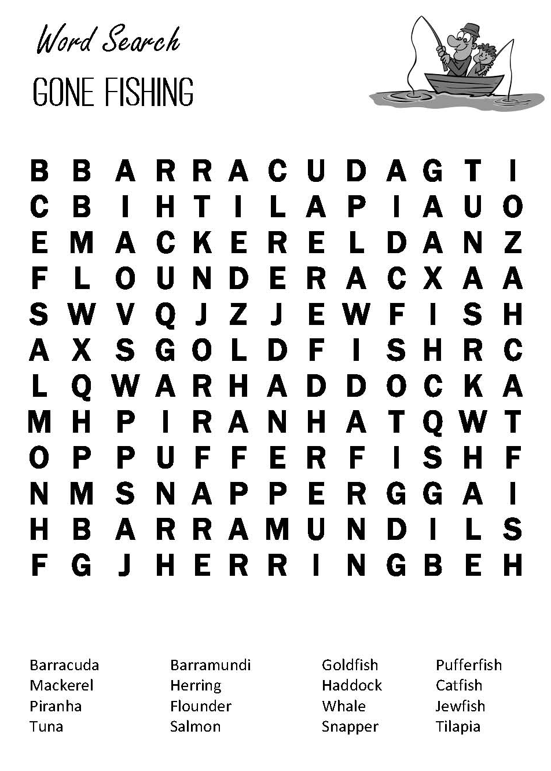

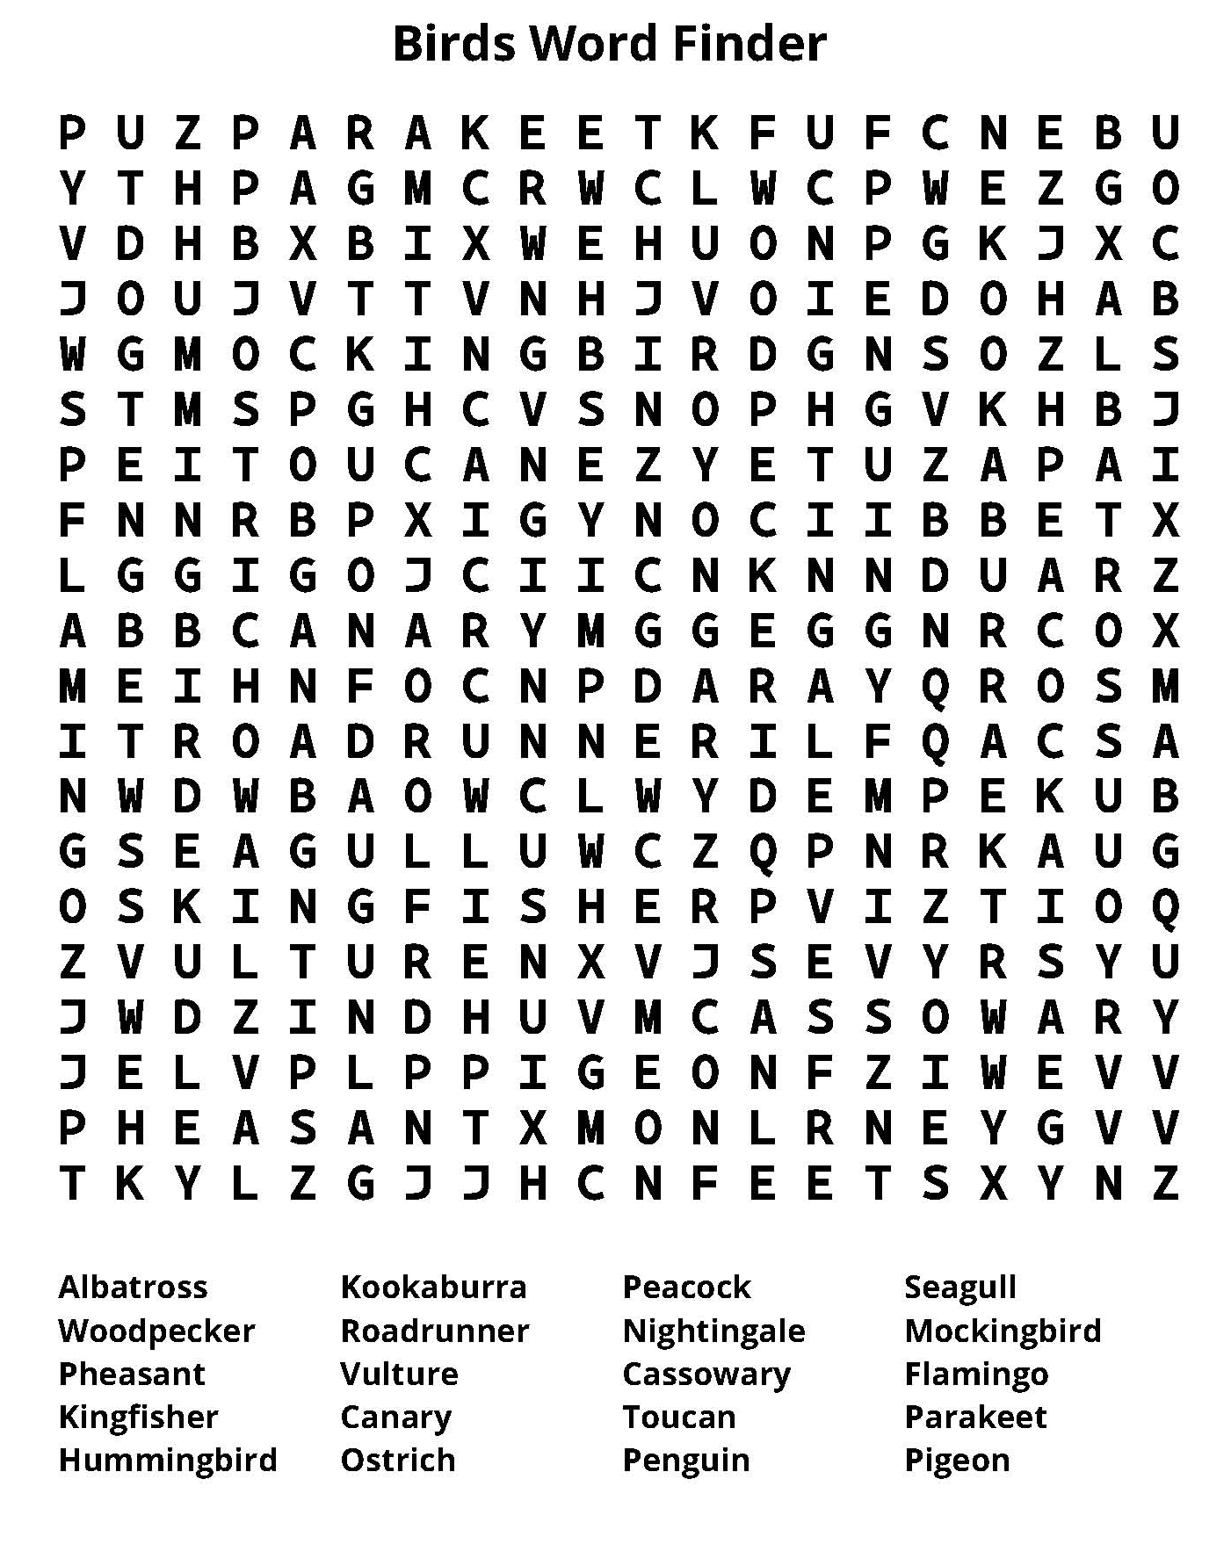

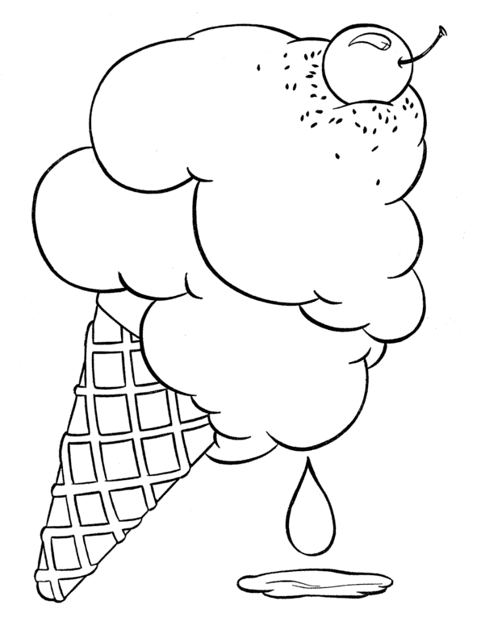
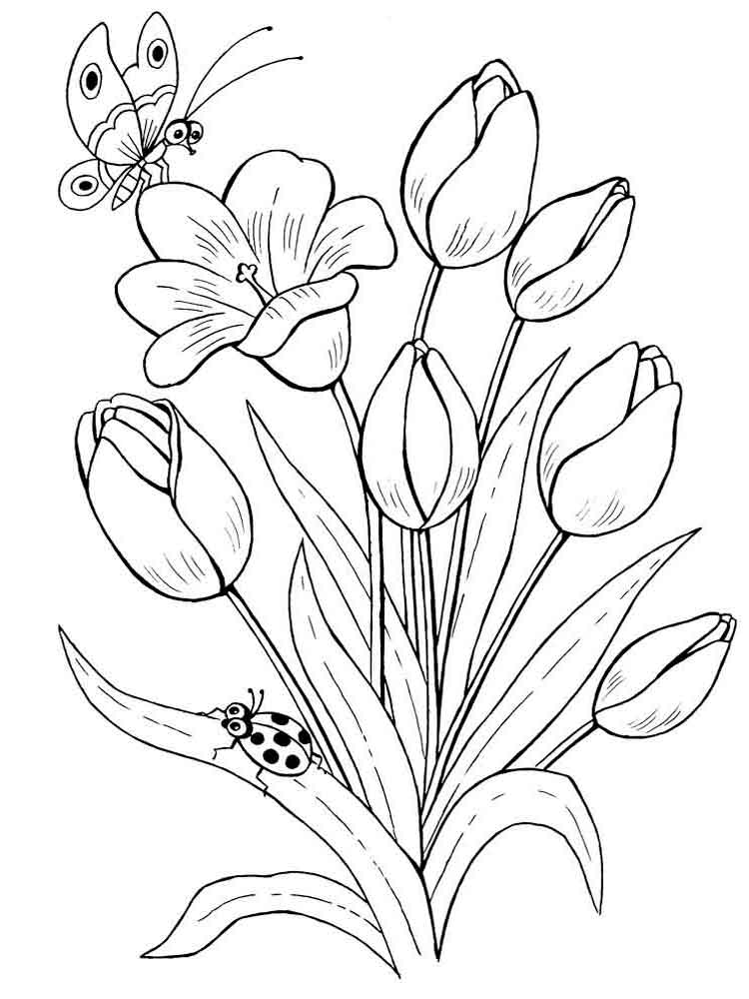
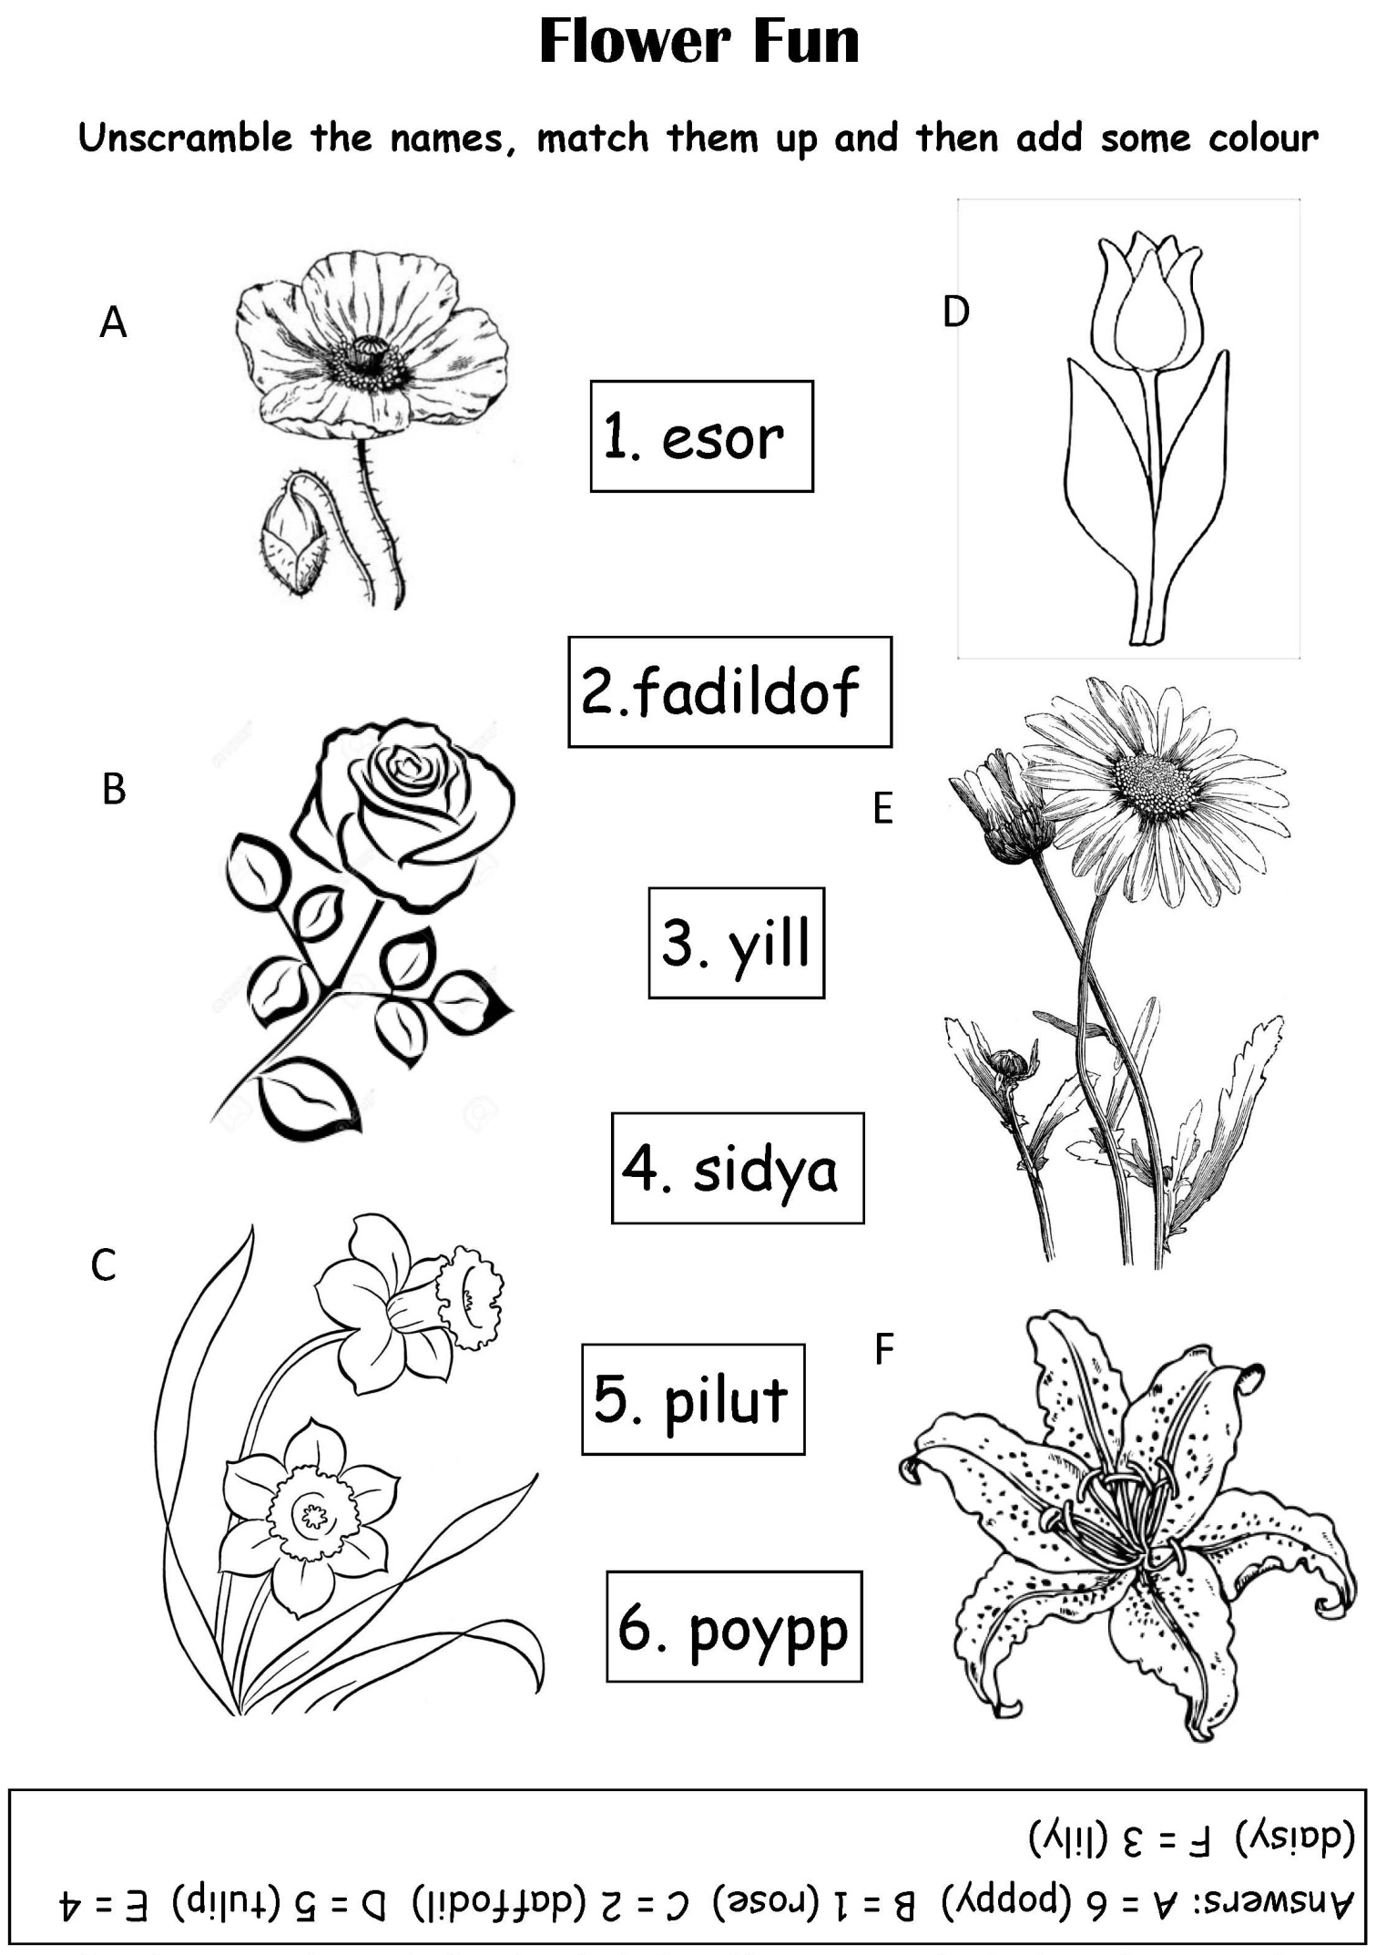
Chocolate Pudding Recipe
Serves: 6
Ingredients
- 425ml whole milk (14½oz)
- 150ml cream (5oz)
- 3 large eggs, lightly beaten
- 30g cornflour (1oz)
- 150g sugar (5oz)
- 3 tablespoons cocoa powder
- pinch salt
- 70g dark chocolate, finely diced (2 ½oz)

Directions
- Heat the milk and cream in a metal bowl over a saucepan of simmering water, making sure the water does not touch the base of the bowl. Do not boil the milk.
- In a separate bowl, beat the eggs, cornflour, sugar, cocoa, salt and diced chocolate.
- Add hot milk one ladleful at a time while whisking, so the chocolate melts but the eggs don't cook.
- Pour mixture into a large saucepan and heat very slowly, stirring, until just below boiling point.
- Blend in a blender until very smooth or beat 5 minutes with a wooden spoon.
- Transfer to a bowl, cover with plastic wrap and chill 2-3 hours in the fridge.

Enjoy!

Remembering the Clothesline
You have to be a "certain age" to appreciate this one....
I can hear my mother now...

THE BASIC RULES FOR CLOTHESLINES:
1. You had to hang the socks by the toes... NOT the top.
2. You hung pants by the BOTTOM/cuffs... NOT the waistbands.
3. You had to WASH the clothesline(s) before hanging any clothes - walk the entire length of each line
with a damp cloth around the lines, because the lines might have been dirty, and leave marks on the clean clothes you pegged there.
4. You had to hang the clothes in a certain order, and always hang "whites" with "whites," and hang them first.
5. You NEVER hung a shirt by the shoulders - always by the tail! What would the neighbours think?
6. Wash day on a Monday! NEVER hang clothes on the weekend, or on Sunday, for Heaven's sake!
7. Hang the sheets and towels on the OUTSIDE lines so you could hide your "unmentionables" in the middle.
8. It didn't matter if it was sub-zero weather... clothes would "freeze-dry."
9. ALWAYS gather the clothes pins when taking down dry clothes! Pins left on the lines were "tacky"!
10. If you were efficient, you would line the clothes up so that each item did not need two clothes pins, but shared one of the clothes pins with the next washed item.
11. Clothes off of the line before dinner time, neatly folded in the clothes basket, and ready to be ironed.
12. IRONED???!! Well, that's a whole OTHER subject!
And now a POEM ...
A clothesline was a news forecast to neighbours passing by,
There were no secrets you could keep when clothes were hung to dry.
It also was a friendly link for neighbours always knew
If company had stopped on by, to spend a night or two.

For then you'd see the "fancy sheets", And towels upon the line;
You'd see the "company table cloths", With intricate designs.
The line announced a baby's birth, From folks who lived inside,
As brand new infant clothes were hung, So carefully with pride!

The ages of the children could, So readily be known
By watching how the sizes changed, You'd know how much they'd grown!
It also told when illness struck, As extra sheets were hung;
Then nightclothes, and a bathrobe too, Haphazardly were strung.

It also said, "On vacation now", When lines hung limp and bare.
It told, "We're back!" when full lines sagged, With not an inch to spare!
New folks in town were scorned upon, If wash was dingy and grey,
As neighbours carefully raised their brows, And looked the other way.

But clotheslines now are of the past, For dryers make work much less.
Now what goes on inside a home, Is anybody's guess!
I really miss that way of life; it was a friendly sign!
When neighbours knew each other best, by what hung out on that line.
Author Unknown

The Pub
By Loretta Kenny

I was born in 1957 in a small rural village in Co. Wexford. My parents ran a fairly large business which consisted of a Grocery Shop, a Mill and a Public House. I lived over this business until I was nearly twelve years of age and I would like to share with you some of the memories of this time.

The Pub was always a hive of activity. We all had to help out as soon as we were able. Bottling Day was always a big event. The stout came from Guinness in barrels and was brought into the Bottling House. It was then transferred into a large open container which had a number of taps attached to it. The bottles, which would have been washed in hot water and cooled down, would be filled to the brim with beer and then it was my turn to cap them. I can still remember pulling in the cap and pulling down the lever to attach the cap. Then each bottle was labelled with the Guinness label which would also include the name of the publican. The bottles were then lined up on the shelves in an adjoining room ready to be transferred into the bar.
At that time it was only men who frequented the bar. There was a small Lounge adjoining the bar which had a piano but I never heard it being played. An odd lady might use this room but only to wait for the CIE bus which stopped outside.

The Fair Day was held once a month on a Wednesday. Farmers would bring their livestock to the village to be sold and others to purchase. We had a second pub next door which would be opened that day to deal with the crowds. There was a big open fire where the men would sit and tell yarns.

Country pubs had a very healthy day and night trade. Every day, Johnny, a local farmer, would call in for his few pints and when he was served would ask for a small glass and would pour a small amount of beer into it. He would then call my little brother (who was about two at the time and always around) and put him sitting up on the stool next to him and say- “Sure a little drop will do him no harm”.

There were plenty of characters who frequented the pub. The Builder (he was the first person we knew who was declared a millionaire), the Buller (he could get very hot-headed and a fight could follow), Long John (he would travel on his ass and cart), Mucksie (our next door neighbour and my Dad’s right hand man) and many others.
Even on Christmas Day there would be a knock on the hall door after Mass and a few of our good customers would be brought in for their Christmas drinks. When you lived over your business you were always on call.

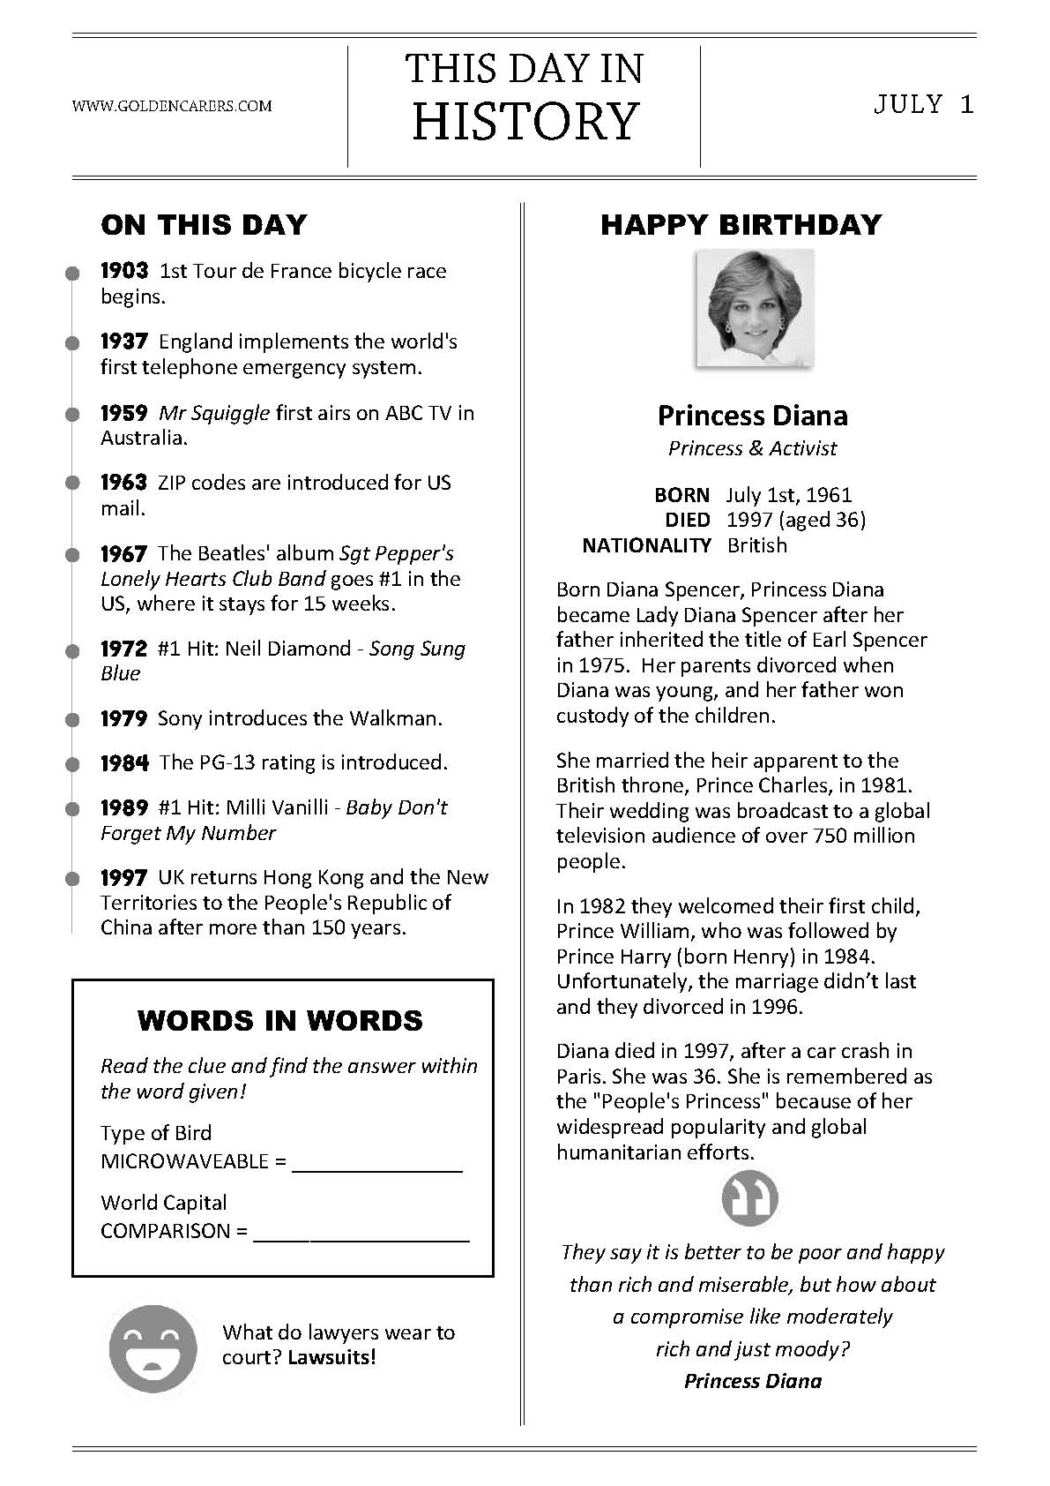
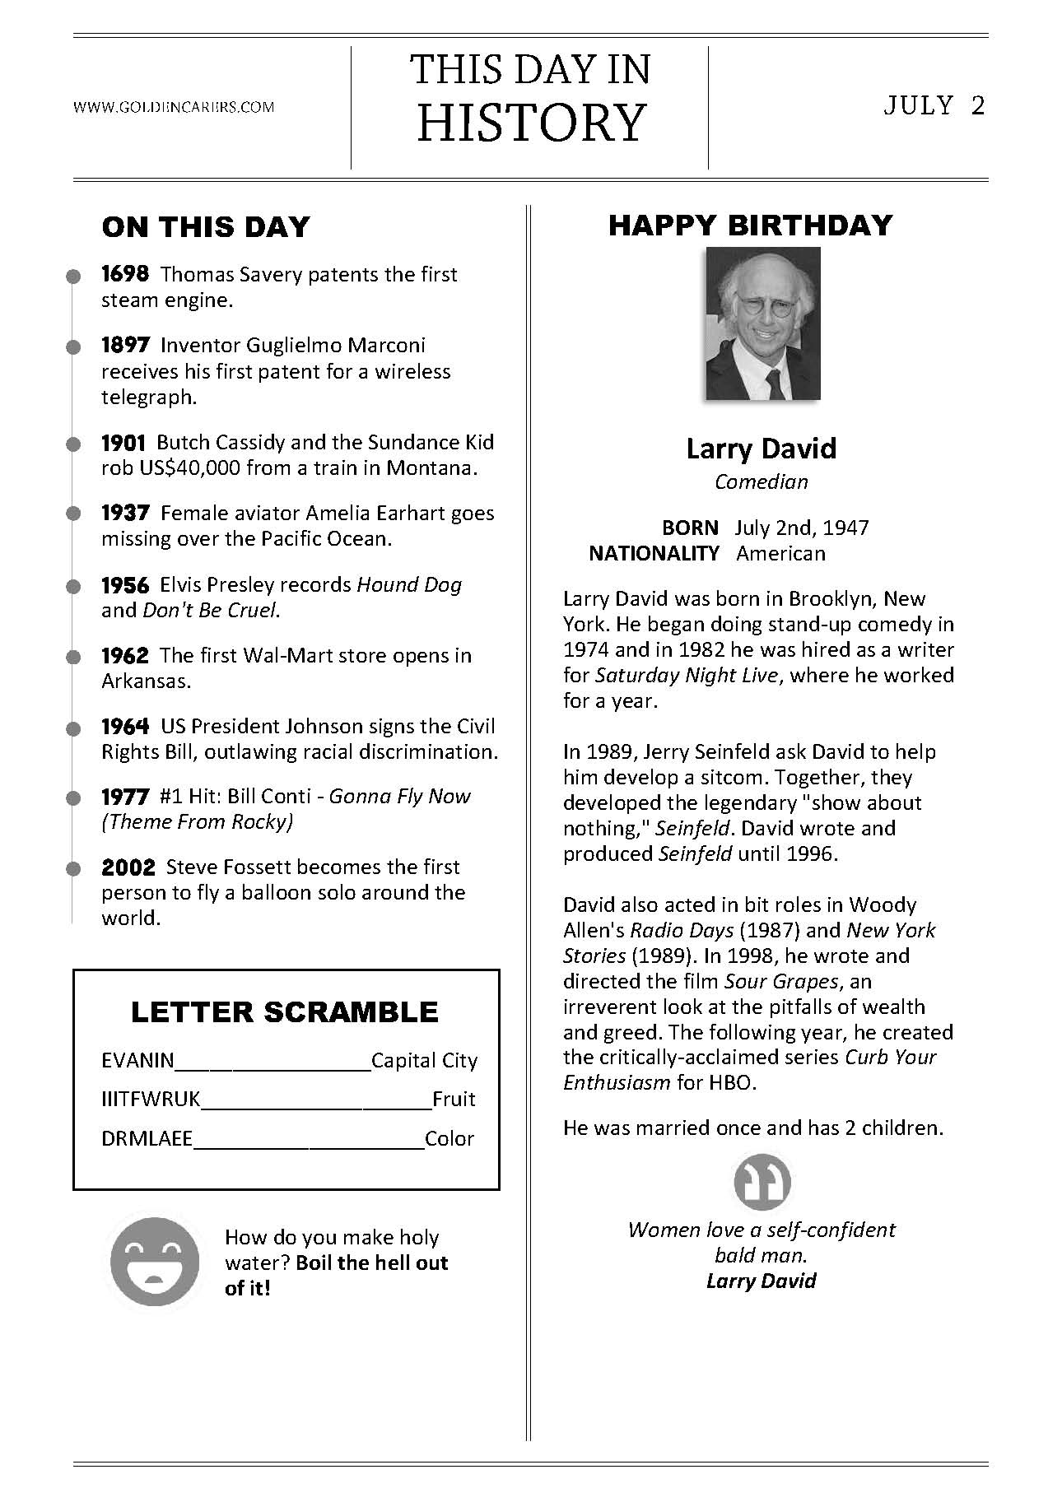
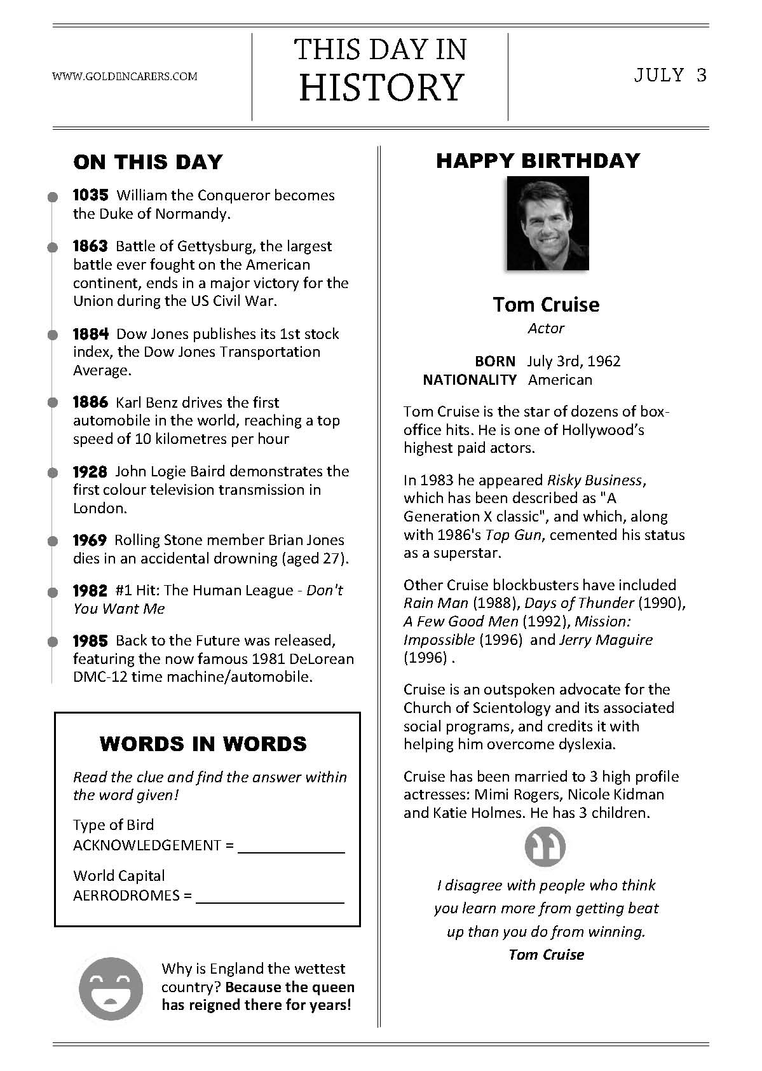
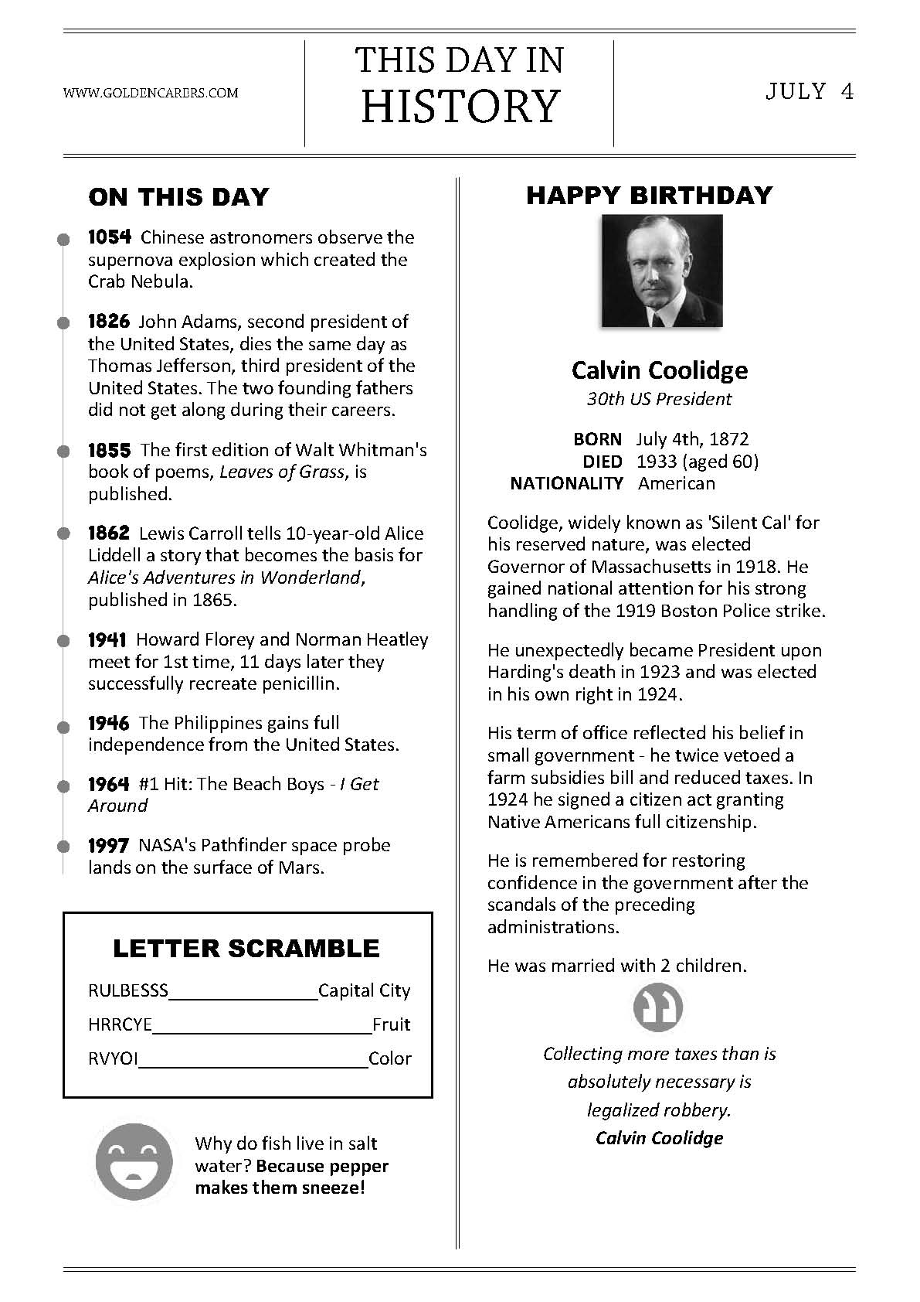
THE FOUR FARRELLYS
By Percy French

In a small hotel in London I was sitting down to dine.
When the waiter brought the register and asked me if I'd sign.
And as I signed I saw a name that set my heart astir —
A certain "Francis Farrelly" had signed the register
I knew a lot of Farrellys and out of all the crew
I kept on "sort of wonderin' " which Farrelly were you.
And when I'd finished dinner I sat back in my chair,
Going round my native land to find, what Farrelly you were.
SOUTH
Were you the keen-eyed Kerryman I met below Kenmare,
Who told me that when Ireland fought "the odds were never fair?"
If Cromwell had met Sarsfield, or Owen Roe O'Neill,
It's not to Mister Gladstone we'd be lookin' for repeal.
Would have Ireland for the Irish, not a Saxon to be seen,
And only Gaelic spoken in that House in College Green. Told me landlords wor the Divil! their agints ten times worst,.
And iv'ry sort of government for Ireland was a curse!
Oh! if you're that Francis Farrelly, your dreams have not come true,
Still, Slainthe! Slainthe! Fransheen! for I like a man like you!
NORTH
Or were you the Francis Farrelly that often used to say
He'd like to blow them Papishes from Derry walls away?
The boy who used to bother me that Orange Lodge to join,
And thought that history started with the Battle o' the Boyne —
I was not all with ye, Francis, the Pope is not ma friend,
But still I hope, poor man, he'll die without that bloody end. -
And when yer quit for care yerself, and get to Kingdom Come,
It's not use teachin' you the harp — you'll play the Orange drum!
Och! man, ye wor a fighter, of that I had no doubt.
For I see ye in Belfast one night when the Antrim Road was out!
And many a time that evenin' I thought that ye wor dead,
The way them Papish pavin' stones was hoppin' off yer head.
Oh! if you're the Francis Farrelly who came from North Tyrone -
Here's lookin' to ye, Francis, but do leave the Pope alone!
EAST
Or were you the Francis Farrelly that in my college days
For strollin on the Kingstown Pier had such a curious craze?
D'y mind them lovely sisters — the blonde and the brunette?
I know I've not forgotten, and I don't think you forget!
That picnic at the Dargle —' and the others at the Scalp —
How my heart was palpitatin' — hers wasn't — not a palp!
Someone said ye married money — any maybe ye were wise,
But the gold you loved was in her hair, and the d'monds in her eyes!
So I like to think ye married her and that you're with her yet,
'Twas some "meleesha" officer that married the brunette;
But the blonde one always loved ye, and I knew you loved her too,
So me blessin's on ye, Francis, and the blue sky over you!
WEST
Or were you the Francis Farrelly I met so long ago,
In the bog below Belmullet, in the County of Mayo?
That long-legged, freckled Francis with the deep-set, wistful eyes,
That seemed to take their colour from those ever-changing skies,
That put his flute together as I sketched the distant scene,
And played me "Planxy Kelly and the "Wakes of Inniskeen."
That told me in the Autumn he'd be Bailin' to the West
To try and make his fortune and send money to the rest.
And would I draw a picture of the place where he was born,
And he'd hang it up, and look at it, and not feel so forlorn.
And when I had it finished, you got up from where you sat,
And you said, "Well, you're the Divil, and I can't say more than that."
Oh' if you're that Francis Farrelly, your fortune may be small,
But I'm thinking — thinking —Francis, that I love you best of all;
And I never can forget you — though it's years and years ago -
In the bog below BeImullet, in the County of Mayo.

Mindfulness and Meditation
Although you cannot always control the mind, you can encourage it to be more at ease. Learning to do this will help you respond rather than react to your thoughts and emotions. This practice gives you the opportunity to train the mind to slow down when it becomes overactive, and helps you practice ease and relaxation instead of perpetuating those difficult mental states.
You can sit upright or lie down for this practice.
Take a few deep breaths. Inhaling, fill the lungs completely.
Hold the breath for just a second or two, and exhale slowly.
As you let the breath go, try to empty the lungs slowly and completely.
If thoughts are present, just leave them be.
Offer yourself two simple phrases of kindness toward the mind:
May my mind be at ease.
May I be at ease with my mind.
Synchronize these phrases with your exhale, offering one phrase every time you breathe out.
Hear each word and try to connect with your own intention to care for the mind.
Even if you can say only one phrase before the mind wanders, you are still moving toward relaxation by continuing to practice.

