August
Activity Pack

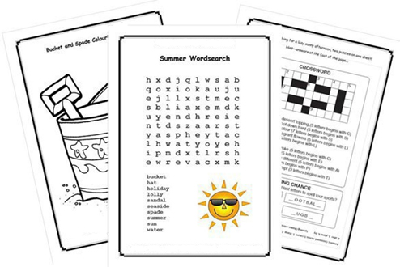

Dear Friends,

We are now in the month of August! We’ve been blessed with some beautiful weather so far and hope you have been able to enjoy it before the leaves begin to turn to autumn.

As always, you all remain in our thoughts during this difficult time. We hope that this activity pack helps to brighten your day and we’d like you to know that the ASI are just a phone call away if you ever need us. Our helpine number is 1800 341 341, with trained staff on the other end to listen to and support you.

This month we have gathered a variety of activities that we hope you will enjoy. We are always looking for ways to improve so if there is anything you would like to see more, or less, of then please feel free to let your local ASI staff know. We love getting feedback and look to tailor our supports to your needs.

We hope you all enjoy this month’s pack…

“No act of kindness,
No matter how small,
Is ever wasted.”
Aesop

Useful Resources:

- Our Free Helpline and Dementia Nurse Support Line are available at:
Phone: 1800 341 341 and Email: helpline@alzheimer.ie

- We are hosting a number of Virtual Cafes. They are a place to come together, share a cuppa and listen to our amazing guest speakers. For information on how to attend visit: https://alzheimer.ie/service/alzheimer-cafe/

- The ASI also have a huge library of factsheets and resources available on: https://alzheimer.ie/get-support/resources-and-factsheets/

- Engaging Dementia are also running an online café each Friday and several webinars. For more information : https://engagingdementia.ie/

- For musical videos and resources Music For Dementia are a wonderful resource: https://musicfordementia.org.uk/

- The Irish Museum of Modern Art (IMMA) have a huge collection available to view online at: https://imma.ie/collection/

- Vocalist Liz Ryan runs a weekly online Tea Dance from the National Concert Hall. Tickets are free and available from the “What’s On” section of: https://www.nch.ie/Online/default.asp

- Emergency Response Numbers: 999 or 112

- HSE 24/7 Your Mental Health Information Helpline: 1800 111 888

Table of Contents

Activity | Pages
True or False – Animals | 5-7
Spot The Difference | 8
Word Ladder | 9-10
Life Soundtrack | 11-12
US Presidents Match-Up | 13-14
A Poem: Tangmalangaloo | 15-16
Covid19 Poem | 17-19
Lavender Rice and Chamomile Dough | 20-21
The Lake Isle of Inisfree | 22
Dust If You Must | 23
Furry Friend | 24
Pages to Colour | 24-27
Funny Sayings | 28
This Day in History | 29-32
Wordsearches | 33-34

True or False – Animals

See if you can figure out if the following statements are
true or false

1. Snakes blink about ten times per minute.
2. Hippophobia is a fear of hippopotamuses.
3. A flea can jump over a hundred times their own height.
4. Gorillas can catch human colds and other illnesses.
5. A baby goat is called a kid.
6. A tiger’s skin is black under their striped fur.
7. A new-born baby panda is smaller than a mouse.
8. A hummingbird can fly backwards.
9. Bulls get angry when they see the color red.
10. The flamingo can only eat when its head is upside down.
11. A group of chickens is called a parliament.
12. The honey bee has been around for 30 million years.
13. A blue whale can weigh as much as 30 elephants together.
14. Horses can’t vomit.

15. Bats are unable to walk because their leg bones are too weak.
16. Dogs love chocolate and it is great for them.
17. Alligators cannot move backwards.
18. Ants sleep an average of five hours per night.
19. Horses are faster than ostriches.
20. Almost half the pigs in the world are kept by farmers in China.

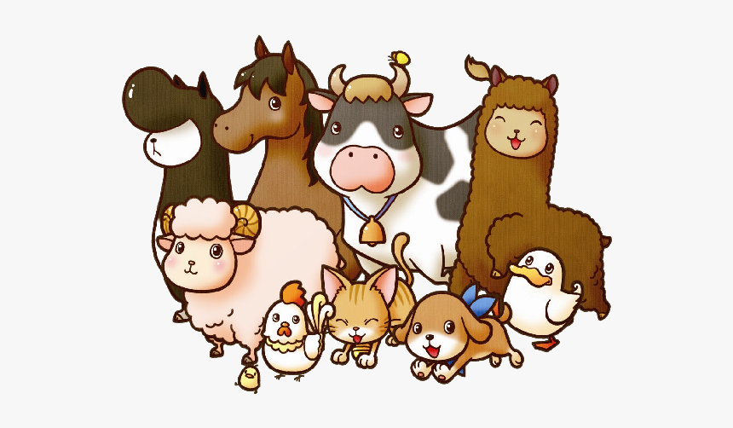
Solutions to True or False – Animals:
1. False (snakes don’t blink at all, they have no eyelids)
2. False (it is the fear of horses)
3. True
4. True
5. True
6. False (their skin is also striped)
7. True
8. True
9. False (they are color blind)
10. True
11. False ( they are called a clutch, a parliament is a group of owls)
12. True
13. True
14. True
15. True
16. False (chocolate is harmful to dogs_
17. True
18. False (ants never sleep)
19. False (ostriches are faster than horses)
20. True
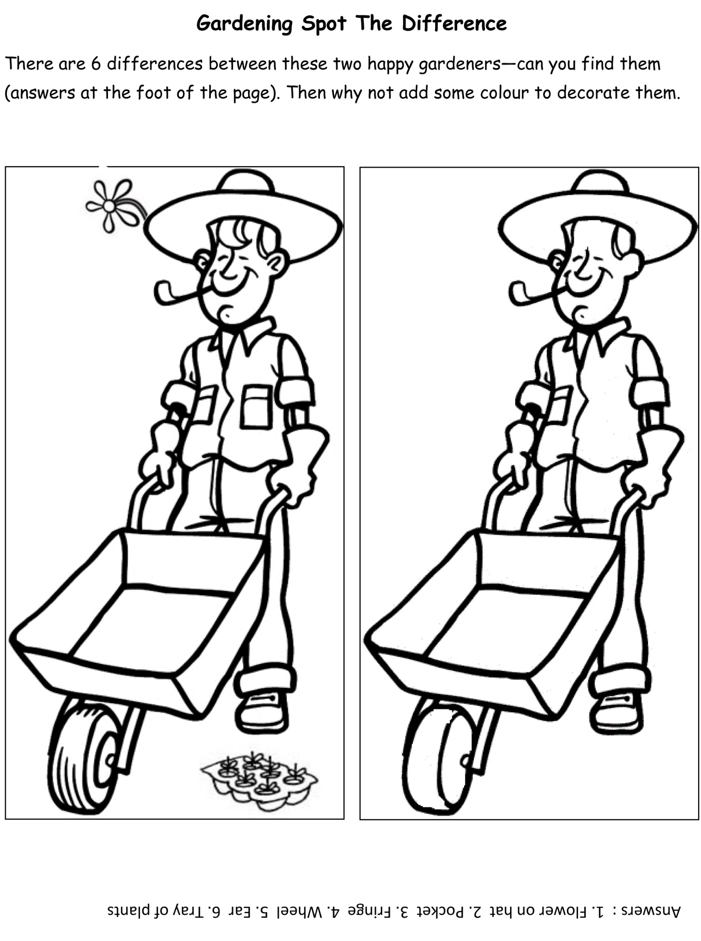

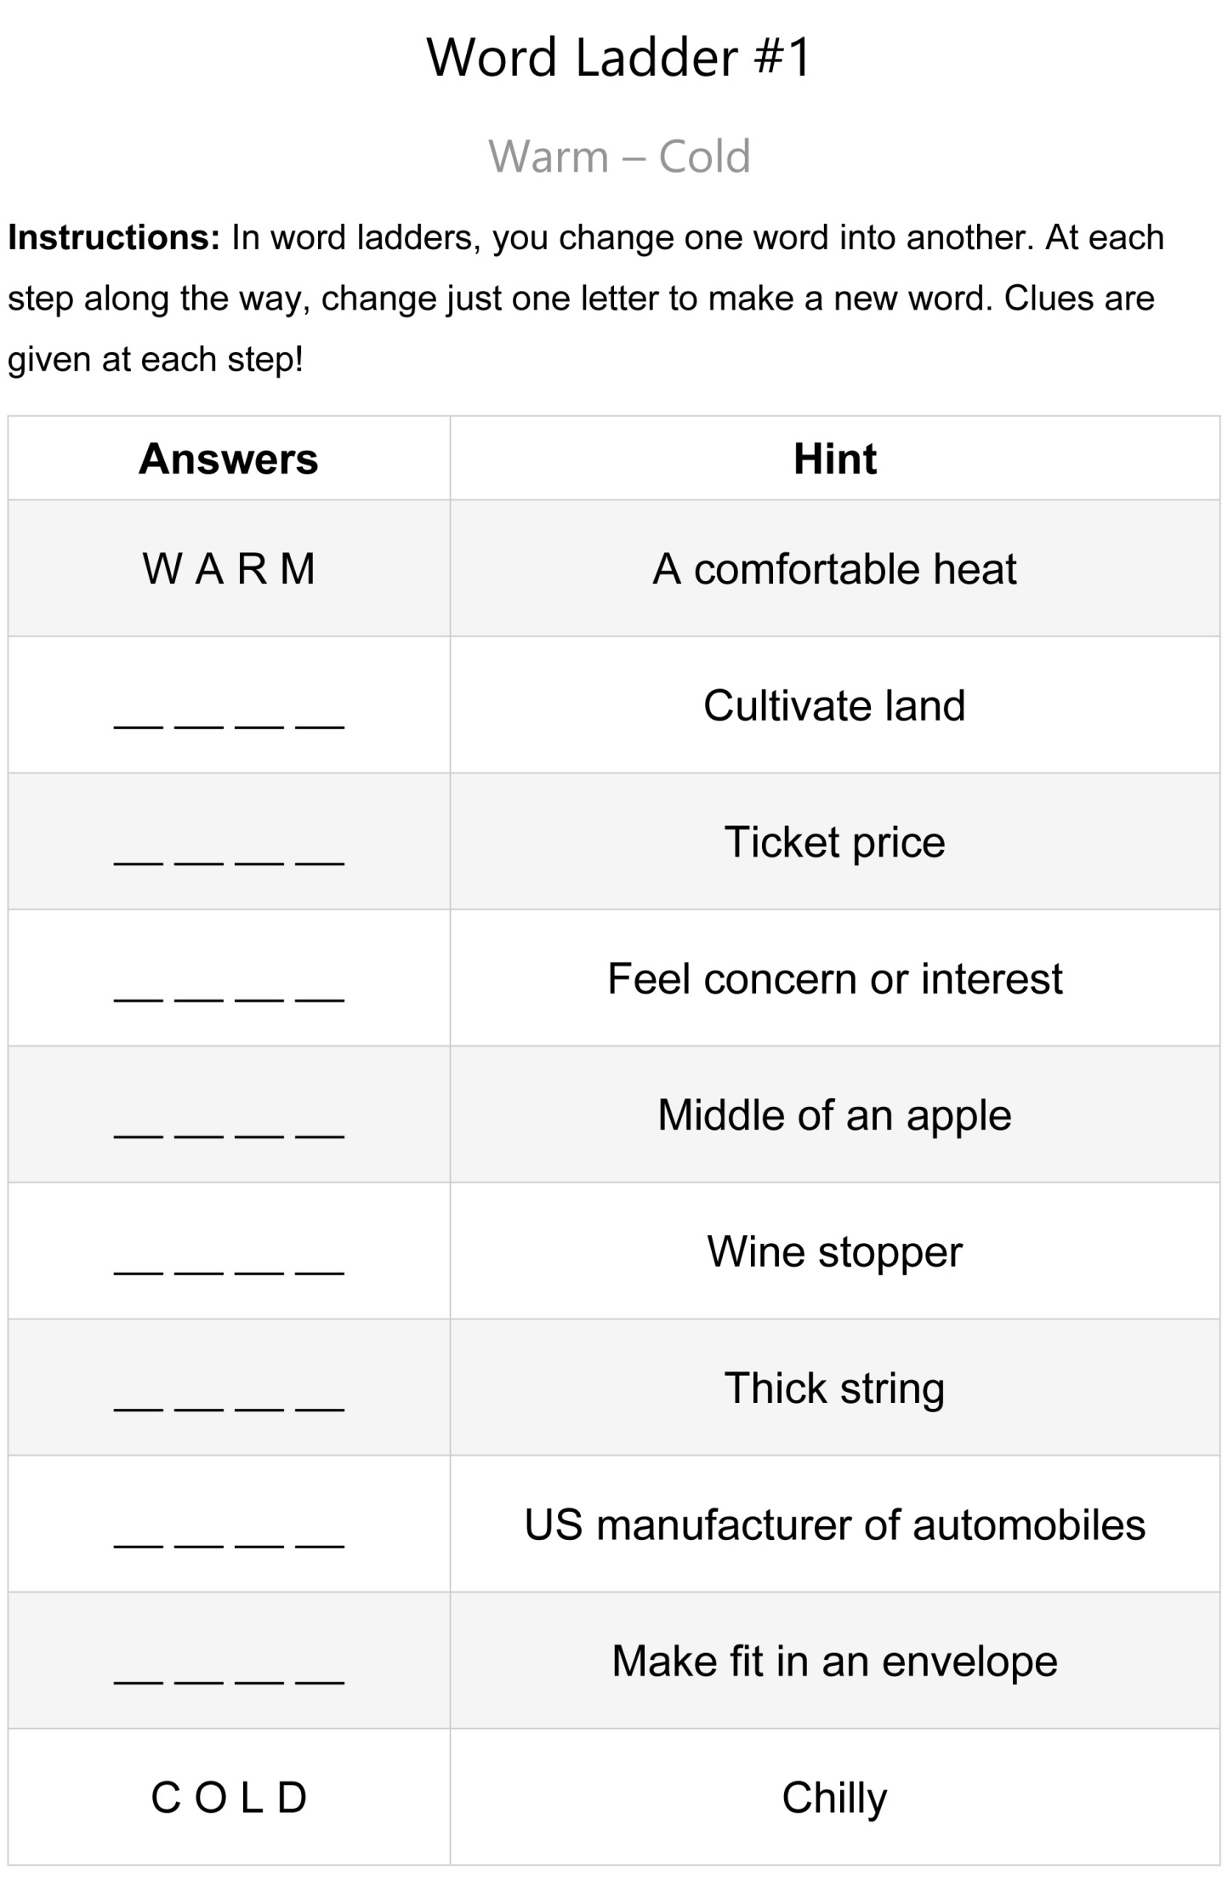
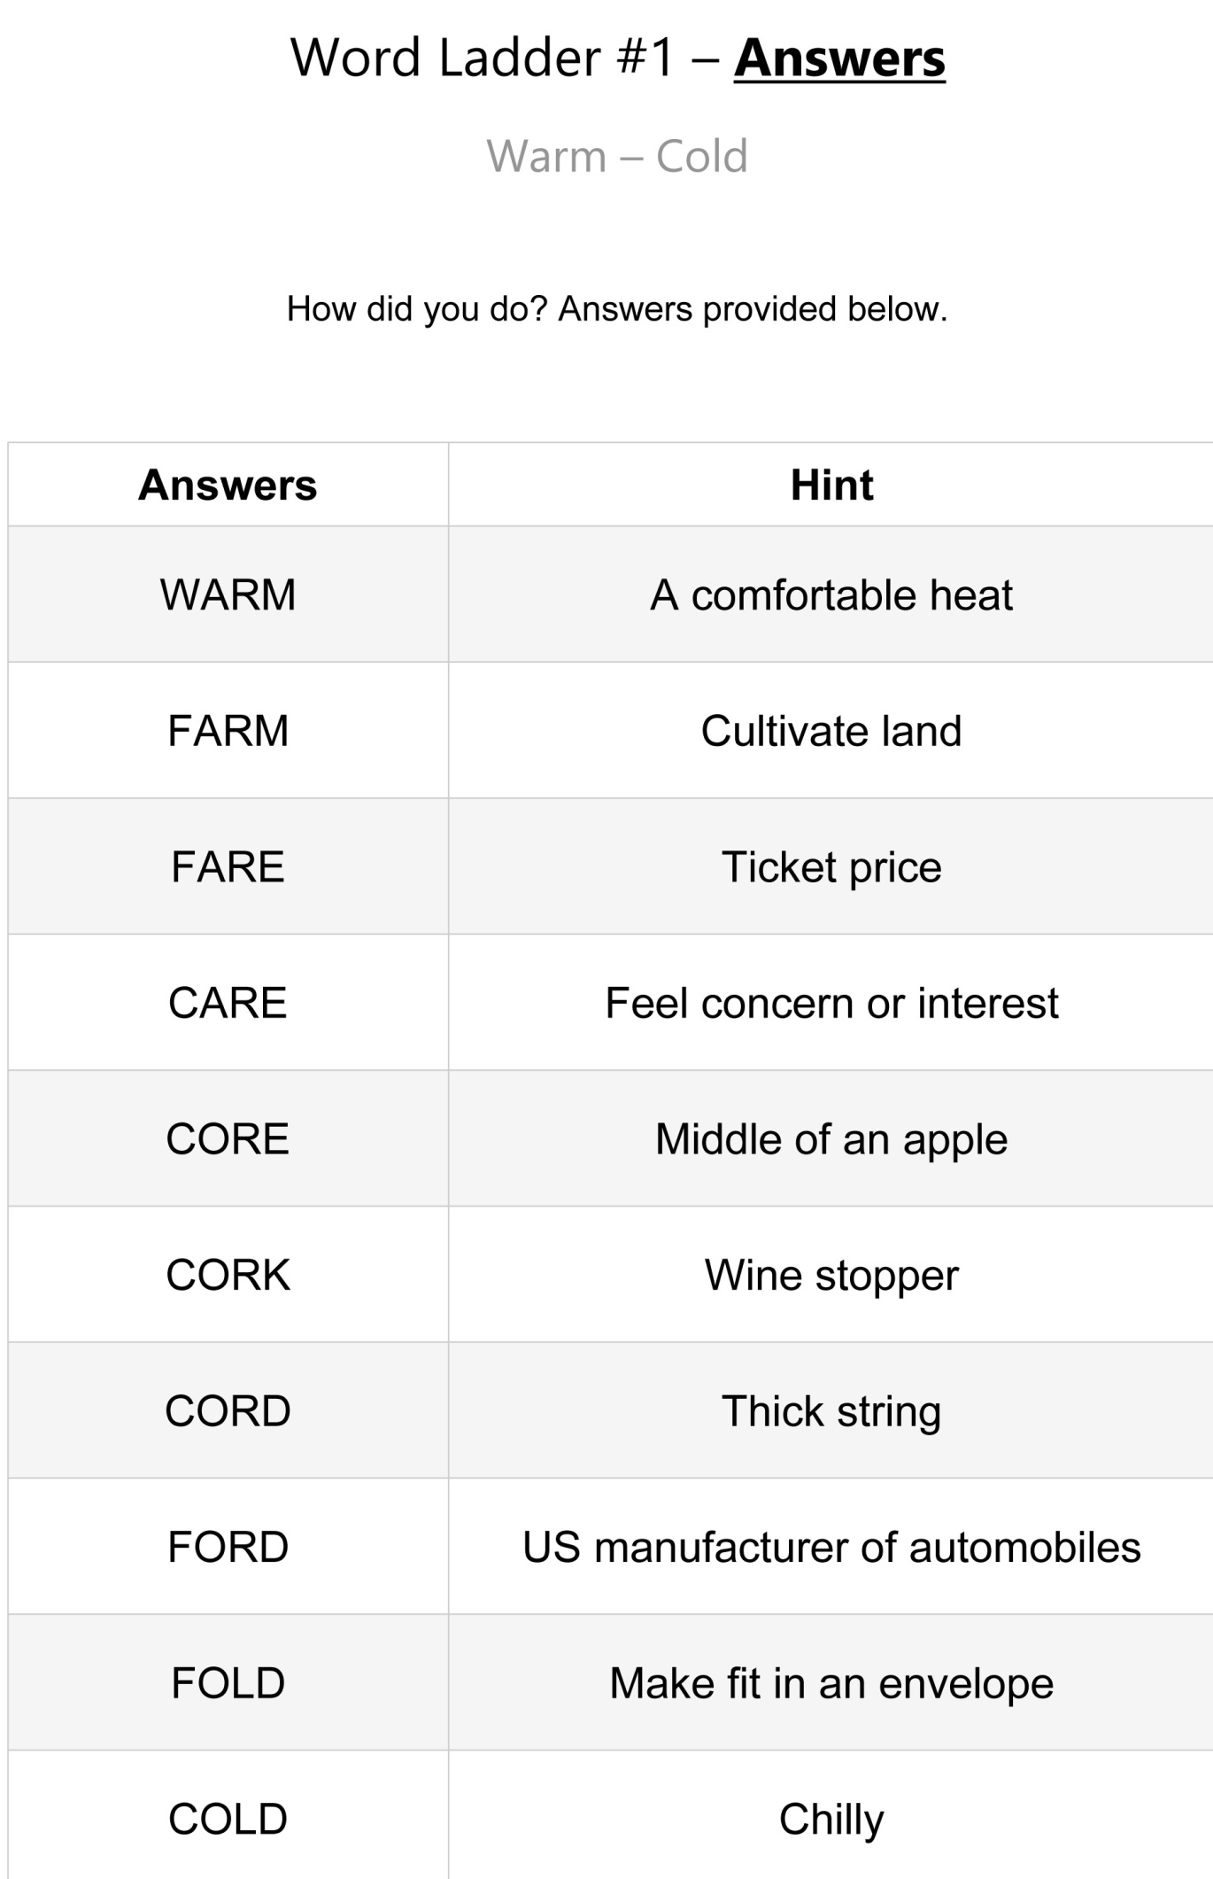
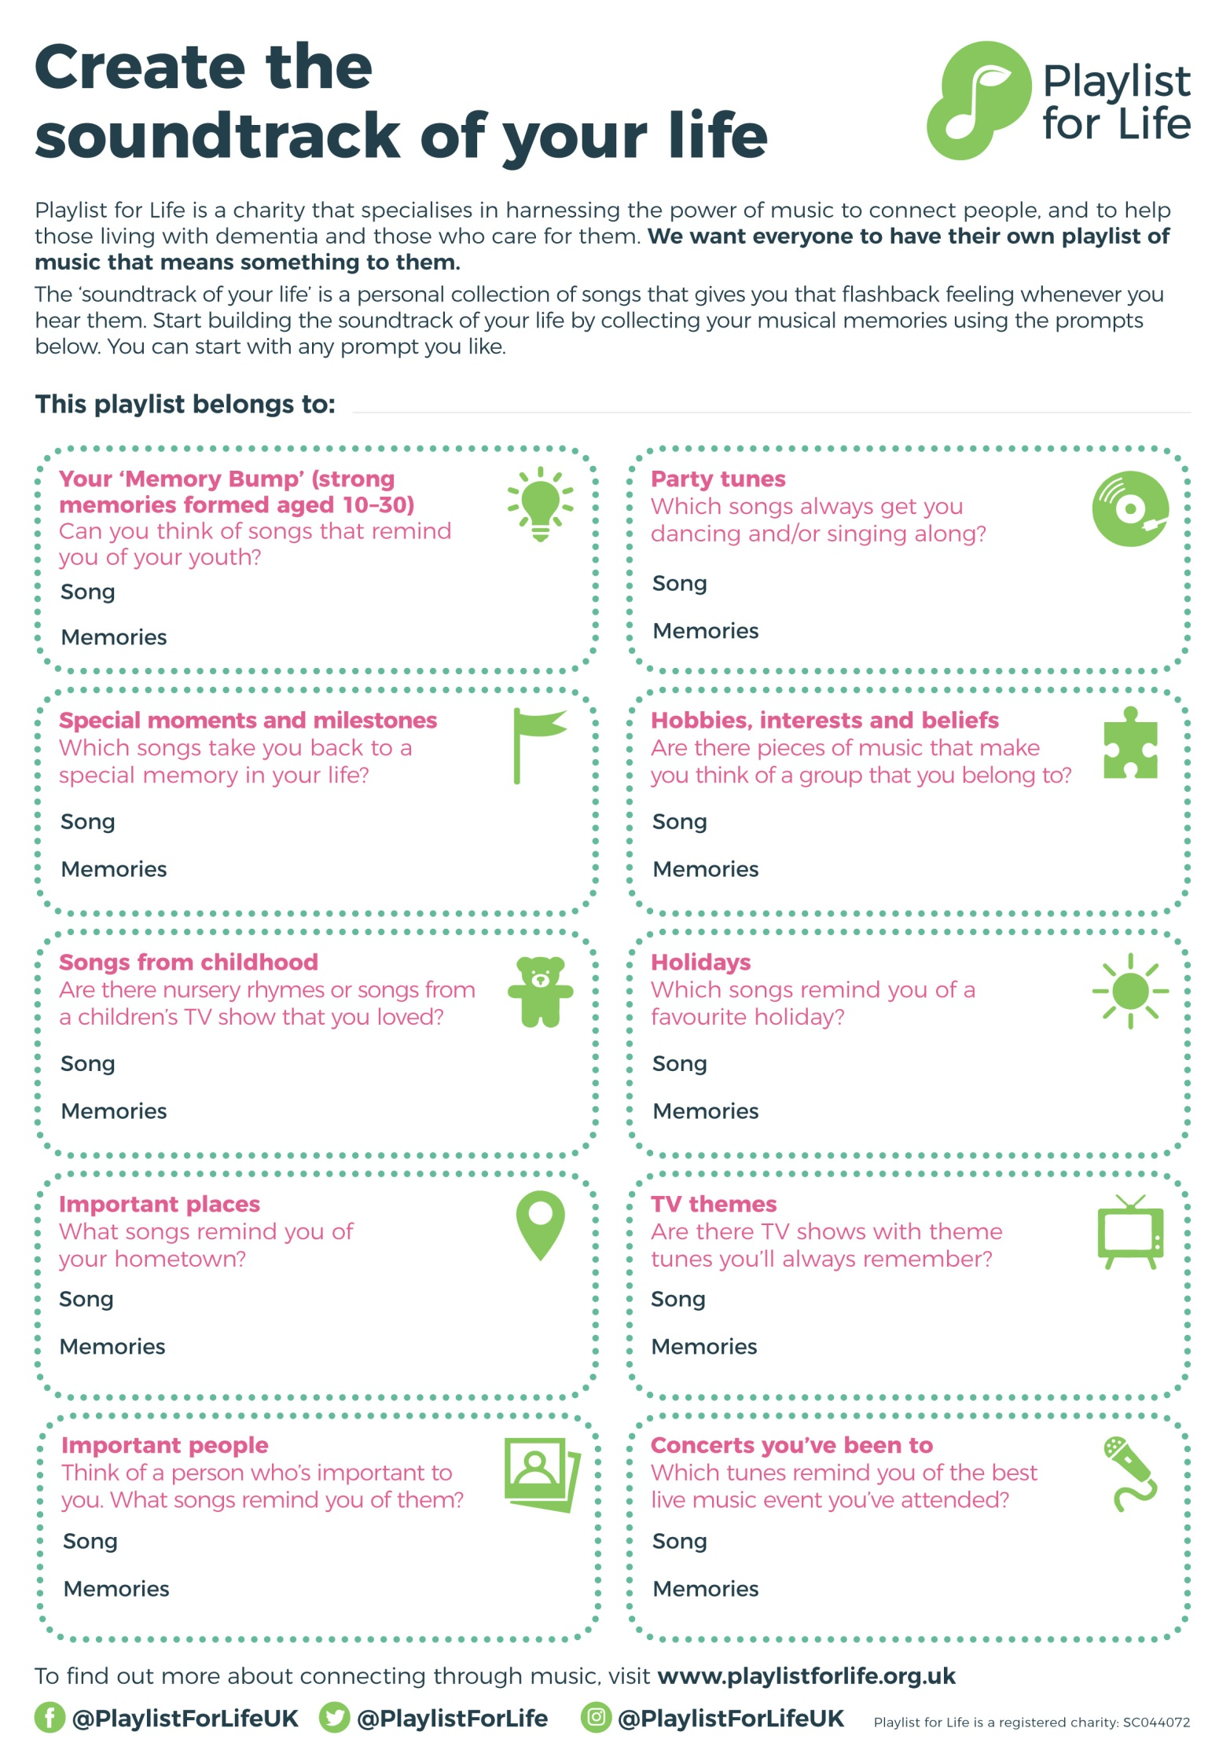
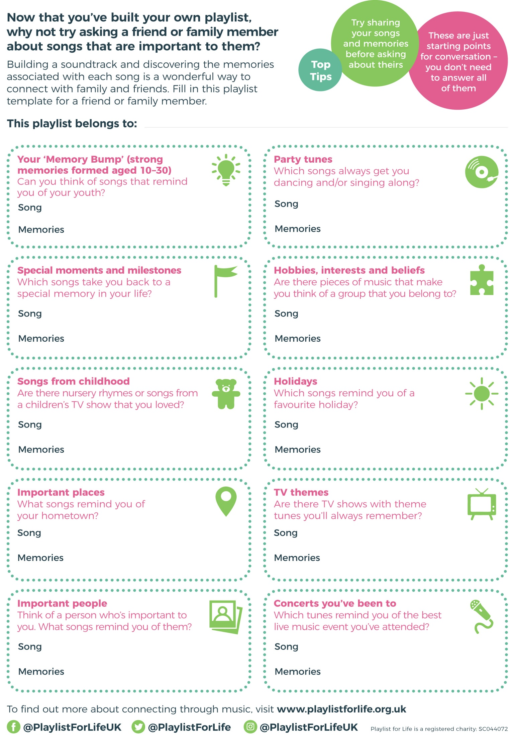
US Presidents and the First Ladies
Draw a line from the president’s name to the name of his wife

George Washington Jacqueline
George H.W. Bush Hilary
Donald J Trump Barbara
Harry S Truman Abigail
John F Kennedy Martha
John Adams Melania
Bill Clinton Elizabeth “Bess”
Franklin D Roosevelt Alice
Gerard R Ford Eleanor
Ronald R Regan Betty
Barack Obama Michelle
Theodore Roosevelt Nancy
Jimmy Carter Rosalynn

Answers US Presidents and the First Ladies:

George Washington ---- Martha
George H.W. Bush ---- Barbara
Donald J Trump ---- Melania
Harry S Truman ---- Elizabeth “Bess”
John F Kennedy ---- Jacqueline
John Adams ---- Abigail
Bill Clinton ---- Hilary
Franklin D Roosevelt ---- Eleanor
Gerard R Ford ---- Betty
Ronald R Regan ---- Nancy
Barack Obama ---- Michelle
Theodore Roosevelt ---- Alice
Jimmy Carter ---- Rosalynn

A Poem: Tangmalangaloo
(NB: For optimum effect, this should be read aloud. In a broad Irish or Australian accent. The Bishop should have a softer Irish accent.)

The bishop sat in lordly state and purple cap sublime,
And galvanized the old bush church at Confirmation time.
And all the kids were mustered up from fifty miles around,
With Sunday clothes, and staring eyes, and ignorance profound.
Now was it fate, or was it grace, whereby they yarded too
An overgrown two-storey lad from Tangmalangaloo?
A hefty son of virgin soil, where nature has her fling,
And grows the trefoil three feet high and mats it in the spring;
Where mighty hills uplift their heads to pierce the welkin’s rim,
And trees sprout up a hundred feet before they shoot a limb;
There everything is big and grand, and men are giants too –
But Christian Knowledge wilts, alas, at Tangmalangaloo.
The bishop summed the youngsters up, as bishops only can;
He cast a searching glance around, then fixed upon his man.
But glum and dumb and undismayed through every bout he sat;
He seemed to think that he was there, but wasn’t sure of that.
The bishop gave a scornful look, as bishops sometimes do,
And glared right through the pagan in from Tangmalangaloo.
“Come, tell me, boy,” his lordship said in crushing tones severe,
“Come, tell me why is Christmas Day the greatest of the year?
“How is it that around the world we celebrate that day
“And send a name upon a card to those who’re far away?
“Why is it wandering ones return with smiles and greetings, too?”
A squall of knowledge hit the lad from Tangmalangaloo.
He gave a lurch which set a-shake the vases on the shelf,
He knocked the benches all askew, up-ending of himself.
And so, how pleased his lordship was, and how he smiled to say,
“That’s good, my boy. Come, tell me now; and what is Christmas Day?”
The ready answer bared a fact no bishop ever knew –
“It’s the day before the races out at Tangmalangaloo.”

The story behind the poem:
That was written by John O’Brien (1878-1952), which was the pen-name of Father (later Monsignor) Patrick Hartigan. He was born in Australia of Irish parents, trained as a Catholic priest and spent his career ministering to small towns in New South Wales. So vast were some of his early territorial responsibilities that he was one of the first priests in Australia to have a motor car. He became parish priest of Narrandera in 1916 and remained there until 1944. The town now has an annual John O’Brien festival in his memory.
O’Brien’s poems were published in periodicals and in two collections, Around the Boree Log (1921) and the posthumous The Parish of St Mel’s (1954) and they were hugely popular, not just in Australia, but also in Ireland, and among the Irish diaspora worldwide.

Covid-19
By Fergus Cleary

Just give me a wee while and my story I’ll tell.
I’m here doing nothing and I’m doing it well.
And how long I’ll continue remains unforeseen
It’s because of this virus called Covid-19.

I first heard about it at the start of the year,
And it’s coming to Europe , the news made that clear.
A deadly pandemic that’s never yet seen.
And there isn’t a cure for Covid-19.

It came with a vengeance, it’s affected us all
And we sure didn’t miss it in old Donegal.
I’m now in confinement in my home in Drumkeen.
For how long, no one knows, cause of Covid-19.

The orders came quickly, that I have to say.
You can only go out once to shop every day.
Observe social distance’ - two metres between
Yourself and the next guy cause of Covid-19.

I thought twas a scandal but then it got worse.
I’m now nearly 80 and because of this curse
I now can’t go shopping, I’ve never been
Since the middle of March cause of Covid-19.

My niece does my shopping, my needs to fulfil.
And she leaves it out gently on the front window sill.
Goodness knows what I’d do, I doubt times would be lean,
If she didn’t assist me out of Covid-19.

I take it in quickly cause it could be much worse.
I have to in case the old dog gets it first.
His sense of smell is amazingly keen,
And he has no regard for this Covid-19.

The crows and the jackdaws they visit as well.
Their eyesight’s amazing it’s not hard to tell.
One grabbed a potato and was never again seen,
A bonus for him cause of Covid-19.

I went for a drive on this fine sunny day,
But a huge Garda checkpoint was soon in my way.
Says one ‘go back home you’re a stupid Gombeen.
Don’t you see you’re in danger of this Covid-19.

Since no vaccine has yet to been found,
Are we destined to stay in eternal lockdown?
I’ve painted and dusted sure the place is now clean.
And it wouldn’t have happened without Covid-19.

I lie in my bed until round about noon
Since I’m eighty years old, I’m told to cocoon.
I’m the healthiest man that this parish has seen
But I’m self-isolating cause of Covid-19.

Sure I still like to hug the girls close to my heart.
But now we must all stay two metres apart.
To end up like this I had never forseen,
It’s the end of my love life, damn this Covid-19.

So how to conclude this I’m not very sure.
They say it may last ‘til someone finds a cure.
So until then, stay safe, keep your mask nice and clean,
And stay out of the way of Covid-19!

Stay Safe!
Lavender Rice & Chamomile Dough for Sensory Engagement
Here are some calming sensory activities. They include familiar scents, kneading and shaping.

Chamomile Play Dough recipe
Ingredients:
- 2 cups plain flour
- ½ cup salt
- 2 teaspoons oil
- 2 Tablespoons of cream of tartar
- Up to 1.5 cup of water
- 2 bags of chamomile tea
- 3 drops of essential rose oil

How to make:
- Boil 1.5 cups of water and brew the two chamomile tea bags for 5 minutes.
- Remove the tea bags and wait for the water to cool.
- Mix the dry ingredients plus the two oils and pour in the chamomile water, mixing as you go. The mixture will be sticky just like bread dough.
- Turn onto a surface and knead for 10 minutes until it becomes smooth, pliable and non-sticky - if needed add a half teaspoon of flour.

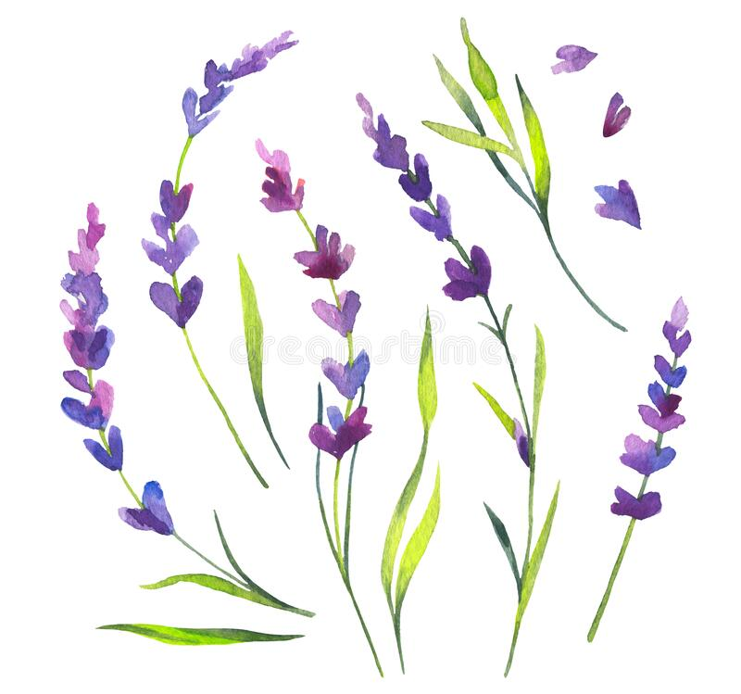

Sensory Lavender Rice Tray
Ideal for those with sensory needs to experience the calming scent of lavender and improve motor skills by scooping, turning, filling, squeezing, and separating.

Ingredients:
- A wooden/plastic/metal tray
- Paper towels
- 2 kg Rice
- A bowl to dye the rice
- 8 teaspoon of white vinegar
- ¼ teaspoon blue food colouring
- Fresh or dried lavender flowers
- Wooden spoons, small bowls, cups
- 3 or 4 drops of essential lavender oil

How to make:
- Line the tray with paper towels.
- Place the rice in the bowl and add ¼ teaspoon of blue food colouring plus 3 or 4 drops of lavender essential oil / Mix well to distribute the colour (put a little more food colouring as desired).
- Pour the rice onto the lined tray and spread out for fast drying
- Place tray in the sun for a couple of hours or leave it overnight for drying.
- Give the person the lavender flower branches to pick and mix with the rice.

The Lake Isle of Innisfree

By William B Yeats

I will arise and go now, and go to Innisfree,
And a small cabin build there, of clay and wattles made;
Nine bean-rows will I have there, a hive for the honey-bee,
And live alone in the bee-loud glade.

And I shall have some peace there, for peace comes dropping slow,
Dropping from the veils of the morning to where the cricket sings;
There midnight’s all a glimmer, and noon a purple glow,
And evening full of the linnet’s wings.

I will arise and go now, for always night and day
I hear lake water lapping with low sounds by the shore;
While I stand on the roadway, or on the pavements grey,
I hear it in the deep heart’s core.

Dust If You Must

Dust if you must, but wouldn't it be better
To paint a picture, or write a letter,
Bake a cake, or plant a seed;
Ponder the difference between want and need?
Dust if you must, but there's not much time,
With rivers to swim, and mountains to climb;
Music to hear, and books to read;
Friends to cherish, and life to lead.
Dust if you must, but the world's out there
With the sun in your eyes, and the wind in your hair;
A flutter of snow, a shower of rain,
This day will not come around again.
Dust if you must, but bear in mind,
Old age will come and it's not kind.
And when you go (and go you must)
You, yourself, will make more dust.

Furry Friend

What would I do without you,
My precious, furry friend?
Part mischief, but all blessing,
And faithful to the end!
You look at me with eyes of love;
You never hold a grudge . . .
You think I'm far too wonderful
To criticize or judge.
It seems your greatest joy in life
Is being close to me . . .
I think God knew how comforting
Your warm, soft fur would be.
I know you think you're human,
But I'm glad it isn't true . . .
The world would be a nicer place
If folks were more like you!

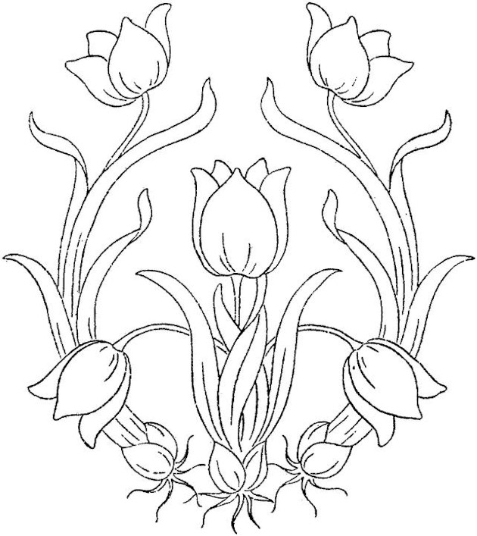

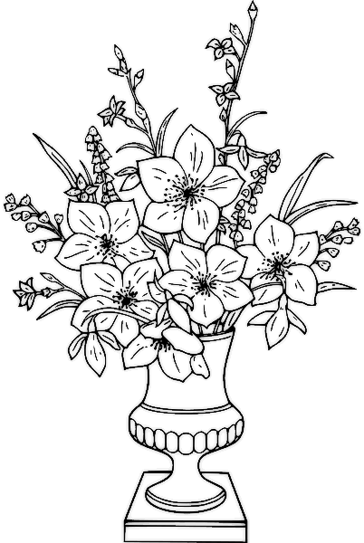

FUNNY SAYINGS !!!

- I am on a seafood diet. I see food, and I eat it.
- I don't need a hair stylist, my pillow gives me a new hairstyle every morning.
- Don't worry if plan A fails, there are 25 more letters in the alphabet.
- If I'm not back in five minutes, just wait longer...
- A bank is a place that will lend you money, if you can prove that you don’t need it.
- A balanced diet means a cupcake in each hand.
- Doing nothing is hard, you never know when you're done.
- If you’re not supposed to eat at night, why is there a light bulb in the refrigerator?
- Don’t drink while driving – you might spill the beer.
- I think the worst time to have a heart attack is during a game of charades.
- I refuse to answer that question on the grounds that I don't know the answer.
- Alcohol doesn't solve any problem, but neither does milk.
- My wallet is like an onion. When I open it, it makes me cry...
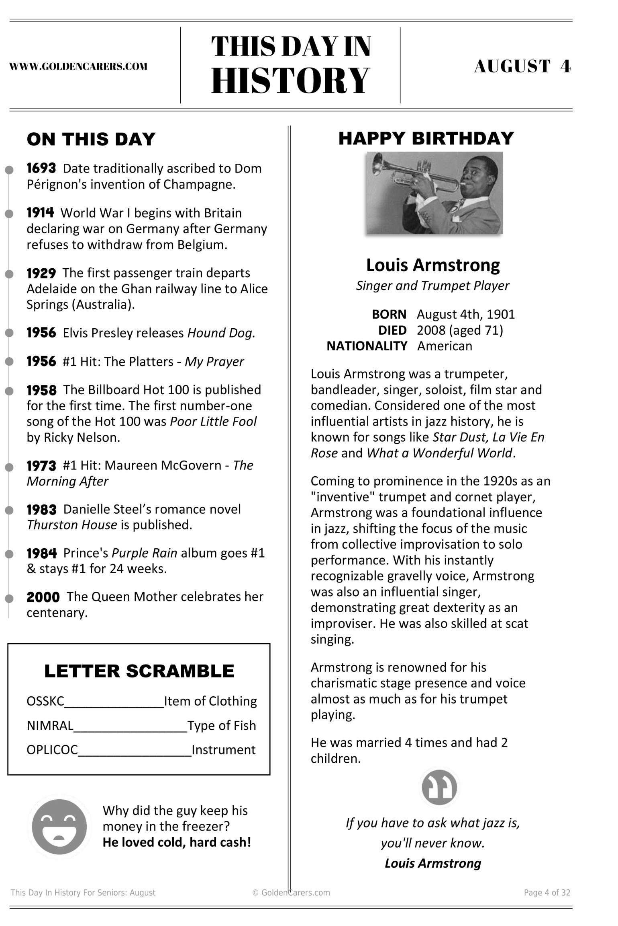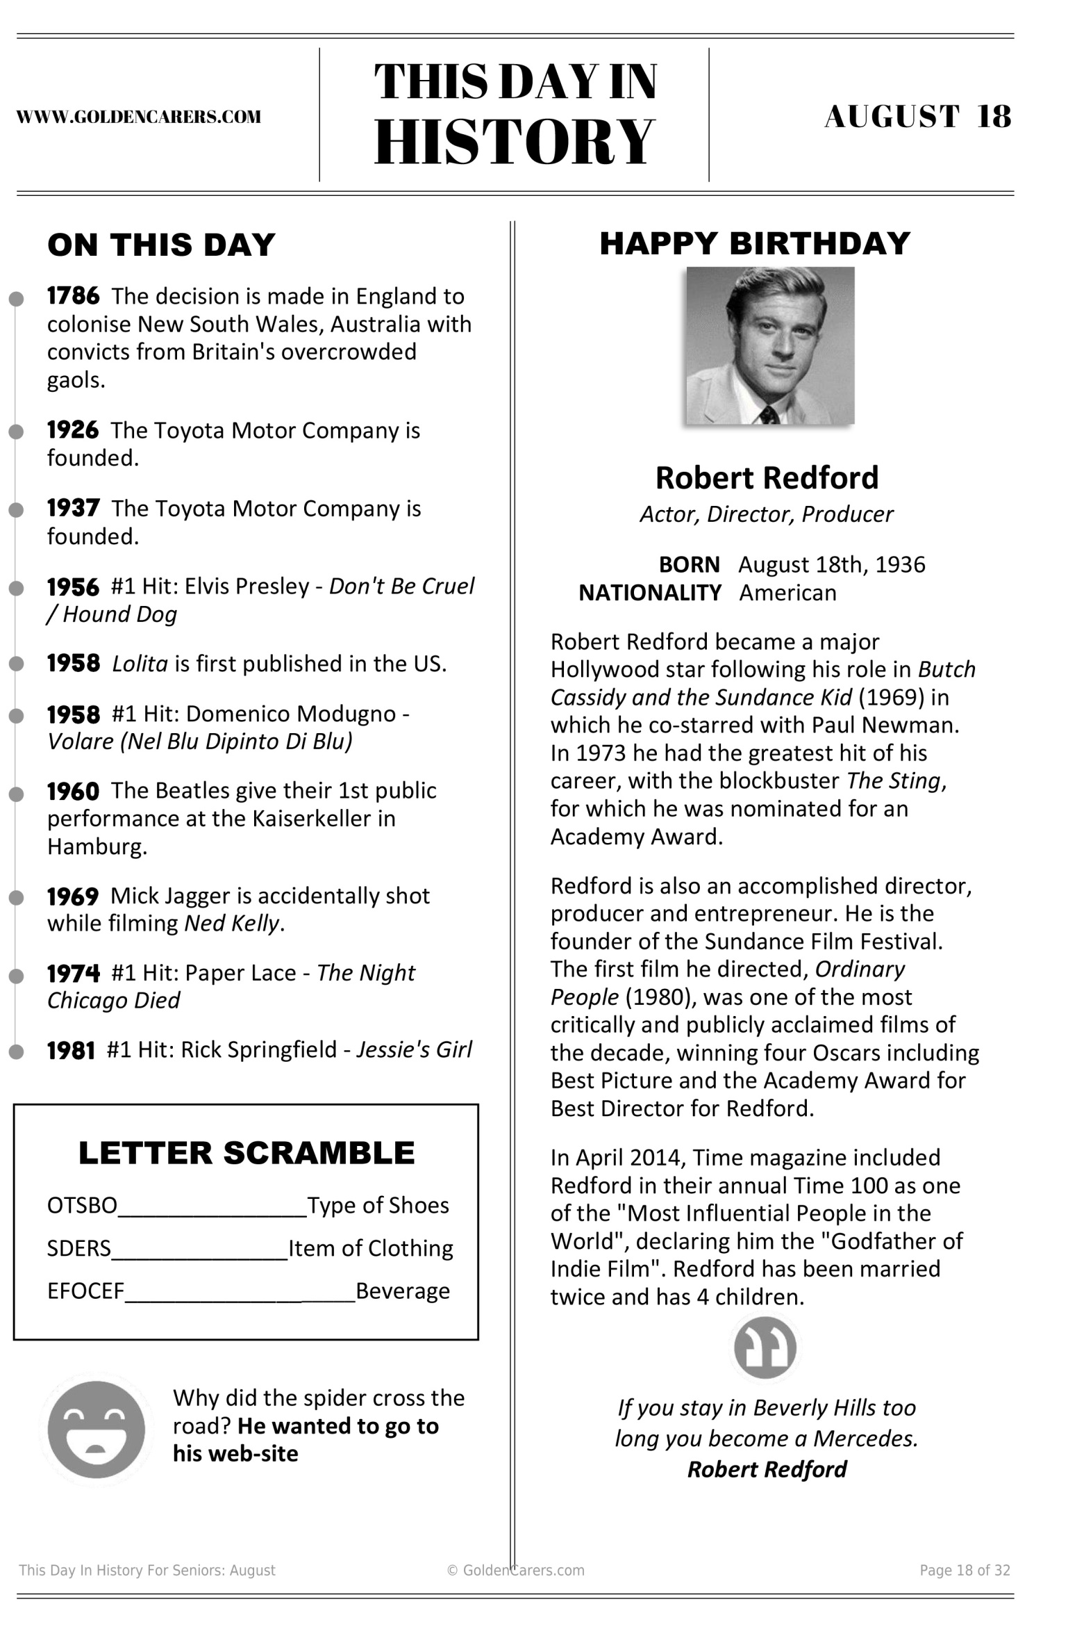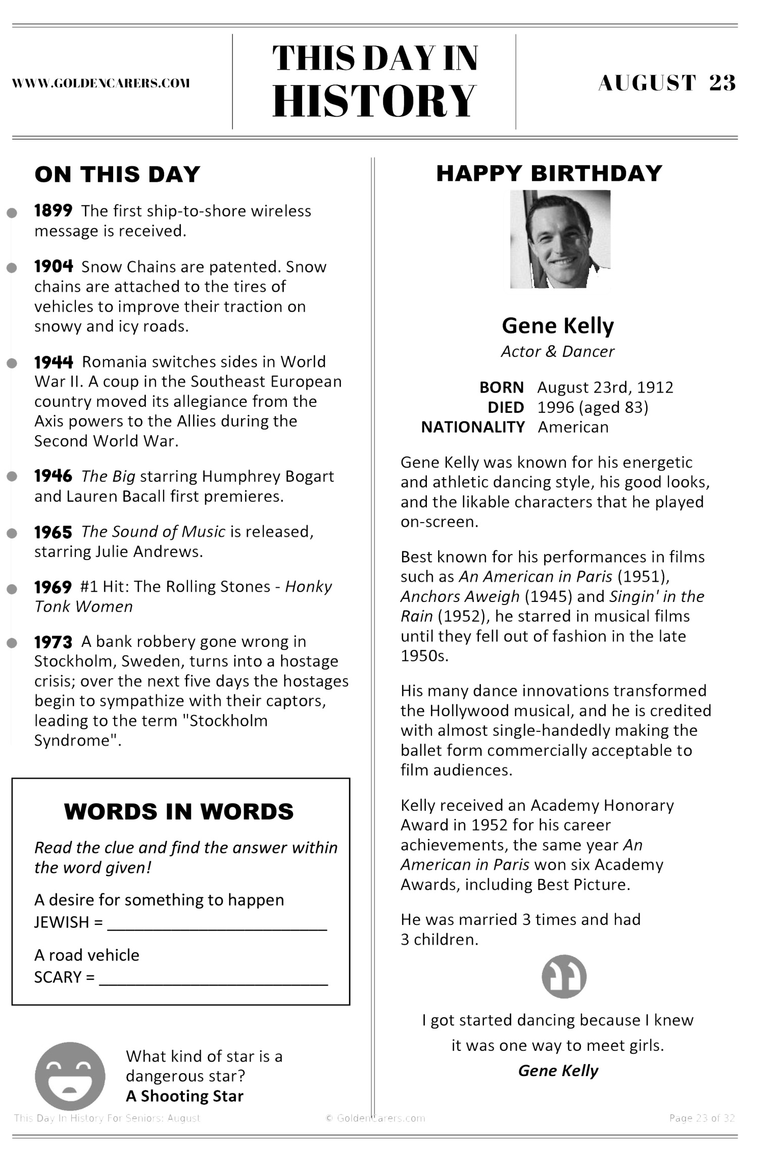
Sounds of Summer
X | P | C | Q | K | I | A | O | V | J | H | X | V | C | D
T | S | G | M | P | G | I | G | G | L | E | S | Q | Z | T
X | P | S | S | K | F | R | O | Q | Q | L | K | F | R | V
Y | S | T | B | A | S | P | G | R | E | L | X | J | B | K
I | S | E | C | E | E | L | S | B | Q | O | L | K | H | F
F | P | R | O | S | R | A | I | N | D | R | O | P | S | S
Y | L | E | D | G | J | N | O | L | B | R | E | E | Z | E
E | A | O | B | M | P | E | M | U | S | I | C | F | E | V
B | S | Z | I | U | L | A | U | G | H | T | E | R | S | C
A | H | M | R | P | V | O | C | O | N | C | E | R | T | L
R | I | Z | D | K | E | E | O | I | B | F | R | F | U | J
K | N | Z | S | C | C | H | O | L | I | D | A | Y | S | I
I | G | I | O | A | C | Z | Q | B | N | C | D | Y | W | R
N | T | Q | N | E | Z | J | A | T | W | B | B | Z | U | F
G | D | Z | G | Q | C | O | B | J | O | Y | X | B | V | L

AIRPLANE BARKING
BIRDSONG BREEZE
CONCERT GIGGLES
HELLO HOLIDAYS
JOY LAUGHTER
MUSIC RAINDROPS
SPLASHING STEREO
Rock N Roll
T | N | C | P | R | E | S | L | E | Y | Y | R | K | H | I
G | B | G | V | I | V | U | L | M | Z | X | B | H | L | N
V | O | D | R | W | E | P | J | V | E | R | L | Y | E | H
M | T | P | C | E | R | R | M | T | X | U | R | Z | E | O
A | K | R | U | O | L | E | L | V | I | S | Y | Q | Z | L
U | S | A | D | U | Y | M | U | A | H | H | L | Y | G | L
B | U | D | D | Y | V | E | E | P | V | O | O | M | B | Y
R | W | H | X | K | I | S | S | G | A | V | X | Z | O | O
M | K | X | P | W | F | L | Y | I | B | I | G | E | P | B
P | A | L | Z | B | O | Y | S | T | E | Z | X | C | P | W
I | M | U | J | A | C | V | V | P | A | Q | U | E | E | N
I | F | F | H | K | U | K | H | N | T | B | L | P | R | M
S | O | M | G | R | H | J | H | D | L | Y | W | L | H | L
K | E | E | G | I | N | X | E | B | E | A | C | H | Z | Z
D | E | C | R | I | C | K | E | T | S | S | K | T | M | H

BEACH BEATLES BOPPER SUPREMES
BOYS BUDDY
CRICKETS ELVIS
EVERLY HOLLY
KISS PRESLEY
QUEEN RUSH

