September
Activity Pack

Dear Friends,

We are in September now and as the leaves begin to golden and the air becomes cooler in the evenings we hope you are keeping safe and warm.

We continue to hope you are well and want you to know that now, during World Alzheimer’s Month, we are here for you as much as ever. We have a variety of online activities, talks and resources created especially for this month, and details can be found on our website:
https://alzheimer.ie/creating-change/awareness-raising/world-alzheimers-month-2020/
The ASI are just a phone call away if you ever need us. Our helpine number is 1800 341 341, with trained staff on the other end to listen to and support you.

We hope you all enjoy this September Activity Pack!

“For beautiful eyes, look for the good in others;
For beautiful lips, speak only words of kindness;
And for poise,
Walk with the knowledge that you are never alone.”
Audrey Hepburn

Useful Resources:

- Our Free Helpline and Dementia Nurse Support Line are available at:
Phone: 1800 341 341 and Email: helpline@alzheimer.ie

- We are hosting a number of Virtual Cafes. They are a place to come together, share a cuppa and listen to our amazing guest speakers. For information on how to attend visit: https://alzheimer.ie/service/alzheimer-cafe/

- The ASI also have a huge library of factsheets and resources available on: https://alzheimer.ie/get-support/resources-and-factsheets/

- Engaging Dementia are also running an online café each Friday and several webinars. For more information : https://engagingdementia.ie/

- For musical videos and resources Music For Dementia are a wonderful resource: https://musicfordementia.org.uk/

- The Irish Museum of Modern Art (IMMA) have a huge collection available to view online at: https://imma.ie/collection/

- During October and November vocalist Liz Ryan will run a weekly online Tea Dance from the National Concert Hall. Tickets are free and available from the “What’s On” section of: https://www.nch.ie/Online/default.asp

- Emergency Response Numbers: 999 or 112

- HSE 24/7 Your Mental Health Information Helpline: 1800 111 888

Table of Contents

Activity | Pages
Cloud Bounce Activity | 5
Sports Quiz | 6 – 7
Sensory Poetry – Bakery | 8 – 9
Match The Tools | 10
Dances Wordsearch | 11
Days Wordsearch | 12
Afternoon Tea Story | 13 – 15
The Forge | 16 – 17
The Giant’s Causeway | 18 – 19
The Ballad of Rum Poem | 20 – 21
My Teeth Poem | 22 – 23
Who Am I? | 24 – 25
September Quiz | 26 – 27
The Wild Atlantic Way Lyrics | 28 – 29
Medication Practice | 30 - 32

Cloud Bounce Activity
Gentle physical warm up – an activity for individuals

WHAT YOU WILL NEED: A white balloon

METHOD:
Show an inflated white balloon to your partner - say that you have specially chosen a white balloon because it reminds you of clouds.

Ideas that you could try:
Explain that you are going to pass the balloon back and forth accompanied by a piece of music – “Raindrops Keep Falling On My Head” is an ideal piece of music!
Put on the music without further explanation and give it a go!
- Work together to try different ways of passing the balloon.
- Seeing how high in the air you can get the balloon to go.
- Bouncing the balloon from person to person on one finger.
- Passing the balloon for as long as you can without it touching the floor / table.
- Bouncing the balloon off your head.
- Bouncing the balloon off any part of your body except your hand.

Sport quiz questions
Answers can be found below.

1. What are the five colours of the Olympic rings?
2. In football, which team has won the Champions League (formerly the European Cup) the most?
3. How many players are there in a rugby league team?
4. Which horse is the only three-time winner of the Grand National?
5. Since 1977, where has snooker's World Championship taken place?
6. In tennis, what piece of fruit is found at the top of the men's Wimbledon trophy?
7. Who won the FIFA Women's World Cup in 2019?
8. In bowling, what is the term given for three consecutive strikes?
9. How many world titles has Phil Taylor won in darts?
10. In golf, where does the Masters take place?
11. In 2016, who announced their retirement days after becoming F1 world champion?
12. Who holds the women's record for the 100m sprint?

Sport quiz answers

1. Blue, yellow, black, green and red
2. Real Madrid (13)
3. 13
4. Red Rum
5. Crucible Theatre
6. Pineapple
7. USA
8. A turkey
9. 16
10. Augusta National
11. Nico Rosberg
12. Florence Griffith-Joyner (10.49s)

Sensory Poetry – Bakery

METHOD:
Gather a small selection of ingredients.
Three or four are sufficient - a good selection could be flour, chocolate chips, fresh yeast, and some ready rolled icing.
Have a piece of paper to hand to write down all the different ideas that you come up with.

To begin:
Lay out a selection of ingredients – explain that you are going to use them as inspiration to create a piece of poetry.
Begin by looking at the ingredients together –
Do you recognise any of them?
What are they?
What would they be used for?
What recipe would they be useful for?

Then go through the four different ingredients looking at each in more detail.
For Example:
Flour:
Looking at the flour what would you use it to make?
Have the flour in a bowl so it is easy to touch.
What does the flour feel like?
How would you describe the texture to somebody else?
How does it smell?
What does it look like in the bowl?
Put a small amount on the palm of your hand and blow it into the air. What does
that look like? How does that feel?
Any other questions that you come up with.

Chocolate Chips:
What are they?
What would you use them for?
What do they look like?
What would happen to them when they are cooked?
What recipe would you use them in?
How do they taste?
Anything else...

To finish:
Read back the poems that have been created.
Can you come up with a name for each of them?

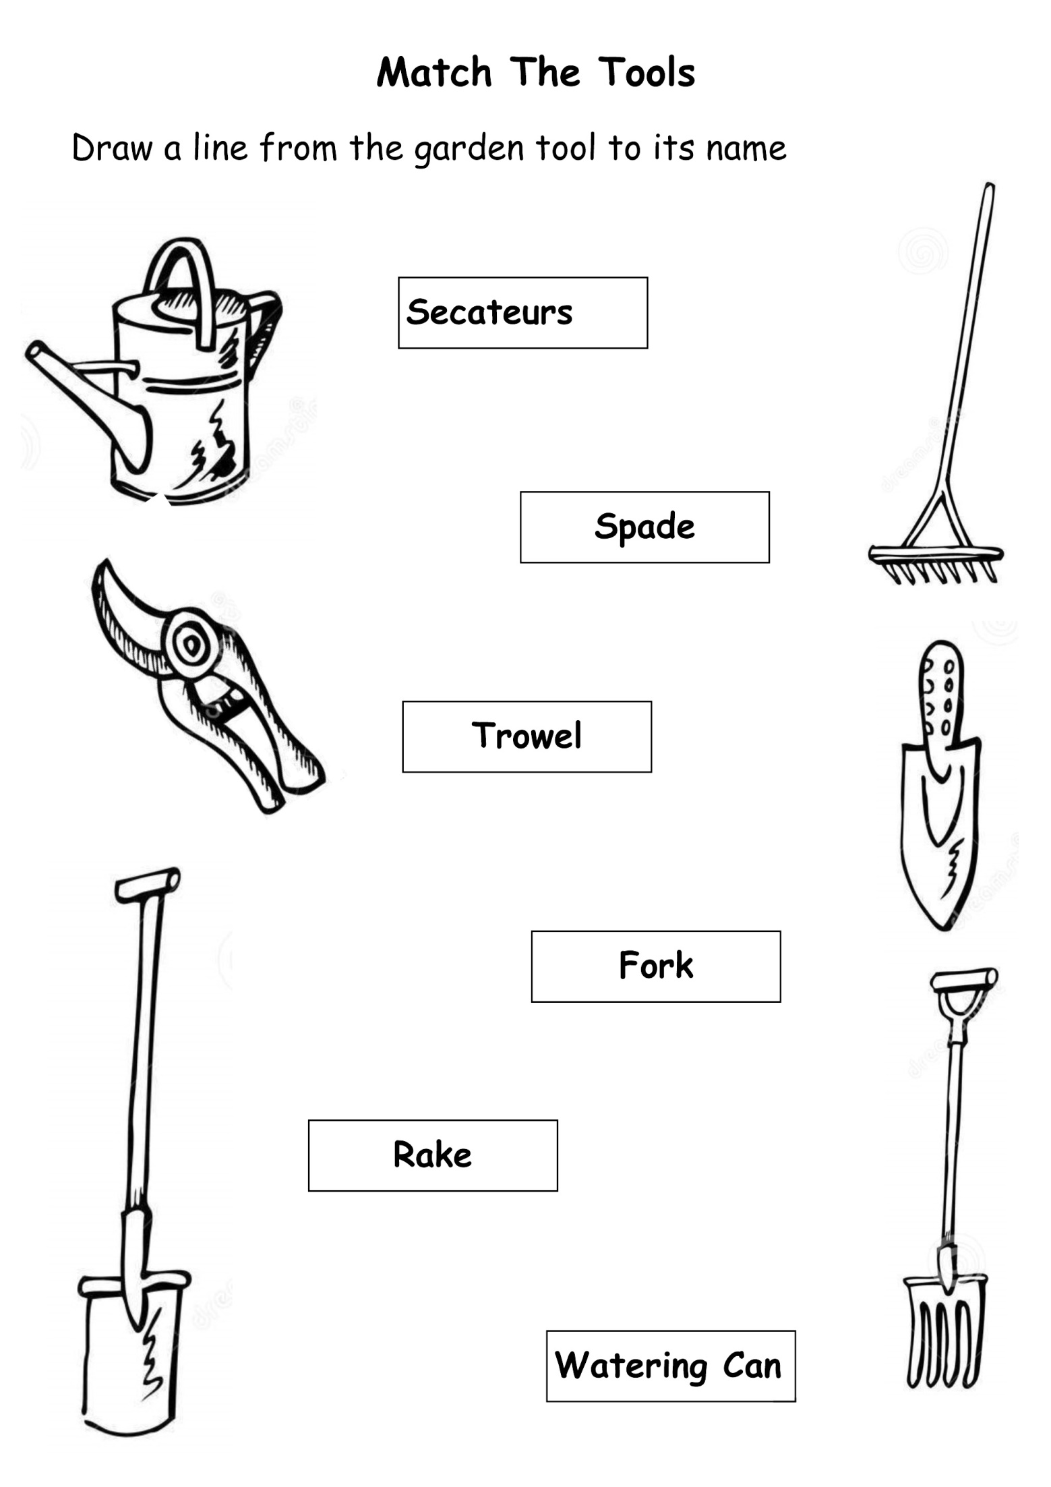
Dance The Night Away Wordsearch

Y | J | O | Q | W | A | M | L | K | F | X | F | Q | K | O
J | B | I | T | W | I | S | T | T | B | M | M | C | P | D
Q | G | D | N | R | U | I | B | K | S | H | E | U | Z | U
O | E | B | L | M | X | P | Z | U | B | E | E | I | L | J
J | S | K | F | B | S | P | F | W | E | X | L | P | V | D
V | D | C | G | A | Z | W | L | U | L | I | N | D | Y | K
C | M | N | G | L | C | H | A | R | L | E | S | T | O | N
S | A | F | S | L | H | I | M | R | Y | V | N | A | X | K
X | H | P | N | E | F | U | E | E | D | G | I | P | Z | L
L | B | H | Z | T | U | P | N | S | A | I | R | S | S | P
K | H | N | I | I | W | W | C | W | N | C | I | W | J | C
I | J | C | Q | V | I | R | O | A | C | W | S | I | V | J
X | O | H | P | O | L | K | A | L | E | H | H | N | X | N
Q | D | I | S | C | O | B | W | T | M | W | W | G | W | D
M | H | S | Y | M | J | A | Z | Z | C | B | H | A | N | S

BALLET BELLYDANCE
CHARLESTON DISCO
FLAMENCO IRISH
JAZZ LINDY
POLKA SWING
TAP TWIST
WALTZ

Days of the Week Wordsearch

X | Y | N | P | F | Z | C | V | F | T | C | W | E | W | U
N | D | O | G | U | F | R | I | D | A | Y | F | O | M | Y
T | K | S | X | W | Q | L | Q | K | I | G | T | I | O | C
U | E | J | V | N | C | Z | N | I | G | T | P | M | N | G
N | Q | C | I | S | O | E | N | A | T | U | T | K | D | T
X | Q | T | K | A | C | N | E | Y | Q | E | O | C | A | H
A | C | L | Y | T | Z | P | P | H | O | S | M | G | Y | U
S | H | O | K | U | A | S | E | L | M | D | O | A | Q | R
U | Y | B | T | R | V | H | E | P | M | A | R | G | Q | S
N | I | T | O | D | A | Y | H | V | V | Y | R | X | C | D
D | B | F | U | A | E | N | Y | L | W | Y | O | D | C | A
A | A | X | W | Y | Q | V | R | P | J | K | W | I | W | Y
Y | A | F | O | W | E | D | N | E | S | D | A | Y | K | X
S | Y | R | Y | E | S | T | E | R | D | A | Y | W | N | D
R | K | T | E | U | I | H | H | Y | M | M | I | F | F | Z

MONDAY TOMORROW
TUESDAY WEDNESDAY
TODAY FRIDAY
THURSDAY SATURDAY
SUNDAY YESTERDAY

Tea Parties and Afternoon Tea
The origins of afternoon tea can be traced back to the early 1800s, a period when dinner was taken late in the evening, and Anna Russell, the seventh Duchess of Bedford. Annoyed by hunger pains caused by only having two meals a day, the Duchess scheduled time to take tea and enjoy a snack in the afternoon. The Duchess first conducted this as a private ceremony but was eventually joined by her acquaintances, and the practice was perpetuated throughout England.
Many hotels and restaurants have broken with tradition and reinvented the quintessential British afternoon tea. The Sanderson hotel has created a Mad Hatter’s Afternoon Tea, complete with ladybird cakes, coffee-flavoured pocket watch-shaped macaroons and innovative cocktails. The Shangri-La Hotel at the Shard’s Ting restaurant has also added a twist to traditional treats, replacing scones, sandwiches and tarts with dumplings, ribs and sushi. The Pret-a-portea at The Berkeley has added a fashion twist with cakes designed after the top trends of the season.
Afternoon tea was originally an upper-class social event with a menu traditionally made up of delicate finger foods ranging from small sandwiches to scones, pastries and cakes. The working class could not afford such an indulgent treat so instead introduced high tea – a much heartier affair usually involving tea, bread, meat, pies and crackers.
The most expensive tea bag in the world was created by Boodles jewellers to celebrate PG Tips’s 75th anniversary. The diamond- encrusted bag was valued at £7,500.
One of Britain’s most expensive afternoon teas was offered by the Cliveden hotel in Berkshire. The meal was priced at £550 per couple and used some of the world’s priciest ingredients, including rare Da Hong Pao tea leaves, which sell for more than £2,000 per kilogram; beluga caviar; mini canapé sandwiches made with
iberico ham; and the Cliveden House chocolate opera cake, made from Amedei Porcelana, one of the most expensive chocolates in the world.

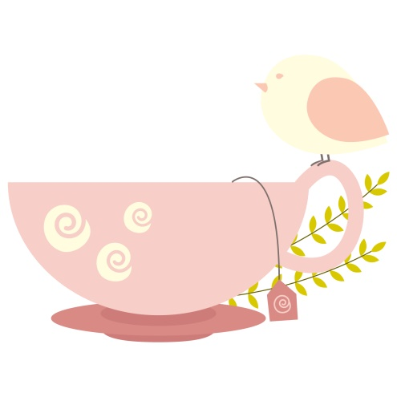

ROYAL GARDEN PARTIES
Over the course of each year, The Queen welcomes over 30,000 guests to spend a relaxed summer afternoon in the beautiful gardens of Buckingham Palace or the Palace of Holyroodhouse. At each Garden Party, around 27,000 cups of tea, 20,000 sandwiches and 20,000 slices of cake are consumed! Garden Parties are an important way for The Queen to speak to a broad range of people from all walks of life, all of whom have made a positive impact in their community.
Every summer, The Queen hosts three Garden Parties at Buckingham Palace, and one at the Palace of Holyroodhouse in Scotland. Historically, Garden Parties took the place of presentation parties attended by debutantes, and have evolved into a way of recognising and rewarding public service.
For a Garden Party, gentlemen wear morning dress or lounge suits, while women wear day dress, usually with hats or fascinators. National dress and uniform are also often worn.

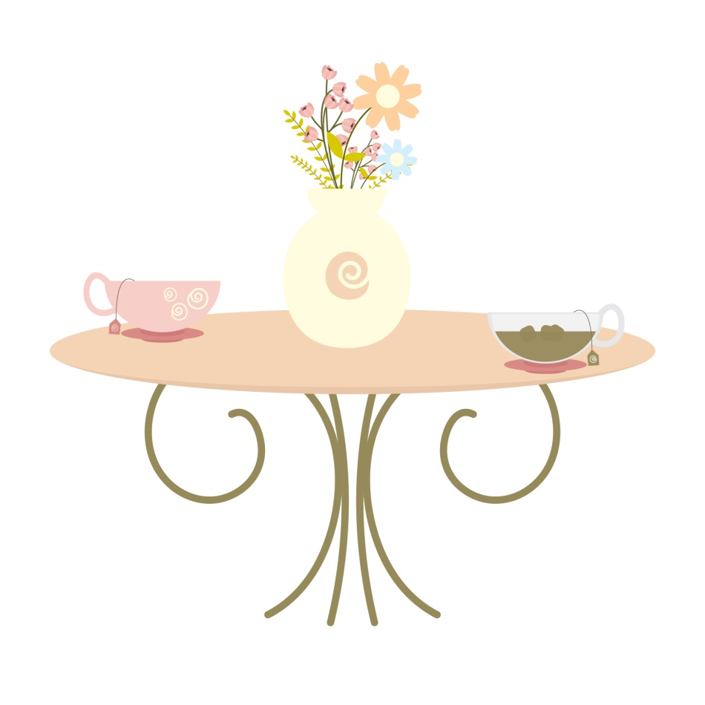

THE FORGE
My best memory of the Forge is the smell and the sound of hammering as I approached it.
The Blacksmith was a very important man in Irish Society before the arrival of the car or tractor. Back then he was a farmers best friend, he worked alongside him in all his daily work. He pulled the trap as people went to Mass every Sunday, brought the family to the nearest town, brought them to visit family relatives, even brought him home safely from the nearest public house on a Saturday night without guidance and they were used to pull the Hearse to the Church and Cemetery. Back in the 1800s the horse brought them to the nearest Port, where the pony and trap were sold there, before a family joined a ship going to England on their journey to America.
But, the horse had to be cared for and the person who tended to one of his needs was the Blacksmith. The Blacksmith worked from his Forge, and there was a Forge in every parish back then. “The Smithys” was also a great meeting place for people as they lined up with their horses. Local happenings would be discussed, and someone might have a newspaper and Country and World events would be discussed, like the World War, or our Government, or the Economic War, or whatever was going on at that time.
The Blacksmith shod the horse (put shoes on the horse) also ponies and donkeys, but he was also a kind of engineer, and inventor. He repaired machinery, welded a part of a machine that had broken off or pointing harrow pins, he moulded and invented items that were requested.
With the use of the Furnace he was able to make metal flexible and made the rims for wheels, he also made gates.
His tools were the “Anvil” which had a flat top and pointed end, the “Furnace” which was the fire that was used to heat the object enough to make it able to be moulded, his Tongs which held the object as it was moulded, the “Barrel of Water” which he used to cool the object down, the “Bellows” which were used to fan the fire to make sure it was at the right temperature. He was clad in an Apron which was made of leather. He would lift the horse’s leg and place it between his legs, have a few nails nearby and would hammer the new horse shoe onto the hoof and do the same with the other 3 legs, and of the man went after paying, and his horse going “Clip Clop Clip Clop” on the country road. It was also believed the water from the forge cured warts.

How the Giant’s Causeway was Formed
(Written by Claddagh Design)

The Giant’s Causeway is made up of around 40,000 interlocking basalt columns, on the coast of county Antrim. The nearest town is Bushmills (where the whiskey of the same name originated), and it’s around an hour’s drive from Belfast. It was formed long before either of those places existed, however – in fact it was formed long before Ireland was inhabited by humans, some 60 million years ago. During the Paleogene period, the land mass that would eventually become Ireland was subject to high levels of volcanic activity. On the surface of the land were extensive chalk beds, which some very fast moving molten basalt pushed up through to form a lava plateau. As the lava cooled and solidified, it contracted and the surface fractured – similar to when mud dries out in the sun. As it cooled down further, the cracks continued in a downward motion, leaving hexagonal pillars of basalt.
The cliff edge of the Giant’s Causeway that visitors can see today is in fact the edge of the lava plateau. The larger fissures can be clearly seen in the cliff edge as bands of dark rock which cut down the cliff face and jut out towards the sea. This occurred in three periods of volcanic activity which resulted in three flows, now known as the Lower, Middle and Upper Basalts. It’s the Middle Basalts that formed the famous columns; variations in the cooling rate resulted in its undulating appearance. Weathering has created various other formations that have been given romantic (and not so romantic!) names such as the Giant’s Eyes, the Chimney Stacks, the Harp, the Organ, the Wishing Chair and the Camel’s Hump. Although the majority of the columns are hexagonal, some have up to eight sides. The tallest basalt column is around 12 metres high, while the solidified lava in the cliffs is up to 28 metres thick in some places.
If you’re slightly baffled by the mention of volcanoes, lava, and Ireland in the same sentence, you shouldn’t be. 60 million years ago the land mass that the Causeway formed on was actually attached to the eastern seaboard of America and would have had the same latitude as northern Spain has now, with hot and humid conditions prevalent. The tectonic plates that all of earth’s land is part of moved over the subsequent millions of years, and we eventually ended up where we are now! Similar formations can be found at the opposite point of the coast in Scotland (more about that later), as well as in parts of America, Australia and Vietnam – none are quite as spectacular as Ireland’s Giant’s Causeway however!
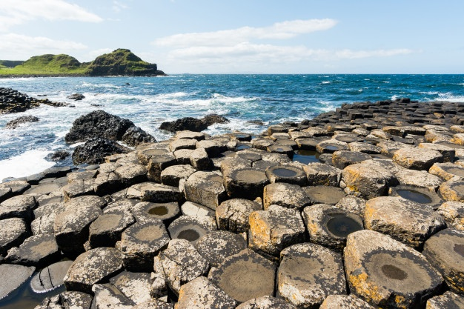

Be sure to visit the ASI Facebook Page during the last week of Sept when Storyteller Jon O’Sullivan “ScealaÍ Beag” will be sharing the Legend of the Giant’s Causeway!

The Ballad Of Rum By Peter R Wolveridge

A dog wandered into our garden one day,
A friendly old mutt, didn't look like a stray.
We never discovered whence he had come,
But we brushed him and fed him and the kids called him Rum.
Now as family members, even dogs must work hard,
So we put Rum on duty next door in our yard,
Bright eyed and watchful by night and by day,
But not much of a guard dog, I'm sorry to say.
He barked at the cats and he'd bark at a toad,
He barked at the cattle outside on the road,
He barked at the horses - so where did he fail?
You see, Rum liked people, and he just wagged his tail.
He liked the yard labour, an amiable bunch.
They fed our dog tidbits and scraps from their lunch.
Rum wolfed it all down, but to our dismay
He seemed to get fatter with each passing day.
Then one night when Rum was laid at his ease,
A burglar crept in just as quiet as you please.
He saw no alarms, heard no siren howling,
No guard dog for sure, there'd be barking and growling.
But Rum was awake and he'd seen him alright,
Delighted with company this time of the night,
He flew through the yard, his new friend to greet,
And his weight bowled the burglar right off of his feet.
The intruder got up and ran off with a wail
And Rum right behind him still wagging his tail.
He departed the yard he'd come in to burgle
Like a champion athlete clearing a hurdle.
But Rum couldn't jump gates, so sadly instead
He picked up the thief's wallet and went back to bed.
Next morning the evidence everyone viewed,
When Rum brought it to us, (just a little bit chewed).
Once given the wallet, the police didn't fail
To capture the burglar and put him in jail.
His confession like wildfire spread through the town,
How a big vicious guard dog had knocked the thief down.
We all howled with laughter when we heard the story,
And Rum was our hero, he was basking in glory.
There's been no attempts since to burgle our yard,
For everyone knows now that Rum is on guard.

To hear this poem read by ASI’s very own Danielle Keogh please visit the ASI Facebook Page during the last week of September!
OH, I WISH I’D LOOKED AFTER MY TEETH
by Pam Ayres

Oh, I wish I’d looked after me teeth,
And spotted the perils beneath,
All the toffees I chewed,
And the sweet sticky food,
Oh, I wish I’d looked after me teeth.
I wish I’d been that much more willin’
When I had more tooth there than fillin’
To pass up gobstoppers,
From respect to me choppers
And to buy something else with me shillin’
When I think of the lollies I licked,
And the liquorice allsorts I picked,
Sherbet dabs, big and little,
All that hard peanut brittle,
My conscience gets horribly pricked.
My Mother, she told me no end,
‘If you got a tooth, you got a friend’
I was young then, and careless,
My toothbrush was hairless,
I never had much time to spend.
Oh I showed them the toothpaste all right,
I flashed it about late at night,
But up-and-down brushin’
And pokin’ and fussin’

Didn’t seem worth the time... I could bite!
If I’d known I was paving the way,
To cavities, caps and decay,
The murder of fiIlin’s
Injections and drillin’s
I’d have thrown all me sherbet away.

So I lay in the old dentist’s chair,
And I gaze up his nose in despair,
And his drill it do whine,
In these molars of mine,
‘Two amalgum’ he’ll say, ‘for in there’
How I laughed at my Mother’s false teeth,
As they foamed in the waters beneath,
But now comes the reckonin’
It’s me they are beckonin’
Oh, I wish I’d looked after me teeth.

Who Am I?

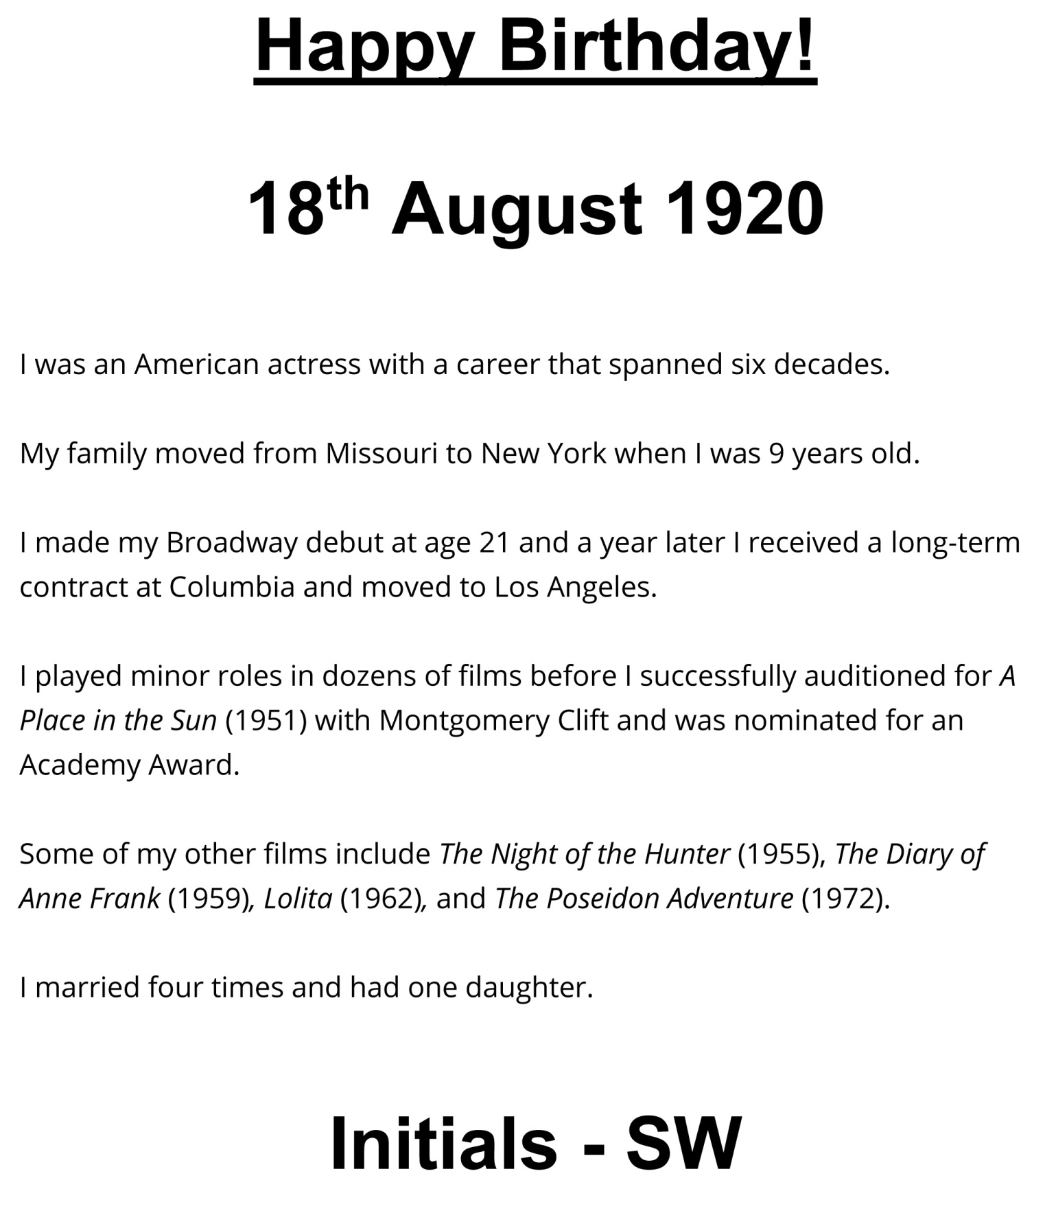

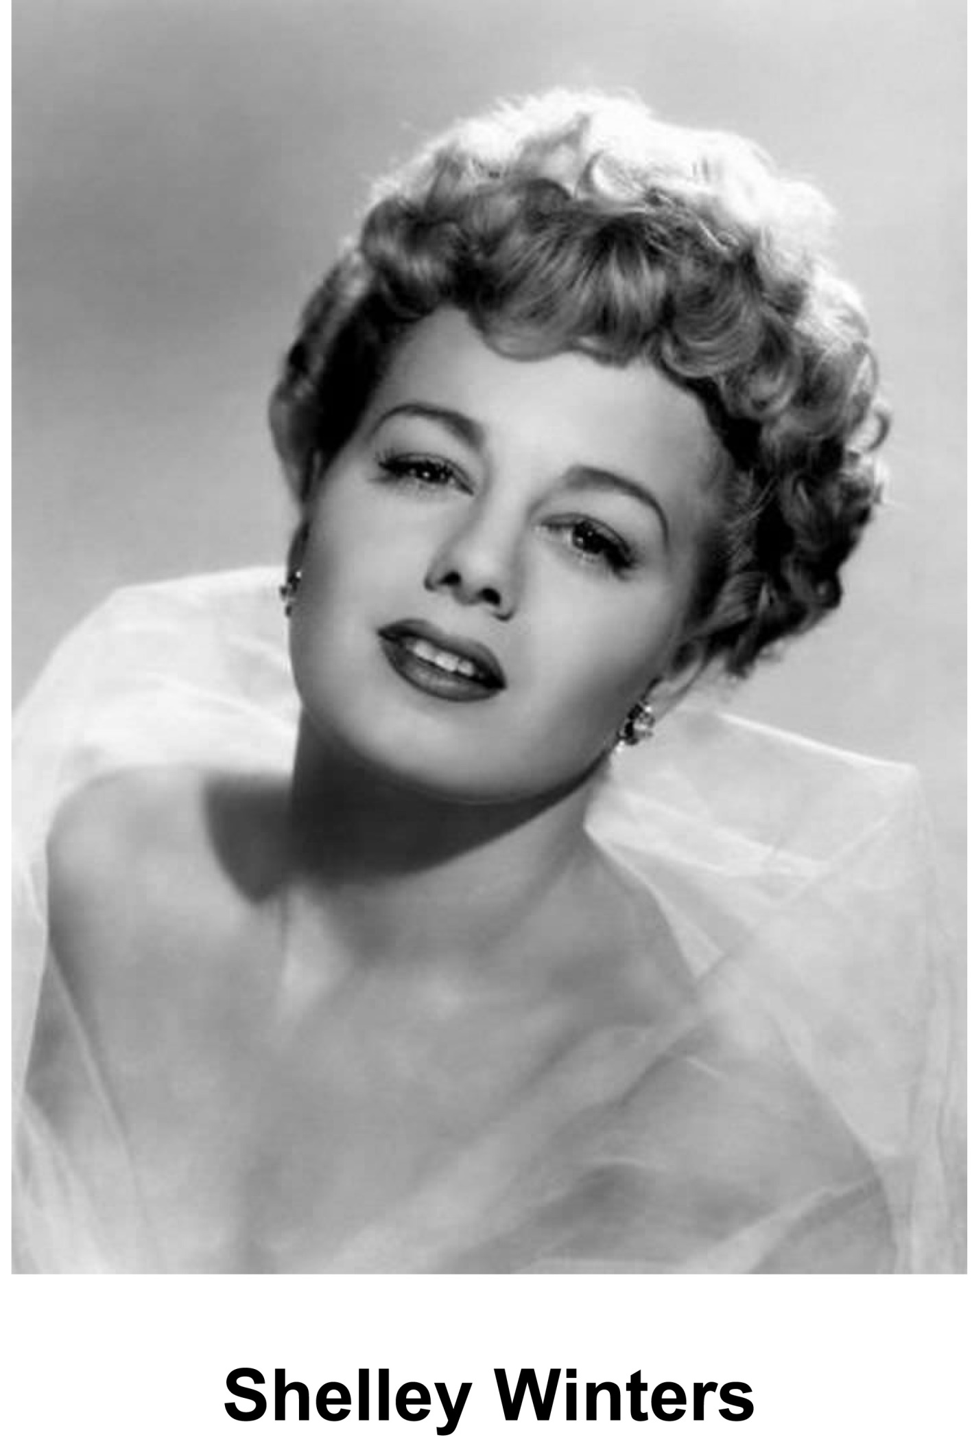
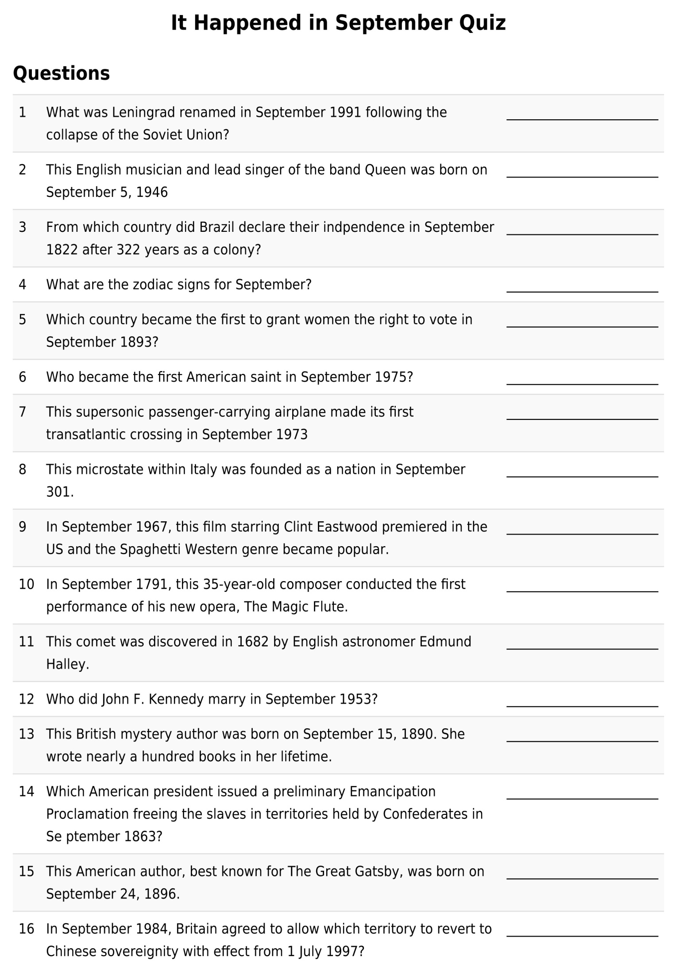
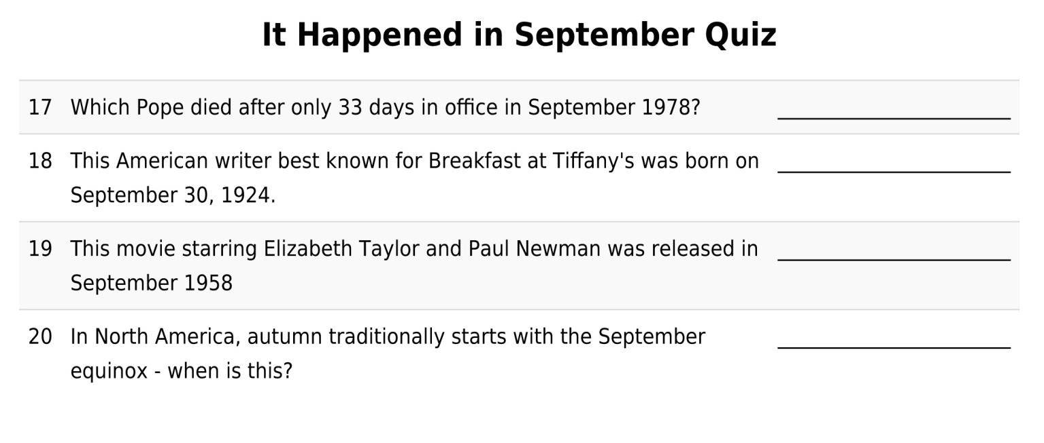

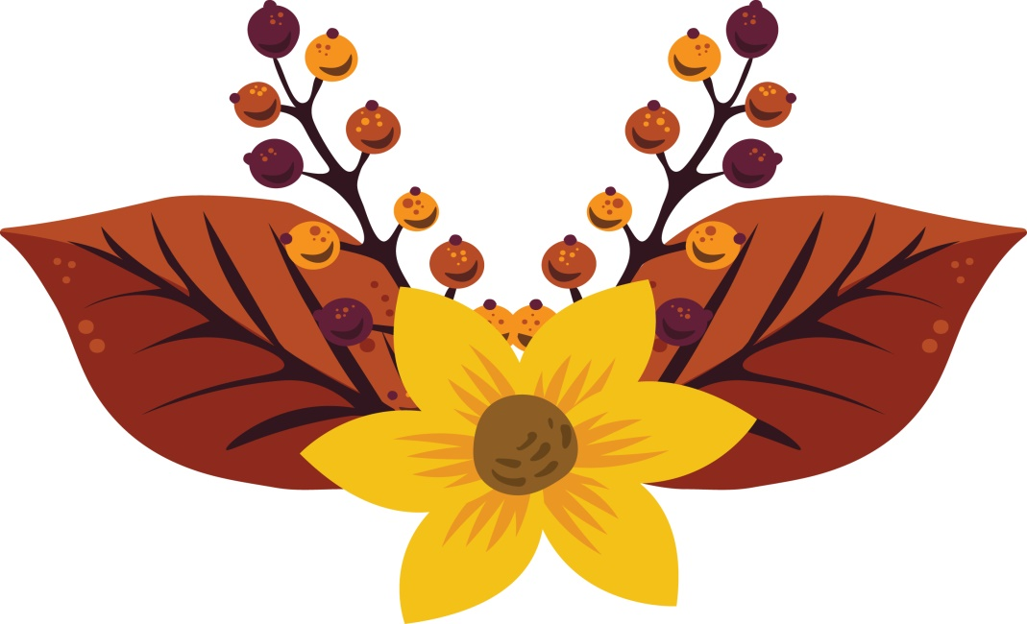

The Wild Atlantic Way - By Aoife Scott
When will you bring me, my love
I'm counting down the days
When will you bring me, my love
All along the Wild Atlantic Way?

I'm sixty years in Nova Scotia
Waiting for the day
The day that we're returning homeward
All along the Wild Atlantic Way

When will you bring me, my love
I'm counting down the days
When will you bring me, my love
All along the Wild Atlantic Way?

Remember when we went to Bunbeg
The shipwreck in the bay
We sat and watched the north west sunset
All along the Wild Atlantic Way

The time that we climbed Croagh Patrick
And nearly went astray
Our legs were aching, falling off us
All along the Wild Atlantic Way

When will you bring me, my love
I'm counting down the days
When will you bring me, my love
All along the Wild Atlantic Way?

The time that we went skinny dippin'
Down in Derrynea
Smelling Galway's salted ocean
All along the Wild Atlantic Way

The day that we heard Willie Clancy
Piping in Malbay
We sang and danced till the early morning
All along the Wild Atlantic Way

When will you bring me, my love
I'm counting down the days
When will you bring me, my love
All along the Wild Atlantic Way?

I'd watch you catch the fish near Dingle
As currachs rowed away
I'd wait for you with the half-light gloaming
All along the Wild Atlantic Way

Cycling back from the Black Ball Head
Skin salty from the spray
The ocean looming out beyond us
All along the Wild Atlantic Way

When will you bring me, my love
I'm counting down the days
When will you bring me, my love
All along the Wild Atlantic Way?

To hear this performed by musician and singer Siobhán O’Donnell please visit the ASI Facebook Page during the last week of September!

Meditation for Alzheimer Society for September 2020

By Rose Marie Murphy (Dip Yoga, Dip Yoga Therapist).

Meditation when practiced regularly, even for short periods, creates a sense of calm, gives clarity of thought and brings a greater awareness to both the mind and the physical body.

“Yoga is the control of the thought waves of the mind “
(Patanjali’s Yoga Sutras).

The above quotation guides us to use our Yoga practise to still the mind by using physical postures, breathing and relaxation.
When we try to be still and quiet all sorts of distractions come in to try and stop us. This is quite normal and we can get frustrated with ourselves when this happens. So the use of the breath as a focus to bring us back into the present moment can help us to let go of these frustrations and just accept that we are human and we then continue on to try and do our best with the practise.
Meditation is traditionally taught in a sitting position but there are many activities that we do which can be very meditative e.g. gardening, walking, chopping our vegetables when we cook, doing a jigsaw. So if sitting is not for us we can try to be in the present moment when we carry out tasks we enjoy and this can then become very meditative.

A short practise:
- Let others in the house know you are taking a little quiet time so you won’t be disturbed.
- Put your phone on silent
- Place a little blanket around the shoulders as you may get chilled
- Sit in a comfortable position with the back straight.
- Soles of the feet on the floor.
- Rest your hands on your lap
- Close your eyes if this is comfortable or gaze downwards to the floor.
- Become aware of your environment and any sounds you can hear.
- Take your attention then into your physical body on your chair:
  - Be aware of the soles of your feet
  - Your legs
  - Your sit bones
  - The length of your spine supported by the chair
  - The front of your body
  - Your arms and hands
  - Your face and head
  - Then take your attention to the tip of your nose, be aware of the cool air going into your nostrils and the warm air coming out. Do not change the breath or force it in any way it’s just a gentle awareness.
- On the next in breath mentally repeat the word IN and on the out breath OUT. Continue for a few rounds
- Next time on the in breath mentally repeat the word Deep and on the out breath Slow
- On the in breath repeat Calm and on the out breath Ease
- On the in breath Smile and then on the out breath Release
- On the in breath Present Moment and on the out breath Wonderful moment

- You can take as much or as little time as you wish with this practise, just enjoy it.

- When you wish to finish let go of the repetitions and become aware again of your environment and the sounds you can hear.

- Then think about your physical body and how it feels

- Take a little stretch as if you were waking up in the morning and open your eyes. Look around the room.

- Do not get up suddenly, take your time and when you feel fully back to yourself slowly come to standing.

- When we practise relaxation/meditation our heart rate slows, our blood pressure and temperature drops so it is really important to come back slowly and with awareness.

- Sometimes it is nice to practise this lying down in your bed at night, and while you may wander off into sleep that’s okay.

- It’s also nice to get someone else to read the practise to us so that we can just enjoy it. Once you do it a few times the key words will just come to you.

This meditation comes from the practise of Thich Nhat Hanh who is a Buddhist monk and peace activist.

To see a video of Rose Marie Murphy performing mindfulness and yoga practice that you can follow at home please visit the ASI Facebook Page during the last week of September for our Activities Week!

