October
Activity Pack

Dear Friends,

As October rolls in and the nights get colder we urge you to stay warm, comfortable, and to take time to appreciate the beauty of the Autumn.
Crisp, cool air; the beautiful turning of the leaves to rich orange, gold and browns; the warmth of a cup of tea or hot chocolate by the fireplace or under a blanket as it rains outside.
We hope you are finding ways to fill your day with meaning and purpose, and that this activity book might help with that.

Remember, the ASI are just a phone call away if you ever need us. Our helpine number is 1800 341 341, with trained staff on the other end to listen to and support you.

We hope you all enjoy this October’s Activity Pack!

“My friend – you never expect too much of me.
You are glad when I succeed,
but my failure makes no difference to you.
You give me all the help you can – but, more important,
You are simply there.”
Wendy Jane Smith

Useful Resources:

- Our Free Helpline and Dementia Nurse Support Line are available at:
Phone: 1800 341 341 and Email: helpline@alzheimer.ie

- We are hosting a number of Virtual Cafes. They are a place to come together, share a cuppa and listen to our amazing guest speakers. For information on how to attend visit: https://alzheimer.ie/service/alzheimer-cafe/

- The ASI also have a huge library of factsheets and resources available on: https://alzheimer.ie/get-support/resources-and-factsheets/

- M4D Radio is a 24/7 online radio station with songs specifically picked to evoke memories and aid reminiscence. To find out more and to listen, please visit: https://m4dradio.com/

- From now until January IMMA are running “Armchair Azure” online gallery tours fro those living with dementia. For more information visit: https://imma.ie/whats-on/armchair-azure-programme/

- During October and November vocalist Liz Ryan will run a weekly online Tea Dance from the National Concert Hall. Tickets are free and available from the “What’s On” section of: https://www.nch.ie/Online/default.asp

- Emergency Response Numbers: 999 or 112

- HSE 24/7 Your Mental Health Information Helpline: 1800 111 888

Table of Contents

Activity | Pages
Irish Knowledge Quiz | 5-6
Bookmark Designing | 7
Pages to Colour | 8-12
Dear Mr. Examiner Poem | 13-14
Midnight in the Pantry Poem | 15
A Trio of Limericks | 16
Proverbs Recall | 17
Name It! Game | 18
Halloween Wordsearch | 19
Hot Drinks Wordsearch | 20
Carrot and Apple Muffins | 21-22
Spot the Difference | 23
October Spooky Crossword | 24-25
Hello Mary Lou | 26
He’ll Have To Go | 27
Mindful Meditation | 28-30

Irish Knowledge Quiz

- How many main rail stations does Dublin have?
- Which is the oldest college on College Green?
- Which musical instrument was adopted as a logo by Guinness?
- What is 'uisce beatha'?
- Who was the cabbie who co-starred in the 'Quiet Man' film?
- Who played Lawrence of Arabia in the film of the same name?
- Name the fairy that allegedly comes to certain Irish families to forewarn of death?
- What is the fish or salmon associated with in Irish mythology?
- What is Ireland's National Holiday?
- Which Michael brought Irish dancing to a wider audience?
- Which slithery reptile does Ireland famously lack?
- How many moles are there in Ireland?
- What sort of Park is at Fota in Co. Cork?
- What type of music is celebrated at an annual Cork festival?
Answers:

- Two
- Trinity College
- The harp
- Irish Whiskey
- Barry Fitzgerald
- Peter O'Toole
- Banshee (or Bean-sidhe)
- Wisdom (Knowledge)
- St Patrick's Day
- Flatley
- Snakes
- None
- Wildlife
- Jazz

Print and Decorate Your Own Bookmarks:
Autumn is a wonderful time to enjoy a good book – or perhaps you know an avid reader who would like a new bookmark.
Below are two bookmarks for you to cut out and keep and blank one for you to design your own!

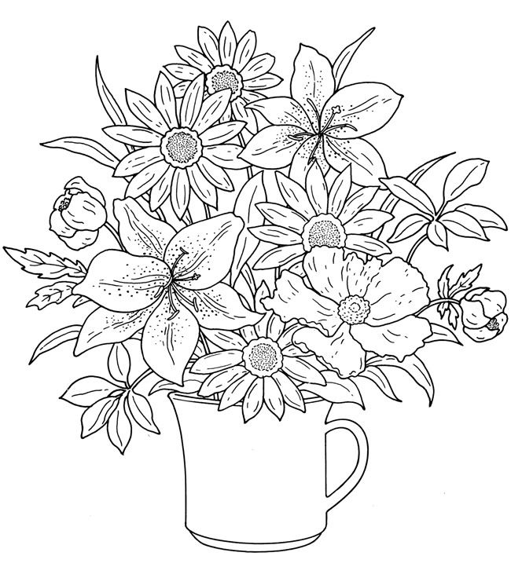

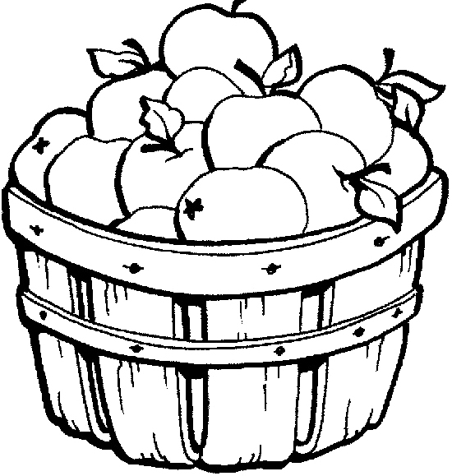

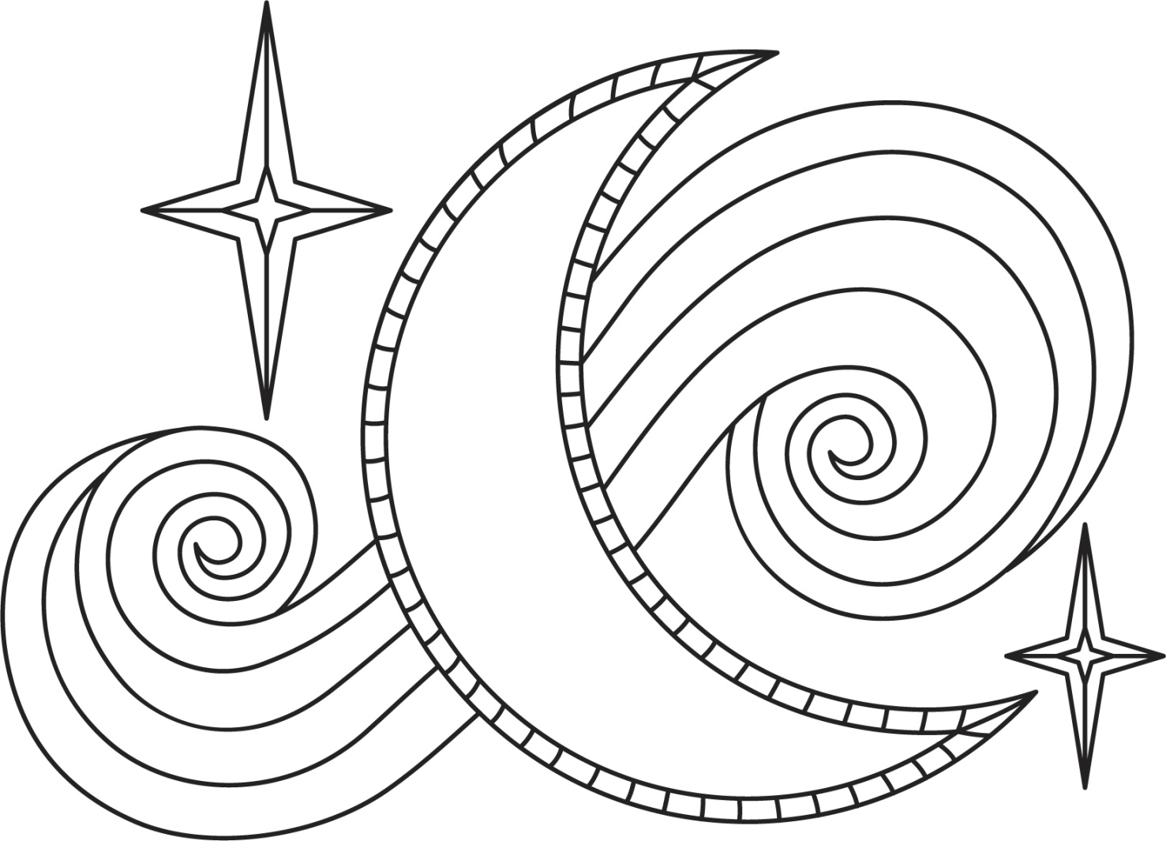

Dear Mr. Examiner - By Gareth Owen

Thank you so much for your questions
I've read them most carefully through
But there isn't a single one of them
That I know the answer to.

I've written my name as instructed
Put the year, the month and the day
But after I'd finished doing that
I had nothing further to say.

So I thought I'd write you a letter
Fairly informally
About what I can see from my desk here
And what it's like to be me.

Mandy has written ten pages
But it's probably frightful guff
And Angela Smith is copying
The answers off her cuff!
Miss Quinlan is marking our homework
The clock keeps ticking away
I suppose for anyone outside
It's just another day.

There'll be mothers going on errands
Grandmothers sipping tea
Unemployed men doing crosswords
or watching 'Crown Court' on TV.

The rain has finally stopped here
The sun has started to shine
And in a back garden in Sutton Drive
A housewife hangs shirts on a line.

A class flies past to play tennis
The cathedral clock has just pealed
A lawnmower chugs backwards and forwards
Up on the hockey field.

Miss Quinlan's just read what I've written
Her face is an absolute mask
Before she collects the papers in
I've a sort of favours to ask.

I thought your questions were lovely
I've only myself to blame
But couldn't you give me some marks
For writing the date and my name?

Midnight In The Pantry by Edgar Guest
You can boast your round of pleasures, praise the sound of popping corks,
Where the orchestra is playing to the rattle of the forks,
And your after-opera dinner you may think superbly fine,
But that can’t compare, I’m certain, to the joy that’s always mine.
When I reach my little dwelling—source, of all sincere delight—
And I prowl around the pantry in the waning hours of night.
When my business, or my pleasure, has detained me until late,
And it’s midnight, say, or after, when I reach my own estate.
Though I’m weary with my toiling I don’t hustle up to bed,
For the inner man is hungry and he’s anxious to be fed,
Then I feel a thrill of glory from my head down to my feet
As I prowl around the pantry after something good to eat.
Oft I hear a call above me: ‘Goodness gracious, come to bed!’
And I know that I’ve disturbed her by my overeager tread,
But I’ve found a glass of jelly and some bread and butter, too,
And a bit of cold fried chicken and I answer: ‘When I’m through!’
Oh, there’s no cafe that better serves my precious appetite
Than the pantry in our kitchen when I get home late at night.
You may boast your shining silver, and the linen and the flowers,
And the music and the laughter and the lights that hang in showers.
You may have your cafe table with its brilliant array,
But it doesn’t charm yours truly when I’m on my homeward way,
For a greater joy awaits me, as I hunger for a bite—
Just the joy of pantry-prowling in the middle of the night.

A Trio of Limericks to Make You Smile

There was a young lady named Rose,
Who had a large wart on her nose.
When she had it removed,
Her appearance improve,
But her glasses slipped down to her toes.

An elderly man called Keith
Mislaid his set of false teeth -
They'd been laid on a chair,
He'd forgot they were there,
Sat down, and was bitten beneath.

There was an Old Man with a beard,
Who said, 'It is just as I feared!
Two Owls and a Hen,
Four Larks and a Wren,
Have all built their nests in my beard!

Proverbs Recall
Test your knowledge of proverbs with a friend –
You say the first half and see if they know the ending!

- TWO WRONGS - DON’T MAKE A RIGHT
- THE PEN IS MIGHTIER - THAN THE SWORD
- WHEN THE GOING GETS TOUGH - THE TOUGH GET GOING
- NO MAN IS - AN ISLAND
- HOPE FOR THE BEST - BUT PREPARE FOR THE WORST
- BETTER LATE - THAN NEVER
- BIRDS OF A FEATHER - FLOCK TOGETHER
- KEEP YOUR FRIENDS CLOSE - AND YOUR ENEMIES CLOSER
- A PICTURE IS WORTH - A THOUSAND WORDS
- THERE’S NO PLACE - LIKE HOME
- THE EARLY BIRD CATCHES - THE WORM
- NEVER LOOK A GIFT HORSE - IN THE MOUTH
- YOU CAN’T ALWAYS GET- WHAT YOU WANT
- BEGGARS - CAN’T BE CHOOSERS
- ACTIONS SPEAK LOUDER - THAN WORDS

Name It! Game
∙ Name as many as possible in each category, or,
∙ Find a chosen number of answers in each category
- Types of chocolate bars
- Different species of trees
- Languages
- Exotic fruits
- Types of hats
- Famous movie stars from your youth
- Wild flowers
- Fish and other animals that live in the ocean
- Types of footwear
- Things that can fly
- Implements to write or draw with
- Dog breeds
- Colours in the rainbow
- Root vegetables
- Types of weather

HALLOWEEN WORDSEARCH
Q | P | F | R | I | G | H | T | T | W | V | D | X | Q | D
R | T | R | C | J | Z | F | T | R | I | C | K | R | G | J
F | E | A | C | A | G | L | S | O | Z | U | R | A | F | M
A | X | N | G | Z | H | A | I | H | A | K | R | N | T | U
Z | Z | K | M | Q | O | N | T | Z | R | V | V | Y | Q | M
J | Y | E | T | I | U | T | K | G | D | J | N | L | W | M
F | V | N | K | Z | L | E | P | M | M | C | V | B | M | Y
K | L | S | B | L | D | R | U | F | C | V | H | O | O | C
Z | R | T | H | Y | H | N | M | R | Q | X | Z | Q | D | W
H | W | E | N | Z | G | S | P | O | O | K | Y | P | J | Q
S | I | I | Y | O | H | P | K | C | C | Q | W | W | I | F
J | T | N | E | M | O | J | I | D | I | T | I | B | U | N
Y | W | K | D | B | S | N | N | N | J | Z | T | Y | I | V
V | K | N | Z | I | T | V | C | B | L | E | C | C | G | B
O | X | T | R | E | A | T | A | C | E | M | H | H | H | Y

GHOST GHOUL
WITCH WIZARD
SPOOKY FRANKENSTEIN
TRICK TREAT
YETI ZOMBIE
MUMMY PUMPKIN
HOT DRINKS WORDSEARCH
J | N | K | O | C | Y | L | J | Y | Z | P | L | W | P | H
C | W | I | N | E | H | Q | F | T | S | S | N | K | O | Z
I | N | K | G | K | J | Y | E | T | F | G | Z | D | J | S
D | M | C | N | K | T | B | B | G | O | G | Q | S | T | P
E | U | O | C | J | P | A | A | C | A | Z | U | E | C | R
R | L | F | A | B | A | C | H | E | E | I | F | M | A | N
H | L | F | R | J | X | H | N | E | H | Z | F | O | M | J
Q | E | E | A | B | U | O | Q | Y | I | X | A | C | O | Y
J | D | E | O | D | R | C | Z | S | N | J | X | H | M | Q
Z | P | H | W | Y | U | O | C | D | J | G | E | A | I | F
A | L | F | F | I | A | L | I | O | L | W | E | X | L | Z
M | A | T | C | H | A | A | V | I | D | K | B | I | E | N
N | T | B | A | Z | P | T | O | D | D | Y | A | J | J | Q
D | T | A | P | P | L | E | Q | J | C | U | S | X | T | M
T | E | A | P | I | H | U | O | Z | I | N | Z | H | W | H

CHOCOLATE TEA
COFFEE APPLE
CIDER MULLED
WINE MOCHA
MATCHA CAMOMILE
TODDY LATTE

Lauren's Carrot and Apple Muffin Recipe

(by Lauren Gaffney, on Spunout.ie)

Ingredients:

220g self raising flour

30g porridge oats

20g desiccated coconut

25g raisins

3 tsp cinnamon

1tsp baking powder

1 grated carrot

1 grated apple (optional)

2 eggs 180ml sunflower oil

3tbsp honey/maple syrup

Method:
- Preheat the oven to 180 degrees
- Line a muffin tin with muffin cases
- Weigh out dry ingredients and mix together in a large mixing bowl
- Grate the carrot and apple (if using) and add these to the dry ingredients
- In a separate measuring jug, crack open the egg and lightly beat it
- Add the sunflower oil and honey to the beaten egg and mix
- Add this into the dry ingredients, ensuring it is thoroughly mixed through, but don’t over mix it
- Pour into the prepared tin - this mix usually makes 5-6 large muffins or about 10 smaller ones, depending on whatever size you like
- Bake in the preheated oven for 25 mins or until a skewer comes out clean when inserted into the middle of the muffin
10.Cool on a wire rack for a few mins before digging in

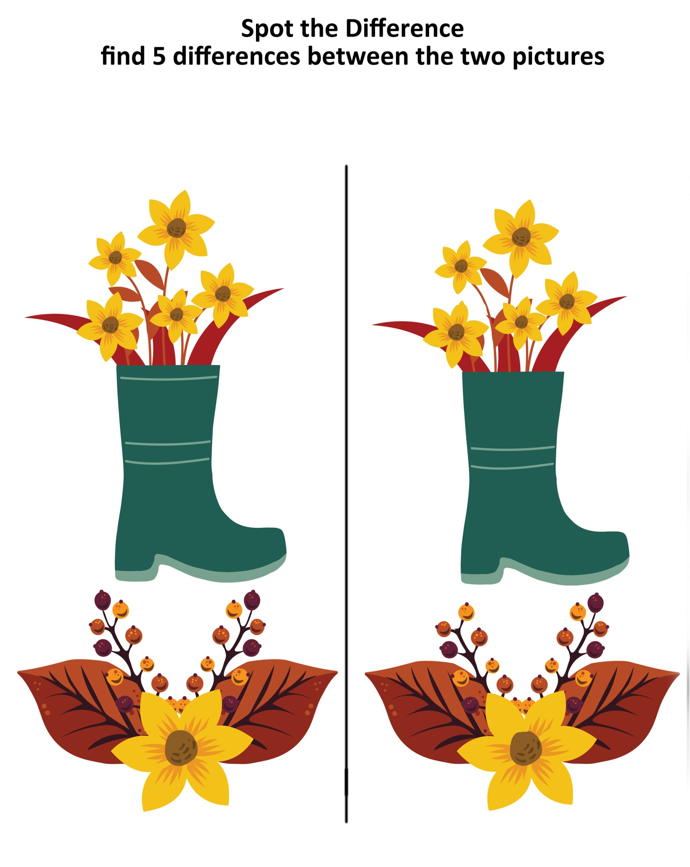

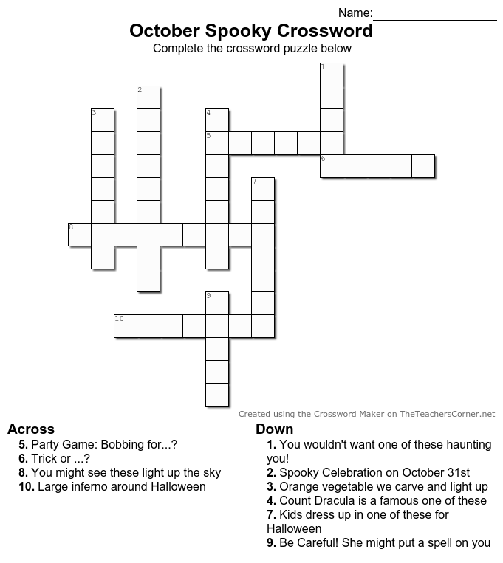

Answers:
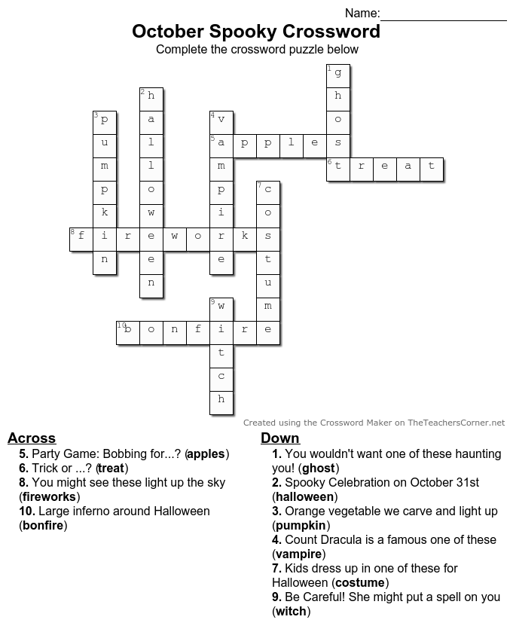
Sing-Along: Hello Mary Lou by Gene Pitney

Hello Mary Lou, goodbye heart
Sweet Mary Lou I'm so in love with you.
I knew Mary Lou, we’d never part
So hello Mary Lou, goodbye heart.
You passed me by one sunny day
Flashed those big brown eyes my way
And oh I wanted you forever more.
Now I'm not one that's get around
I swear my feet’s stuck to the ground
And though I never did meet you before,
I said:
Hello Mary Lou, goodbye heart
Sweet Mary Lou I'm so in love with you.
I knew Mary Lou, we’d never part
So hello Mary Lou, goodbye heart.
I saw your lips, I heard your voice
Believe me I just had no choice
Wild horses couldn't make me stay away
I thought about a moonlit night
My arms around you good and tight
That's all I had to see for me to say
Hey, hey, hey.
Hello Mary Lou, goodbye heart
Sweet Mary Lou I'm so in love with you.
I knew Mary Lou, we’d never part
So hello Mary Lou, goodbye heart.

Sing-Along: He'll Have To Go by Jim Reeves

Put your sweet lips a little closer to the phone
Let's pretend that we're together, all alone
I'll tell the man to turn the jukebox way down low
And you can tell your friend there with you he'll have to go

Whisper to me, tell me do you love me true
Or is he holding you the way I do?
Tho' love is blind, make up your mind, I've got to know
Should I hang up, or will you tell him he'll have to go?

You can't say the words I want to hear
While you're with another man
Do you want me, answer yes or no
Darling, I will understand

Put your sweet lips a little closer to the phone
Let's pretend that we're together, all alone
I'll tell the man to turn the jukebox way down low
And you can tell your friend there with you he'll have to go

Mindful Meditation

Find a quiet place where you can be free from distractions
And take a comfortable seat that promotes good posture
Set a timer for 5 minutes or longer,
But choose a meditation length that will allow you to feel successful
Consistent meditation of just 5 minutes per day, is far better than one occasional 30-minute session

With your eyes opened or closed, breathe gently in and out through your nose
And then as you sit here, watching the breath
Draw attention to your heart, and your desire to experience clam, peace and ease
Connect to this yearning inside of you
And then silently, to yourself
Commit to remaining here, for the duration of your timer
And commit to the practice of simply watching and noticing the breath
And then having made that heartfelt commitment,
Return to your job, which is breath awareness

Perhaps settling in on the feeling of the breath
As it moves in and out through your nose
From the tip of the nose
To the space between your eyebrows

Listen, for the ways in which the breath is speaking to you
Stay open, stay curious
And remain free from any judgment or self-criticism
The breath is perfect right now, just as it is
Your role, is simply to watch

(pause 2 breaths)

Eventually, you’ll notice the mind has wandered from breath awareness
When this happens, spend no time wondering why
Spend no time asking where the mind has gone to
Spend no time on self-blame
Simply turn the mind around, as quickly as you can
And come back to your job of watching the breath

Go right back to that space in the body
Where you notice the breath most clearly
Returning perhaps to a sense of awe, wonder or amazement
How precious is this one cycle of breath?

(pause 2 breaths)

Each time the mind wanders, turn the mind around without pausing to self-criticise

(pause 2 breaths)

Stay right here,
Present, aware, and honoring your intention
This intention, this job, of watching the breath

(pause 2 breaths)

With practice, you’ll notice sooner when the mind has wandered
With practice, you’ll return to breath awareness more quickly
With practice, you’ll remain present with the breath for longer intervals between distractions

(pause 2 breaths)

So continue to practice, until your timer has gone off
And when your practice is complete,
Take a moment to recognize the goodness in the work you have done
Recognize the benefits of the effort you have made
Dedicate your efforts to your own healing,
And to the healing of all persons, everywhere.

