December
Activity Pack

Dear Friends,

As we approach the end of the year we hope you have a warm home and good company this holiday season.
Remember that even before the New Year arrives, the light starts to come back into our evenings. The Winter Solstice (the longest night) falls on the 21st of December, so by Christmas Day the skies are brightening and welcoming the sun to stay a little longer – reminding us that after every period of darkness comes the light.
We wish you all a very Merry Christmas and joyous start to the New Year.

Remember, the ASI are just a phone call away if you ever need us. Our helpline number is 1800 341 341, with trained staff on the other end to listen to and support you.

We hope you all enjoy this December’s Activity Pack!

“It is not so much our friends’ help that helps us,
As the confident knowledge that they will help us”

Epicurus (c.300BC)

Useful Resources:

- Our Free Helpline and Dementia Nurse Support Line are available at:
Phone: 1800 341 341 and Email: helpline@alzheimer.ie

- The ASI have a special Virtual Memory Tree this year. By lighting up a star on our tree you can keep your memories alive and your donation will help the ASI to support the 500,000 people in Ireland whose families have been impacted by dementia. www.memorytree.ie

- We are hosting a number of Virtual Cafes. They are a place to come together, share a cuppa and listen to our amazing guest speakers. For information on how to attend visit: https://alzheimer.ie/service/alzheimer-cafe/

- The ASI also have a huge library of factsheets and resources available on: https://alzheimer.ie/get-support/resources-and-factsheets/

- M4D Radio is a 24/7 online radio station with songs specifically picked to evoke memories and aid reminiscence. To find out more and to listen, please visit: https://m4dradio.com/

- From now until January IMMA are running “Armchair Azure” online gallery tours for those living with dementia. For more information visit: https://imma.ie/whats-on/armchair-azure-programme/

- Emergency Response Numbers: 999 or 112

- HSE 24/7 Your Mental Health Information Helpline: 1800 111 888

Table of Contents

Activity | Pages
General Knowledge Quiz | 5-6
A Winter Themed quiz | 7-8
Pictures to Colour | 9-13
Perfect Presents Wordsearch | 14
Let It Snow Wordsearch | 15
Riddle Me This! | 16
Two Little Kittens | 17
The Sheep | 18
Spot the Difference | 19-20
Crosswords | 21-24
The Talkative Princess | 25-26
A Treasure | 27
When You Were Sweet Sixteen | 28
The Banks of My Own Lovely Lee | 29-30
Guided Relaxation | 31-32

General Knowledge Quiz – Questions:

- What type of trees do dates grow on?
- In the nursery rhyme, whose wife "could eat no lean"?
- By land area, which is the largest state in the USA?
- According to an old proverb, what "gathers no moss"?
- Which type of cycle has only one wheel?
- What is the name of the rubber disc hit in a ice hockey match?
- Which sea separates the islands of Ireland and Great Britain?
- How many sides does a decagon have?
- The first expedition to reach the South Pole was led by which Norwegian explorer?
- If your hobby is philately, what do you collect?
- Hollywood is a suburb of which American city?
- What do Americans call Autumn?
Answers:
- Palm trees
- Jack Sprat's
- Alaska
- A rolling stone
- A unicycle
- A puck
- Irish Sea
- 10
- Roald Amundsen
10.Stamps
- Los Angeles
- The fall

A Winter Themed Quiz - Questions:

1. Which two of Father Christmas's reindeers are named after meteorological terms?
2. Who, from his cave, can hear the noisy Christmas festivities that take place in Whoville?
3. In the poem 'The Night Before Christmas', visions of what danced in children's heads?
4. Popular in Victorian England at Christmas and also appearing in the Dickens' story A Christmas Carol, what is 'Smoking Bishop'?
5. In the 1947 Christmas comedy-drama Miracle on 34th Street, which actress plays the little girl brought up not to believe in Santa Claus?
6. Bob Geldof and Midge Ur wrote the song 'Do They Know It's Christmas?' in which year?
7. 'Driving Home for Christmas' was used in Christmas commercials for which UK frozen foods supermarket chain in 1997, 1998, and 2011?
8. Christmas Island, a territory of the Commonwealth of Australia, is located in which ocean?
9. Which novelty Christmas song was written in 1944 by New York music teacher Donald Yetter Gardner?
10. Which country was the first to use the tradition of the Christmas tree?

Answers:

1. Donner and Blitzen (the names mean 'thunder' and 'lightning' in German)
2. The Grinch (from How the Grinch Stole Christmas!, a children's book by Dr. Seuss)
3. Sugar Plums
4. A type of mulled wine
5. Natalie Wood
6. 1984
7. Iceland
8. Indian Ocean
9. All I Want for Christmas Is My Two Front Teeth
10. Germany

Pictures to Colour

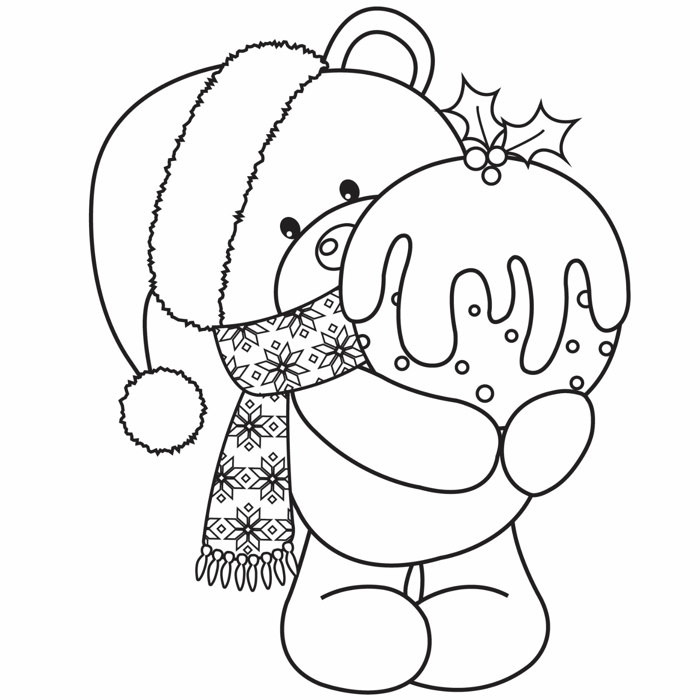

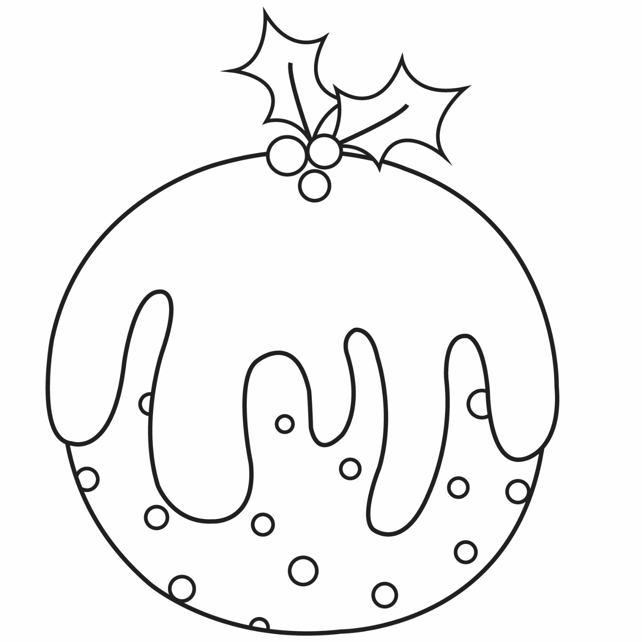

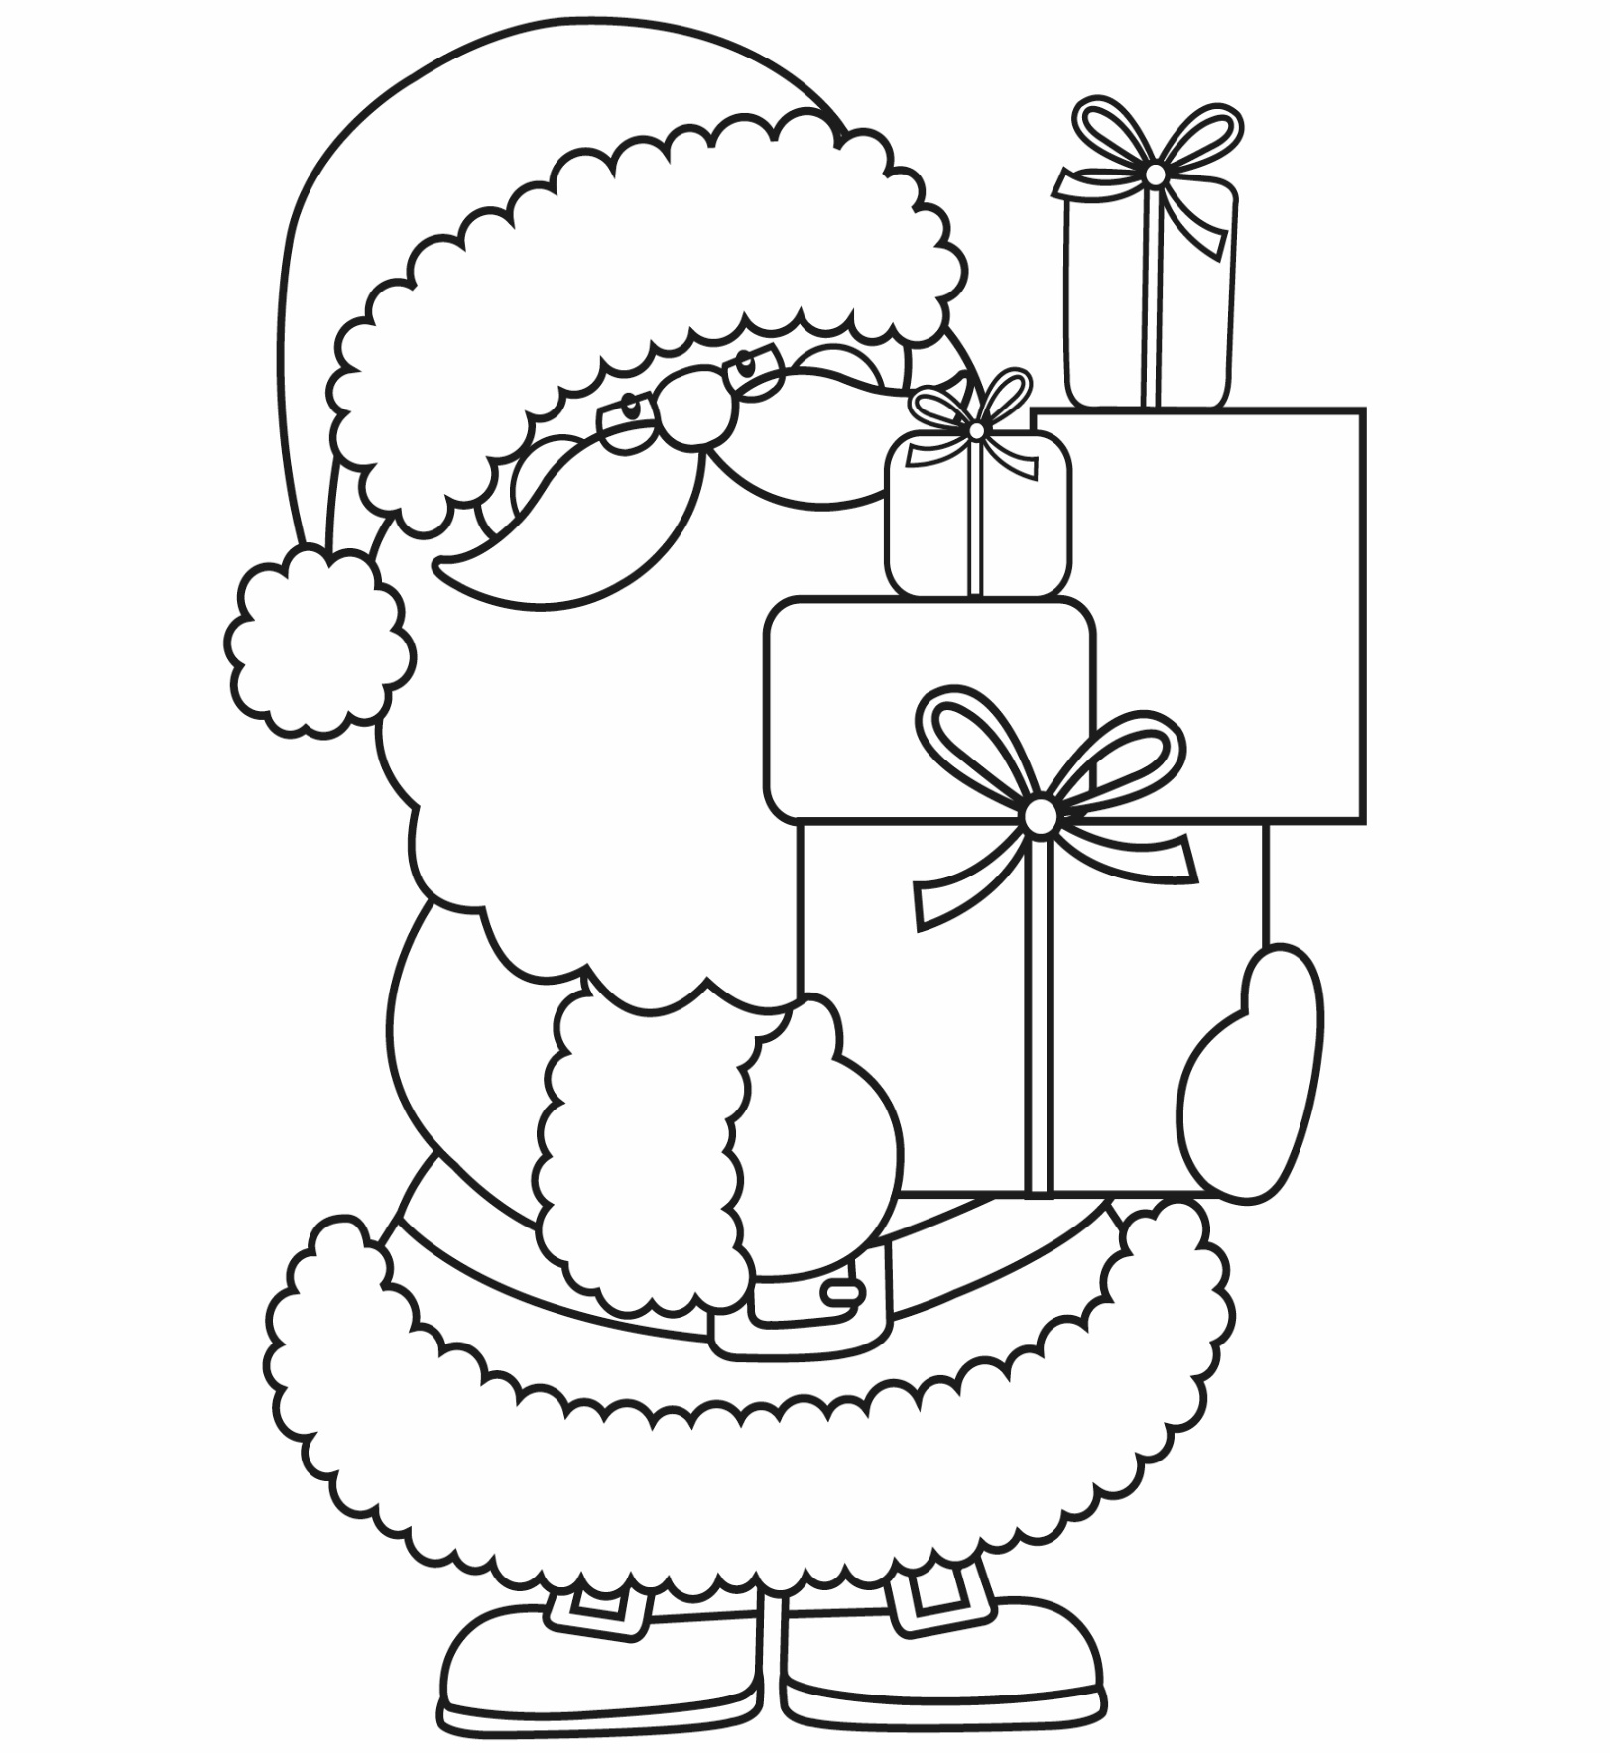

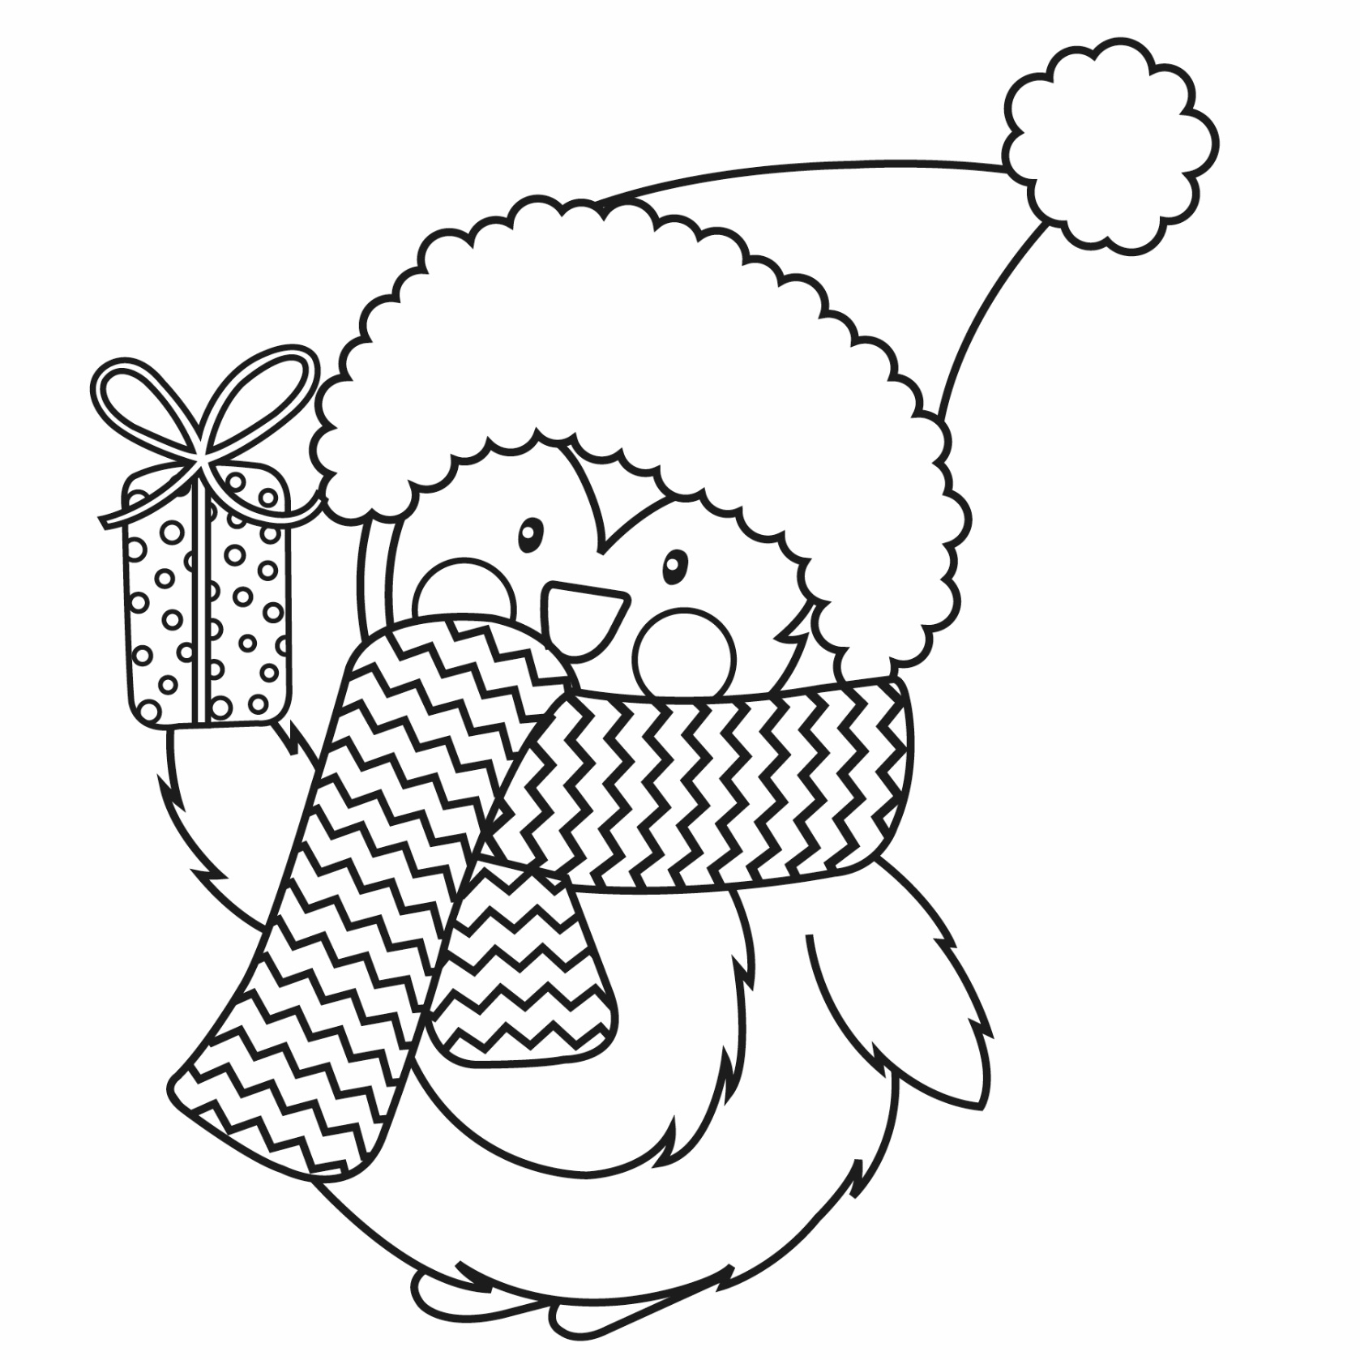

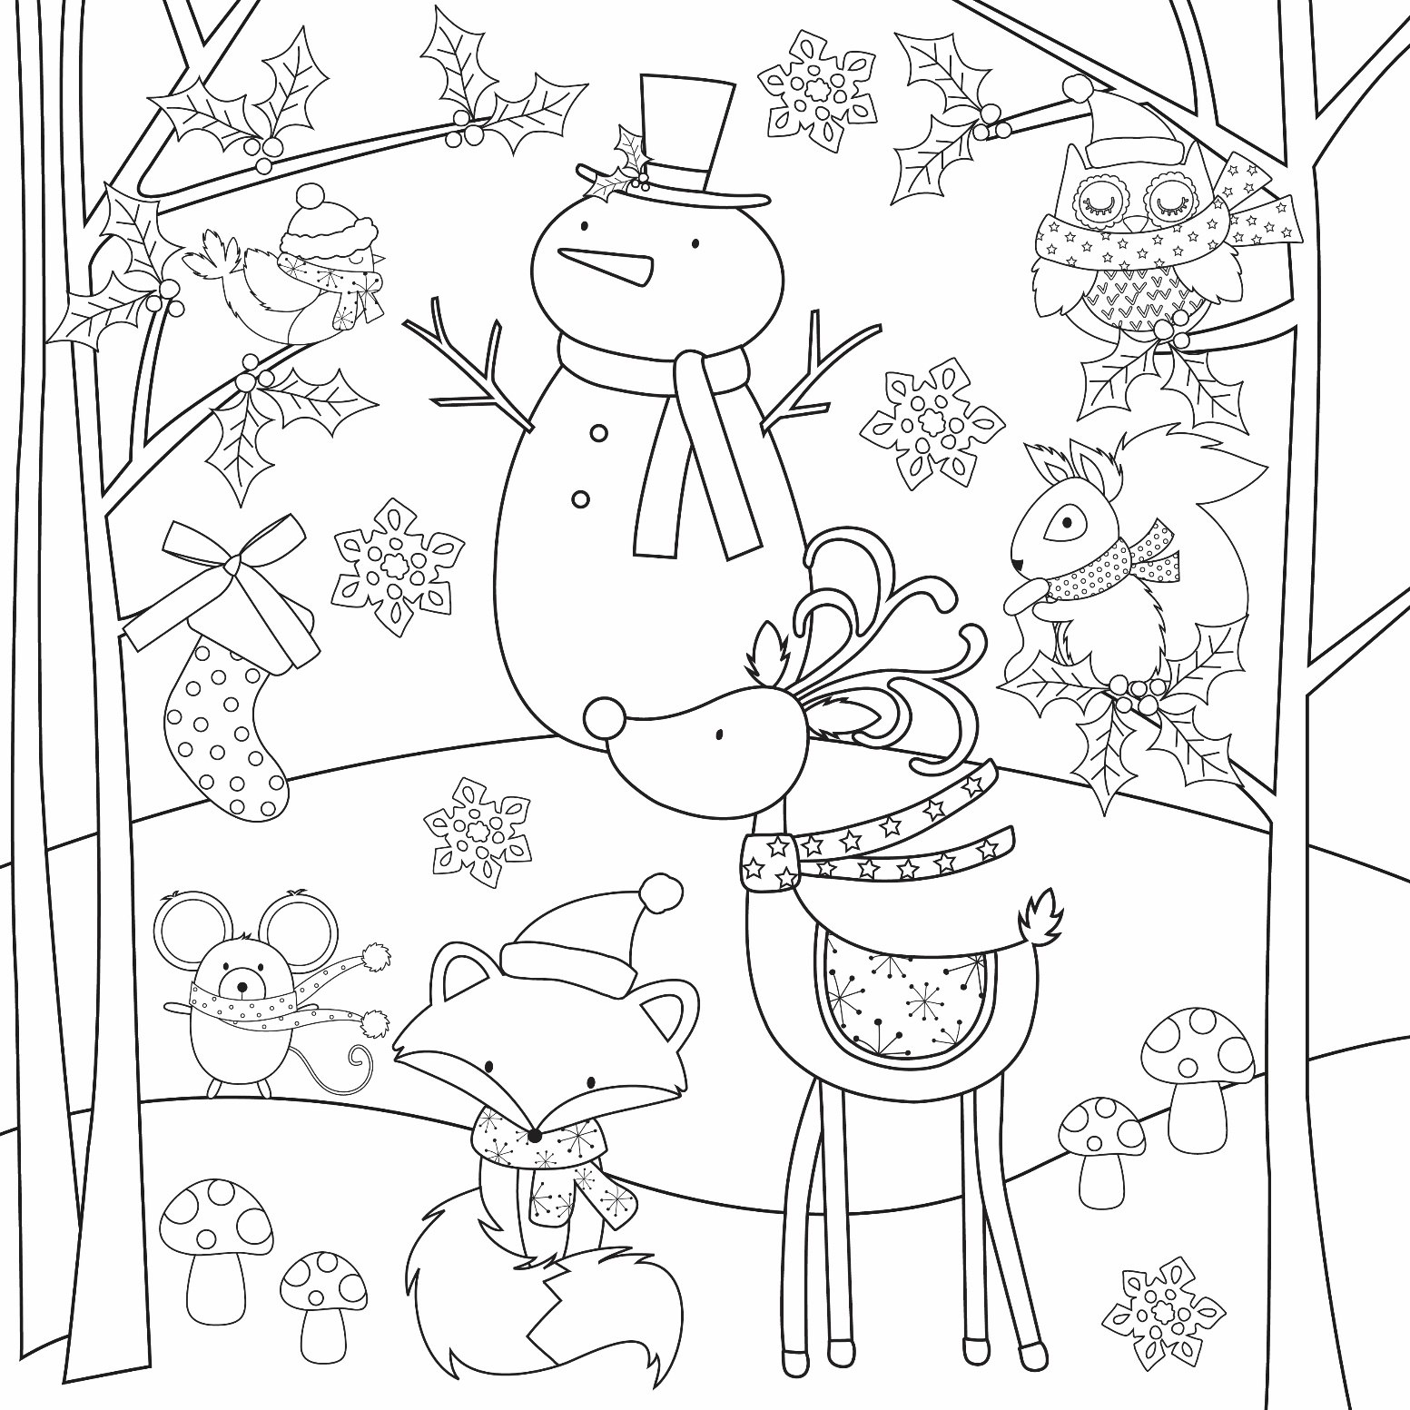

Perfect Presents Wordsearch
D | A | V | B | D | O | E | N | B | P | R | K | L | T | O
J | U | S | O | C | K | S | R | O | G | U | E | A | C | M
W | N | O | E | A | W | P | J | O | N | T | D | W | B | D
G | M | Q | G | W | N | N | S | K | X | M | J | B | B | R
H | H | B | P | W | N | T | D | S | W | W | K | P | Z | I
Y | P | J | L | H | S | R | M | W | R | M | Q | R | Q | I
Q | F | A | A | I | C | A | N | D | L | E | V | N | G | L
Y | O | L | N | S | A | I | M | P | X | W | R | N | T | K
W | O | P | E | T | R | N | E | M | J | F | I | B | O | H
Y | T | J | S | L | F | D | O | P | U | W | X | W | O | I
R | B | O | R | E | H | C | R | A | Y | O | N | S | L | M
M | A | G | Z | K | G | D | O | L | L | Y | A | Y | K | W
Y | L | L | K | D | K | L | F | K | P | F | M | F | I | L
R | L | N | Q | U | P | E | R | F | U | M | E | N | T | C
K | Y | Y | K | W | K | C | L | Q | Z | N | K | H | R | G

BOOKS CANDLE
CRAYONS DOLLY
FOOTBALL PERFUME
PLANE SCARF
SOCKS TOOLKIT
TRAIN WHISTLE

Let it Snow Wordsearch
X | R | I | S | D | V | Y | E | X | J | B | Y | O | D | C
S | T | O | R | M | G | A | K | P | O | D | D | U | C | R
O | R | L | L | Z | B | Z | S | R | X | S | O | U | I | I
Y | U | W | N | K | R | L | N | X | T | S | I | C | Y | S
C | B | E | E | Q | I | K | O | U | F | L | A | K | E | P
P | K | F | R | O | S | T | W | N | T | E | D | X | L | O
B | F | J | L | D | K | S | M | S | V | I | T | R | A | T
H | L | P | B | S | R | F | A | Y | M | G | A | G | S | D
P | U | N | W | D | X | I | N | D | C | H | I | L | L | Y
G | R | N | B | Z | R | H | W | K | T | Q | Z | R | C | X
R | R | R | Q | D | G | X | W | H | O | B | R | C | X | K
D | Y | M | L | S | M | S | K | I | I | I | N | G | T | A
J | U | W | I | P | L | S | I | W | J | G | A | L | D | P
A | V | A | L | A | N | C | H | E | U | R | R | D | V | P
T | B | B | J | A | I | Y | X | X | I | I | E | Y | P | Q

AVALANCHE BRISK
CHILLY CRISP
FLAKE FLURRY
FROST ICY
SKIIING SLEIGH
SNOWMAN STORM

Riddle Me This!

- What two things can you never eat for breakfast?
Lunch and Dinner.

- What has a face and two hands but no arms or legs?
A Clock.

- What tastes better than it smells?
A Tongue.

- What kind of room has no doors or windows?
A Mushroom.

- What goes up and never comes down?
Your Age.

- What word becomes shorter when you add two letters to it?
Short.

- Two children are born on the same day from the same mother but they are not twins. How is that possible?
They are two out of three triplets!

- Johnny's mother had three children. The first child was named April. The second child was named May. What was the third child's name?
Johnny!
Two Little Kittens - Anonymous Author (circa 1880)

Two little kittens, one stormy night,
Began to quarrel, and then to fight;
One had a mouse, the other had none,
And that's the way the quarrel begun.

"I'll have that mouse," said the biggest cat;
"You'll have that mouse? We'll see about that!"
"I will have that mouse," said the eldest son;
"You shan't have the mouse," said the little one.

I told you before 'twas a stormy night
When these two little kittens began to fight;
The old woman seized her sweeping broom,
And swept the two kittens right out of the room.

The ground was covered with frost and snow,
And the two little kittens had nowhere to go;
So they laid them down on the mat at the door,
While the old woman finished sweeping the floor.

Then they crept in, as quiet as mice,
All wet with the snow, and cold as ice,
For they found it was better, that stormy night,
To lie down and sleep than to quarrel and fight.

The Sheep by Ann and Jane Taylor

"Lazy sheep, pray tell me why
In the pleasant fields you lie,
Eating grass, and daisies white,
From the morning till the night?
Everything can something do,
But what kind of use are you?"

"Nay, my little master, nay,
Do not serve me so, I pray;
Don't you see the wool that grows
On my back, to make you clothes?
Cold, and very cold, you'd be
If you had not wool from me.

True, it seems a pleasant thing,
To nip the daisies in the spring;
But many chilly nights I pass
On the cold and dewy grass,
Or pick a scanty dinner, where
All the common's brown and bare.

Then the farmer comes at last,
When the merry spring is past,
And cuts my woolly coat away,
To warm you in the winter's day:
Little master, this is why
In the pleasant fields I lie."
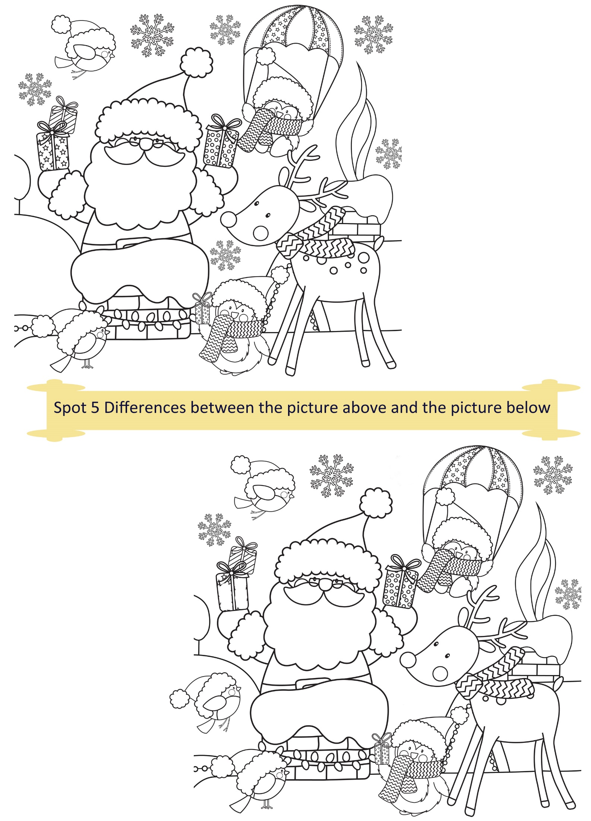
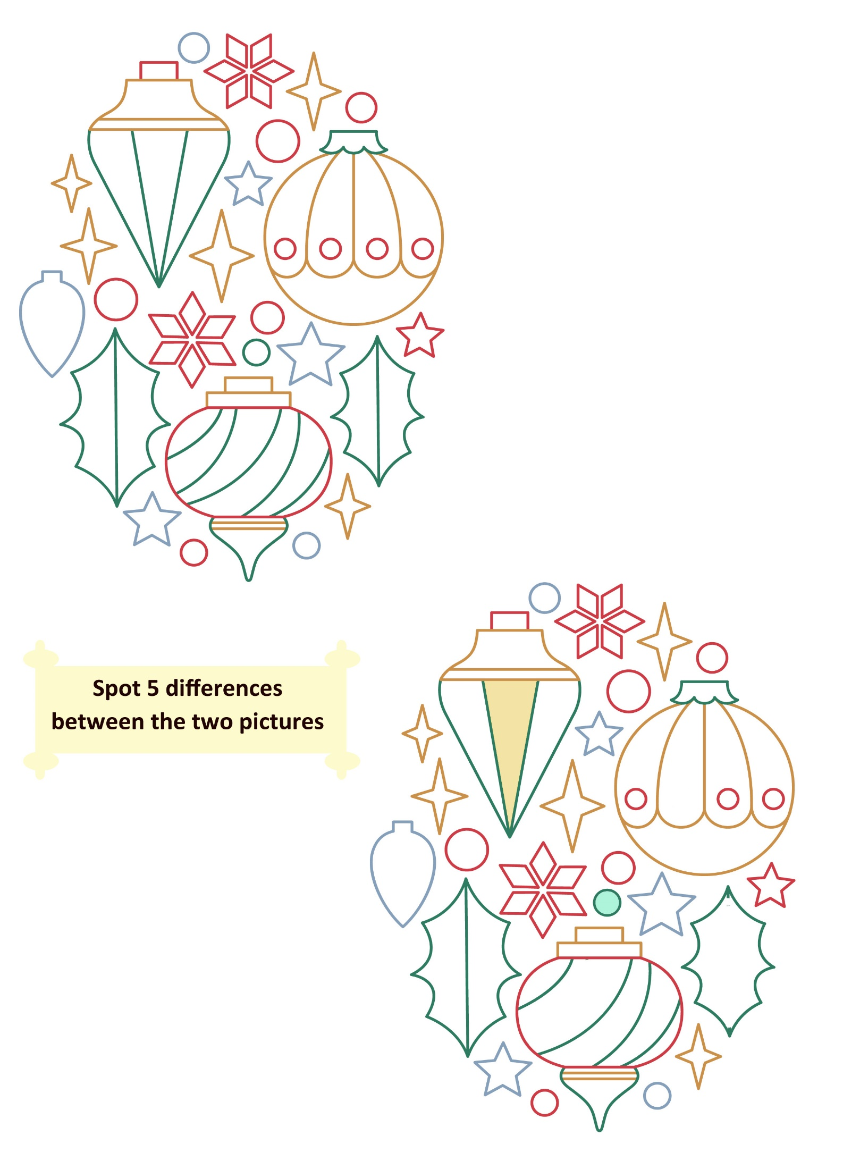
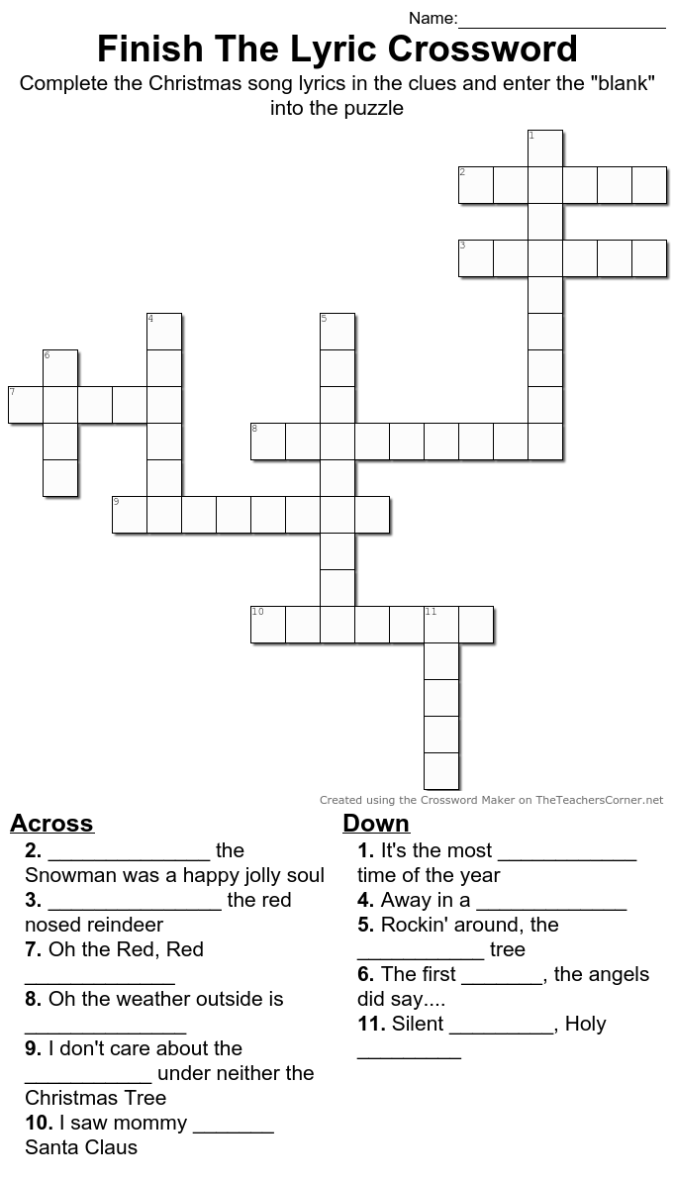21
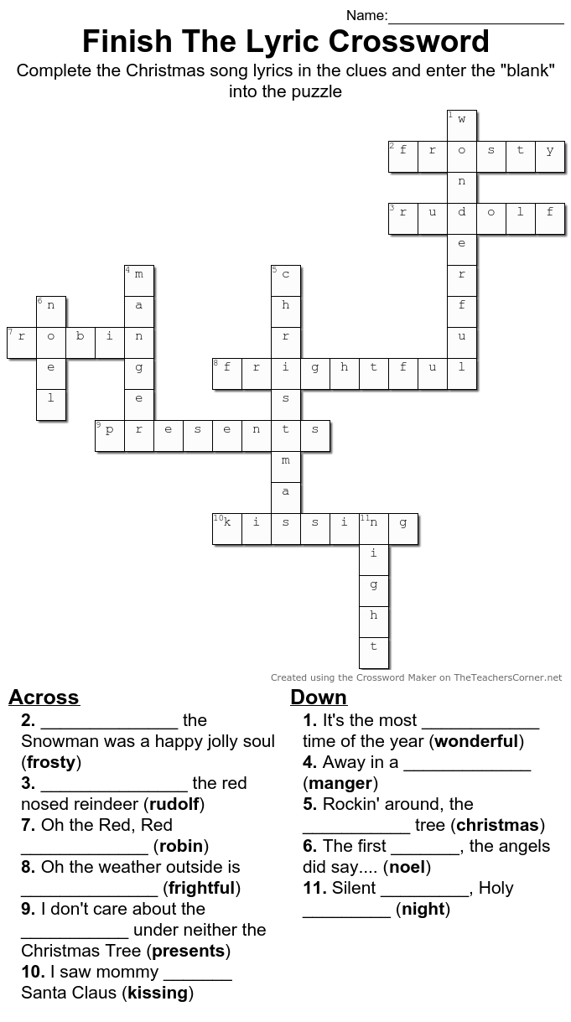22
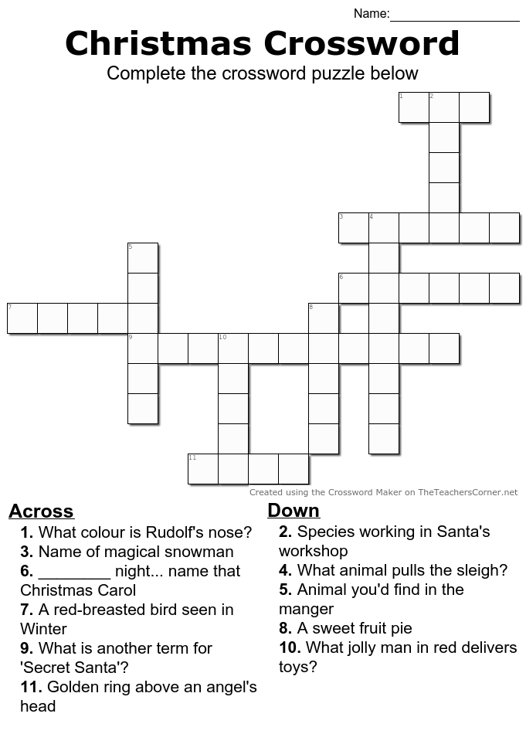

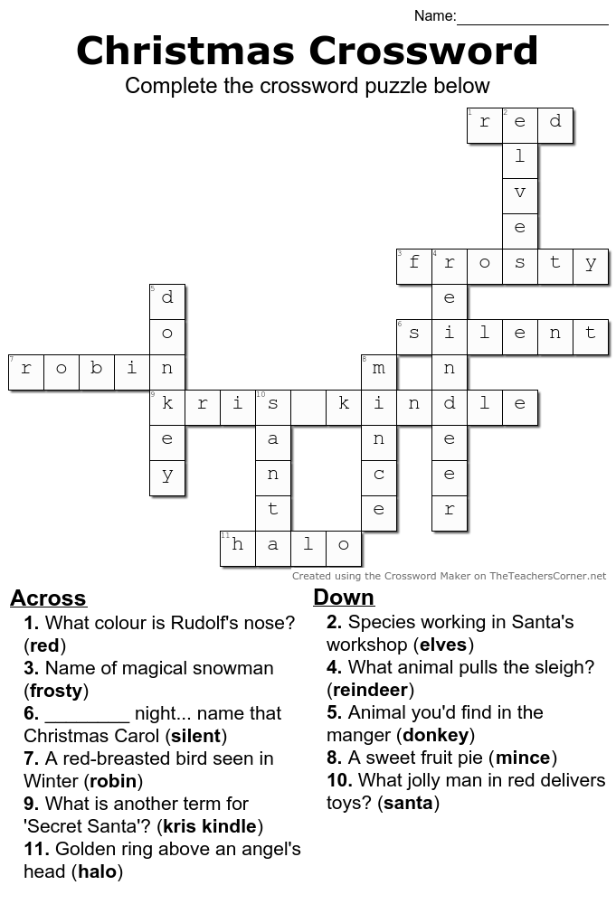
The Talkative Princess (A Folktale heard in Donegal)

Long ago there was a king who had a daughter whose tongue went so fast as she talked there was no stopping it. So he gave out word that the man who could stop her tongue should have the princess as their wife and half of his kingdom into the bargain.
Now three brothers who heard this made up their minds to go and try their luck. First of all the two eldest went, for they thought they thought they were the cleverest, but clever as they were they could not keep up with her tongue at all and got well thrashed besides.
Then John the youngest, set off and when he had gone a little way he found an elastic band on the road and he picked it up. When he had gone a little farther he found a piece of a broken plate and he picked that up too. A little farther on he found a dead magpie, and a little farther on still, a rams crooked horns, and at last, just as he was crossing the fields by the kings palace, where they were pitching out manure, he found a worn-out-shoe-sole. All these things he took with him into the palace, and went before the Princess.
John asked her could he cook his magpie. " I am afraid it will burst" answered the Princess. "Never fear, for I'll just put this band round it", said the lad as he pulled it out. "The fat will run out of it", said the Princess. "Then I will hold this under it" said the lad, and showed her the piece of broken plate.

"You are so crooked in your words", said the Princess. "No I am not crooked", said the lad "but this is" as he held up one of the horns. "Well I never saw the match of this in all my days!", said the Princess. Then the lad showed her the other matching ram's horn. "You have come to wear my tongue out with all of your nonsense!", "No I have not", said the lad "but this is worn out" as he pulled out the old shoe sole.

To this the Princess had nothing to say - she had fairly lost her voice as it seemed he had a reply to everything, and secretly she admired his wit! Then John having won the victory got the Princess to wife and half the kingdom, and they lived happily ever after talking their whole lives through.

A Treasure (A Folktale heard in Mayo)

Once upon a time there was a man and his wife and they had nothing to eat. They left home to seek their fortune. The man told his wife to pull the door after her. Misunderstanding him, she pulled it after her on the road and when he noticed they had travelled too far to return.

When night came on they were passing through a wood. They went up on a tree and brought the door with them resting for the night. During the night there came a band of robbers and bags of gold with them. Where did they camp, but right under the tree where the old pair were resting! After a while the woman got tired holding the door and at last she let it go. It made a terrible noise going down. When the robbers heard the noise up over them they thought it was a sleeping bear falling on top of them and that they’d be caught and killed for sure!

They went off in a hurry and left all the bags of money after them. As soon as the robbers were gone the man and his wife came down from the tree and got all the money. They brought it home and lived happy ever after – they even bought a new door!

When You Were Sweet Sixteen
By James Thornton (performed by The Fureys)

When first I saw the love light in your eye
I dreamt the world held naught but joy for me
And even though we drifted far apart
I never dream, but what I dream of thee

I love you as I never loved before
Since first I met you on the village green
Come to me or my dream of love is o'er
I love you as I loved you
When you were sweet
When you were sweet sixteen

Last night I dreamt I held your hand in mine
And once again you were my happy bride
I kissed you as I did in Auld Lang Syne
As to the church we wandered side by side

I love you as I never loved before
Since first I met you on the village green
Come to me or my dream of love is o'er
I love you as I loved you
When you were sweet
When you were sweet sixteen

The Banks Of My Own Lovely Lee lyrics
by Seán O Sé / John Fitzgerald

How oft do my thoughts in their fancy take flight
To the home of my childhood away,
To the days when each patriot's vision seem'd bright
Ere I dreamed that those joys should decay.
When my heart was as light as the wild winds that blow
Down the Mardyke through each elm tree,
Where we sported and play'd 'neath each green leafy shade
On the banks of my own lovely Lee,
Where we sported and play'd 'neath each green leafy shade
On the banks of my own lovely Lee.

And then in the springtime of laughter and song
Can I ever forget the sweet hours?
With the friends of my youth as we rambled along
'Mongst the green mossy banks and wild flowers.
And then, when the evening sun's sinking to rest
Shed its golden light over the sea
The maid with her lover the wild daisies pressed
On the banks of my own lovely Lee,
The maid with her lover the wild daisies pressed
On the banks of my own lovely Lee

'Tis a beautiful land this dear isle of song
Its gems shed their light to the world
And her faithful sons bore thro' ages of wrong,
The standard St. Patrick unfurled.
Oh! would I were there with the friends I love best
And my fond bosom's partner with me
We'd roam thy banks over, and when weary we'd rest
By thy waters, my own lovely Lee,
We'd roam thy banks over, and when weary we'd rest
By thy waters, my own lovely Lee.

Oh what joys should be mine ere this life should decline
To seek shells on thy sea-gilded shore.
While the steel-feathered eagle, oft splashing the brine
Brings longing for freedom once more.
Oh all that on earth I wish for or crave
Is that my last crimson drop be for thee,
To moisten the grass of my forefathers' grave
On the banks of my own lovely Lee,
To moisten the grass of my forefathers' grave
On the banks of my own lovely Lee.

Guided Relaxation: Visualizing the New Year

Just imagine you’re lying somewhere very comfortable, and your body starts to relax more and more. You begin to feel warm and cozy inside even though the outside air has grown crisp. The trees have lost their leaves and have gone to sleep for the winter.

Imagine yourself curled up in front of a nice warm fireplace. You watch as the flames flicker yellow and red. The golden yellow flame seems to relax you even further as you enjoy its warmth. As you lie here enjoying this moment of relaxation, you start to remember some wonderful things that have happened this past year.

There have been many moments that have made you happy; many moments that have made you smile and grateful.

It’s been a good year.

You’ve grown on the outside and on the inside too. You’re smarter and wiser this year. You know yourself better, and you’re getting to know your personal gifts more and more.

The new year will bring a brand new start.

Now is the time to think about all the amazing things you want to accomplish. Remember, you can achieve anything you put your mind to!
So start to imagine all the wonderful things you’d like to do this coming year. Maybe you want to get better at something you enjoy doing, or perhaps learn a new skill. Maybe you want to spend more time on yourself.

Whatever you decide to do this coming year will be a wonderful goal to work towards each and every day.

Always remember to have faith in yourself and in your ability to accomplish your dreams. By using your heart and your mind together, you can create a fantastic year filled with joy, happiness, and fun!

Now take in a deep breath and imagine yourself at the end of the year having accomplished all these wonderful things you’ve been thinking about. Doesn’t it feel wonderful?

Picture yourself as having succeeded, and hold on tightly to that image in your mind and heart!

Now allow peacefulness and happiness to fill up your entire body, going into each and every cell.

When you’re ready you can open your eyes and give your body a big stretch… and be ready to live your dream!

