February
Activity Pack

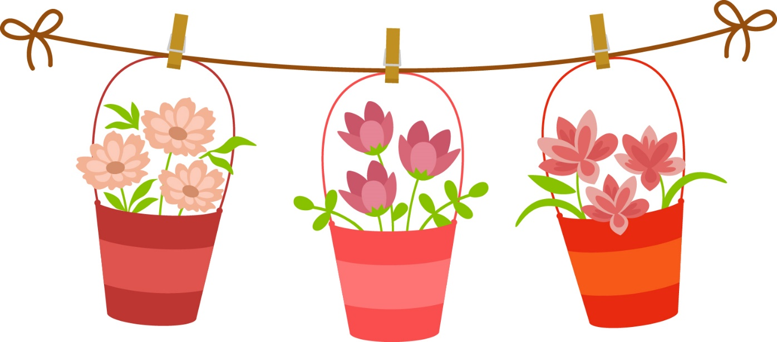

Dear Friends,

February is finally on our doorstep and though there’s still a nip in the air we will soon see the first touches of Spring.

This month we see the celebration of St. Valentine’s Day and it’s a good opportunity not only to show love and kindness to those close to you but also to yourself. Treat yourself to flowers, chocolates, or give yourself time to listen to your favourite song – whatever brings you joy.

Remember, the ASI are just a phone call away if you ever need us. Our helpline number is 1800 341 341, with trained staff on the other end to listen to and support you.

Much love from us to you…

“In family life, love is the oil that eases friction,
the cement that binds closer together,
and the music that brings harmony.”

—Friedrich Nietzsche
Useful Resources:

- Our Free Helpline and Dementia Nurse Support Line are available at:
Phone: 1800 341 341 and Email: helpline@alzheimer.ie

- The Irish Museum of Modern Art is running a series called “Talking Art Online” where they take a close look at selected artworks from the IMMA Collection and discuss IMMA exhibitions with their Visitor Engagement Team from the comfort of your living room. To book and for more information, please email talkingart@imma.ie or phone 01 612 9955

- We are hosting several Virtual Cafes. They are a place to come together, share a cuppa and listen to our amazing guest speakers. For information on how to attend visit: https://alzheimer.ie/service/alzheimer-cafe/

- The ASI also have a huge library of factsheets and resources available on: https://alzheimer.ie/get-support/resources-and-factsheets/

- M4D Radio is a 24/7 online radio station with songs specifically picked to evoke memories and aid reminiscence. To find out more and to listen, please visit: https://m4dradio.com/

- The BBC have curated a remarkable online archive of videos, images and audio clips to aid reminiscence and covers a wide variety of subject matter. Please visit: https://remarc.bbcrewind.co.uk/ to check it out.

- Emergency Response Numbers: 999 or 112

- HSE 24/7 Your Mental Health Information Helpline: 1800 111 888

Table of Contents

Activity | Pages
Bird Mazes | 5 – 6
I Spy and Count | 7
Kindness Meditation | 8 – 9
Word Puzzle | 10 – 11
Valentines Pictures to Colour | 12 – 16
Wordsearch | 17 – 18
Word Scramble | 19
Proverbs | 20 – 21
“A Birthday” Poem | 22
How Do I Love Thee | 23
She Walks In Beauty | 24
Make A Valentine | 25 – 26
The Black Velvet Band Lyrics | 27 - 28
Eileen O’Grady Lyrics | 29

Help the Bird to Find Her Nest!
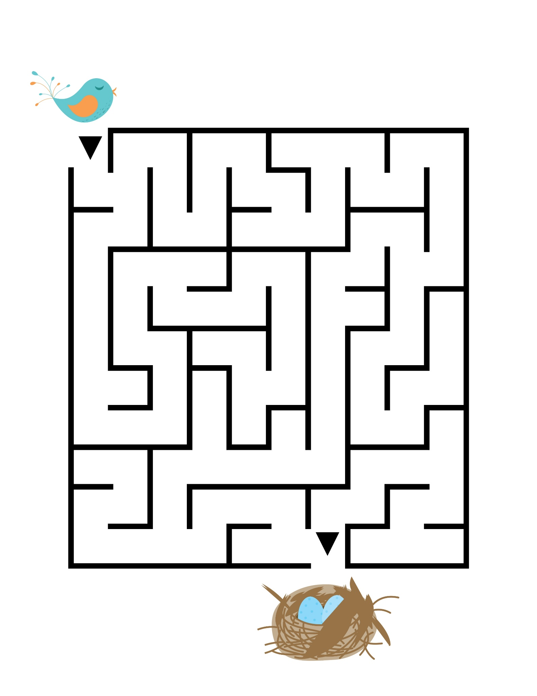

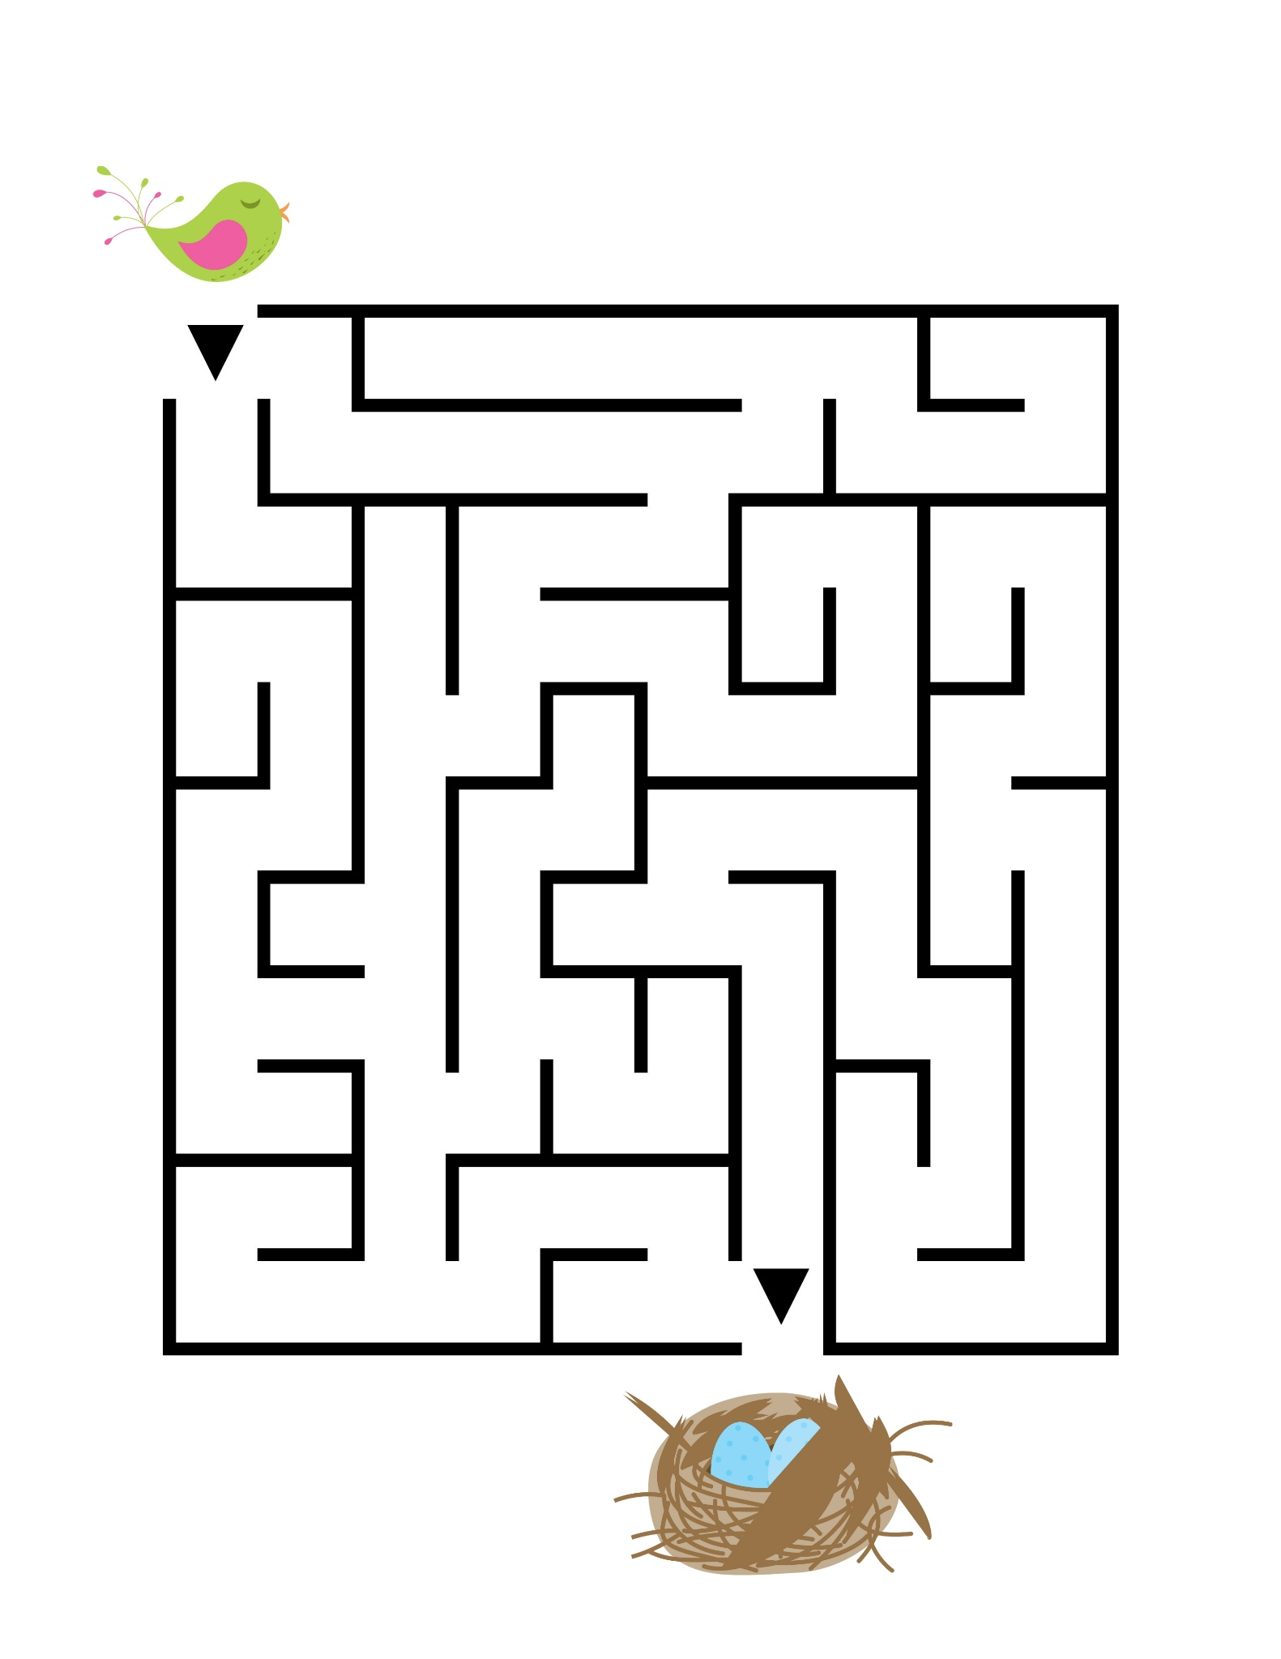

See how many of each animal you can find and write the number below!

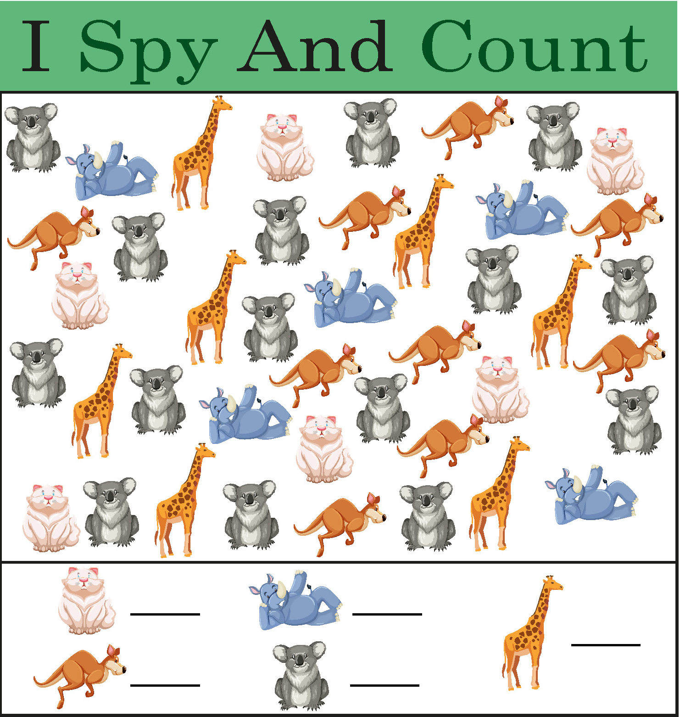

Bucket Of Kindness Mediation
Close your eyes and take a very deep breath.
Keep breathing deeply and feel the cool air
come in through your nose and flow all the way
down to your belly. Feel your belly extend as you breathe in.

Now, listen carefully to all the quiet sounds
outside and around you. You may hear outside
noises, maybe cars, birds or something else…
just listen.
Now, turn your focus within. Listen quietly to what you hear happening within your body.

Can you hear your heart beating? Can you hear
your breath as you breathe slowly in and out?
Maybe your tummy is making noises, or you’re
listening to the sound of your breath, or your
heartbeat. Whatever is going on inside, just take
time to listen.

Imagine now inside of you, there is a big beautiful bucket.
Everyone has one though we can’t see it with our eyes.
When we feel good, our buckets are full.
When we’re feeling bad, our buckets are low… or even empty.
We all want our buckets to be full of love, kindness,
peacefulness, and happiness.
Everyone does. So, we can make a choice each and every day to show loving kindness to others and help fill up their buckets.

If your bucket ever feels low or empty – you can
take in a deep breath and remember how loved
you are. You can choose to be grateful for the
good things and people you have in your life
and focus on that.

Now when you’re ready…. take in a deep breath.
Open your eyes and give you wonderful body a big, wonderful stretch!
You’ve done a great job!

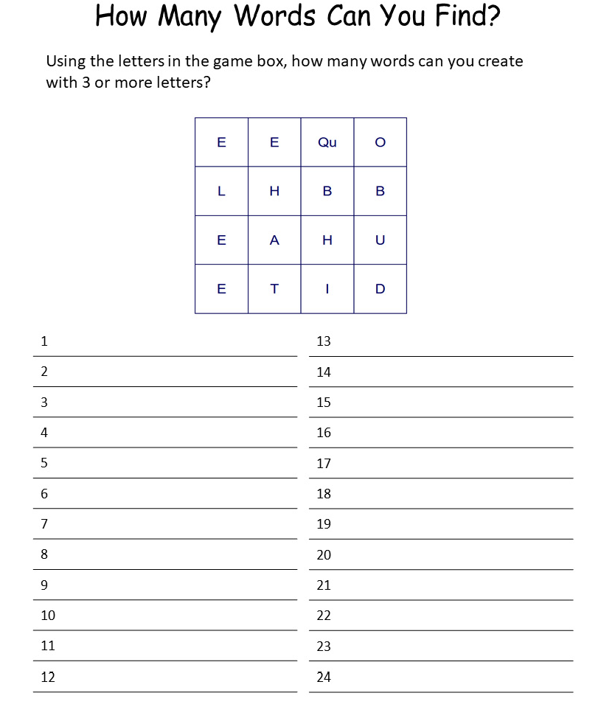
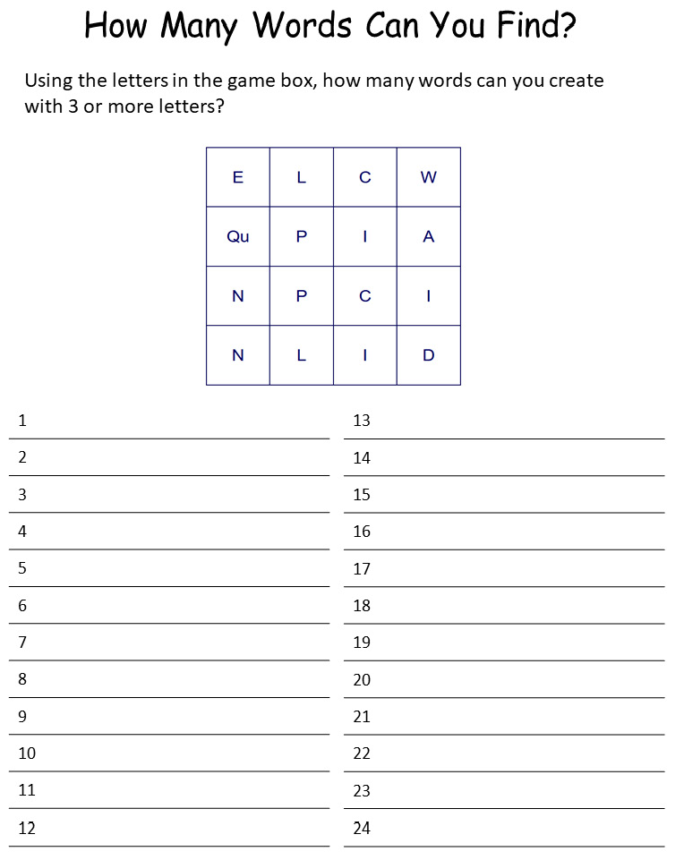

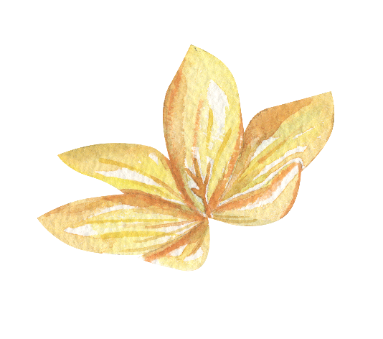
Valentines Pictures to Colour
We would love to see some of your artwork! Please contact us on Facebook or Email danielle.keogh@alzheimer.ie if you’d like us to showcase your paintings!

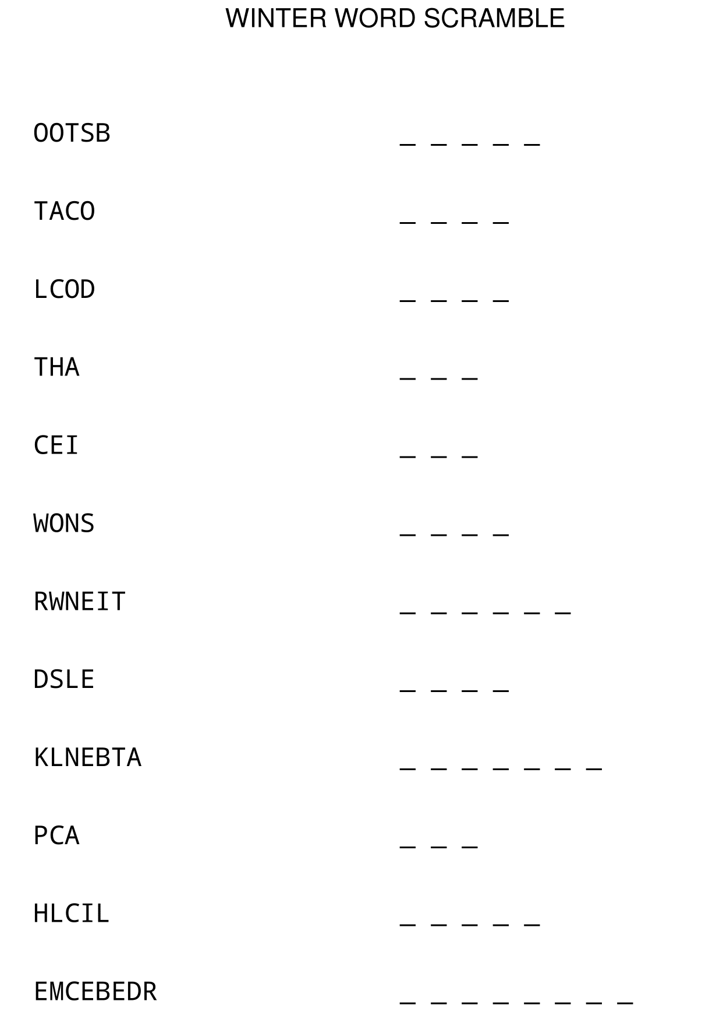
Answers:
Boots, coat, hat, ice, snow
Winter, sled, winter, cap, chill, December.
Seanfhocal/Proverbs

‘Seanfhocal’ is the Irish word for proverb, literally meaning ‘old word’. The following proverbs have been around for centuries. The following are some commonly used proverbs and their meanings.

1 Hindsight is the best insight to foresight – Learn from your past mistakes to avoid making new ones.

2. Every man is sociable until a cow invades his garden – Everybody has their off days!

3. Hunger is good sauce – hunger makes any food taste good.

4. Experience is the comb that life gives a bald man – A man who has lived long enough to lose his hair will no doubt know a thing or two about life.

5. Do not resent growing old, many are denied the privilege – this one of the few self-explanatory proverbs!

6. Complain that you have no shoes until you meet a man who has no feet – be thankful for what you have because there will always be someone in a worse situation than you.

7. It’s a long road that has no turning – Always doing the same thing is neither beneficial nor entertaining.

8. Many a ship is lost within sight of the harbour – don’t let your guard down no matter how safe you think things may be.

9. Life is like a cup of tea; it’s all in how you make it – how you live your life is a result of what you do in it.

10. It is the quiet pigs that eat the meal – this can be compared to ‘the early bird catches the worm’.

11. It’s a lonely washing that has no man’s shirt in it – everybody needs someone to love (and wash clothes for).

12. It’s not a delay to stop and sharpen the scythe – take every opportunity to learn.

13. No matter how many rooms you have in your house, you’re only able to sleep in one bed – it doesn’t matter how many possessions you have, we all have the same basic needs in life.

14. When the drop is inside the sense is outside – alcohol leads to senseless activities!
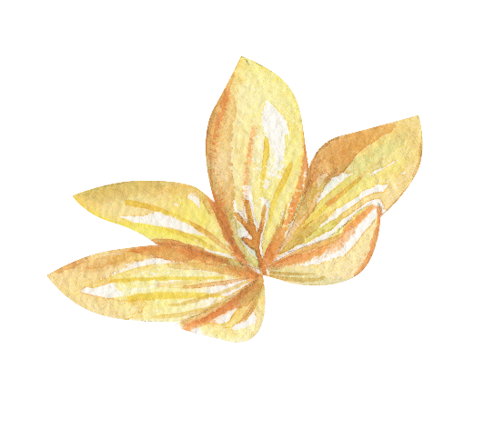
A Birthday by Christina Rossetti

My heart is like a singing bird
Whose nest is in a water’d shoot;
My heart is like an apple-tree
Whose boughs are bent with thickset fruit;
My heart is like a rainbow shell
That paddles in a halcyon sea;
My heart is gladder than all these
Because my love is come to me.

Raise me a dais of silk and down;
Hang it with vair and purple dyes;
Carve it in doves and pomegranates,
And peacocks with a hundred eyes;
Work it in gold and silver grapes,
In leaves and silver fleurs-de-lys;
Because the birthday of my life
Is come, my love is come to me.

How Do I Love Thee? (Sonnet 43)
Elizabeth Barrett Browning

How do I love thee? Let me count the ways.
I love thee to the depth and breadth and height
My soul can reach, when feeling out of sight
For the ends of being and ideal grace.
I love thee to the level of every day's
Most quiet need, by sun and candle-light.

I love thee freely, as men strive for right.
I love thee purely, as they turn from praise.
I love thee with the passion put to use
In my old griefs, and with my childhood's faith.

I love thee with a love I seemed to lose
With my lost saints. I love thee with the breath,
Smiles, tears, of all my life; and, if God choose,
I shall but love thee better after death.

She Walks in Beauty
By Lord Byron

She walks in beauty, like the night
Of cloudless climes and starry skies;
And all that’s best of dark and bright
Meet in her aspect and her eyes;
Thus mellowed to that tender light
Which heaven to gaudy day denies.

One shade the more, one ray the less,
Had half impaired the nameless grace
Which waves in every raven tress,
Or softly lightens o’er her face;
Where thoughts serenely sweet express,
How pure, how dear their dwelling-place.

And on that cheek, and o’er that brow,
So soft, so calm, yet eloquent,
The smiles that win, the tints that glow,
But tell of days in goodness spent,
A mind at peace with all below,
A heart whose love is innocent!
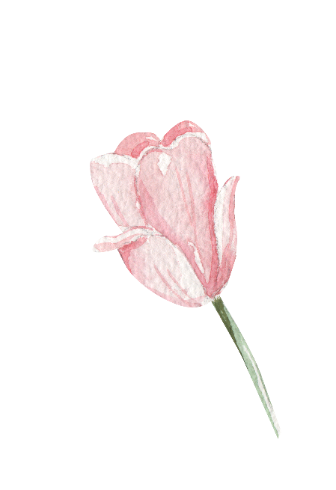
Make Your Own Valentine!

Carefully cut out the Valentine images below and stick/glue them to a blank piece of paper, fold in half, and write your message inside for someone you love!

Be My Valentine

The Black Velvet Band
The Dubliners

In a neat little town they call Belfast
Apprentice to a trade I was bound
And many's an hour's sweet happiness
Have I spent in this neat little town.
A sad misfortune came over me
Which caused me to stray from the land
Far away from my friends and relations
Betrayed by the black velvet band.

Her eyes they shone like diamonds
I thought her the queen of the land
And her hair hung over her shoulders
Tied up with a black velvet band.

I took a stroll down Broadway
Meaning not long for to stay
When who should I meet but this pretty fair maid
Came a traipsing along the highway.
She was both fair and handsome
Her neck it was just like a swans'
And her hair is hung over her shoulder
Tied up with a black velvet band.

Her eyes they shone like diamonds
I thought her the queen of the land
And her hair hung over her shoulders
Tied up with a black velvet band.

I took a stroll with this pretty fair maid
And the gentleman passing us by
Well I knew she meant the doing of him
By the look in her roguish black eye
A gold watch she took from his pocket
And placed it right into my hand
And the very first thing I said was
Bad 'cess to the black velvet band.

Her eyes they shone like diamonds
I thought her the queen of the land
And her hair hung over her shoulders
Tied up with a black velvet band.

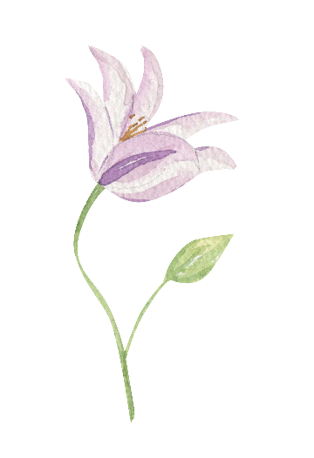

Eileen O’Grady - Author: unknown

Now Eileen O'Grady,
the real Irish lady,
I'm longing to call her my own
I'll not be contented,
until she has consented,
To be Mistress Barney Malone
I met this fair treasure,
while walking for pleasure,
She looked up at me then she cried
Without any warning
'The top of the morning'
And then up to her I replied

Come, come, beautiful Eileen,
Come for a drive with me
Over the mountain, down by the fountain
Over the high road and down by the low road

Make up your mind, don't be unkind
And we'll drive to Castlebar
To the road I'm no stranger, For you there's no danger
So just come along in my old jaunting car
Now Eileen said 'No sir, with you I won't go, sir
Don't think it ungrateful of me
I'd rather go walking, than have people talking
You know what the story would be'
'No Eileen my jewel, don't treat me so cruel
To treat me this way is a shame
Give over your blarney And say I'm your Barney
And don't keep me waiting in vain'

