January
Activity Pack

Dear Friends,

Let us begin by wishing you the happiest of New Years!
We truly hope that 2021 will bring light and hope into our futures and that you know you are never far from our thoughts.

As our evenings slowly grow brighter day by day so too does the prospect of a year in which we hope to be more present in each other’s lives.
Remember, the ASI are just a phone call away if you ever need us. Our helpline number is 1800 341 341, with trained staff on the other end to listen to and support you.

We hope you all enjoy this first activity pack of 2021!

“A friend by - a phone call, popping in,
a small surprise or a chance meeting…
Puts a little jam on today’s bread and butter”

Unknown

Useful Resources:

- Our Free Helpline and Dementia Nurse Support Line are available at:
Phone: 1800 341 341 and Email: helpline@alzheimer.ie

- The Irish Museum of Modern Art is running a series called “Talking Art Online” where they take a close look at selected artworks from the IMMA Collection and discuss IMMA exhibitions with their Visitor Engagement Team from the comfort of your living room. To book and for more information, please email talkingart@imma.ie or phone 01 612 9955

- We are hosting several Virtual Cafes. They are a place to come together, share a cuppa and listen to our amazing guest speakers. For information on how to attend visit: https://alzheimer.ie/service/alzheimer-cafe/

- The ASI also have a huge library of factsheets and resources available on: https://alzheimer.ie/get-support/resources-and-factsheets/

- M4D Radio is a 24/7 online radio station with songs specifically picked to evoke memories and aid reminiscence. To find out more and to listen, please visit: https://m4dradio.com/

- The BBC have curated a remarkable online archive of videos, images and audio clips to aid reminiscence and covers a wide variety of subject matter. Please visit: https://remarc.bbcrewind.co.uk/ to check it out.

- Emergency Response Numbers: 999 or 112

- HSE 24/7 Your Mental Health Information Helpline: 1800 111 888

Table of Contents

Activity | Pages
Good Night and Good Morning | 5
Pictures to Colour | 6-12
Funny Limericks and Rhymes | 13
Buttercups and Daisies | 14-15
I-Spy and Count | 16
Bird Folktales | 17
My Shadow | 18
Annie’s Song Lyrics | 19
Beautiful City Lyrics | 20-21
Gentle Stretching Exercises | 22-23
A Story about Churning | 24
Butterfly Meditation | 25-26

Good Night and Good Morning
By Richard Monckton Milnes, Lord Houghton

A fair little girl sat under a tree,
Sewing as long as her eyes could see;
Then smoothed her work, and folded it right,
And said, "Dear work, good night! good night!"
Such a number of rooks came over her head,
Crying, "Caw! Caw!" on their way to bed;
She said, as she watched their curious flight,
"Little black things, good night! good night!"

The horses neighed, and the oxen lowed,
The sheep's "Bleat! bleat!" came over the road;
All seeming to say, with a quiet delight,
"Good little girl, good night! good night!"
She did not say to the sun, "Good night!"
Though she saw him there like a ball of light,
For she knew he had earth's time to keep
All over the world, and never could sleep.

The tall pink foxglove bowed his head,
The violets curtsied and went to bed;
And good little Lucy tied up her hair,
And said on her knees her favourite prayer.
And while on her pillow she softly lay,
She knew nothing more till again it was day;
And all things said to the beautiful sun,
"Good morning! good morning! our work is begun!
Pictures to Colour

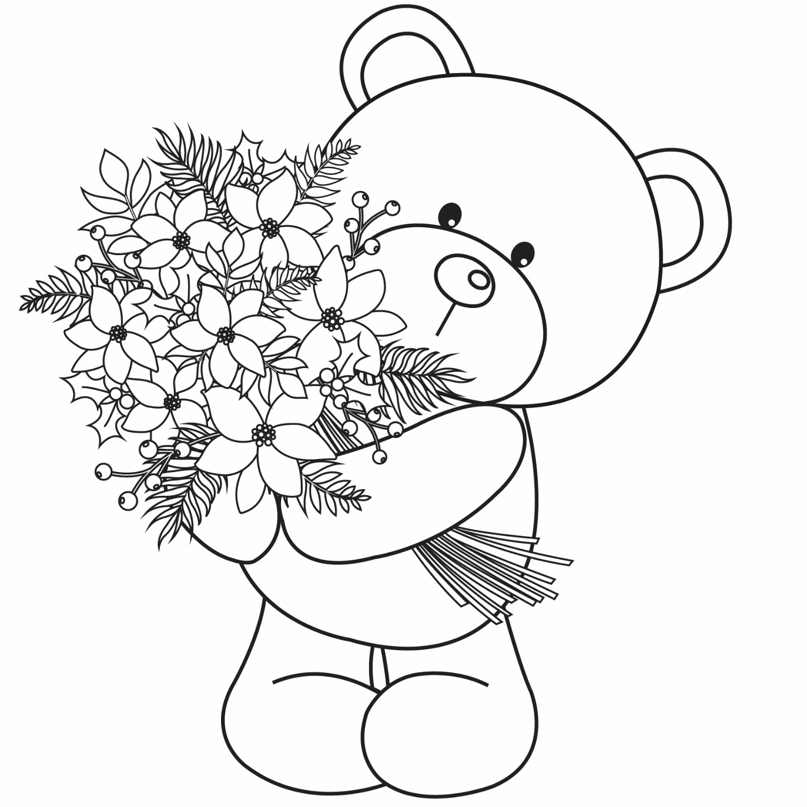

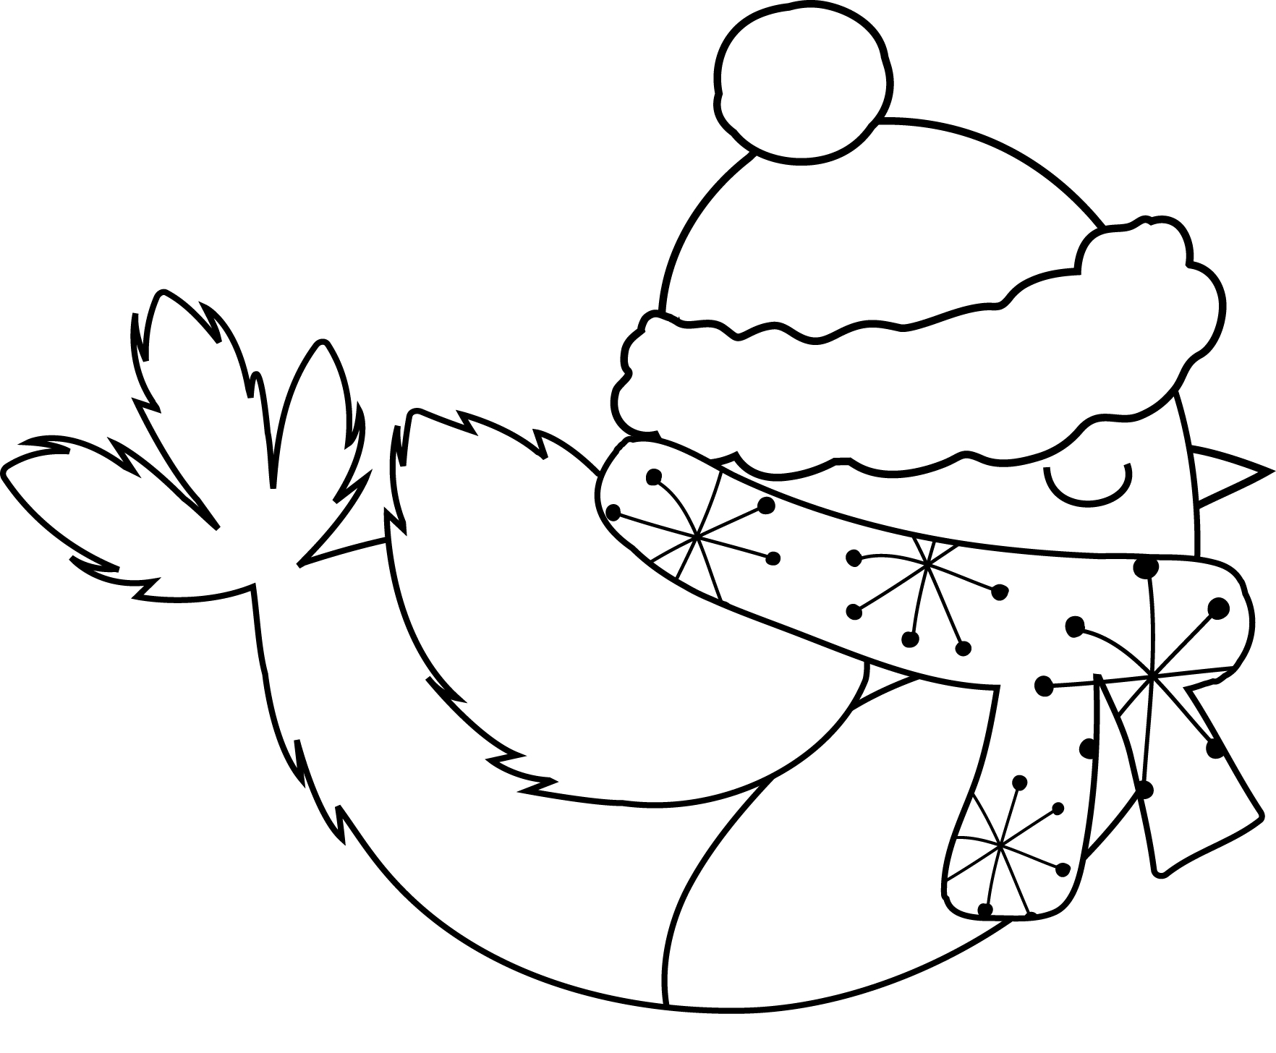

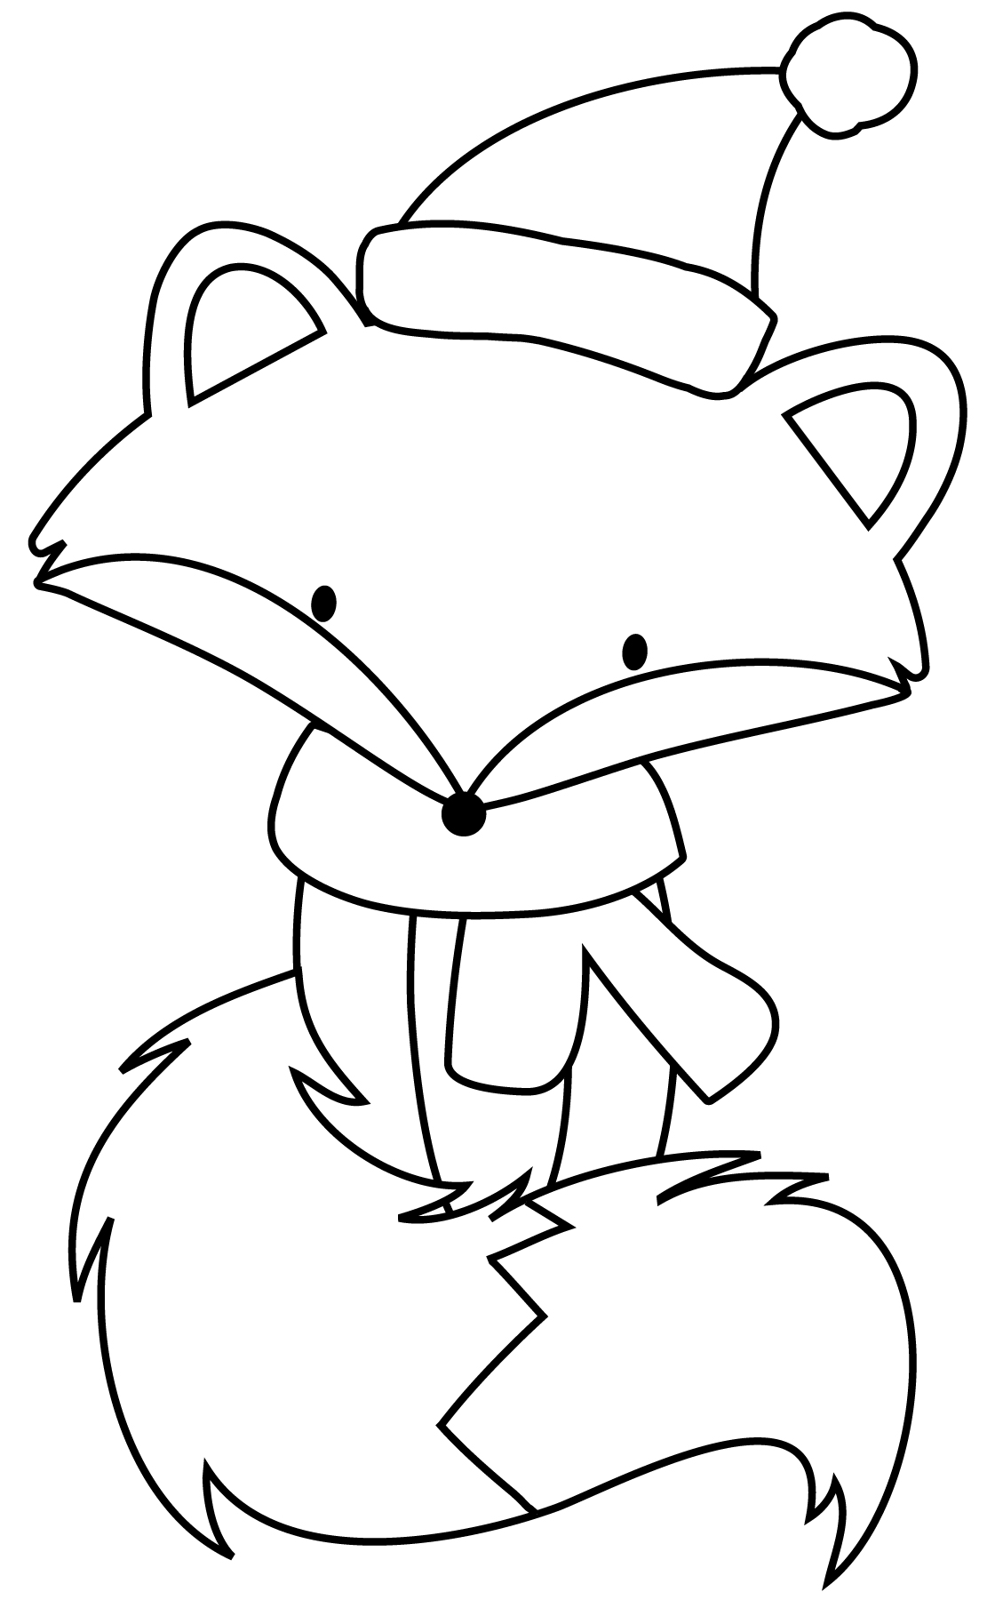

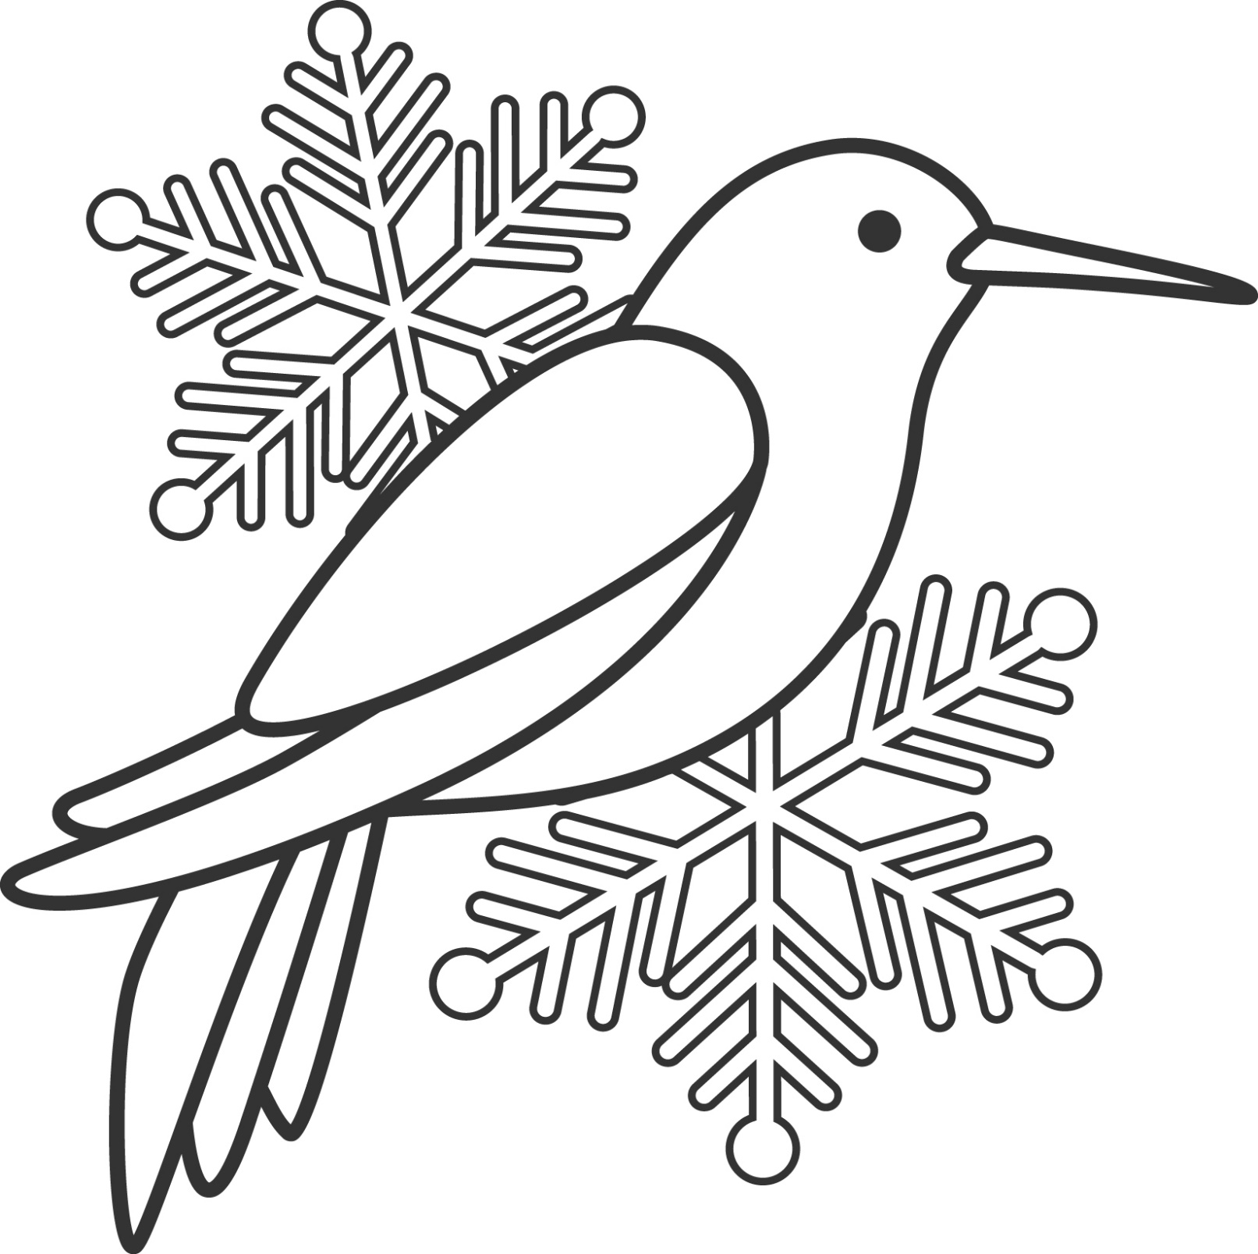

Funny Limericks and Rhymes
There was a young lady of Cork,
Whose Pa made a fortune in pork.
He bought for his daughter,
A tutor who taught her,
To balance green peas on her fork.

I'd rather have Fingers than Toes,
I'd rather have Ears than a Nose.
And as for my Hair,
I'm glad it's all there,
I'll be awfully said, when it goes.

A man and his lady-love, Min,
Skated out where the ice was quite thin.
Had a quarrel, no doubt,
For I hear they fell out,
What a blessing they didn't fall in!

There was a young lady of Lynn,
Who was so excessively thin.
That when she assayed,
To drink lemonade,
She slipped through the straw and fell in!

Buttercups and Daisies by Mary Howitt

Buttercups and daisies-
Oh the pretty flowers,
Coming ere the springtime
To tell of sunny hours.
While the trees are leafless,
While the fields are bare,
Buttercups and daisies
Spring up here and there.

Ere the snowdrop peepeth,
Ere the crocus bold,
Ere the early primrose
Opens its paly gold,
Somewhere on a sunny bank
Buttercups are bright;
Somewhere 'mong the frozen grass
Peeps the daisy white.

Little hardy flowers
Like to children poor,
Playing in their sturdy health
By their mother's door:
Purple with the north wind,
Yet alert and bold;
Fearing not and caring not,
Though they be a-cold.

What to them is weather!
What are stormy showers!
Buttercups and daisies
Are these human flowers!
He who gave them hardship
And a life of care,
Gave them likewise hardy strength,
And patient hearts, to bear.

Welcome yellow buttercups,
Welcome daisies white,
Ye are in my spirit
Visioned, a delight!
Coming ere the springtime
Of sunny hours to tell-
Speaking to our hearts of Him
Who doeth all things well.

The King of the Birds Folktale

Once upon a time all the birds agreed to have a king, but no bird would agree to another bird being king, so they agreed for all the birds to start together and who ever flew highest would be the king.

When they were starting the wren hid among the eagle's feathers. The eagle flew up high above all the other birds and shouted out "I am the king of the birds", but while he was shouting the wren fluttered out of his feathers and flew up high above him then the wren shouted out, "I am the king of the birds. This is how the wren became king of the birds.

Folktale from Longford:
Why the Swallow Has a Forky Tail

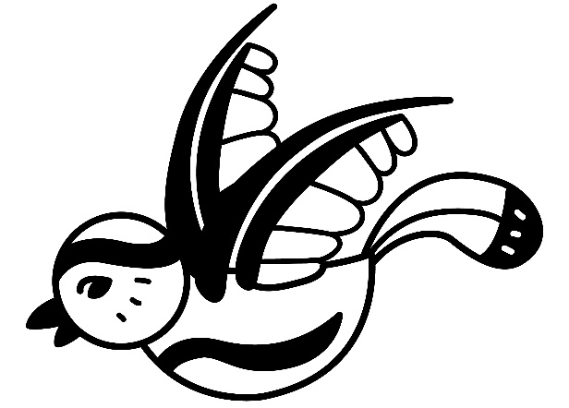
It is said that one time a swallow was sitting in a tree, a snake was on one of the branches of the tree, when he saw the swallow, it crawled along until it was just beside the swallow. The swallow saw it and was going to fly away but the snake caught it by the tail, the swallow pulled to get away and he left the middle of his tail in the snake’s mouth. This is how the swallow has a forky tail.

My Shadow by Robert Louis Stevenson

I have a little shadow that goes in and out with me,
And what can be the use of him is more than I can see.
He is very, very like me from the heels up to the head;
And I see him jump before me, when I jump into my bed.

The funniest things about him is the way he likes to grow-
Not at all like proper children, which is always very slow;
For he sometimes shoots up taller like an India rubber ball,
And he sometimes gets so little that there's none of him at all.

He hasn't got a notion of how children ought to play,
And can only make a fool of me in every sort of way.
He stays so close beside me, he's a coward you can see;
I'd think shame to stick to nursie as that shadow sticks to me!

One morning, very early, before the sun was up,
I rose and found the shining dew on every buttercup;
But my lazy little shadow, like an arrant sleepy-head,
Had stayed at home behind me and was fast asleep in bed.

Annie's Song by John Denver

You fill up my senses
Like a night in a forest
Like the mountains in springtime
Like a walk in the rain
Like a storm in the desert
Like a sleepy blue ocean
You fill up my senses, Come fill me again

Come, let me love you
Let me give my life to you
Let me drown in your laughter
Let me die in your arms
Let me lay down beside you
Let me always be with you
Come, let me love you, Come love me again

Let me give my life to you
Come, let me love you, Come love me again

You fill up my senses
Like a night in a forest
Like the mountains in springtime
Like a walk in the rain
Like a storm in the desert
Like a sleepy blue ocean
You fill up my senses, Come fill me again

Beautiful City Lyrics by John Fitzgerald

I have sought to discover a haven of rest
Where the sun sinks by night in the land of the West
I have dwelt with the red man in green forest bowers
O’er the wild rolling prairie bespangled with flowers
I have hived to the north, where the hardy pine grows
‘Mid the wolf and the bear, and the bleak winter snows
I have roamed through all climates, but none could I see
Like the green hills of Cork and my home by the Lee

Beautiful city, charming and pretty
Beautiful city, my home by the Lee

I have slumbered in palm groves by clear running streams
And the wild groves of Blarney come haunting my dreams
I have listened to bells on the soft summer wind
But the sweet bells of Shandon were dear to my mind
I have mixed in gay dances my sorrows to hide
But there’s none like the maiden that’s now by my side
There is nought in the land of the slave or the free
Like the green hills of Cork and my home by the Lee

Beautiful city, charming and pretty
Beautiful city, my home by the Lee

The bold feudal castles look down on the Rhine
That flows through the land of the olive and vine
There is freedom and health in the fresh mountain breeze
That careers round the home of the brave Tyrolese
There is beauty and love in all spots of the earth
To the heart that can call it the land of its birth
But of all the fair countries, the dearest to me
Are the green hills of Cork and my home by the Lee

Beautiful city, charming and pretty
Beautiful city, my home by the Lee

Gentle Stretching Exercises for Older Persons
(by healthline.com)
Please only do exercises if your health allows

Toe taps
To strengthen the lower legs
Sitting in a chair and keeping your heels on the floor, lift your toes high enough that you can feel the muscles along your shin working. (This helps keep blood circulating in your legs and also strengthens the lower leg.)
Repeat 20 times.

Heel raises
To strengthen the upper calves
Sitting in a chair, keep your toes and the balls of your feet on the floor and lift your heels.
Repeat 20 times.

Knee lifts
To strengthen the thighs
Seated in a chair, with your arms resting but not pressing on the armrests, contract your right quadriceps muscles and lift your leg. Your knee and the back of your thigh should be 2 or 3 inches off the seat.
Pause for 3 seconds and slowly lower your leg.
Complete 8 to 12 repetitions and then repeat with the opposite leg.

Shoulder and upper back stretch
To stretch the shoulders and back
Bend your right arm, raising it so your elbow is chest level and your right fist is near your left shoulder.
Place your left hand on your right elbow and gently pull your right arm across your chest.
Hold for 20 to 30 seconds.
Repeat with the opposite arm.

Ankle rotations
To strengthen the calves
Seated in a chair, lift your right foot off the floor and slowly rotate your foot 5 times to the right and then 5 times to the left.
Repeat with the left foot.

Neck stretch
To relieve tension in the neck and upper back
Sit with your feet flat on the floor, shoulder-width apart. Keep your hands relaxed at your sides.
Don’t tip your head forward or backward as you turn your head slowly to the right. Stop when you feel a slight stretch. Hold for 10 to 30 seconds.
Now turn to the left. Hold for 10 to 30 seconds.
Repeat 3 to 5 times.

A Story About Churning from Co. Mayo

We have a churn at home. It is two feet and six inches in height. It was made about fifteen years ago, by a cooper named Edward Nicholoson of Ballygarris but he lives in Castlebar now. It is composed of the bottom which is made of oak. The hoops are made of steel, and the lid is made of white deal. The handle of the churn dash is made of ash. The butter hands and the dish are made of deal. We churn twice a week in Summer and once a week in Winter. My Mother makes the churning. When a stranger comes in to a house where there is a churning being made he takes a hold of the churn dash and gives a few blows and says "God bless the cows."
It is said, that's if that was not done that the butter would be stolen.

It is said that it is not right to let out a man smoking a pipe whilst churning unless he takes the churn and says "God bless the work".

There are various kneads kinds of churns namely "the barrel churn" and the "machine churns". When the butter gathers in small lumps the churning is made. Some people take out the butter with their hands and other people take it out with a butter cup. If the people have too much butter they sell some of it. People make bread with the buttermilk.

Butterfly Meditation

Close your eyes and take in a nice deep breath.

Let the sights and sounds of this room fade away as you focus on your breathing and get ready to visualize a fun and relaxing adventure. Your body begins to feel deeply relaxed and sinks down further where you are. Your arms and legs begin to feel very heavy. You patiently enjoy this time as your mind and body continue to relax.

Now, imagine you’re a beautiful butterfly fluttering high in the sky. Below you, there is a lovely green valley with lots of colourful flowers, just waiting for you to enjoy. You feel the wind gently blow against your delicate wings. As the wind touches you, it gently blows away any worries or any stress you feel. Your mind is clear and calm. You feel light as the wind itself - a cheerful butterfly gliding and fluttering anywhere you wish to go.

Did you know that as a butterfly moves from flower to flower, it spreads just what the other plants need to thrive and grow? You are like that, too. You can flutter about peacefully and beautifully - spreading kindness, happiness, and goodness wherever you go!

The sun touches your colourful body and warms you. The big, puffy clouds floating in the sky remind you how relaxed and calm you can be whenever you want, just by thinking about it.
It’s so nice to be this light and airy.
Your butterfly self has left any worries or fears behind.

You love how it feels to beat your wings and fly, and anytime you start to feel tired, you can land on a leaf or flower and rest. You spread your lovely wings in a huge stretch. You are completely peaceful and content as you allow your true happiness to shine through. It feels so good.

Your body is calm, and your mind is peaceful.
You can fly around as long as you’d like – exploring or just floating gently on the wind.

Take in a deep breath now and exhale slowly.
When you are ready, give your body another big stretch and slowly open your eyes.

What did you like best about being a butterfly? Keep that feeling with you if you can. And remember, you can always come back here - or to any calming place - just by using your mind.

