March
Activity Pack

Dear Friends,

They say “March comes in like a lion, out like a lamb” and with the cold weather easing and the daffodils beginning to bloom we can see Spring on our doorstep.

We have created an Irish themed pack for this month in honour of St. Patrick’s Day and we also have the first part of a fantastic collaboration with the Irish Museum of Modern Art.
As part of their “Art and Aging” Programme of events they have created ten “Talking Art with IMMA” packs. Each is designed to highlight a selected work from the IMMA Collection, accompanied with a range of conversational prompts that form a guided way of exploring artworks. They are specifically designed for older persons and those living with dementia, and we are delighted to bring these artworks into your home over the coming months.

Slán Go Fóill!

“May peace and plenty be the first to lift the latch to your door,
And may happiness be your guest today and everymore…”
- Irish Blessing

Useful Resources:

- Our Free Helpline and Dementia Nurse Support Line are available at:
Phone: 1800 341 341 and Email: helpline@alzheimer.ie

- Do you know an older person who would like support using their smart phone or tablet?
Age Action Ireland are offering 5 hours free remote tutoring to help people learn to use Apps, email, Zoom, Facetime etc.
Call 01 4756989 or email gettingstarted@ageaction.ie

- We are hosting several Virtual Cafes. They are a place to come together, share a cuppa and listen to our amazing guest speakers. For information on how to attend visit: https://alzheimer.ie/service/alzheimer-cafe/

- The ASI also have a huge library of factsheets and resources available on: https://alzheimer.ie/get-support/resources-and-factsheets/

- M4D Radio is a 24/7 online radio station with songs specifically picked to evoke memories and aid reminiscence. To find out more and to listen, please visit: https://m4dradio.com/

- The BBC have curated a remarkable online archive of videos, images and audio clips to aid reminiscence and covers a wide variety of subject matter. Please visit: https://remarc.bbcrewind.co.uk/ to check it out.

- Emergency Response Numbers: 999 or 112

- HSE 24/7 Your Mental Health Information Helpline: 1800 111 888

Table of Contents

Activity | Pages
Eileen Oge | 5-6
Talking Art With IMMA | 7-11
Galway Bay Lyrics | 12
The Shoemaking Leprechaun | 13
Spraying The Potatoes Poem | 14-15
A Pint of Plain is Your Only Man Poem | 16
What Is Pink? Poem | 17
St. Patrick’s Day Pages to Colour | 18-23
St. Patrick’s Day Memos | 24-25
Irish Proverbs | 26-27
A Springtime Meditation | 28-29

Eileen Oge by Percy French

Eileen Oge oh that the darlin's name is
Through the Barony her features they were famous
If we all loved her who was there to blame us
For wasn't she the Pride of Petravore?
But her beauty made us all so shy
Not a man could look her in the eye
Boys, oh boys, sure that's the reason why
We're in mournin' for the Pride of Petravore

Chorus (after every verse):
Eileen Oge, my heart is growin' grey
Ever since the day you wandered far away
Eileen Oge, there's good fish in the sea
But there's none of them like the Pride of Petravore

Friday at the fair in Ballintubber
Eileen met McGrath the cattle jobber
Got to set my mark upon the robber
For he stole away the Pride of Petravore
He never seemed to see the girl at all
Even when she ogled him from underneath her shawl
Lookin' big and masterful when she was lookin' small
Most provokin' for the Pride of Petravore

So it went as was in the beginning
Eileen Oge was bent upon the winning
Big McGrath contentedly was grinning
Being courted by the Pride of Petravore
Says he: “I know a girl that could knock you into fits”
At that Eileen nearly lost her wits
The upshot of the ruction is that now the robber sits
With his arm around the Pride of Petravore

Boys, oh boys, with fate it's hard to grapple
Of my eyes Eileen was the apple
Now I see her walkin' to the chapel
With the hardest featured man in Petravore
Now, boys, this is all I have to say:
When you do your courtin' make no display
If you want them to run after you, just walk the other way
For they're mostly like the Pride of Petravore

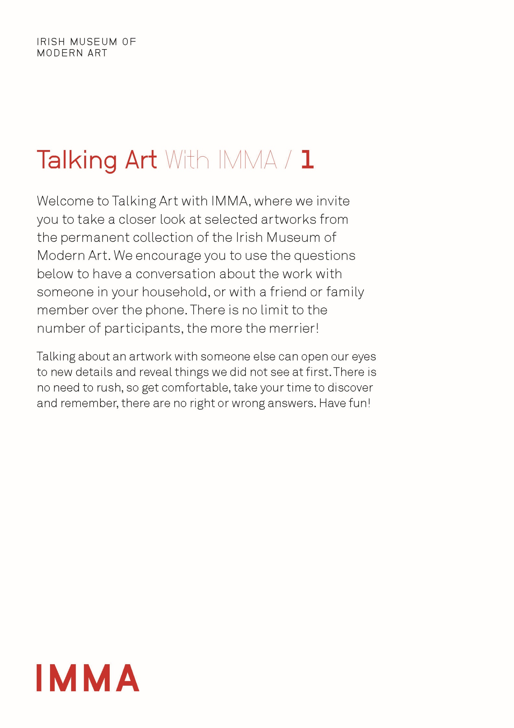

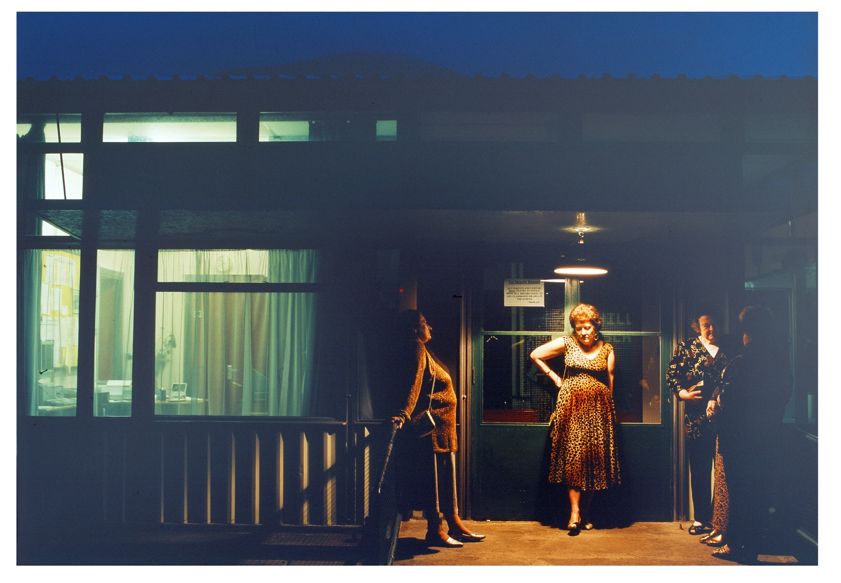
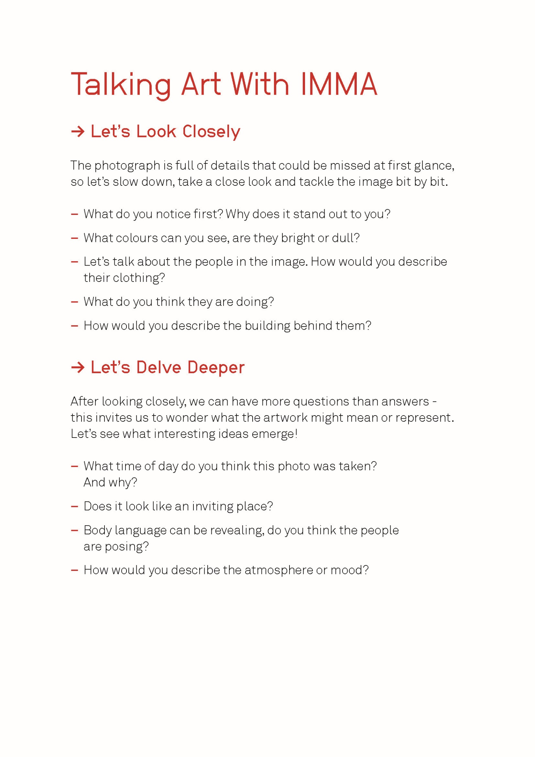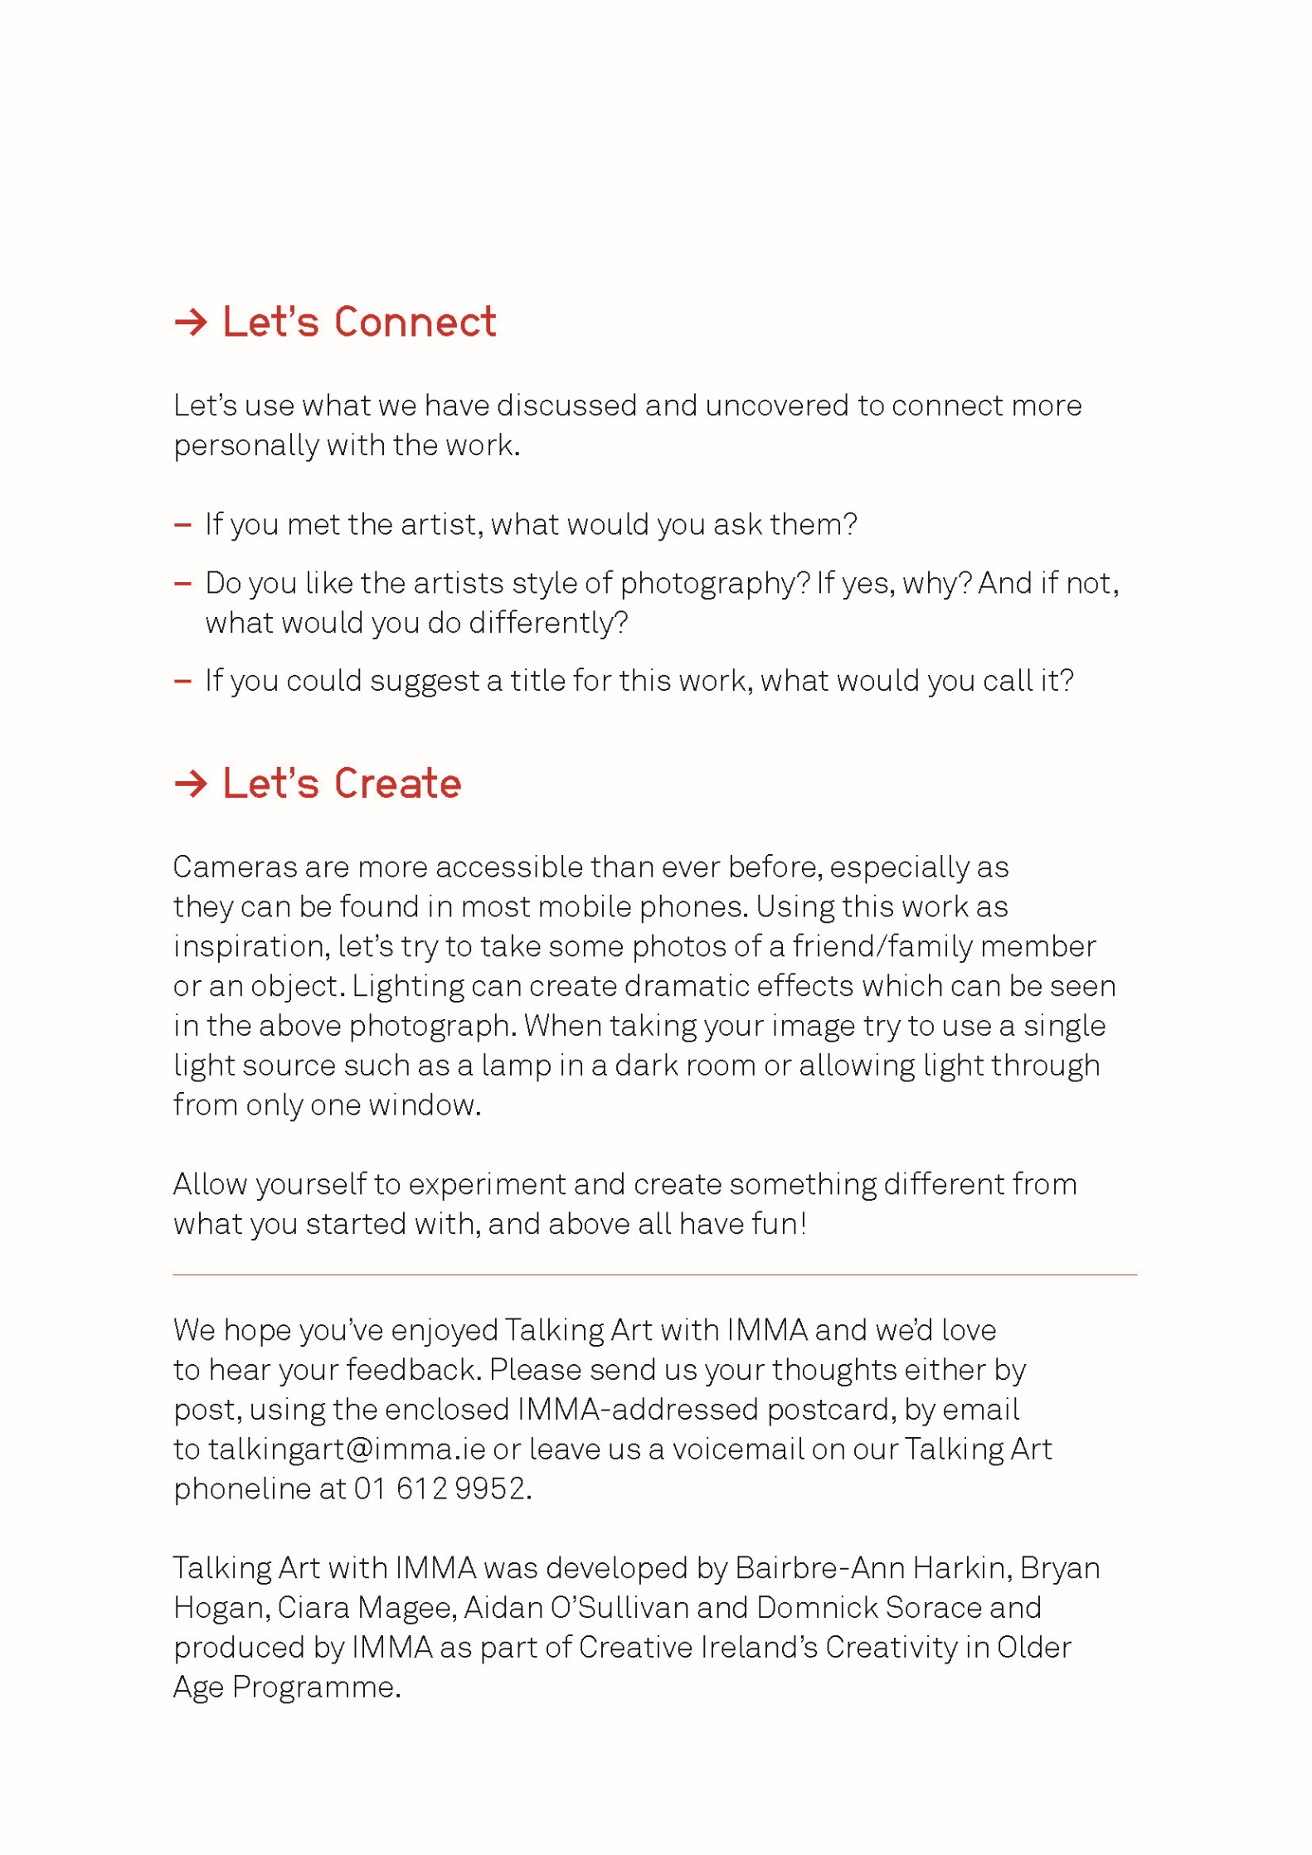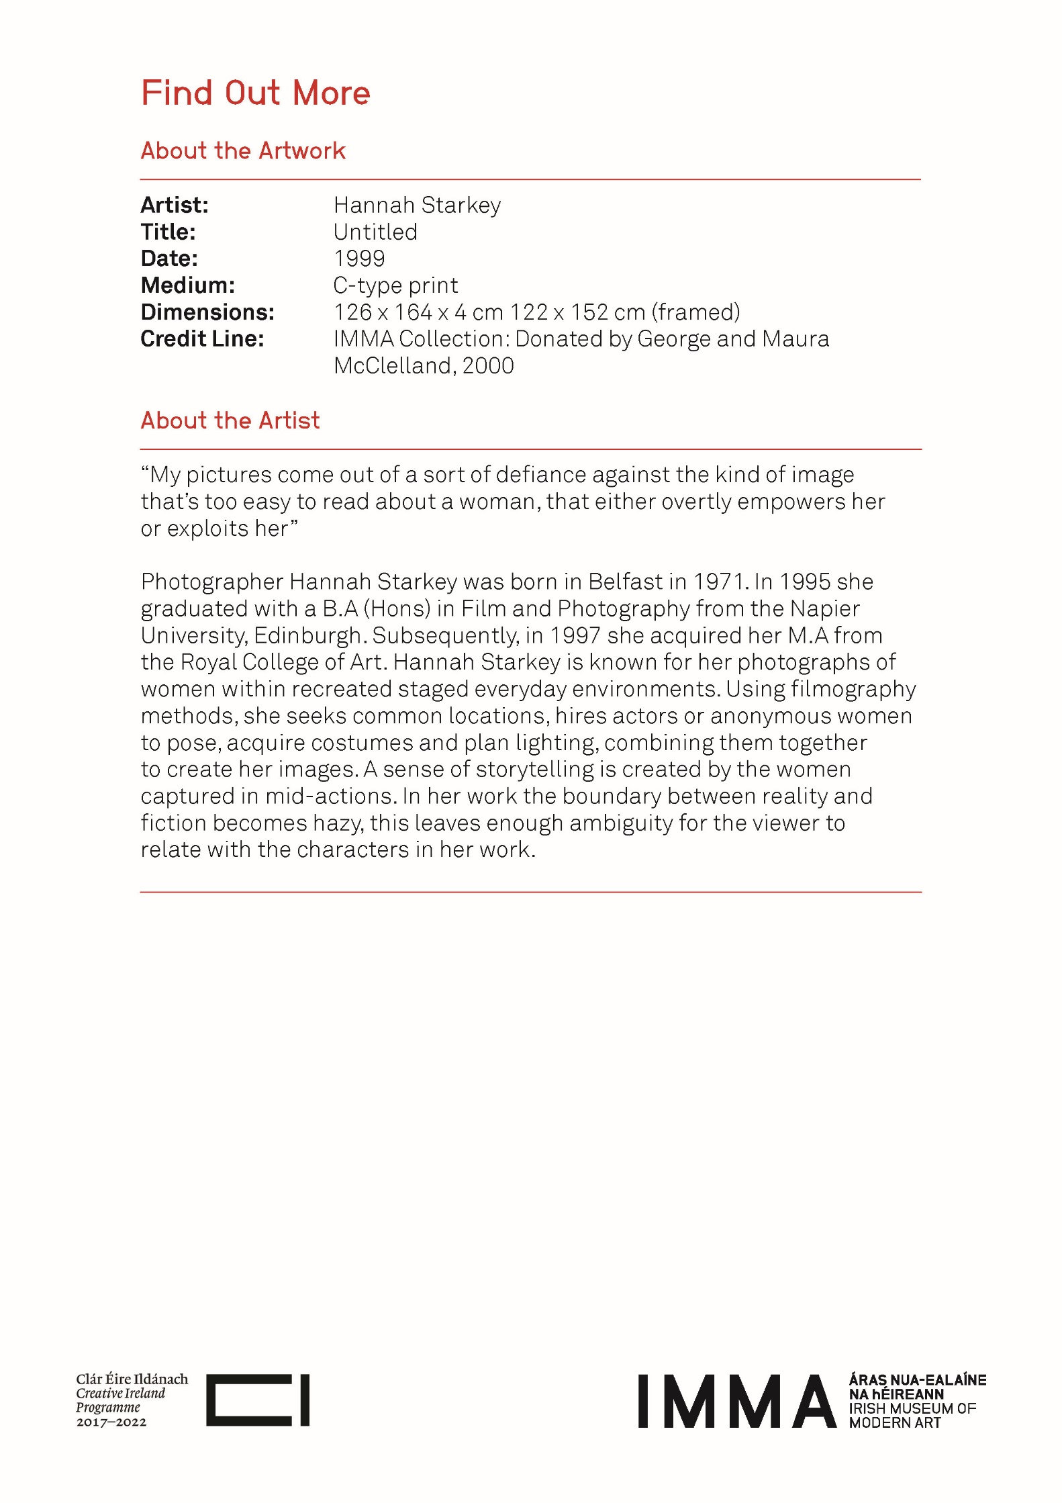
Galway Bay by Dr. Arthur Colahan

If you ever go across the sea to Ireland
than maybe at the closing of your day
you can sit and watch the moon rise over Claddah
or watch the sun go down on Galway Bay

Just to hear again the ripple of the trout stream
the women in the meadow makin' hay
or to sit beside a turf fire in a cabin
and watch the barefoot gossoms as they play

Oh the breezed blowing o're the sea from Ireland
are perfumed by the heather as they blow
and the women in the uplands diggin' praties
speak a language that the strangers do not know

Oh the strangers came and tried to teach us their ways
they blamed us just for bein' what we are
but they might as well go chasing after moonbeams
or light a penny candle from a star

And if there's going to be a life hereafter
and something tells me sure there's going to be
I will ask my God to let me make my Heaven
in the dear old land across the Irish Sea
The Shoemaking Leprechaun – An Irish Folktale

The old people say that long ago Leprechauns were often seen. It is said they used to wear a red hat and coat. They used to be seen sitting under a tree making shoes.

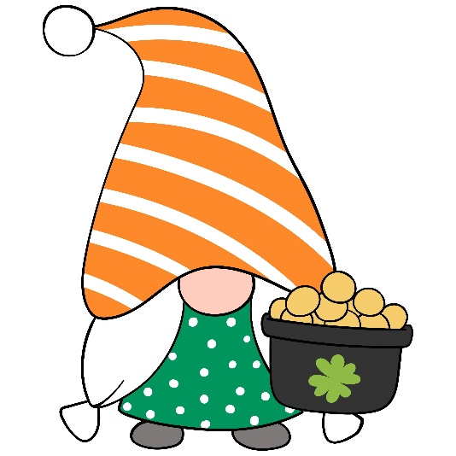
The old people say that there was once a poor man and he wanted to catch the Leprechaun as he heard they had a pot of gold. He used to go out every night and wait in the dark. One night he caught him sitting under a tree mending shoes. The Leprechaun asked the man to let him go but the man would not. Then he told him he would make the man wealthy if only he would let him go. He told him to go to a tree, to dig three foot deep, and he would get a box under it. Then the man went to the tree, dug three foot deep, and he got the box. Inside he found a last, an awl, some leather, tacks and a hammer. The man we disheartened but took the box ome, knowing he would not see the Leprechaun again in that area. The man began shoe making every day and, in time, became one of the land’s finest shoemakers and became very rich – just as the Leprechaun promised!

Spraying the Potatoes by Patrick Kavanagh

The barrels of blue potato-spray
Stood on a headland in July
Beside an orchard wall where roses
Were young girls hanging from the sky.

The flocks of green potato stalks
Were blossom spread for sudden flight,
The Kerr’s Pinks in frivelled blue,
The Arran Banners wearing white.

And over that potato-field
A lazy veil of woven sun,
Dandelions growing on headlands, showing
Their unloved hearts to everyone.

And I was there with a knapsack sprayer
On the barrel’s edge poised. A wasp was floating
Dead on a sunken briar leaf
Over a copper-poisoned ocean.

The axle-roll of a rut-locked cart
Broke the burnt stick of noon in two.
An old man came through a cornfield
Remembering his youth and some Ruth he knew.
He turned my way. ‘God further the work’.
He echoed an ancient farming prayer.
I thanked him. He eyed the potato drills.
He said: ‘You are bound to have good ones there’.

We talked and our talk was a theme of kings,
A theme for strings. He hunkered down
In the shade of the orchard wall. O roses
The old man dies in the young girl’s frown.

And poet lost to potato-fields,
Remembering the lime and copper smell
Of the spraying barrels he is not lost
Or till blossomed stalks cannot weave a spell.

A Pint of Plain is Your Only Man by Brian O’Neill

When things go wrong and will not come right,
Though you do the best you can,
When life looks black as the hour of night –
A pint of plain is your only man.

When money’s tight and hard to get
And your horse has also ran,
When all you have is a heap of debt –
A pint of plain is your only man.

When health is bad and your heart feels strange,
And your face is pale and wan,
When doctors say you need a change,
A pint of plain is your only man.

When food is scarce and your larder bare
And no rashers grease your pan,
When hunger grows as your meals are rare –
A pint of plain is your only man.

In time of trouble and lousey strife,
You have still got a darlint plan
You still can turn to a brighter life –
A pint of plain is your only man.
What is Pink? By Christina Rossetti

What is pink? A rose is pink
By the fountain's brink.
What is red? A poppy's red
In its barley bed.
What is blue? The sky is blue
Where the clouds float through.
What is white? A swan is white
Sailing in the light.
What is yellow? Pears are yellow,
Rich and ripe and mellow.
What is green? The grass is green,
With small flowers between.
What is violet? Clouds are violet
In the summer twilight.
What is orange? Why, an orange,
Just an orange!

(take time to look at the items around you – can you find something for each colour mentioned in the poem?
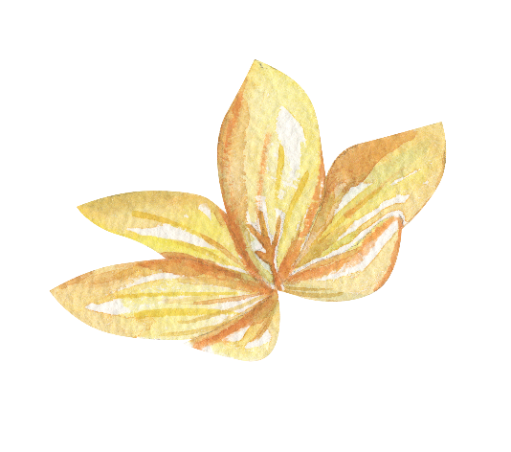
St. Patricks Day Pictures to Colour
We would love to see some of your artwork! Please contact us on Facebook, or Email danielle.keogh@alzheimer.ie if you’d like us to showcase your paintings!

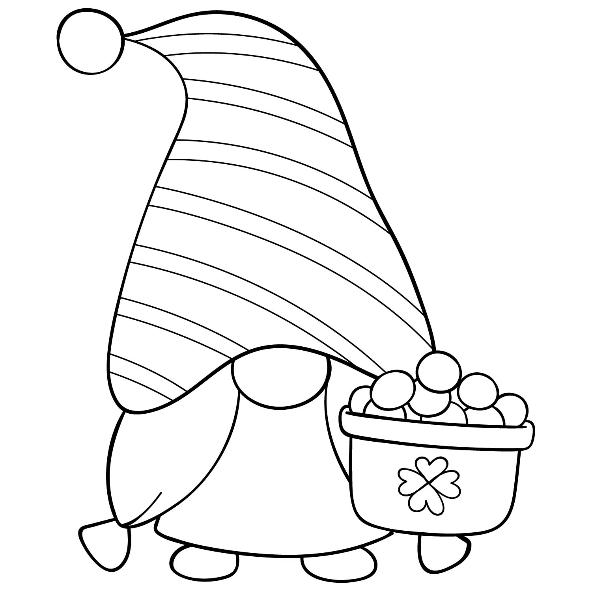

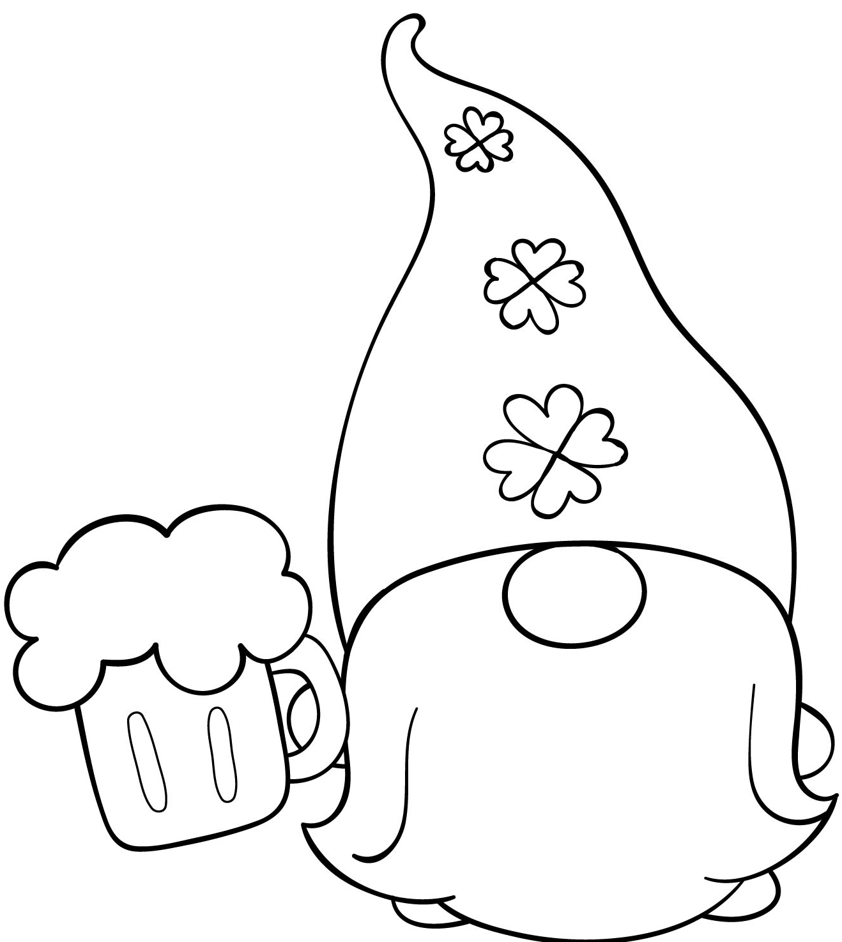

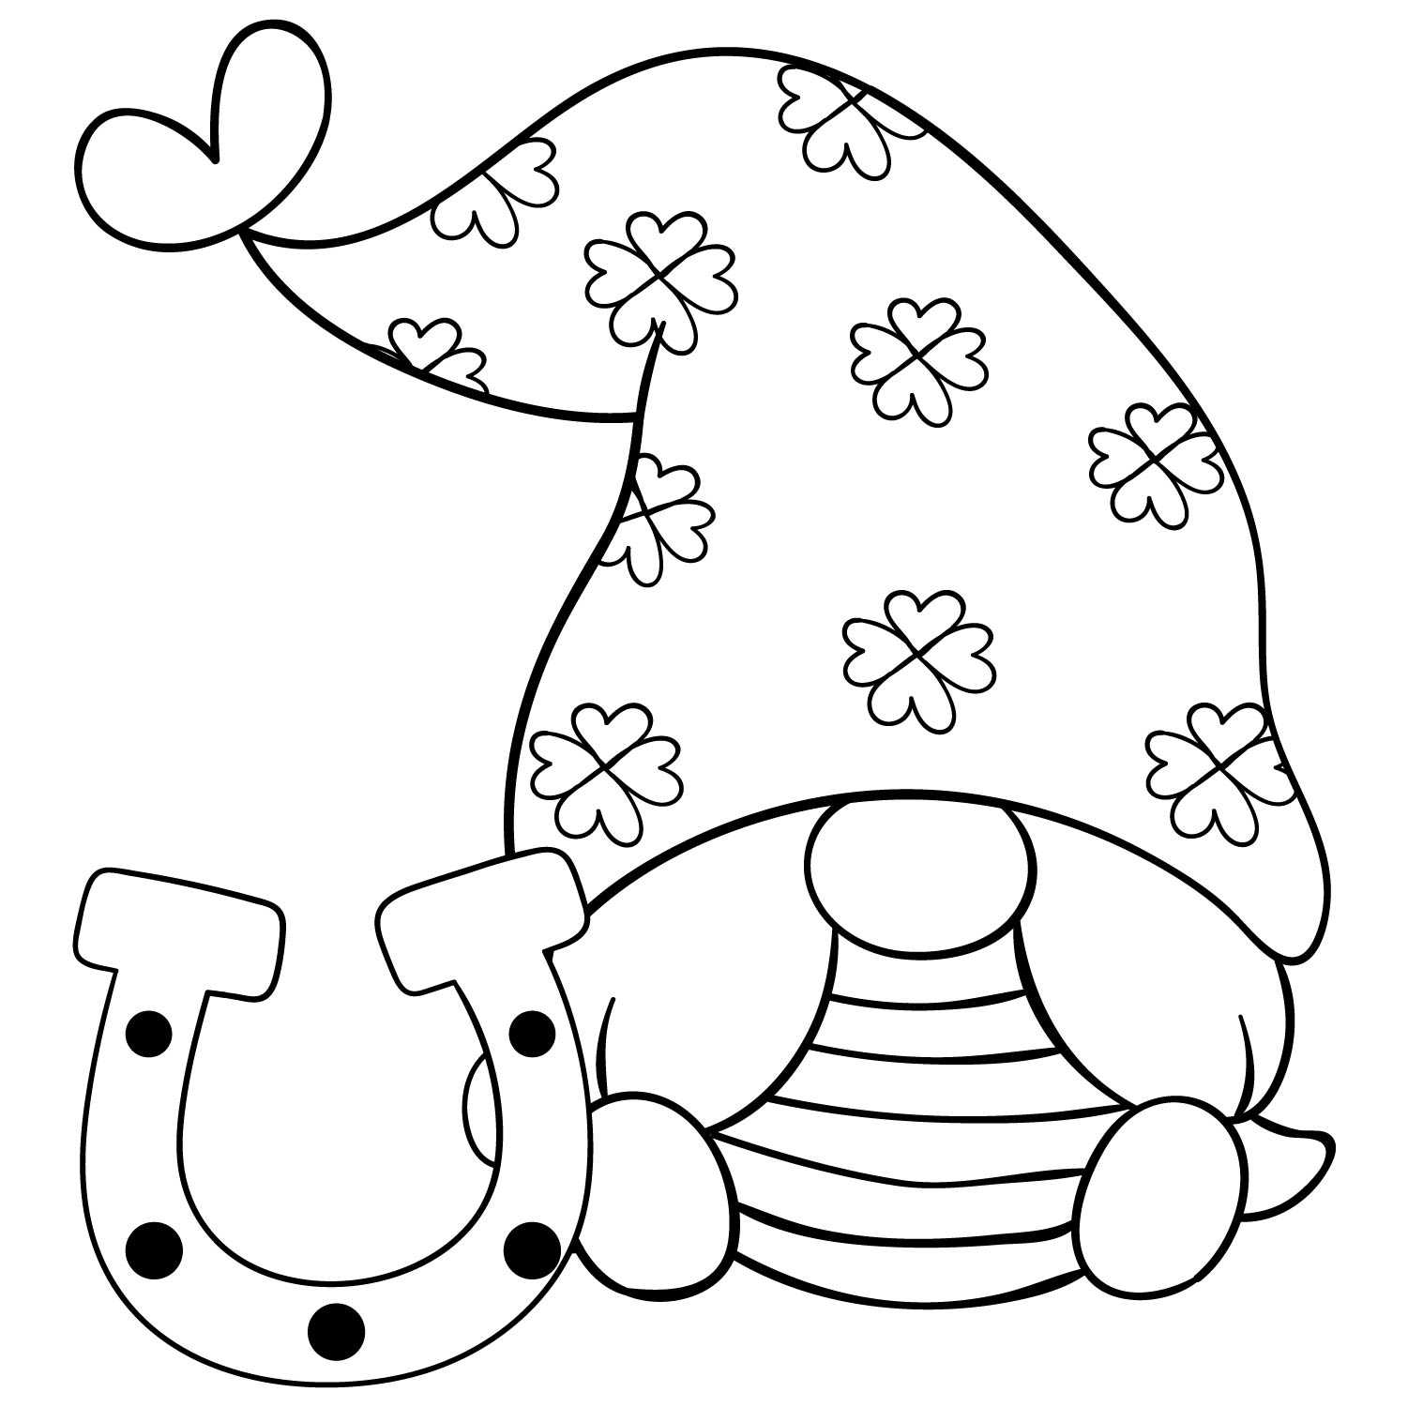

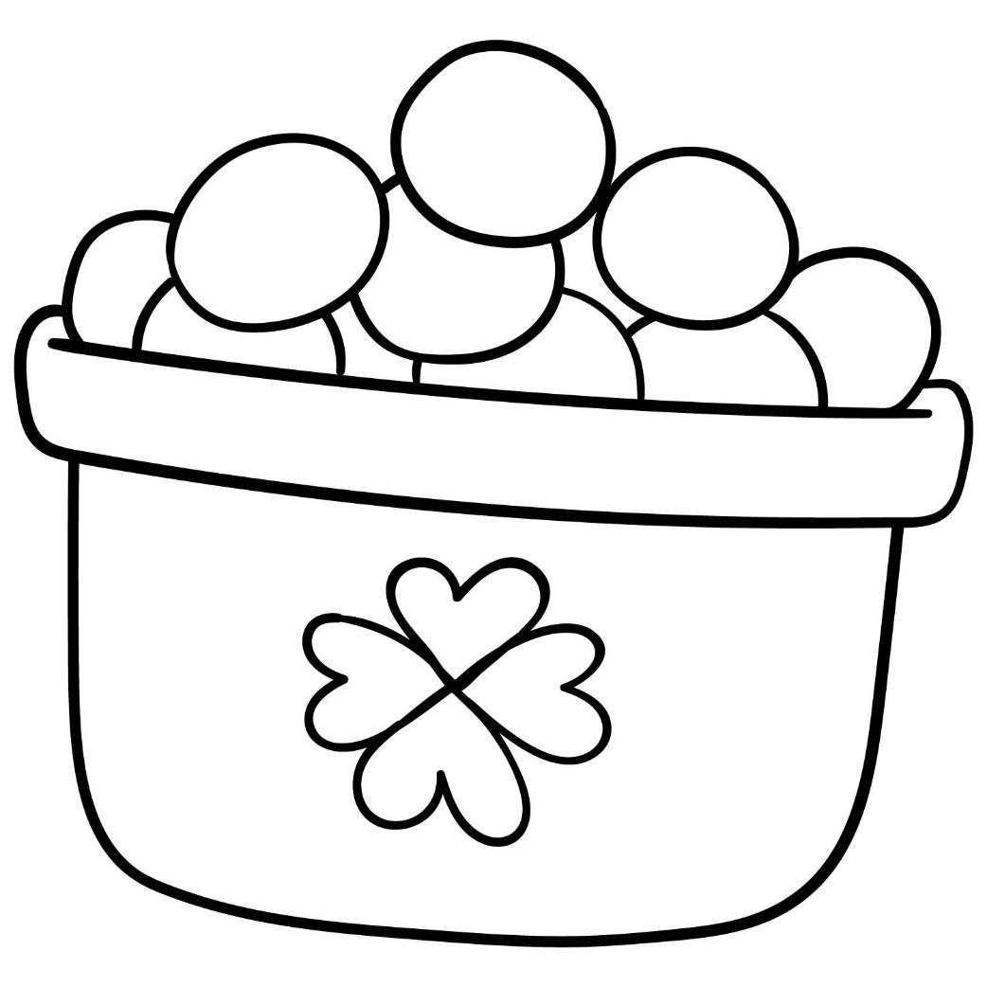

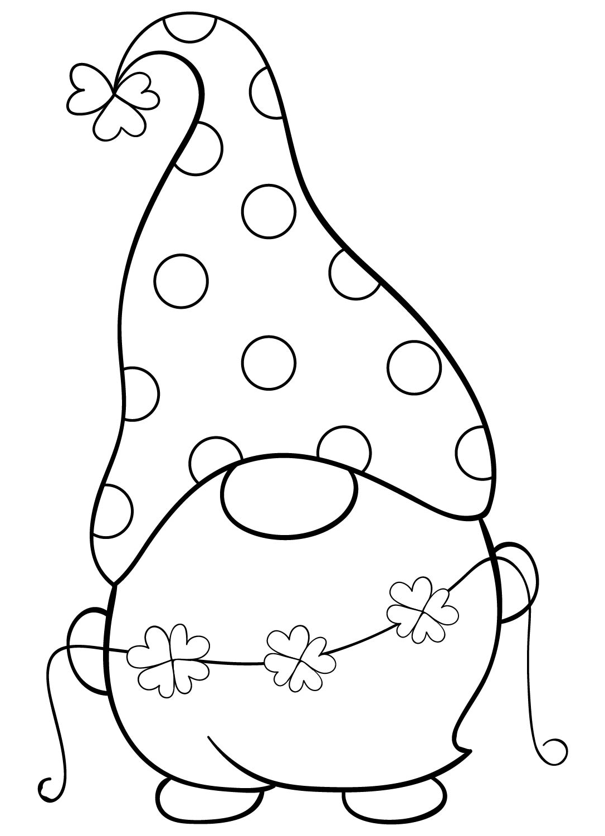

St. Patrick’s Day Memos
Cut out these memo cards and write lucky messages on them to give to those you love or place about the house.

Irish Proverbs and Their Meanings

If you are looking for a friend without a fault you will be without a friend forever – nobody’s perfect!

A lamb’s bleat is often more telling than a dog’s bark – sometimes being subtle works better than being loud and forthright.

You’ve got to do your own growing, no matter how tall your father was – success is never guaranteed.

It’s better to pay the butcher than the doctor – paying good money for good food is better than eating bad food and having poor health as a result.

It’s as easy to catch a cold in a King’s castle as in a shepherd’s hut – everyone is human, wealth is no measure of health.

A good word never broke a tooth – kindness is always returned.

An empty sack does not stand – lying and dishonesty gets you nowhere.

When the apple is ripe, it will fall – what will be will be.

He didn’t lick it off a stone – people’s personalities or actions are always influenced by someone.

You never miss the water until the well has run dry – you don’t appreciate what you have until it’s gone.

The mill may grind slowly, but it grinds finely – slow and steady wins the race.

However long the day, the evening will come – bad times don’t last forever.

You’ll never plough a field by turning it over in your mind – stop thinking and start doing!

You’ll arrive back with one arm as long as the other – Whatever you intend to do is pointless and won’t change anything.

The longest road out is the shortest road home – time and effort always pays off in the end.

A Springtime Mediation

With Spring right around the corner, we’re focusing
on this season’s sense of renewal and personal improvement.
Lie down and allow your body to become very
comfortable. Close your eyes now and begin to pay
attention to how your breath flows in and out of
your body.

Spring is coming soon. Tis new and fresh season
is a good time to make room for new wonderful
things to happen in your life. Remember that you
are growing and changing each day! Every season
brings a new you. Think about how during the
winter months certain fowers disappear only to
come back to life stronger during the spring time.
Imagine yourself now being a flower, ready to
sprout from the flower bulb.

As spring approaches, the rains fall from the
heavens and you soak up the water completely. It
renews you and gently wakes you up. Notice how
you look forward to feeling the beautiful warmth
of the sun once again. Now you break through the
bulb and start to grow into the beautiful, bright,
proud flower that you are becoming.

Tis is much like how it is in life. We choose new
goals or things to strive for, and work towards those
which makes us feel amazing and good each and
every day. We always strive to show the best in ourselves
and to be the best we can possibly be.

Think about something new that you’d like to do or
achieve, or something you’d like to improve upon
in your life right now. What is it that you’d like to be
able to do better? Focus on that for a moment now
and imagine yourself growing and learning and
becoming better at that exact thing.
See yourself being perfect at whatever it is that you
wish to do. See it your mind as already being real
and true.

Feel your heart welling
up because of your achievement. Tis is what you
set your mind to, what you focused on. Because
of your focus and your efort to improve yourself
each and every day and because you BELIEVE IN
YOURSELF, you have made it happen!

Just as a flower comes back stronger each and every
spring, you do too. When you’re ready,
give your body a big stretch and open your eyes

