April
Activity Pack

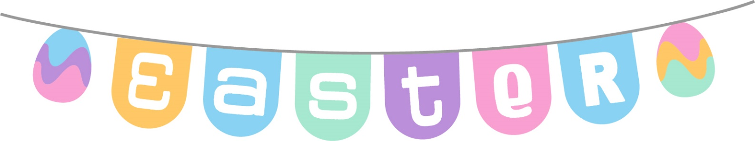

Dear Friends,

What a beautiful stretch we are having in the evenings as Spring turns to Summer and the sun blesses us with longer days.

We have created an Easter themed pack for this month and we also have the second part of a fantastic collaboration with the Irish Museum of Modern Art – “Talking Art with IMMA”.

We look at some old Irish traditions surrounding this time of year and have a variety of activities for you to enjoy. We would love to hear from you if you would like to suggest something, or if you’d like to share your artwork with us and have it featured on our social media. We also welcome poems and stories to be included in the pack if we have any artists or writers out there! Please contact Danielle at danielle.keogh@alzheimer.ie if you’d like to contribute.

So whether attending mass, eating a hot cross bun or going on an easter egg hunt – we hope this April brings you joy.

"The beautiful spring came, and when nature resumes her loveliness, the human soul is apt to revive also."
Harriet Ann Jacobs

Useful Resources:

- Our Free Helpline and Dementia Nurse Support Line are available at:
Phone: 1800 341 341 and Email: helpline@alzheimer.ie

- Do you know an older person who would like support using their smart phone or tablet?
Age Action Ireland are offering 5 hours free remote tutoring to help people learn to use Apps, email, Zoom, Facetime etc.
Call 01 4756989 or email gettingstarted@ageaction.ie

- We are hosting several Virtual Cafes. They are a place to come together, share a cuppa and listen to our amazing guest speakers. For information on how to attend visit: https://alzheimer.ie/service/alzheimer-cafe/

- The ASI also have a huge library of factsheets and resources available on: https://alzheimer.ie/get-support/resources-and-factsheets/

- M4D Radio is a 24/7 online radio station with songs specifically picked to evoke memories and aid reminiscence. To find out more and to listen, please visit: https://m4dradio.com/

- The BBC have curated a remarkable online archive of videos, images and audio clips to aid reminiscence and covers a wide variety of subject matter. Please visit: https://remarc.bbcrewind.co.uk/ to check it out.

- Emergency Response Numbers: 999 or 112

- HSE 24/7 Your Mental Health Information Helpline: 1800 111 888

Table of Contents

Activity | Pages
Spot the Difference | 5-6
Easter Wordsearch | 7
April Wordsearch | 8
I-Spy and Counting | 9
Irish Proverbs | 10-11
Easter Gift Tags | 12
Carrickfergus Lyrics | 13
Cliffs of Dooneen | 14
Morning Has Broken | 15
Pictures to Colour | 16-21
Old Irish Stories and Folklore | 22-23
I Wish You Joy | 24
Nine Little Goslings Poem | 25-26
Talking Art with IMMA | 27-29
Practising Gratitude | 30

Spot the Difference
See if you can see the 5 differences between these two pictures

Spot the Difference
See if you can see the 5 differences between these two pictures

Easter Wordsearch
B | L | A | M | B | T | K | K | W | Z | O | B | X | I | A
D | G | D | W | C | H | W | U | S | U | J | P | B | S | M
V | M | V | A | C | U | N | N | X | D | Z | T | V | A | C
Z | H | Y | W | Q | N | Q | U | U | Q | O | E | L | P | A
P | B | P | U | U | T | C | C | B | I | E | C | E | R | T
A | O | P | V | F | X | O | M | C | Y | G | P | A | A | T
R | P | T | I | I | P | L | L | H | U | G | O | S | Y | L
A | X | T | R | D | T | O | M | O | U | R | Q | T | E | G
D | E | K | Y | M | X | U | S | C | P | P | X | E | R | S
E | P | Z | C | F | E | R | U | O | B | L | Z | R | U | Y
J | M | H | H | H | O | E | P | L | D | M | B | G | T | X
Z | F | I | U | V | K | M | A | A | D | D | U | X | K | H
O | L | U | R | T | V | X | I | T | N | E | N | O | T | C
K | H | X | C | B | O | N | N | E | T | D | N | Z | V | N
W | F | G | H | Y | M | F | T | P | S | E | Y | Q | T | O

BONNET BUNNY
CHOCOLATE CHURCH
COLOUR EASTER
EGG HUNT
LAMB PAINT
PARADE PRAYER

April Wordsearch
A | W | K | N | J | F | L | H | E | X | I | T | X | J | Z
S | L | C | A | G | V | D | S | H | O | W | E | R | S | W
I | L | B | X | N | Y | E | A | S | T | E | R | I | S | R
O | C | D | S | P | R | I | N | G | G | D | N | Z | K | A
Q | H | A | G | R | A | S | S | D | R | P | O | G | K | B
A | I | F | G | I | M | V | S | S | D | A | R | L | F | B
L | C | F | M | Y | C | A | W | U | T | M | A | G | G | I
A | K | O | D | A | K | B | T | N | D | O | I | T | M | T
W | S | D | N | O | Q | R | X | D | E | P | N | Y | B | R
N | A | I | X | J | F | E | I | A | P | J | B | A | T | B
M | P | L | B | W | K | E | Q | Y | W | S | O | P | S | Z
O | J | S | Z | L | G | Z | I | D | E | U | W | R | Y | M
W | M | X | W | C | T | E | Q | Y | V | U | D | I | W | M
E | M | L | A | M | B | X | K | B | A | H | V | L | L | O
R | E | N | V | L | F | I | S | K | Z | E | L | Z | X | F

APRIL BREEZE
CHICKS DAFFODILS
EASTER GRASS
LAMB LAWNMOWER
RABBIT RAINBOW
SHOWERS SPRING
SUNDAY

I-Spy and Counting
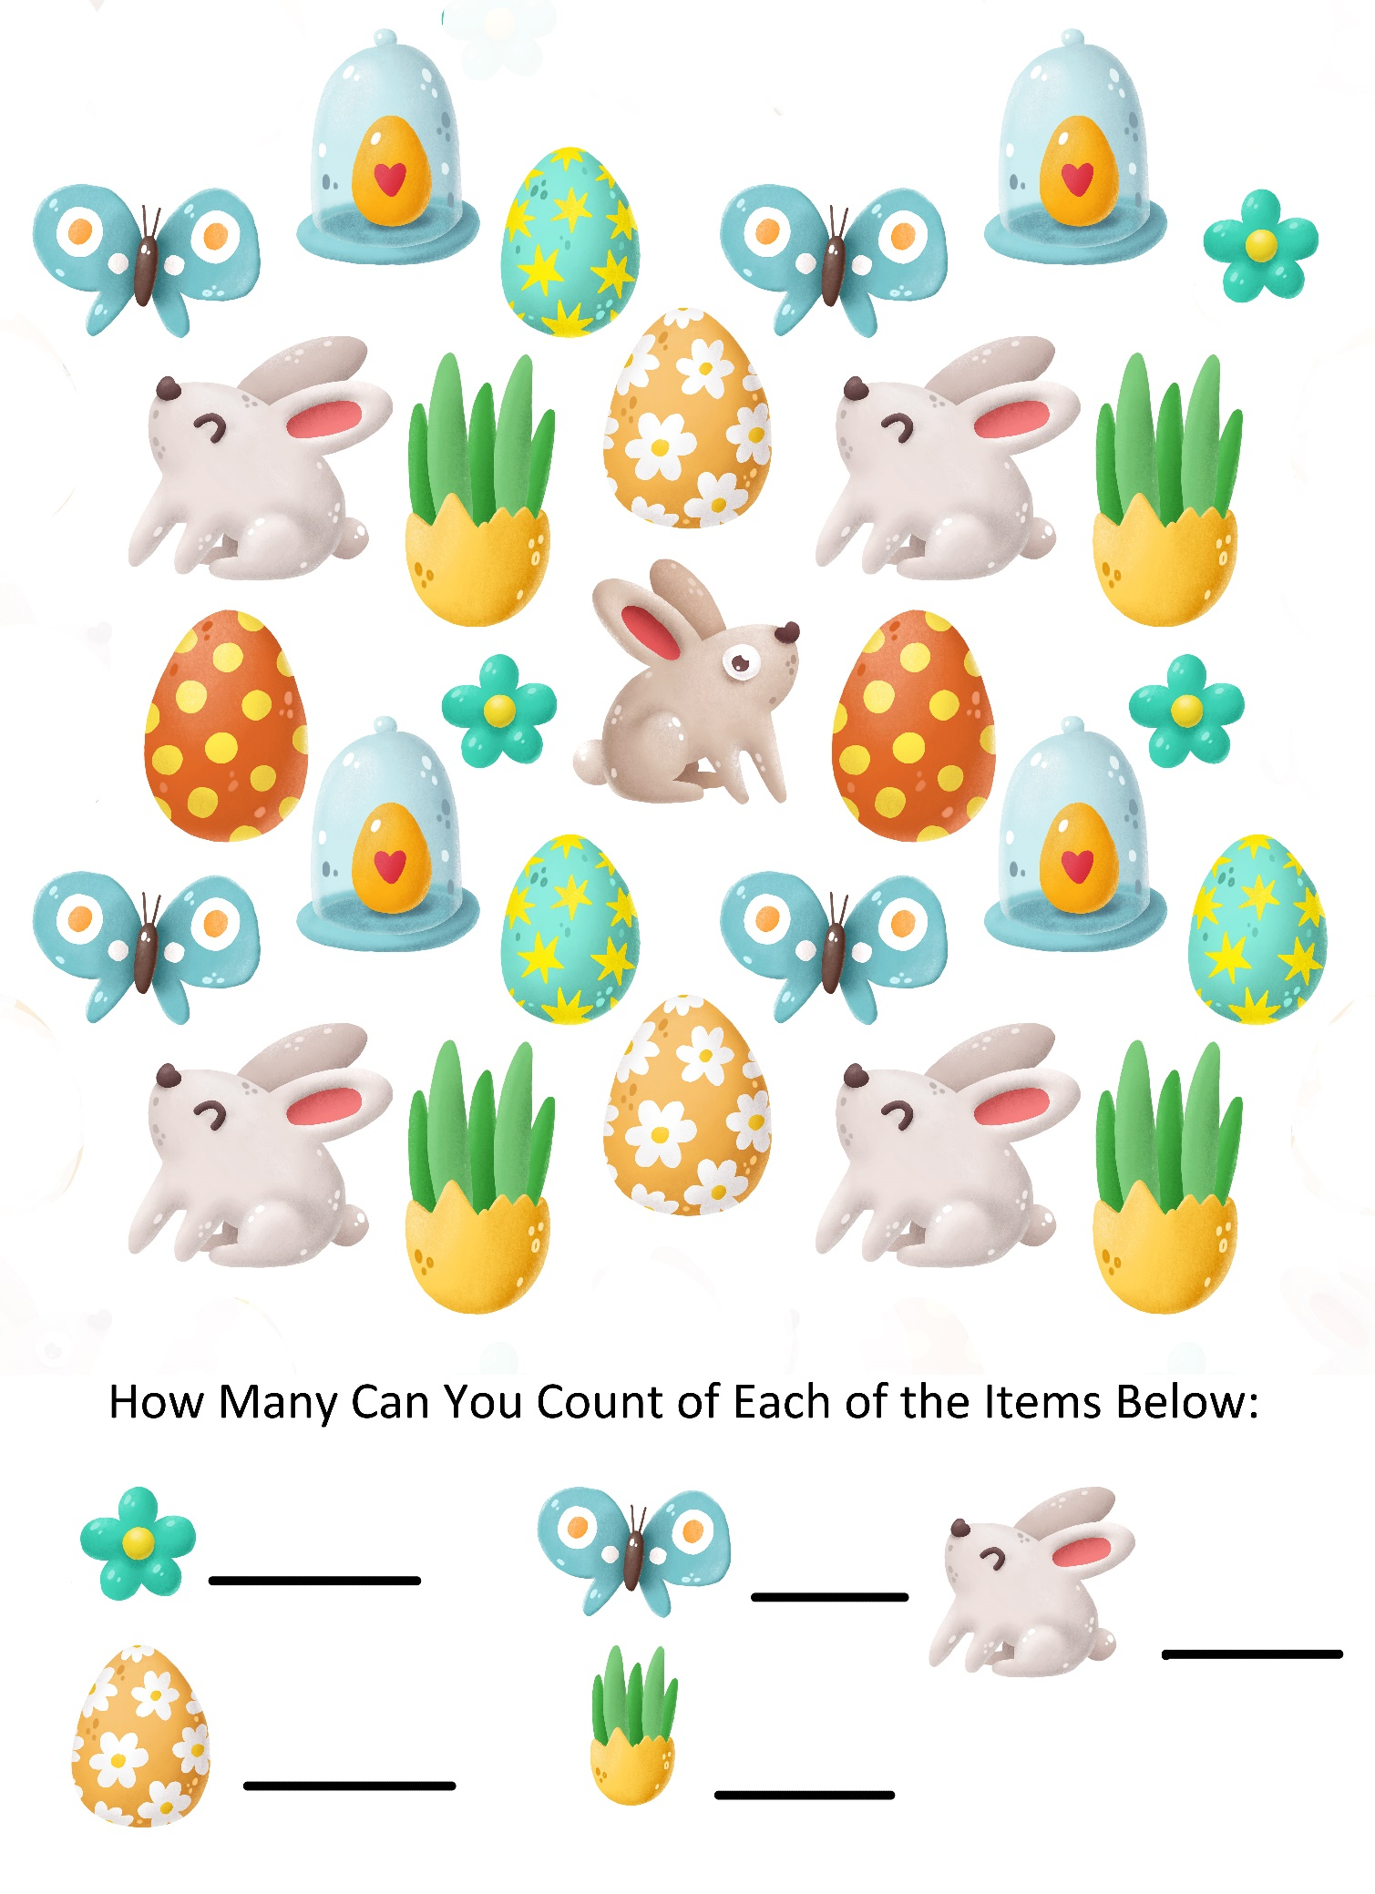
Irish Proverbs and Their Meanings

- Don’t fear an ill wind if your haystacks are tied down – There is no need to worry about things if you’re properly prepared.

- The skin of the old sheep is on the rafter no sooner than the skin of the young sheep – nobody is immune to death or bad health no matter what their age.

- It takes time to build castles – hard work and planning will reap rewards eventually.

- A man’s mouth often breaks his nose – if you talk too much you can get in trouble.

- The older the fiddle the sweeter the tune – things improve with age.

- There’s no use boiling your cabbage twice – once something is done, there’s no need to revisit it; leave the past behind.

- A friend’s eye is a good mirror – trust your friends’ opinions.

- A good beginning is half the work – getting things started is the hardest part.

- Sunshine always follows rain – good things come after bad things; there is a light at the end of the tunnel.
- Good luck beats early rising – some people are more fortunate than others for no real reason.

- A wren in the hand is better than a crane out of it – a small success is better than a big failure.

- A blind man is no judge of colours – knowledge is not equal to experience.

- God’s help is nearer than the door – don’t run away from your problems.

- A windy day is not a day for thatching – don’t plan for the future in times of uncertainty.

- Every patient is a doctor after his cure – people who solve their own problems think they are experts in everyone else’s.

- You must crack the nuts before you can eat the kernel – success takes hard work.

- Show the fatted calf but not the thing that fattened him – be wary of giving away the secrets to success.

- If you lie down with dogs you’ll rise with fleas – don’t expect to mingle with bad people and not pick up some bad habits yourself.

Easter Gift Tags
At Easter some people like to exchange flowers or Easter Eggs. Here are some Easter Gift Tags for you to use.

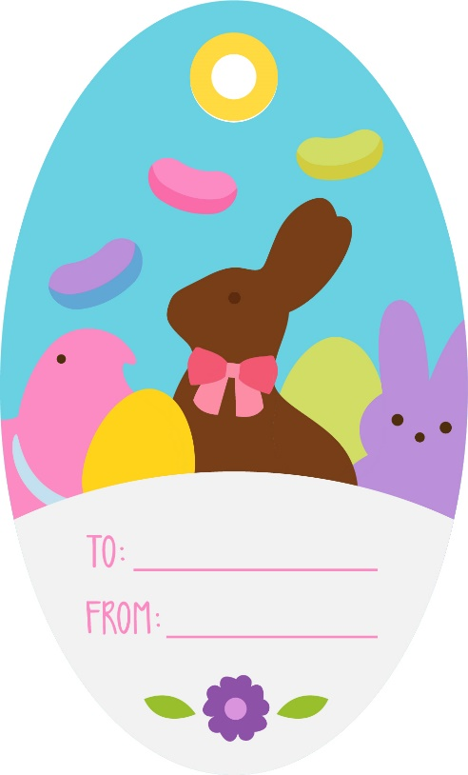
Carrickfergus performed by The Dubliners

I wish I was in Carrickfergus
Only for nights in Ballygrand
I would swim over the deepest ocean
Only for nights in Ballygrand.

But the sea is wide and I cannot swim over
And neither have I the wings to fly
I wish I had a handsome boatsman
To ferry me over my love and I.

My childhood days bring back sad reflections
Of happy times there spent so long ago
My boyhood friends and my own relations
Have all past on now with the melting snow.

So I'll spend my days in this endless roving
Soft is the grass and shore, my bed is free
Oh to be home now in Carrickfergus
On the long rode down to the salty sea.

Now in Kilkenny it is reported
On marble stone there as black as ink
With gold and silver I would support her
But I'll sing no more now til I get a drink.

Cause I'm drunk today and I'm seldom sober
A handsome rover from town to town
Ah but I'm sick now my days are number
Come all me young men and lay me down
Come all me young men and lay me down.
Cliffs of Dooneen by Christy Moore

You may travel far far from your own native home
Far away oer the mountains far away oer the foam
But of all the fine places that I've ever seen,
There's none to compare with The Cliffs of Dooneen.

Take a view over the water fine sights you'll see there
You'll see the high rocky slopes on the West coast of Clare
The towns of Kilrush and Kilkee can be seen
From the high rocky slopes at The Cliffs of Dooneen.

Its a nice place to be on a fine Summer's day
Watching all the wild flowers that ne'er do decay
The hare and lofty pheasant are plain to be seen
Making homes for their young round The Cliffs of Dooneen.

Fare thee well to Dooneen fare thee well for a while
And to all the fine people I'm leaving behind
To the streams and the meadows where late I have been
And the high rocky slopes of The Cliffs of Dooneen.

Morning Has Broken by Cat Stevens

Morning has broken like the first morning
Blackbird has spoken like the first bird
Praise for the singing, praise for the morning
Praise for them springing fresh from the world.

Sweet the rains new fall, sunlit from Heaven
Like the first dewfall on the first grass
Praise for the sweetness of the wet garden
Sprung in completeness where His feet pass.

Mine is the sunlight, mine is the morning
Born of the one light, Eden saw play
Praise with elation, praise every morning
God's recreation of the new day.

Pictures To Colour

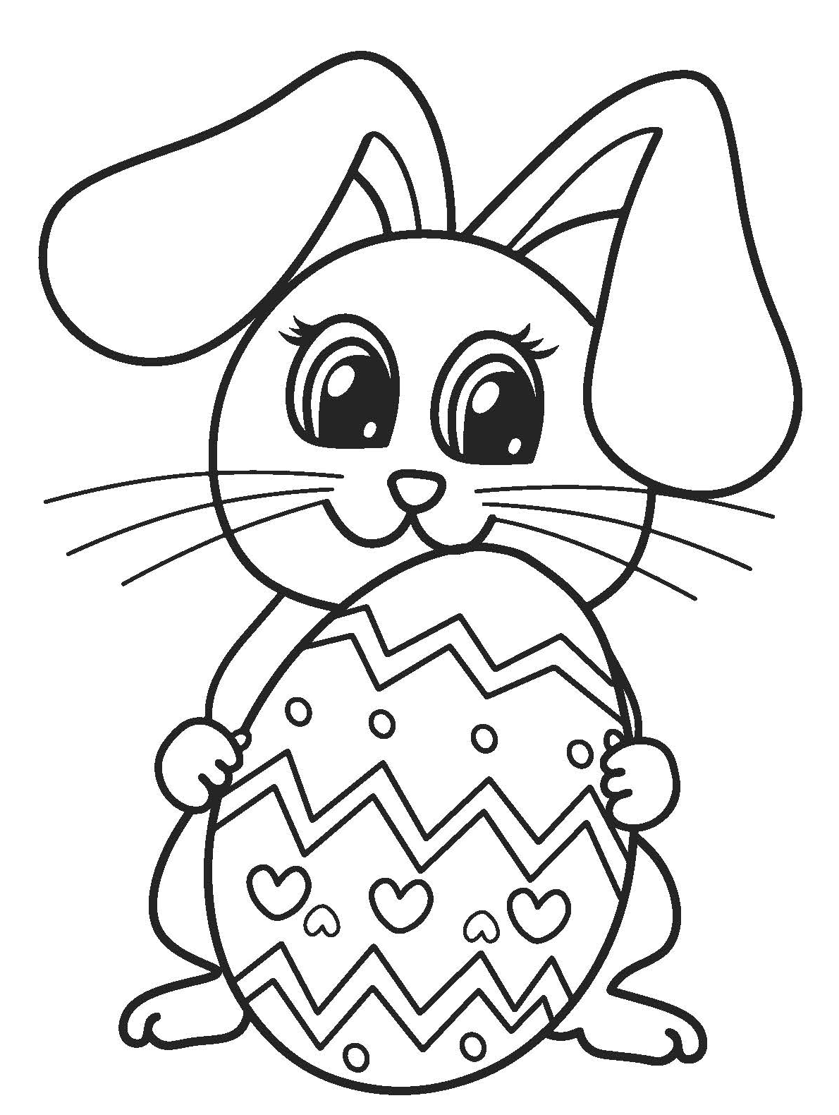

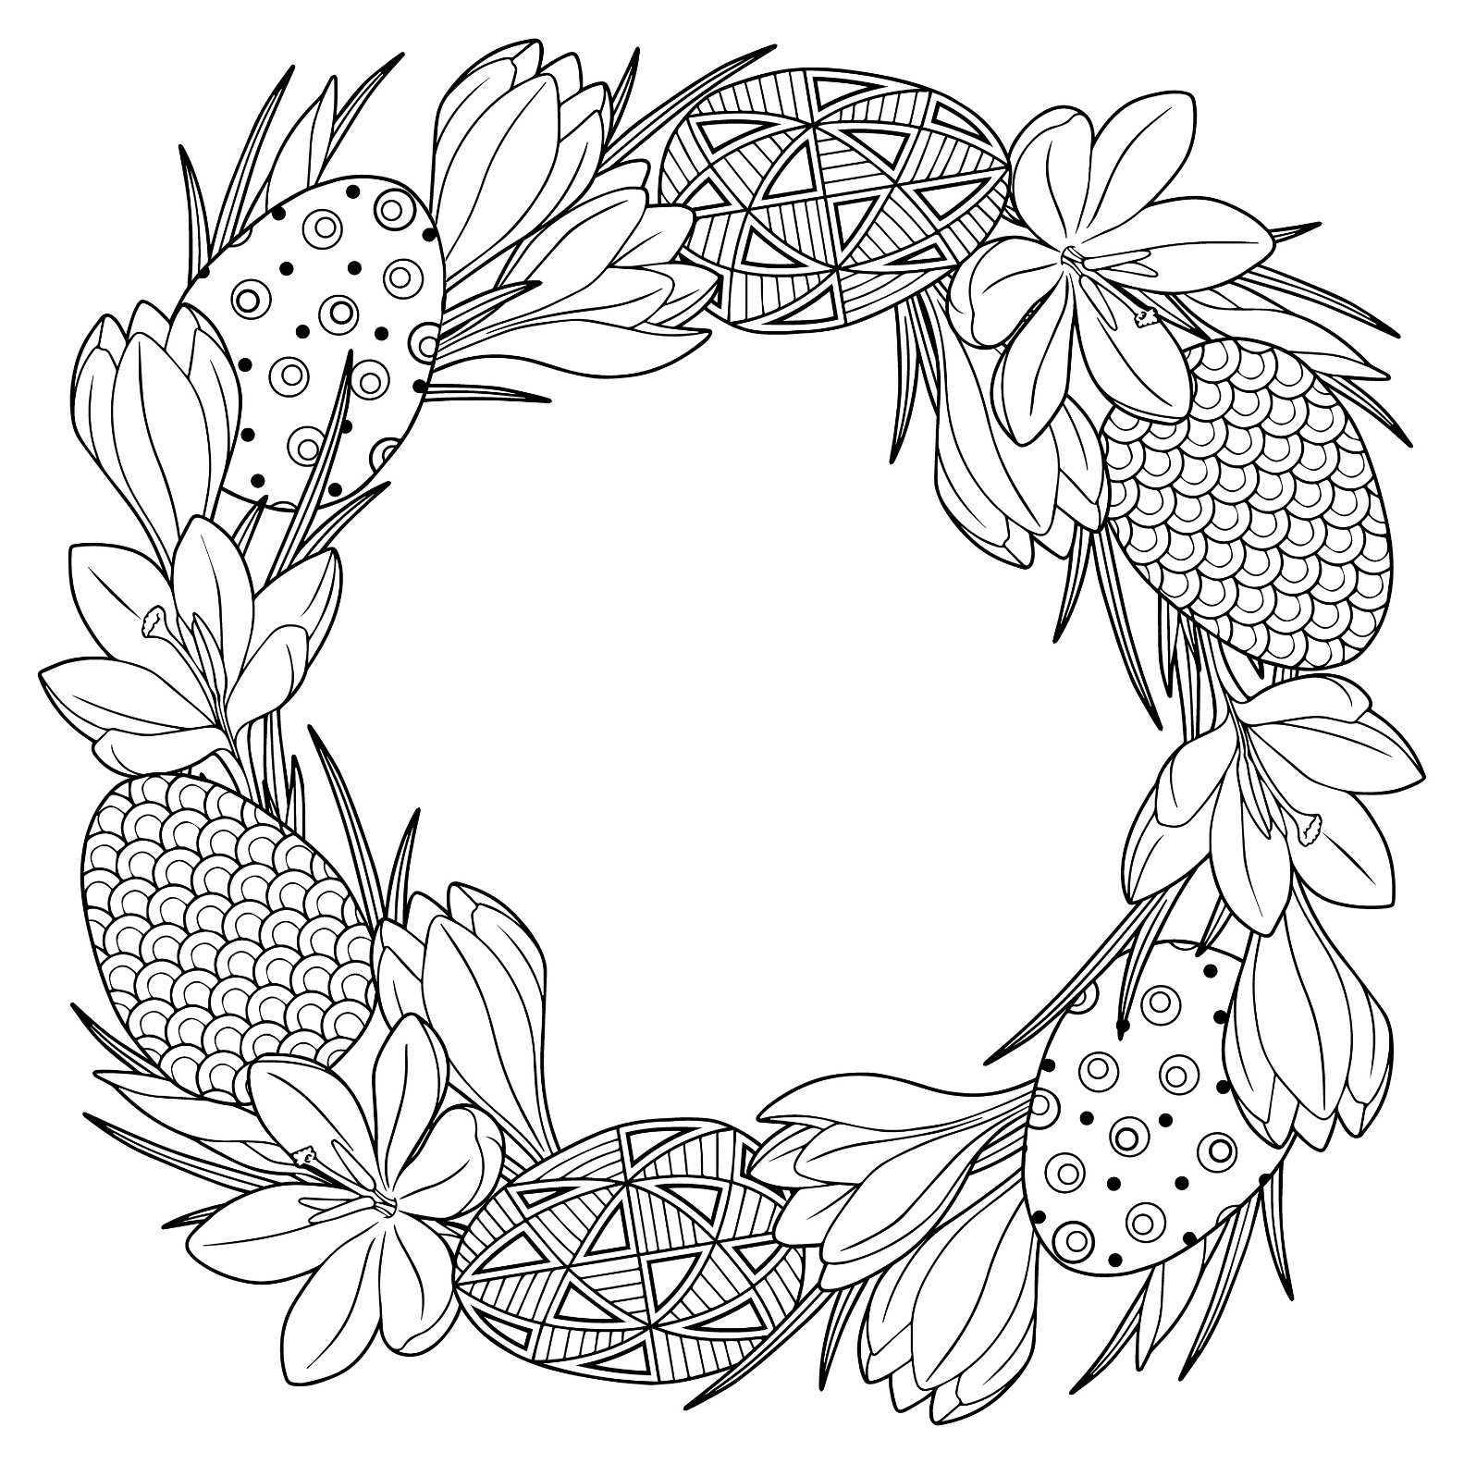

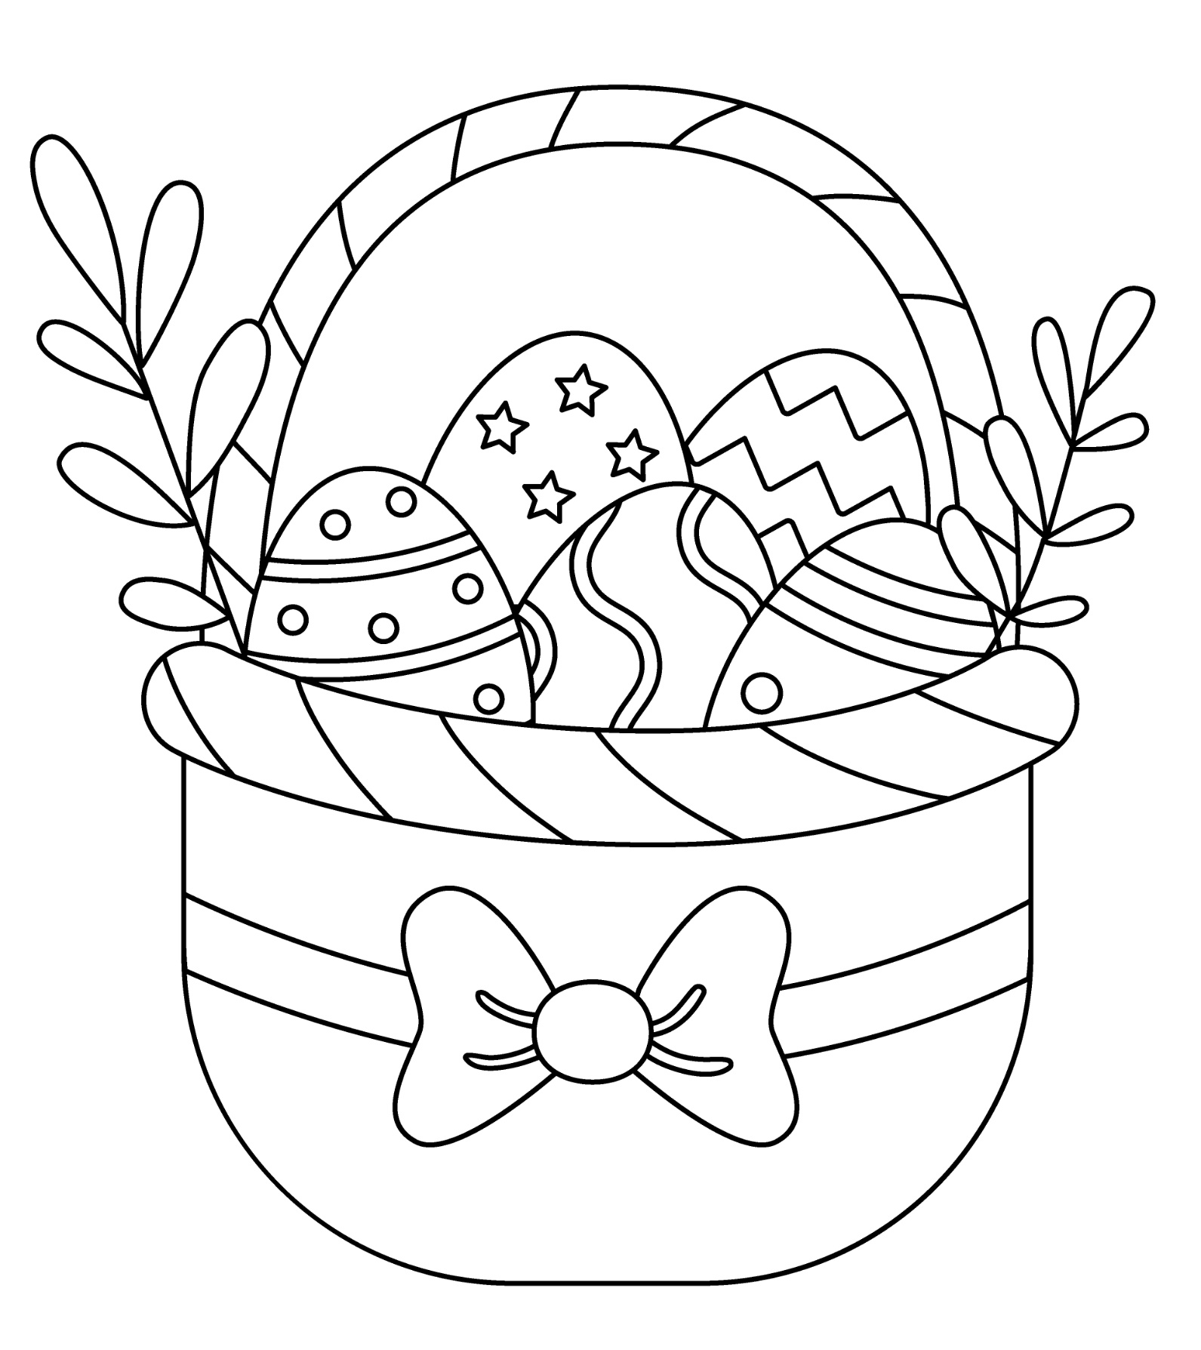

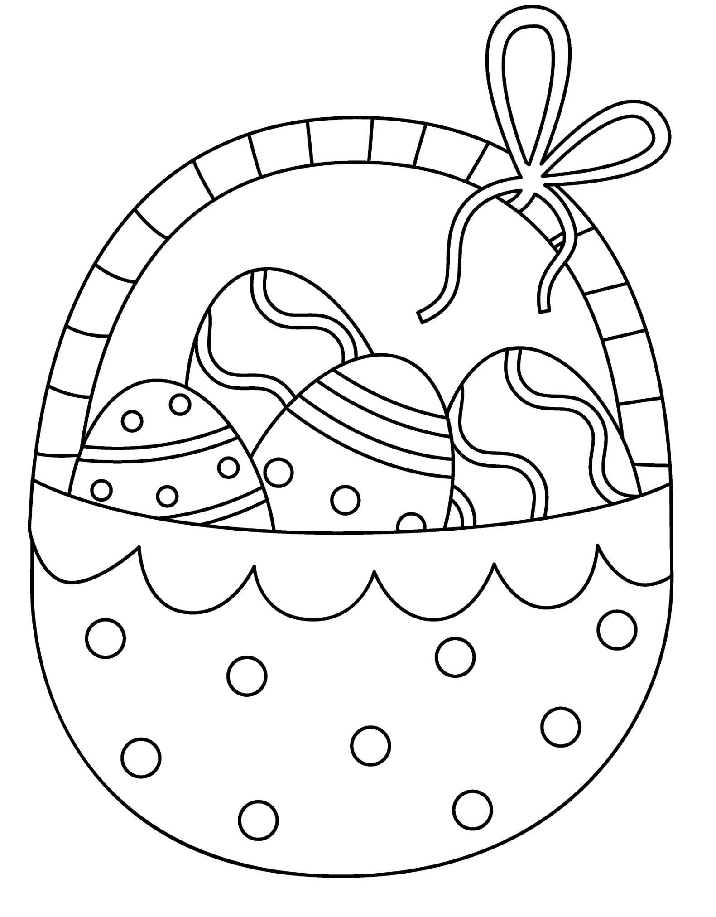

Old Irish Stories and Folklore

Easter Described by Bríghid Ní Ódhra in April 1938
We will have Easter next Sunday. The day before is holy Saturday. The sun dances on Easter Sunday morning and in the evening. We are sure that this Easter will be lovely for the weather is lovely. Easter is celebrated in honour of the death and the resurrection of Our Lord. We are sure that we will get holidays at Easter. The sun dances twice a day with joy for it was on Easter Sunday Our Lord rose from the dead. Easter is the nicest season of the year. Friday will be Good Friday the day Our Lord was crucified. The days are lovely and dry, the sun is lovely and hot. The birds are to be heard singing in the sky morning and evening and many times during the day. Easter will only last two weeks. Easter Sunday everyone will get two eggs in the morning. Easter will have two bank holidays, Friday and Monday.

Old Irish Easter Folklore
Taking three sups of Easter water in name of Holy Trinity.
Easter water sprinkled in house and fields on May Eve.
Drop of Easter water put in first mash of bran given to a cow after calving.
Hair burned from cows udder with blessed candle when first milked after calving.
Easter water put into first churn, into "sciollain". Kept in house for seven years and there is then a cure in it.

Easter Customs in Ireland 1938 by Bridget Claire, Co. Cavan.
There are still some Easter Customs left in this district.
On Easter Sunday morning most people eat two eggs for their breakfast. On that evening children gather together and light a fire outside in the fields. This fire is called cludog. Another custom is that a few days before easter the poor people send their children around through the country gathering eggs for easter. This fire is lighted in honour of Saint Patrick lighting his fire on the hill of slain on Easter Saturday. Also the lighting of the fire on Easter Sunday is held in honour of our Lord from the dead,.
Easter always comes in April or May. It is a great feast day in all countries. On the night before easter several of the people do not go to bed the way they would be able to see the sun and moon dancing.

April Traditions of Yesteryear from Philomena Tighe
Children make a picnic every Easter Sunday round here. They usually make it on a hill or in a liss. Long ago they used to be beating one another out in eating the most eggs at this picnic. Children from about 5 years to seventeen or eighteen years used to go to it. The first of April is called "April Fool Day" in this district because people make April fools of one another. If someone said to a person that there were a lot of parcels in a room for her, and if she did not think of the first of April and she to go to the room and no parcels in it, the other person would say "April fool go to school and kiss the leg of the black stool." Children and grown-up people cod one another for fun. Children make a May-bush on the last day of April for the first of May round here.
I Wish You Joy

Joy in the Springtime,
when life is young and the heart is beating high;
joy in growth, joy in endeavour, joy in expectation.
May the shine of the morning sun be in your smile,
may the sound of the April wind blow through your laughter,
May the fragrance of the first flowers make sacred all your friendships,
may leaf and bud and blossom,
blue sky and golden sun,
combine to make your Springtime a harmony of days.

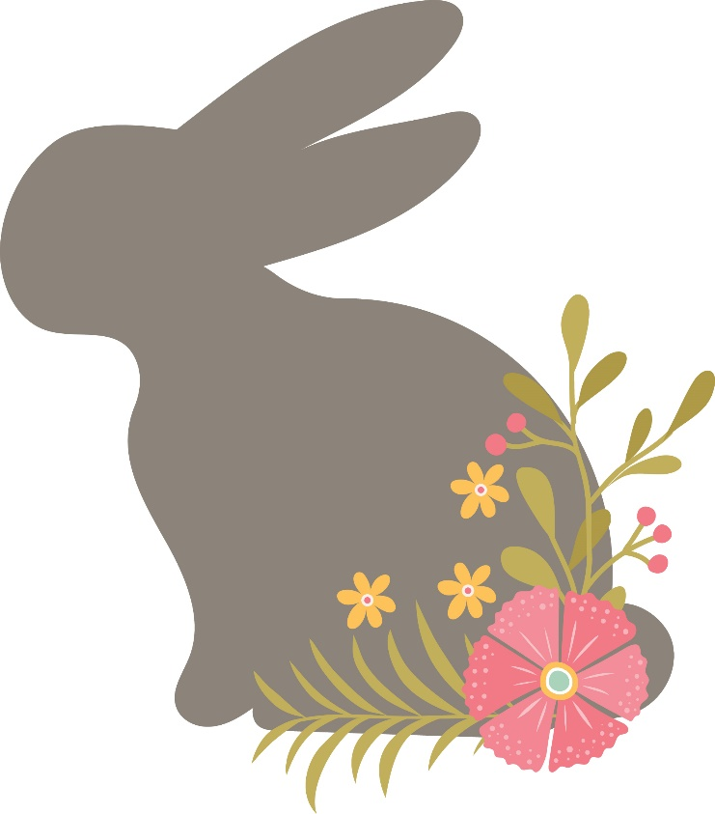

Nine Little Goslings by Susan Coolidge

When nursery lamps are veiled, and nurse is singing
In accents low,
Timing her music to the cradle's swinging,
Now fast, now slow,—

Singing of Baby Bunting, soft and furry
In rabbit cloak,
Or rock-a-byed amid the toss and flurry
Of wind-swept oak;

Of Boy-Blue sleeping with his horn beside him,
Of my son John,
Who went to bed (let all good boys deride him)
With stockings on;

Of sweet Bo-Peep following her lambkins straying;
Of Dames in shoes;
Of cows, considerate, 'mid the Piper's playing,
Which tune to choose;

Of Gotham's wise men bowling o'er the billow,
Or him, less wise,
Who chose rough bramble-bushes for a pillow,
And scratched his eyes,—

It may be, while she sings, that through the portal
Soft footsteps glide,
And, all invisible to grown-up mortal,
At cradle side

Sits Mother Goose herself, the dear old mother,
And rocks and croons,
In tones which Baby hearkens, but no other,
Her old-new tunes!

I think it must be so, else why, years after,
Do we retrace
And mix with shadowy, recollected laughter
Thoughts of that face;

Seen, yet unseen, beaming across the ages,
Brim-full of fun
And wit and wisdom, baffling all the sages
Under the sun?

A grown-up child has place still, which no other
May dare refuse;
I, grown up, bring this offering to our Mother,
To Mother Goose;

And, standing with the babies at that olden,
Immortal knee,
I seem to feel her smile, benign and golden,
Falling on me.
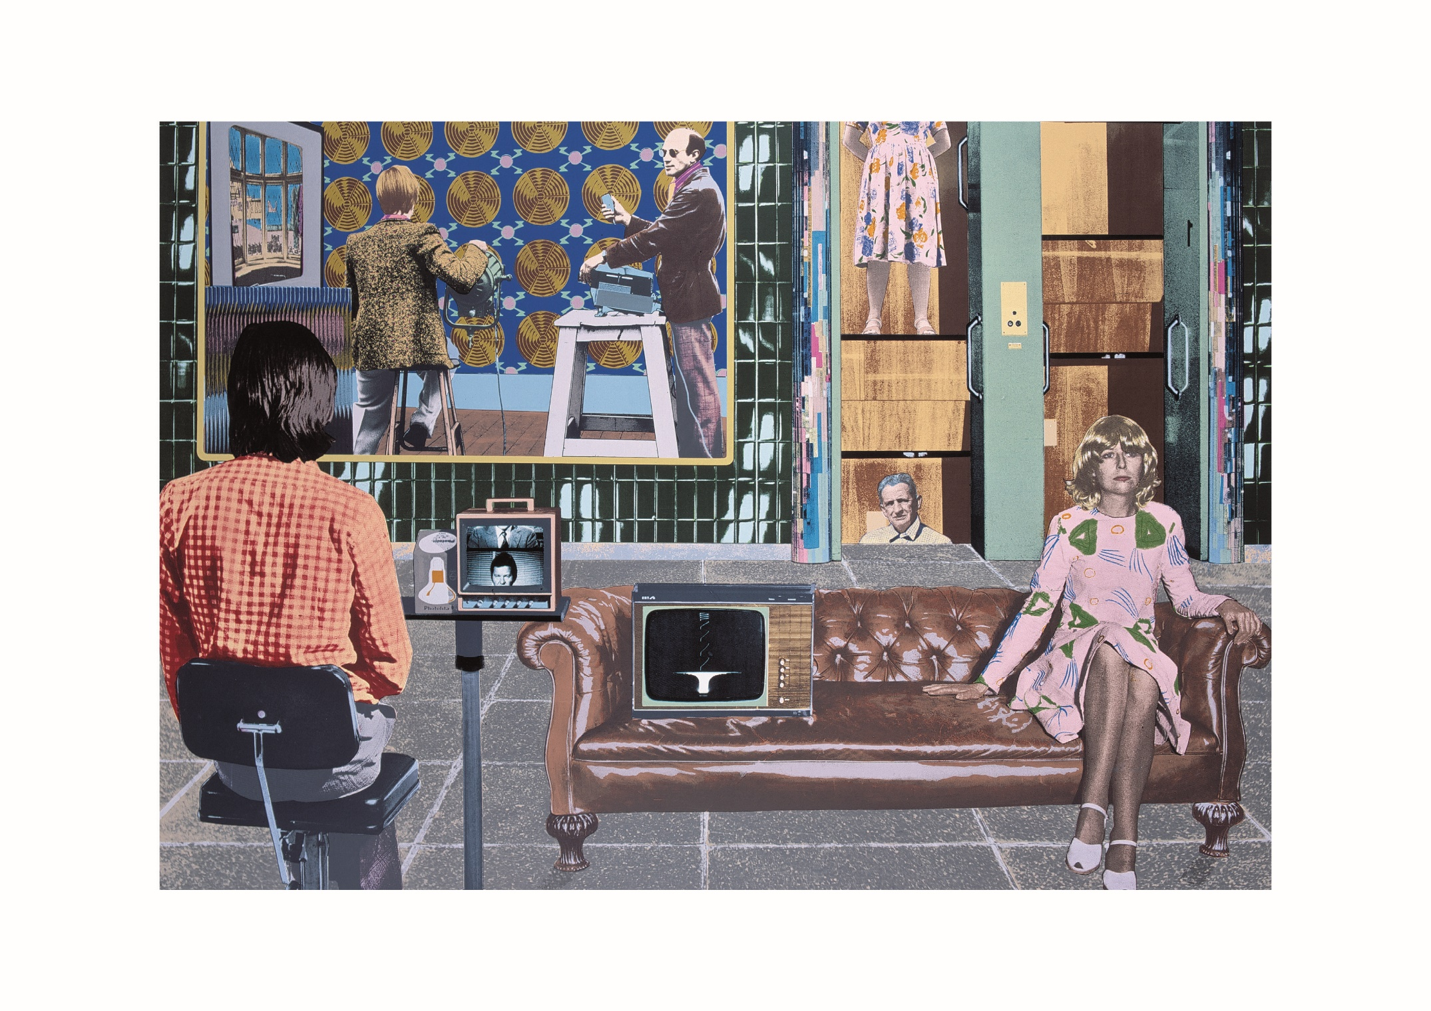
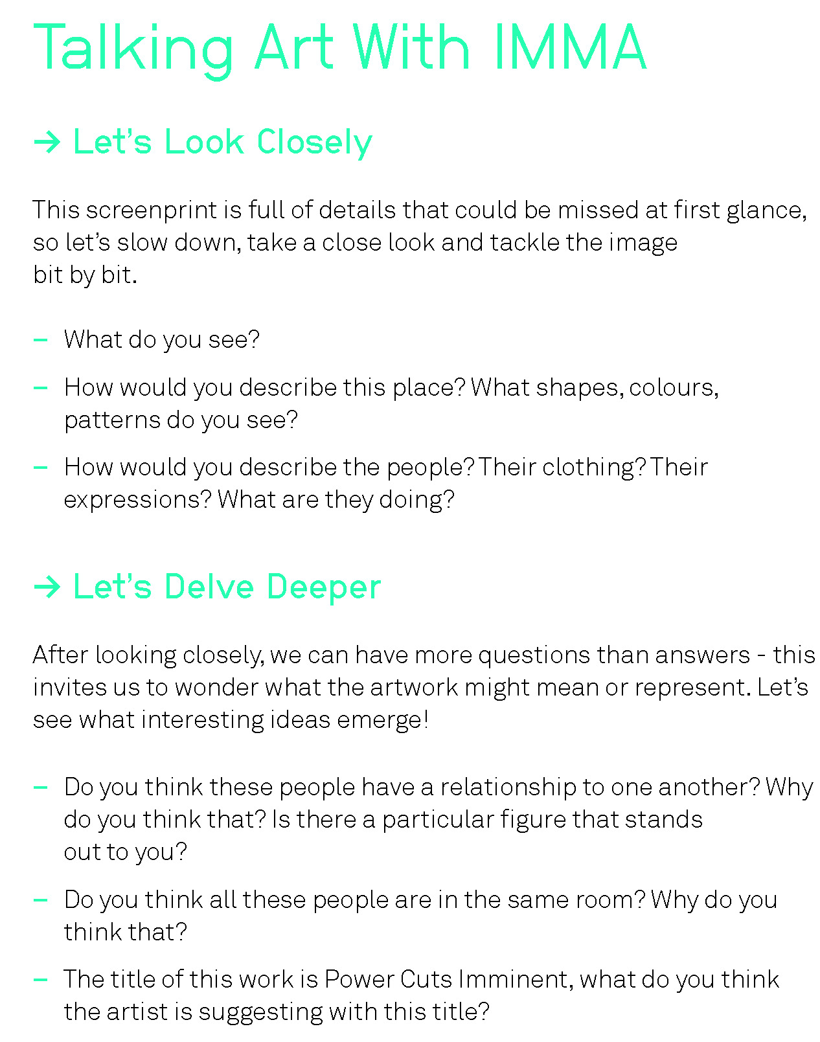

Practising Gratitude
It is proven to be beneficial to our mood and health to give thanks each day for 3 things we are grateful to have in our lives. Use the memos below to list things you are grateful for and if it’s someone you care about why not let them know?

