May
Activity Pack

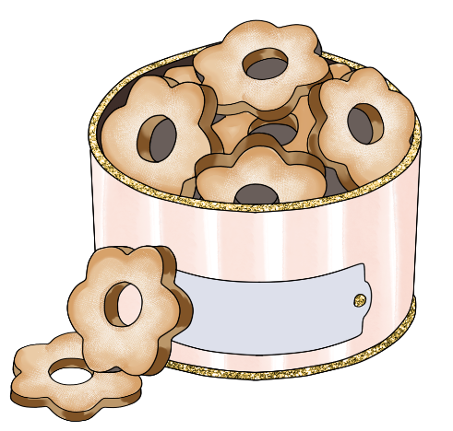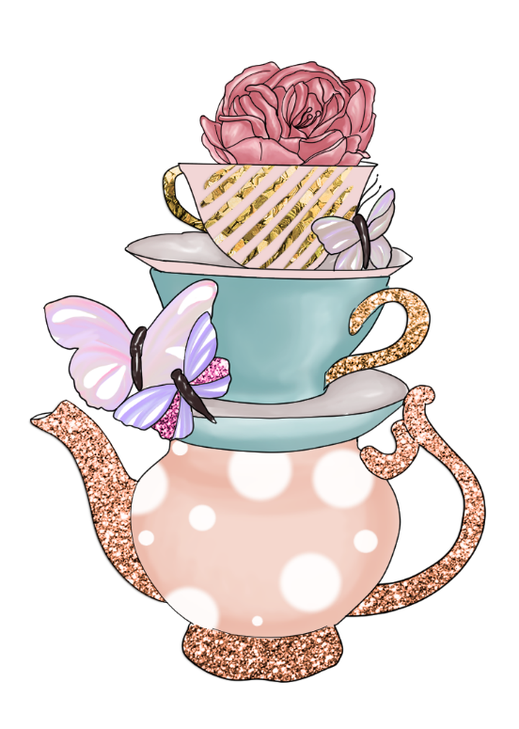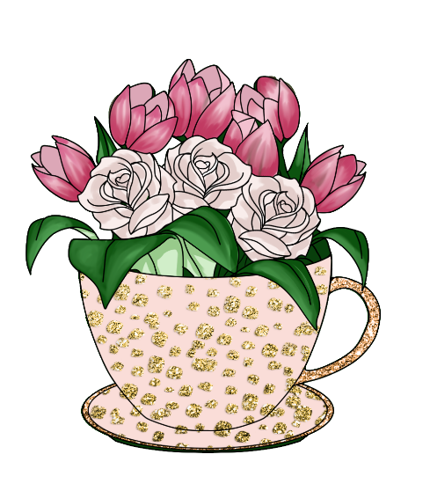

Dear Friends,

We hope you are enjoying the warmer weather and are able to see nature in full bloom.

To celebrate the ASI’s Alzheimer’s Tea Day on May 6th, we have made the theme of this pack “Afternoon Tea”! So we encourage you to pour a cuppa, have something sweet and enjoy all the stories and activities we have inside.
We also have the third part of a fantastic collaboration with the Irish Museum of Modern Art – “Talking Art with IMMA”.

We welcome poems and stories to be included in the pack if we have any artists or writers out there! Or if you’d like your Tea Day artwork from this pack, or photos of any local fundraising events, displayed on our social media please send your images via email to Danielle at danielle.keogh@alzheimer.ie.

“Come and share a pot of tea,
My home is warm and my friendship’s free”
Emilie Barnes

Useful Resources:

- Our Free Helpline and Dementia Nurse Support Line are available at:
Phone: 1800 341 341 and Email: helpline@alzheimer.ie

- Do you know an older person who would like support using their smart phone or tablet?
Age Action Ireland are offering 5 hours free remote tutoring to help people learn to use Apps, email, Zoom, Facetime etc.
Call 01 4756989 or email gettingstarted@ageaction.ie

- We are hosting several Virtual Cafes. They are a place to come together, share a cuppa and listen to our amazing guest speakers. For information on how to attend visit: https://alzheimer.ie/service/alzheimer-cafe/

- The ASI also have a huge library of factsheets and resources available on: https://alzheimer.ie/get-support/resources-and-factsheets/

- M4D Radio is a 24/7 online radio station with songs specifically picked to evoke memories and aid reminiscence. To find out more and to listen, please visit: https://m4dradio.com/

- The BBC have curated a remarkable online archive of videos, images and audio clips to aid reminiscence and covers a wide variety of subject matter. Please visit: https://remarc.bbcrewind.co.uk/ to check it out.

- Emergency Response Numbers: 999 or 112

- HSE 24/7 Your Mental Health Information Helpline: 1800 111 888

Table of Contents

Activity | Pages
Spot The Difference | 5-6
Afternoon Tea Wordsearch | 7
Tea Types Wordsearch | 8
I-Spy and Counting | 9
Irish Proverbs | 10-11
Maze Puzzle | 12
Small and Early Poem | 13
A Loving Recipe for a Perfect Cup of Tea | 14
Tea for Two Lyrics | 15
Pictures to Colour | 16-21
A Tall Tea Tale | 22
A Fairy Tale from Donegal | 23
If I Knew You Were Coming Lyrics | 24
When I Take My Sugar To Tea Lyrics | 25
Talking Art with IMMA | 26-28
Have a Garden Party | 29-30

Spot the Difference
See if you can see the 5 differences between these two pictures

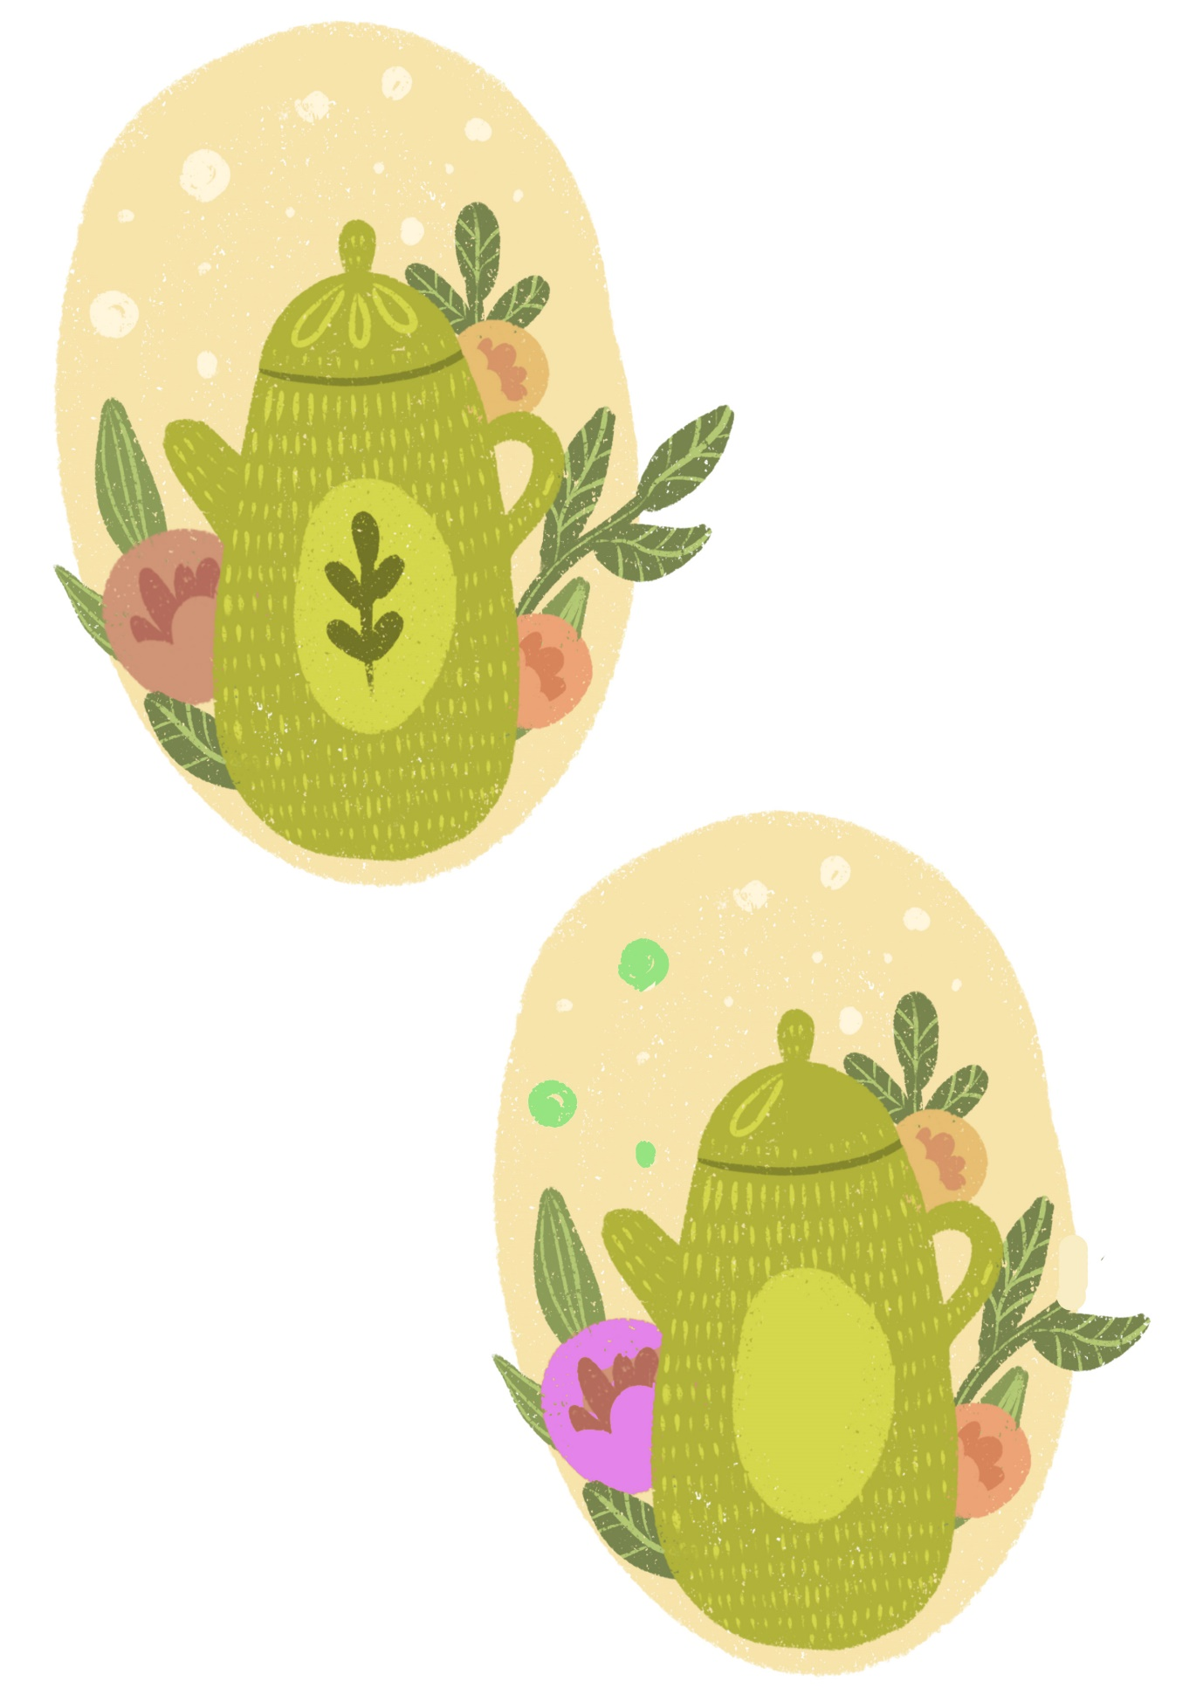
Spot the Difference
See if you can see the 5 differences between these two pictures
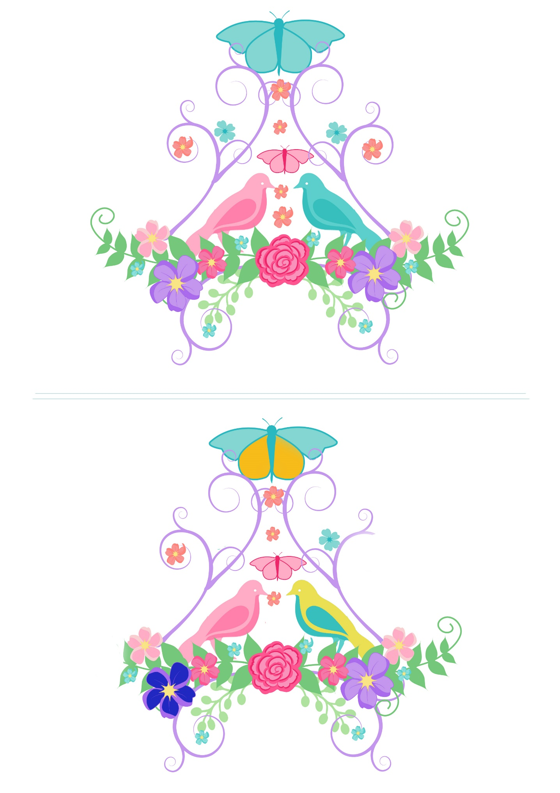
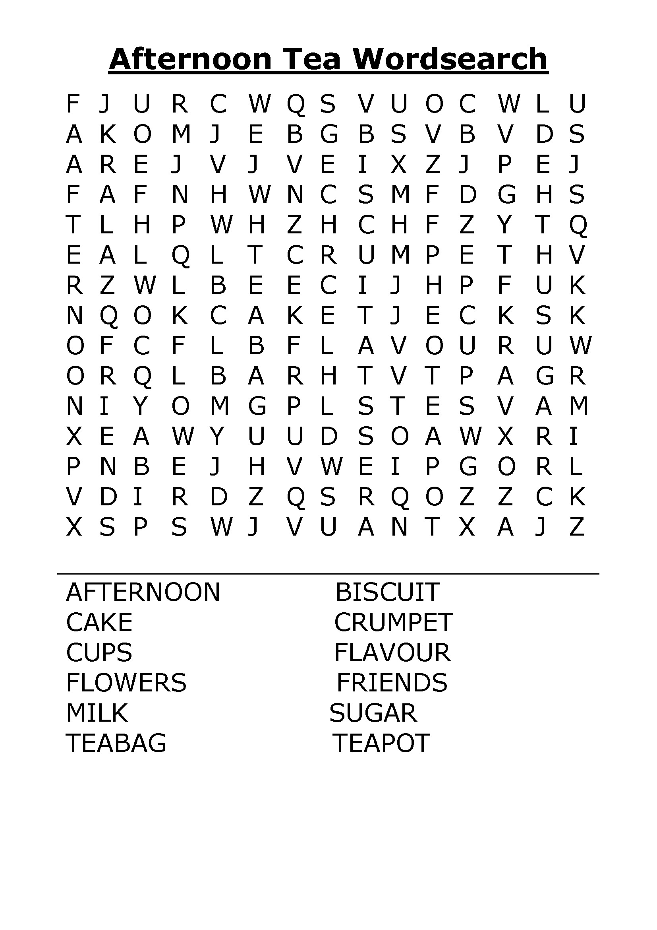
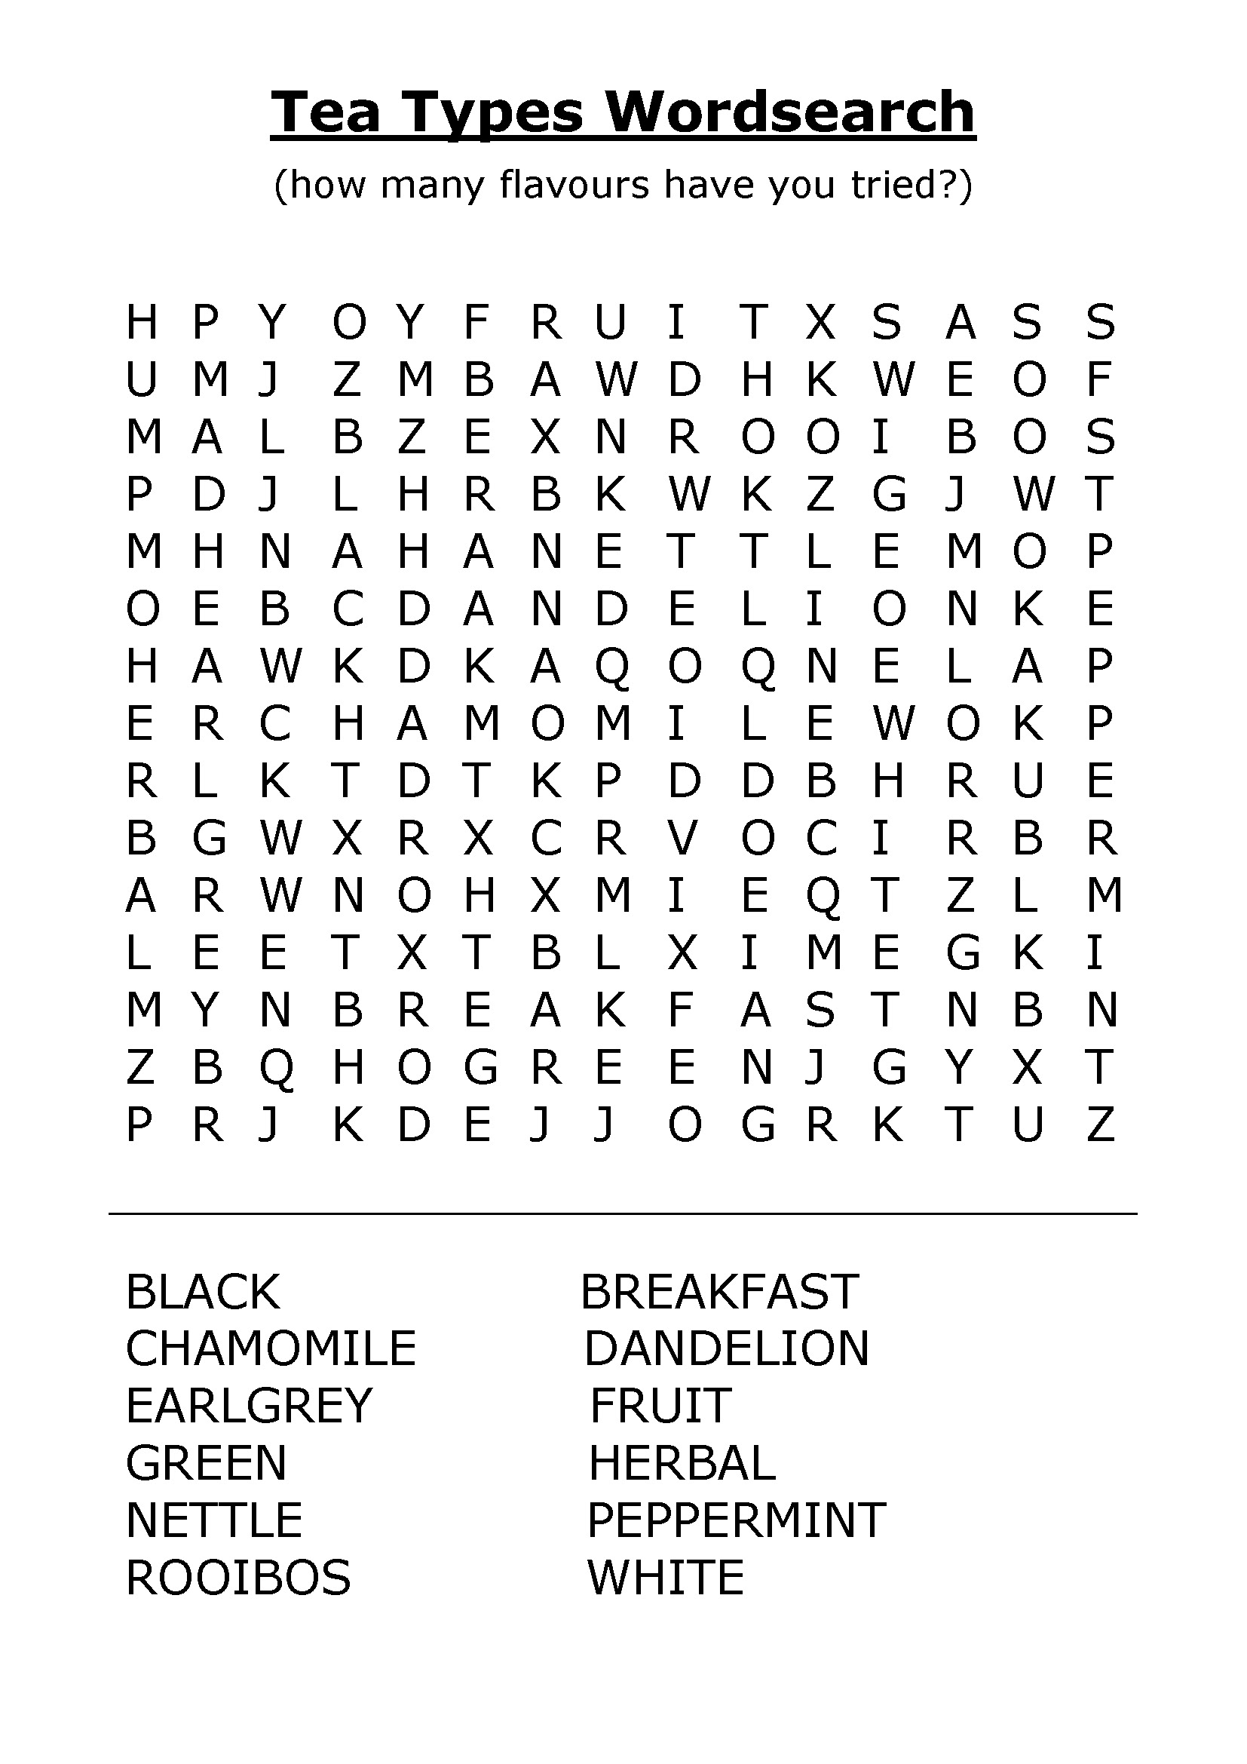
I-Spy and Counting

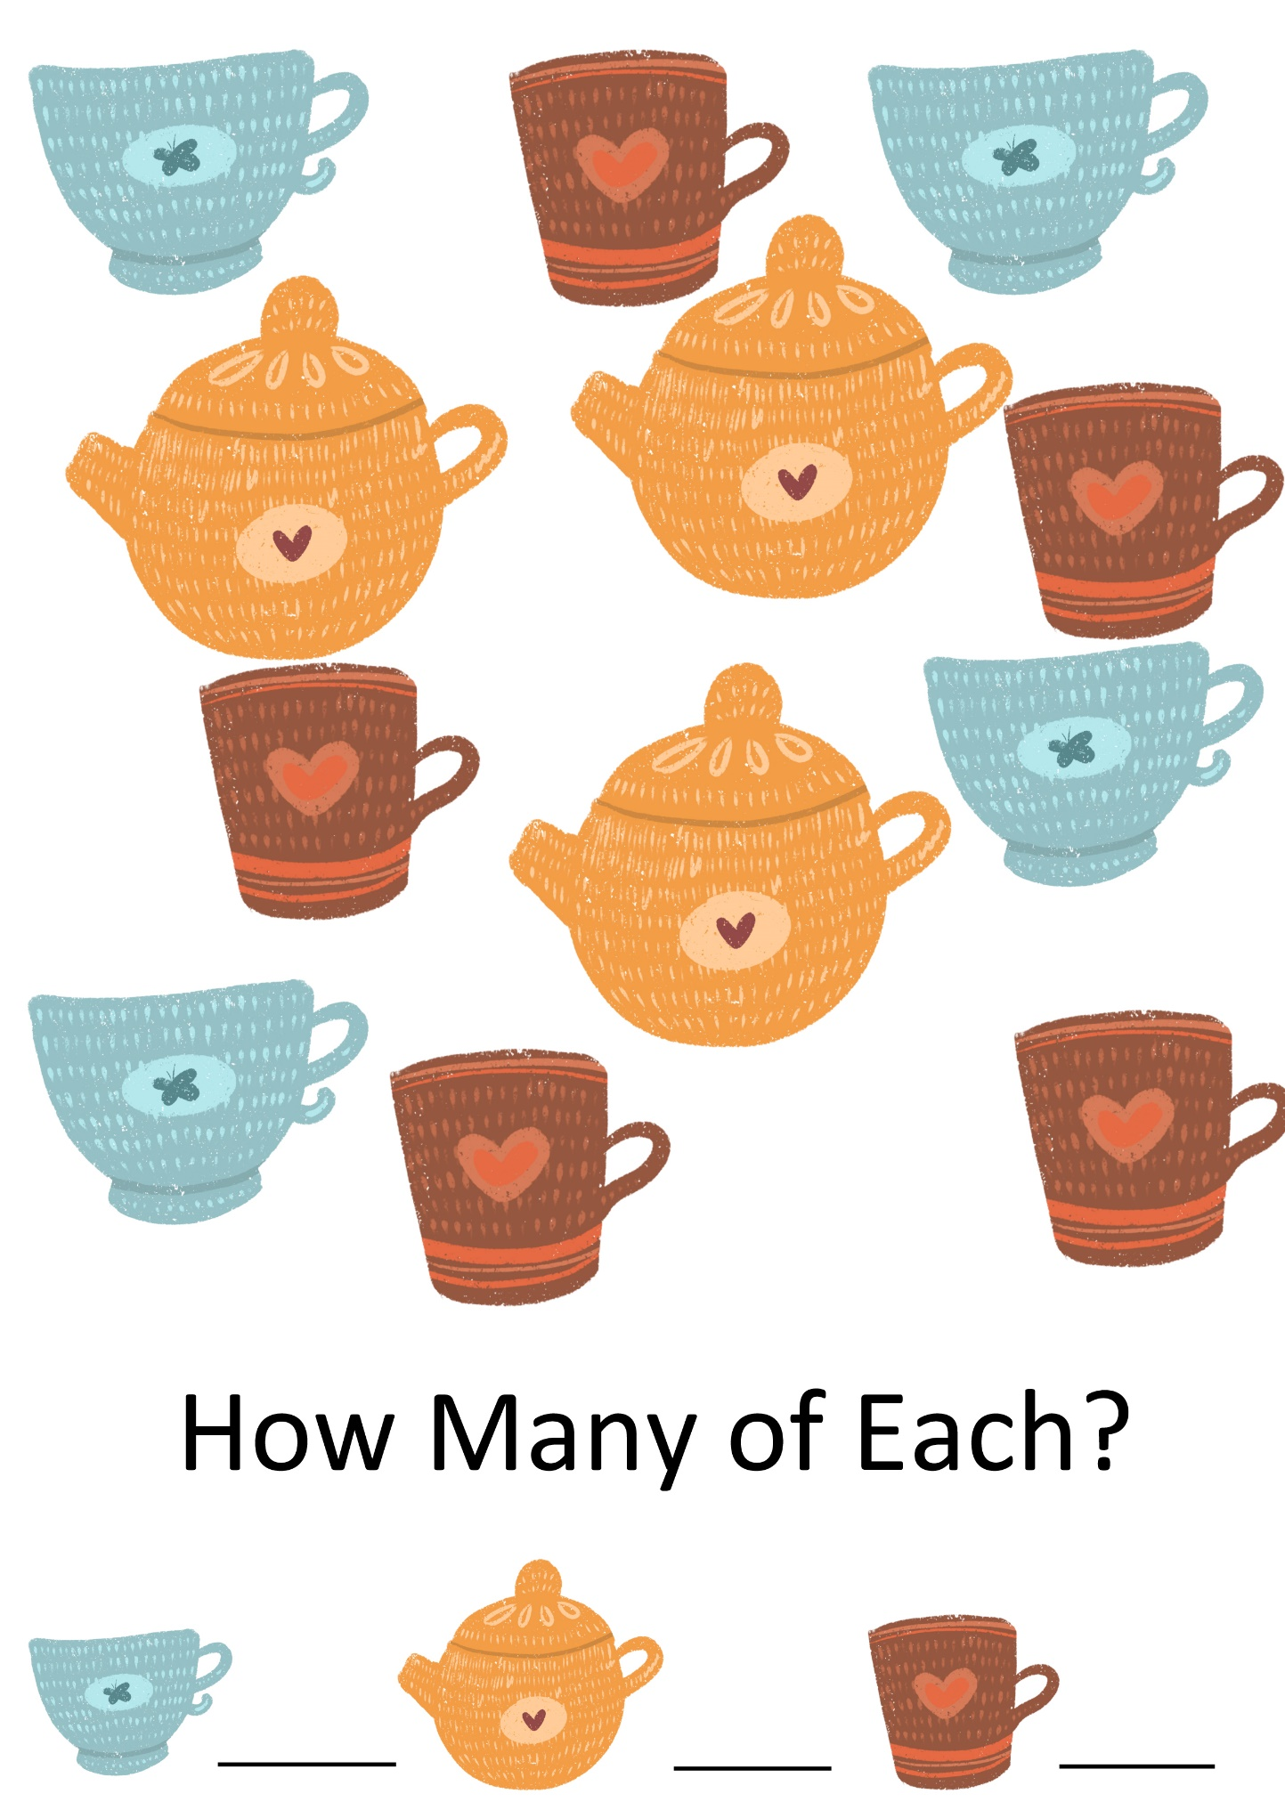
Irish Proverbs and Their Meanings

- An awkward colt often becomes a beautiful horse – everything can be improved.
- A wild goose never reared a tame gosling – children learn by example.
- The best way to keep loyalty in a man’s heart is to keep money in his purse – another self-explanatory one.
- A trout in the pot is better than a salmon in the sea – be thankful for what you have rather than chasing after what you can never get.
- An old broom knows the dirty corners best – wisdom comes with experience.
- Any man can lose his hat in a fairy wind – some things are out of anyone’s control.
- Don’t make little of your dish for it may be an ignorant man who judges it – never undersell yourself.
- The cat is always dignified until the dog comes by – everyone has something or someone that makes them angry.
- Wide is the door of the little cottage – it is often poor people who are most generous.
- Everyone lays a burden on the willing horse – people are quick to take helpful people for granted.
- It is easy to halve the potato where there is love – if you love someone you will share whatever you have without resentment
- Enough and no waste is as good as a feast – Having enough is better than having too much.
- While a person is out, his food goes cold – good things turn bad if left neglected.
- Do not take the thatch from your own roof to buy slates for another man’s house – you can’t help others unless you help yourself first.

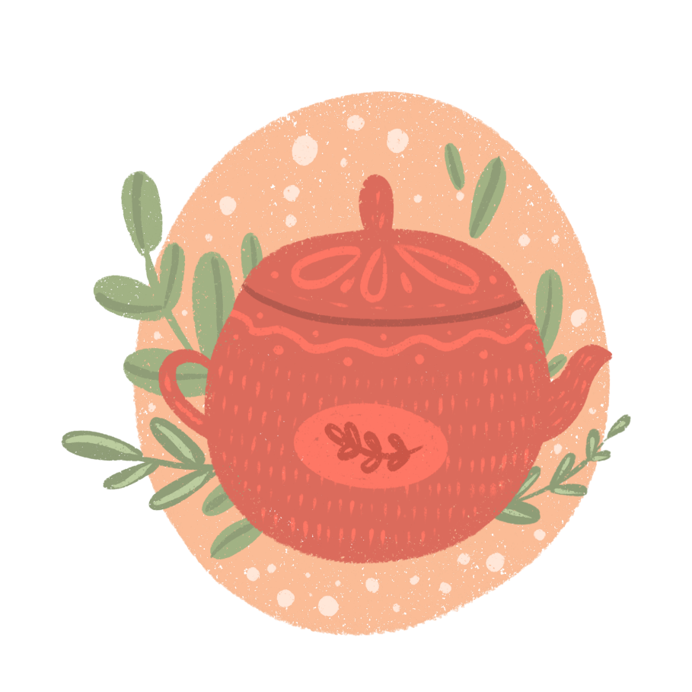

Help the Bird Through The Maze

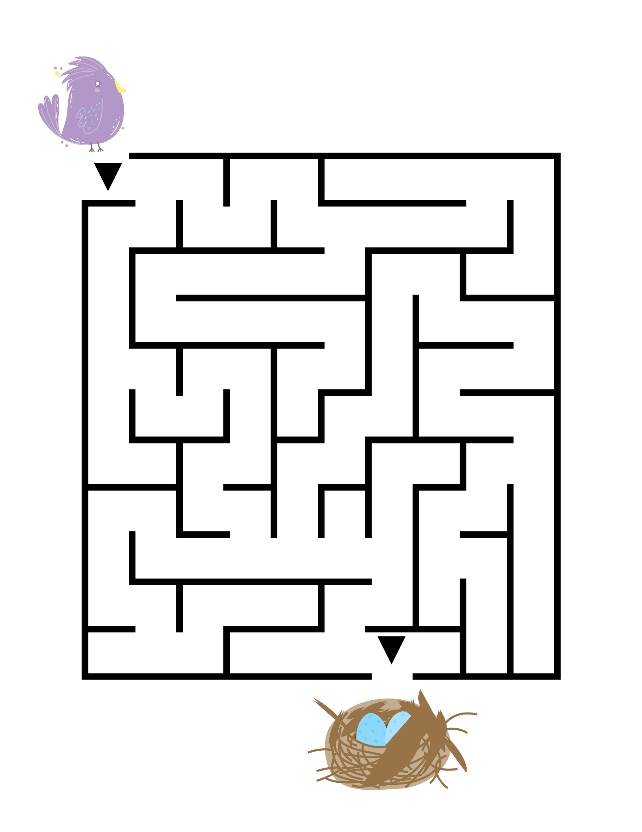
Small and Early by Tudor Jenks

When Dorothy and I took tea, we sat upon the floor;
No matter how much tea I drank, she always gave me more;
Our table was the scarlet box in which her tea-set came;
Our guests, an armless one-eyed doll, a wooden horse gone lame.
She poured out nothing, very fast,—the tea-pot tipped on high,
And in the bowl found sugar lumps unseen by my dull eye.
She added rich (pretended) cream—it seemed a wilful waste,
For though she overflowed the cup, it did not change the taste.

She asked, “Take milk?” or “Sugar?” and though I answered, “No,”
She put them in, and told me that I “must take it so!”
She ’d say “Another cup, Papa?” and I, “No, thank you, Ma’am,”
But then I had to take it—her courtesy was sham.
Still, being neither green, nor black, nor English-breakfast tea,
It did not give her guests the “nerves”—whatever those may be.
Though often I upset my cup, she only minded when
I would mistake the empty cups for those she ’d filled again.

She tasted my cup gingerly, for fear I ’d burn my tongue;
Indeed, she really hurt my pride—she made me feel so young.
I must have drunk some two score cups, and Dorothy sixteen,
Allowing only needful time to pour them, in between.
We stirred with massive pewter spoons, and sipped in courtly ease,
With all the ceremony of the stately Japanese.
At length she put the cups away. “Goodnight, Papa,” she said;
And I went to a real tea, and Dorothy to bed.
A Loving Recipe for a Perfect Cup of Tea - by Anonymous

1 Willing friend who loves to sit and share
1 Grateful heart to have a friend that cares
1 Beautiful garden to show us God is near
Many wonderful memories of times shared throughout the years.
Lots of smiles and laughter to brighten up our days
Many prayers that we prayed for each other along the way
I’m so blessed to have a friend like you
To share in everything I do.
For one special friend sharing a special cup of tea
Truly makes this a perfect recipe.

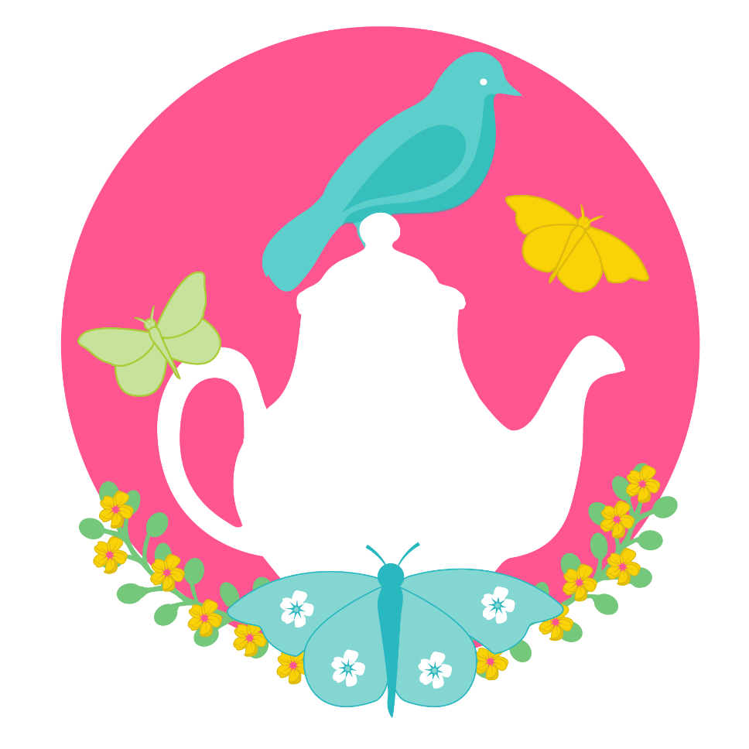

Tea for Two by Doris Day

Picture you upon my knee,
Just tea for two and two for tea,
Just me for you
And you for me alone.

Nobody near us
To see us or hear us,
No friends or relations
On weekend vacations.
We won't have it known, dear,
That we own a telephone, dear;

Day will break and you'll awake
And start to bake a sugar cake,
For me to take
For all the boys to see.

We will raise a family,
A boy for you, a girl for me.
Oh, can't you see
How happy we would be?
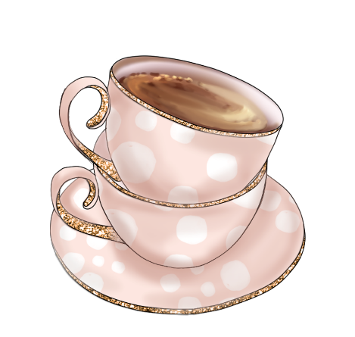
Pictures To Colour

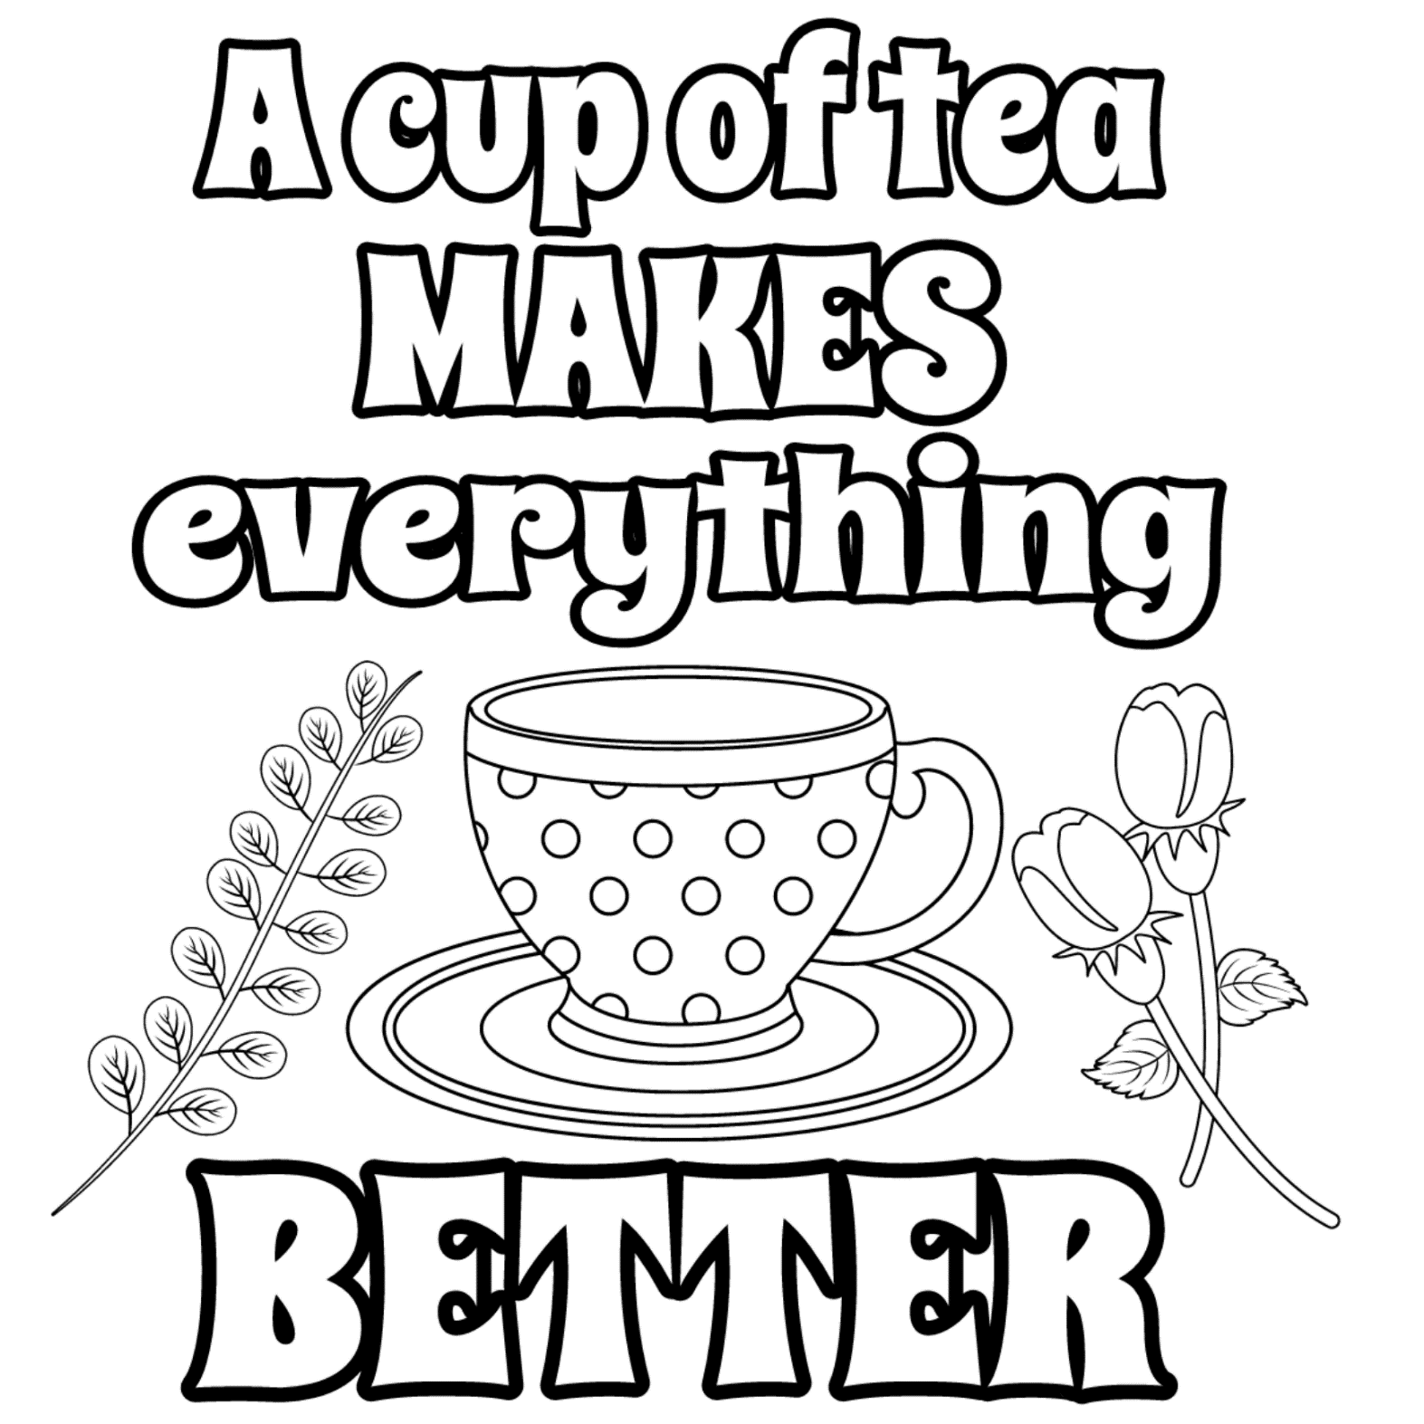

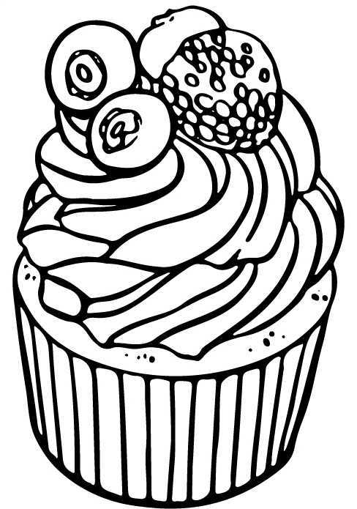

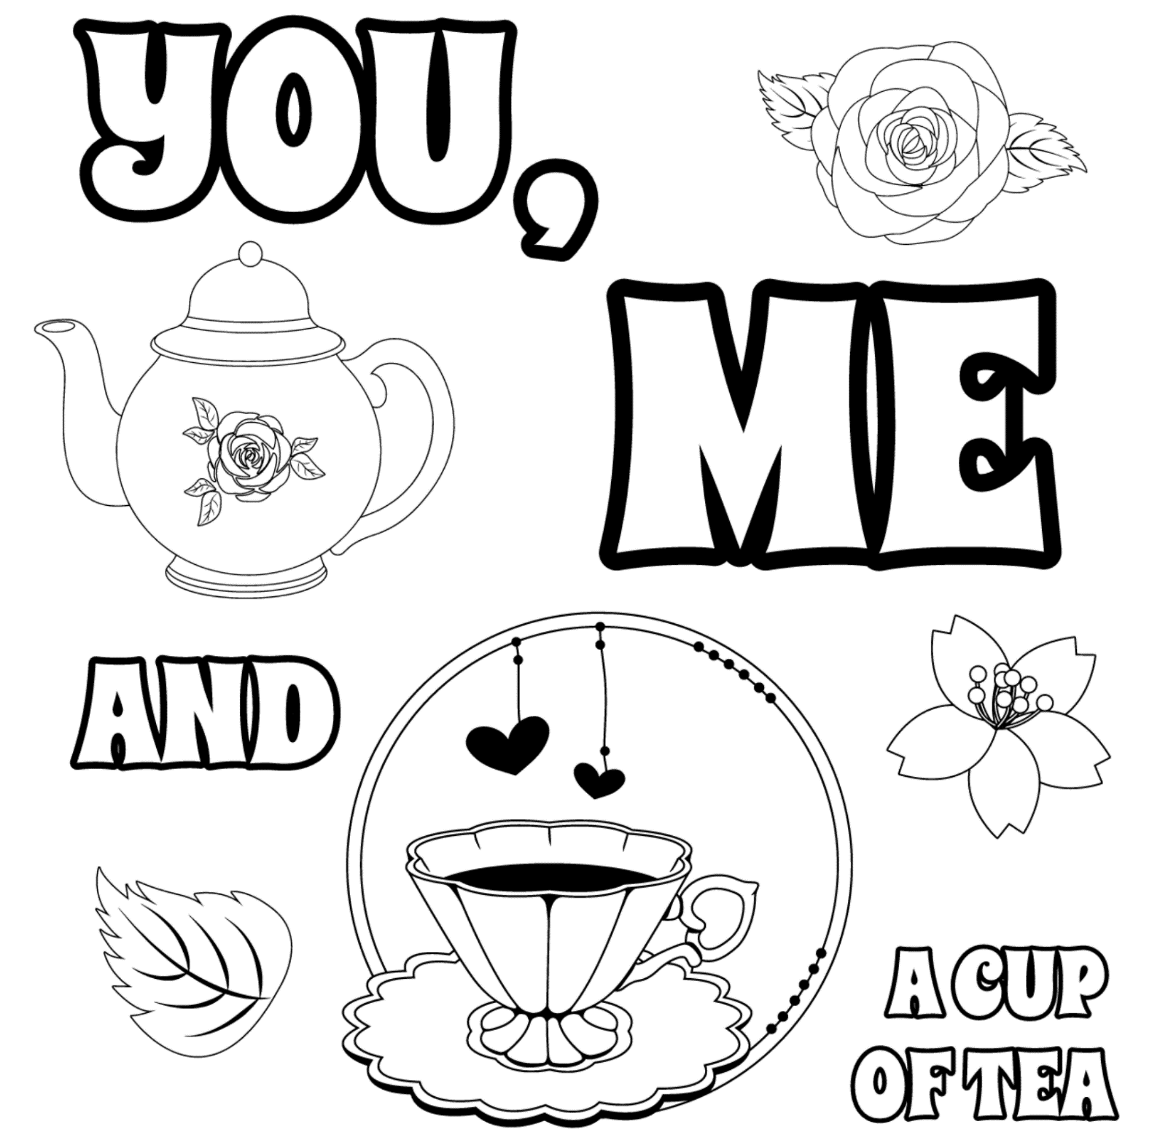

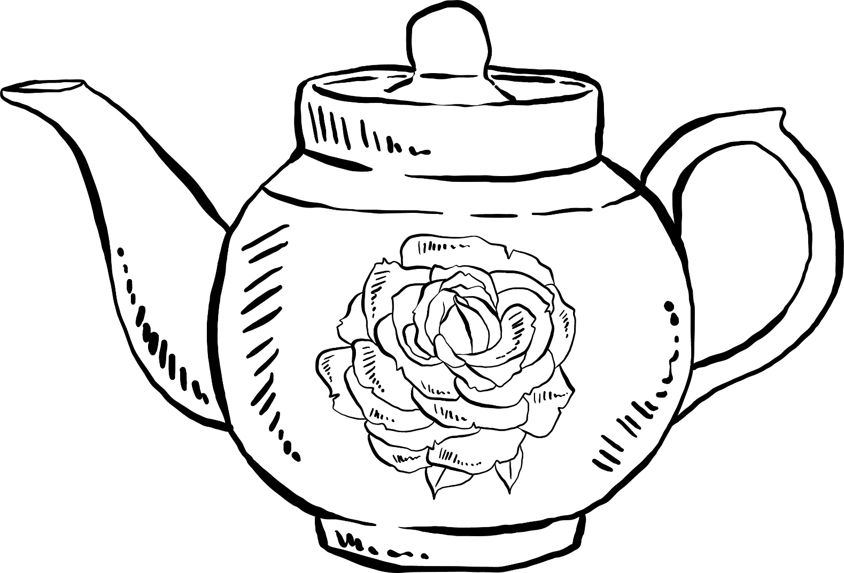

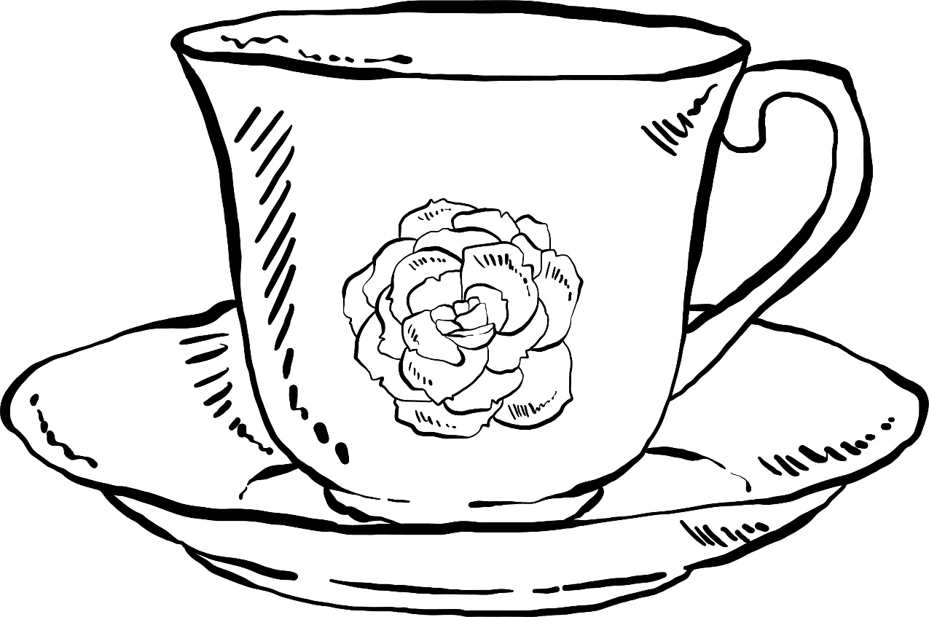

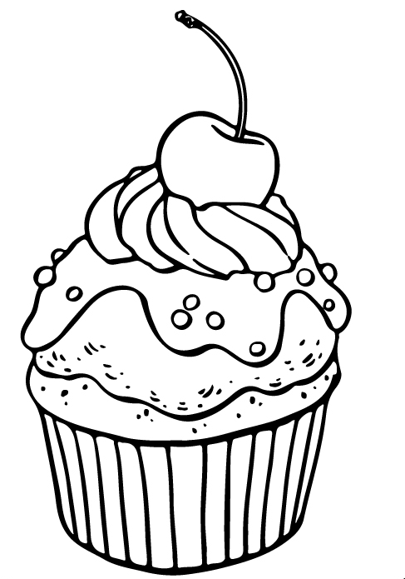

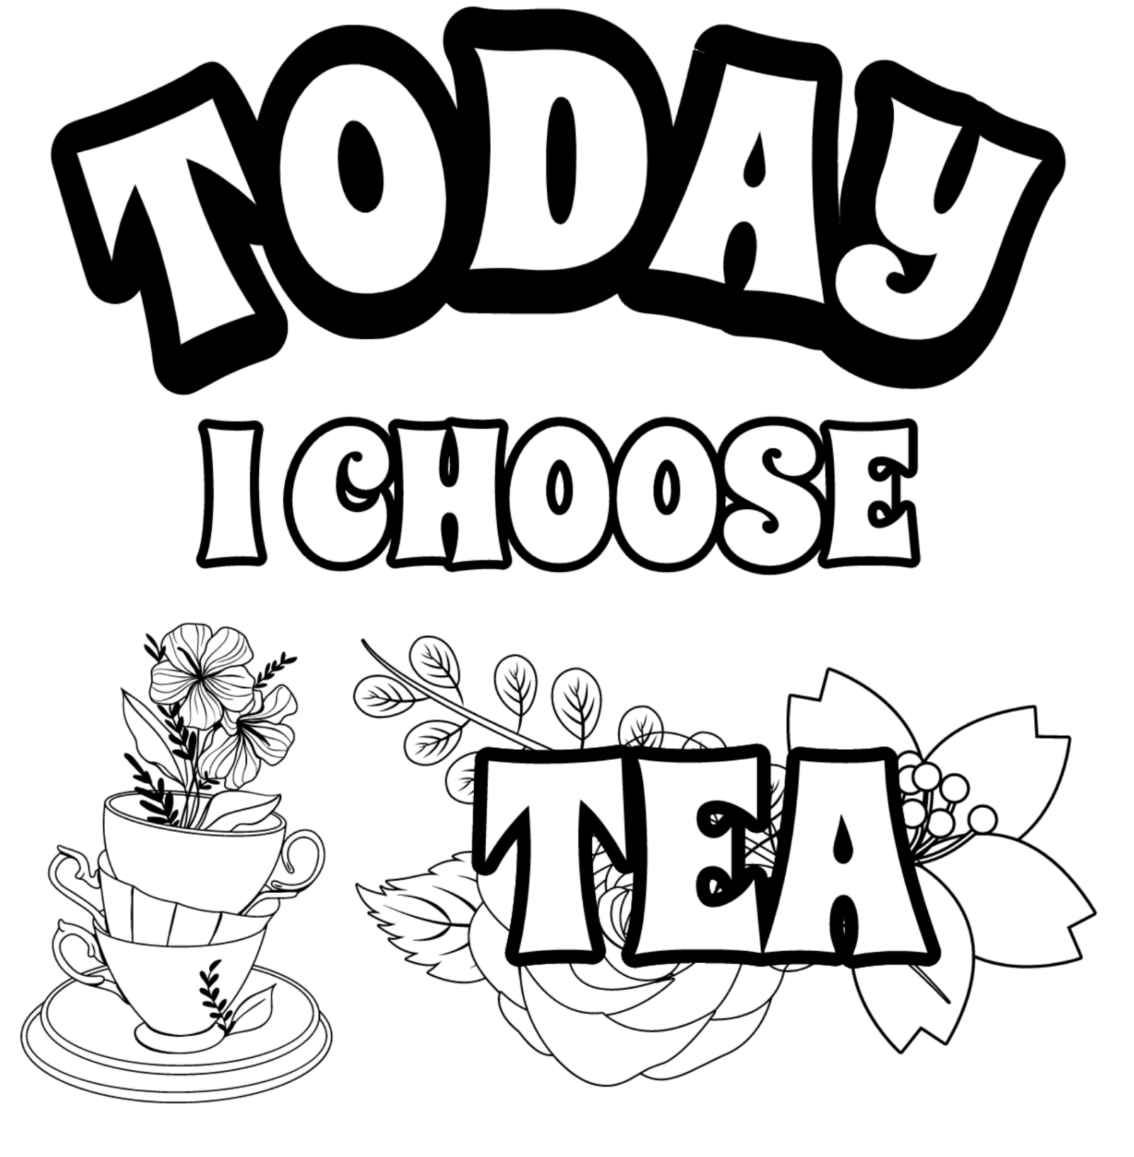

Old Irish Stories and Folklore

A Tall Tea Tale
Once upon a time before people used to drink tea a man went to Cork one day to pay his rent. After travelling around the city he felt very hungry. He went into a hotel and asked for a plate of porridge. The waitress told him that she had no porridge and she asked him would he have a cup of tea. The man said he never heard of tea before and asked what kind was it. The waitress gave him a cup of tea and she had milk and sugar put in it, when she was giving it to him she said "That’s the best Congo tea and I hope you will like it". He drank it and he said it was lovely, and he asked for a second cup and she gave it to him, but she did not put the sugar or milk in it, instead she put the milk and sugar on the table and said, "Sweeten it to your liking", he did not know what she meant, he drank some of the tea and it burned him, and he threw the rest of it away. He went to pay for the tea and when he was paying the waitress she asked him how did he like the tea, and he said that the "Congo tea" was lovely, but the "Sweeten to Your Liking tea” was just horrible!
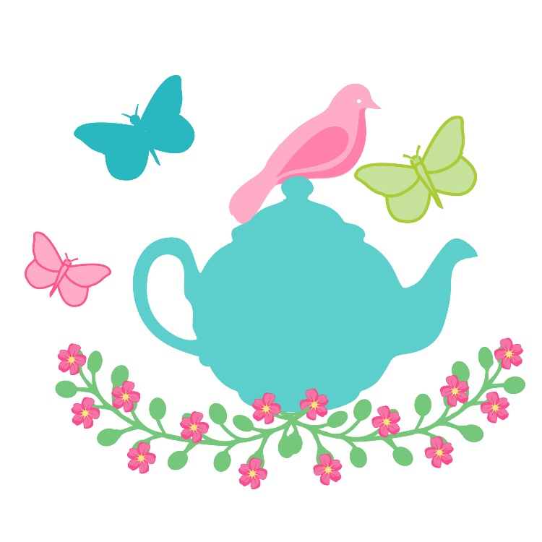
A Fairy Tale from Donegal
Once upon a time there was a poor man and woman who lived in a wee house. One day there came an old man and he asked the woman of the house to make him some tea and the poor woman said I have got very little tea in the house and I cannot make you any. The man said if you would make it for me you will be lucky. The woman wished to be kind so made the tea and when the man finished it he said there is a crock of gold in the garden at the side of a large old tree. The man of the house went out to dig and came upon the crock of gold. A few days after that an old woman came in, and asked for tea. Not having much but knowing they were now fortunate and should share, she was provided with tea and after she was finished she looked down at the crock of gold and there was writing on the crock. The man and woman said no one could understand the writing and the old woman wisely said the writing on the crock said: “Same in the other side” before winking and going on her way. The man went out to the garden and dug for a while he got the crock of gold on the other side of the tree. (This story was told by a man named Mr. William Simms who lived in Drimore many years ago)
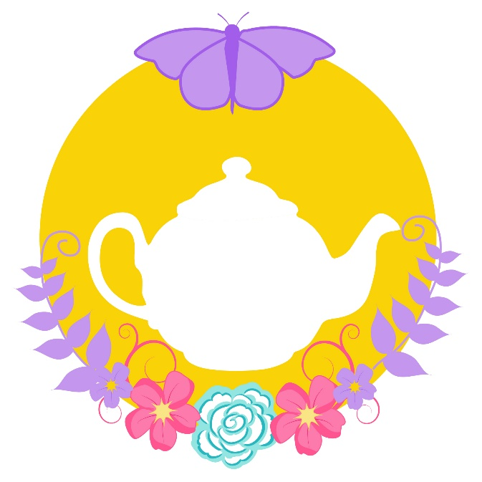
If I Knew You Were Comin' I'd've Baked A Cake
by Eileen Barton
Come in!
Well, well, well. Look who's here.
I haven't seen you in many a year.

If I knew you were comin' I'd've baked a cake, baked a cake,
baked a cake
If I knew you were comin' I'd've baked a cake
Howdya do, howdya do, howdya do?

Had you dropped me a letter, I'd a-hired a band,
grandest band in the land,
Had you dropped me a letter, I'd a-hired a band
And spread the welcome mat for you.

Oh, I don't know where you came from
'Cause I don't know where you've been
But it really doesn't matter
Grab a chair and fill your platter
And dig, dig, dig right in.

If I knew you were comin' I'd've baked a cake, hired a band, goodness sake!
If I knew you were comin' I'd've baked a cake
Howdya do, howdya do, howdya do?
(Repeat)

When I Take My Sugar To Tea
By Sammy Fain / Irving Kahal / Pierre Norman

I'm just a little "Jackie Horner"
since I met my sugar cane.
That gang of mine has been revealin'
that they're feelin' sore.
I left the lamp light on the corner,
for the moon in lover's lane.
I'm doing things I never did before.

When I take my sugar to tea, all the
boys are jealous of me, 'cause I
never take her where the gang goes,
When I take my sugar to tea.
I'm a rowdy dowdy, that's me,
She's a high hat baby, that's she,
So I never take her where the gang goes,
When I take my sugar to tea.

Ev'ry Sunday afternoon,
we forget about our cares,
rubbing elbows at the Ritz,
with those millionaires.
When I take my sugar to tea,
I'm as Ritzy as can be,
'cause I never take her where the gang goes,
When I take my sugar to tea.

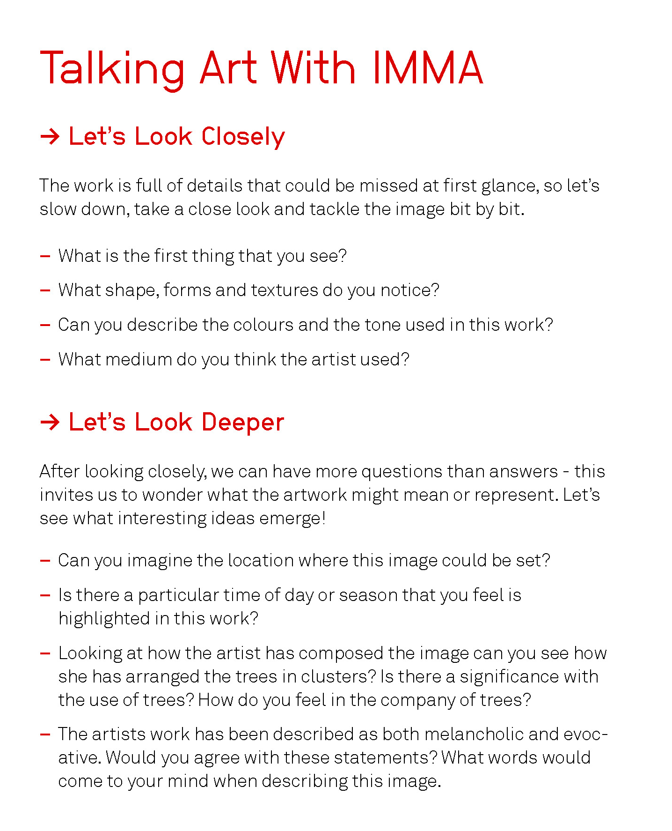

Have A Garden Party!

Why not enjoy the good weather, make a pot of tea, bake or buy some cakes and biscuits and have a mini garden party?
Get dressed up nice, put on some tea dance tunes, pop a tablecloth on the garden table – whatever would bring some joy to your day!
If you feel like being spoilt - you could even have a loved one act as “waiter” and bring you a menu of items, serve you tea, and most importantly – do the washing up!

Here are some pictures to use to make a menu for your garden party, be sure to pick out some of your favourite treats – how many have you tried?:

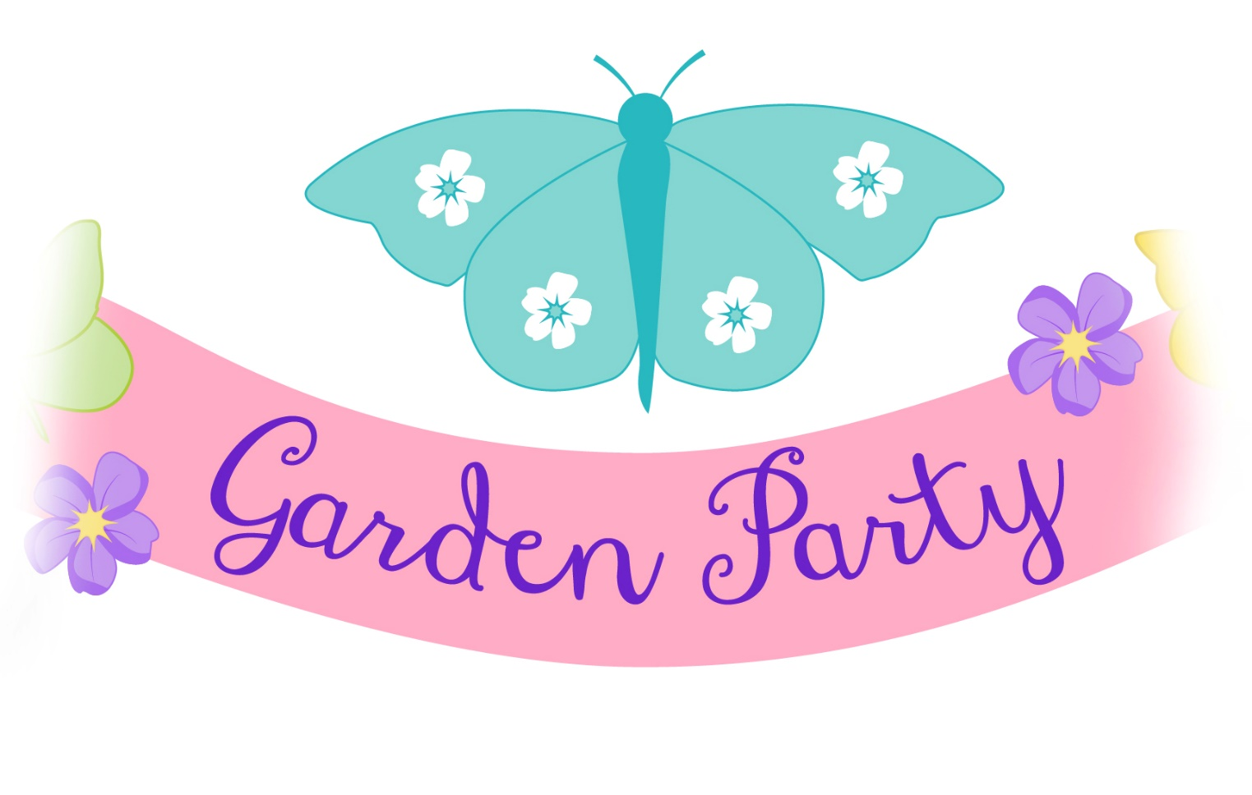

Can you name everything on the menu?
