June
Activity Pack

Dear Friends,

We have been having some beautiful weather across the country and we hope you’ve been able to enjoy it.

We have created a sports themed pack for this month to celebrate our upcoming collaboration with Shelbourne for their new dementia inclusive Football Memories event.

We have old Irish tales of local sporting legends, some songs you might know and have a variety of other activities for you to enjoy.

We would love to hear from you if you would like to suggest something, or if you’d like to share your artwork with us and have it featured on our social media. We also welcome poems and stories to be included in the pack if we have any artists or writers out there! Please contact Danielle at danielle.keogh@alzheimer.ie if you’d like to contribute.

“It is not the size of a man,
but the size of his heart that matters.”
– Evander Holyfield

Useful Resources:

- Our Free Helpline and Dementia Nurse Support Line are available at:
Phone: 1800 341 341 and Email: helpline@alzheimer.ie

The ASI are delighted to be working in collaboration with Shelbourne to launch their Football Memories event on the 24th of June at 4pm. Please email: shelbournefootballmemories@alzheimer.ie

- We are hosting several Virtual Cafes. They are a place to come together, share a cuppa and listen to our amazing guest speakers. For information on how to attend visit: https://alzheimer.ie/service/alzheimer-cafe/

- The ASI also have a huge library of factsheets and resources available on: https://alzheimer.ie/get-support/resources-and-factsheets/

- M4D Radio is a 24/7 online radio station with songs specifically picked to evoke memories and aid reminiscence. To find out more and to listen, please visit: https://m4dradio.com/

- Each Thursday we run the ASI National Virtual Choir. If you would like to join in, sing along or sit back and make some musical memories please email: asinationalvirtualchoir@alzheimer.ie

- Emergency Response Numbers: 999 or 112

- HSE 24/7 Your Mental Health Information Helpline: 1800 111 888

Table of Contents

Activity | Pages
Spot the Difference | 5-6
Irish Proverbs | 7
Football Reminiscence | 8
Pictures to Colour | 9-17
Talking Art with IMMA | 18-20
Trasna na dTonnta Lyrics | 21
Olympic Games Poem | 22
Put ‘Em Under Pressure Lyrics | 23
Jon My Football Hero Poem | 24
Sporting Tales from Ireland | 25-26
Name that Sport Game | 27
It’s All in the Swing Poem | 28
Thankful Heart Meditation | 29-30

Spot the Difference
See if you can see the differences between these two pictures
Spot the Difference
See if you can see the differences between these two pictures

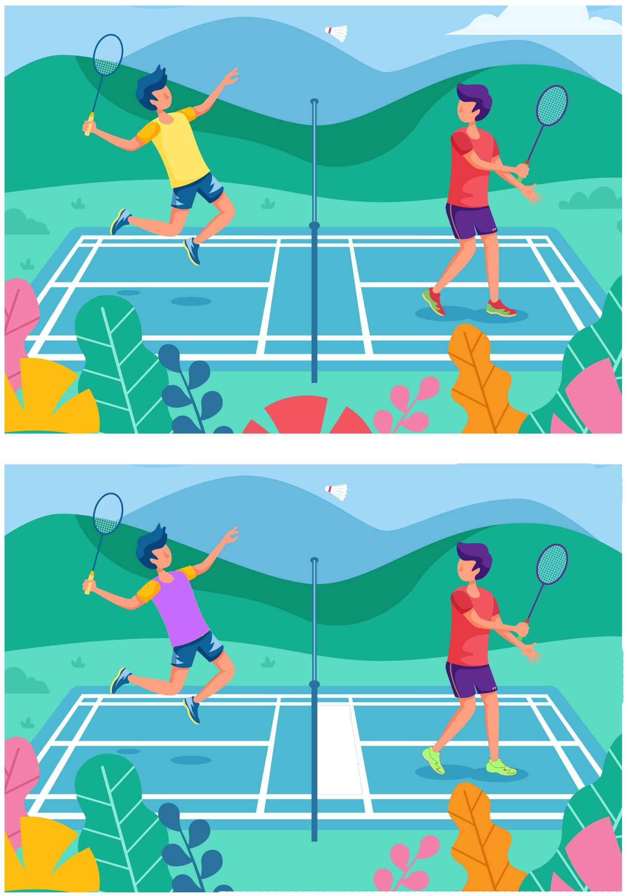
Irish Proverbs and Their Meanings

- It is better to be a coward for a minute than dead for the rest of your life – safety is better than bravery.
- Better to spend money like there’s no tomorrow than spend tonight like there’s no money – live in the moment.
- Never dread the winter til the snow is on the blanket – there is no need to worry about the cold while you have a roof over your head.
- One beetle recognises another – Like attracts like (Aithníonn ciaróg, ciaróg eile)
- It’s long road that has no turn in it – (Is fada an bóthar nach bhfuil aon chasadh ann) – Be nice to people because you never know when you might meet/need them in the future.
- Put silk on a goat and it’s still a goat – (Cuir síoda ar ghabhar agus is gabhar i gcónaí é) – It means it doesn’t matter how well you dress up, if you’re not attractive it won’t make any difference!

Football Reminiscence
Using the images below have a conversation about sporting memories: Are the items below are familiar? What sounds might you hear at a football match? What do people do to celebrate a big win? Do you have a favourite team or player? Have you ever gone to a live football match?

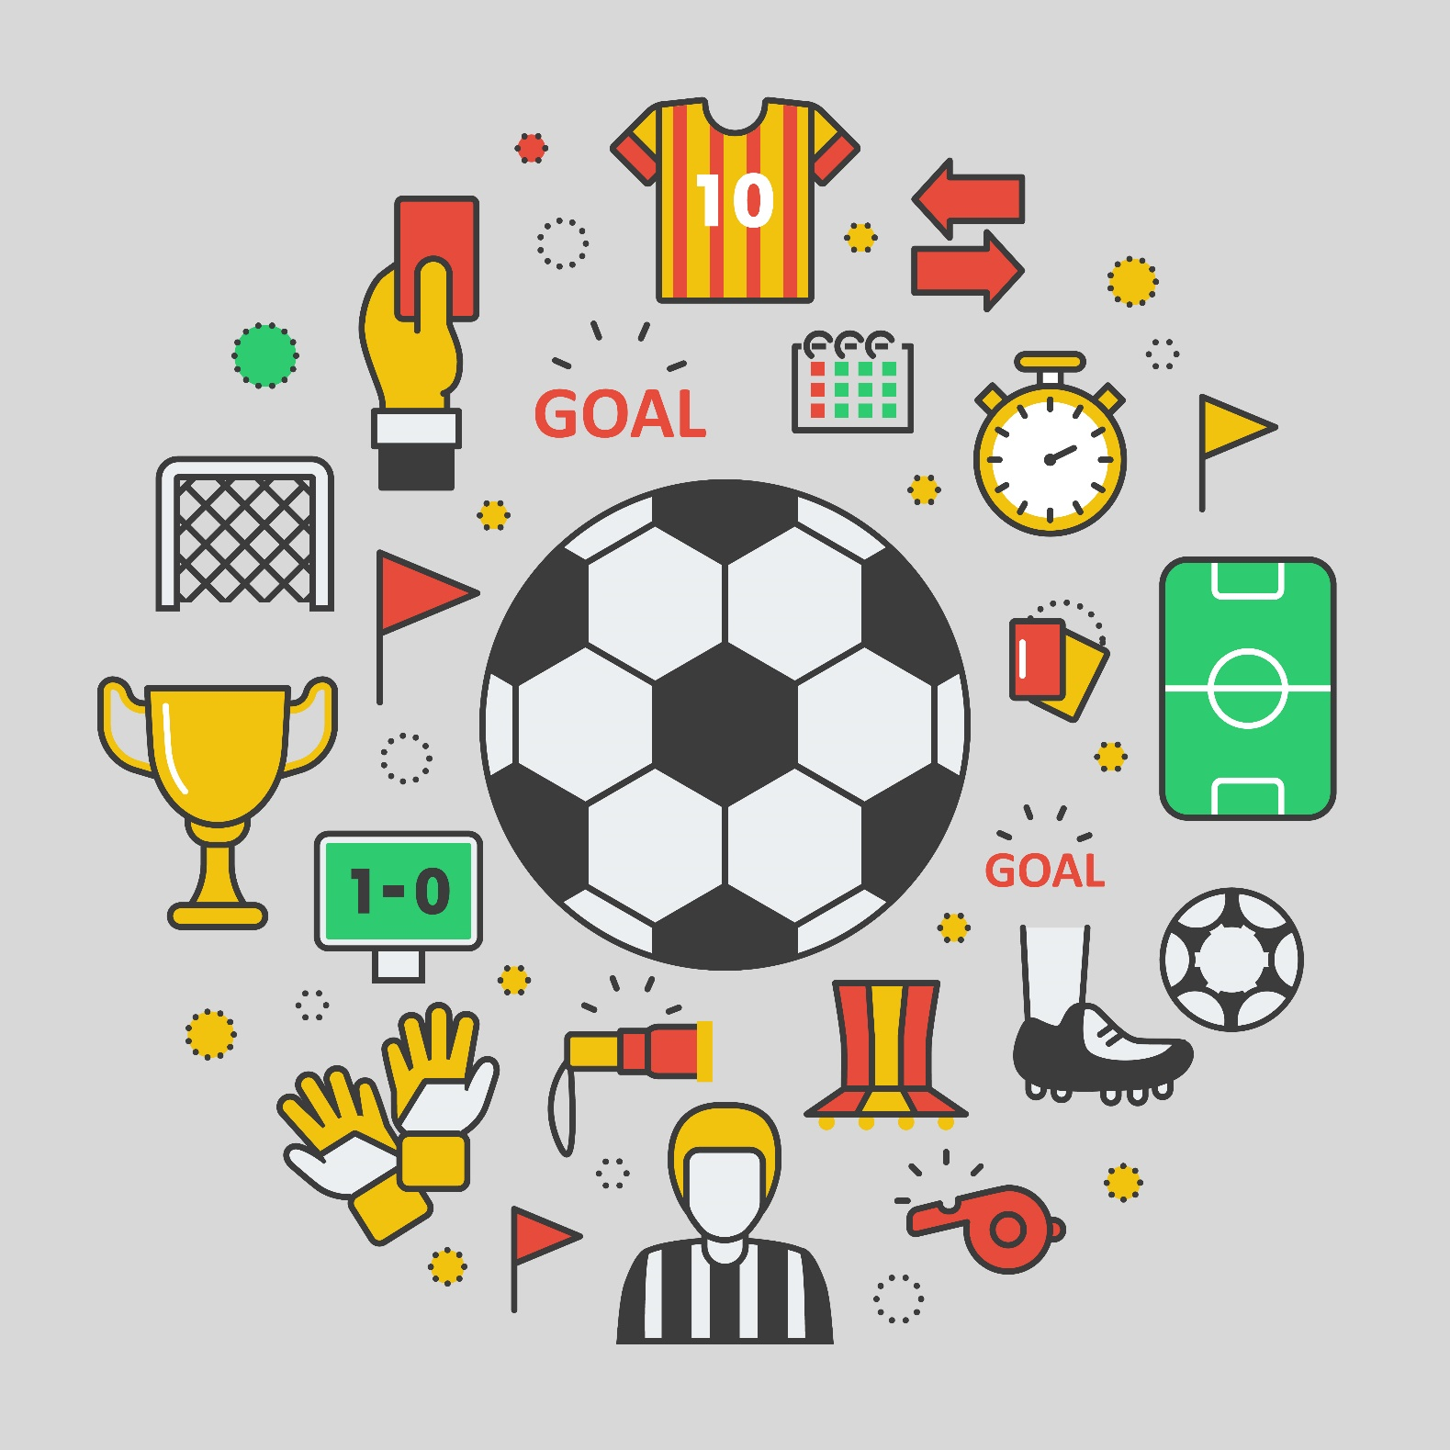

Pictures to Colour

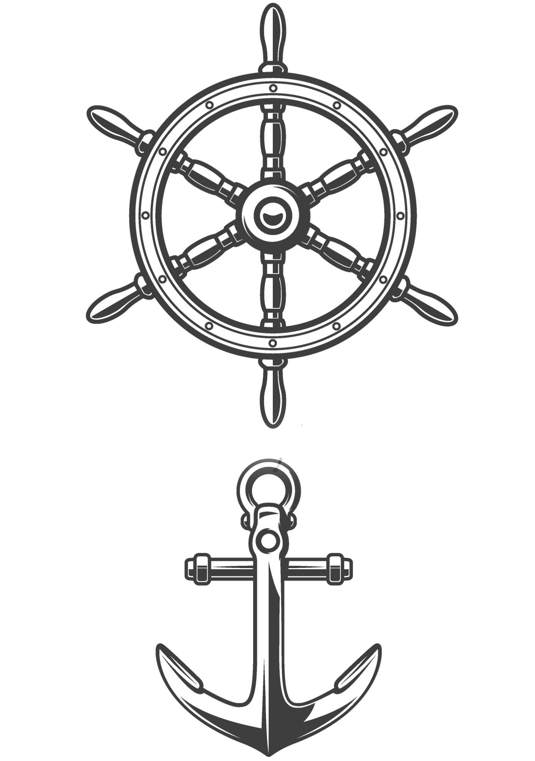
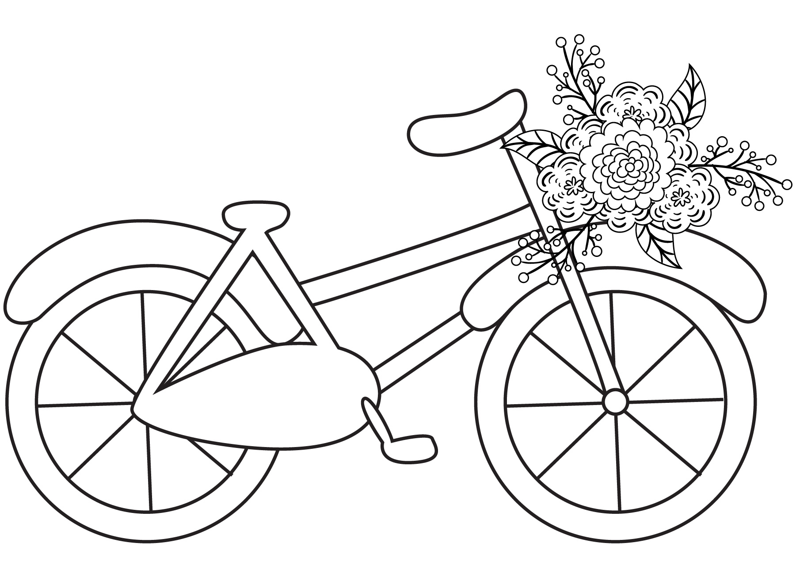
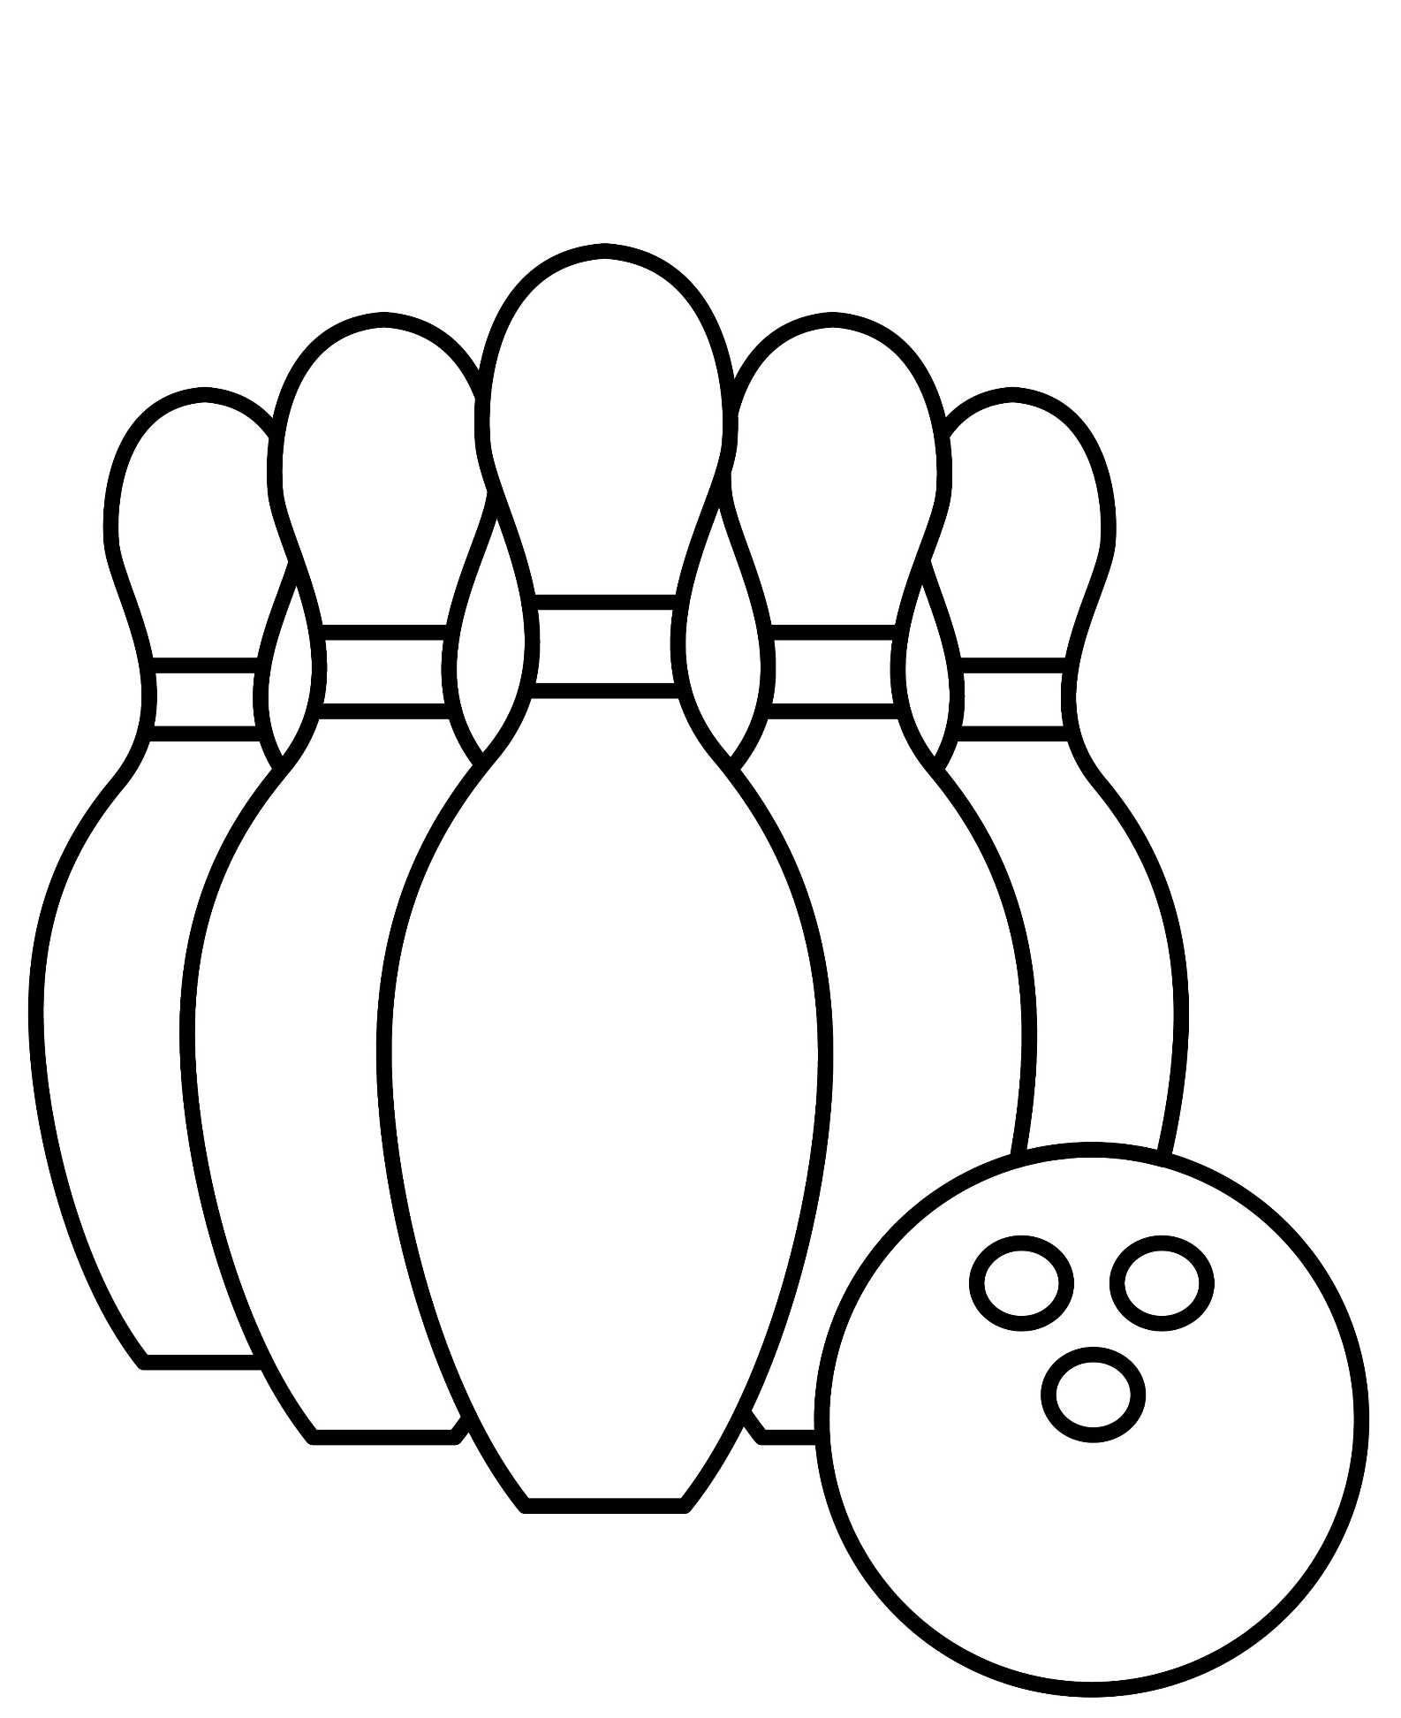

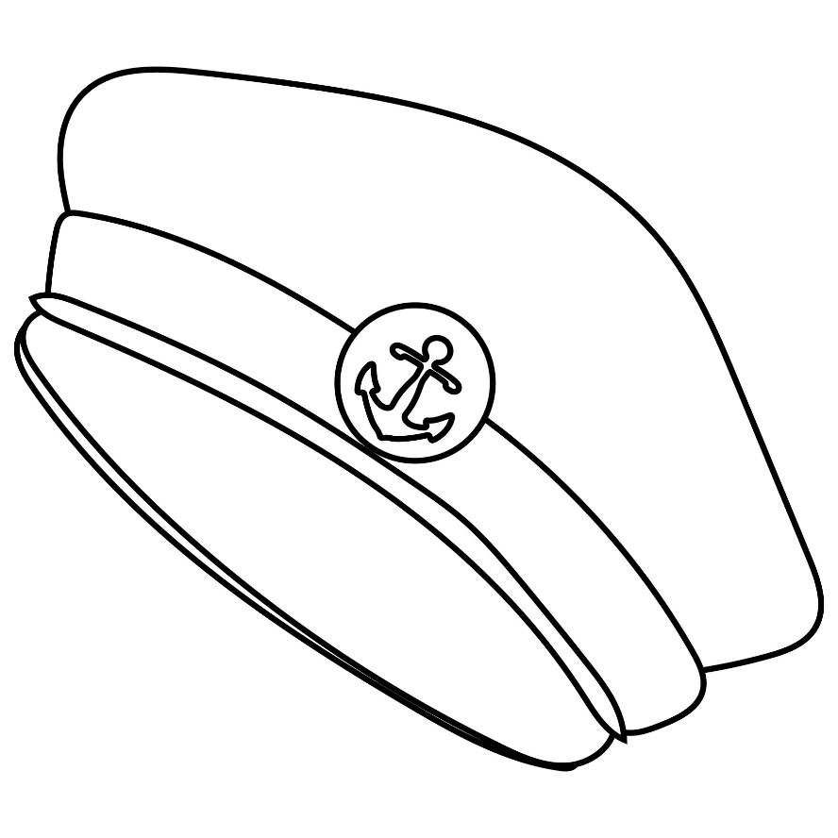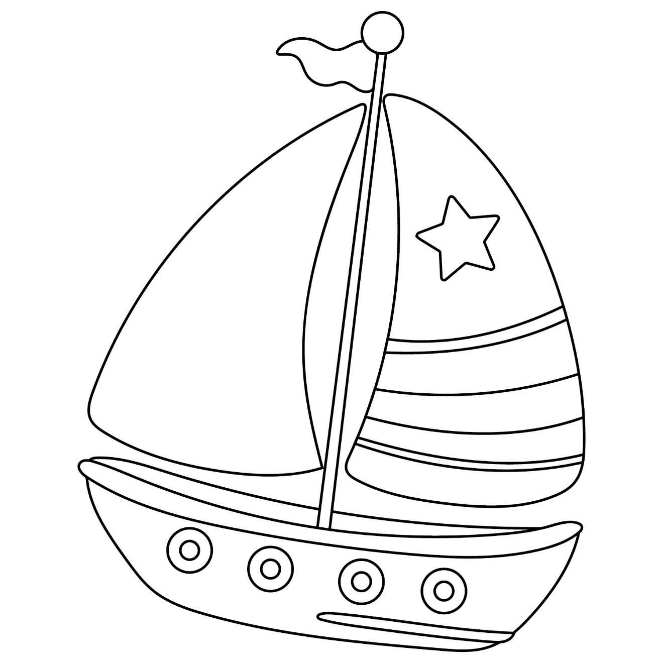
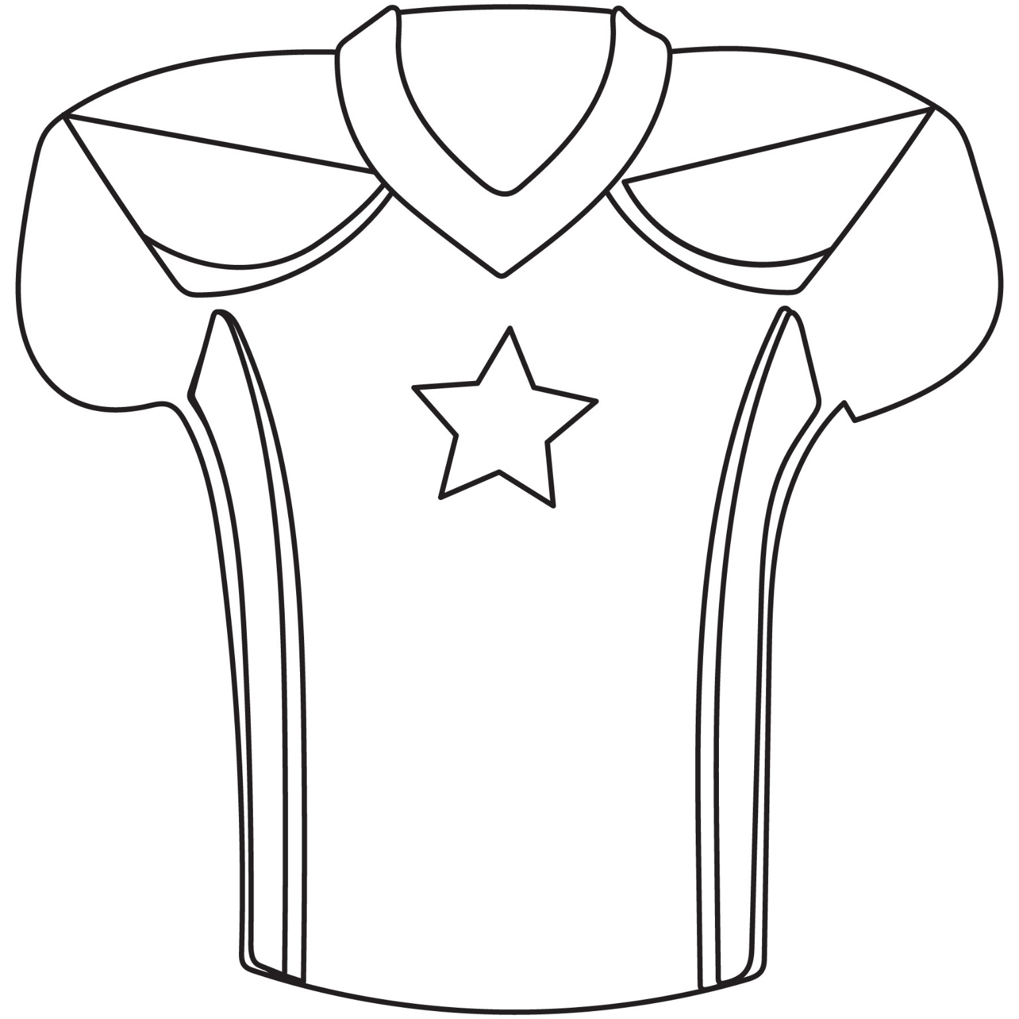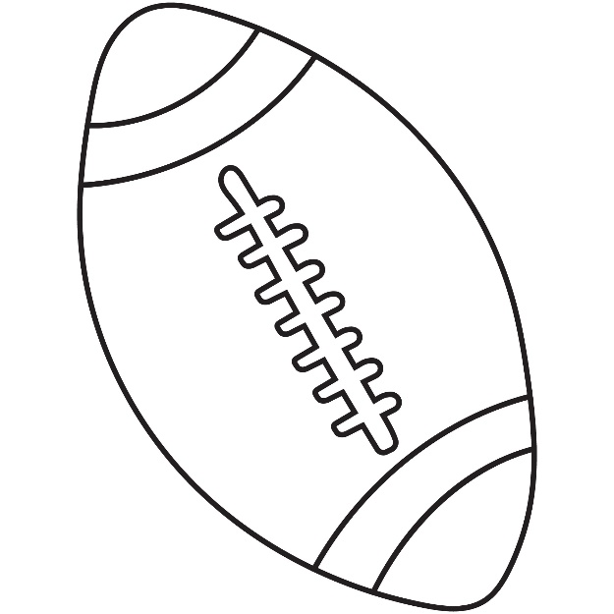
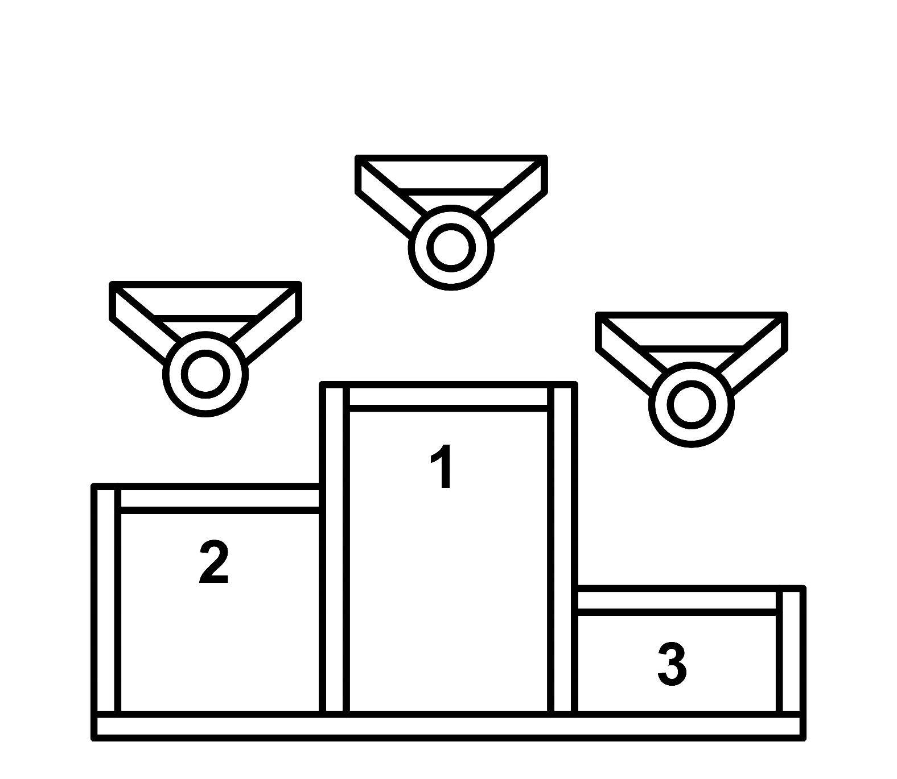
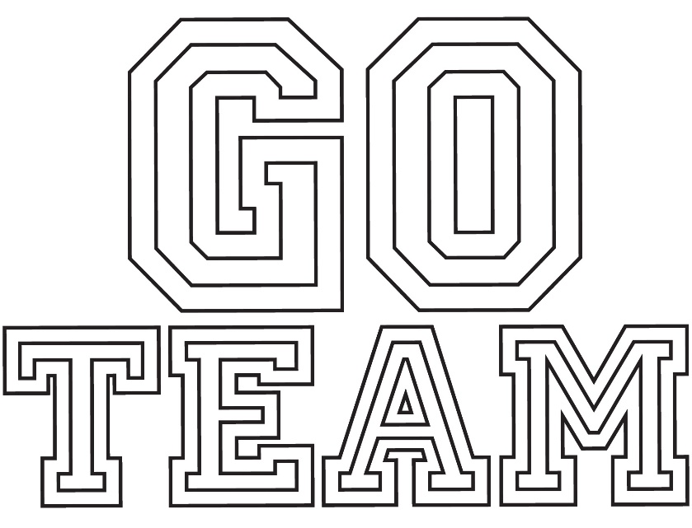

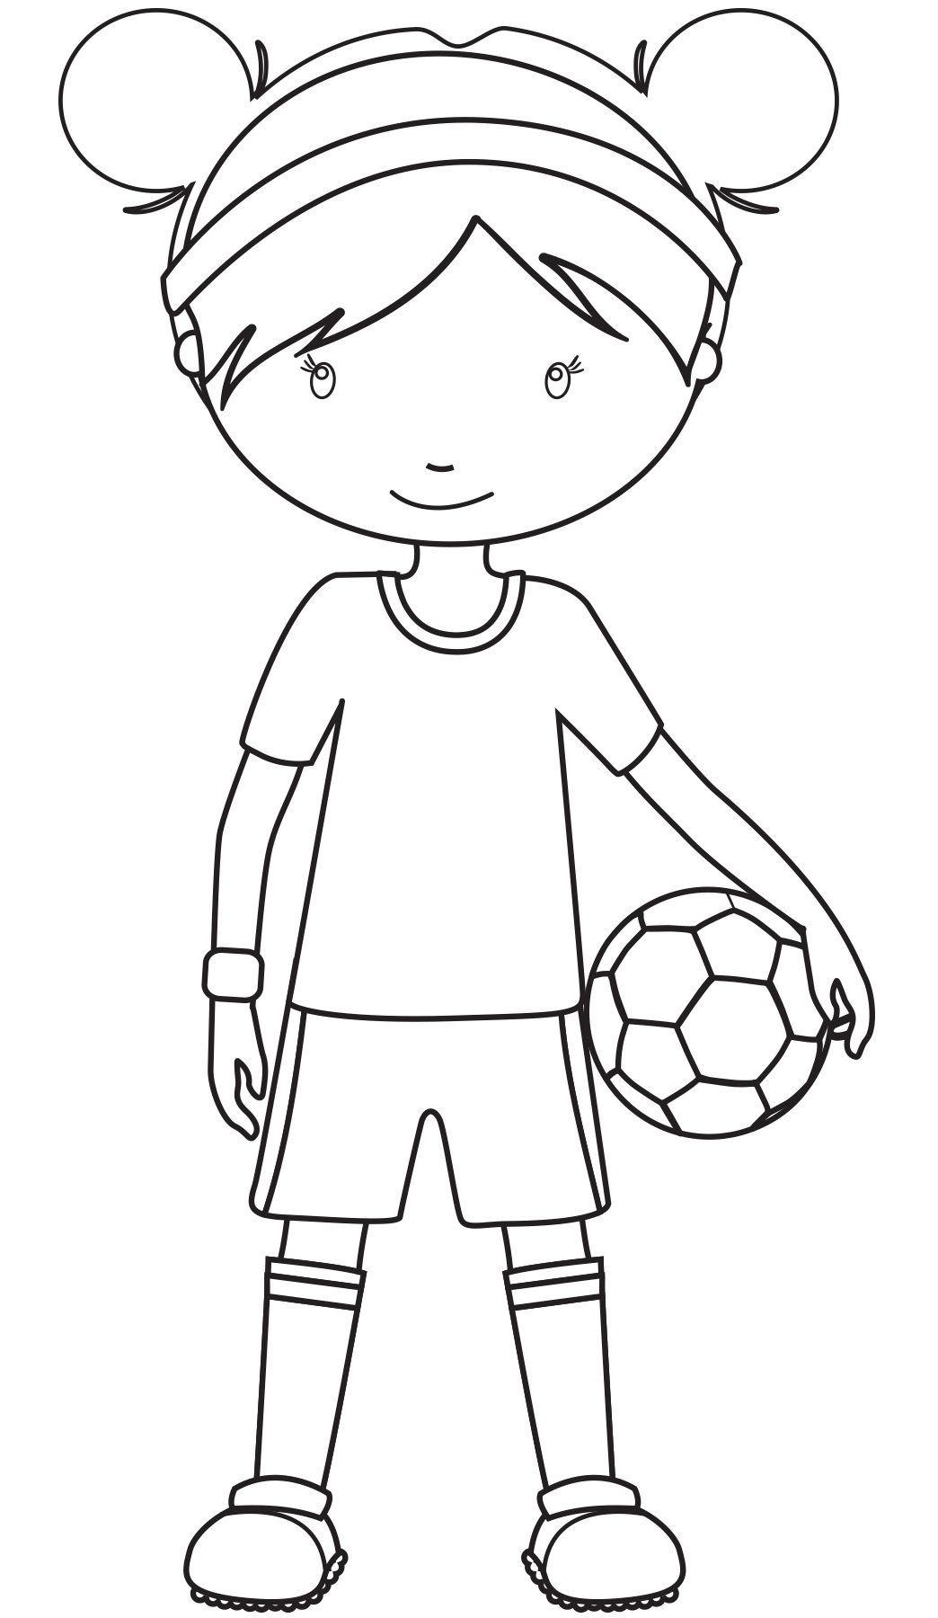
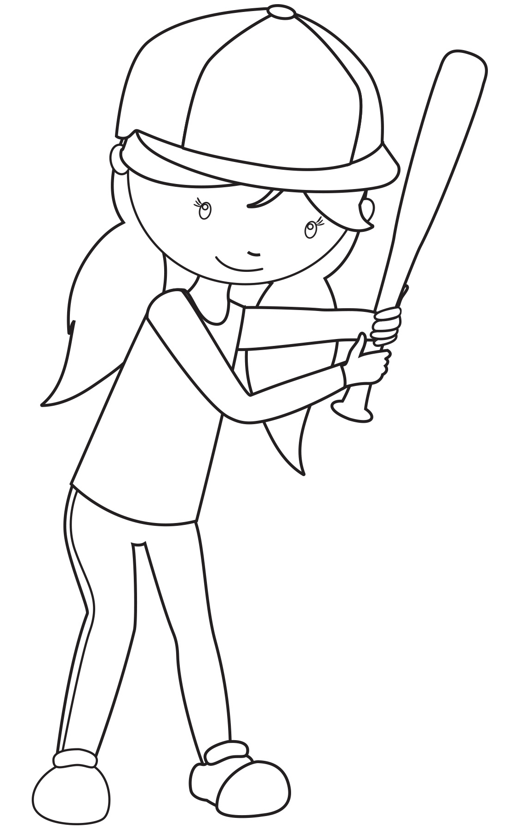
Talking Art with IMMA
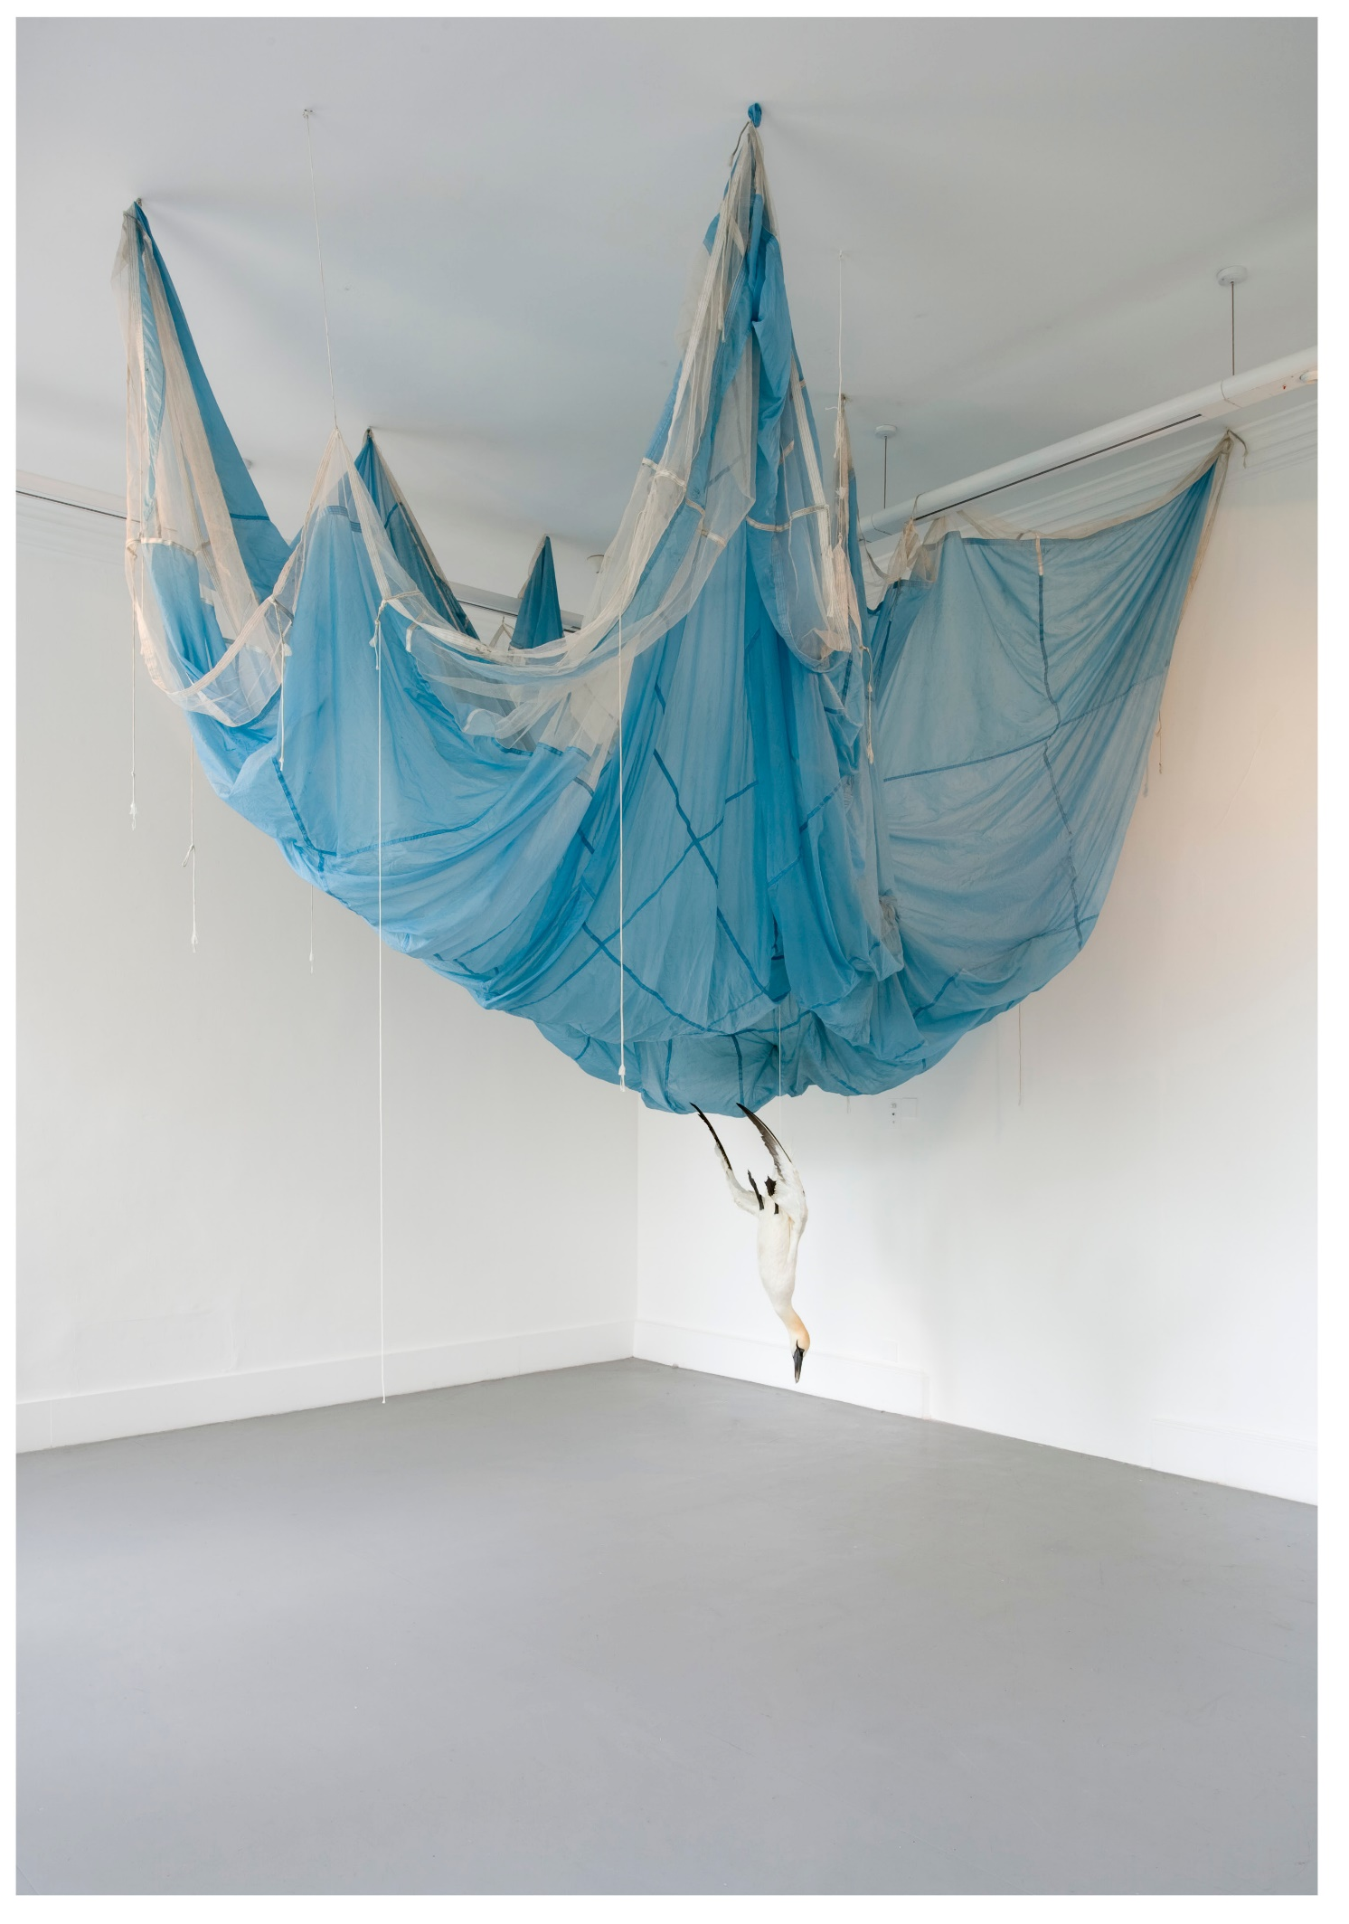
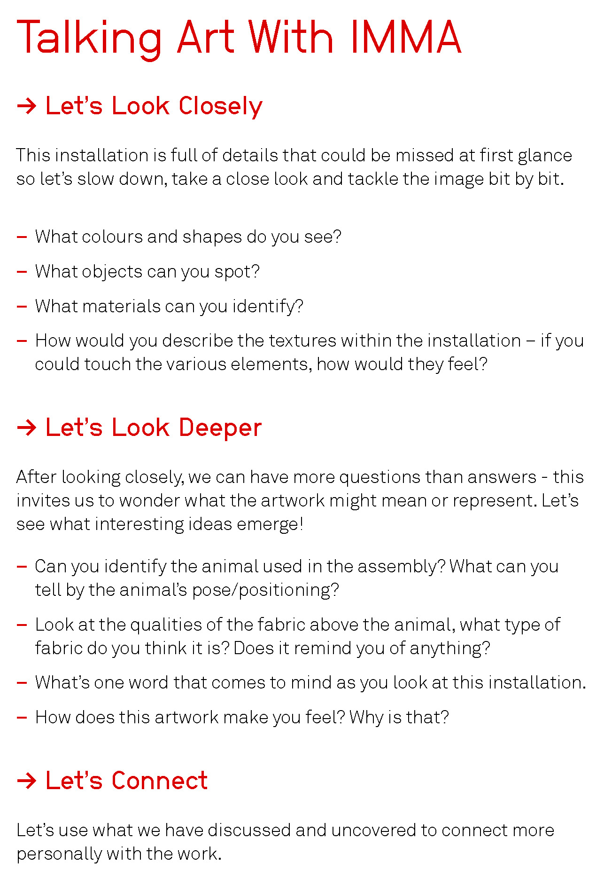

Trasna na dTonnta - Across the Waves
Curfá:
Trasna na dtonnta, dul siar, dul siar,
Slán leis an uaigneas ‘is slán leis an gcian;
Geal é mo chroí, agus geal í an ghrian,
Geal a bheith ag filleadh go hÉirinn!
Chonaic mo dhóthain de Thíortha i gcéin,
Ór agus airgead, saibhreas an tsaoil,
Éiríonn an croí ‘nam le breacadh gach lae
‘S mé druidim le dúthaigh mo mhuintir!
Curfá
Muintir an Iarthair ‘siad cairde mo chroí,
Fáilte ‘is féile bheidh romham ar gach taobh.
Ar fhágaint an tsaoil seo, sé ghuidhim ar an Rí
Gur leosan a shinfear i gcill mé.
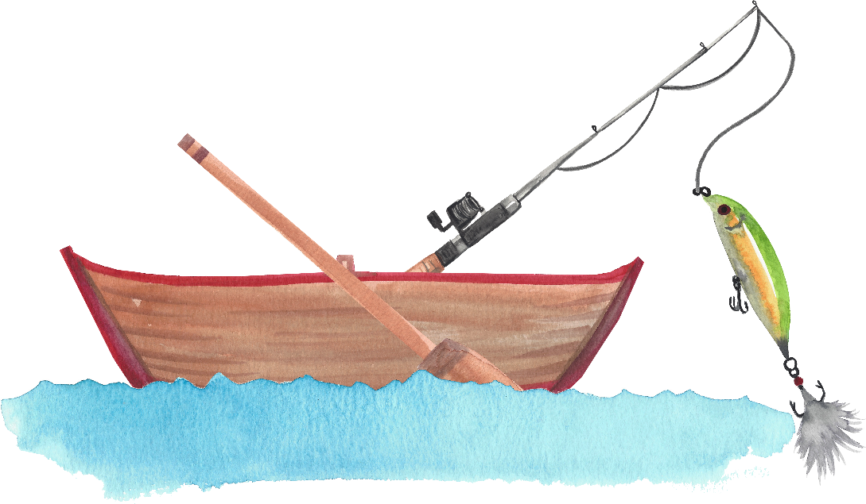
Véarsa breise
Ar mo thriall siar ó éirigh mo chroí
An aimsir go hálainn is tonnta deas réidh
Stiúradh go díreach go dúthaigh mo chliabh
‘S bheidh mé in Éirinn amárach!

Olympic Games By Ken Budden

Only for those of a special breed,
Living a dream, a chance to succeed,
Yesterday's hopes and desires coming true,
Making your mark with records anew
Proving hard work and the daily grind,
Instructing the body, conditioning the mind
Can capture a medal for the whole world to see, with
Glamour and Pride for your country,
As you stand aloft and you flag is flown high, there's
Memories forever, and a tear in your eye,
Enjoying the moment, the admiring looks,
Securing you name in the history books.

Put ‘Em Under Pressure
We gotta' fight for The World Cup - Go and Compete
We'll prepare and go, and do our best
we'll put 'em under pressure
The game is about being affective
Being aggressive winning the ball
Getting on with the play
We'll put 'em under pressure
Olé Olé Olé Olé, Olé Olé
Olé Olé Olé Olé, Olé Olé
We're all part of Jackie's Army
We're all off to Italy
And we'll really shake them up
When we win The World Cup
'Cos Ireland are the greatest football team!
Put 'em under pressure
It's not going to be easy for us
But it's not going to be easy for them either
Re-inflict our game on the people
Put 'em under pressure
You've got a game to win
Put 'em under pressure
We're all part of Jackie's Army
We're all off to Italy
And we'll really shake them up
When we win The World Cup
'Cos Ireland are the greatest football team!

Jon My Football Hero By Judy More
One day my little boy of three
With great big smiling eyes
Said, "I'm going to play some football mom
With all the bigger guys!"

Dressed in homemade football gear
You raced out towards the street
I chuckled to myself, but yet...
My heart plunged to my feet.

You came back in fifteen minutes
No scratches on your skin
With much dismay you then announced,
"They wouldn't let me in"!

You claimed they said you couldn't play
Because you were too small
I promised you you'd play one day
When you grew strong and tall.

My promise to you held so true
For now that time is here,
My smiling football player
Is in his senior year.

I'm proud of you and all you've done
And for all that you will be
If I just had one wish, I'd wish
That you could still be three.

Our Local Sporting Heroes – A Tale from Co. Cork
Mr Thomas Garde of Castlemartyr was one of the best runners in Ireland in his time. He was champion of Munster at the 440 yds, and was barely beaten for the 440 yds Championship of Ireland. He won a great race 80 yds one day in Lisgoold. He was scratch man against great men, and he won on the tape amidst great excitement. There was another runner Mr J.J. Buckley of Cork at this time. He also won a good many 110 yds races. There was a dispute arose as to who was the better man. The Midleton Committee arranged a special race for 300 yds at Midleton sports and both men competed. This was a great draw for Midleton, and the crowd was the greatest ever seen at a sports meeting in East Cork. Mr J. Garde won the race and was shouldered off the field. He holds over one hundred prizes won at different sports meetings all over Ireland.

Great Swimmers – A Tale from Co Kilkenny
About the year 1927 there lived a man in Lisdowney in the Co. Kilkenny whose name was Edward Doyle. Every year he went to a sports in Thomastown and each year he won first prize for swimming. A white duck was put swimming on the river Nore and he had to swim after it on the water. He dived under the water and when he came near the duck he put his hand up and caught the duck by the leg. When the sports was over he brought the duck home under his arm.
How Sports Were Held - Co. Leitrim
In olden times sports were held in the townland of Fearnaught in the Co. Leitrim. The sports were continued for three days.
The people used to come from the five neighbouring counties, namely Cavan, Sligo, Roscommon, Longford and Fermanagh.
The sports were a benefit to my grandfather as he was paid for the field.
All kinds of amusements were indulged in namely, boxing, wrestling, racing, jumping, singing, and dancing. There was gamecock fighting and gamecocks were brought from the surrounding counties.
Hundreds use to come to support their own representatives The best boxer in my district was a man by the name of Pat Bohan of McLoughra, Mohill.
He was about five feet ten inches in height. He worked in England. There were two hundred men working with him and he was the best boxer amongst them. One morning a man named Jack Bulger came a distance of forty miles to have a bout with him. After a contest of forty rounds, Bohan won the fight. He also had many bouts in Ireland and he always had an easy victory.
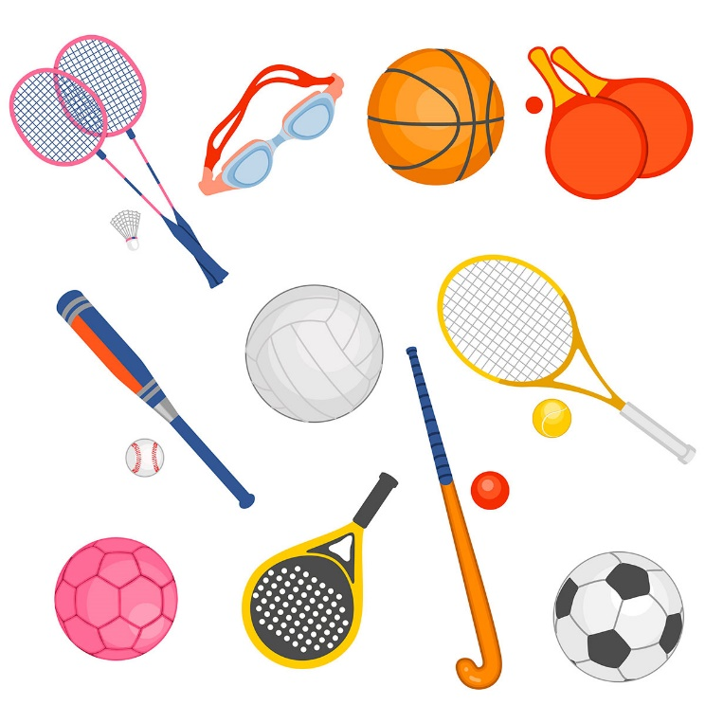
Name the Sport
Can you name the sports shown below?
How many of them have you played?
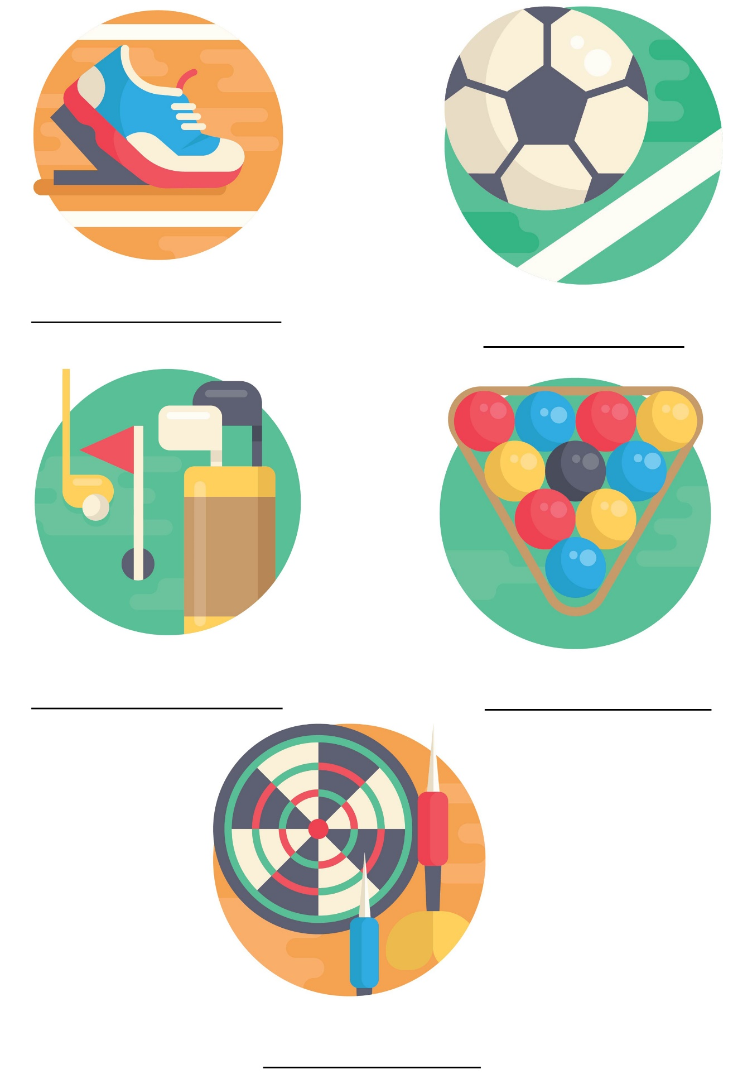
It's All in the Swing by Laura McKenzie

Who says I’m getting old?
My hairs are not gray,
Its beautiful sterling silver,
The finest silver around!

Who says I’m getting old?
My face isn’t bright red,
I’m not having hot flashes,
I just have constant sunburn
- I love the outdoors!

Who says I’m getting old?
Not me I’m as young as I feel!
- Tennis anyone?

Thankful Heart Meditation

Take a nice deep breath, and close your eyes.
Breathe in deeply, and exhale slowly.
Exhale out any stress, tension, or tightness you
feel anywhere in your body. Focus your attention
on your head, face, and neck and allow all your
muscles to become very relaxed.
Feel the tension melting away.

Feel the relaxation coming over your entire
body. Relax as it flows down your shoulders,
relaxing them and melting away any tension you
hold there. Feel the relaxation flow down your entire body.
Enjoy how relaxed and comfortable you become.
It feels wonderful to be warm and deeply relaxed all over.

Now, picture in your mind a beautiful day outside with sunshine everywhere. You’ve just spent an entire fun-filled day at a water park.
It’s the end of the day and time for one last ride
down the lazy river before you leave. You dip a
toe into the river and step down into it, feeling
the cool water touch your warm skin.
The sunshine makes you feel so good inside.
You jump up on your water float and begin your lovely,
calming last ride of the day.
As the float takes you lazily down the river, you
decide to put your fingers into the water.
You allow them to glide back and forth in the water to make circles and swirls around your fingers as you continue floating down this cool, calm river.

Some days are fast and busy.
Some days are slower and more relaxed.
You remind yourself that you are thankful for it all.
You know that each day is special and different , and by being
grateful for each day, life just keeps getting better and better.

Gratitude is when our hearts feel thankful for experiences because we know that experiences help us grow.
Gratitude fills up our hearts with happiness.
Now it’s time to gather your thoughts and keep all your gratitude in your heart as you find yourself back in your room once again.

