July
Activity Pack

Dear Friends,

We are in the height of summer and my goodness is the sun shining! We hope you are able to safely enjoy being outside with a nice cool drink and a sunhat!

This month’s activity pack theme is “The Great Outdoors” - think camping, campfires, nature trails and singing under the stars.

We have songs, stories, and games to pass the time under the summer sun and the mild, bright evenings.

We would love to hear from you if you would like to suggest something, or if you’d like to share your artwork with us and have it featured on our social media. We also welcome poems and stories to be included in the pack if we have any artists or writers out there! Please contact Danielle at danielle.keogh@alzheimer.ie if you’d like to contribute.

“"There's no wi-fi in the mountains,
but you'll find no better connection."
– Anonymous

Useful Resources:

- Our Free Helpline is available at: 1800 341 341

- The ASI are delighted to be working in collaboration with Shelbourne on their upcoming Football Memories event on the
29th of July at 4pm. For an invite, please email: shelbournefootballmemories@alzheimer.ie

- We are hosting several Virtual Cafes. They are a place to come together, share a cuppa and listen to our amazing guest speakers. For information on how to attend visit: https://alzheimer.ie/service/alzheimer-cafe/

- The ASI also have a huge library of factsheets and resources available on: https://alzheimer.ie/get-support/resources-and-factsheets/

- M4D Radio is a 24/7 online radio station with songs specifically picked to evoke memories and aid reminiscence. To find out more and to listen, please visit: https://m4dradio.com/

- Each Thursday we run the ASI National Virtual Choir. If you would like to join in, sing along or sit back and make some musical memories please email: asinationalvirtualchoir@alzheimer.ie

- Emergency Response Numbers: 999 or 112

- HSE 24/7 Your Mental Health Information Helpline: 1800 111 888

Table of Contents

Activity | Pages
Spot the Difference | 5-6
Pictures to Colour | 7-13
Mushroom Picking Game | 14
A Camping Morn | 15-16
Grass Poem | 17
Bed in Summer Poem | 18
An Poc ar Buile Poem | 19-20
Your Campsite | 21
An Old Tale of Travelling Tribes | 22-23
Where’s My Tent? | 24
Pat Murphy’s Meadow | 25
The Games I Play | 26
A Double Scare | 27
Ballad of Johnny O’Dell | 28-29
Guided Mediation for Sleep | 30

Spot the Difference
See if you can see the 5 differences between these two pictures
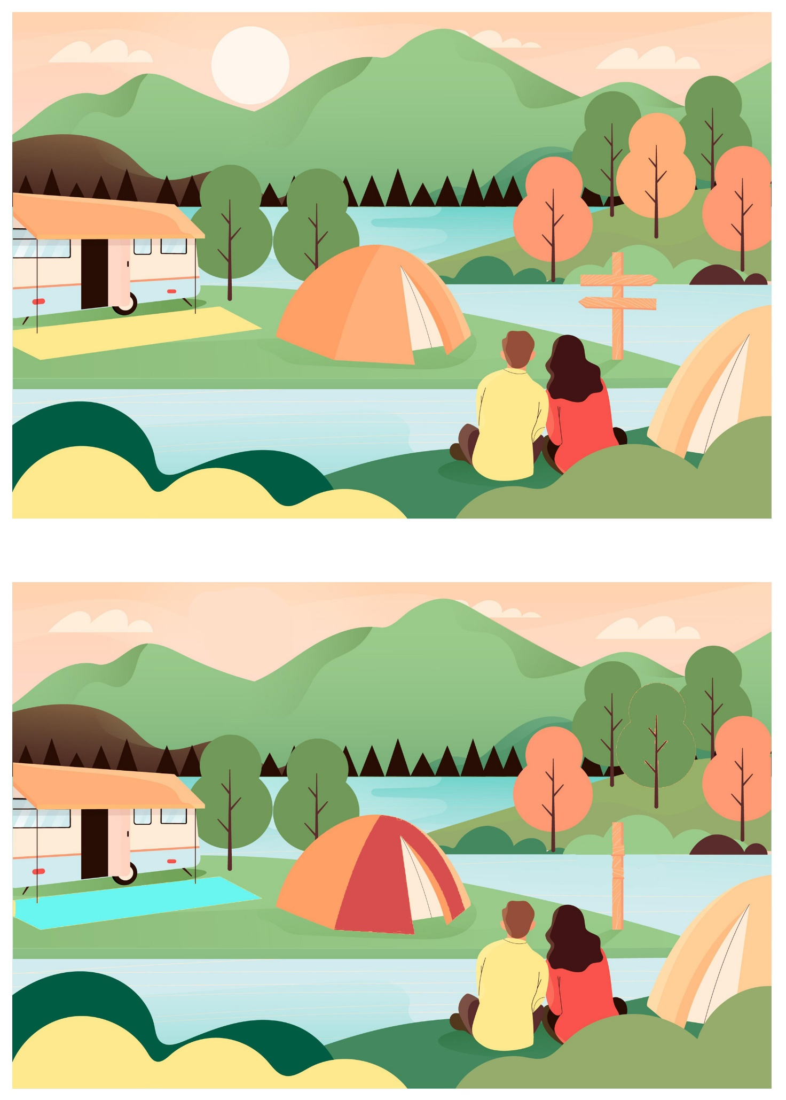
Spot the Difference
See if you can see the 5 differences between these two pictures

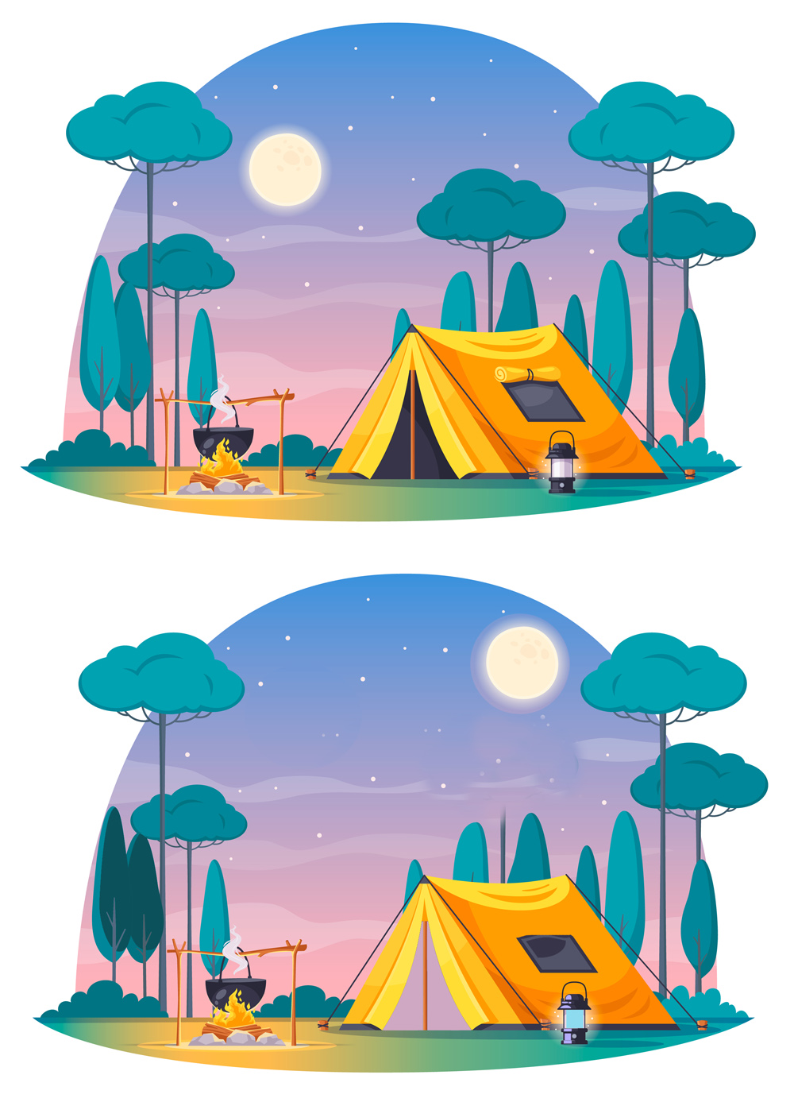
Pictures to Colour
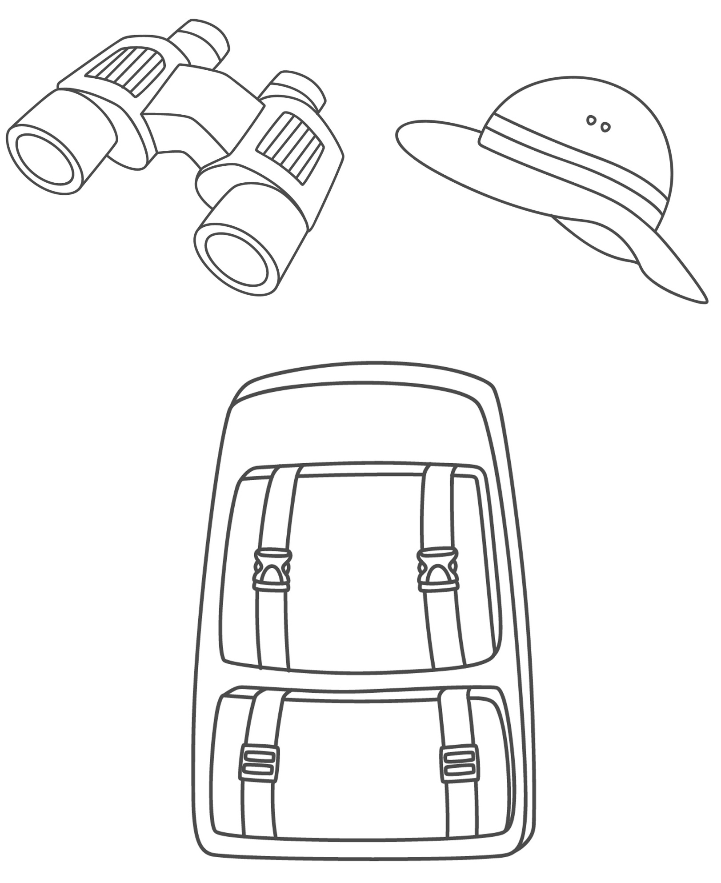
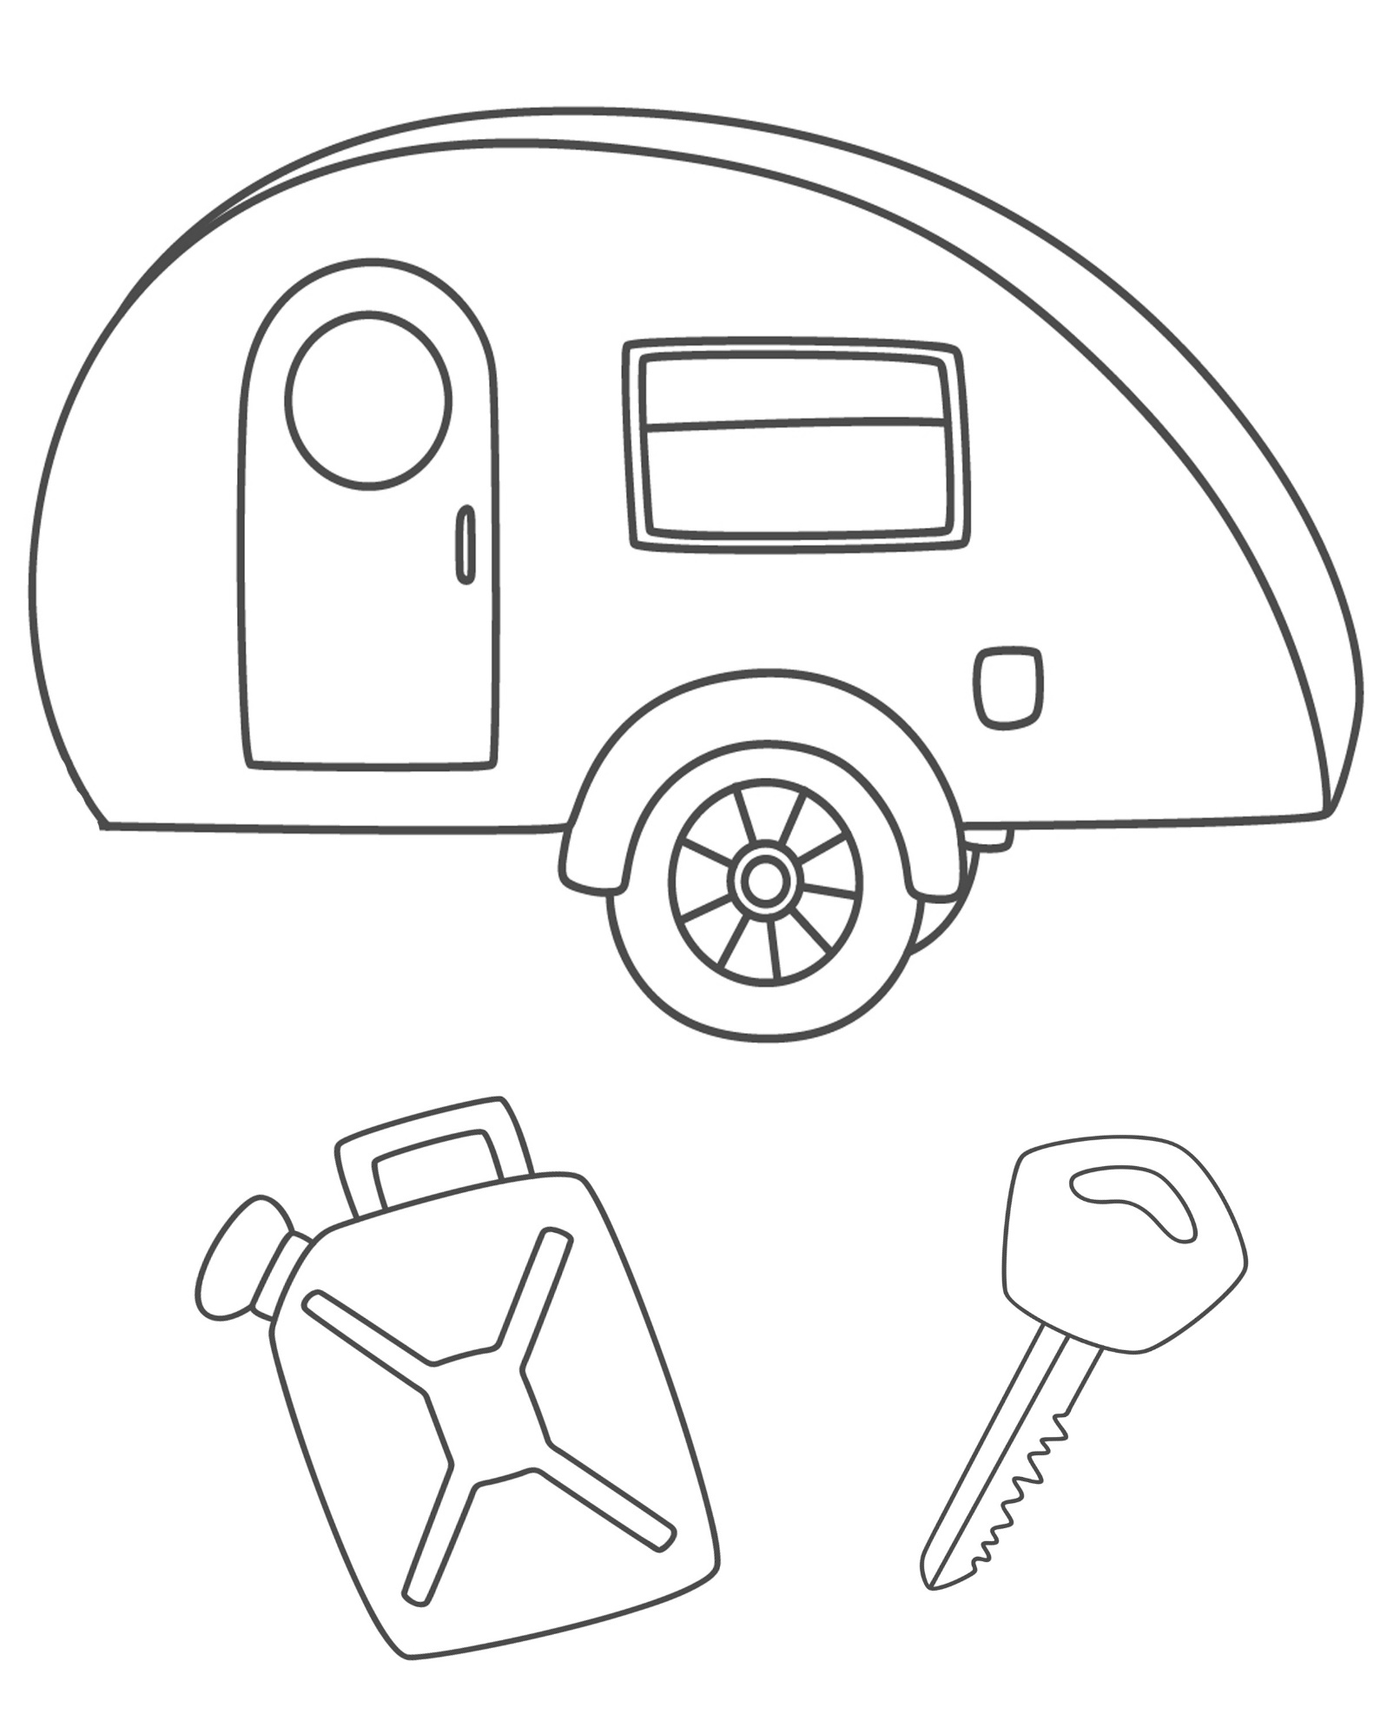

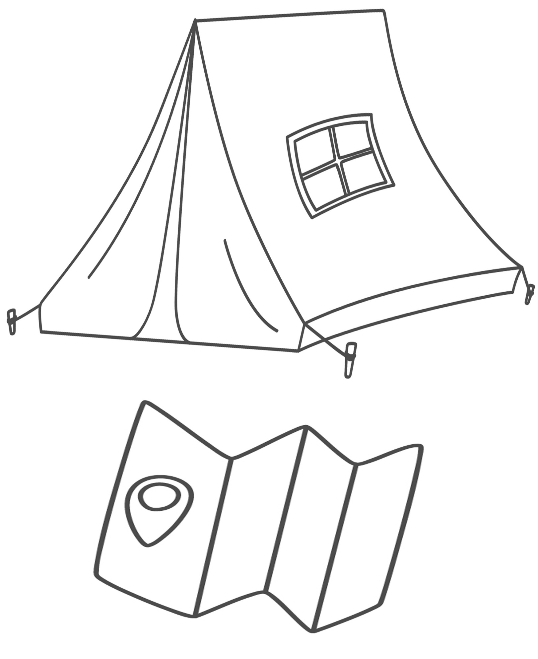

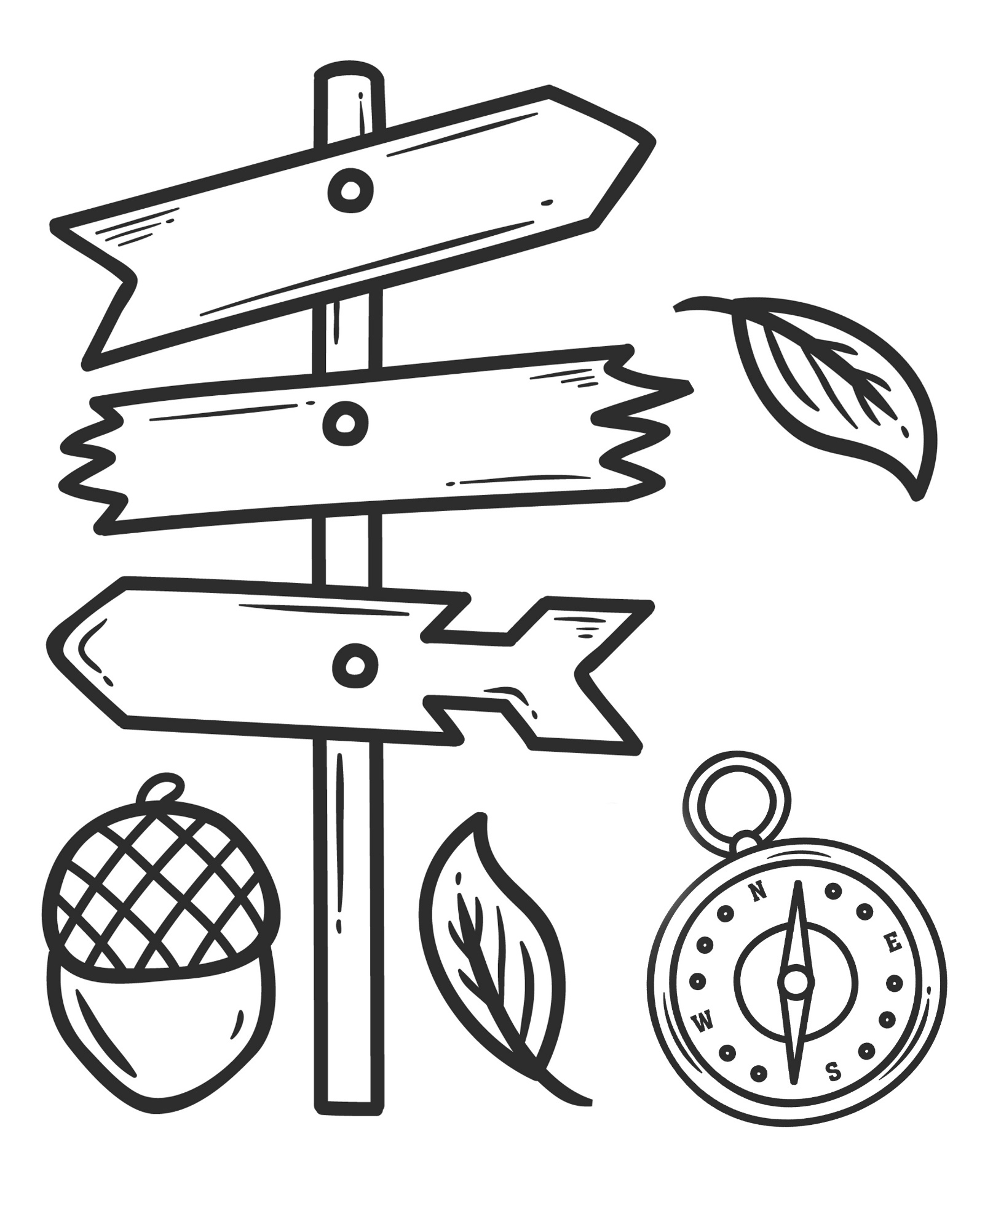

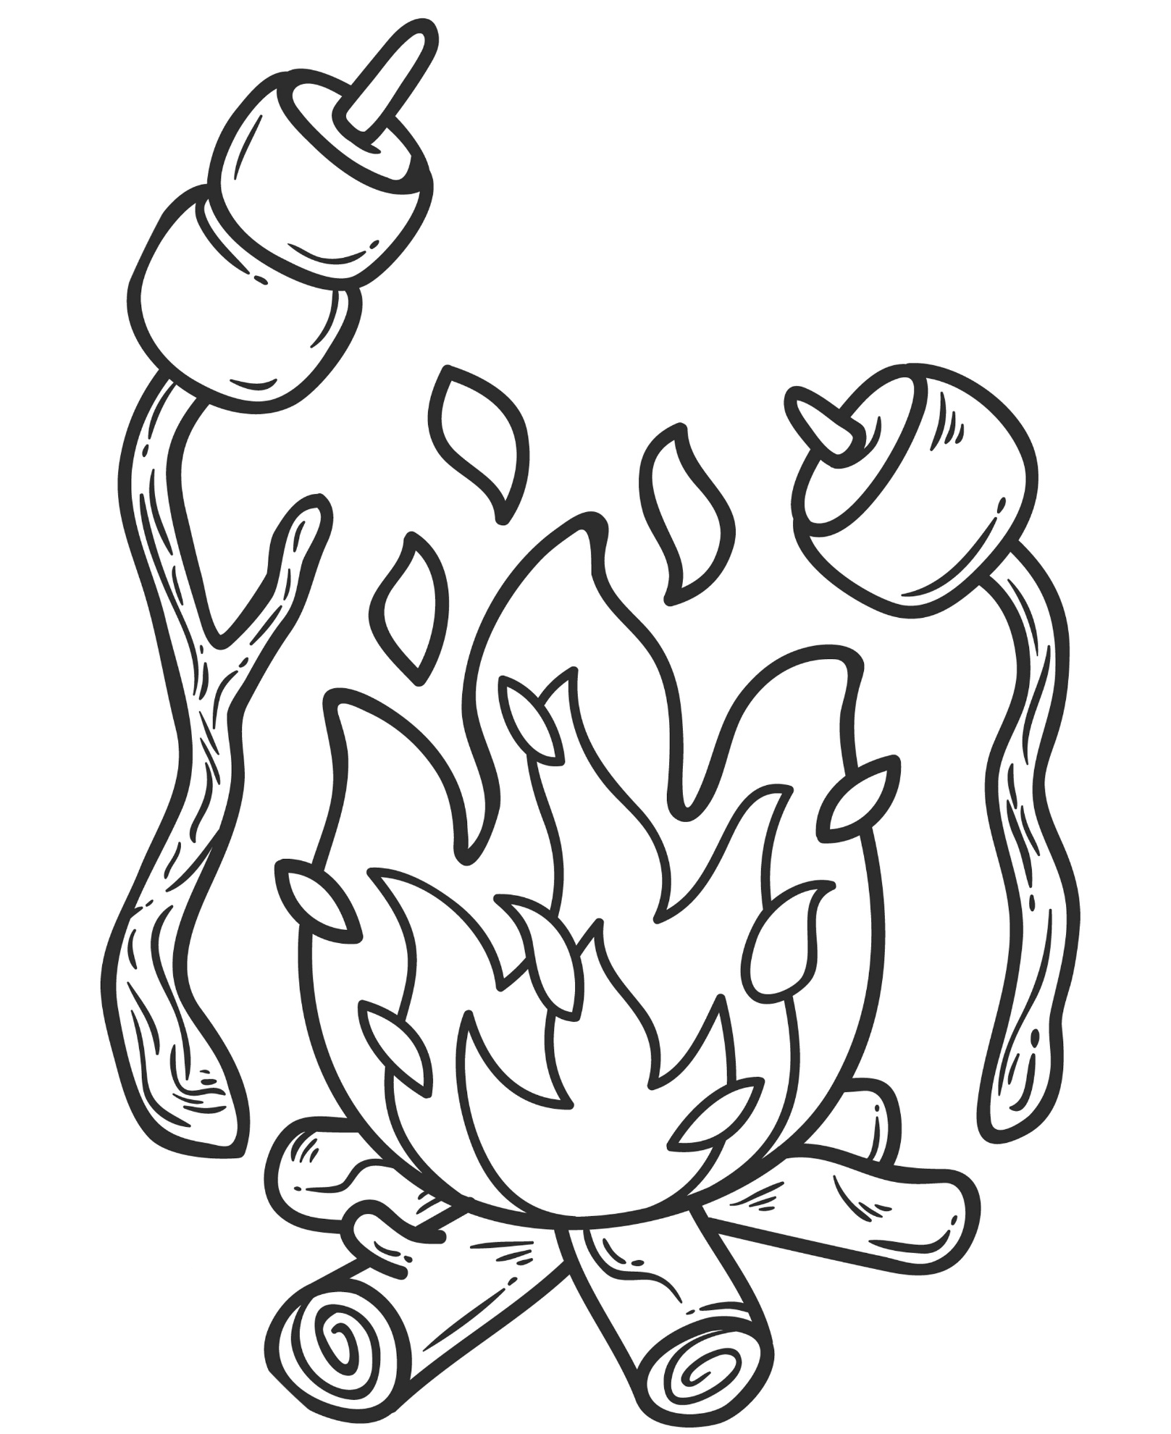

Mushroom Picking Game
How many of each type of mushroom can you see?
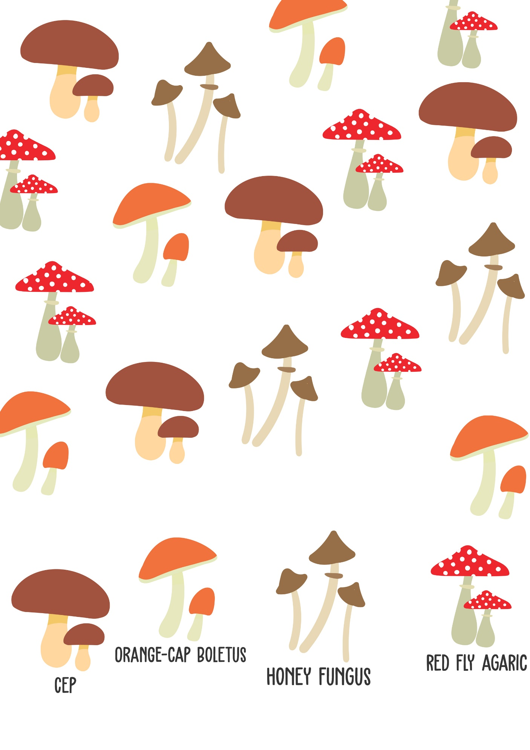

A Camping Morn by George Miller

The fire pit has been made
The kindling has been laid
The match was put to the dry, dry wood
And the flames began to play

The fire now is burning bright
The coffee pot is on
It is the way to start the day
On this cloudy, misty morn

The quiet of the darkened night
Flowed back thru greyish mounds
The moon was playing hide and seek
With drifting wispy clouds

A shadow blanketed the camp again
Closing out the morning light
The breeze then chased a leaf down hill
Like a windblown handmade kite

The icy hued moon was sliding
It soon would leave our sight
The hope for sun should soon come about
From this sharp and frosty night

And from the sky quite unexpectedly
Came rain drops as big as grapes
It pattered through the shroud of trees
A whooshing sound it makes

The raindrops hit the burning logs
With a hissing reptile sound
That caused an apparition of pure-white smoke
To eerily hug the ground

As fast as the rain began to fall
It just as quickly did dismiss
And launching shafts of sunlight
Replaced the lingering patchy mist

The sleepy woodlands did then awake
To the grandeur of a brand new dawn
And flitting through that peerless sky
The birds began their morning song!

Grass by Emily Dickson

“The grass so little has to do, --
A sphere of simple green,
With only butterflies to brood,
And bees to entertain,

And even when it dies, to pass
In odours so divine,
As lowly spices gone to sleep,
Or amulets of pine.

And then to dwell in sovereign barns,
And dream the days away, --
The grass so little has to do,
I wish I were the hay!”

Bed in Summer by Robert Louis Stevenson

In winter I get up at night
And dress by yellow candle-light.
In summer quite the other way,
I have to go to bed by day.

I have to go to bed and see
The birds still hopping on the tree,
Or hear the grown-up people's feet
Still going past me in the street.

And does it not seem hard to you,
When all the sky is clear and blue,
And I should like so much to play,
To have to go to bed by day?

An Poc ar Buile (The Mad Puck Goat!)
From an original poem by Dónal Ó Mulláin
in the early 20th century

Ag gabháil dom sior chun Droichead Uí Mhóradha,
Píce im dhóid 's mé ag dul i meithil,
Cé casfaí orm i gcuma ceoidh,
Ach pocán crón is é ar buile.

Curfá:

Ailliliú, puilliliú, ailliliú tá an puc ar buile!
Ailliliú, puilliliú, ailliliú tá an puc ar buile!

Do ritheamar trasna trí ruillógach,
Is do ghluais an comhrac ar fud na muinge,
Is treascairt do bhfuair sé sna turtóga,
Chuas ina ainneoin ina dhrom le fuinneamh.

Curfá

Níor fhág sé carraig go raibh scót ann,
Ná gur rith le fórsa chun mé a mhilleadh,
S'Ansan sea do cháith sé an léim ba mhó,
Le fána mhór na Faille Bríce.

Curfá

Bhí garda mór i mBaile an Róistigh,
Is bhailigh fórsa chun sinn a chlipeadh,
Do bhuail sé rop dá adhairc sa tóin ann,
S'dá bhríste nua do dhein sé giobail.

Curfá

I nDaingean Uí Chúis le haghaidh an tráthnóna,
Bhí an sagart paróiste amach 'nár gcoinnibh,
Is é dúirt gurbh é an diabhal ba Dhóigh leis,
A ghaibh an treo ar phocán buile.

Curfá

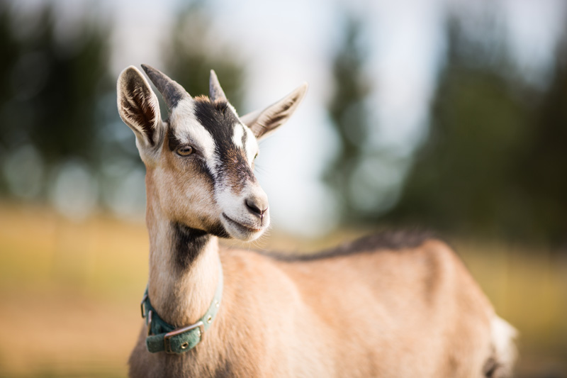

Your Campsite!
Use the signs below to imagine your perfect campsite and what areas you might like to have in it. What might you do in each area?
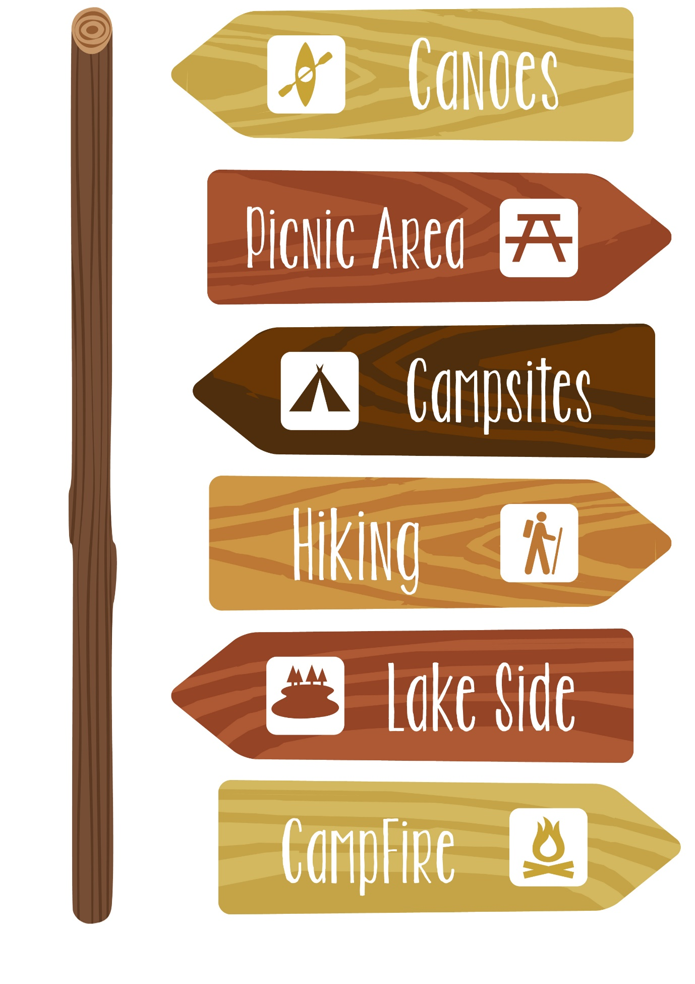
A Old Tale of Travelling Tribes by Robert Rogan, Co. Sligo

Long ago in Ireland there was a tribe of people called poets. These people were always going from house village to village and all along till any news they heard was all over Ireland.
These people were very fond of music and storytelling and earned their living this way, but they seldom worked in fields, houses, or gardens.

These people were dying out as the years went past and in their place came a lazy tribe called tramps. These people had their own huts and clans. Some of these people were good working people but the majority were unused to work and do not like it. They prefer to beg and sing songs on the street for a few pence. The people were very generous towards these people and used to let them sleep in their houses.
In some cases if the houses were too small they would let them sleep in good outhouses and barns. The people used to give them butter, sugar, milk, and plenty of wheaten bread.

There are other tribes called traders or tinsmiths. The tinsmiths make cans saucepans and other articles and sell them in villages, towns, and country houses.
The sewers make little tables mat lace and other various articles. There are a few people going around here who are a long time begging, their names are Gaffney or "The Old Bog Road," which he was named on account of a song he made up and used to sing on the streets. There is another named John Nancy: he is a curious individual and never wears any shoes or boots he is a good worker and he gets plenty to eat and a good bed from any one he will go to and work for. He comes of a very respectable family up in Bunnyconnlon but there is some sort of stray on him. There is another man named John Roche, who was in the war and was shell shocked. Since then he goes around like a wanderer but like John Nancy he comes of respectable people. They own a farm outside Ballina.

All those other clans have special places for camping. They camp in byways away from main roads and centres. Still they camp near a shop and near a wood or bog where turf or wood is easily procured. They also camp near a well so that water is easy to get. They also look for a place where wild fowl and rabbits are plentiful. These they trap and snare with much skill. They eat some of the game and sell more if they have them plentiful. They have several ways of earning money that other people have not.

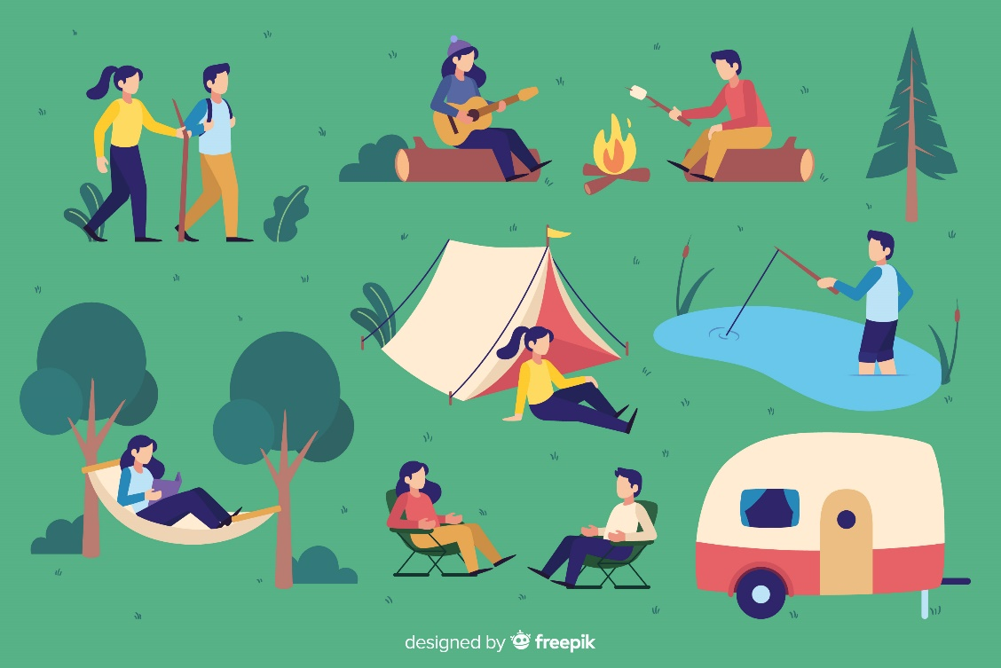

Where’s My Tent?
My tent is pointed in shape…. My tent is near some trees…
My tent are guide ropes attached… Which is my tent?

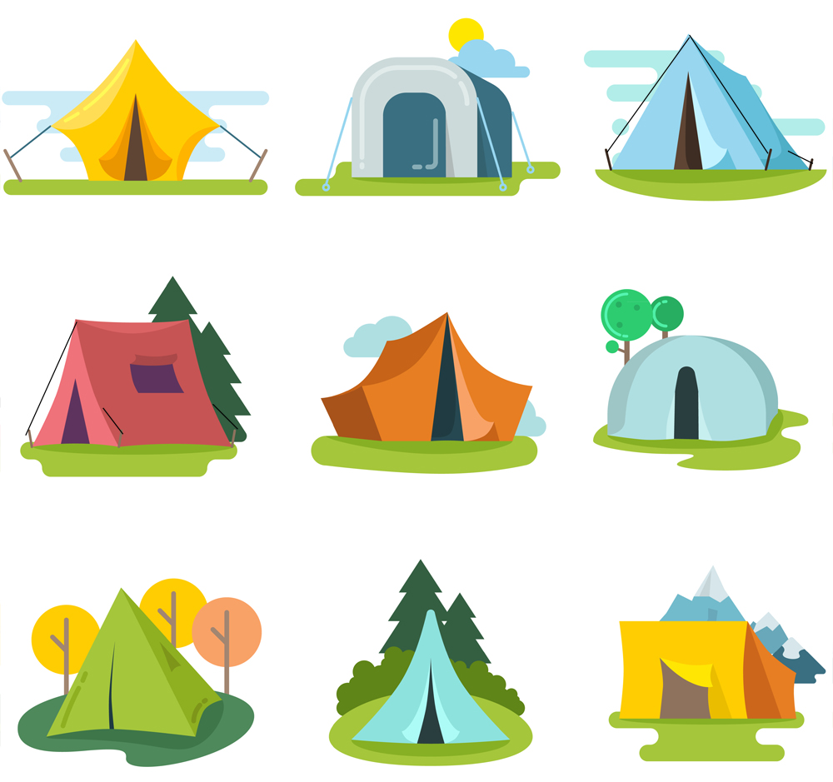

Answer: The red tent!

Pat Murphy's Meadow. Written by J.M. Devine

The autumn days are here again and the night winds chilly grow
The woodlands turn to golden hue and the harvest moon's aglow
To hear again of days long past, to come no more I know
When I mowed Pat Murphy's meadow in the sunny long ago

I see again the ocean and the distant sails afar
As the maidens in the meadow strikes up "Dark Lough na Gar"
There was music soft and tender in the winds that whisper low
When I mowed Pat Murphy's meadow in the summer long ago

Where are the happy boys and girls that danced the gay quadrilles
Or the singer who warbled sweetly "The Burning Granite Mill"
To hear again at sunset "Where Sweet Afton Waters Flow"
When I mowed Pat Murphy's meadow in the sunny long ago

Those days are but a memory like the snows of yesteryear,
And when evening shades are falling, all alone I shed a tear
On my cheek I feel the soft touch of the winds that whisper low
When I mowed Pat Murphy's meadow in the sunny long ago
When I mowed Pat Murphy's meadow in the sunny long ago

“The Games I Play” by Geraldine Howard Co.Cork 1938

The games I play are "Ring a Rosie" "London Bridges" "Jenny Jo" "Pickery" also Skipping and Marbles. I have a bicycle and I go for a sport ride every evening. I am soon going to learn "Tennis" and "Camogie".
When the season comes for blackberry picking I love to go out in the country and spend the evening along by the hedge rows, picking flowers and making chains, and necklaces from them. I like picking mushrooms when the time comes. I also like to go camping in the summer with my companion. In Winter I like skating and snowballing. When the long winter evening comes I like indoor games such as "Ludo" "Draughts" "Blind Man's Buff" "Musical Chairs" and "Burn the Biscuit".

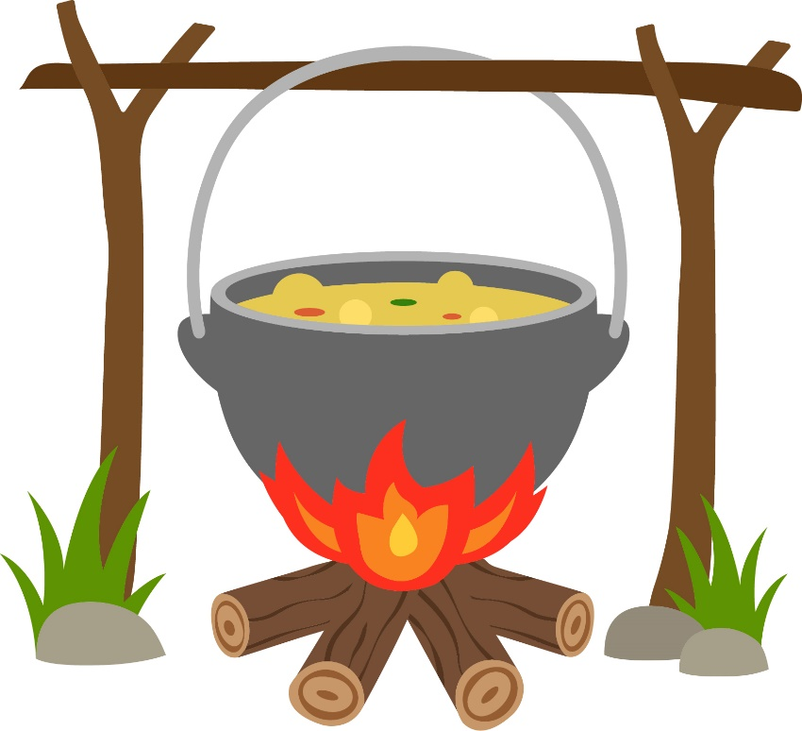

A Double Scare by P. Garvey Co. Galway

Once there was a mischievous boy who was very fond playing cards. One night he went playing cards about two miles from his home. He stayed playing cards there until it was very late. It was about one o’clock when he was coming home. There was a grave-yard near the road he had to pass. There were a great number of people coming home from a dance, so the boy thought of a great plan to frighten them. He turned his coat inside out and it’s a white cloth round him, and lay down near the wall.

However there were bandits and thieves camping near the grave-yard. One of them died the day before and their clan wanted to bury him in holy ground and they were not allowed. They thought of a plan to bring the remains of the thief at night-time and bury him, so that nobody would know about it. They succeeded in bringing the coffin into the grave-yard all right, and they left the coffin up on the wall the boy was lying near. They were making great noise and suddenly the boy looked up to see what was making the noise, and there he saw the coffin. He got a terrible fright and he got up and began to roar and run as fast as he could, over ditches and drains until he reached home. The bandits got frightened too when the saw the boy running and roaring with the white cloth over him like a ghost and they ran away also forgetting about the coffin and leaving it on the wall!

Ballad of Johnny O'Dell

Wild are the tales of the Pony Express
And most of them are true if I don't miss my guess.
But wildest of all tales that they tell
Is that of fearless young Johnny O'Dell.

Johnny was little, but he was a man
Whom none could outride, outshoot or outplan.
Ride, he could ride anything that could run
And could outdo any man with a gun.

Back in those days there were men in the West
And Johnny O'Dell was as good as the best.
Only the bravest could carry the mail
Through terrible dangers that haunted the trail.

Dangers there were on the night I describe,
For Johnny encountered a bandit tribe.
Jackie, his horse, gave a new burst of speed.
No bandit on foot could equal that steed.

Bullets and arrows whizzed over his head
As into the foe and right through them he sped.
Outlaws had raided the station ahead
The horses were stolen, his partner was dead.

Onward went Johnny over the trail.
For such was the life when you carry the mail
Rivers they forded for bridges there were none
While crossing one stream he was stopped by a gun.

"Halt!" cried a man on the bank of the creek-
As together they fired by the light of the sun.
Still lay the stranger whom Johnny had met,
For all that I know he is lying there yet.

Onward went Johnny into the West,
As a spot of crimson appeared on his vest.
Together they continued their hazardous ride,
The powerful horse with the brave man astride.

Into the town of Red Gulch did they go,
As blotches of blood marked their way through the snow.
This was the end of the perilous trail
Through bullets, and arrows; through blizzards and hail.

Johnny dismounted and cried with a wail,
"Oh, Darn it all, I've forgotten the mail!"

Guided Meditation for Sleep
(do this while lying in bed, ready for sleep)

With your eyes closed, begin to focus on your breathing. Take in a nice, deep breath through your nose and feel it fill up your lungs. Feel your belly fill up with the air, then let it go. As you breathe, you feel the bed rising up to meet and support you, and you allow yourself to grow heavier and heavier with each breath.

Feel your body sinking into the softness of your bed. As your body becomes still, your mind begins to drift. You see a green meadow, soft and peaceful. You feel the breeze blowing against your cheek. You feel the grass underneath your feet. You listen and you hear the stillness of nature. You breathe and look around the meadow. You see the houses down in the valley and the mountains in the distance. You fill your lungs with air. In and out. In and out. With your mind clear of any other thought, you tell yourself this affirmation:
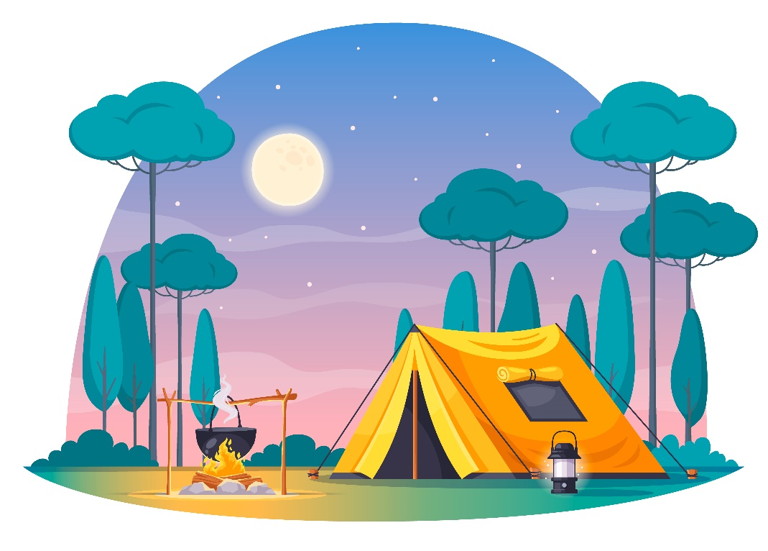
I am peaceful.
I am peaceful.
I am peaceful.

