August
Activity Pack

Dear Friends,

The year is really flying by and we find ourselves already in August! The long days and milder weather make is a wonderful time to take a moment to pause and reflect.

This month’s activity pack theme is “Relaxation”. This can come in many forms – reading, walking, gardening, prayer, treating yourself to a pampering treatment or even a round of golf!

We realise the life can be a rollercoaster at times and we want to take this opportunity to emphasize the importance of taking time out to look after ourselves, slow down and take a break to
re-energise.

We would love to hear from you if you would like to suggest a theme for a pack, or if you’d like to share your artwork with us and have it featured on our social media. We also welcome poems and stories to be included in the pack if we have any artists or writers out there! Please contact Danielle at danielle.keogh@alzheimer.ie if you’d like to contribute.

“Peace cannot be kept by force,
it can only be achieved by understanding.”
Albert Einstein
Useful Resources:

- Our Free Helpline is available at: 1800 341 341

- Armchair Azure is a free online experience designed for people living with dementia and their families and friends. During Armchair Azure, you will explore a selection of artwork from IMMA’s Collection with a facilitator to guide you.
For more information please email: edcommbooking@imma.ie

- We are hosting several Virtual Cafes. They are a place to come together, share a cuppa and listen to our amazing guest speakers. For information on how to attend visit: https://alzheimer.ie/service/alzheimer-cafe/

- The ASI also have a huge library of factsheets and resources available on: https://alzheimer.ie/get-support/resources-and-factsheets/

- M4D Radio is a 24/7 online radio station with songs specifically picked to evoke memories and aid reminiscence. To find out more and to listen, please visit: https://m4dradio.com/

- Each Thursday in Sept we will run the ASI National Virtual Choir. If you would like to join in, sing along or sit back and make some musical memories please email: asinationalvirtualchoir@alzheimer.ie

- Emergency Response Numbers: 999 or 112

- HSE 24/7 Your Mental Health Information Helpline: 1800 111 888

Table of Contents

Activity | Pages
Gardening Spot the Difference | 5 – 6
Pampering Wordsearch | 7
Relaxing Activities Wordsearch | 8
Fishing Counting Game | 9
Sudoku | 10
Garden Maze | 11
Pictures to Colour | 12 – 18
Aromatherapy Scents | 19 – 20
Pampering Day | 21
A Perfect Day Poem | 22
Treasure Poem | 23
Cúl an Tí Poem | 24
Take Me Home, Country Roads | 25 – 26
Come by the Hills | 27
Shetland Ponies Story | 28 – 29
Enchanted Fall Forest Meditation | 30 - 31

Gardening Spot the Difference
See if you can see the 5 differences between these two pictures
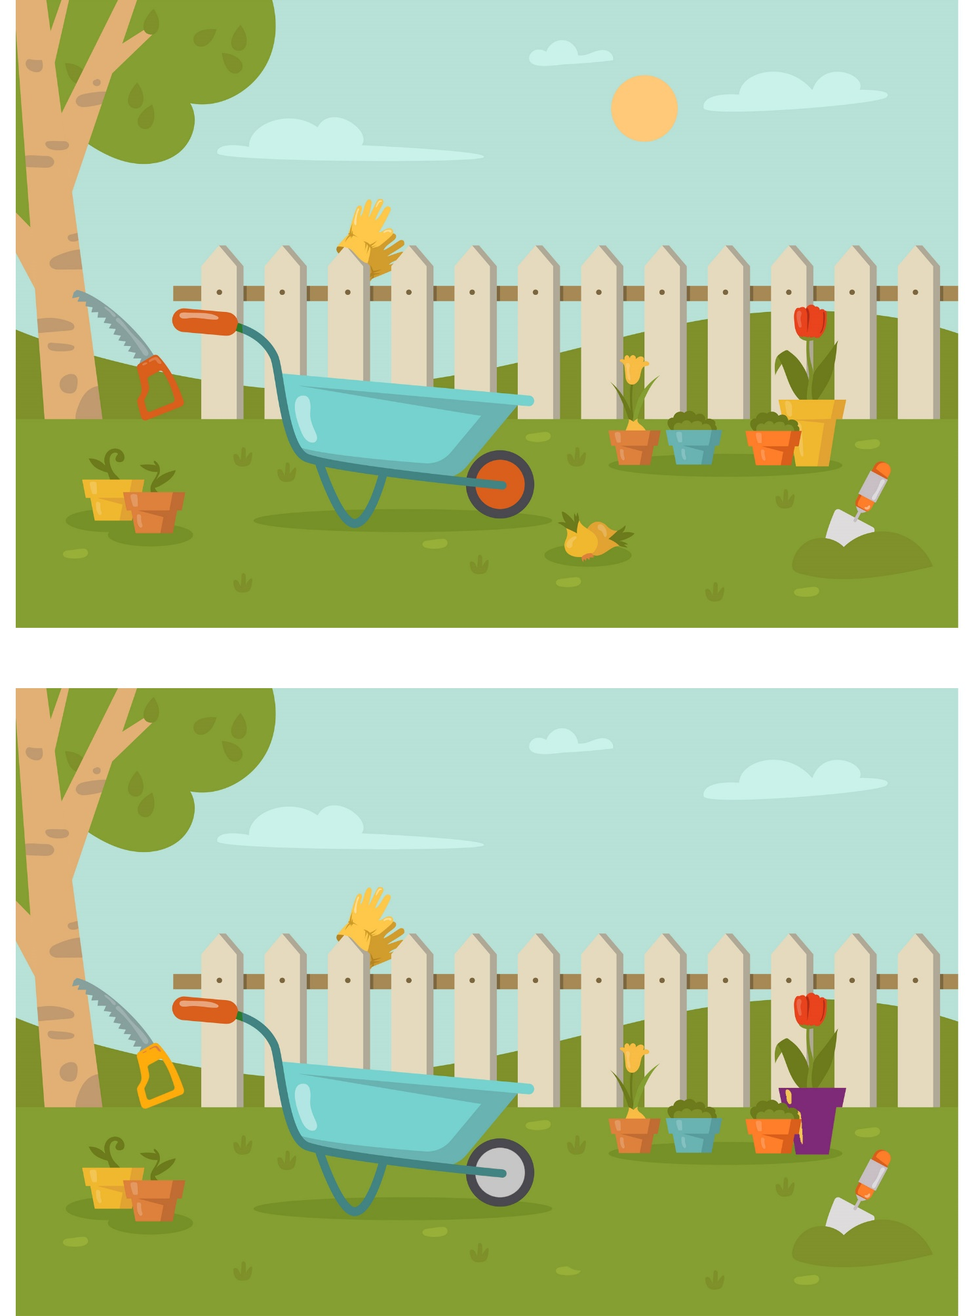
Gardening Spot the Difference
See if you can see the 5 differences between these two pictures

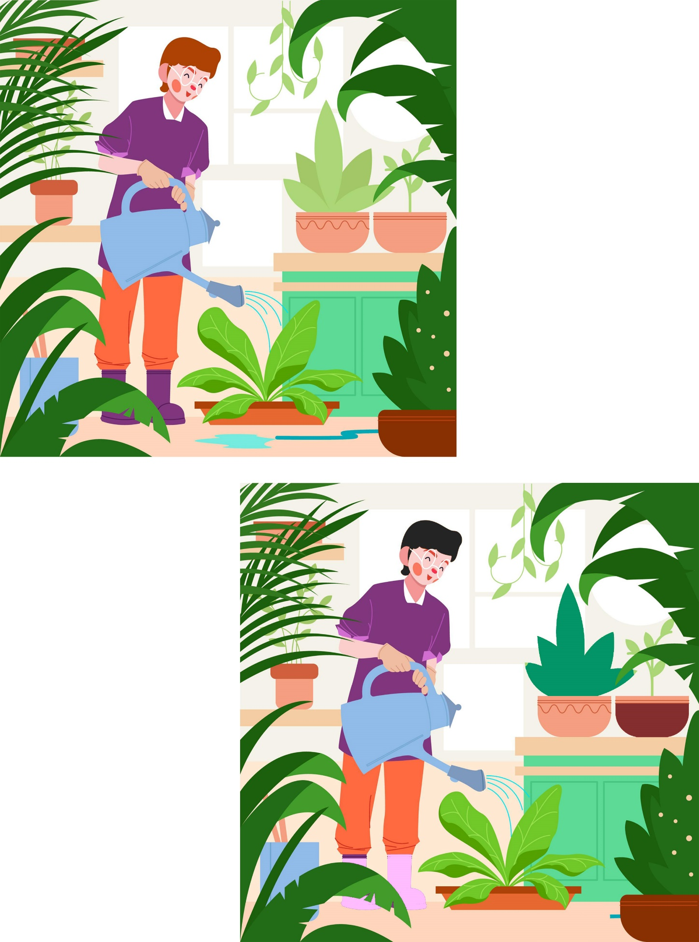
Pampering Wordsearch
K | M | O | L | X | F | T | N | S | E | T | F | Z | M | P
J | A | A | T | M | O | P | P | P | D | Q | B | R | A | T
X | S | R | R | E | L | A | X | A | T | I | O | N | N | W
R | S | O | L | G | G | U | E | R | Z | M | U | S | I | C
H | A | M | G | H | J | G | J | E | O | L | L | H | C | H
A | G | A | R | D | P | Q | L | F | V | P | H | O | U | Z
I | E | T | O | M | D | K | X | R | F | N | K | O | R | V
R | F | H | O | D | J | S | Z | E | A | H | Y | X | E | T
C | X | E | M | U | Y | G | V | S | C | U | A | G | Z | U
U | O | R | I | A | E | Q | D | H | I | J | W | I | F | L
T | Y | A | N | J | E | U | P | M | A | T | L | F | C | B
N | H | P | G | U | B | H | P | E | L | G | N | P | I | J
D | C | Y | B | I | I | L | J | N | Y | C | A | P | I | U
W | D | E | Q | A | E | K | Q | T | O | J | M | U | Y | R
P | E | D | I | C | U | R | E | V | W | V | T | E | X | C

HAIRCUT MANICURE
PEDICURE MASSAGE
AROMATHERAPY RELAXATION
MUSIC FACIAL
REFRESHMENT GROOMING

Relaxing Activities Wordsearch
X | H | H | C | G | M | I | N | D | F | U | L | E | E | U
N | D | D | L | F | W | D | P | S | I | N | G | I | N | G
I | V | J | I | Q | G | C | A | X | R | F | A | N | K | Z
U | E | O | P | L | O | J | I | Z | Y | E | O | B | E | U
V | N | J | Q | Q | L | Y | N | D | T | T | A | I | O | W
G | F | P | U | A | F | R | T | J | G | I | W | V | L | Z
T | E | L | E | V | I | S | I | O | N | G | U | T | T | G
Z | M | H | M | I | N | L | N | Q | S | E | S | F | V | F
C | U | D | A | W | G | E | G | U | S | K | O | R | Q | B
W | S | B | S | N | Q | Y | H | A | O | X | D | O | P | O
A | I | V | S | Y | R | E | A | D | I | N | G | U | E | V
O | C | U | A | V | Y | F | I | S | H | I | N | G | V | I
Z | Y | P | G | M | E | D | I | T | A | T | E | L | T | E
C | L | F | E | D | L | D | N | A | P | V | S | K | V | M
G | A | R | D | E | N | I | N | G | T | C | F | C | X | V

FISHING GARDENING
GOLFING MASSAGE
MEDITATE MINDFUL
MUSIC NAP
PAINTING READING
SINGING TELEVISION

Fishing Counting Game
Oh no! Someone has dropped their fishing tackle box!
Count the different fishing lures and write your totals below
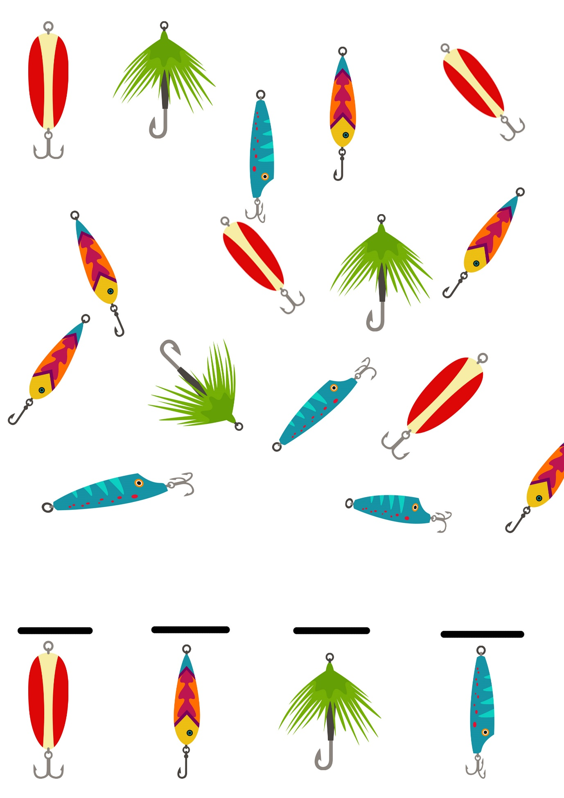
6x6 Sudoku
- Every square has to contain a single number.
- Only the numbers from 1 through to 6 can be used.
- Each 3×2 box can only contain each number from 1 to 6 once
- Each vertical and horizontal column can only contain each number from 1 to 6 once

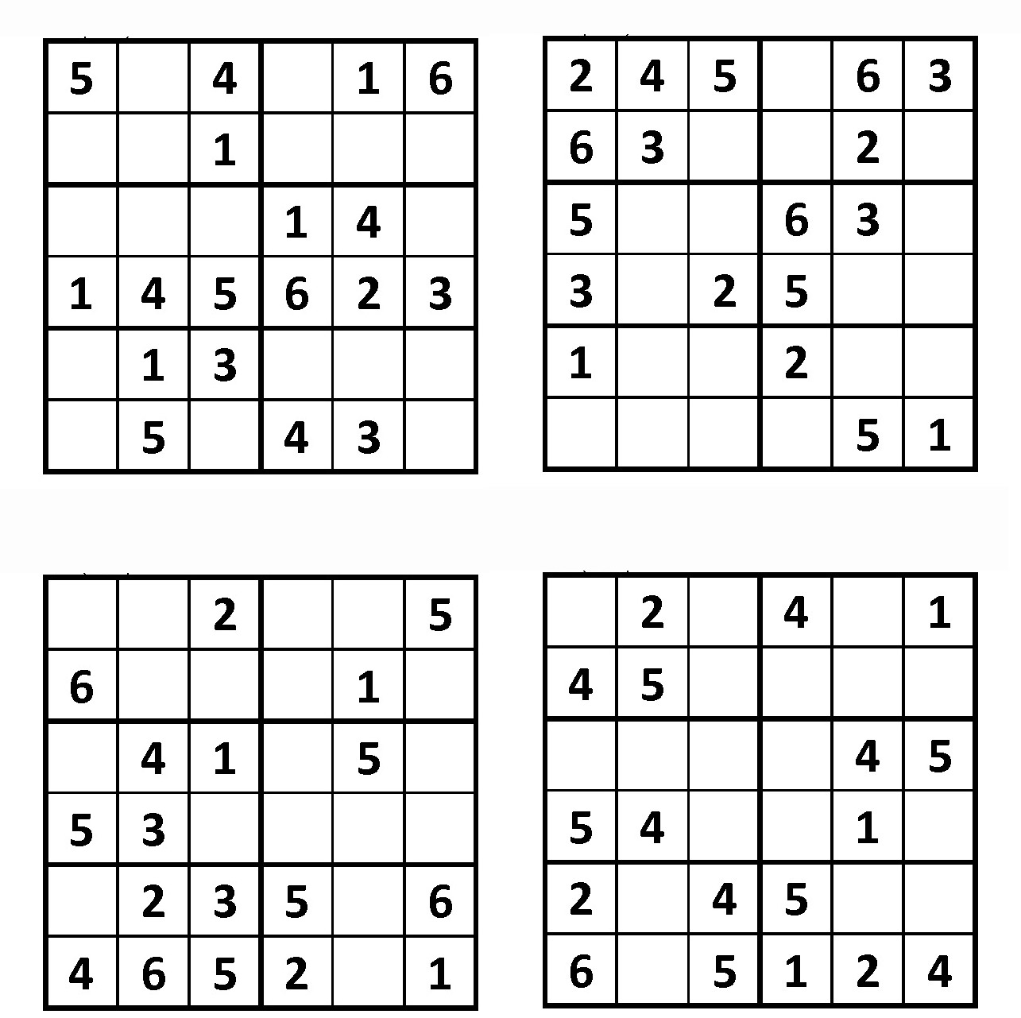

Garden Maze Puzzle
Help carry the plant to the garden!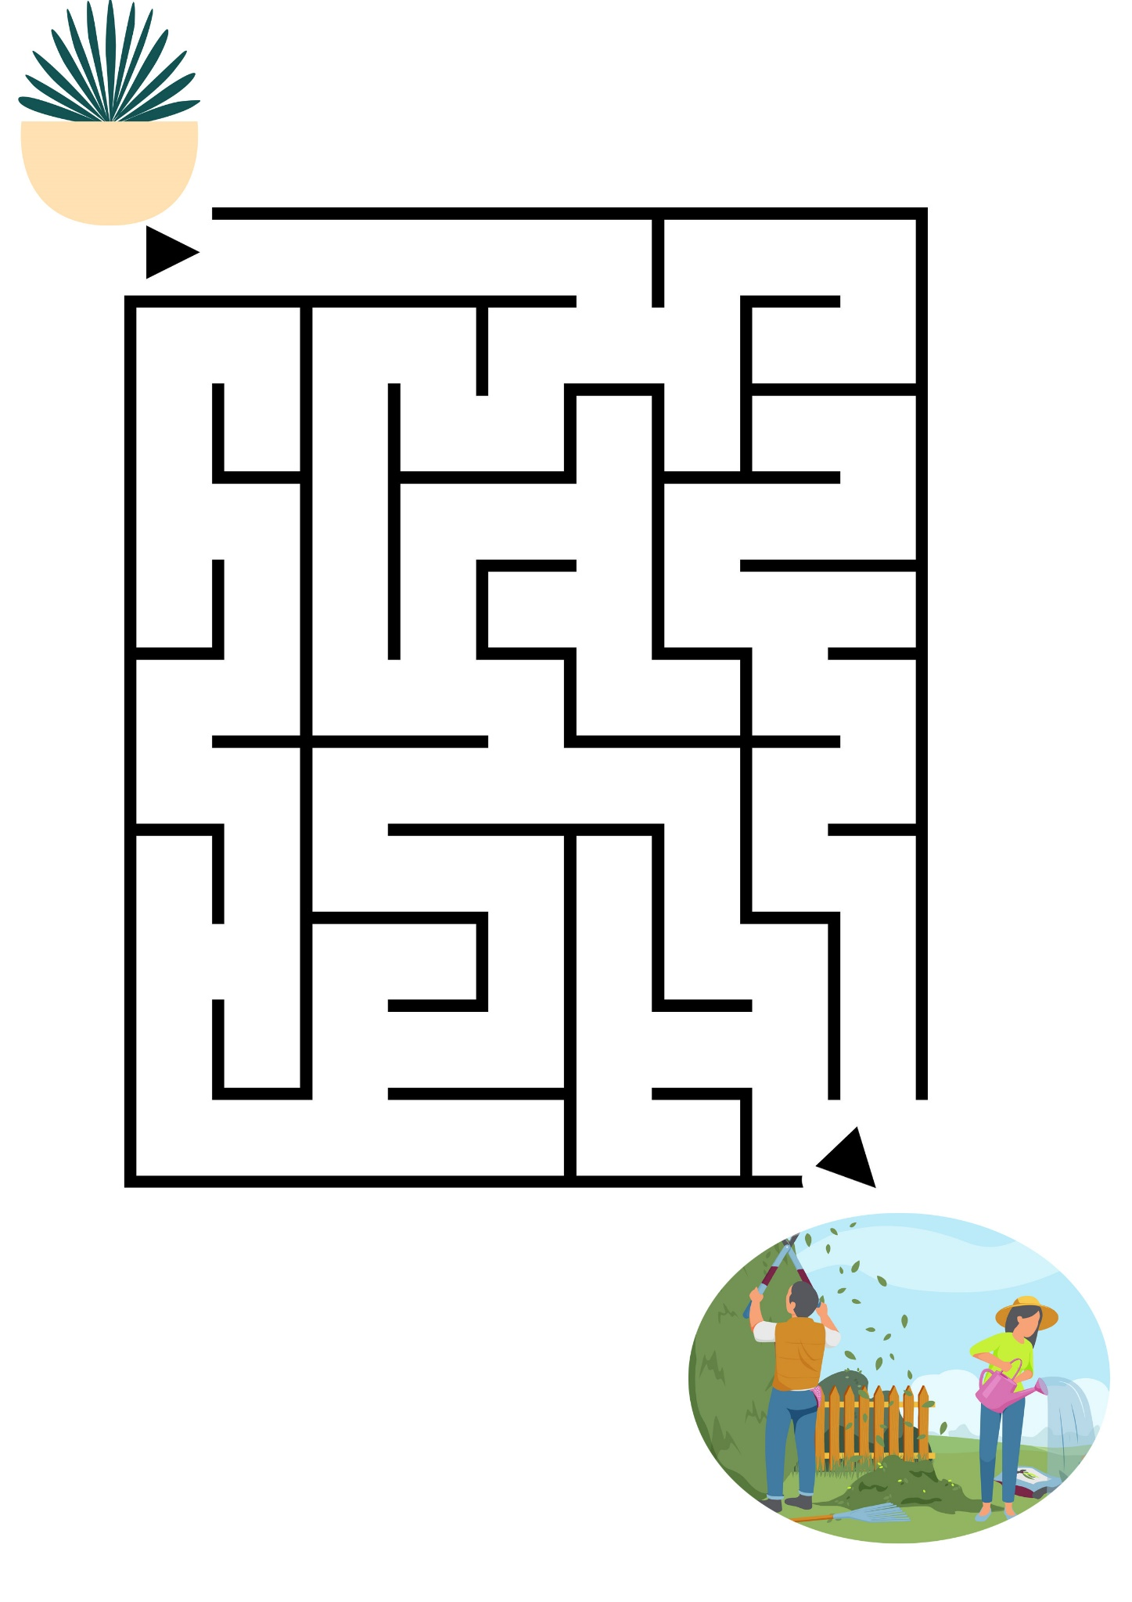
Pictures to Colour
We have included some ”mandala” designs for you to colour – some people colour, or visualise, these whilst mediating to help relax and give insight as they relax into the pattern.

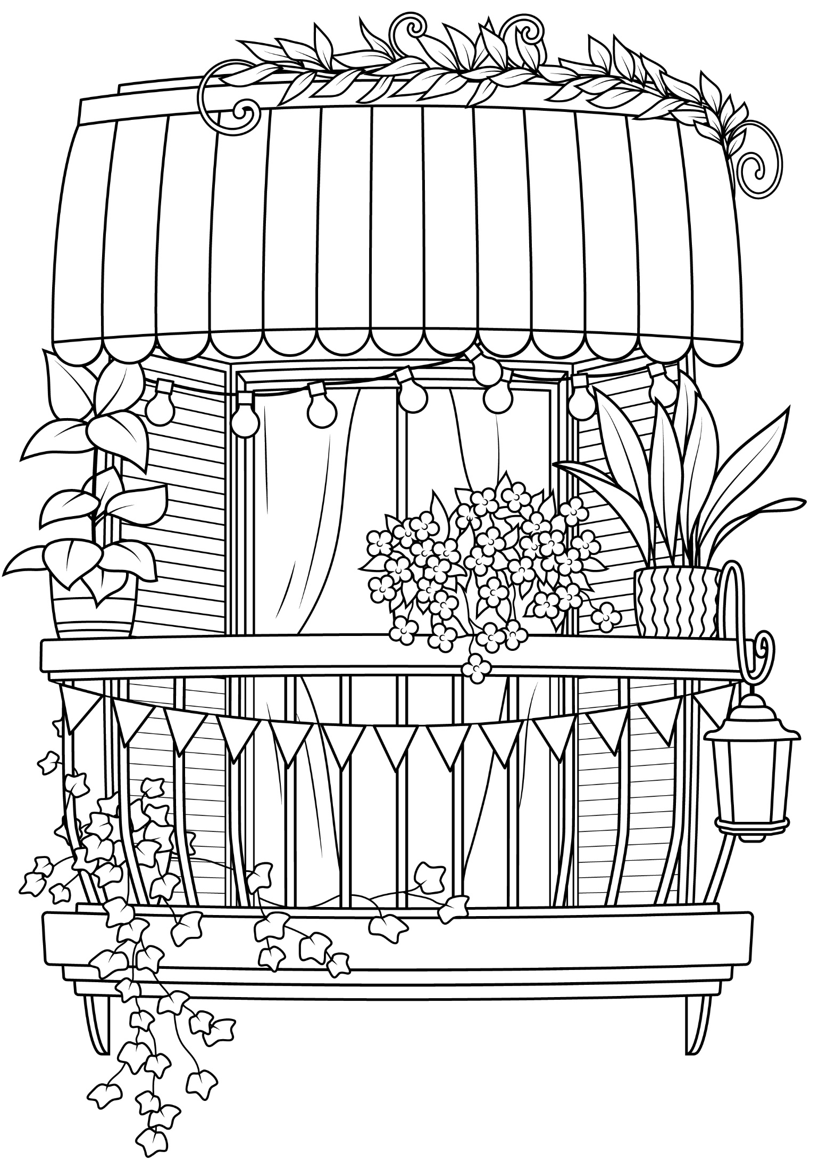
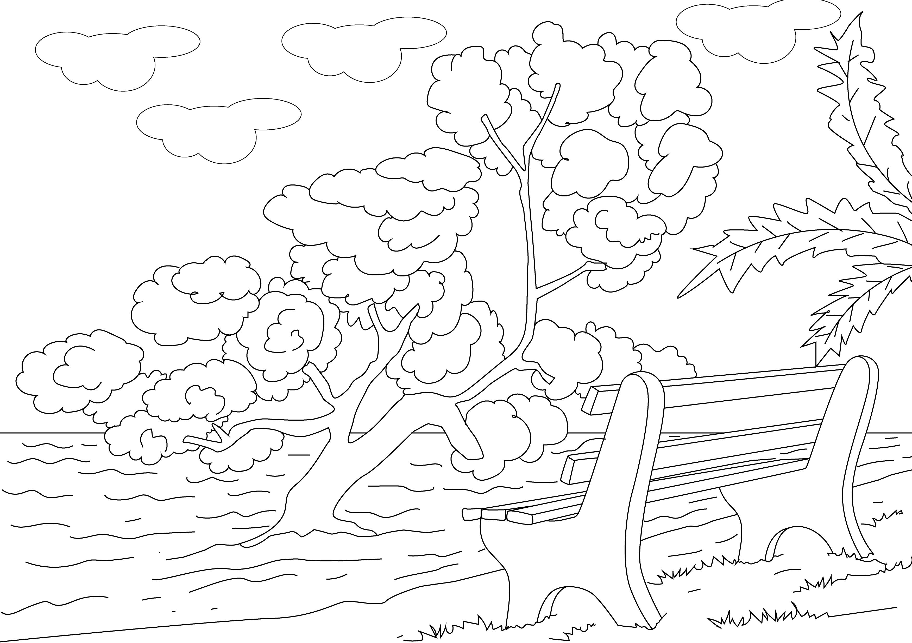

Aromatherapy Scents
Essential oils have been used for thousands of years for their exquisite aromas and ability to calm and relax us. Aromas can trigger emotional and even physical responses and allow vivid memory recall of people or places.
You might like to include the scents below in incense, diffusers, hand cream or lotion, shower gel etc. Be sure however that you do not have any allergies as all scents may not be suitable for everyone.

Rosemary
You’ve probably cooked with rosemary before, but you should also consider including this fragrance as part of your aromatherapy routine. Rosemary has both energizing and relaxing effects, so if you need to improve your concentration and reduce stress while working on a major project, you should definitely try it out.

Lavender
Lavender is one of the most popular scents for relaxing and falling asleep, and with good reason. This fragrance oil has many calming properties, and it can help release tension, soothe racing thoughts and help you unwind. Whether you’re stressed from work or just want to supercharge a relaxing evening, lavender will help you calm down and unwind in no time.

Jasmine
This sweet, rich floral scent is known for its calming properties. If you’re tired and stressed, this fragrance oil will help soothe your tension and promote relaxation. Jasmine is not only available as an oil but can also be found in many candles, perfumes, soaps and even alcohol and desserts.

Vanilla
This sweet, mild scent doesn’t get enough credit for its calming properties. While many people dismiss vanilla as a pedestrian fragrance, it’s a fantastic base scent that will also help you relax—not to mention it makes your whole house smell like baked goods, minus the hassle and mess of getting in the kitchen. We call that a win-win.

Peppermint
If you’re looking for an invigorating yet calming scent, but don’t want a citrus fragrance, then peppermint is a good alternative. The minty nature of this refreshing scent will gently invigorate you while soothing away tension.
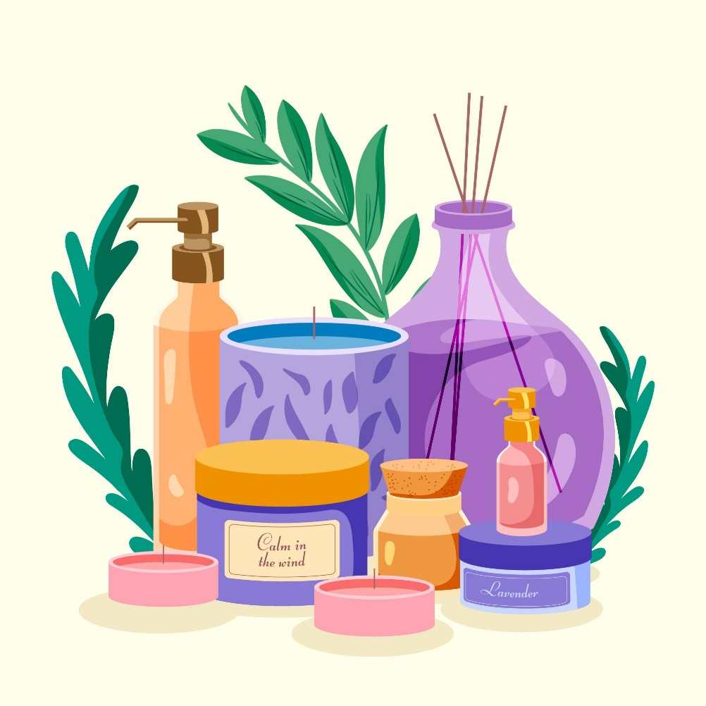
Pampering Day

If you can’t do out to a salon or beautician, why not have a pampering day at home?
- Here are some ideas of activities you might like to include:
- Set the scene with some relaxing music, low light and candles if safe to do so.
- Begin by taking some slow, deep breathes and relaxing your body and mind.
- Stretch each limb out and relax it into a comfortable position.
- Begin with a gentle hand massage using lotion if you like, this can be on yourself or on a loved one. Take your time and enjoy the contact and this gentle form of care.
- You might like to have a bubble bath – treat yourself to a glass of wine, some chocolate or even a nice cup of tea!
- Giving your nails a trim and file can really make you feel good and if you like finish with a coat of your favourite polish.
- Put your feet up and read a book with a hot drink and some calm music in the background.
- If assisting a loved one why not do their hair? Wash, comb and dry it into a style and finish with a spritz of perfume or cologne.
- The main thing is not to rush – set out some dedicated time to give to these activities.

A Perfect Day
by Carrie Jacobs Bond

When you come to the end of a perfect day
And you sit alone with your thought
While the chimes ring out with a song so gay
For the joy that the day has brought,
Do you think what the end of a perfect day
Can mean to a tired heart?
When the sun goes down with a flaming ray
And the dear friends have to part?

Well, this is the end of a perfect day,
Near the end of a journey, too;
But it leaves a thought that is big and strong,
With a wish that is kind and true;
For mem'ry has painted this perfect day
With colors that never fade,
And we find, at the end of a perfect day,
The soul of a friend we've made.

Treasures By Patricia L. Cisco

Treasures come in so many ways:
the sun that lights the cloudy days,
a rainbow from a summer shower,
a rose that blooms within an hour.
Yes, treasures come in so many ways.

A baby's staring, wandering gaze,
a dolphin's dance on ocean waves.
Yes, treasures come in so many ways.

The heart beats of two souls in love,
a beautiful white and peaceful dove.
Yes, treasures come in so many ways.

A sky full of snowflakes of rarest form,
a cup of cocoa to keep us warm.
Yes, treasures come in so many ways.

A house full of family on holidays.
For these treasures we should give God praise!
Yes, treasures come in so many ways.

I could keep on counting for days and days!

Cúl an Tí by Sean ORiiordain

Cúl an Tí
Tá Tír na nÓg ar chúl an tí,
Tír álainn trína chéile,
Lucht cheithre chos ag súil na slí,
Gan bróga orthu ná léine,
Gan Béarla acu ná Gaeilge.

Ach fásann clóca ar gach droím
Sa tír seo trína chéile,
Is labhartar teanga ar chúl a’ tí
Nár thuig aon fhear ach Aesop,
Is tá sé siúd sa chré anois.

Tá cearca ann is ál sicín,
Is lacha righin mhothaolach,
Is gadhar mór dubh mar namhaid sa tír
Ag drannadh le gach éinne,
Is cat ag crú na gréine.

Sa chúinne thiar tá banc dramhaíl,
Is iontaisi an tsaoil ann,
Coinnleoir, búclaí, seanhata tuí,
Is trúmpa balbh néata,
Is citeal bán mar ghé ann.

Take Me Home, Country Roads by John Denver
Almost heaven, West Virginia
Blue Ridge Mountains, Shenandoah River
Life is old there, older than the trees
Younger than the mountains, growin' like a breeze

Country roads, take me home
To the place I belong
West Virginia, mountain mama
Take me home, country roads

All my memories gather 'round her
Miner's lady, stranger to blue water
Dark and dusty, painted on the sky
Misty taste of moonshine, teardrop in my eye

Country roads, take me home
To the place I belong
West Virginia, mountain mama
Take me home, country roads

I hear her voice in the mornin' hour, she calls me
The radio reminds me of my home far away
Drivin' down the road, I get a feelin'
That I should've been home yesterday, yesterday

Country roads, take me home
To the place I belong
West Virginia, mountain mama
Take me home, country roads

Country roads, take me home
To the place I belong
West Virginia, mountain mama
Take me home, country roads

Take me home, (down) country roads
Take me home, (down) country roads

Come by the Hills By Tommy Makem

Oh, come by the hills to the land where fancy is free.
Stand where the peaks meet the sky and the loughs meet the sea,
Where rivers run clear, bracken is gold in the sun;
Ah, the cares of tomorrow can wait till this day is done.

Oh, come by the hills to the land where life is a song.
Stand where the birds fill the air with their joy all day long,
Where the trees sway in time, even the wind sings in tune;
Ah, the cares of tomorrow can wait till this day is done.

Oh, come by the hills to the land where legend remains.
The stories of old fill the heart and may yet come again,
Where the past has been lost, the future is still to be won;
Ah, the cares of tomorrow can wait till this day is done.

Oh, come by the hills to the land where fancy is free.
Stand where the peaks meet the sky and the loughs meet the sea,
Where rivers run clear, bracken is gold in the sun;
Ah, the cares of tomorrow can wait till this day is done.
Shetland Ponies

I remember the morning perfectly. The bay was all dotted with the white sails of the fishing boats. The town was all awake carrying dried fish to the boats at anchor, and on the corners of the streets were gathered women and young girls selling potatoes they had just brought in from the distant field. We took a rowboat, and rowed across Bressay Sound to Bressay Island, and then walking across it, and after looking back at the town and out at sea, we came to a small strait, and had to hire another boat to take us across the water to Noss Island. This island is not very large but has more green grass than any other of the Shetland group. One end of it almost buries itself in the sea, and then it gradually rises higher and higher, until the opposite end rises a thousand feet right up from the sea. There is only one house on the island, and in that lives the keeper of the ponies and his two children. I wish you could have seen these children when they saw us coming in the boat.

They hardly ever leave the island themselves, and so when any strangers come to see their ponies, how happy it makes them! They were very pretty and bright children, too. They had light hair and bright blue eyes, and cheeks as red as roses. Running down with them, was their pet dog, who seemed just as glad as any of the rest to see strangers. The house the man lived in was very lonely-looking to us. It was built of stone, and then painted white, and stood on a little knoll overlooking the blue waters of the cold North Sea.

After a short rest we walked out to explore the island and see the ponies. Here was their home and we should see them here in their real life. As we walked along, we came to a part of the island where it was rather sandy, and there found such a nest of rabbits. We almost stumbled into their holes, there were so many of them when we came upon them. There must have been fully a hundred nibbling the short grass or standing up to see who was coming to disturb them. The keeper said they were a great nuisance to the island, they undermined it so.

But a sight that interested us more than that of the rabbits was the great herd of ponies we saw before us.
There must have been fully two hundred of the shaggy-maned little fellows. Some were eating, some biting one another, some running as though having a race, and others stood still looking at us. When we came nearer the whole herd pricked up their ears, gave little snorts of anger, and galloped away as fast as their short legs could carry them.
The keeper told us that when one wishes a pony, to ride or sell, he must take the one he keeps near his house, mount him, and then riding out to the herd, lasso one at a time until you obtain all you wish. In winter the ponies of Noss Island have rather a hard time of it. Though there is not much snow on the island, still the winds often blow very fiercely, and poor pony has no warm barn to go to. Sometimes the keeper builds a wall about a square piece of ground, and pony can go into the enclosure and so be somewhat sheltered. But usually he must face the wind and storm, no matter what the weather.
Enchanted Fall Forest Mediation

Gently close your eyes and take in a nice deep breath.
Do this several times and allow your body to relax more and more with each deep breath. Notice how peaceful you become with this deep breathing. Notice how all your muscles begin to relax and feel good and loose. Continue to breathe normally now as I guide you on this marvellous adventure!

Imagine yourself now, walking down a well-worn path in a beautiful forest. The trees have changed all their foliage and now you see an amazing display of colours – gold, red, orange and speckles of green. Leaves crunch beneath your feet as you walk along. The air smells so crisp and fresh. Its coolness tickles your nose and ears. It feels so very wonderful to be out here, in nature, enjoying the beauty of this place. In the distance you hear a waterfall, and you carefully walk towards the rushing water sound. As you come to the path’s end, you see the rushing stream.

You see the most beautiful white waterfall right in front of you. It’s so calming and looks as if wet sunshine is cascading down onto large rocks. The sound of rushing water relaxes you. The water must be pretty cold because its fall now and days are growing shorter. Sit down a while and enjoy the spectacular scenery. Listen as the water pounds down on the rocks.

Here any stress or worries you have seem to be washed away for good. The sound of the waterfall gushing down seems to make you relax more. It clears your mind and washes away any frustration and difficult thoughts. Allow the sounds to wash any worries away… just let them go.

You may notice that you’re feeling calm and relaxed here in this place. This magical forest dressed up for fall is a special place just for you. You can come back here at any time to calm your body and mind and let go of any worries or stress.

You know that everyone has worries and stress sometimes. The difference is that you know how to deal with them. When you want to relax and find peace, you can come here just by thinking of this place and imagining yourself here. This calm, peaceful place by the waterfall invites you to wash away your worries or stress anytime.

