September
Activity Pack

Dear Friends,

September marks the 10th anniversary of World Alzheimer Month and to honour this we have made this month’s pack themed around “The Mind”.

We all know that looking after our minds and mental health is important but so easy to overlook at times. This pack is full of activities to help engage your mind with puzzles, healthy food ideas, reminiscence activities, mediation and more.

We always want you to know that you ever have concerns about your mind or memory, or that of a loved one, to reach out to either your GP or the ASI Helpline on 1800 341 341 and be reassured that help and support is there for you.

We would love to hear from you if you would like to suggest a theme for a pack, or if you’d like to share your artwork with us and have it featured on our social media. We also welcome poems and stories to be included in the pack if we have any artists or writers out there! Please contact Danielle at danielle.keogh@alzheimer.ie if you’d like to contribute.

“Fond memory brings the light of other days around me.”
Thomas Moore
Useful Resources:

- Our Free Helpline is available at: 1800 341 341

- 50808 text service: 50808 provides a safe space where you’re listened to by a trained Crisis Volunteer. You’ll text back and forth, only sharing what you feel comfortable with. Text the word “hello” to 50808 to begin.

- We are hosting several Virtual Cafes. They are a place to come together, share a cuppa and listen to our amazing guest speakers. For information on how to attend visit: https://alzheimer.ie/service/alzheimer-cafe/

- The ASI also have a huge library of factsheets and resources available on: https://alzheimer.ie/get-support/resources-and-factsheets/

- M4D Radio is a 24/7 online radio station with songs specifically picked to evoke memories and aid reminiscence. To find out more and to listen, please visit: https://m4dradio.com/

- Contact ALONE if you have concerns about your own wellbeing, or the wellbeing of an older person you know. Their National Support Line is available seven days a week from 8am – 8pm on 0818 222 024

- Emergency Response Numbers: 999 or 112

- HSE 24/7 Your Mental Health Information Helpline: 1800 111 888

Table of Contents

Activity | Pages
Meditation Spot the Difference | 5
Outdoor Activities Spot the Difference | 6
My Mind Wordsearch | 7
Photo Memories Counting Game | 8
Irish Proverbs Recall Game | 9
Spanish Omelette Recipe | 10 - 11
Pictures to Colour | 12 – 17
Quiz | 18
Reminiscing Part 1 | 19
Reminiscing Part 2 | 20
Musical Memories | 21
Spiritual Relaxation | 22 – 23
Ár n-Athair | 24
Twinkle Twinkle | 25
Humorous Poems | 26
The Violet | 27
Relaxation with Guided Imagery | 28 – 29
A Limerick Son’s Cunning Story | 30 – 31

Mediation Spot the Difference
See if you can see the 5 differences between these two pictures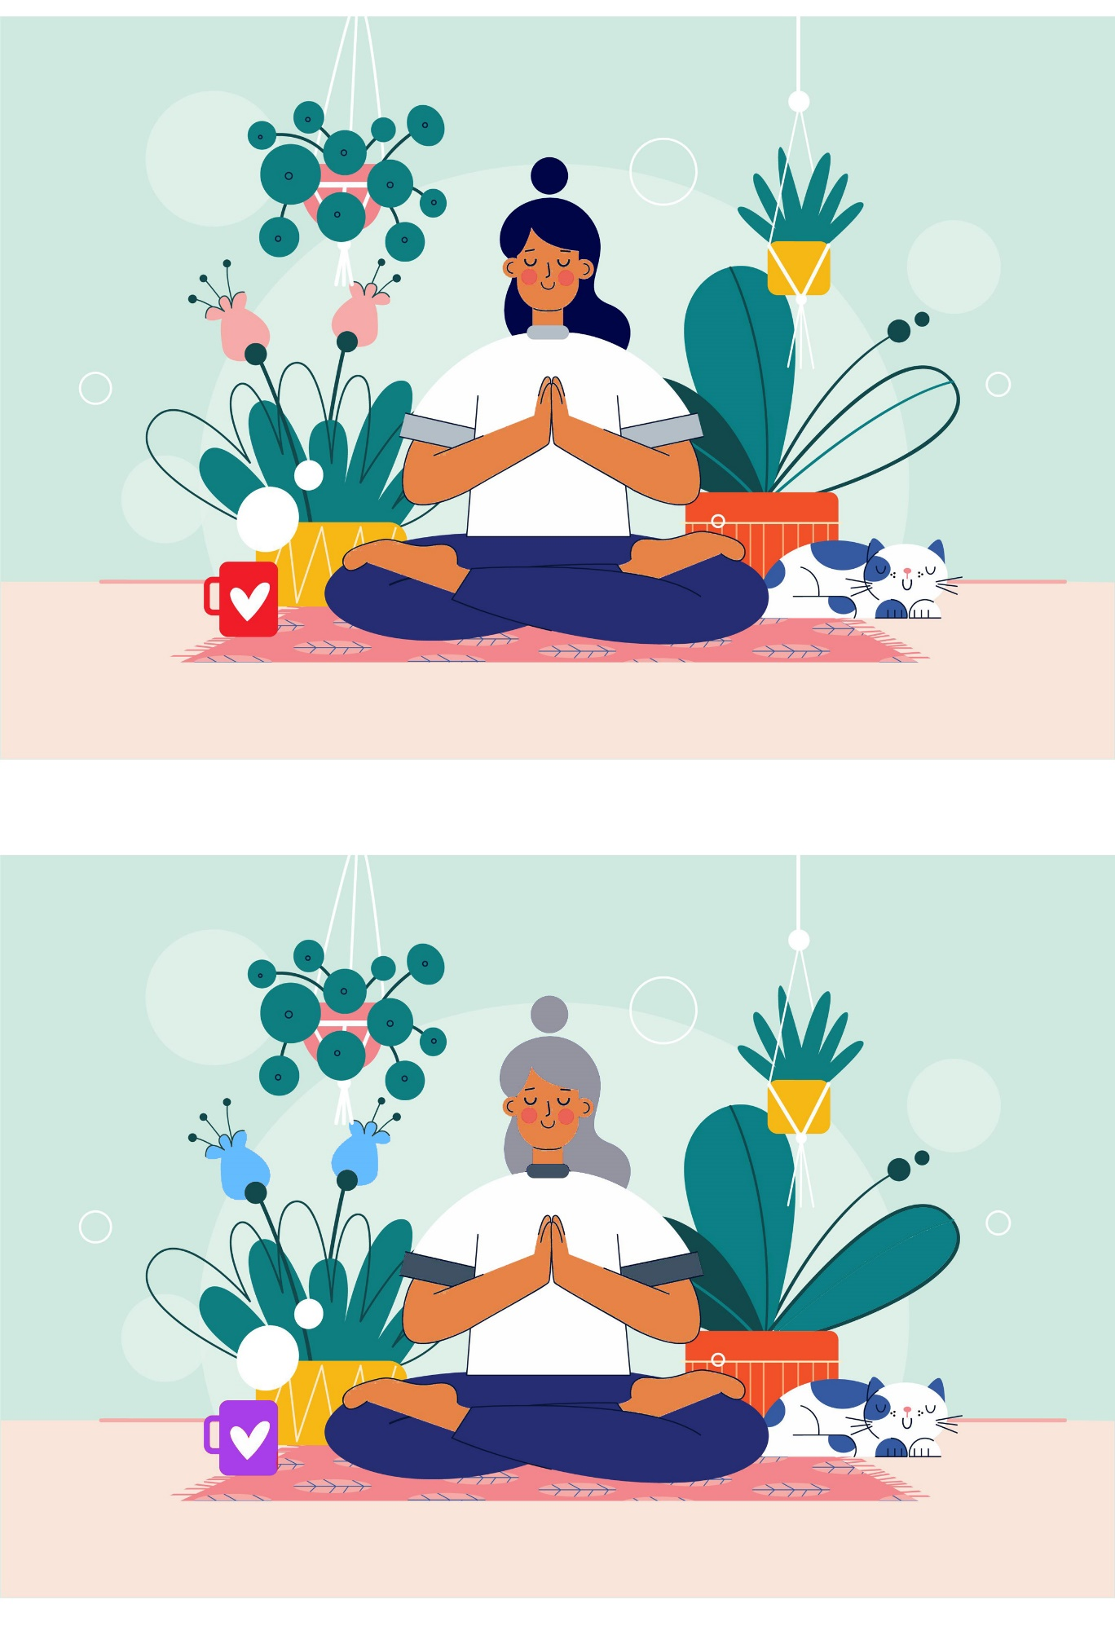
Outdoor Activities Spot the Difference
See if you can see the 5 differences between these two pictures
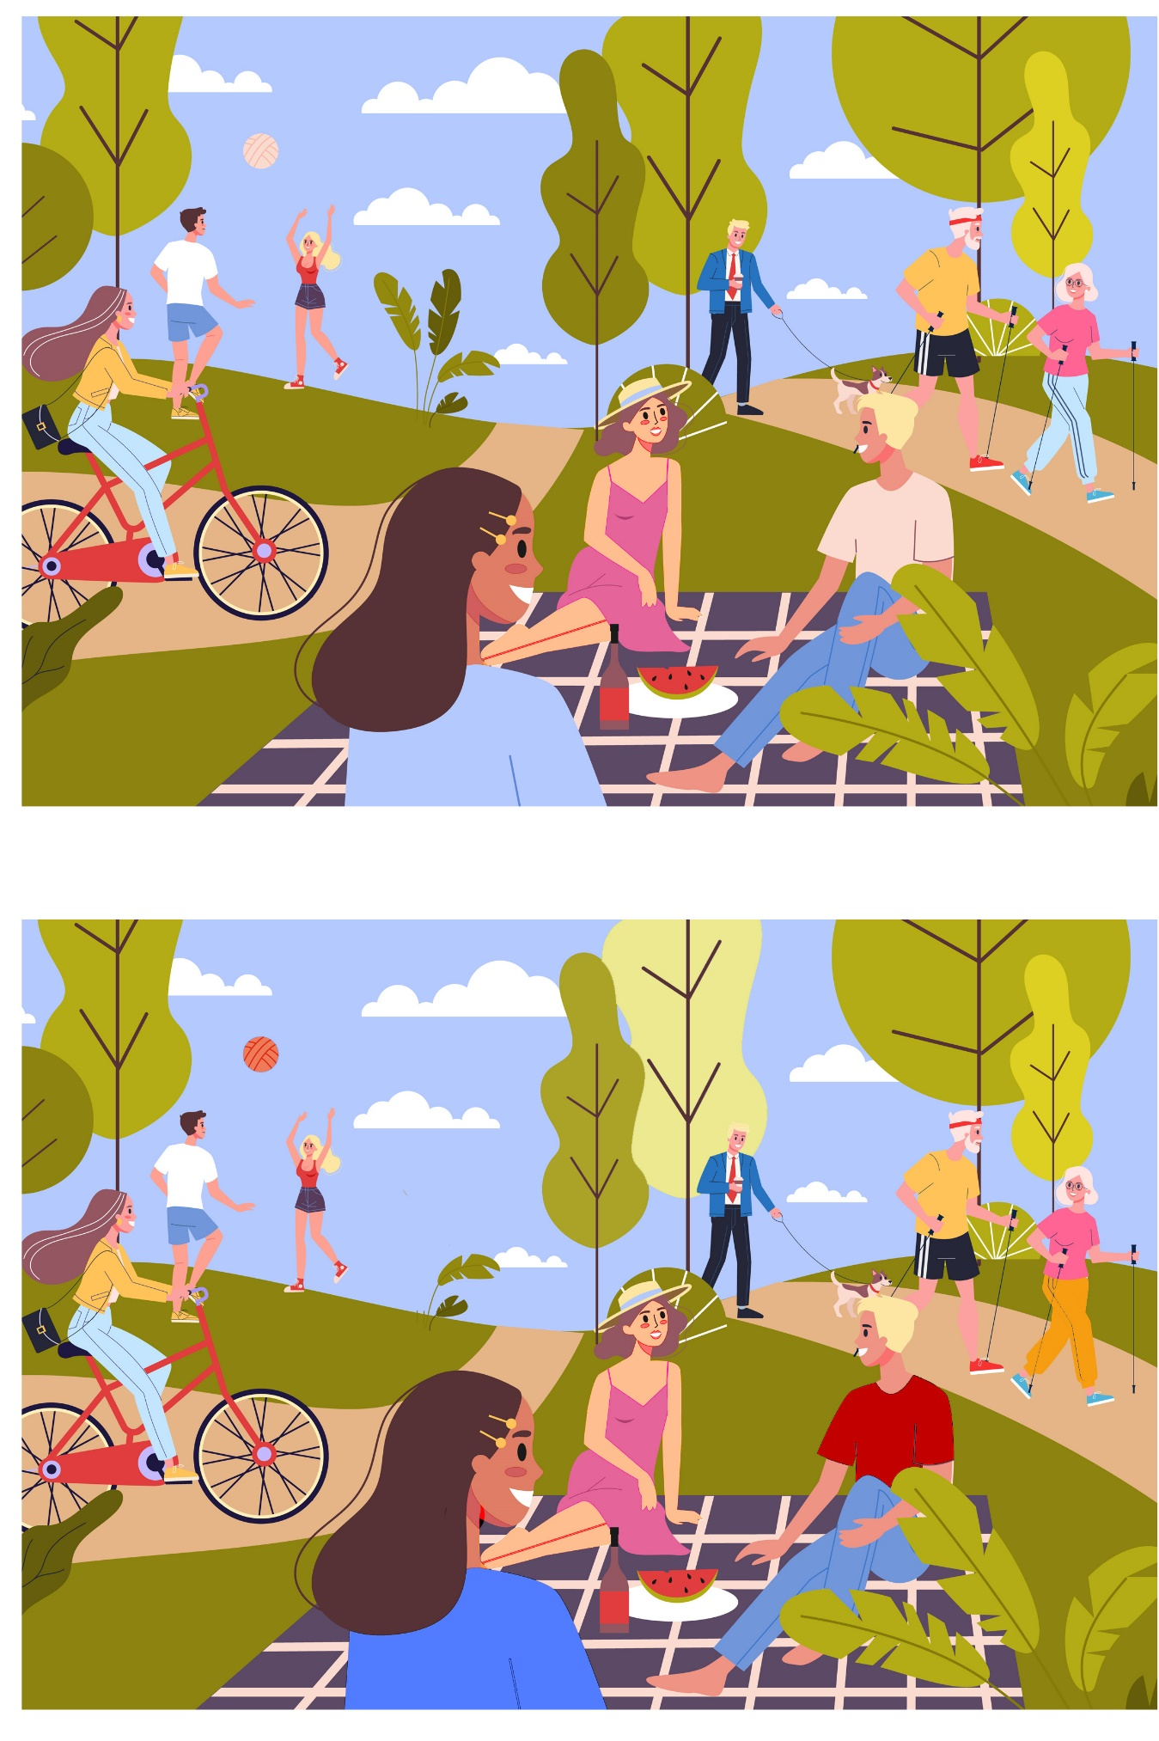
My Mind Wordsearch
B | G | Y | P | M | A | D | C | Z | N | D | Q | R | I | N
A | G | R | E | M | I | N | I | S | C | E | N | L | H | I
F | Z | R | V | C | J | Z | W | V | R | E | S | T | T | H
C | T | Q | X | O | K | J | A | A | W | P | Z | R | D | T
K | D | M | B | M | Z | D | E | X | E | R | C | I | S | E
X | D | P | B | M | E | D | I | T | A | T | E | P | U | X
D | I | G | H | U | X | T | V | V | F | U | Q | M | H | M
T | E | V | K | N | J | L | K | Q | T | S | H | A | R | E
T | T | A | X | I | I | R | D | Z | Q | F | X | S | M | M
V | P | L | M | C | A | S | F | O | C | C | H | K | W | O
V | R | E | L | A | X | A | T | I | O | N | E | S | X | R
V | N | O | S | T | A | L | G | I | A | H | A | I | X | I
F | P | V | D | E | T | V | G | B | F | X | L | L | B | E
L | M | S | U | P | P | O | R | T | L | T | T | B | I | S
Y | A | A | U | J | K | U | J | M | K | D | H | U | Z | B

COMMUNICATE DIET
EXERCISE HEALTH
MEDITATE MEMORIES
NOSTALGIA RELAXATION
REMINISCE REST
SHARE SUPPORT

Photo Memories Counting Game
The memories wall is looking crowded! But how many repeats of each image are there? Write the number below and think of your favourite photo memories in your house.
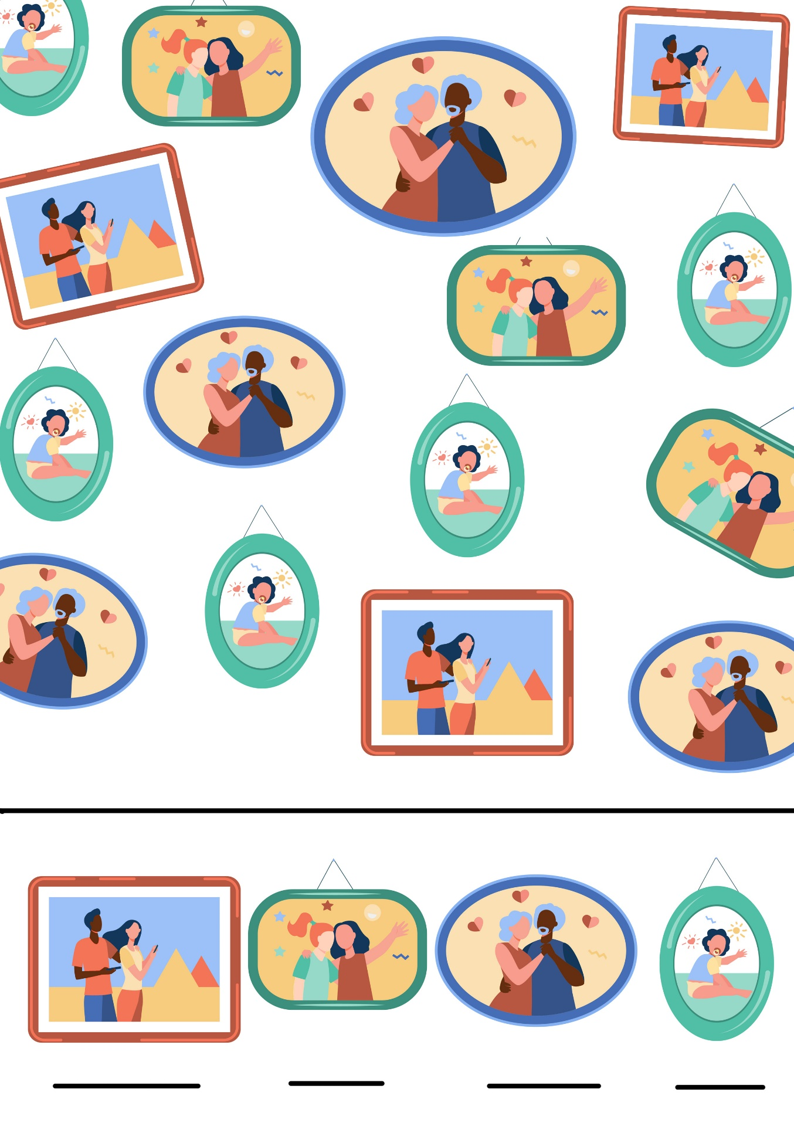
Irish Proverbs Recall Game
See how many of these Irish Proverbs you know?
Think about what their meanings are and when you might use them…

1. A bird in the hand is worth two in the bush.
2. All is not gold that glitters.
3. Live horse and you'll get grass.
4. A stitch in time saves nine.
5. A wilful waste is a woeful want.
6. There is many a noble heart behind a shabby coat.
7. A rolling stone gathers no moss.
8. A friend in need is a friend indeed.
9. After a storm comes a calm.
10. Empty vessels make the most noise.
11. Make hay while the sun shines.
12. Look before you leap.

Spanish Omelette Recipe
Eating healthily helps promote good brain health so here’s an easy and delicious lunchtime recipe for you to try!

Ingredients:
- 500g new potatoes
- 1 onion, preferably white
- 150ml extra-virgin olive oil
- 3 tbsp chopped flat-leaf parsley
- 6 eggs
(This amount serves 3 to 4 people)

Method:
STEP 1
Peel the new potatoes or leave the skins on, if you prefer.
Cut them into thick slices.
Chop the onion.

STEP 2
Heat the extra-virgin olive oil in a large frying pan, add the potatoes and onion and simmer gently, partially covered, for 30 mins, stirring occasionally until the potatoes are softened.
Strain the potatoes and onion and place into a large bowl

STEP 3
Beat the eggs in a bowl, then stir into the potatoes and onion.
Add the parsley and plenty of salt and pepper.
Heat a little of the oil in a smaller pan.

STEP 4
Tip everything into the small pan and cook on a moderate heat, using a spatula to shape the omelette.

STEP 5
When almost set, place a plate on top of the pan carefully then flip everything to tip the omelette into the plate.
Slide the upside down omelette back into the pan and cook a few more minutes.

STEP 6
Allow to cool a little, serve on a plate and enjoy!

Pictures to Colour

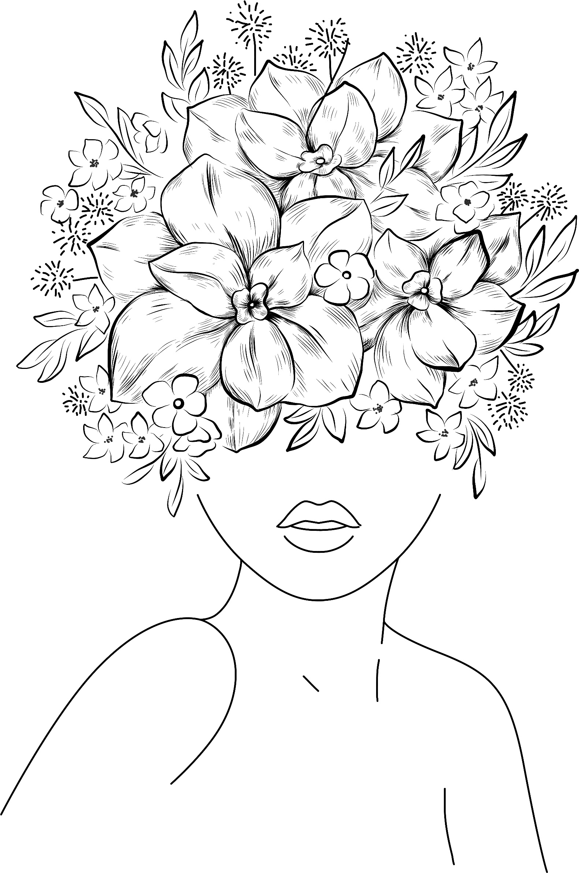
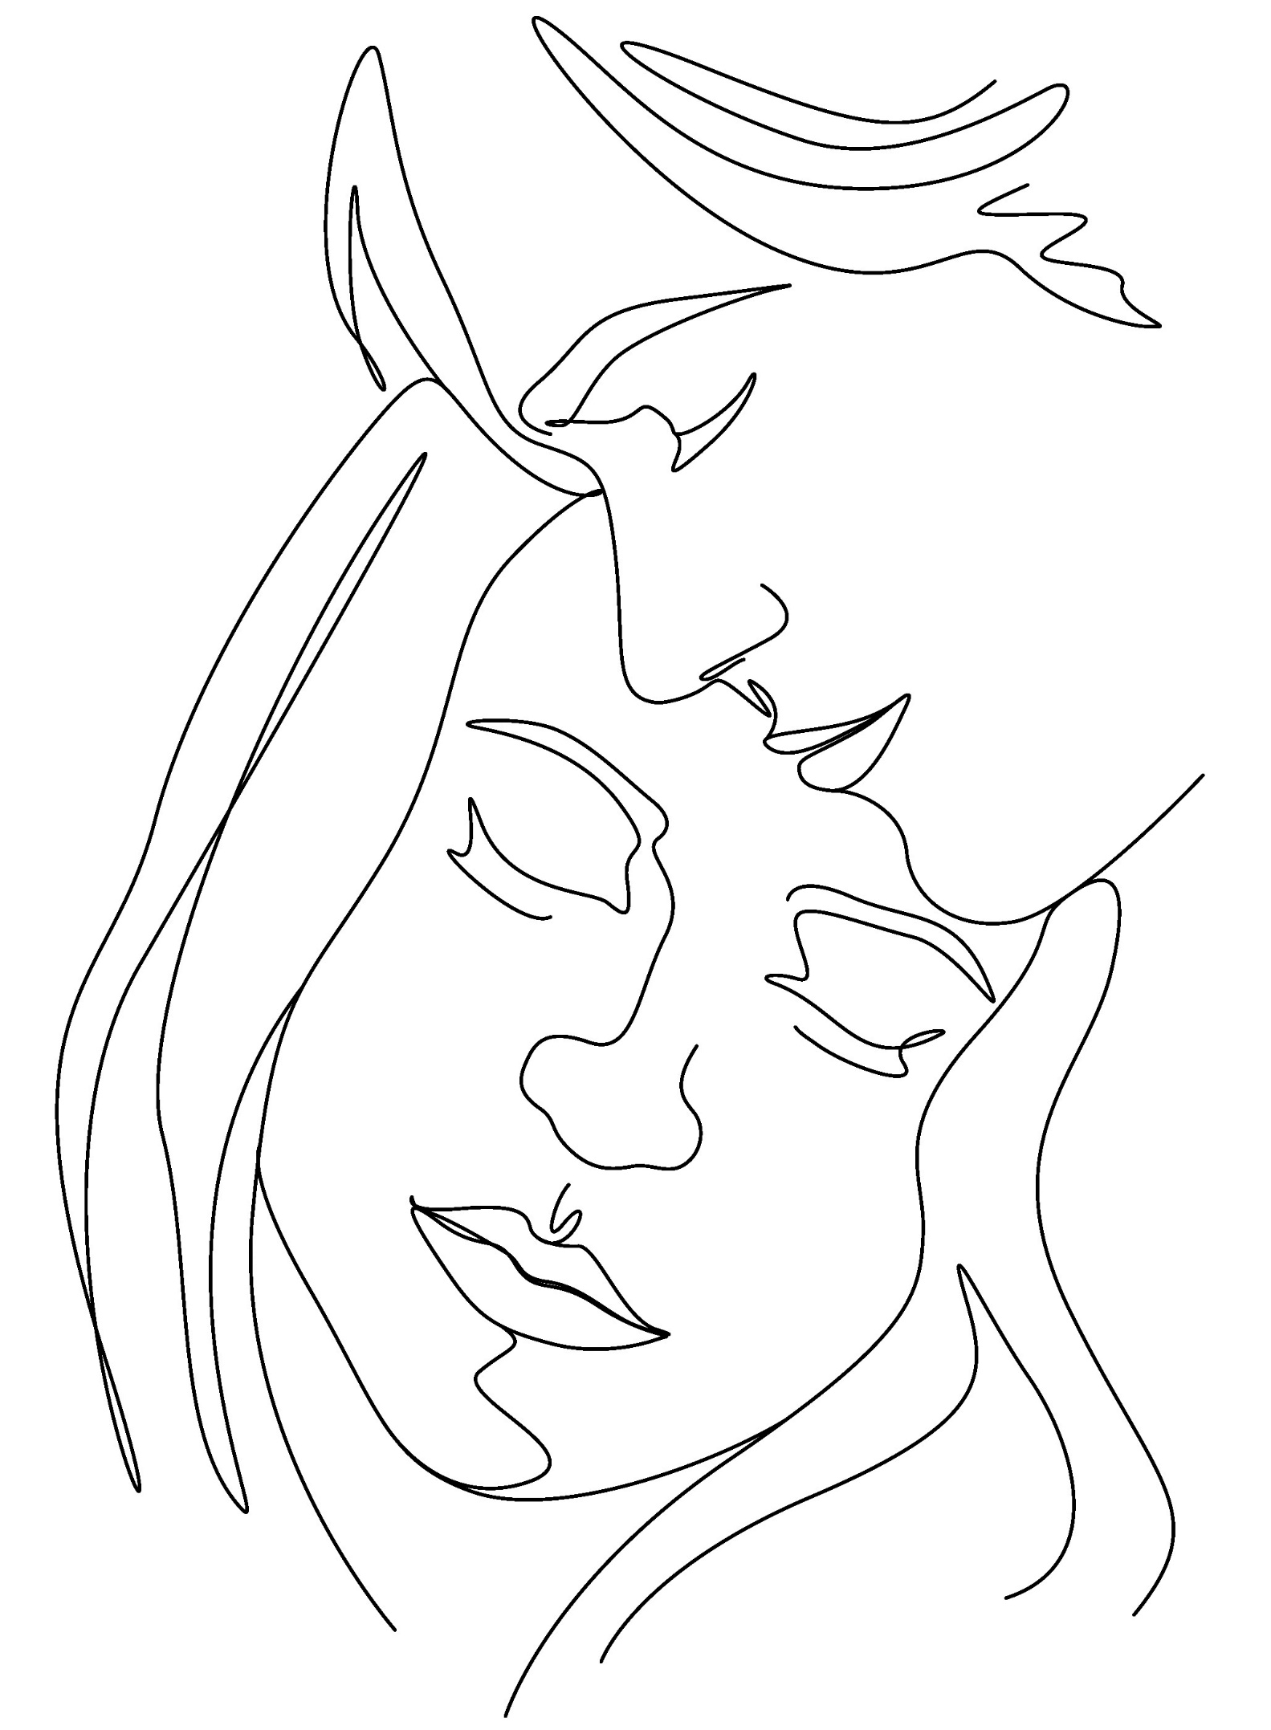
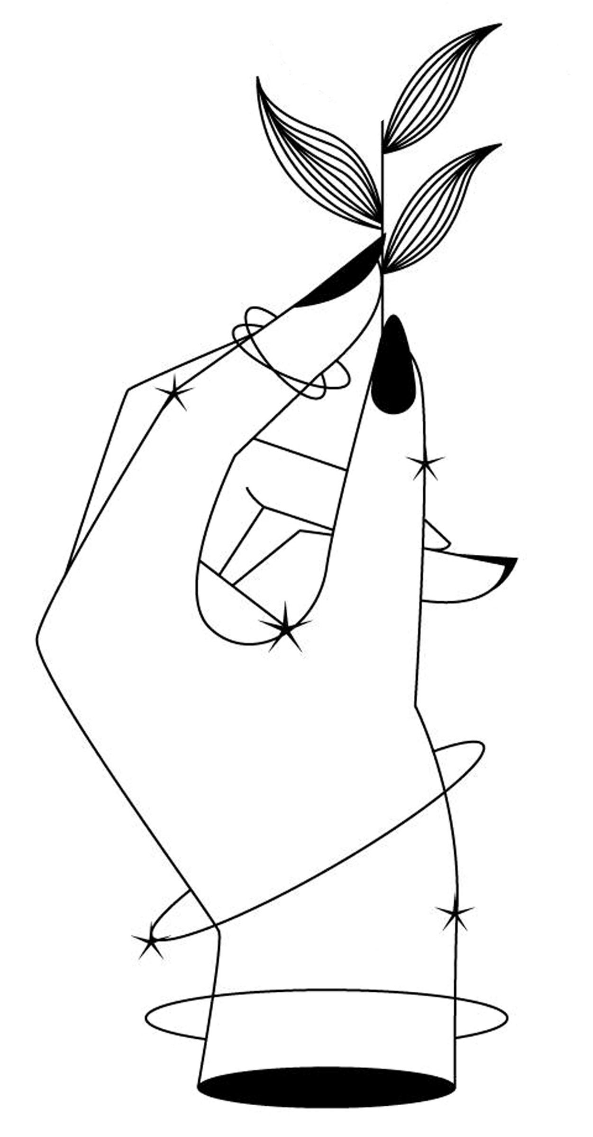
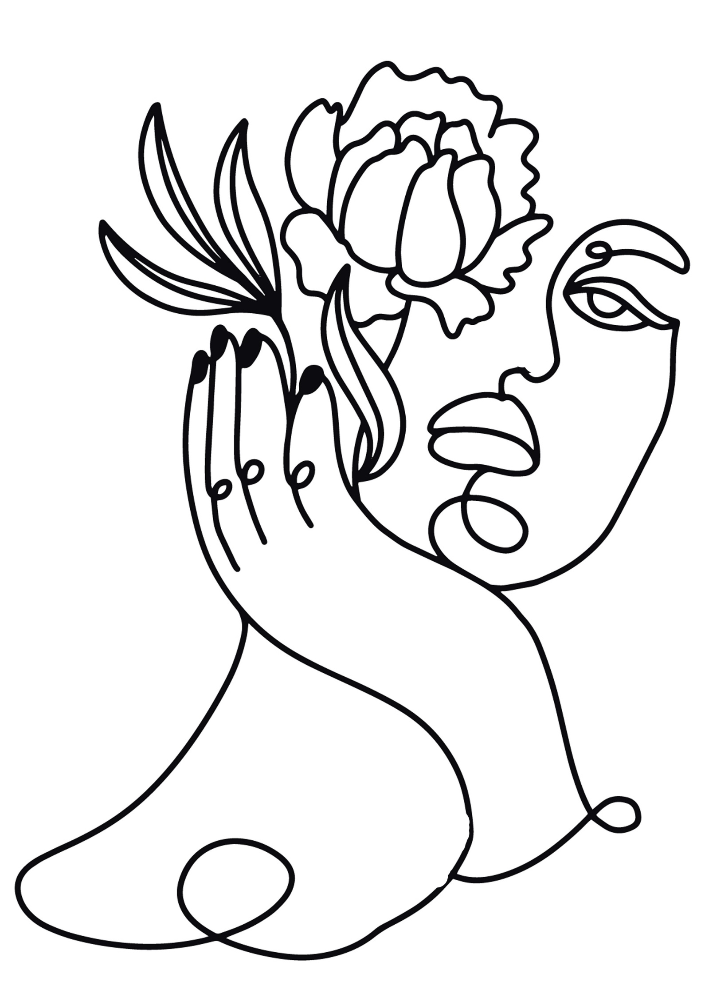

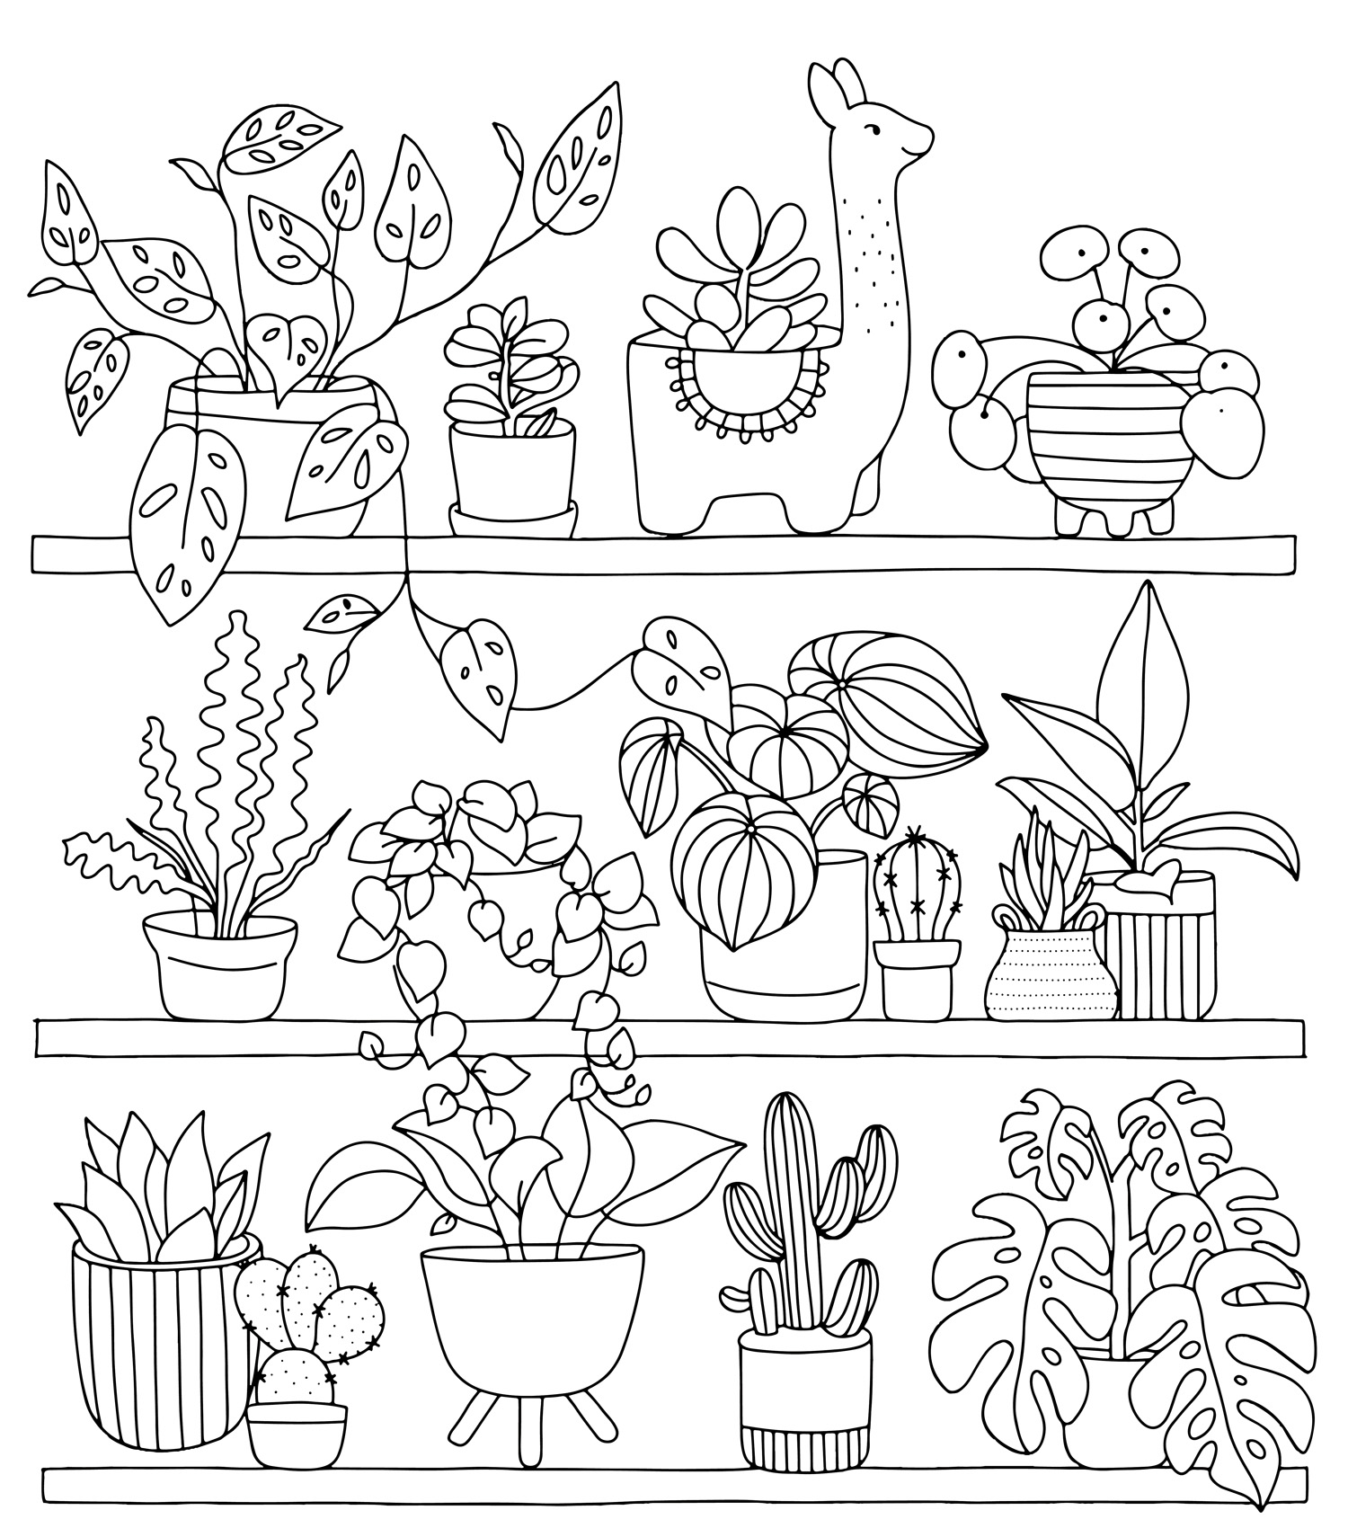

Quiz
Test your brain with this quiz!
Quizzes are a great way of keeping our minds active and exercised

- The Irish tricolour is the flag of which African country when turned backwards? Ivory Coast
- What was the first antibiotic used in medicine? Penicillin
- Name the most northerly & southerly points in Ireland? Malin head & Mizen Head
- Which word can be placed before bottle, bell and bird? Blue
- What colour are aircraft black boxes? Bright orange
- The Book of Kells was written in what language? Latin
- In what year was the Battle of Clontarf? 1014
- What German state is Munich in? Bavaria
- What is the capitol of Czech Republic? Prague
- How many keys on a standard modern day piano? 88
- What was the singer Madonna’s first single? Holiday
- Name the song title and artist – “It’s 9 o’clock on a Saturday, the regular crowd shuffles in…”: Billy Joel, Piano Man
- Which country legend known for Island in the Stream and The Gambler sadly died in March? Kenny Rogers

Reminiscing Part 1

Having a reminiscence session is brilliant for thinking back, stimlating our mind and prompting memory recall. Visual aids such as photos, souvenirs or items of clothing can be a good way to help recollection.
Gather 3 or 4 items or photographs from your house and sit, perhaps with a loved one, and discuss who it is connected to, where did it come from,
what year is it from?
Reminiscing Part 2
Use the frames below to write in some of your favourite things from your past – songs, foods, gifts. Fill each one with something you love and spend time to think reflect on each.

Reminiscing – Musical Memories
Below is a list of number 1 hits from this month throughout the ages.
Go through the list and see how many songs you remember.
Can you hum the tune or even sing some of the words?
If you don’t recall have someone play the song for you if possible and see if you can sing along.

21/09/1956 | LAY DOWN YOUR ARMS | ANNE SHELTON
26/09/1958 | CAROLINA MOON/STUPID CUPID | CONNIE FRANCIS
11/09/1959 | ONLY SIXTEEN | CRAIG DOUGLAS
29/09/1960 | TELL LAURA I LOVE HER | RICKY VALANCE
13/09/1962 | SHE'S NOT YOU | ELVIS PRESLEY
24/09/1964 | I'M INTO SOMETHING GOOD | HERMAN'S HERMITS
06/09/1967 | THE LAST WALTZ | ENGELBERT HUMPERDINCK
19/09/1970 | BAND OF GOLD | FREDA PAYNE
21/09/1974 | KUNG FU FIGHTING | CARL DOUGLAS
04/09/1976 | DANCING QUEEN | ABBA
19/09/1981 | PRINCE CHARMING | ADAM & THE ANTS
08/09/1984 | I JUST CALLED TO SAY I LOVE YOU | STEVIE WONDER
24/09/1988 | HE AIN'T HEAVY, HE'S MY BROTHER | HOLLIES
15/09/1990 | THE JOKER | STEVE MILLER BAND
19/09/1998 | MILLENNIUM | ROBBIE WILLIAMS
24/09/2011 | WHAT MAKES YOU BEAUTIFUL | ONE DIRECTION

Spiritual Relaxation

Many people find that prayer or mindful reflection can help calm their mind and provide comfort and ease when we may have stress or troubling thoughts.
The following is a small prayer, suitable for everyone, to help us in times when our mind might be uneasy.

“Give me the strength to continue to push on, to work toward my goals, and to be gentle toward myself in times of failure. Give me the courage to stand up for what is right and to get out of bed each day, especially when the day seems bleak.

Give me the patience to be compassionate and helpful toward others and myself, and to know when it is best to remain quiet. Give me the clarity to be grateful for all that I have, and to realize when I have something to give to others. Give me the capacity to love and forgive others, especially the ones who have wronged me. Give me the serenity to find happiness and peace in each day.

Give me the knowledge to take responsibility for my mistakes, and the ability to let go of things and people who no longer help me grow. Give me the power to be greater than fear and larger than hate.

Let me have the capability to live in the moment, dance in the rain, sing in the shower, and live life to the fullest. Give me the understanding of embattled individuals who are struggling and the power to not take their attacks personally. Let me have the perspective to see the bigger picture in all situations I may face. Let me have the potential to change what I can change, and do what I can to make the world a better place. Let me have the ability to let things that do not serve me go.

And most of all, let me have the intelligence to realize that most of these traits already exist within me. Give me the strength, curiosity and courage to find them within myself and others.”

Ár n-Athair (The “Our Father” as Gaeilge)

Ár n-Athair atá ar neamh,
Go naofar d'ainim,
Go dtagfadh do ríocht,
Go ndéantar do thoil ar an talamh mar a dhéantar ar neamh.
Ár n-arán laethúil tabhair dúinn inniu,
agus maith dúinn ár bhfiacha
mar a mhaithimidne dár bhféichiúna féin
(Ach ná lig sinn i gcathú, ach saor sinn ó olc,)

Amen

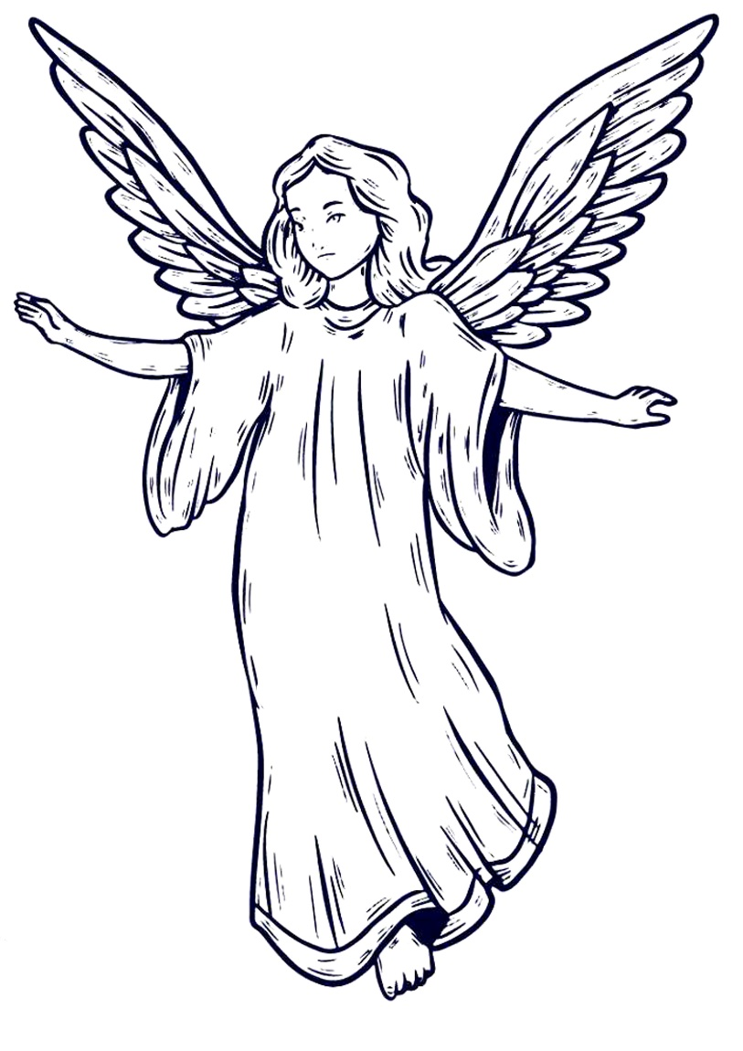
Twinkle Twinkle
Many of us will have learnt this rhyme as a child but did you know there’s much more to it than most people know?
See how much you know.

“Twinkle, Twinkle, Little Star.
Twinkle, twinkle, little star!
How I wonder what you are,
Up above the world so high,
Like a diamond in the sky.

When the glorious sun is set,
When the grass with dew is wet,
Then you show your little light,
Twinkle, twinkle all the night.

In the dark-blue sky you keep,
And often through my curtains peep,
For you never shut your eye,
Till the sun is in the sky.

As your bright and tiny spark
Guides the traveller in the dark,
Though I know not what you are,
Twinkle, twinkle, little star!”

Humorous Poems by Edward Lear
1.
There was an Old Man with a beard,
Who said, "It is just as I feared!—
Two Owls and a Hen,
Four Larks and a Wren,
Have all built their nests in my beard!"

2.
There was a Young Lady of Ryde,
Whose shoe-strings were seldom untied;
She purchased some clogs,
And some small spotty dogs,
And frequently walked about Ryde.

3.
There was an Old Man with a nose,
Who said, "If you choose to suppose,
That my nose is too long,
You are certainly wrong!"
That remarkable Man with a nose.

4.
There was a Young Lady whose bonnet,
Came untied when the birds sate upon it;
But she said, "I don't care!
All the birds in the air
Are welcome to sit on my bonnet!"
"The Violet," by Jane Taylor (1783-1824)

Down in a green and shady bed
A modest violet grew;
Its stalk was bent, it hung its head,
As if to hide from view.
And yet it was a lovely flower,
No colours bright and fair;
It might have graced a rosy bower,
Instead of hiding there.
Yet there it was content to bloom,
In modest tints arrayed;
And there diffused its sweet perfume,
Within the silent shade.
Then let me to the valley go,
This pretty flower to see;
That I may also learn to grow
In sweet humility.
Relaxation with Guided Imagery for Mental Calm
You might like to read this to a loved one to help them take a moments calm whilst listening to you read this script. You could add gentle music to the background or light a scented candle.

Take a slow, deep inhale and a complete exhale.
As you begin awareness of your breath, start to notice what thoughts are going through your mind. What are you thinking about?

Do not get caught up in your thoughts, but just begin to notice them as they travel across your mind. Let them go as they pass, and watch them come and go. Continue to breathe deeply.

I will begin to describe settings. Allow your mind to jump immediately to those settings. Let your mind be free to travel, and do not become attached to any one setting or image. You are a traveller jumping from place to place in your mind.
Now we will begin.

An ocean. A deep, blue ocean. A beach with white sand. A seagull flying over the sand. Pelicans chasing the current over the waves.

The waves crashing on the beach. The white sand. The desert. Cactus in the desert. Blue sky. Blue, cloudless sky. Birds singing.

A walled garden. Lush, green grass. Storm clouds. A cool breeze. The crack of thunder. The dark sky illuminated by lightning.

A long, dirt road stretching toward the horizon. A grove of olive trees. A farmer. A woman pulling water from a well. Children playing in the distance.

A tall tree, stretching up to the sky. Blue sky. Warm sun.

Mountains in the distance, topped with snow.
A farmhouse. A stable. Horses enclosed in a corral.

Sunset. A flock of black birds in the sky. The hoot of an owl. The sounds of crickets. An old front porch with a swing.

A glass of cold lemonade. A warm chair next to the fireplace. A rose garden in full bloom. White, puffy clouds. White dove.

Burning candle. Flickering flame. Warmth and comfort.
Now take a slow, deep inhale. Long, complete exhale.
Open your eyes.

A Limerick Son’s Cunning
Told by William Horan, Noig, Askeaton. Co. Limerick

There was once a Limerick man who had three sons. One day he said to them, "I have kept ye all your life and now it is time for ye to help me. I have no money and I am not able to work at all" Next day the three sons agreed to go away and look for work. So they went to crossroads. The first said he would go to the left and the second to the right and the third boy went on straight. The first came to a village and was hired to a miller. The second came to another village and was hired to a shoemaker. The third came to another village and was hired to a farmer. They all agreed before they went that they would come back after a year.

After a year the first asked for his wages. The man said he had no money but he would give him a magic donkey and every time he would say "brathbrickle" it would throw up a shower of gold. Our friend was very glad and took the donkey with him. He journeyed all that day until night fell. Then he went into a lodgings house. He stopped there that night but before he went to bed he asked the man of the house how much would he charge. "A week’s wage" said the greedy man. Then our friend went out to his donkey and said "brathbrickle". At that moment the donkey threw up the gold. But all this time the man of the house was listening and heard all our friend said. In went the man of the house and went to bed. Our friend went to bed also. In the middle of the night the man of the house got up and took away the magic donkey. He got another donkey the very same and put him in place of the good donkey. Our friend got up in the morning and went home to his father. That night he invited all the neighbours to come and see the donkey throw up the gold. All were waiting to this gold and he had a new table cloth spread for the gold. All was ready and he said "brathbrickle" but the donkey shyly began to roar and all the people ran.

The second man asked for his wages. His master said he had no money but he would give him a magic table and every time he would say "Table be laid" it was full of every kind of food. To make a long story short he fell into the same misfortune. The same greedy man heard the boy and stolen the magic table.

Now the third asked for his wages. His master said he had no money but he would give him a magic stick. He came to the same house as the two before and got lodgings there. Every time he would say "stick - do your duty" it would wallop all round it, hitting whoever was in it’s path. He would show no one what he had. He went to bed and during the night he heard the man coming up to steal from him. He said to the stick, "Stick - do your duty". The stick started to wallop all round it. Then the man of the house said "call back your stick!". “I will” said the man “if you give me my brothers’ donkey and table”. "Oh I will, just make it stop!” said the man. The son then got the donkey and table and went home and told his brothers that he had returned their magical belongings.
They lived happily ever after that with enough food and money for life and God help anyone who tried to take it away!

