September
Activity Pack
1
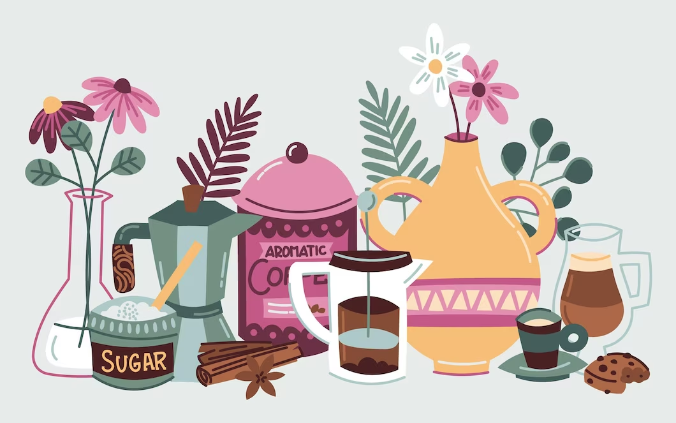

Dear Friends,
As we step into the crisp month of September, where the cooler air carries the promise of autumn and the leaves begin to fall, creating a cosy ambiance, we wanted to take a moment to reach out and let you know that you are in our thoughts. Even though we may not have the opportunity to gather in person sometimes, we are here to offer our unwavering support in any way we can.
In the spirit of embracing the changing season, we have prepared an exciting array of resources for you to explore. This month's activity pack revolves around the theme of embracing the cooler weather, enjoying the outdoors, and finding joy in the simple moments. We believe that these activities will not only bring you closer together but also provide moments of pure delight and shared memories.
We sincerely hope that this month's pack, filled with autumnal adventures, brings you immense joy, laughter, and a renewed sense of togetherness. As we bid farewell to the end of summer, we welcome the cosy times ahead.
Wishing you a season of endless fun this September and cherished moments.

If you’d like to display any fundraising pictures, or photos of any local fundraising event to be shared on our social media please send your images via email to iseultkinsella@alzheimer.ie
- "By all these lovely tokens, September days are here. With summer's best of weather and autumn's best of cheer."
- -Helen Hunt Jackson

Useful Resources:
- Our Free Helpline and Dementia Nurse Support Line are available at: Phone: 1800 341 341 and Email: helpline@alzheimer.ie
- The ASI now also has a new online Virtual Dementia Hub where you can go for a full range of activities – you can even listen to some wonderful poetry and songs recorded especially . Just go to www.virtualdementiahub.ie
- We are hosting a number of Virtual Cafes. They are a place to come together, share a cuppa and listen to our amazing guest speakers. For information on how to attend visit: https://alzheimer.ie/service/alzheimer-cafe/
- The ASI also have a huge library of factsheets and resources available on: https://alzheimer.ie/get-support/resources-and-factsheets/
- For musical videos and resources Music For Dementia are a wonderful resource: https://musicfordementia.org.uk/
- The Irish Museum of Modern Art (IMMA) have a huge collection available to view online at: https://imma.ie/collection/
- Emergency Response Numbers: 999 or 112 9. HSE 24/7 Your Mental Health Information Helpline: 1800 111 888

Table of Contents

Activity | Pages
September Themed Trivia Quiz | 6
September Word Search | 7
Fall Word Search Scramble | 8-9
Spot the Difference | 10-11
Photos Memories Counting Game | 12
General Knowledge Themed True or False | 13
How Many Leaves Can You Guess Right? | 14
Pictures to Colour | 15-21
September Poem | 22-23
Humorous Poems | 24
Scavenger Hunt | 25-26
September Morn’ Song | 27-28
Reminiscence | 29-32
Spiritual Relaxation | 33-24

September Themed Trivia Quiz!

- Question: What is the Latin name for the month of September?
  - Answer: September comes from the Latin word "septem," which means seven.
- Question: In which month does the autumnal equinox occur?
  - Answer: The autumnal equinox, marking the first day of fall, usually occurs in September.
- Question: Which famous playwright was born on September 26, 1565?
  - Answer: William Shakespeare
- Question: What is the birthstone for September?
  - Answer: Sapphire
- Question: In ancient Roman times, what harvest festival was celebrated in September?
  - Answer: The Saturnalia
- Question: Which American holiday is celebrated on the first Monday of September?
  - Answer: Labor Day
- Question: What is the September birth flower?
  - Answer: Aster
- Question: Which well-known Oktoberfest, a beer festival, often starts in September and extends into October?
  - Answer: Munich Oktoberfest
- Question: In which constellation does the sun reside during most of September?
  - Answer: Virgo
- Question: September was originally the seventh month of the Roman calendar. Which Roman emperor's name is associated with this month?
  - Answer: Augustus Caesar
- Question: Which historic document, a cornerstone of American democracy, was signed on September 17, 1787?
  - Answer: The United States Constitution
- Question: What are the traditional colours associated with fall leaves?
  - Answer: Red, orange, and yellow
- Question: What natural phenomenon causes leaves to change colour in the fall?
  - Answer: Decreased sunlight triggers the breakdown of chlorophyll, revealing other pigments in leaves.
- Question: What is the name of the traditional British harvest festival celebrated in September?
  - Answer: Harvest Festival or Harvest Home
- Question: Which Shakespearean play features the line "Shall I compare thee to a summer's day?"
  - Answer: Sonnet 18 ("Shall I compare thee to a summer's day?")

September Word Search!

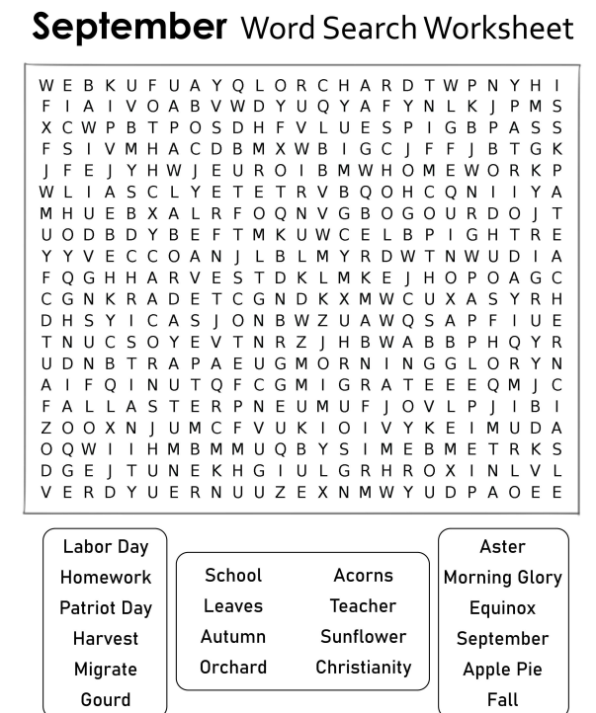

Fall Word Scramble!

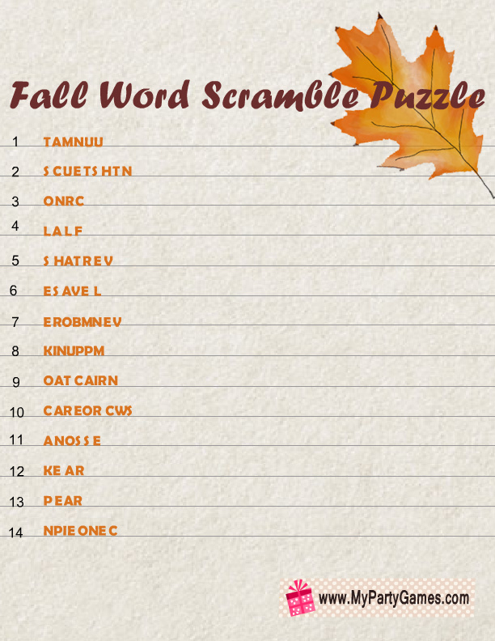
Answers to Fall Scramble:

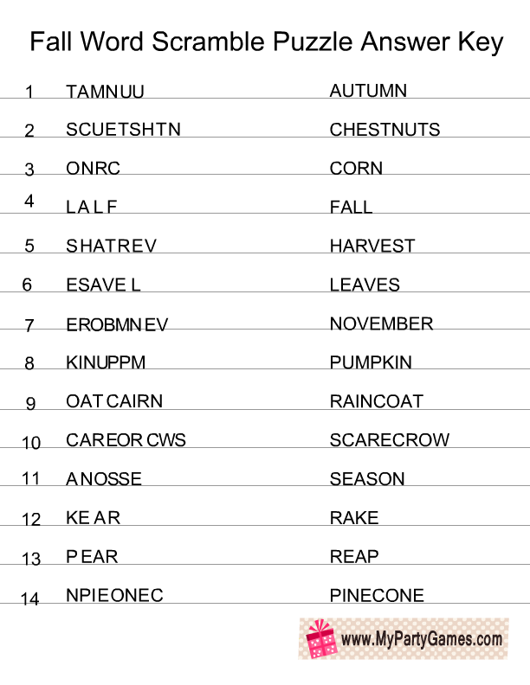

Meditation Spot the Difference!:
Spot the Difference!
Can you spot 5 differences in the picture?
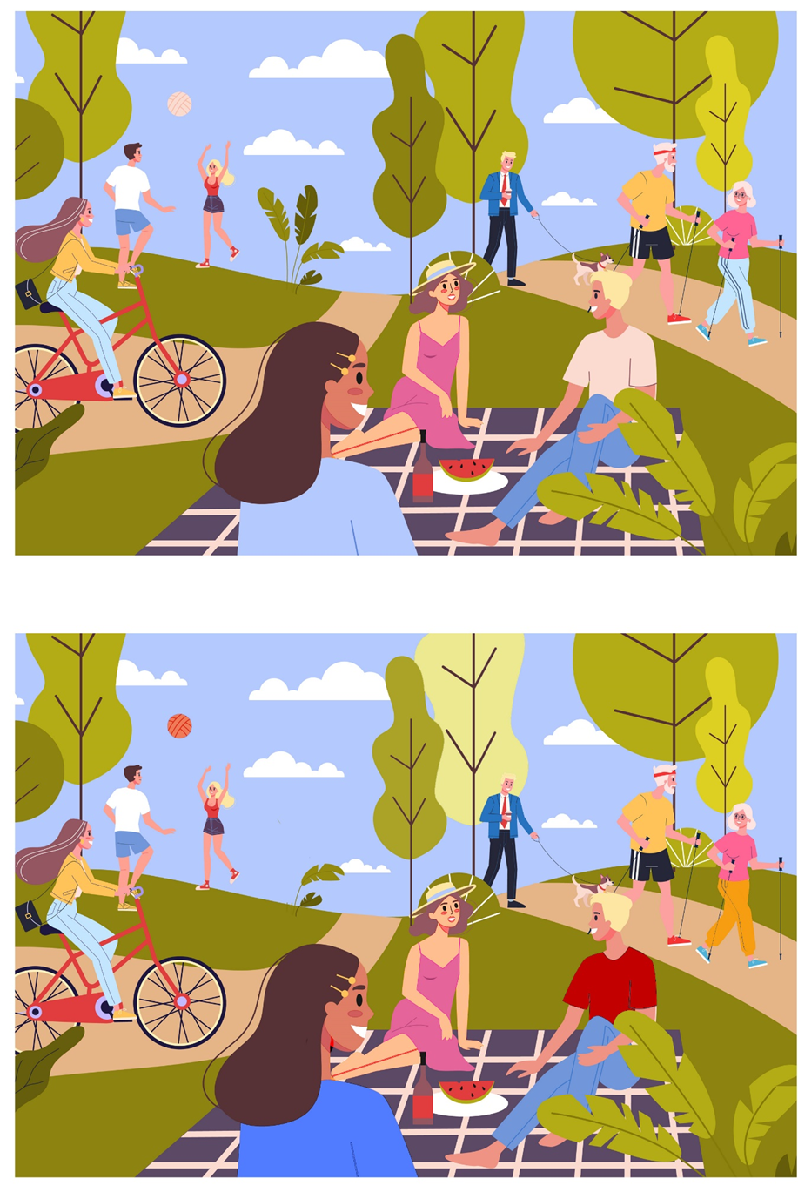

Photo Memories Counting Game:
The memories wall is looking crowded! But how many repeats of each image are there? Write the number below and think of your favourite photo memories in your house.

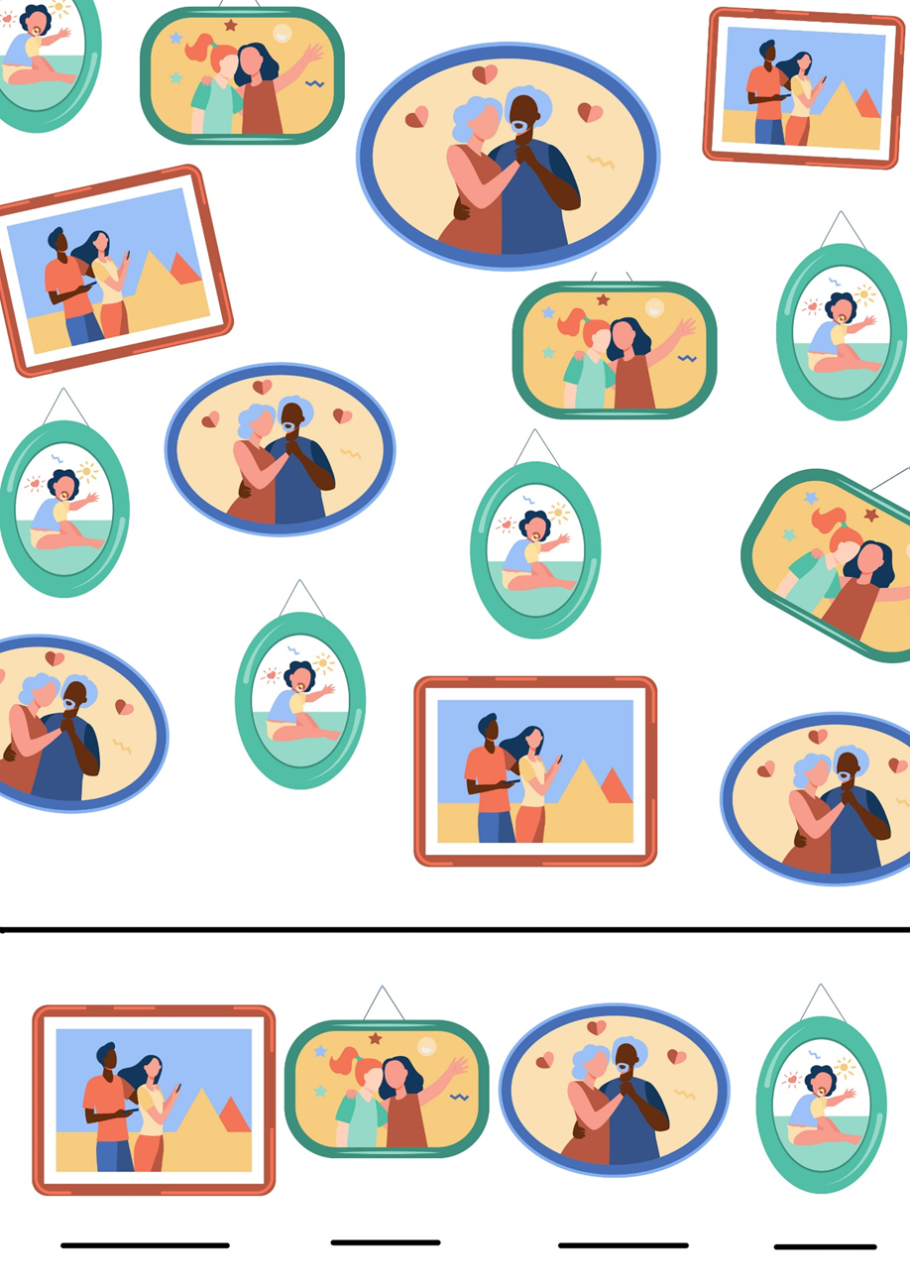

General Knowledge Themed True or False!:

- Question: September is the first month of the year.
  - Answer: False
- Question: Ireland is known as the "Emerald Isle" due to its lush green landscapes.
  - Answer: True
- Question: Elvis Presley was a popular singer in the 1960s.
  - Answer: True
- Question: Audrey Hepburn was a famous actress in the 1960s.
  - Answer: True
- Question: The Beatles were a famous rock band from the 1960s.
  - Answer: True
- Question: Dublin is the capital city of Ireland.
  - Answer: True
- Question: The 60s were known for the rise of hippie culture and flower power.
  - Answer: True
- Question: September is the only month with 30 days.
  - Answer: False
- Question: "Somewhere Over the Rainbow" was a hit song in the 1960s.
  - Answer: False
- Question: The Cliffs of Moher are famous natural landmarks located in Ireland.
  - Answer: True
- Question: The 1969 moon landing was part of the Apollo 11 mission.
  - Answer: True
- Question: Judy Garland played the iconic role of Mary Poppins in the 1960s.
  - Answer: False
- Question: St. Patrick's Day is celebrated in September in Ireland.
  - Answer: False
- Question: The 1960s saw the rise of influential civil rights movements.
  - Answer: True
- Question: "I Want to Hold Your Hand" is a well-known song by The Rolling Stones.
  - Answer: False

How Many Leaves Can You Guess Right?:

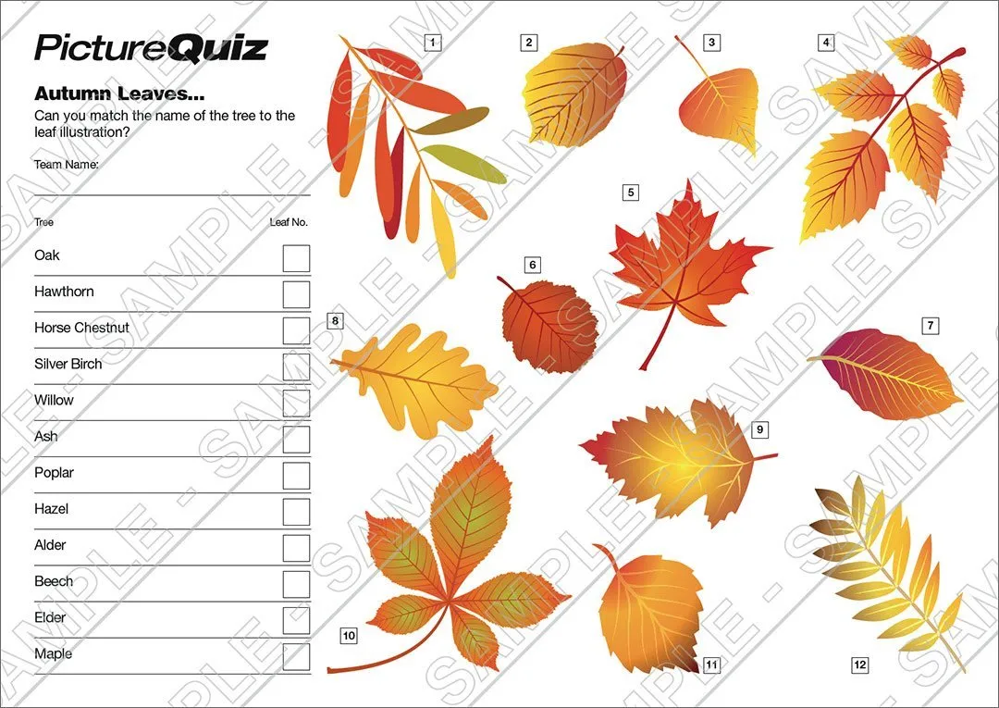

Pictures to Colour!:
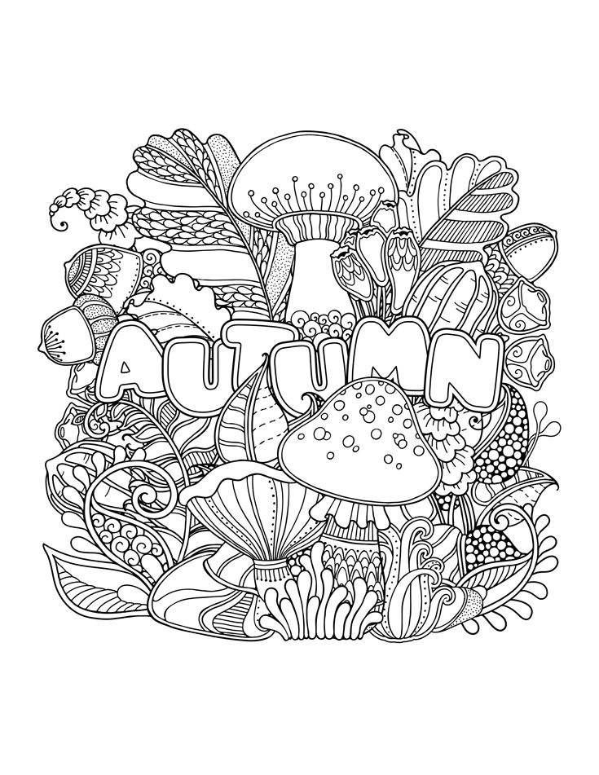
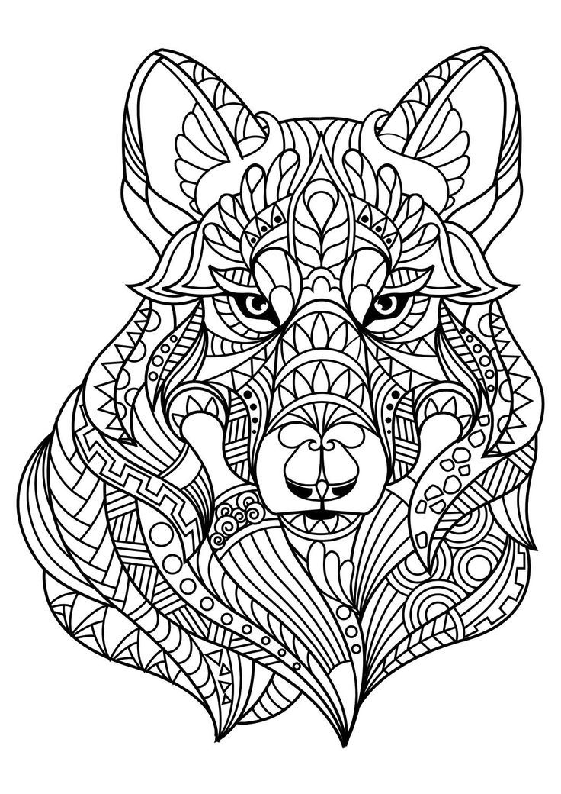

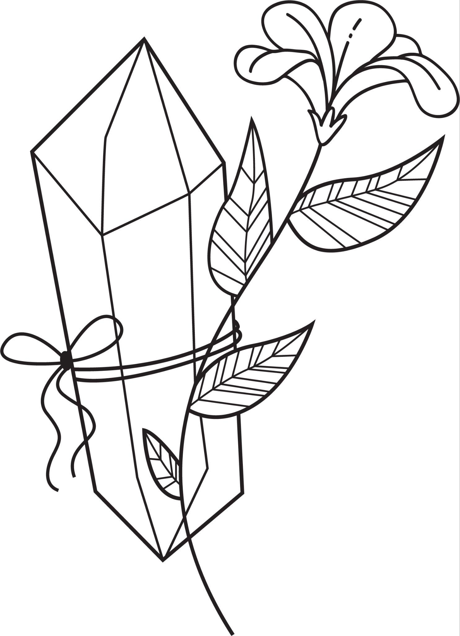
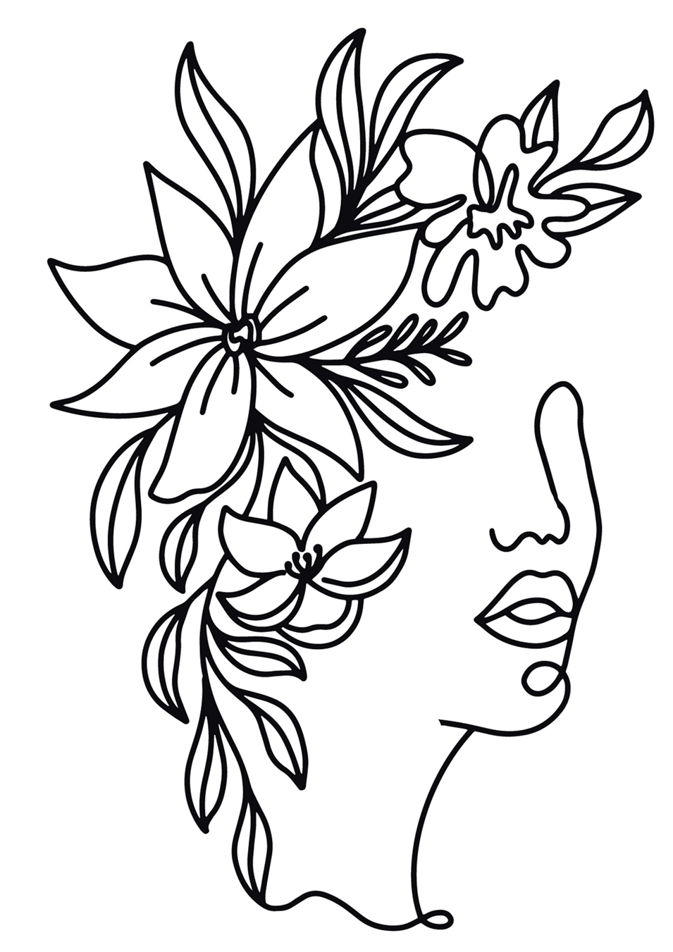

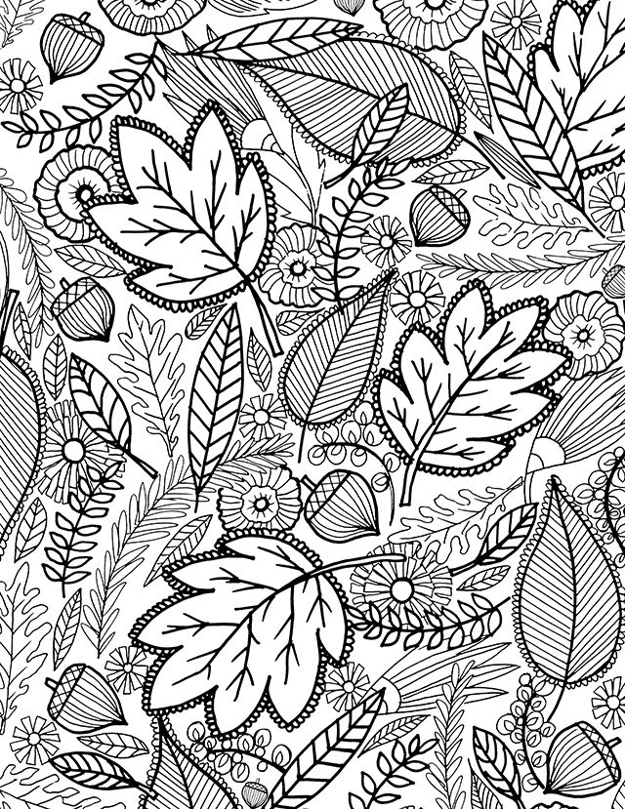

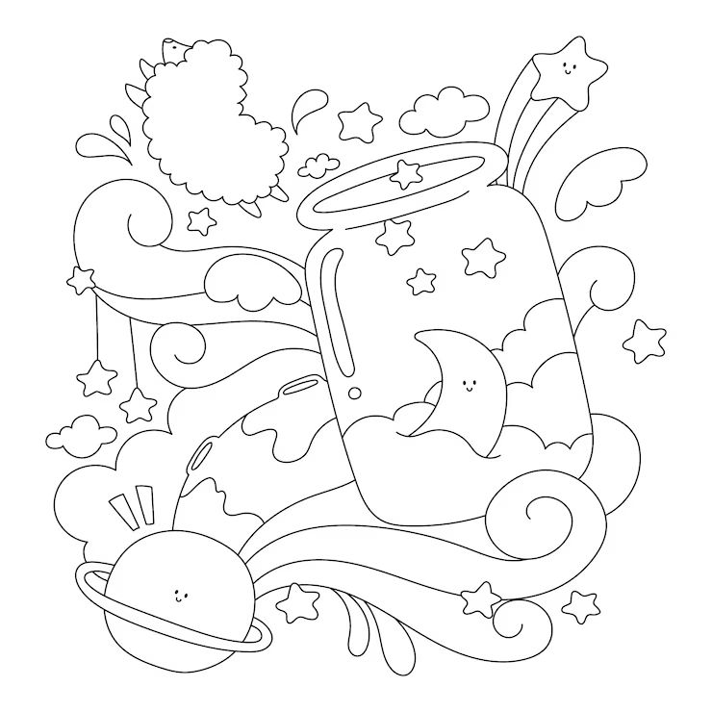

September
By Helen Hunt Jackson:

The golden-rod is yellow;
The corn is turning brown;
The trees in apple orchards
With fruit are bending down.

The gentian's bluest fringes
Are curling in the sun;
In dusty pods the milkweed
Its hidden silk has spun.

The sedges flaunt their harvest,
In every meadow nook;
And asters by the brook-side
Make asters in the brook,

From dewy lanes at morning
The grapes' sweet odors rise;
At noon the roads all flutter
With yellow butterflies.

By all these lovely tokens
September days are here,
With summer's best of weather,
And autumn's best of cheer.

But none of all this beauty
Which floods the earth and air
Is unto me the secret
Which makes September fair.

'T is a thing which I remember;
To name it thrills me yet:
One day of one September
I never can forget.
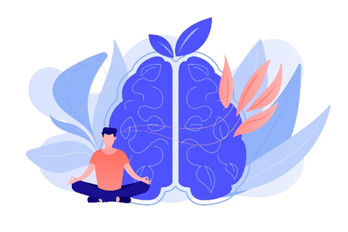

Humorous Poems by Edward Lear:
1.
There was an Old Man with a beard,
Who said, "It is just as I feared!—
Two Owls and a Hen,
Four Larks and a Wren,
Have all built their nests in my beard!"
2.
There was a Young Lady of Ryde,
Whose shoe-strings were seldom untied;
She purchased some clogs,
And some small spotty dogs,
And frequently walked about Ryde.
3.
There was an Old Man with a nose,
Who said, "If you choose to suppose,
That my nose is too long,
You are certainly wrong!"
That remarkable Man with a nose.
4.
There was a Young Lady whose bonnet,
Came untied when the birds sate upon it;
But she said, "I don't care!
All the birds in the air
Are welcome to sit on my bonnet!"
Scavenger Hunt: Exploring the Irish Garden:
Instructions:
- Preparation: Prepare a list of items and clues that can be found in the garden. Write these on a piece of paper or card and provide one copy to each participant or team.
- Pairs or Small Teams: Pair individuals with dementia and their caregivers in teams if possible. This encourages collaboration and provides opportunities for engagement.
- Instructions: Explain the rules and objectives of the scavenger hunt. Emphasise that it's a fun and relaxed activity, and encourage participants to work together to find the items and solve clues.
- Safety: Prioritise safety. Make sure the garden area is free from hazards, and provide assistance as needed to ensure a comfortable experience.
Scavenger Hunt List and Clues:
- Colourful Blooms: Find a flower with red petals. (Hint: Look near the edge of the garden.)
- Garden Friends: Locate a place where birds might visit. (Hint: It's a cosy spot.)
- Tiny Treasures: Search for a small pebble or stone. (Hint: It's close to a tree.)
- Shady Oasis: Find a comfortable place to sit and relax. (Hint: It's under a leafy canopy.)
- Nature's Art: Discover a leaf with an interesting shape. (Hint: It's near the ground.)
- Whispering Leaves: Find a tree with rustling leaves. (Hint: Listen for the sound.)
- Water Wonders: Locate a source of water in the garden. (Hint: It's a small container.)
- Sunlit Spot: Find a place where the sunlight hits the ground. (Hint: It's near a wall.)
- Fragrant Find: Search for a flower with a pleasant smell. (Hint: Follow your nose!)
- Garden Beauty: Discover a spot with a view that you enjoy. (Hint: It's near a bench.)
Bonus Clue: Look around and find something that reminds you of a beautiful Irish landscape. What does it remind you of?
End of the Hunt: Gather everyone back together and share the items you've found, the clues you've solved, and any thoughts about the bonus clue.
This outdoor scavenger hunt encourages participants to explore the garden, observe nature's beauty, and enjoy the company of each other. It provides a mix of sensory experiences and cognitive engagement, making it a fulfilling and enjoyable activity for individuals with dementia and their caregivers.
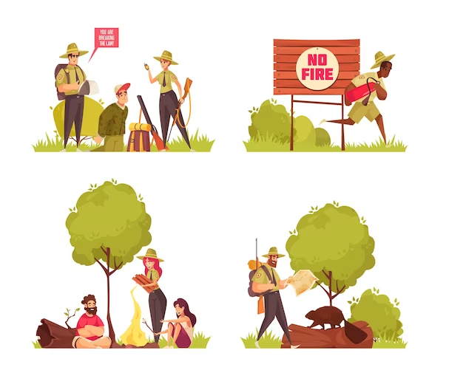

September Morn’
By Neil Diamond:
Stay for just a while
Stay and let me look at you
It's been so long, I hardly knew you
Standing in the door
Stay with me a while
I only wanna talk to you
We've travelled halfway 'round the world
To find ourselves again
September morn
We danced until the night
Became a brand new day
Two lovers playing scenes
From some romantic play
September morning
Still can make me feel that way
Look at what you've done
Why, you've become a grown-up girl
I still can hear you crying
In a corner of your room
And look how far we've come
So far from where we used to be
But not so far that we've forgotten
How it was before
September morn
Do you remember
How we danced that night away
Two lovers playing scenes
From some romantic play
September morning
Still can make me feel that way
September morn
We danced until the night
Became a brand new day
Two lovers playing scenes
From some romantic play
September morning
Still can make me feel that way
September morn
We danced until the night
Became a brand new day
Two lovers playing scenes
From some romantic play
September morning
Still can make me feel that way
September morning
Still can make me feel that way
Reminiscing – Musical Memories
Below is a list of number 1 hits from this month throughout the ages.
Go through the list and see how many songs you remember.
Can you hum the tune or even sing some of the words?
If you don’t recall have someone play the song for you if possible and see if you can sing along.

21/09/1956 | LAY DOWN YOUR ARMS | ANNE SHELTON
26/09/1958 | CAROLINA MOON/STUPID CUPID | CONNIE FRANCIS
11/09/1959 | ONLY SIXTEEN | CRAIG DOUGLAS
29/09/1960 | TELL LAURA I LOVE HER | RICKY VALANCE
13/09/1962 | SHE'S NOT YOU | ELVIS PRESLEY
24/09/1964 | I'M INTO SOMETHING GOOD | HERMAN'S HERMITS
06/09/1967 | THE LAST WALTZ | ENGELBERT HUMPERDINCK
19/09/1970 | BAND OF GOLD | FREDA PAYNE
21/09/1974 | KUNG FU FIGHTING | CARL DOUGLAS
04/09/1976 | DANCING QUEEN | ABBA
19/09/1981 | PRINCE CHARMING | ADAM & THE ANTS
08/09/1984 | I JUST CALLED TO SAY I LOVE YOU | STEVIE WONDER
24/09/1988 | HE AIN'T HEAVY, HE'S MY BROTHER | HOLLIES
15/09/1990 | THE JOKER | STEVE MILLER BAND
19/09/1998 | MILLENNIUM | ROBBIE WILLIAMS
24/09/2011 | WHAT MAKES YOU BEAUTIFUL | ONE DIRECTION

Reminiscence:
Having a reminiscence session is brilliant for thinking back, stimulating our mind and prompting memory recall. Visual aids such as photos, souvenirs or items of clothing can be a good way to help recollection.
Gather 3 or 4 items or photographs from your house and sit, perhaps with a loved one, and discuss who it is connected to, where did it come from,
what year is it from?

OR
Game: Memory Treasure Hunt - Rediscovering Familiar Items:
Objective: To engage participants in a fun treasure hunt-style activity that encourages them to locate and reminisce about familiar objects in their living environment.
Instructions:
- Preparation: Gather a list of common objects that are often found in the living environment. These could include items like a clock, a chair, a book, a photo frame, a vase, a TV remote, a stuffed animal, etc.
- Create Clues: Prepare simple clues or descriptions for each object on the list. The clues can be direct or slightly cryptic, depending on the cognitive abilities of the participants.
- Scavenger Hunt Setup: Place each object in a different location within the room or area where the game will be played. Hide the objects in plain sight, making sure they are easily accessible and safe to handle.
- Individual Play: Provide a printed list of clues to each participant. Encourage them to read the clue and locate the corresponding object in the room.
- Group Play: Read the clues out loud to the group, one by one. Participants can take turns guessing which object the clue refers to, and then everyone can search for the object together.
- Guidance and Support: Offer assistance and hints if participants are having trouble finding certain objects. Create a supportive and positive atmosphere.
- Conversations and Reminiscence: As participants find each object, encourage them to share memories, stories, or thoughts related to that object. Engage in conversation and create a comfortable space for reminiscing.

Spiritual Relaxation:

Many people find that prayer or mindful reflection can help calm their mind and provide comfort and ease when we may have stress or troubling thoughts.
The following is a small prayer, suitable for everyone, to help us in times when our mind might be uneasy.

“Give me the strength to continue to push on, to work toward my goals, and to be gentle toward myself in times of failure. Give me the courage to stand up for what is right and to get out of bed each day, especially when the day seems bleak.

Give me the patience to be compassionate and helpful toward others and myself, and to know when it is best to remain quiet. Give me the clarity to be grateful for all that I have, and to realise when I have something to give to others. Give me the capacity to love and forgive others, especially the ones who have wronged me. Give me the serenity to find happiness and peace in each day.

Give me the knowledge to take responsibility for my mistakes, and the ability to let go of things and people who no longer help me grow. Give me the power to be greater than fear and larger than hate.

Let me have the capability to live in the moment, dance in the rain, sing in the shower, and live life to the fullest. Give me the understanding of embattled individuals who are struggling and the power to not take their attacks personally. Let me have the perspective to see the bigger picture in all situations I may face. Let me have the potential to change what I can change, and do what I can to make the world a better place. Let me have the ability to let things that do not serve me go.

And most of all, let me have the intelligence to realise that most of these traits already exist within me. Give me the strength, curiosity and courage to find them within myself and others.”

