September
Activity Pack
2
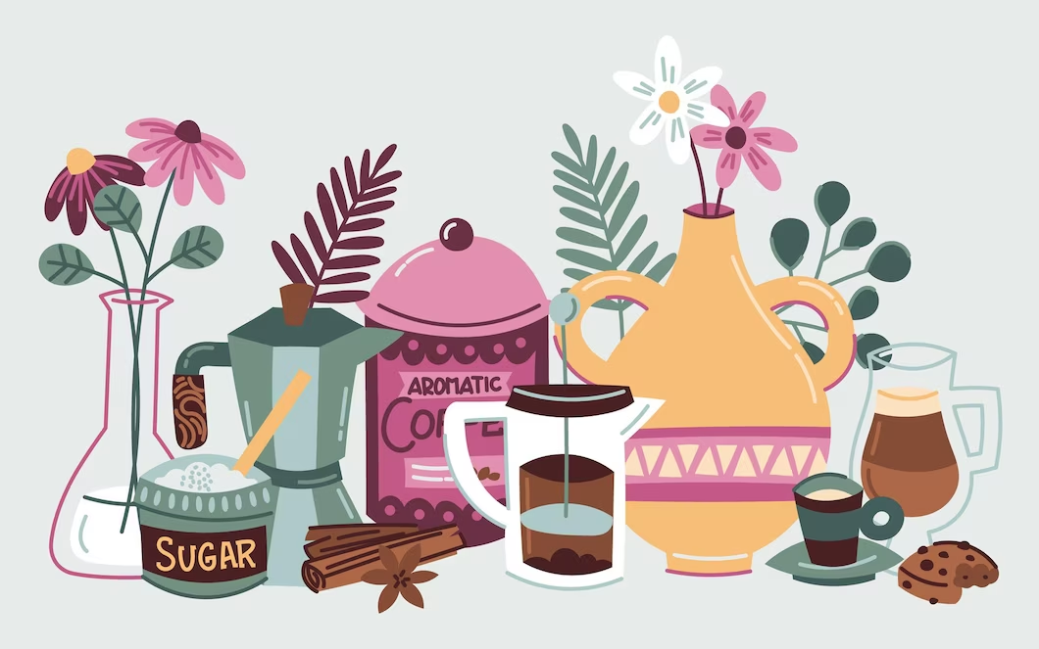

Dear Friends,
As we step into the crisp month of September, where the cooler air carries the promise of autumn and the leaves begin to fall, creating a cosy ambiance, we wanted to take a moment to reach out and let you know that you are in our thoughts. Even though we may not have the opportunity to gather in person sometimes, we are here to offer our unwavering support in any way we can.
In the spirit of embracing the changing season, we have prepared an exciting array of resources for you to explore. This month's activity pack revolves around the theme of embracing the cooler weather, enjoying the outdoors, and finding joy in the simple moments. We believe that these activities will not only bring you closer together but also provide moments of pure delight and shared memories.
We sincerely hope that this month's pack, filled with autumnal adventures, brings you immense joy, laughter, and a renewed sense of togetherness. As we bid farewell to the end of summer, we welcome the cosy times ahead.
Wishing you a season of endless fun this September and cherished moments.

If you’d like to display any fundraising pictures, or photos of any local fundraising event to be shared on our social media please send your images via email to iseultkinsella@alzheimer.ie
- "By all these lovely tokens, September days are here. With summer's best of weather and autumn's best of cheer."
- -Helen Hunt Jackson

Useful Resources:
- Our Free Helpline and Dementia Nurse Support Line are available at: Phone: 1800 341 341 and Email: helpline@alzheimer.ie
- The ASI now also has a new online Virtual Dementia Hub where you can go for a full range of activities – you can even listen to some wonderful poetry and songs recorded especially . Just go to www.virtualdementiahub.ie
- We are hosting a number of Virtual Cafes. They are a place to come together, share a cuppa and listen to our amazing guest speakers. For information on how to attend visit: https://alzheimer.ie/service/alzheimer-cafe/
- The ASI also have a huge library of factsheets and resources available on: https://alzheimer.ie/get-support/resources-and-factsheets/
- For musical videos and resources Music For Dementia are a wonderful resource: https://musicfordementia.org.uk/
- The Irish Museum of Modern Art (IMMA) have a huge collection available to view online at: https://imma.ie/collection/
- Emergency Response Numbers: 999 or 112 9. HSE 24/7 Your Mental Health Information Helpline: 1800 111 888

Table of Contents

Activity | Pages
Quiz September and Nature Exploration | 6
September Word Search | 7
Fishing Counting Game | 8
The Moon Poem | 9
Treasures Poem | 10-11
Take me Home Country Roads Song | 12-13
How the Giants Causeway Was Formed | 14-15
Make an Autumn Garland | 16-17
Chocolate Chip Banana Bread Recipe | 18-19
Word Scramble | 20
Spot the Difference | 21-22
General Knowledge Themed True or False | 23
Nature Bingo | 25-28
Pictures to Colour | 29-34
September Poem | 35-36
Humorous Poems | 37
Scavenger Hunt | 38-39
Spiritual Relaxation | 40-41

Quiz: September & Nature Exploration:
- Question: In September, the days start to get shorter and the nights get longer. Is this true or false?
  - Answer: True
- Question: What is the birthstone for September: Sapphire or Ruby?
  - Answer: Sapphire
- Question: September marks the beginning of which season: Spring or Autumn?
  - Answer: Autumn
- Question: During autumn, leaves change colour. Can you name one color that leaves might turn in September?
  - Answer: Red, Orange, Yellow
- Question: In September, migratory birds begin their journey to warmer regions. Is this true or false?
  - Answer: True
- Question: What type of fruit is often associated with September and can be used in pies and jams?
  - Answer: Apples
- Question: In Ireland, September is known for unpredictable weather. What phrase describes this weather pattern?
  - Answer: "Four seasons in one day"
- Question: Mushrooms start to appear in forests in September. True or false?
  - Answer: True
- Question: Which month comes after September: October or May?
  - Answer: October
- Question: The autumnal equinox occurs in September. What does this day mark?
  - Answer: The first day of autumn when day and night are nearly equal.
- Question: What is the name of the fruit that ripens and falls from trees in September?
  - Answer: Acorns
- Question: Name a fall flower that blooms in September, often used to make tea.
  - Answer: Chamomile
- Question: September is a popular time for grape harvesting. What beverage is made from grapes?
  - Answer: Wine
- Question: Can you name an animal that might be seen preparing for hibernation in September?
  - Answer: Squirrels, Bears
- Question: What are the large, round, orange fruits associated with Halloween that are often harvested in September?
  - Answer: Pumpkins

September Word Search!

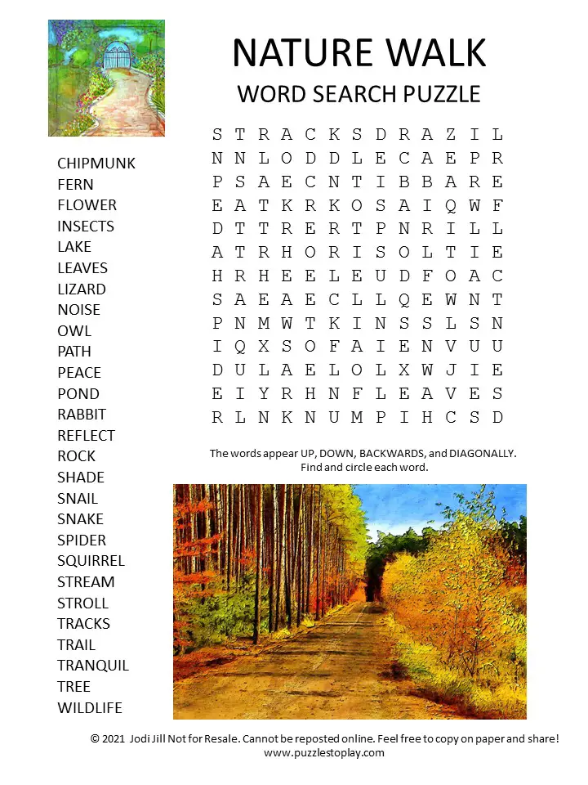
Fishing Counting Game
Oh no! Someone has dropped their fishing tackle box!
Count the different fishing lures and write your totals below
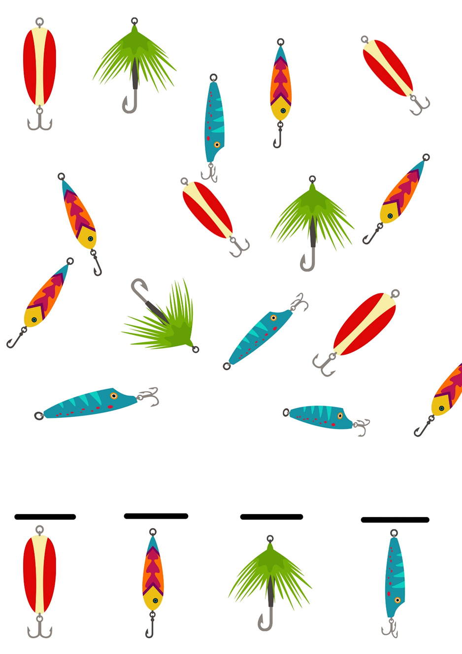

The Moon by Robert Louis Stevenson

The moon has a face like the clock in the hall;
She shines on thieves on the garden wall,
On streets and fields and harbour quays,
And birdies asleep in the forks of the trees.

The squalling cat and the squeaking mouse,
The howling dog by the door of the house,
The bat that lies in bed at noon,
All love to be out by the light of the moon.

But all of the things that belong to the day
Cuddle to sleep to be out of her way;
And flowers and children close their eyes
Till up in the morning the sun shall arise.

Treasures By Patricia L. Cisco

Treasures come in so many ways:
the sun that lights the cloudy days,
a rainbow from a summer shower,
a rose that blooms within an hour.
Yes, treasures come in so many ways.

A baby's staring, wandering gaze,
a dolphin's dance on ocean waves.
Yes, treasures come in so many ways.

The heart beats of two souls in love,
a beautiful white and peaceful dove.
Yes, treasures come in so many ways.

A sky full of snowflakes of rarest form,
a cup of cocoa to keep us warm.
Yes, treasures come in so many ways.

A house full of family on holidays.
For these treasures we should give God praise!
Yes, treasures come in so many ways.

I could keep on counting for days and days!

Take Me Home, Country Roads by John Denver
Almost heaven, West Virginia
Blue Ridge Mountains, Shenandoah River
Life is old there, older than the trees
Younger than the mountains, growin' like a breeze

Country roads, take me home
To the place I belong
West Virginia, mountain mama
Take me home, country roads

All my memories gather 'round her
Miner's lady, stranger to blue water
Dark and dusty, painted on the sky
Misty taste of moonshine, teardrop in my eye

Country roads, take me home
To the place I belong
West Virginia, mountain mama
Take me home, country roads

I hear her voice in the mornin' hour, she calls me
The radio reminds me of my home far away
Drivin' down the road, I get a feelin'
That I should've been home yesterday, yesterday

Country roads, take me home
To the place I belong
West Virginia, mountain mama
Take me home, country roads

Country roads, take me home
To the place I belong
West Virginia, mountain mama
Take me home, country roads

Take me home, (down) country roads
Take me home, (down) country roads

How the Giant’s Causeway was Formed
(Written by Claddagh Design)

The Giant’s Causeway is made up of around 40,000 interlocking basalt columns, on the coast of county Antrim. The nearest town is Bushmills (where the whiskey of the same name originated), and it’s around an hour’s drive from Belfast. It was formed long before either of those places existed, however – in fact it was formed long before Ireland was inhabited by humans, some 60 million years ago. During the Paleogene period, the land mass that would eventually become Ireland was subject to high levels of volcanic activity. On the surface of the land were extensive chalk beds, which some very fast moving molten basalt pushed up through to form a lava plateau. As the lava cooled and solidified, it contracted and the surface fractured – similar to when mud dries out in the sun. As it cooled down further, the cracks continued in a downward motion, leaving hexagonal pillars of basalt.
The cliff edge of the Giant’s Causeway that visitors can see today is in fact the edge of the lava plateau. The larger fissures can be clearly seen in the cliff edge as bands of dark rock which cut down the cliff face and jut out towards the sea. This occurred in three periods of volcanic activity which resulted in three flows, now known as the Lower, Middle and Upper Basalts. It’s the Middle Basalts that formed the famous columns; variations in the cooling rate resulted in its undulating appearance. Weathering has created various other formations that have been given romantic (and not so romantic!) names such as the Giant’s Eyes, the Chimney Stacks, the Harp, the Organ, the Wishing Chair and the Camel’s Hump. Although the majority of the columns are hexagonal, some have up to eight sides. The tallest basalt column is around 12 metres high, while the solidified lava in the cliffs is up to 28 metres thick in some places.
If you’re slightly baffled by the mention of volcanoes, lava, and Ireland in the same sentence, you shouldn’t be. 60 million years ago the land mass that the Causeway formed on was actually attached to the eastern seaboard of America and would have had the same latitude as northern Spain has now, with hot and humid conditions prevalent. The tectonic plates that all of earth’s land is part of moved over the subsequent millions of years, and we eventually ended up where we are now! Similar formations can be found at the opposite point of the coast in Scotland (more about that later), as well as in parts of America, Australia and Vietnam – none are quite as spectacular as Ireland’s Giant’s Causeway however!

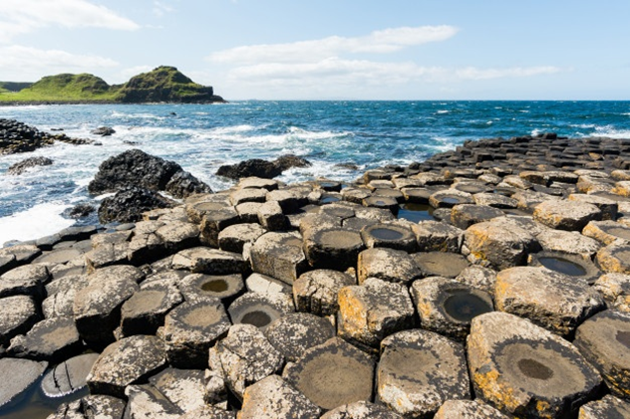

Make an Autumn Garland!:

Materials Needed:
- String or twine
- Fall leaves (real or artificial)
- Small pinecones
- Acorns (optional)
- Faux berries (optional)
- Glue or tape
Step-by-Step Instructions:
- Gather Your Supplies: Set up a crafting area with all the materials you'll need. Make sure the leaves and other decorations are clean and dry.
- Prepare the Leaves: If you're using real leaves, make sure they are dry and not too brittle. If they are too delicate, consider using artificial leaves, which are more durable. If using real leaves, you can press them between heavy books for a day to flatten them.
- Cut the String: Decide how long you want your garland to be. Cut a piece of string or twine to that length, adding a few extra inches on each end for hanging.
- Attach the First Leaf: Lay the first leaf along the string, about 2-3 inches from one end. If you're using artificial leaves, they may have wire stems that you can wrap around the string to secure them. If using real leaves, you can use a small piece of tape or glue to attach them.
- Add Pinecones and Decorations: Attach pinecones, acorns, and any other decorations you have chosen to the string. You can space them out evenly or cluster them together for variety.
- Attach More Leaves: Continue attaching leaves along the string, alternating them with the decorations. You can overlap the leaves slightly to create a layered effect.
- Secure the Ends: Once you've attached all your decorations, add another leaf or decoration at the end of the string to secure them in place.
- Hang the Garland: Find a suitable place to hang your garland. You can drape it across a mantle, hang it on a wall, or even use it as a table runner.
- Adjust and Arrange: Take a step back and look at your garland. Adjust the position of the leaves and decorations to make sure they're evenly spaced and arranged to your liking.
- Enjoy: Your autumn garland is now ready to be enjoyed! It adds a touch of seasonal beauty to your home.

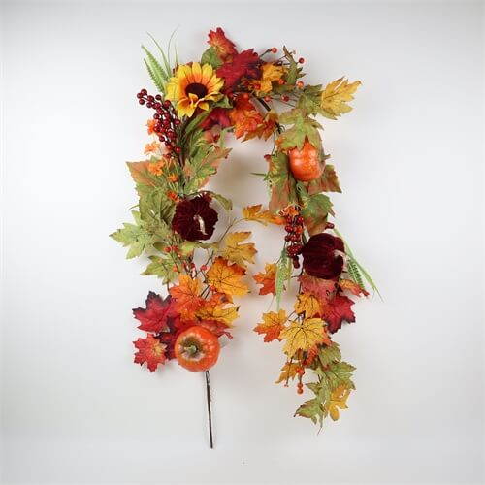

Chocolate Chip Banana Bread Cake
Ingredients:
- 1 ½ cups all-purpose flour
- 1 teaspoon baking soda
- ¼ teaspoon salt
- ½ teaspoon ground cinnamon
- ½ cup unsalted butter, softened
- ½ cup granulated sugar
- ½ cup brown sugar, packed
- 2 large eggs
- 1 teaspoon vanilla extract
- 3 ripe bananas, mashed
- ½ cup sour cream
- 1 cup chocolate chips
- Chopped nuts (optional)
Step-by-Step Guide:
- Preheat Oven: Preheat your oven to 350°F (175°C). Grease and flour a round cake pan.
- Mix Dry Ingredients: In a medium bowl, whisk together the flour, baking soda, salt, and ground cinnamon. Set aside.
- Cream Butter and Sugars: In a large bowl, cream together the softened butter, granulated sugar, and brown sugar until the mixture is light and fluffy.
- Add Eggs and Vanilla: Add the eggs one at a time, beating well after each addition. Mix in the vanilla extract.
- Incorporate Bananas and Sour Cream: Stir in the mashed bananas and sour cream until well combined.
- Combine Dry Ingredients: Gradually add the dry ingredient mixture to the banana mixture, mixing until just combined.
- Fold in Chocolate Chips: Gently fold in the chocolate chips and chopped nuts (if using).
- Pour Batter into Pan: Pour the batter into the prepared cake pan and spread it evenly.
- Bake: Place the cake pan in the preheated oven and bake for 40-45 minutes, or until a toothpick inserted into the center comes out clean.
- Cool: Once baked, remove the cake from the oven and let it cool in the pan for about 10 minutes. Then, transfer the cake to a wire rack to cool completely.
- Decorate (Optional): You can sprinkle some powdered sugar on top of the cake or even drizzle a simple glaze made from powdered sugar and a little milk.
- Slice and Serve: Once the cake is completely cool, slice it and serve. Enjoy it with a cup of tea or coffee!
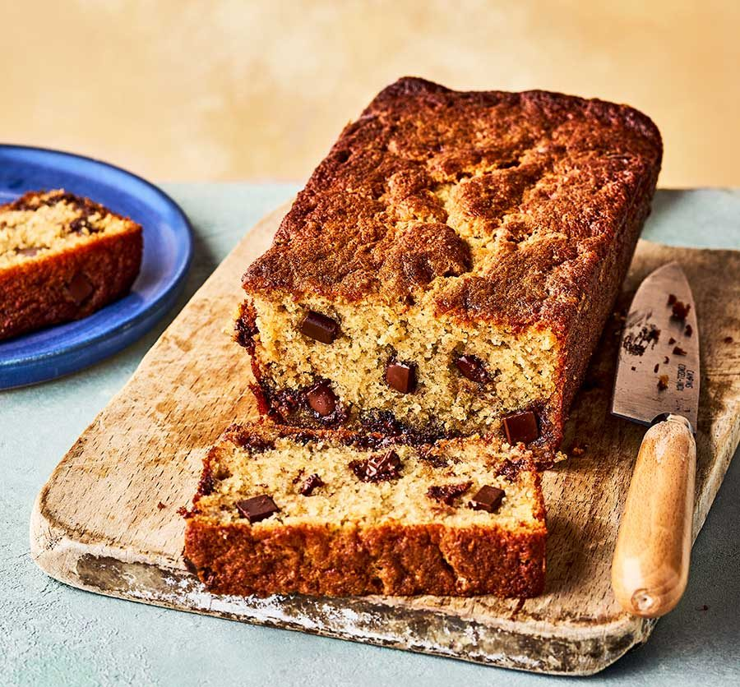

Word Scramble: September Theme
- RGMUO
  - Answer: GOURM
- EMBTEPER
  - Answer: SEPTEMBER
- VLAEES
  - Answer: LEAVES
- GTHRIVAN
  - Answer: HARVESTING
- TUMMSOEA
  - Answer: AUTUMN
- YATRDA
  - Answer: TODAY
- LRPUISECB
  - Answer: PUBLISHER
- MRWEA
  - Answer: WARM
- REAYLPLTOC
  - Answer: PEACEFULLY
- HSUKAYY
  - Answer: HAYSTACK
- CEOLRD
  - Answer: COLDER
- ETMOEBPR
  - Answer: TEMPER
- YRATINLEKWT
  - Answer: LATELY
- TRGOEIHTTOAWNS
  - Answer: GROWTH
- SNUPRERISET
  - Answer: SUNRISE

Meditation Spot the Difference!:

Spot the Difference!
Can you spot 5 differences in the picture?
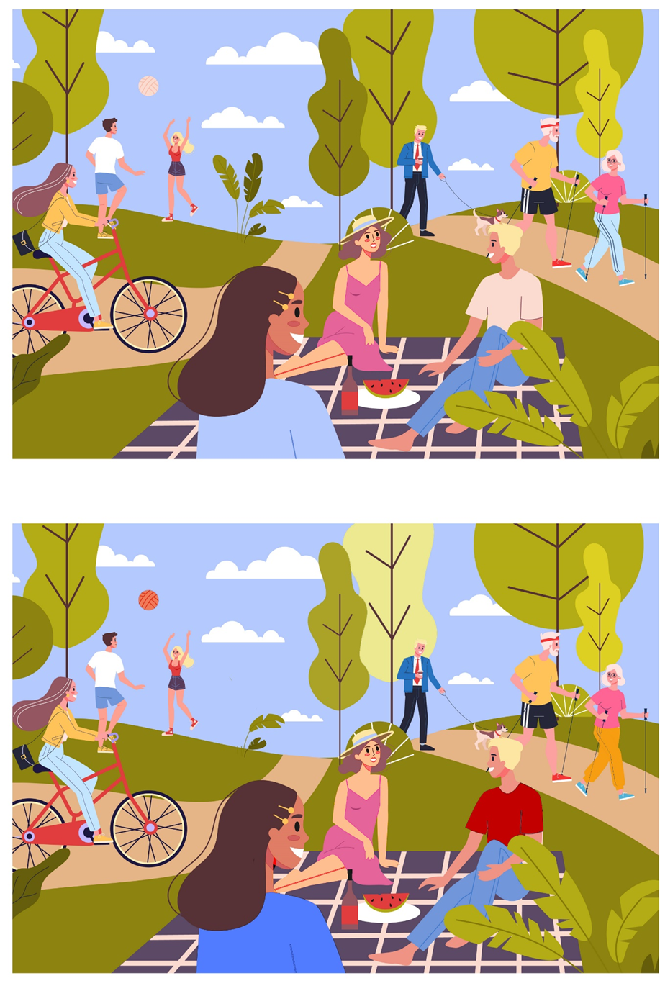

General Knowledge Themed True or False!:

- Question: September is the first month of the year.
  - Answer: False
- Question: Ireland is known as the "Emerald Isle" due to its lush green landscapes.
  - Answer: True
- Question: Elvis Presley was a popular singer in the 1960s.
  - Answer: True
- Question: Audrey Hepburn was a famous actress in the 1960s.
  - Answer: True
- Question: The Beatles were a famous rock band from the 1960s.
  - Answer: True
- Question: Dublin is the capital city of Ireland.
  - Answer: True
- Question: The 60s were known for the rise of hippie culture and flower power.
  - Answer: True
- Question: September is the only month with 30 days.
  - Answer: False
- Question: "Somewhere Over the Rainbow" was a hit song in the 1960s.
  - Answer: False
- Question: The Cliffs of Moher are famous natural landmarks located in Ireland.
  - Answer: True
- Question: The 1969 moon landing was part of the Apollo 11 mission.
  - Answer: True
- Question: Judy Garland played the iconic role of Mary Poppins in the 1960s.
  - Answer: False
- Question: St. Patrick's Day is celebrated in September in Ireland.
  - Answer: False
- Question: The 1960s saw the rise of influential civil rights movements.
  - Answer: True
- Question: "I Want to Hold Your Hand" is a well-known song by The Rolling Stones.
  - Answer: False

Nature Bingo:
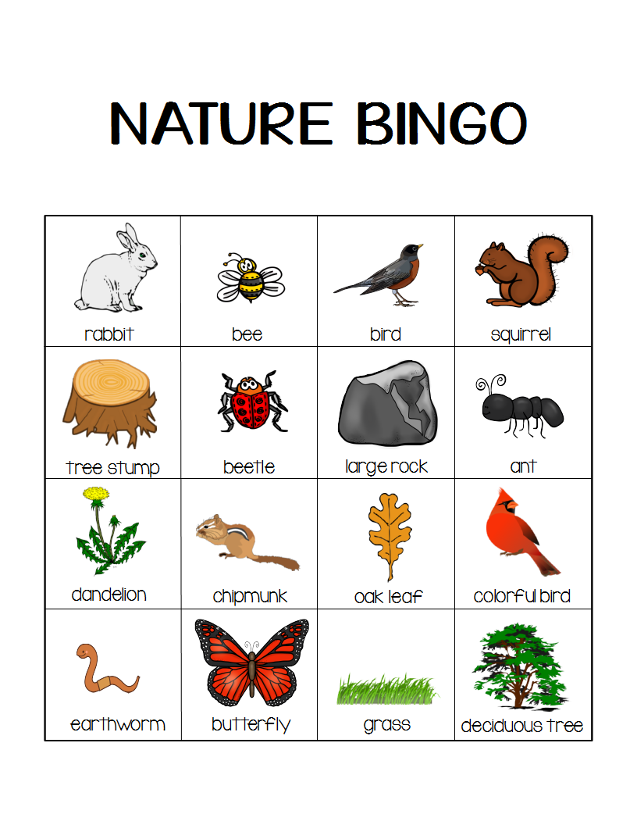
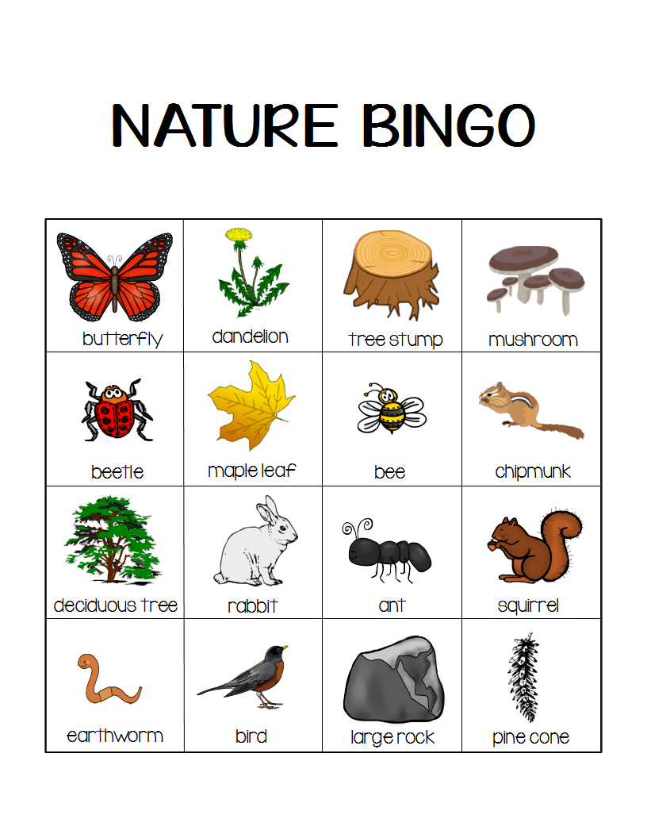

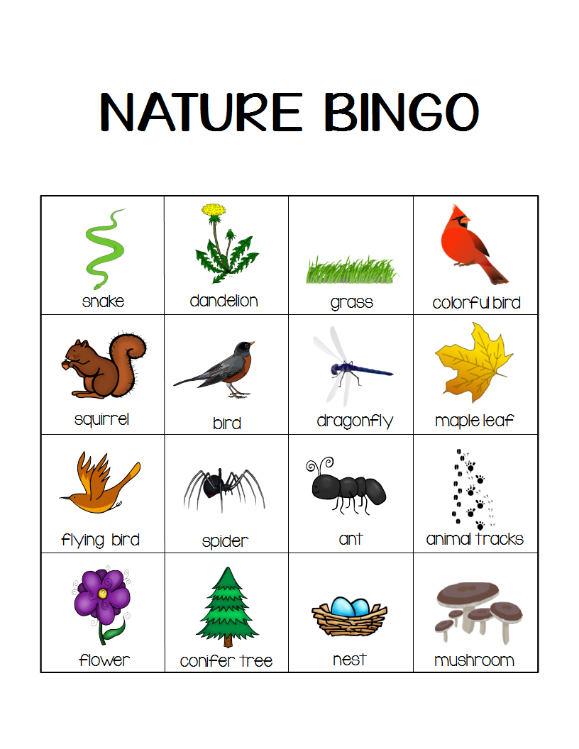
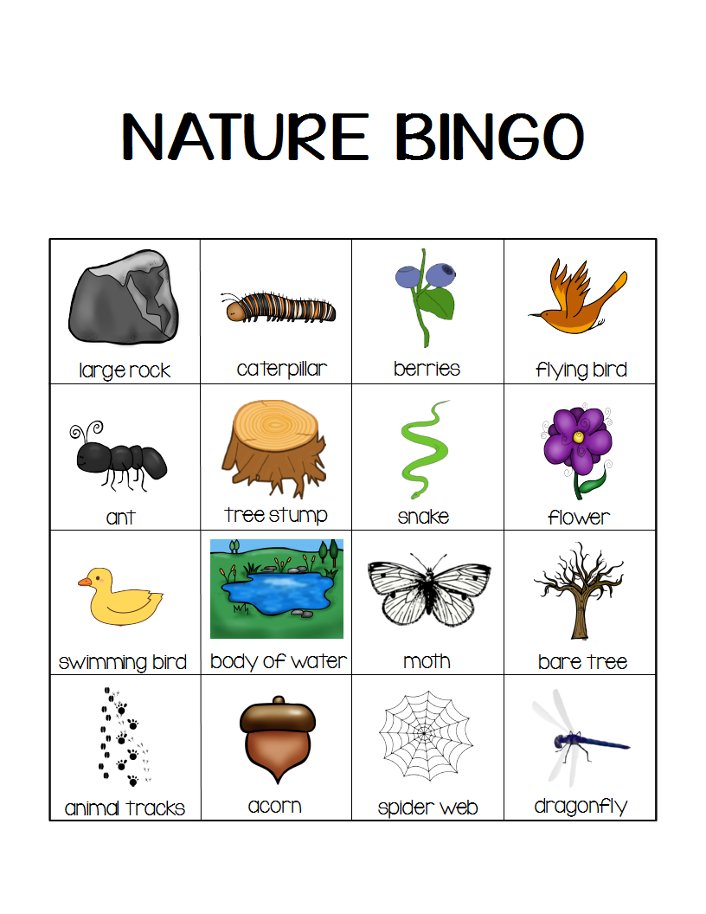

Pictures to Colour!:
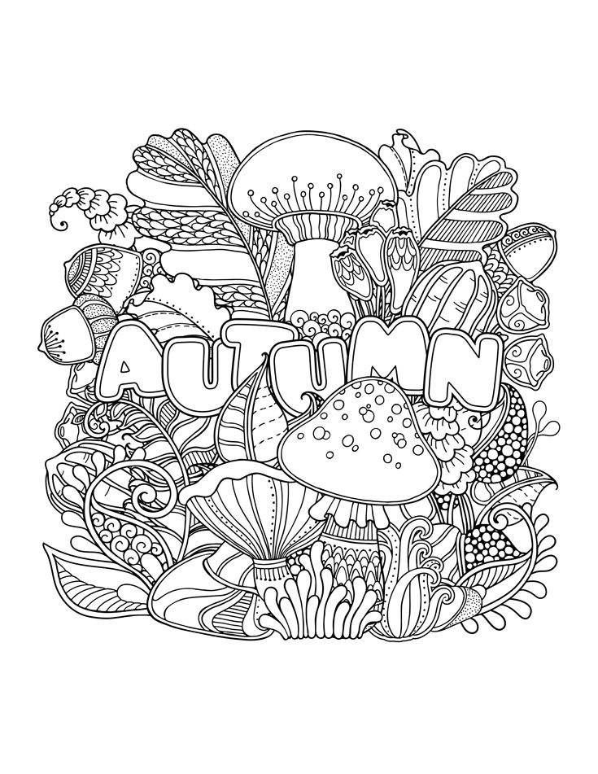
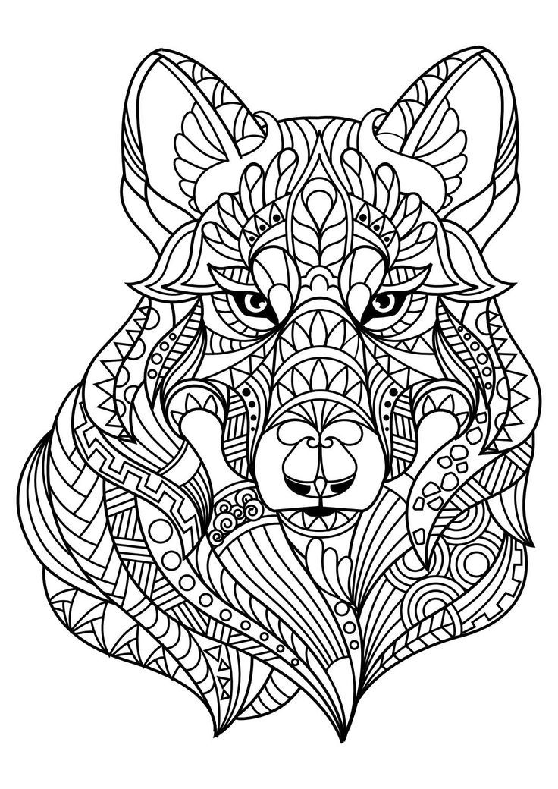

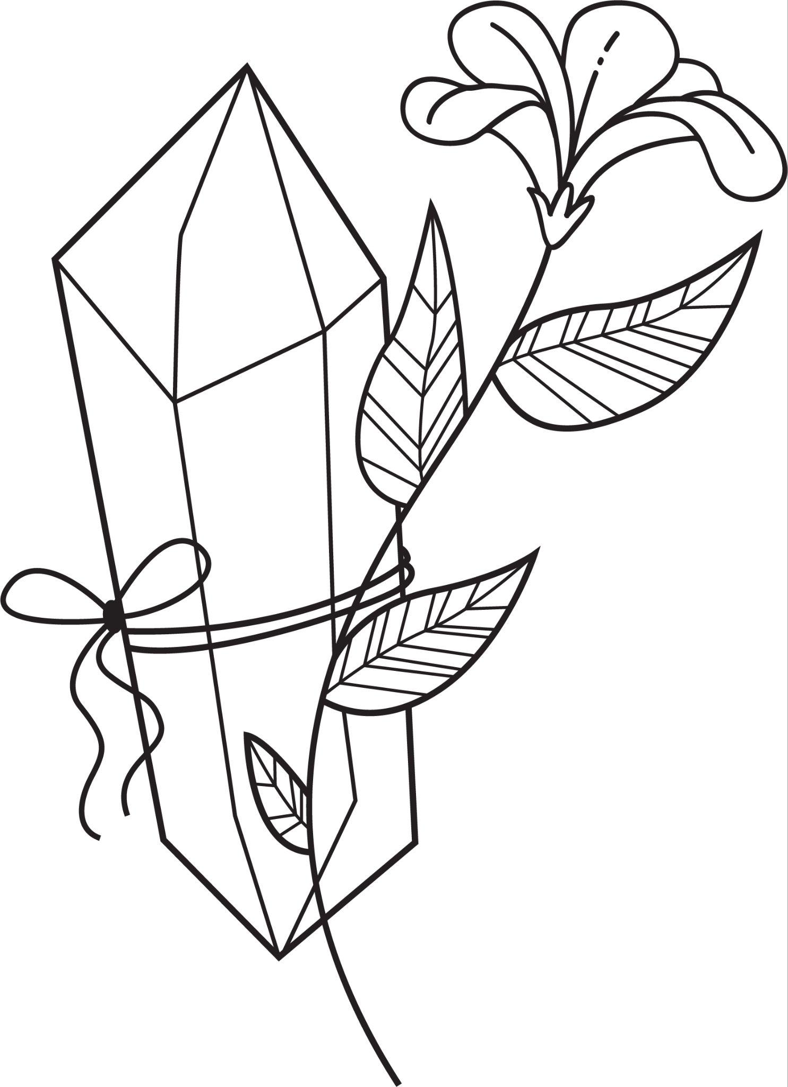
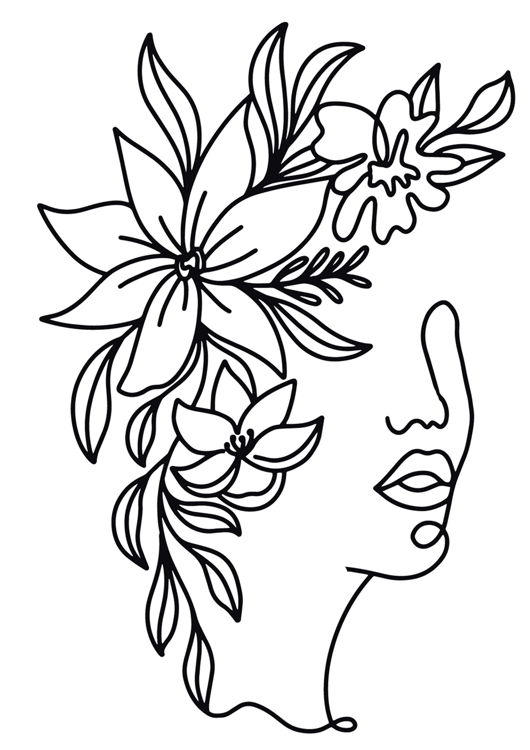

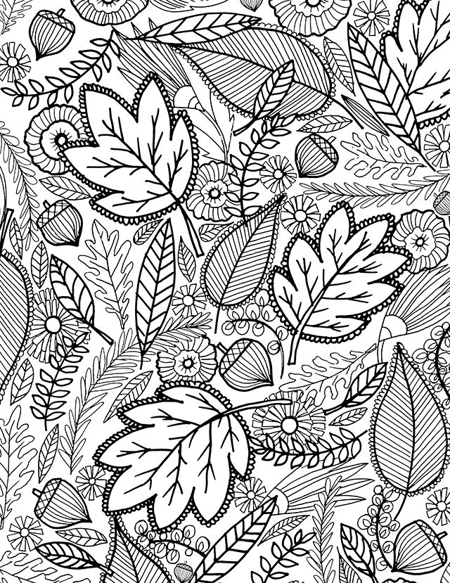

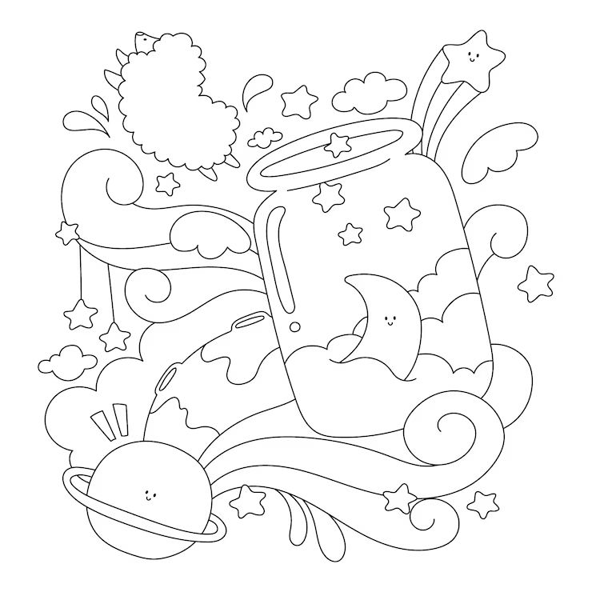

September
By Helen Hunt Jackson:

The golden-rod is yellow;
The corn is turning brown;
The trees in apple orchards
With fruit are bending down.

The gentian's bluest fringes
Are curling in the sun;
In dusty pods the milkweed
Its hidden silk has spun.

The sedges flaunt their harvest,
In every meadow nook;
And asters by the brook-side
Make asters in the brook,

From dewy lanes at morning
The grapes' sweet odors rise;
At noon the roads all flutter
With yellow butterflies.

By all these lovely tokens
September days are here,
With summer's best of weather,
And autumn's best of cheer.

But none of all this beauty
Which floods the earth and air
Is unto me the secret
Which makes September fair.

'T is a thing which I remember;
To name it thrills me yet:
One day of one September
I never can forget.

Humorous Poems by Edward Lear:
1.
There was an Old Man with a beard,
Who said, "It is just as I feared!—
Two Owls and a Hen,
Four Larks and a Wren,
Have all built their nests in my beard!"
2.
There was a Young Lady of Ryde,
Whose shoe-strings were seldom untied;
She purchased some clogs,
And some small spotty dogs,
And frequently walked about Ryde.
3.
There was an Old Man with a nose,
Who said, "If you choose to suppose,
That my nose is too long,
You are certainly wrong!"
That remarkable Man with a nose.
4.
There was a Young Lady whose bonnet,
Came untied when the birds sate upon it;
But she said, "I don't care!
All the birds in the air
Are welcome to sit on my bonnet!"
Scavenger Hunt: Exploring the Irish Garden:
Instructions:
- Preparation: Prepare a list of items and clues that can be found in the garden. Write these on a piece of paper or card and provide one copy to each participant or team.
- Pairs or Small Teams: Pair individuals with dementia and their caregivers in teams if possible. This encourages collaboration and provides opportunities for engagement.
- Instructions: Explain the rules and objectives of the scavenger hunt. Emphasise that it's a fun and relaxed activity, and encourage participants to work together to find the items and solve clues.
- Safety: Prioritise safety. Make sure the garden area is free from hazards, and provide assistance as needed to ensure a comfortable experience.
Scavenger Hunt List and Clues:
- Colourful Blooms: Find a flower with red petals. (Hint: Look near the edge of the garden.)
- Garden Friends: Locate a place where birds might visit. (Hint: It's a cosy spot.)
- Tiny Treasures: Search for a small pebble or stone. (Hint: It's close to a tree.)
- Shady Oasis: Find a comfortable place to sit and relax. (Hint: It's under a leafy canopy.)
- Nature's Art: Discover a leaf with an interesting shape. (Hint: It's near the ground.)
- Whispering Leaves: Find a tree with rustling leaves. (Hint: Listen for the sound.)
- Water Wonders: Locate a source of water in the garden. (Hint: It's a small container.)
- Sunlit Spot: Find a place where the sunlight hits the ground. (Hint: It's near a wall.)
- Fragrant Find: Search for a flower with a pleasant smell. (Hint: Follow your nose!)
- Garden Beauty: Discover a spot with a view that you enjoy. (Hint: It's near a bench.)
Bonus Clue: Look around and find something that reminds you of a beautiful Irish landscape. What does it remind you of?
End of the Hunt: Gather everyone back together and share the items you've found, the clues you've solved, and any thoughts about the bonus clue.
This outdoor scavenger hunt encourages participants to explore the garden, observe nature's beauty, and enjoy the company of each other. It provides a mix of sensory experiences and cognitive engagement, making it a fulfilling and enjoyable activity for individuals with dementia and their caregivers.
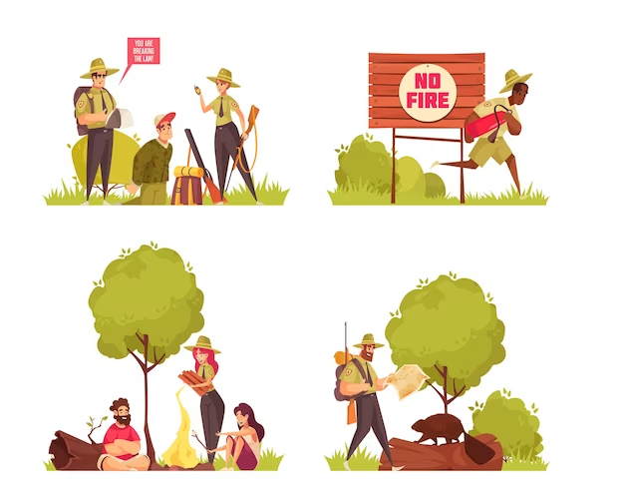

Spiritual Relaxation:

Many people find that prayer or mindful reflection can help calm their mind and provide comfort and ease when we may have stress or troubling thoughts.
The following is a small prayer, suitable for everyone, to help us in times when our mind might be uneasy.

“Give me the strength to continue to push on, to work toward my goals, and to be gentle toward myself in times of failure. Give me the courage to stand up for what is right and to get out of bed each day, especially when the day seems bleak.

Give me the patience to be compassionate and helpful toward others and myself, and to know when it is best to remain quiet. Give me the clarity to be grateful for all that I have, and to realise when I have something to give to others. Give me the capacity to love and forgive others, especially the ones who have wronged me. Give me the serenity to find happiness and peace in each day.

Give me the knowledge to take responsibility for my mistakes, and the ability to let go of things and people who no longer help me grow. Give me the power to be greater than fear and larger than hate.

Let me have the capability to live in the moment, dance in the rain, sing in the shower, and live life to the fullest. Give me the understanding of embattled individuals who are struggling and the power to not take their attacks personally. Let me have the perspective to see the bigger picture in all situations I may face. Let me have the potential to change what I can change, and do what I can to make the world a better place. Let me have the ability to let things that do not serve me go.

And most of all, let me have the intelligence to realise that most of these traits already exist within me. Give me the strength, curiosity and courage to find them within myself and others.”

