December
Activity Pack 2

Dear Friends,

As we approach the close of the year, we extend warm wishes for a festive season filled with the comforts of home and the joy of good company.

As the New Year beckons, take solace in the returning light even before its official arrival. The Winter Solstice, marking the longest night, occurs on December 21st. By Christmas Day, the skies begin to brighten, welcoming the sun to linger a little longer—a poignant reminder that after every period of darkness, there comes light.
With heartfelt warmth, we wish you a Merry Christmas and a joyous commencement to the New Year.

Reflecting on the year gone by, we want to express our deep gratitude for your unwavering support. This year has seen significant milestones for ASI, including the opening of our 50th Day Care Centre, the establishment of the first dementia-specific shopping centre, and the creation of the first dementia-specific town. These achievements are a testament to the collective effort and dedication of our community.

As we express our gratitude, we also look forward to the promise of the coming year. May it bring you and your loved one’s health, happiness, and an abundance of cherished moments.
Remember, ASI is just a phone call away should you ever need us. Our helpline number is 1800 341 341, and our volunteers are ready to listen and support you.
May you thoroughly enjoy this December’s Activity Pack!

"What good is the warmth of summer, without the cold of winter to give it sweetness."
— John Steinbeck

Useful Resources:
Useful Resources:
- Christmas can be overwhelming for many people who are caring for someone with dementia. Our resource- Caring at Christmas provides tips on how to care for someone at Christmas. You can get this by calling our Helpline on 1800 341 341
2. The ASI now also has a new online Virtual Dementia Hub where you can go for a full range of activities – you can even listen to some wonderful poetry and songs especially. Just go to www.virtualdementiahub.ie
3. We are hosting a number of Virtual Cafes. They are a place to come together, share a cuppa and listen to our amazing guest speakers. For information on how to attend visit: https://alzheimer.ie/service/alzheimer-cafe/
4. The ASI also have a huge library of factsheets and resources available on: https://alzheimer.ie/get-support/resources-and-factsheets/
5. For musical videos and resources Music For Dementia are a wonderful resource: https://musicfordementia.org.uk/
6. The Irish Museum of Modern Art (IMMA) have a huge collection available to view online at: https://imma.ie/collection/
7. Emergency Response Numbers: 999 or 112 9. HSE 24/7 Your Mental Health Information Helpline: 1800 111 888

Table of Contents

Activity | Pages
Gingerbread Recipe | 6-7
Let it Snow Let it Snow Let it Snow by Dean Martin | 9-10
Pictures to Colour | 11-14
Christmas Scavenger Hunt | 15
5 Second Christmas Game | 16
Christmas Trivia Quiz | 17-18
Winter Wonderland by Faith Hill | 19-20
Riddle me This | 21-22
The Sheep by Anne and Jane Taylor | 23-24
Spot the Difference | 25-26
Hand Print Wreath | 28
When You Were Sweet Sixteen  By James Thornton (performed by The Fureys) | 29-30
The Banks Of My Own Lovely Lee lyrics by Seán O Sé / John Fitzgerald | 31-32
Guided Meditation for a relaxing New Year | 34-36

Gingerbread Biscuit Recipe

What you need:
- 75g butter
- 3 1/2tbsp golden syrup
- 60g light soft brown sugar
- 175g plain flour
- 1/4 tsp bicarbonate of soda
- 2tsp ground ginger

How to make gingerbread biscuits:
- Add butter, golden syrup and light brown sugar to a pan. Stir on a low heat until sugar has dissolved.

- Add flour, bicarbonate of soda and ginger to a mixing bowl then stir together. Make a well in the centre and pour in the sugar and butter mixture.

- Stir together to form a dough (it might be easiest to use your hands).

- Wrap in clingfilm and let chill for 30mins to firm up.

- Lay the dough between two sheets of baking parchment. Press dough lightly with a rolling pin. Give a quarter turn than repeat.

- Give it a final quarter turn, then start to roll backwards and forwards, giving regular quarter turns. Until dough is roughly thickness of a £1 coin.

- Using a biscuit cutter cut out the shapes. Bake at 190°C (170°C fan) mark 5 for 10-12min, until lightly golden brown.

- The biscuits won't be firm but will harden when left to cool outside the oven.

- Enjoy!

Let It Snow! Let It Snow! Let It Snow! - Dean Martin
Oh, the weather outside is frightful
But the fire is so delightful
And since we've no place to go
Let it snow, let it snow, let it snow

Man, it doesn't show signs of stopping
And I've brought me some corn for popping
The lights are turned way down low
Let it snow, let it snow

When we finally kiss goodnight
How I'll hate going out in the storm
But if you really hold me tight
All the way home I'll be warm

And the fire is slowly dying
And, my dear, we're still goodbying
But as long as you love me so
Let it snow, let it snow, and snow

When we finally kiss goodnight
How I'll hate going out in the storm
But if you really grab me tight
All the way home I'll be warm

Oh, the fire is slowly dying
And, my dear, we're still goodbying
But as long as you love me so
Let it snow, let it snow, let it snow

Pictures to Colour

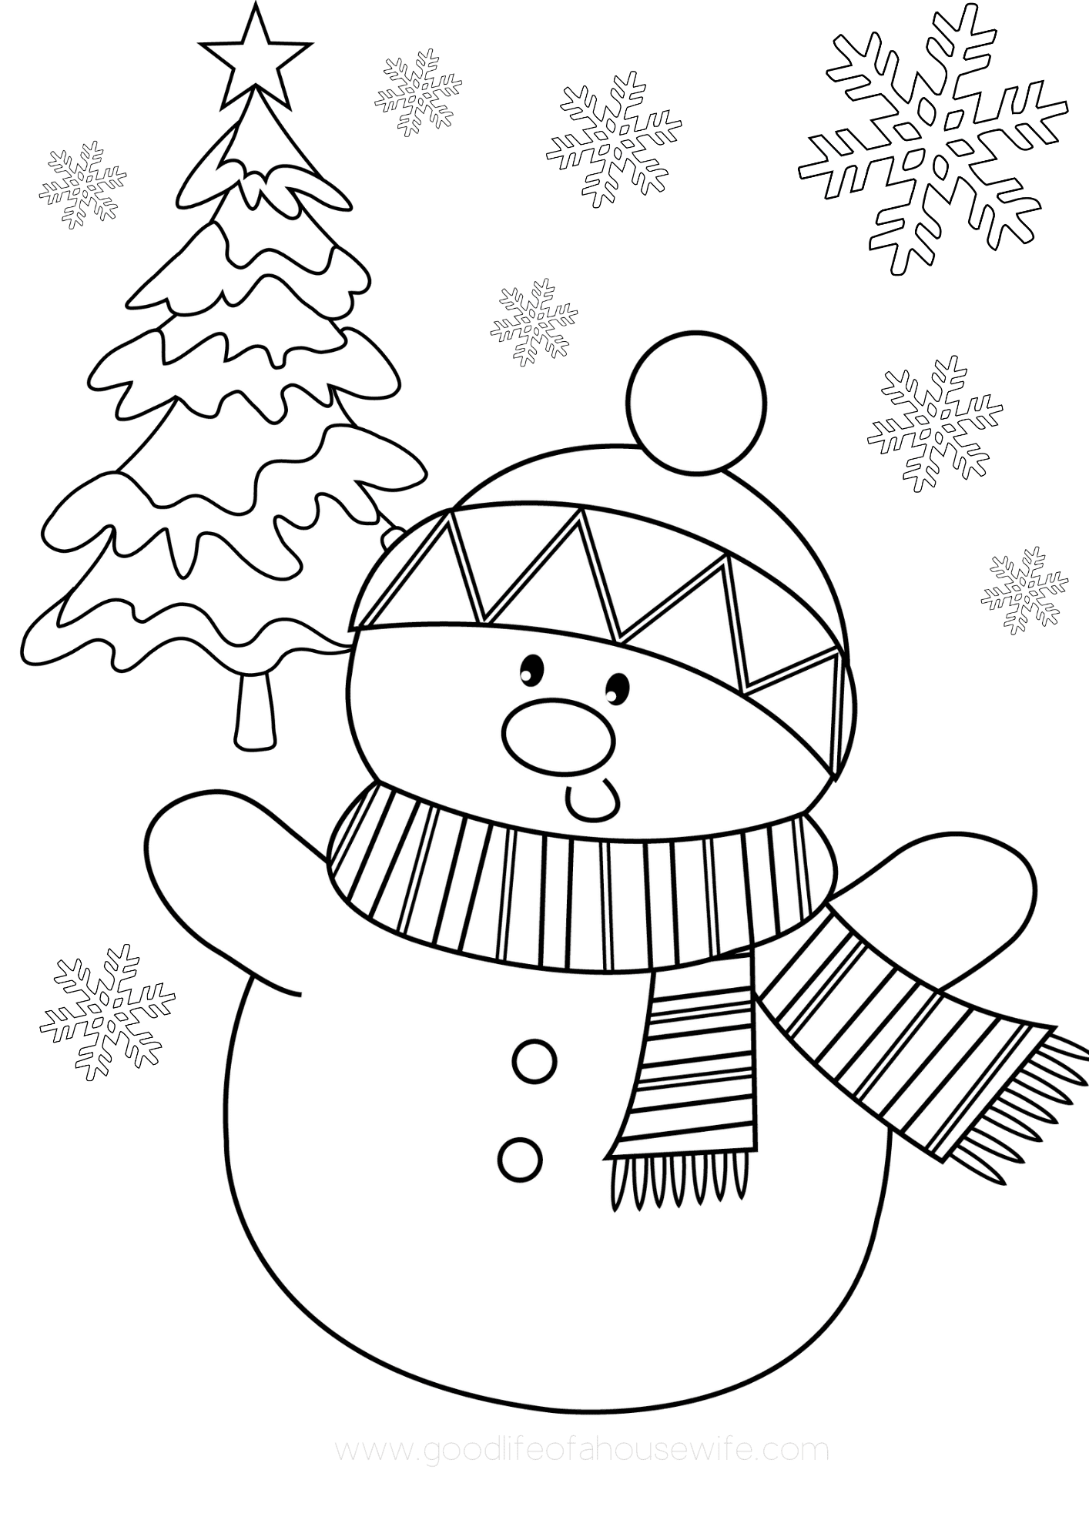

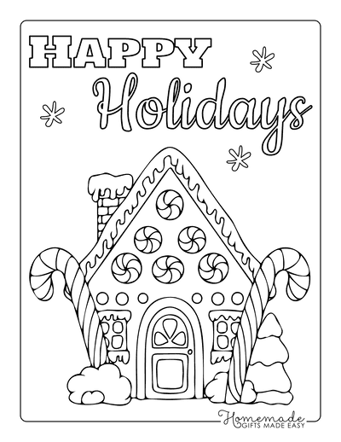

Christmas Scavenger Hunt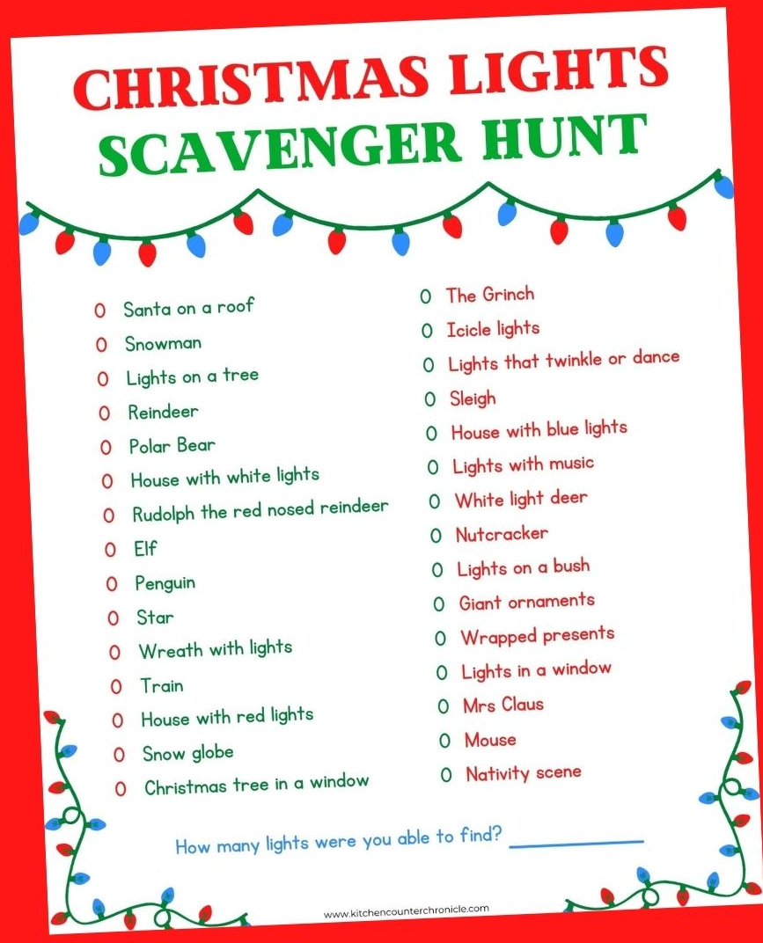

5 Second Christmas Game

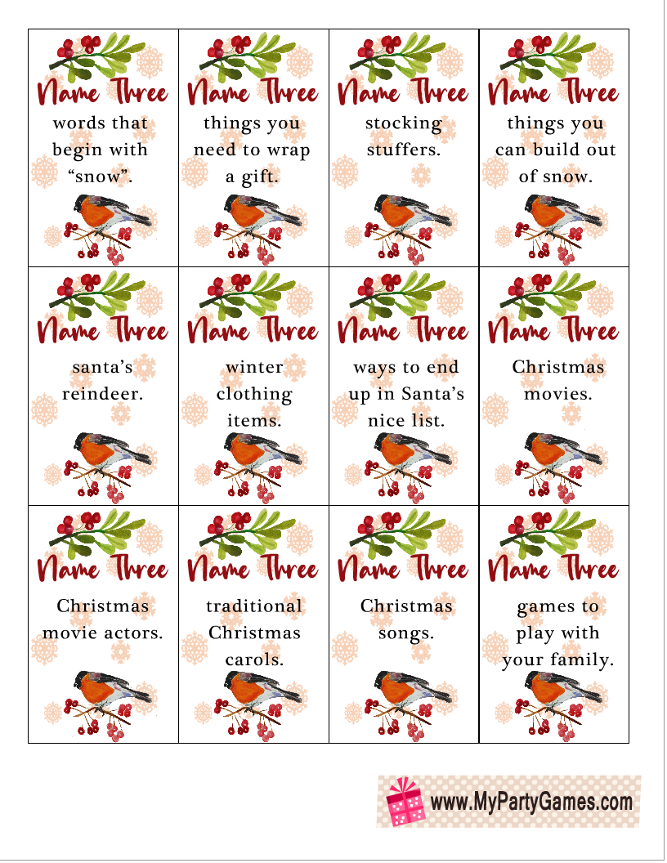
Christmas Trivia Quiz
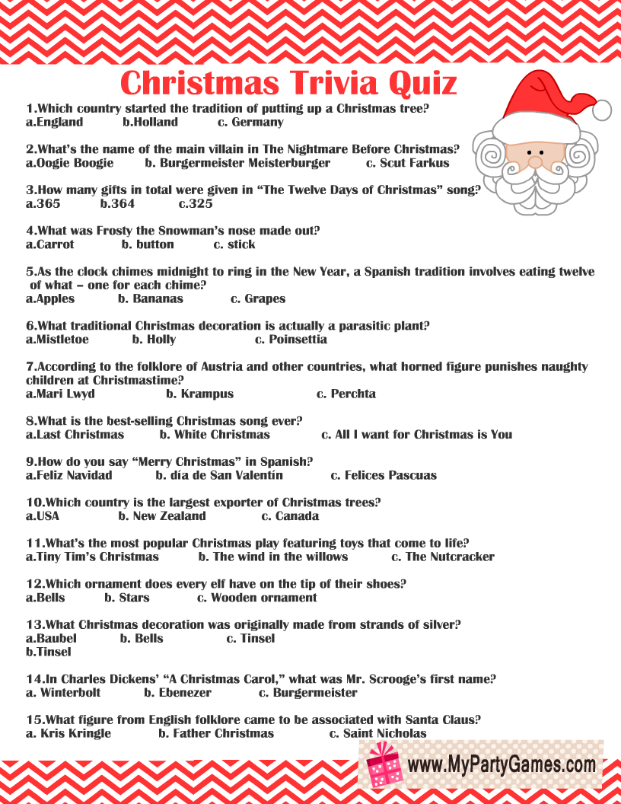
Christmas Trivia Quiz Answers

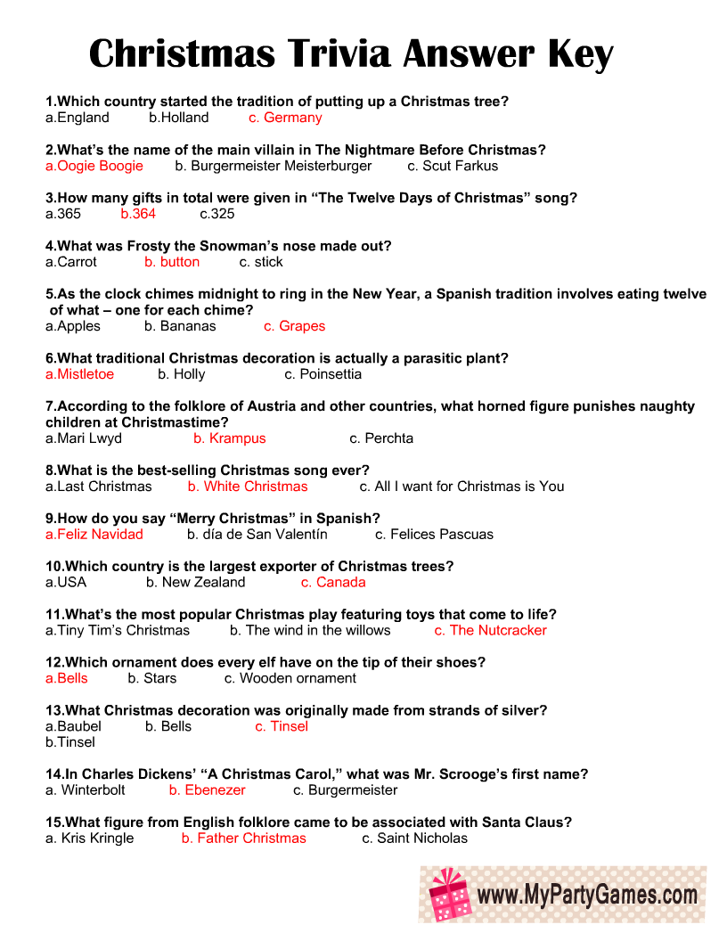
Winter Wonderland - Faith Hill
Sleigh bells ring, are you listening?
In the lane, snow is glistening
A beautiful sight, we're happy tonight
Walking in a winter wonderland
Gone away is the bluebird
Here to stay, is the new bird
Singing our song, as we go along
Walking in a winter wonderland
In the meadow we can build a snowman
Then pretend that he is Parson Brown
He'll say are you married? We'll say, no man
But you can do the job when you're in town
Later on, we'll conspire
As we dream by the fire
To face unafraid, the plans that we've made
Walking in a winter wonderland
In the meadow we can build a snowman
And pretend that he's a circus clown
We'll have lots of fun with Mr. Snowman
Until the other kiddies knock him down
When it snows, ain't it thrillin'?
Though you know, kids are chillin'
We'll frolic and play, the Eskimo way
Walking in a winter wonderland

Riddle Me This!

- What two things can you never eat for breakfast?
Lunch and Dinner.

- What has a face and two hands but no arms or legs?
A Clock.

- What tastes better than it smells?
A Tongue.

- What kind of room has no doors or windows?
A Mushroom.

- What goes up and never comes down?
Your Age.

- What word becomes shorter when you add two letters to it?
Short.

- Two children are born on the same day from the same mother but they are not twins. How is that possible?
They are two out of three triplets!

- Johnny's mother had three children. The first child was named April. The second child was named May. What was the third child's name?
Johnny!

The Sheep by Ann and Jane Taylor

"Lazy sheep, pray tell me why
In the pleasant fields you lie,
Eating grass, and daisies white,
From the morning till the night?
Everything can something do,
But what kind of use are you?"

"Nay, my little master, nay,
Do not serve me so, I pray;
Don't you see the wool that grows
On my back, to make you clothes?
Cold, and very cold, you'd be
If you had not wool from me.

True, it seems a pleasant thing,
To nip the daisies in the spring;
But many chilly nights I pass
On the cold and dewy grass,
Or pick a scanty dinner, where
All the common's brown and bare.

Then the farmer comes at last,
When the merry spring is past,
And cuts my woolly coat away,
To warm you in the winter's day:
Little master, this is why
In the pleasant fields I lie."
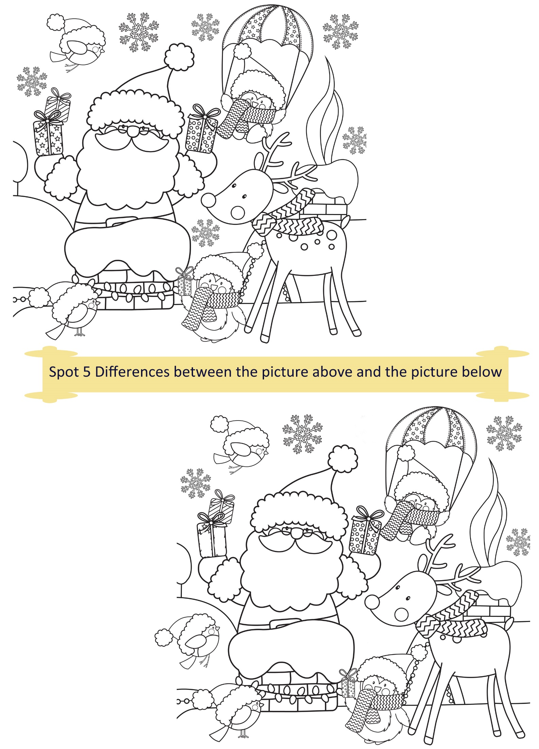
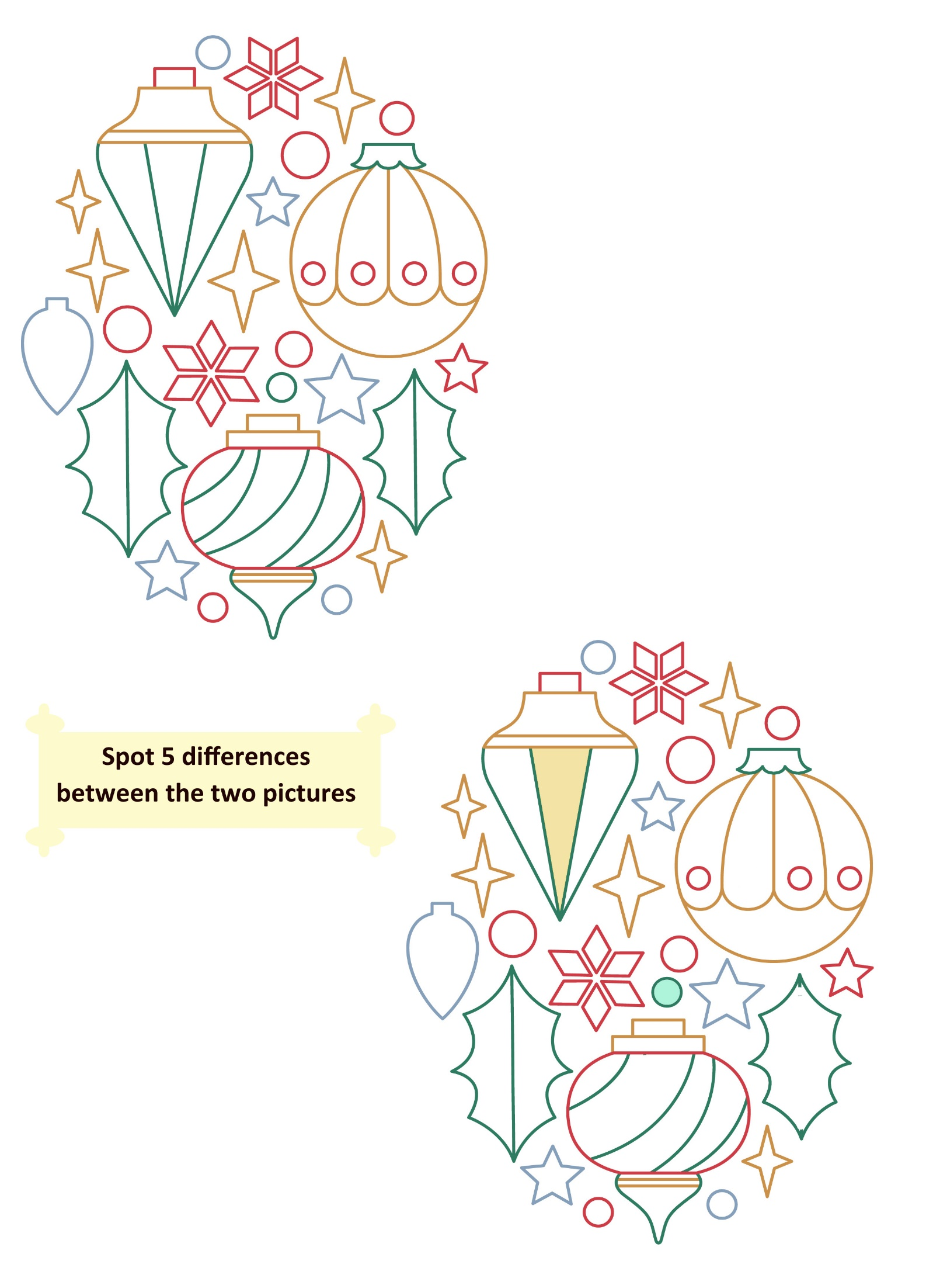

Hand Print Wreath
Materials:
- Green cardstock – this package is great since it comes in a few different colours
- Red pom poms
- Red craft rhinestones
- Red ribbon
- Paper plate
- Green paint (optional)
Instructions:

- First cut out the circle centre of your paper plate.
Then paint it green. This is optional as most of the paper plate won’t be shown but a few small pieces may peak through.
- Now cut out your handprints.
Because you need quite a few, you can trace and cut out one and then use that to trace the rest. You can also fold over the cardstock 4 times so that when you’re cutting you get 4 handprints.
- Now glue to your paper plate.
- Alternate the different green handprints when gluing down.
- Glue on your pom poms and rhinestones. We put 3 together to make them look like holly.
- Finally add a red ribbon bow to the front and a loop of ribbon to the back for hanging.
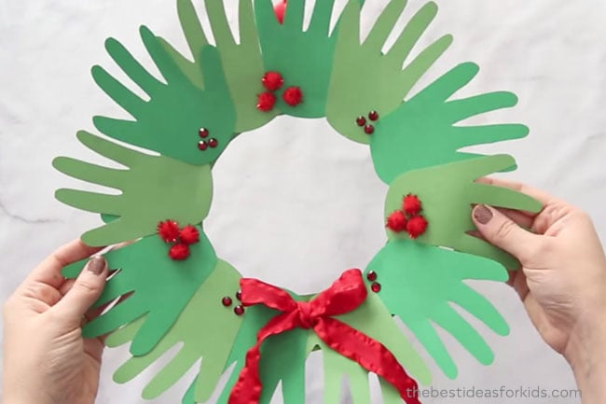

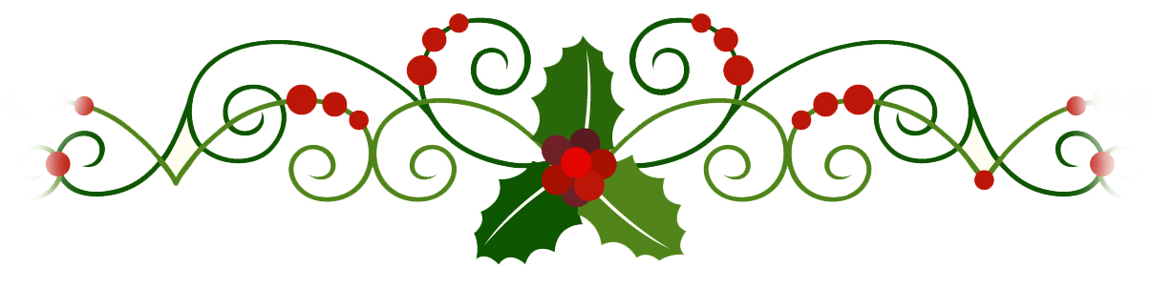
When You Were Sweet Sixteen
By James Thornton (performed by The Fureys)

When first I saw the love light in your eye
I dreamt the world held naught but joy for me
And even though we drifted far apart
I never dream, but what I dream of thee

I love you as I never loved before
Since first I met you on the village green
Come to me or my dream of love is o'er
I love you as I loved you
When you were sweet
When you were sweet sixteen

Last night I dreamt I held your hand in mine
And once again you were my happy bride
I kissed you as I did in Auld Lang Syne
As to the church we wandered side by side

I love you as I never loved before
Since first I met you on the village green
Come to me or my dream of love is o'er
I love you as I loved you
When you were sweet
When you were sweet sixteen

The Banks Of My Own Lovely Lee lyrics
by Seán O Sé / John Fitzgerald

How oft do my thoughts in their fancy take flight
To the home of my childhood away,
To the days when each patriot's vision seem'd bright
Ere I dreamed that those joys should decay.
When my heart was as light as the wild winds that blow
Down the Mardyke through each elm tree,
Where we sported and play'd 'neath each green leafy shade
On the banks of my own lovely Lee,
Where we sported and play'd 'neath each green leafy shade
On the banks of my own lovely Lee.

And then in the springtime of laughter and song
Can I ever forget the sweet hours?
With the friends of my youth as we rambled along
'Mongst the green mossy banks and wild flowers.
And then, when the evening sun's sinking to rest
Shed its golden light over the sea
The maid with her lover the wild daisies pressed
On the banks of my own lovely Lee,
The maid with her lover the wild daisies pressed
On the banks of my own lovely Lee

'Tis a beautiful land this dear isle of song
Its gems shed their light to the world
And her faithful sons bore thro' ages of wrong,
The standard St. Patrick unfurled.
Oh! would I were there with the friends I love best
And my fond bosom's partner with me
We'd roam thy banks over, and when weary we'd rest
By thy waters, my own lovely Lee,
We'd roam thy banks over, and when weary we'd rest
By thy waters, my own lovely Lee.

Oh what joys should be mine ere this life should decline
To seek shells on thy sea-gilded shore.
While the steel-feathered eagle, oft splashing the brine
Brings longing for freedom once more.
Oh all that on earth I wish for or crave
Is that my last crimson drop be for thee,
To moisten the grass of my forefathers' grave
On the banks of my own lovely Lee,
To moisten the grass of my forefathers' grave
On the banks of my own lovely Lee.

Guided Relaxation: Visualizing the New Year

Just imagine you’re lying somewhere very comfortable, and your body starts to relax more and more. You begin to feel warm and cozy inside even though the outside air has grown crisp. The trees have lost their leaves and have gone to sleep for the winter.

Imagine yourself curled up in front of a nice warm fireplace. You watch as the flames flicker yellow and red. The golden yellow flame seems to relax you even further as you enjoy its warmth. As you lie here enjoying this moment of relaxation, you start to remember some wonderful things that have happened this past year.

There have been many moments that have made you happy; many moments that have made you smile and grateful.

It’s been a good year.

You’ve grown on the outside and on the inside too. You’re smarter and wiser this year. You know yourself better, and you’re getting to know your personal gifts more and more.

The new year will bring a brand new start.

Now is the time to think about all the amazing things you want to accomplish. Remember, you can achieve anything you put your mind to!
So start to imagine all the wonderful things you’d like to do this coming year. Maybe you want to get better at something you enjoy doing, or perhaps learn a new skill. Maybe you want to spend more time on yourself.

Whatever you decide to do this coming year will be a wonderful goal to work towards each and every day.

Always remember to have faith in yourself and in your ability to accomplish your dreams. By using your heart and your mind together, you can create a fantastic year filled with joy, happiness, and fun!

Now take in a deep breath and imagine yourself at the end of the year having accomplished all these wonderful things you’ve been thinking about. Doesn’t it feel wonderful?

Picture yourself as having succeeded, and hold on tightly to that image in your mind and heart!

Now allow peacefulness and happiness to fill up your entire body, going into each and every cell.

When you’re ready you can open your eyes and give your body a big stretch… and be ready to live your dream!

