January

Activity Pack 2



Dear Friends,

Wishing you the happiest of New Years as we embark on the journey into 2024! May this year bring an abundance of light, hope, and joy into our lives, and may you always be aware that you are never far from our thoughts.

As our evenings gradually grow brighter with each passing day, so does the promise of a year in which we aspire to be more present in each other's lives. Remember, the ASI is just a phone call away whenever you need us. Our helpline number, 1800 341 341, connects you with our volunteers ready to listen and support you.

We hope that January unfolds for all our readers a prosperous, exciting, and healthy new year. Your support has been invaluable, and we extend our heartfelt thanks. Here's to a successful and fulfilling new year ahead!



“New month, new intentions, new goals, new love, new light, and new beginnings.”  
— April Mae Monterrosa

**Useful Resources:**

**Useful Resources:**

2. The ASI now also has a new online Virtual Dementia Hub where you can go for a full range of activities – you can even listen to some wonderful poetry and songs especially. Just go to [www.virtualdementiahub.ie](http://www.virtualdementiahub.ie)

3. We are hosting a number of Virtual Cafes. They are a place to come together, share a cuppa and listen to our amazing guest speakers. For information on how to attend visit: <https://alzheimer.ie/service/alzheimer-cafe/>

4. The ASI also have a huge library of factsheets and resources available on: <https://alzheimer.ie/get-support/resources-and-factsheets/>

5. For musical videos and resources Music For Dementia are a wonderful resource: <https://musicfordementia.org.uk/>

6. The Irish Museum of Modern Art (IMMA) have a huge collection available to view online at: <https://imma.ie/collection/>

7. Emergency Response Numbers: 999 or 112 9. HSE 24/7 Your Mental Health Information Helpline: 1800 111 888

8. Our Free Helpline is available at: Phone: **1800 341 341** and Email: [**helpline@alzheimer.ie**](mailto:helpline@alzheimer.ie)

9. The Irish Museum of Modern Art is running a series called “Talking Art Online” where they take a close look at selected artworks from the IMMA Collection and discuss IMMA exhibitions with their Visitor Engagement Team from the comfort of your living room. To book and for more information, please email talkingart@imma.ie or phone 01 612 9955

**Table of Contents**

|  |  |
| --- | --- |
| *Activity* | *Pages* |
| Lavendar Rice and Chamomile Dough for Sensory Engagement | **5** |
| Sensory Bottle Activity | **7-8** |
| General Knowledge Quiz | **9-13** |
| 9 Funny Limericks | **14-15** |
| Create the Soundtrack of Your Life | **17** |
| US Presidents and the First Ladies | **18-19** |
| Pictures to Colour | **20-25** |
| New Years WordSearch | **26** |
| The Pub By Loretta Kenny | **27-28** |
| Help the Birds Find Their Nests | **30-31** |
| Funny Limericks and Rhymes | **32** |
| Buttercups and Daises by Mary Howett | **33-34** |
| Get to Know Me | **35** |
| Butterfly Meditation | **36-37** |

Lavender Rice & Chamomile Dough for Sensory Engagement

Here are some calming sensory activities. They include familiar scents, kneading and shaping.

**Chamomile Play Dough recipe**

**Ingredients:**

* 2 cups plain flour
* ½ cup salt
* 2 teaspoons oil
* 2 Tablespoons of cream of tartar
* Up to 1.5 cup of water
* 2 bags of chamomile tea
* 3 drops of essential rose oil

**How to make**:

1. Boil 1.5 cups of water and brew the two chamomile tea bags for 5 minutes.
2. Remove the tea bags and wait for the water to cool.
3. Mix the dry ingredients plus the two oils and pour in the chamomile water, mixing as you go. The mixture will be sticky just like bread dough.
4. Turn onto a surface and knead for 10 minutes until it becomes smooth, pliable and non-sticky - if needed add a half teaspoon of flour.

**"Sensory Bottles" activity.**

These bottles are visually engaging, promote relaxation, and provide tactile and visual stimulation. Here's a step-by-step guide with pictures on how to make Sensory Bottles:

**Materials Needed:**

1. Clear plastic bottles with lids (empty water or soda bottles work well)
2. Clear hair gel or clear glue
3. Water
4. Food colouring
5. Glitter in various colours and sizes
6. Small plastic or rubber objects (e.g., beads, buttons, miniature toys)
7. Super glue or hot glue gun

**Instructions:**

**Step 1:** Gather Materials Collect all the necessary materials, ensuring you have enough bottles and a variety of colourful and textured items for the sensory experience.

**Step 2:** Empty Bottles Start with empty, clean plastic bottles. Remove any labels or residue.

**Step 3:** Fill Bottles with Gel Fill each bottle about one-third full of clear hair gel or clear glue. This will create a viscous and visually interesting base for the sensory experience.

**Step 4:** Add Water Fill the rest of the bottle with water, leaving some space at the top. The water will help the contents move more freely when the bottles are shaken.

**Step 5:** Add Food Colouring Drop a few drops of food colouring into each bottle. Choose colours that are visually stimulating and appealing. Seal the bottle and shake it to mix the colour.

**Step 6:** Add Glitter Sprinkle a variety of glitter into each bottle. The glitter will float and create a captivating visual effect. Experiment with different colours and sizes of glitter.

**Step 7:** Add Small Objects Drop small plastic or rubber objects into each bottle. These objects will float and move around, providing tactile stimulation when the bottle is handled.

**Step 8:** Seal the Bottles Make sure the lids are securely fastened to avoid any leaks. If necessary, use super glue or a hot glue gun to seal the lids permanently.

**Step 9:** Shake and Enjoy Encourage individuals to shake and manipulate the sensory bottles to experience the soothing visual effects, the movement of objects, and the overall sensory engagement.

**Tips:**

* Customize the sensory bottles based on individuals' preferences, using specific colours, shapes, or objects.
* Ensure that the bottles are securely sealed to prevent any spills or leaks.
* Supervise the activity, especially for individuals with limited dexterity or those prone to putting items in their mouths.

**Top of Form**

**General Knowledge Quiz:**

1. Who was the first man on the moon?
2. What was the name of Sri Lanka before 1972?
3. What happened on the 6th of June 1944?
4. Who was the first woman to become Prime Minister of the UK?
5. What does the acronym EU stand for?
6. Which author created the character of Hercule Poirot?
7. Who was the first President of the US?
8. What is the currency in use in Australia?
9. What type of beverage is Jameson?
10. Which author wrote To Kill a Mockingbird?

**Round 1: Answers**

1. Who was the first man on the moon? **Neil Armstrong**
2. What was the name of Sri Lanka before 1972? **Ceylon**
3. What happened on the 6th of June 1944? **D-day, Normandy Landings**
4. Who was the first woman to become Prime Minister of the UK? **Margaret Thatchet**
5. What does the acronym [**EU**](https://www.quiztriviagames.com/european-union-quiz/) stand for? **European Union**
6. Which author created the character of Hercule Poirot? **Agatha Christie**
7. Who was the first President of the US? **George Washington**
8. What is the currency in use in Australia? **Australian Dollar**
9. What type of beverage is Jameson? **Whiskey**
10. Which author wrote To Kill a Mockingbird? **Harper Lee**
11. Joe DiMaggio was the second husband of which famous actress?
    1. Marilyn Monroe
    2. Betty White
    3. Grace Kelly
    4. Doris Day
12. Which US President was involved in the Watergate scandal in the 70s?
    1. Jimmy Garter
    2. Harry S. Truman
    3. Richard Nixon
    4. Dwight D. Eisenhower
13. Which one of the following Disney movies came first?
    1. Beauty and the Beast
    2. Aladdin
    3. Hercule
    4. Cinderella
14. What is the best medal that can be won at the Olympics?
    1. Diamond
    2. Gold
    3. Silver
    4. Bronze
15. Which instrument is Eric Clapton famous for playing?
    1. Piano
    2. Harmonica
    3. Guitar
    4. Drums

**Round 2: Answers**

1. Joe DiMaggio was the second husband of which famous actress? **Marilyn Monroe**
2. Which [**US President**](https://www.quiztriviagames.com/us-presidents-quiz/) was involved in the Watergate scandal in the 70s? **Richard Nixon**
3. Which one of the following [**Disney**](https://www.quiztriviagames.com/easy-disney-quiz/) movies came first? **Cinderella**
4. What is the best medal that can be won at the Olympics? **Gold**
5. Which instrument is Eric Clapton famous for playing? [**Guitar**](https://www.quiztriviagames.com/guitar-quiz/)

**9 Funny Limericks:**

**Over the Hill**

*"I am sorry to hear, smiling Jill (or Bill, or Phil, you get the idea)*  
*That your birthday's no longer a thrill*  
*All your friends think you're great*  
*So you should celebrate!*  
*You're not old, you're just over the hill."*

**Grumpy**

*“There once was a lady named Donna*  
*Who said to her friends, “I’m not gonna*  
*Eat your candy and cake,*  
*I refuse to partake.*  
*Blow those candles yourself — I don’t wanna!”*

**Thrifty**

*“Mom, I'm sure it will give you a lift*  
*that I've shown such admirable thrift*  
*in choosing a way*  
*to remember your day*  
*with this heart-warming message (no gift!)"*

**Get Over It**

*Don't you hate it when all your joints ache?*  
*All those candles are crushing your cake?*  
*It just leads to depression*  
*So change your expression*  
*And  then party on for Pete's sake!*

**With Friends Like These...**

*“On this day, we party each year!*  
*We come over to drink all your beer!*  
*Then we sing out of tune*  
*Eat some cake and commune*  
*When the drink's gone, we all disappear!”*

**A Vigorous Man**

*“You've conquered the aging disease*  
*that brings lesser men to their knees.*  
*You're a vigorous man*  
*and you've proved you still can*  
*blow out candles with only one wheeze.”*

**It's the Thought that Counts**

*“This year I have something to boast:*  
*I remembered your birthday (almost).*  
*This card may be late*  
*but it's close to the date.*  
*Let's pretend it got lost in the post.”*

**Living the High Life**

(Make sure to read the room first ... :-)

In the many long years since your birth  
You've made multiple laps round the earth  
In that time you have taken  
Your fair share of bacon  
And thus greatly increased your girth!

Credit:  Andrew Loud

**Chin Up**

No matter what friends are asserting  
29 (pick an age) goes on by without hurting  
Your chances for wealth  
For joy and good health  
Are still yours with a little exerting!

**US Presidents and the First Ladies**

**Draw a line from the president’s name to the name of his wife**

George Washington Jacqueline

George H.W. Bush Hilary

Donald J Trump Barbara

Harry S Truman Abigail

John F Kennedy Martha

John Adams Melania

Bill Clinton Elizabeth “Bess”

Franklin D Roosevelt Alice

Gerard R Ford Eleanor

Ronald R Regan Betty

Barack Obama Michelle

Theodore Roosevelt Nancy

Jimmy Carter Rosalynn

***Answers US Presidents and the First Ladies:***

George Washington ---- Martha

George H.W. Bush ---- Barbara

Donald J Trump ---- Melania

Harry S Truman ---- Elizabeth “Bess”

John F Kennedy ---- Jacqueline

John Adams ---- Abigail

Bill Clinton ---- Hilary

Franklin D Roosevelt ---- Eleanor

Gerard R Ford ---- Betty

Ronald R Regan ---- Nancy

Barack Obama ---- Michelle

Theodore Roosevelt ---- Alice

Jimmy Carter ---- Rosalynn

**Pictures to Colour**



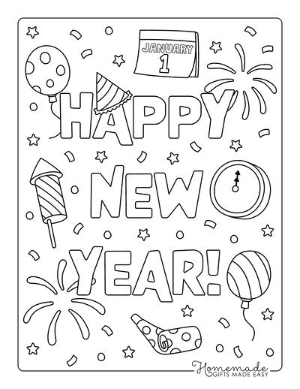

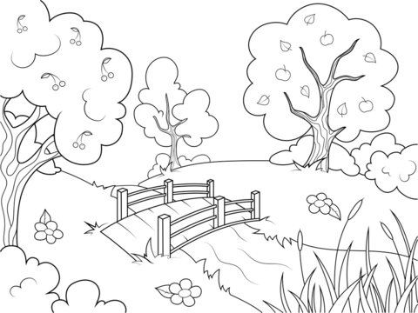

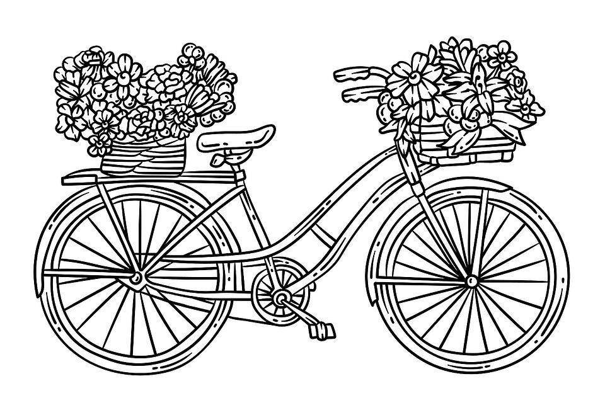



**The Pub**

**By Loretta Kenny**

I was born in 1957 in a small rural village in Co. Wexford. My parents ran a fairly large business which consisted of a Grocery Shop, a Mill and a Public House. I lived over this business until I was nearly twelve years of age and I would like to share with you some of the memories of this time.

The Pub was always a hive of activity. We all had to help out as soon as we were able. Bottling Day was always a big event. The stout came from Guinness in barrels and was brought into the Bottling House. It was then transferred into a large open container which had a number of taps attached to it. The bottles, which would have been washed in hot water and cooled down, would be filled to the brim with beer and then it was my turn to cap them. I can still remember pulling in the cap and pulling down the lever to attach the cap. Then each bottle was labelled with the Guinness label which would also include the name of the publican. The bottles were then lined up on the shelves in an adjoining room ready to be transferred into the bar.

At that time it was only men who frequented the bar. There was a small Lounge adjoining the bar which had a piano but I never heard it being played. An odd lady might use this room but only to wait for the CIE bus which stopped outside.

The Fair Day was held once a month on a Wednesday. Farmers would bring their livestock to the village to be sold and others to purchase. We had a second pub next door which would be opened that day to deal with the crowds. There was a big open fire where the men would sit and tell yarns.

Country pubs had a very healthy day and night trade. Every day, Johnny, a local farmer, would call in for his few pints and when he was served would ask for a small glass and would pour a small amount of beer into it. He would then call my little brother (who was about two at the time and always around) and put him sitting up on the stool next to him and say- “Sure a little drop will do him no harm”.

There were plenty of characters who frequented the pub. The Builder (he was the first person we knew who was declared a millionaire), the Buller (he could get very hot-headed and a fight could follow), Long John (he would travel on his ass and cart), Mucksie (our next door neighbour and my Dad’s right hand man) and many others.

Even on Christmas Day there would be a knock on the hall door after Mass and a few of our good customers would be brought in for their Christmas drinks. When you lived over your business you were always on call.

**Help the Birds Find Their Nests!**

**Funny Limericks and Rhymes**

There was a young lady of Cork,

Whose Pa made a fortune in pork.

He bought for his daughter,

A tutor who taught her,

To balance green peas on her fork.

I'd rather have Fingers than Toes,

I'd rather have Ears than a Nose.

And as for my Hair,

I'm glad it's all there,

I'll be awfully said, when it goes.

A man and his lady-love, Min,

Skated out where the ice was quite thin.

Had a quarrel, no doubt,

For I hear they fell out,

What a blessing they didn't fall in!

There was a young lady of Lynn,

Who was so excessively thin.

That when she assayed,

To drink lemonade,

She slipped through the straw and fell in!

**Buttercups and Daisies by Mary Howitt**

Buttercups and daisies-

Oh the pretty flowers,

Coming ere the springtime

To tell of sunny hours.

While the trees are leafless,

While the fields are bare,

Buttercups and daisies

Spring up here and there.

Ere the snowdrop peepeth,

Ere the crocus bold,

Ere the early primrose

Opens its paly gold,

Somewhere on a sunny bank

Buttercups are bright;

Somewhere 'mong the frozen grass

Peeps the daisy white.

Little hardy flowers

Like to children poor,

Playing in their sturdy health

By their mother's door:

Purple with the north wind,

Yet alert and bold;

Fearing not and caring not,

Though they be a-cold.

What to them is weather!

What are stormy showers!

Buttercups and daisies

Are these human flowers!

He who gave them hardship

And a life of care,

Gave them likewise hardy strength,

And patient hearts, to bear.

Welcome yellow buttercups,

Welcome daisies white,

Ye are in my spirit

Visioned, a delight!

Coming ere the springtime

Of sunny hours to tell-

Speaking to our hearts of Him

Who doeth all things well.

**Get to Know Me Better!:**

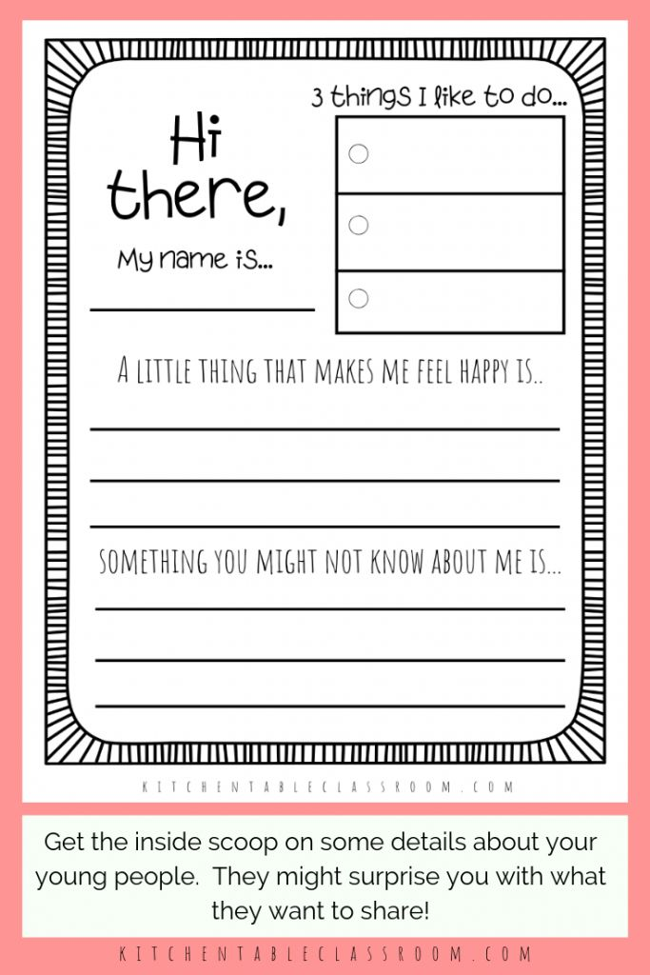

**Butterfly Meditation**

Close your eyes and take in a nice deep breath.

Let the sights and sounds of this room fade away as you focus on your breathing and get ready to visualize a fun and relaxing adventure. Your body begins to feel deeply relaxed and sinks down further where you are. Your arms and legs begin to feel very heavy. You patiently enjoy this time as your mind and body continue to relax.

Now, imagine you’re a beautiful butterfly fluttering high in the sky. Below you, there is a lovely green valley with lots of colourful flowers, just waiting for you to enjoy. You feel the wind gently blow against your delicate wings. As the wind touches you, it gently blows away any worries or any stress you feel. Your mind is clear and calm. You feel light as the wind itself - a cheerful butterfly gliding and fluttering anywhere you wish to go.

Did you know that as a butterfly moves from flower to flower, it spreads just what the other plants need to thrive and grow? You are like that, too. You can flutter about peacefully and beautifully - spreading kindness, happiness, and goodness wherever you go!

The sun touches your colourful body and warms you. The big, puffy clouds floating in the sky remind you how relaxed and calm you can be whenever you want, just by thinking about it.

It’s so nice to be this light and airy.

Your butterfly self has left any worries or fears behind.

You love how it feels to beat your wings and fly, and anytime you start to feel tired, you can land on a leaf or flower and rest. You spread your lovely wings in a huge stretch. You are completely peaceful and content as you allow your true happiness to shine through. It feels so good.

Your body is calm, and your mind is peaceful.

You can fly around as long as you’d like – exploring or just floating gently on the wind.

Take in a deep breath now and exhale slowly.

When you are ready, give your body another big stretch and slowly open your eyes.

What did you like best about being a butterfly? Keep that feeling with you if you can. And remember, you can always come back here - or to any calming place - just by using your mind.