February 2024
Activity Pack 2
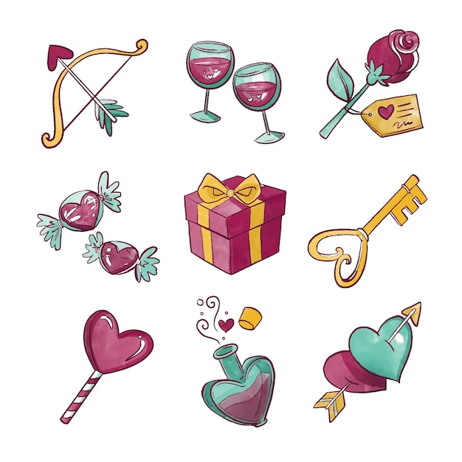

Dear Friends,

Happy February! Love is in the air, and with the promise of Spring around the corner, we're excited to share a special activity pack with you. This month, we're celebrating love in all its beautiful forms – from the warmth of family and the joy of friendship to the kindness of strangers.

In this pack, you'll find a delightful mix of crafts, stories, songs, and pictures that encourage you to reflect on the love that surrounds you. Whether it's a parent's embrace, a lover's kiss, or the wagging tail of a furry friend, love comes in countless shapes and sizes.

As the daffodils begin to bloom and the weather gets milder, take a moment to appreciate the signs of the season, including the cheerful "Loveday" daffodils with buttery yellow petals and a bright orange trumpet.

We've also included activities related to St. Brigid's Day and Pancake Tuesday, adding a touch of Irish tradition to this month's festivities.

We hope you enjoy these activities and that they inspire moments of joy and connection. If you ever want to share photos of your creations or you enjoying these packs, please send them to iseult.kinsella@alzheimer.ie.

Wishing you every kindness and a month filled with love.

“If January is the month of change, February is the month of lasting change. January is for dreamers… February is for doers.”
– Marc Parent

Useful Resources:

▪ Our Free Helpline and Dementia Support Line are available at: Phone: 1800 341 341 and Email: helpline@alzheimer.ie
▪ The Irish Museum of Modern Art is running a series called “Talking Art Online” where they take a close look at selected artworks from the IMMA Collection and discuss IMMA exhibitions with their Visitor Engagement Team from the comfort of your living room. To book and for more information, please email talkingart@imma.ie or phone 01 612 9955
▪ We are hosting several Virtual Cafes. They are a place to come together, share a cuppa and listen to our amazing guest speakers. For information on how to attend visit: https://alzheimer.ie/service/alzheimer-cafe/
▪ The ASI also have a huge library of factsheets and resources available on: https://alzheimer.ie/get-support/resources-andfactsheets/
▪ M4D Radio is a 24/7 online radio station with songs specifically picked to evoke memories and aid reminiscence. To find out more and to listen, please visit: https://m4dradio.com/
▪ The BBC have curated a remarkable online archive of videos, images and audio clips to aid reminiscence and covers a wide variety of subject matter. Please visit: https://remarc.bbcrewind.co.uk/ to check it out.
▪ Emergency Response Numbers: 999 or 112
▪ HSE 24/7 Your Mental Health Information Helpline: 1800 111 888

- Table of Contents

Activity | Pages
Get to Know Me Valentines Edition | 6-7
Valentines Music Quiz | 8-9
iSpy and Counting Game | 10
Paper Roses | 11-12
Valentines Cookies | 13-14
Valentines Maze | 15
It Had To Be You by Frank Sinatra | 16
Always by Frank Sinatra | 17
Valentines Word Search | 18
Spot the Difference | 19
Let’s Make Some Valentines Cards | 20
Love Songs Trivia Quiz | 21-22
Romantic Reminiscence | 23
Pancake Tuesday Games | 24-25
Let’s Make Some Pancakes | 26
Valentines Crossword Puzzle | 27-28
Valentines Pictures to Colour | 29-33
Seanfhocal/Proverbs | 34-35
Facts about Saint Brigid | 36-37
She Walks in Beauty  By Lord Byron | 38-39
Bucket of Kindess Meditation | 40-41

Get to Know Me: Valentine's Edition
Hello, Lovely Friends!
I'm so excited to share a bit about me and all the wonderful things that make my heart flutter. Let's dive into some sweet details about who I am and what fills my world with joy!
- My Name:
- I go by the beautiful name…………………………....
- My Favourite Love Story:
- My heart skips a beat for the timeless love story of....................................
- Treasured Memory:
- One of my most cherished memories is.........................................
- Favourite Love Song:
- Whenever I hear the melody of................................................ my heart dances with delight.
- Sweetest Treat:
- Nothing makes me smile like indulging in....................................................
- Love for Nature:
- My favourite flower, the one that brings warmth to my heart, is.......................................................
- A Perfect Date:
- The ideal date for me would be.........................................
- Beloved Hobby:
- In my free time, I absolutely adore…………………………………..
- Heartwarming Book or Movie:
- The book or movie that never fails to warm my heart is……………………………………………..
10. Secret Valentine's Day Wish: - If I could make one magical wish this Valentine's Day, it would be...........................................
11. Furry Friends: - If I have a pet, their name is…………………………………
12. Love for Creativity: - I express my creativity through........................................
13. Sentimental Treasure: - I hold a dear keepsake close to my heart, and it's.................................
14. Favourite Colour of Love: - The colour that represents love to me is............................
15. Heartfelt Quote: - A quote that speaks to my heart is..................................

Love in the Charts: A Number One Hits Quiz
Question 1:
Which legendary British band sang "I Want to Hold Your Hand," securing a number one hit in 1964?
a) The Rolling Stones
b) The Beatles
c) Queen
d) Led Zeppelin

Question 2:
In 1984, this iconic singer urged us to "Wake Me Up Before You Go-Go." Who is it?
a) Elton John
b) Michael Jackson
c) George Michael (Wham!)
d) Madonna

Question 3:
Which romantic ballad by Whitney Houston became a chart-topping hit in 1992, thanks to its feature in "The Bodyguard"?
a) I Will Always Love You
b) Greatest Love of All
c) I Wanna Dance with Somebody
d) How Will I Know

Question 4:
This catchy tune by Pharrell Williams dominated the charts in 2014. Can you name it?
a) Happy
b) Uptown Funk
c) Despacito
d) Shape of You

Question 5:
Which boy band sang their hearts out with "I'll Make Love to You," reaching number one in 1994?
a) Backstreet Boys
b) *NSYNC
c) Boyz II Men
d) New Kids on the Block

Question 6:
This love anthem by Celine Dion held the top spot in 1998. What's its title?
a) My Heart Will Go On
b) The Power of Love
c) Because You Loved Me
d) It's All Coming Back to Me Now

Question 7:
In February 2008, this British singer-songwriter warmed our hearts with "Bleeding Love." Who is she?
a) Adele
b) Ellie Goulding
c) Leona Lewis
d) Amy Winehouse

Question 8:
Which iconic duo released "Endless Love," a timeless ballad that topped the charts in 1981?
a) Simon & Garfunkel
b) Elton John & Kiki Dee
c) Diana Ross & Lionel Richie
d) Sonny & Cher

I-Spy and Counting Game
Could how many of each of the items there are in the picture below.
When you are finished you can colour it in!

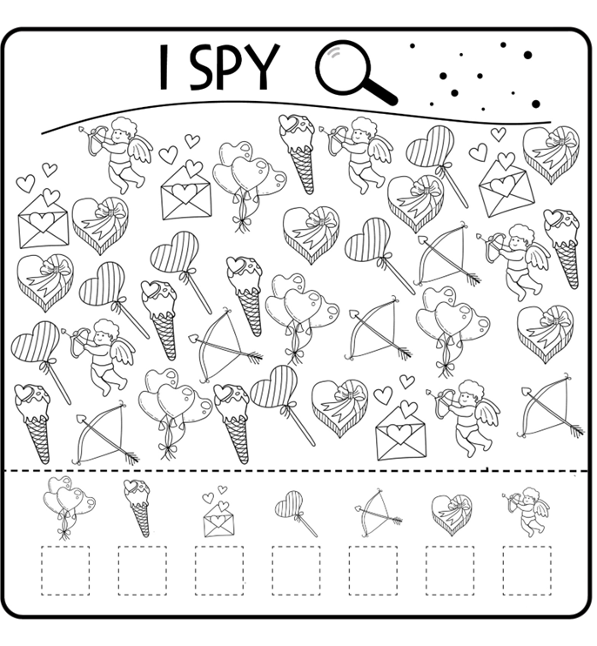
Paper Roses
Create these simple and pretty paper roses, Experiment with colours, textures, add glitter, feathers and we’ve a page of phrases and images after the tutorial that you can cut out and stick on to you bouquet!

Needed:
- White, light paper plates
- Paint, paintbrush
- Scissors
- Admornments such as glitter, gems, stickers etc
- Lollipop sticks or similar.

Instructions:
- Get a plain, light, white paper plate and paint or decorate it as you wish. Do not add too many items at this stage as we will be cutting it.
- Using a scissors, carefully cut out a spiral going from the outside inwards. Use a wavy line to add the texture of petals, or you can get some craft scissors that will give this effect when used.
- Roll up your spiral loosely as seen in the second picture.
- Glue , tape or staple the paper to keep the shape in place.
- Now add any details you like – glitter, gemstones, stickers, feathers etc. you can even lightly spray it with perfume so it smells nice!
- Attach the rose to a green pipecleaner, a lollipop stick or similar to give it a stem.

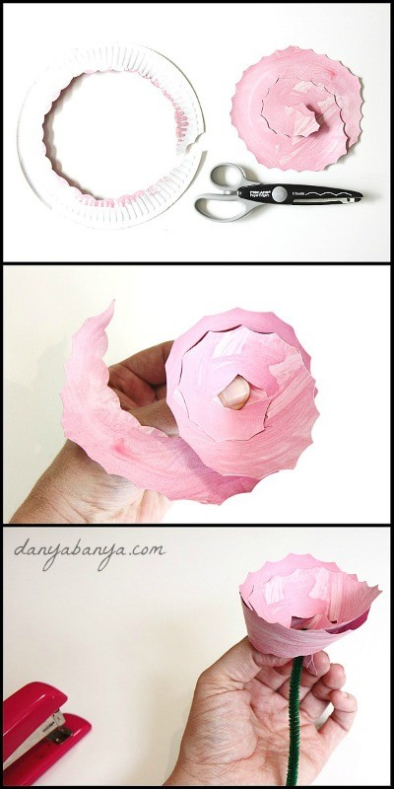

Valentines Cookies:

Ingredients
- 300g plain flour, plus a little extra for dusting
- 200g salted butter, diced
- 120g golden caster sugar
- 2 large egg yolks
- 2 tsp vanilla extract
- ½ tsp rosewater, or 25g/1oz freeze-dried raspberries, whizzed to a powder – we used Waitrose (optional)
- red or pink food colouring

Method
- STEP 1
Tip the flour and butter into a food processor and whizz to fine crumbs. Add the sugar and yolks then whizz to a smooth dough. Remove one-third of the dough, add vanilla to what’s left and pulse to whizz in. Wrap this dough in cling film and leave at room temperature.
- STEP 2
Put the reserved dough back in the processor with the rosewater or dried raspberries, if using, and a drop of food colouring. Pulse and add more colouring to achieve an intense colour. If the dough has become too soft, pulse in a few spoonfuls more flour until a similar consistency to the vanilla dough. Put the dough in the fridge, remembering to remove it 30 mins before you need to roll it out.
- STEP 3
Thickly roll out the coloured dough between baking parchment. Use a small 3-4cm heart cutter to stamp out hearts. Keep re-rolling and stamping until all the dough is used. Line up hearts on top of each other and press to form a cylinder, taking care to retain the heart shape. Wrap in cling film and freeze for 3 hrs until solid.
- STEP 4
When the heart dough is hard, roll the vanilla dough, using your hands, into 3 cylinders the length of the heart stack. Stick one to each ‘side’ of the hearts, pat together to form a fat cylinder, then gently roll on your work surface until it completely encircles the coloured dough, with the frozen heart dough hidden in the centre. Chill for 2 hrs.
- STEP 5
Heat oven to 180C/160C fan/gas 4. Use a sharp knife to slice the log into 1cm-thick discs. Place on trays lined with baking parchment, allowing space for spreading, and bake for 20 mins. Cool on wire racks. Will keep for up to 4 days in an airtight container.

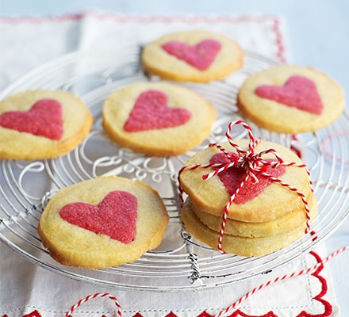

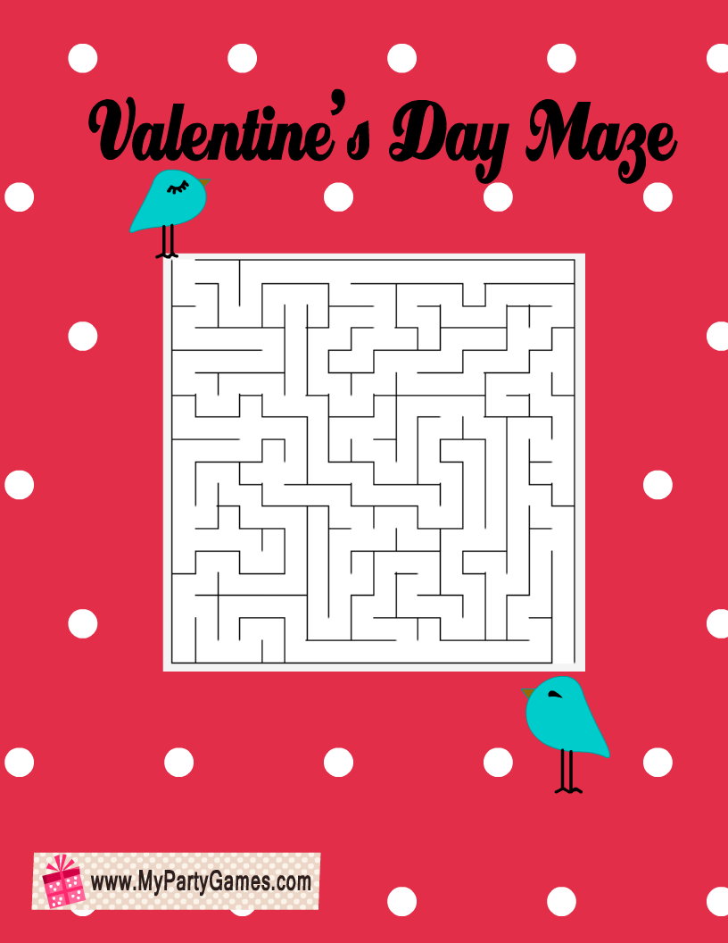

It Had To Be You
By Frank Sinatra
Why do I do just as you say
Why must I just give you your way
Why do I sigh, why don't I try to forget
It must have been that something lovers call fate
Kept me saying I have to wait
I saw them all, just couldn't fall, 'til we met
It had to be you
It had to be you
I wandered around, and I finally found
The somebody who
Could make me be true
And could make me be blue
And even be glad
Just to be sad - thinking of you
Some others I've seen
Might never be mean
Might never be cross, or try to be boss
But they wouldn't do
For nobody else gave me a thrill
With all your faults, I love you still
It had to be you
Wonderful you
It had to be you
For nobody else gave me a thrill
With all your faults, I love you still
It had to be you
Wonderful you
It had to be you

Always
By Frank Sinatra
I'll be lovin' you always
With a love that's true always
When the things you've planned need a helpin' hand
I will understand always, always
Days may not be fair always
That's when I'll be there always
Not for just an hour, not for just a day
Not for just a year, but always
Days may not be fair always
That's when I'll be there always
Not for just an hour, not just a day
Not for just one year, but always
Always
Always
All the time

Valentines Word Search:
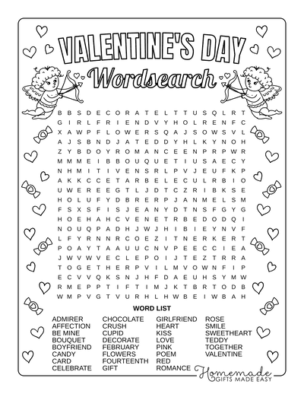
Spot the Difference:

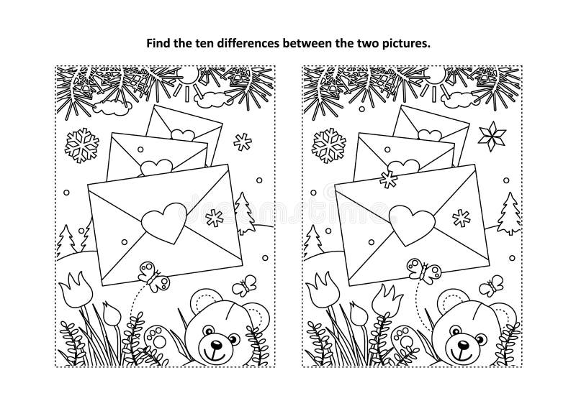

Let’s Make Some Valentines Cards:

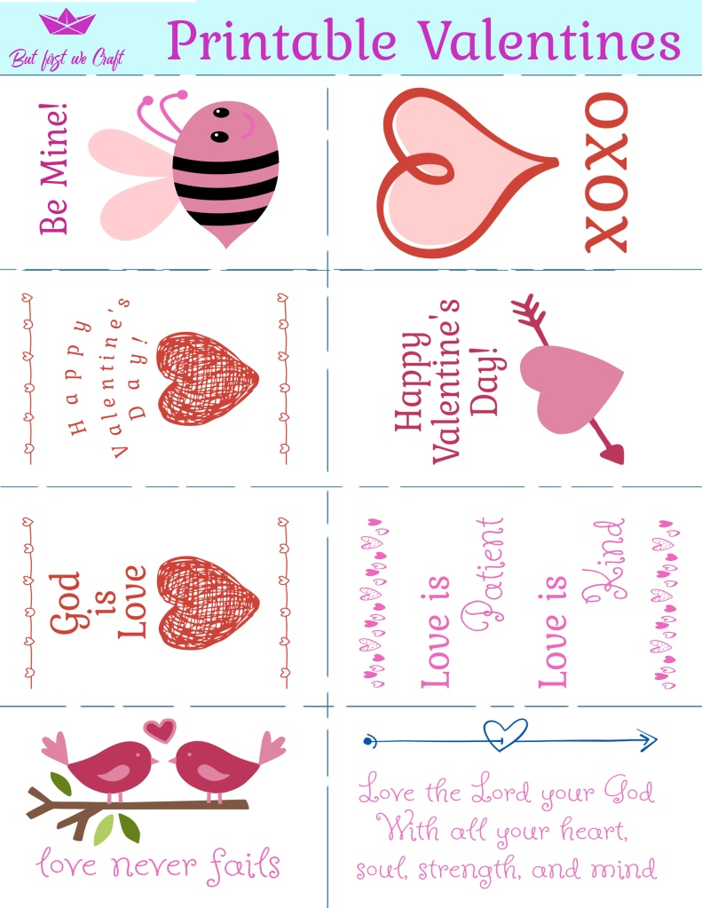
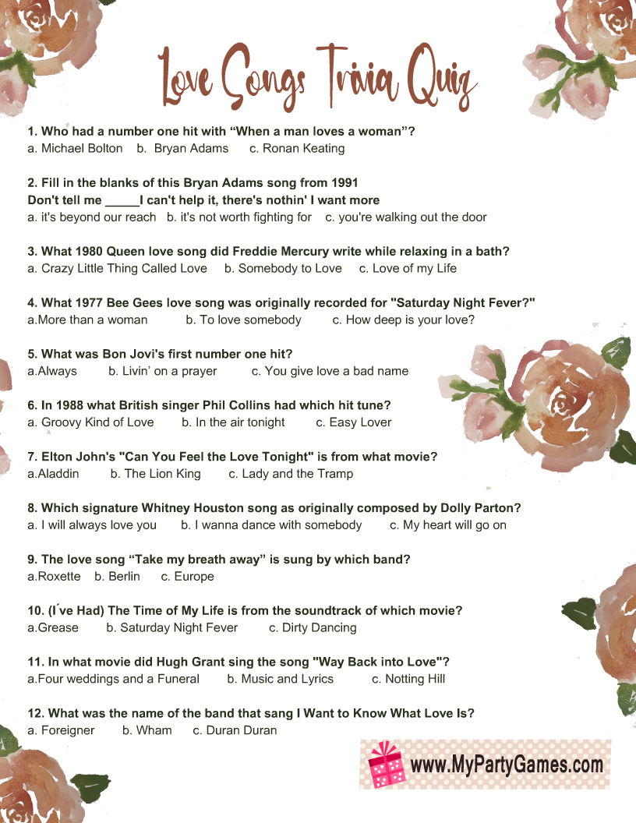

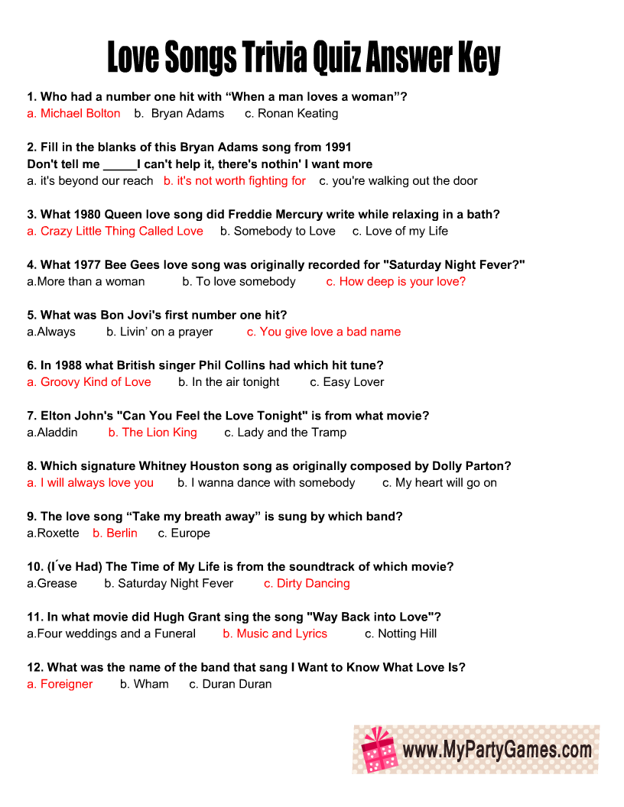

Romantic Reminisce
Here are some questions you might like to ask a friend, or to think upon yourself, to reminisce on some romantic times in your life.
Don’t worry if the answer doesn’t come to you, instead tell a story about a time you keep close to your heart or look at a photo for a loved one.
- Who was the first girl/boy you ever liked?
- Did anyone in particular ever make you blush?
- Do you remember your first kiss?
- Who was your first date? Where did you go? How did you get there?
- How did your parents feel about you dating?
- Did you ever receive gifts from someone you were dating, maybe flowers, cards, or jewellery?
- Did you ever write love letters to anyone or did you receive any love letters?
- How did you meet your wife/husband?
- How did your spouse propose? How did you feel?
- What advice would you give to someone in love?
- Who has been the greatest love in your life?
- What was your favourite date night activity?
- Can you describe your wedding day?
- Tell me about a memorable anniversary celebration.
- What gifts do you remember giving or receiving that meant a lot?
- Can you recall a romantic getaway or vacation you took together?
- What love songs or music do you associate with your relationship?

L O V E
Pancake Tuesday Games!:
- Pancake Flipping Contest:
  - Set up a pancake flipping station. Participants can compete to see who can flip a pancake the most times without dropping it. You can use plastic pancakes or even real ones if you're feeling adventurous!
- Pancake Relay Race:
  - Create a relay race where participants must carry a pancake on a spatula from one end of the room to the other without dropping it. They then pass the pancake to the next team member.
- Pancake Toss:
  - Set up targets on the ground and have participants toss pancakes to see who can land their pancake on the targets. Assign different point values to different targets for added excitement.
- Decorate Your Own Pancake Station:
  - Set up a pancake decorating station with various toppings and encourage participants to get creative with their pancake designs. Award prizes for the most artistic or unique creations.
- Pancake Memory Game:
  - Create a memory game using pictures or drawings of different types of pancakes. Participants take turns flipping cards to find matching pairs.
- Pancake Trivia:
  - Prepare a list of fun and interesting pancake trivia questions. Have a trivia quiz during your event and offer small prizes to participants with the most correct answers.
- Pancake Art Contest:
  - Provide participants with pancake batter in squeeze bottles and let them create pancake art on a hot griddle. Award prizes for the most creative or intricate pancake designs.
- Pancake Tower Challenge:
  - Challenge participants to build the tallest pancake tower using a set number of pancakes. The tower must stand for a certain amount of time to qualify.
- Pancake Juggling:
  - For those with some juggling skills, challenge them to juggle pancakes. Use foam or plastic pancakes for safety.

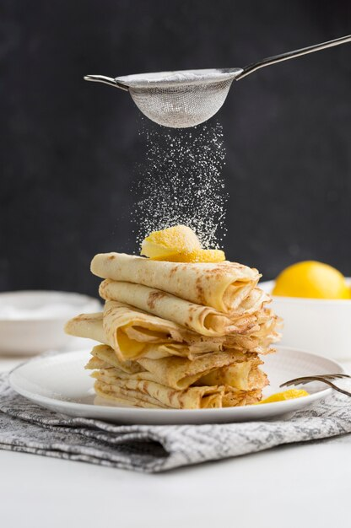

Let’s Make Some Pancakes:
Ingredients:
- 1 ½ cups all-purpose flour
- 3 ½ teaspoons baking powder
- 1 tablespoon white sugar
- ¼ teaspoon salt, or more to taste
- 1 ¼ cups milk
- 3 tablespoons butter, melted
- 1 egg
Directions:
- Sift flour, baking powder, sugar, and salt together in a large bowl. Make a well in the centre and add milk, melted butter, and egg; mix until smooth.
- Heat a lightly oiled griddle or pan over medium-high heat. Pour or scoop the batter onto the griddle, using approximately 1/4 cup for each pancake; cook until bubbles form and the edges are dry, about 2 to 3 minutes. Flip and cook until browned on the other side. Repeat with remaining batter.
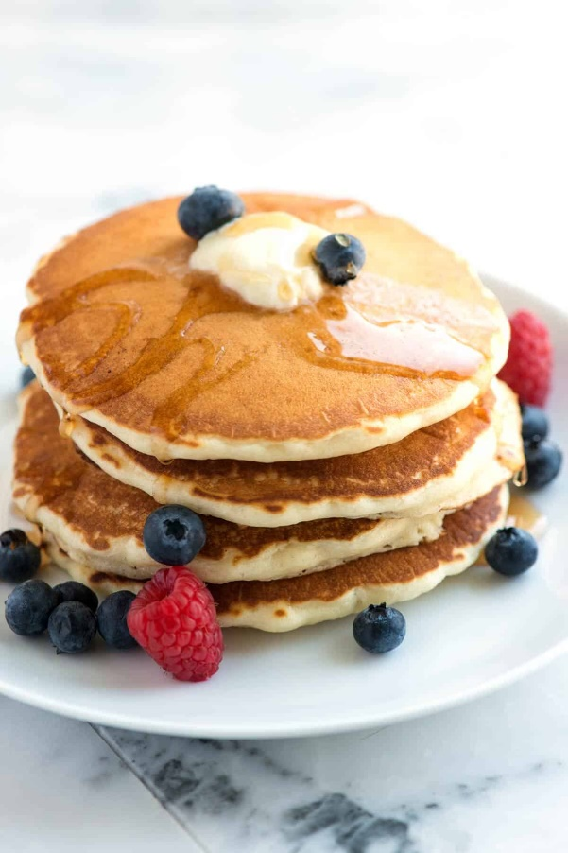
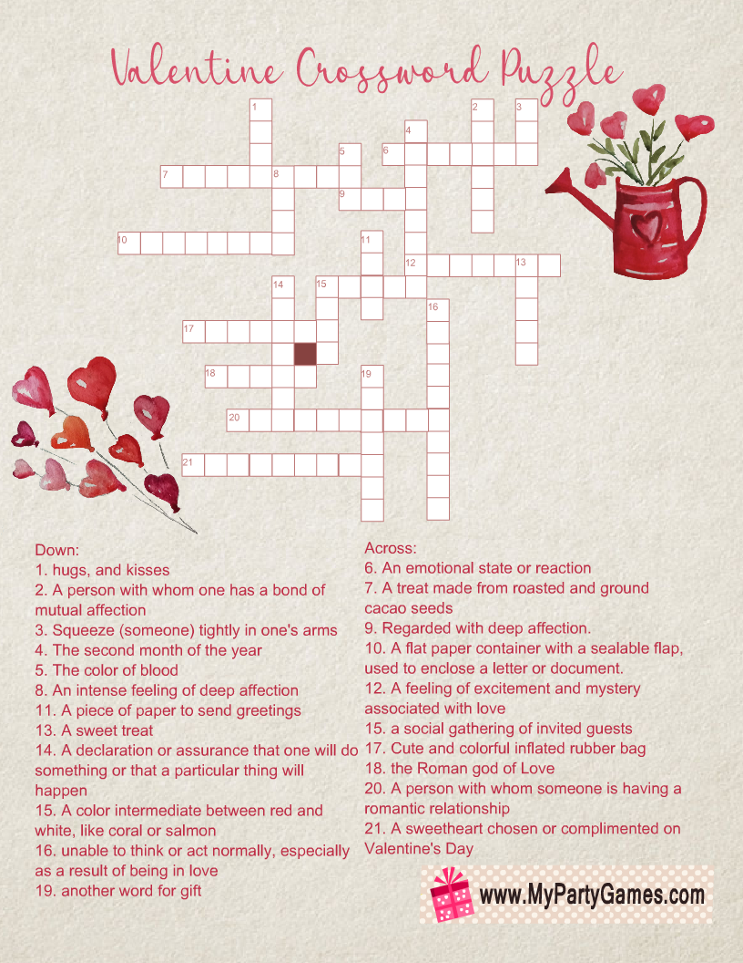

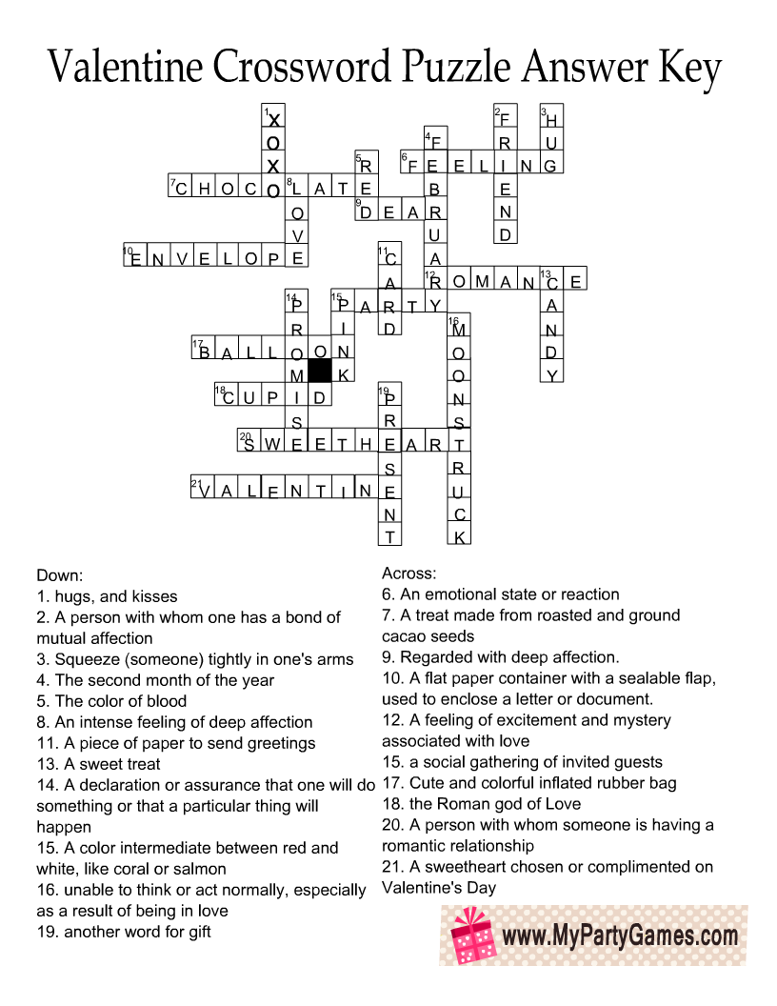

Valentines Pictures to Colour:
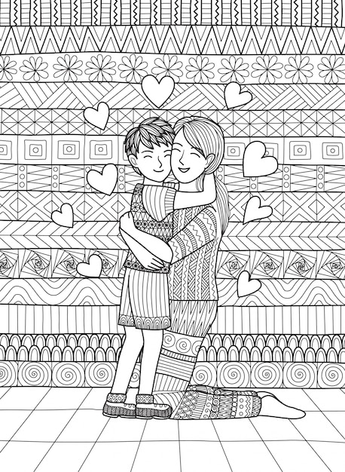
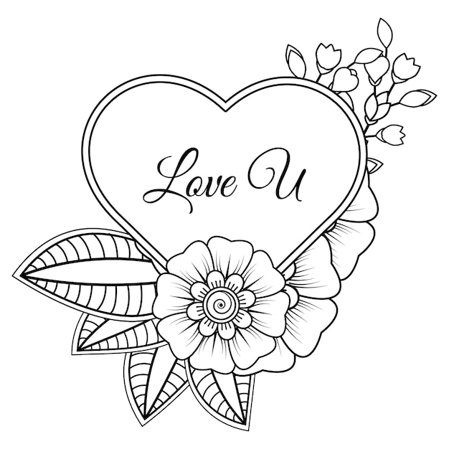

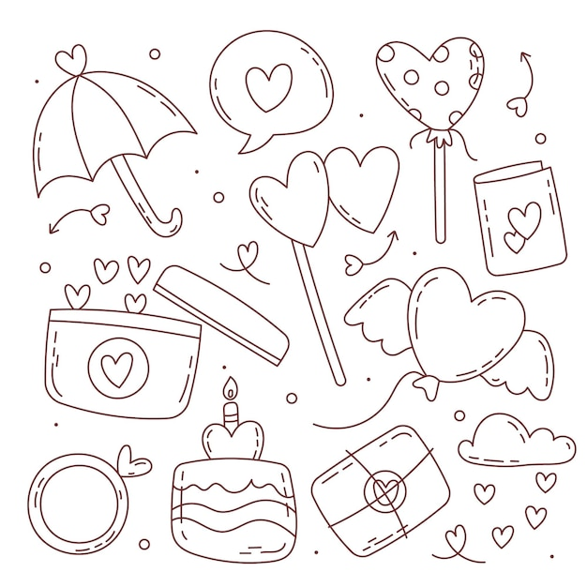

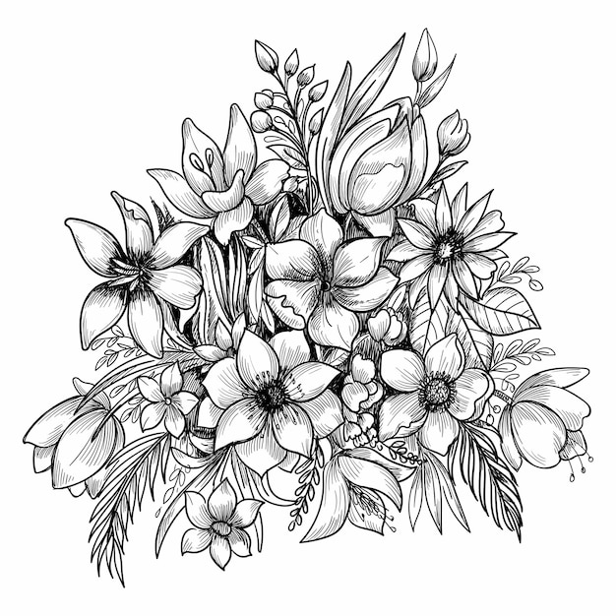

Seanfhocal/Proverbs

‘Seanfhocal’ is the Irish word for proverb, literally meaning ‘old word’. The following proverbs have been around for centuries. The following are some commonly used proverbs and their meanings.

- Hindsight is the best insight to foresight – Learn from your past mistakes to avoid making new ones.
- Every man is sociable until a cow invades his garden – Everybody has their off days!

- Hunger is good sauce – hunger makes any food taste good.

- Experience is the comb that life gives a bald man – A man who has lived long enough to lose his hair will no doubt know a thing or two about life.

- Do not resent growing old, many are denied the privilege – this one of the few self-explanatory proverbs!

- Complain that you have no shoes until you meet a man who has no feet – be thankful for what you have because there will always be someone in a worse situation than you.

- It’s a long road that has no turning – Always doing the same thing is neither beneficial nor entertaining.

- Many a ship is lost within sight of the harbour – don’t let your guard down no matter how safe you think things may be.

- Life is like a cup of tea; it’s all in how you make it – how you live your life is a result of what you do in it.

- It is the quiet pigs that eat the meal – this can be compared to ‘the early bird catches the worm’.

- It’s a lonely washing that has no man’s shirt in it – everybody needs someone to love (and wash clothes for).

- It’s not a delay to stop and sharpen the scythe – take every opportunity to learn.

- No matter how many rooms you have in your house, you’re only able to sleep in one bed – it doesn’t matter how many possessions you have, we all have the same basic needs in life.

- When the drop is inside the sense is outside – alcohol leads to senseless activities!

Facts about Saint Brigid:
- Trailblazing Saint:
  - Did you know that Saint Brigid, also known as Mary of the Gael, is one of Ireland's patron saints alongside Patrick and Columba?
- Powerful Namesake:
  - Did you know that Saint Brigid shares her name with an ancient Celtic goddess, and her feast day on February 1st marks the pagan festival of Imbolc, symbolizing the onset of spring?
- Triple Celebration:
  - Did you know that Saint Brigid is associated with the holy fire of Kildare, which is said to have been kept burning by her nuns for over 1,000 years?
- Nurturing Spirit:
  - Did you know that Saint Brigid is often portrayed with a cow, symbolizing her compassion and generosity? Legend has it that her prayers turned water into milk to feed the hungry.
- Patron of the Arts:
  - Did you know that Saint Brigid is not only revered for her religious contributions but is also considered the patron saint of poets, blacksmiths, and healers?
- Crossing Boundaries:
  - Did you know that Saint Brigid is celebrated not only in Ireland but also in other parts of the world? Churches and places are dedicated to her, and her influence extends beyond her homeland.
- Green Thumb Saint:
  - Did you know that Saint Brigid is connected to agriculture? It is believed that plaited crosses made in her honour were used to bless crops and livestock for a fruitful harvest.
- Compassionate Healer:
  - Did you know that Saint Brigid is attributed with performing miracles, including the healing of the sick and blind? She is remembered for her caring and nurturing nature.
- Protectress of Women:
  - Did you know that Saint Brigid is recognized for her advocacy for women's rights and empowerment? She played a crucial role in challenging societal norms of her time.
- Everlasting Legacy:
  - Did you know that Saint Brigid's influence endures today, with many still observing her feast day and celebrating her legacy in various cultural and religious traditions?

She Walks in Beauty
By Lord Byron

She walks in beauty, like the night
Of cloudless climes and starry skies;
And all that’s best of dark and bright
Meet in her aspect and her eyes;
Thus mellowed to that tender light
Which heaven to gaudy day denies.

One shade the more, one ray the less,
Had half impaired the nameless grace
Which waves in every raven tress,
Or softly lightens o’er her face;
Where thoughts serenely sweet express,
How pure, how dear their dwelling-place.

And on that cheek, and o’er that brow,
So soft, so calm, yet eloquent,
The smiles that win, the tints that glow,
But tell of days in goodness spent,
A mind at peace with all below,
A heart whose love is innocent!

Bucket Of Kindness Mediation
Close your eyes and take a very deep breath.
Keep breathing deeply and feel the cool air
come in through your nose and flow all the way
down to your belly. Feel your belly extend as you breathe in.

Now, listen carefully to all the quiet sounds
outside and around you. You may hear outside
noises, maybe cars, birds or something else…
just listen.
Now, turn your focus within. Listen quietly to what you hear happening within your body.

Can you hear your heart beating? Can you hear
your breath as you breathe slowly in and out?
Maybe your tummy is making noises, or you’re
listening to the sound of your breath, or your
heartbeat. Whatever is going on inside, just take
time to listen.

Imagine now inside of you, there is a big beautiful bucket.
Everyone has one though we can’t see it with our eyes.
When we feel good, our buckets are full.
When we’re feeling bad, our buckets are low… or even empty.
We all want our buckets to be full of love, kindness,
peacefulness, and happiness.
Everyone does. So, we can make a choice each and every day to show loving kindness to others and help fill up their buckets.

If your bucket ever feels low or empty – you can
take in a deep breath and remember how loved
you are. You can choose to be grateful for the
good things and people you have in your life
and focus on that.

Now when you’re ready…. take in a deep breath.
Open your eyes and give you wonderful body a big, wonderful stretch!
You’ve done a great job!

