February 2024
Activity Pack 1
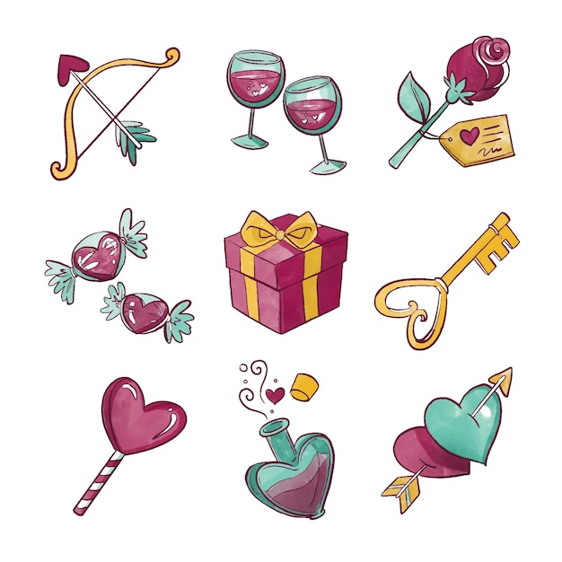

Dear Friends,

Happy February! Love is in the air, and with the promise of Spring around the corner, we're excited to share a special activity pack with you. This month, we're celebrating love in all its beautiful forms – from the warmth of family and the joy of friendship to the kindness of strangers.

In this pack, you'll find a delightful mix of crafts, stories, songs, and pictures that encourage you to reflect on the love that surrounds you. Whether it's a parent's embrace, a lover's kiss, or the wagging tail of a furry friend, love comes in countless shapes and sizes.

As the daffodils begin to bloom and the weather gets milder, take a moment to appreciate the signs of the season, including the cheerful "Loveday" daffodils with buttery yellow petals and a bright orange trumpet.

We've also included activities related to St. Brigid's Day and Pancake Tuesday, adding a touch of Irish tradition to this month's festivities.

We hope you enjoy these activities and that they inspire moments of joy and connection. If you ever want to share photos of your creations or you enjoying these packs, please send them to iseult.kinsella@alzheimer.ie.

Wishing you every kindness and a month filled with love.

“If January is the month of change, February is the month of lasting change. January is for dreamers… February is for doers.”
– Marc Parent

Useful Resources:

▪ Our Free Helpline and Dementia Support Line are available at: Phone: 1800 341 341 and Email: helpline@alzheimer.ie
▪ The Irish Museum of Modern Art is running a series called “Talking Art Online” where they take a close look at selected artworks from the IMMA Collection and discuss IMMA exhibitions with their Visitor Engagement Team from the comfort of your living room. To book and for more information, please email talkingart@imma.ie or phone 01 612 9955
▪ We are hosting several Virtual Cafes. They are a place to come together, share a cuppa and listen to our amazing guest speakers. For information on how to attend visit: https://alzheimer.ie/service/alzheimer-cafe/
▪ The ASI also have a huge library of factsheets and resources available on: https://alzheimer.ie/get-support/resources-andfactsheets/
▪ M4D Radio is a 24/7 online radio station with songs specifically picked to evoke memories and aid reminiscence. To find out more and to listen, please visit: https://m4dradio.com/
▪ The BBC have curated a remarkable online archive of videos, images and audio clips to aid reminiscence and covers a wide variety of subject matter. Please visit: https://remarc.bbcrewind.co.uk/ to check it out.
▪ Emergency Response Numbers: 999 or 112
▪ HSE 24/7 Your Mental Health Information Helpline: 1800 111 888

- Table of Contents

Activity | Pages
February Number Ones | 6
Valentines Day Quiz | 7-9
Love Songs Trivia Quiz | 10-11
iSpy and Count | 12
Tree of Love | 13
Romantic Reminiscence | 14
Pancake Tuesday Games | 15-16
Valentines Crossword Puzzle | 17-18
Valentines Pictures to Colour | 19-24
Seanfhocal/Proverbs | 25-26
Facts about Saint Brigid | 27-28
A Birthday by Christina Rossetti | 29
How Do I Love Thee? (Sonnet 43)  Elizabeth Barrett Browning | 30
She Walks in Beauty  By Lord Byron | 31
Bucket of Kindness | 32-33

February Number Ones

- How many of these classic chart topping songs do you remember?
- Can you hum the tune or even sing a verse or two?
- As a game, get a friend or carer to play the beginning of one of these songs and see if you can guess which one it is – then have a sing along!

DATE | TITLE | ARTIST | WEEKS AT NO.1
06/02/1953 | DON'T LET THE STARS GET IN YOUR EYES | PERRY COMO WITH THE RAMBLERS | 5
17/02/1956 | MEMORIES ARE MADE OF THIS | DEAN MARTIN | 4
22/02/1957 | YOUNG LOVE | TAB HUNTER | 7
27/02/1964 | ANYONE WHO HAD A HEART | CILLA BLACK | 3
04/02/1965 | YOU'VE LOST THAT LOVING FEELIN' | RIGHTEOUS BROTHERS | 2
14/02/1968 | MIGHTY QUINN | MANFRED MANN | 2
22/02/1975 | MAKE ME SMILE (COME UP AND SEE ME) | STEVE HARLEY & COCKNEY REBEL | 2
19/02/1977 | WHEN I NEED YOU | LEO SAYER | 3
03/02/1979 | HEART OF GLASS | BLONDIE | 4
09/02/1985 | I KNOW HIM SO WELL | ELAINE PAIGE & BARBARA DICKSON | 4
20/02/1988 | I SHOULD BE SO LUCKY | KYLIE MINOGUE | 5
22/02/1992 | STAY | SHAKESPEAR'S SISTER | 8
02/02/2002 | HERO | ENRIQUE IGLESIAS | 4
Valentines Day Quiz:

Q 1: Who is the Roman god of love?

A. Zeus
B. Cupid
C. Apollo
D. Mercury
Q 2: In which Shakespeare play do Romeo and Juliet fall in love?

A. Hamlet
B. Macbeth
C. Romeo and Juliet
D. Othello
Q 3: What is the traditional flower associated with Valentine's Day?

A. Tulip
B. Rose
C. Lily
D. Daisy
Q 4: Which of the following is not a symbol of love on Valentine's Day?

A. Heart
B. Arrow
C. Dove
D. Pumpkin
Q 5: What does XOXO stand for in a Valentine's Day context?

A. Hugs and Kisses
B. Extra Ordinary Love
C. Xtreme Outpouring of Love
D. Xylophones of Love
Q 6: What is the most popular gift on Valentine's Day?

A. Chocolates
B. Flowers
C. Jewellery
D. Teddy Bears
Q 7: Which historical figure is known for signing his love letters with "From your Valentine"?

A. William Shakespeare
B. Napoleon Bonaparte
C. Julius Caesar
D. St. Valentine
Q 8: What colour is often associated with love and passion?

A. Blue
B. Green
C. Red
D. Yellow
Q 9: What is the origin of the word "Valentine"?

A. Latin word for Love
B. French word for Friendship
C. Greek word for Passion
D. Roman word for Sweetheart
Q 10 : Which bird is often associated with love and mating for life?

A. Robin
B. Dove
C. Hawk
D. Sparrow
Answers:

B. Cupid
C. Romeo and Juliet
B. Rose
D. Pumpkin
A. Hugs and Kisses
A. Chocolates
D. St. Valentine
C. Red
D. Roman word for Sweetheart
B. Dove

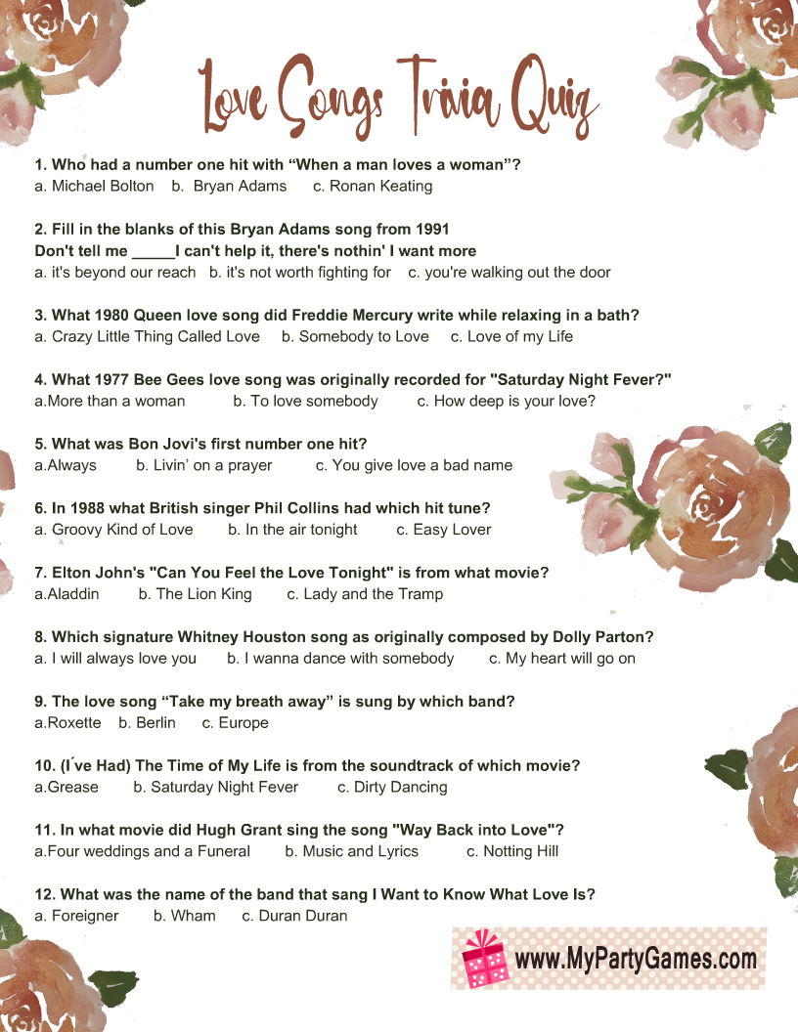

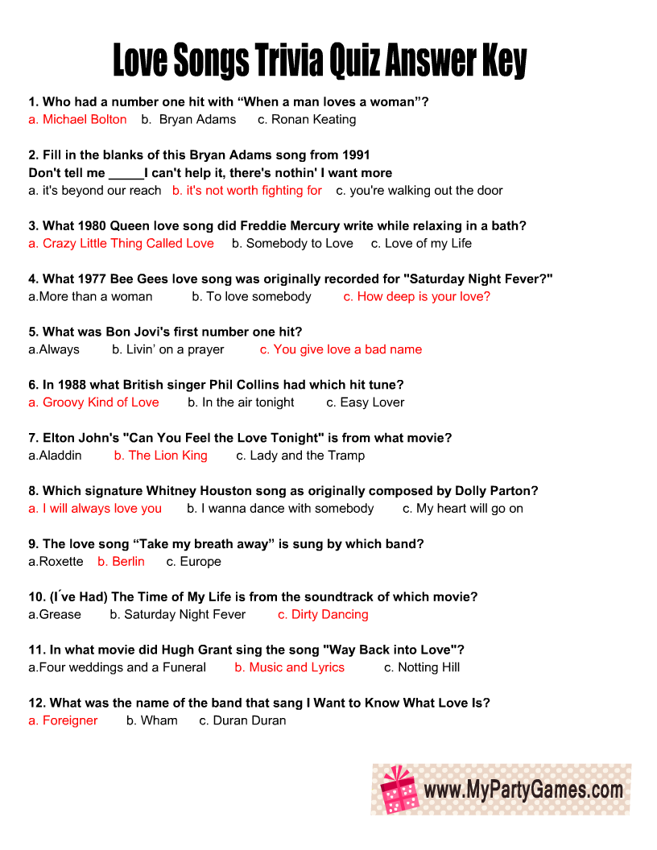
See how many of each animal you can find and write the number below!

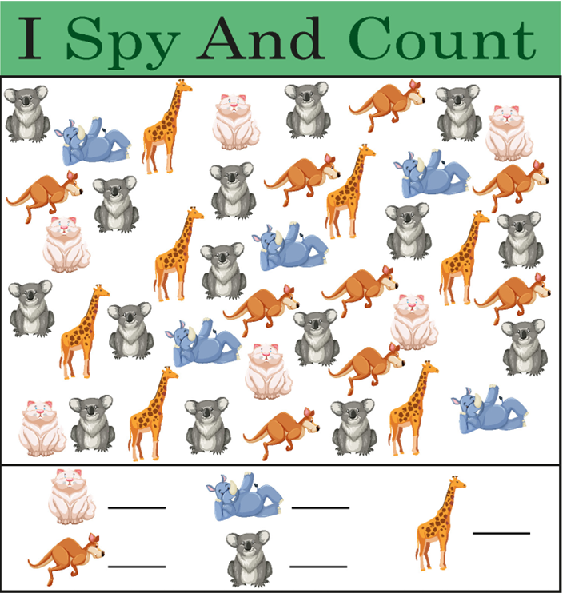
Tree Of Love

Take a moment to think of those around you who mean the most to you. Write their names below on the Tree of Love and don’t forget to include your own! Then write a key word such as “love” , “family”, “warmth” in the space below the hearts to finish it off.

You can keep this heart somewhere you can see it to remind you each day of all the love surrounding you – you can even add on more hearts and names if you like!
Romantic Reminisce
Here are some questions you might like to ask a friend, or to think upon yourself, to reminisce on some romantic times in your life.
Don’t worry if the answer doesn’t come to you, instead tell a story about a time you keep close to your heart or look at a photo for a loved one.
- Who was the first girl/boy you ever liked?
- Did anyone in particular ever make you blush?
- Do you remember your first kiss?
- Who was your first date? Where did you go? How did you get there?
- How did your parents feel about you dating?
- Did you ever receive gifts from someone you were dating, maybe flowers, cards, or jewellery?
- Did you ever write love letters to anyone or did you receive any love letters?
- How did you meet your wife/husband?
- How did your spouse propose? How did you feel?
- What advice would you give to someone in love?
- Who has been the greatest love in your life?
- What was your favourite date night activity?
- Can you describe your wedding day?
- Tell me about a memorable anniversary celebration.
- What gifts do you remember giving or receiving that meant a lot?
- Can you recall a romantic getaway or vacation you took together?
- What love songs or music do you associate with your relationship?

L O V E
Pancake Tuesday Games!:
- Pancake Flipping Contest:
  - Set up a pancake flipping station. Participants can compete to see who can flip a pancake the most times without dropping it. You can use plastic pancakes or even real ones if you're feeling adventurous!
- Pancake Relay Race:
  - Create a relay race where participants must carry a pancake on a spatula from one end of the room to the other without dropping it. They then pass the pancake to the next team member.
- Pancake Toss:
  - Set up targets on the ground and have participants toss pancakes to see who can land their pancake on the targets. Assign different point values to different targets for added excitement.
- Decorate Your Own Pancake Station:
  - Set up a pancake decorating station with various toppings and encourage participants to get creative with their pancake designs. Award prizes for the most artistic or unique creations.
- Pancake Memory Game:
  - Create a memory game using pictures or drawings of different types of pancakes. Participants take turns flipping cards to find matching pairs.
- Pancake Trivia:
  - Prepare a list of fun and interesting pancake trivia questions. Have a trivia quiz during your event and offer small prizes to participants with the most correct answers.
- Pancake Art Contest:
  - Provide participants with pancake batter in squeeze bottles and let them create pancake art on a hot griddle. Award prizes for the most creative or intricate pancake designs.
- Pancake Tower Challenge:
  - Challenge participants to build the tallest pancake tower using a set number of pancakes. The tower must stand for a certain amount of time to qualify.
- Pancake Juggling:
  - For those with some juggling skills, challenge them to juggle pancakes. Use foam or plastic pancakes for safety.

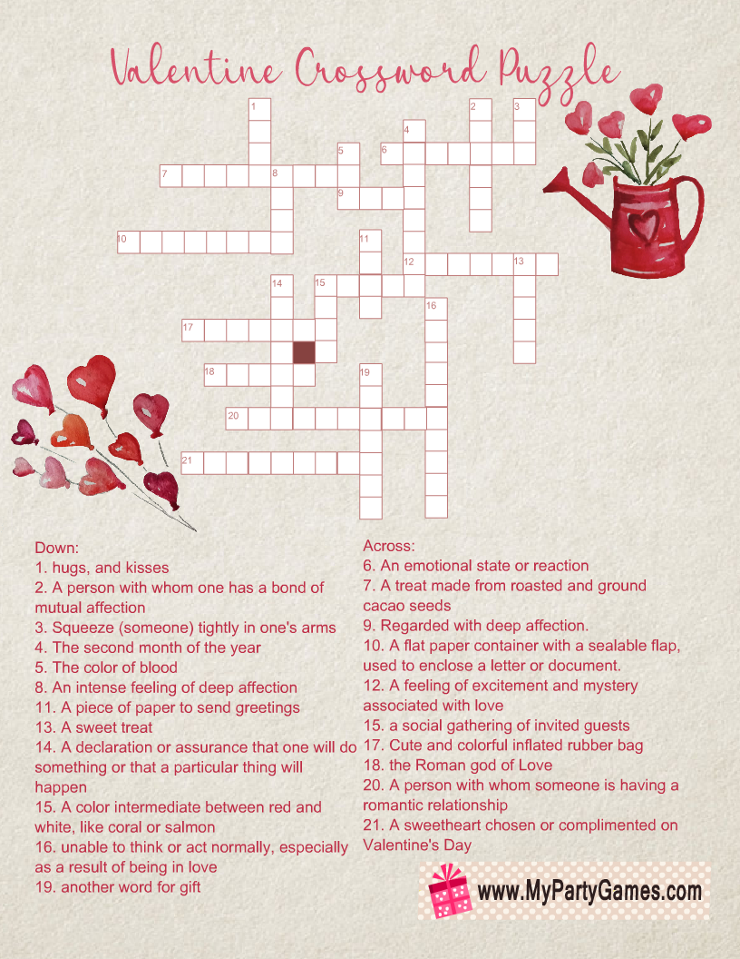

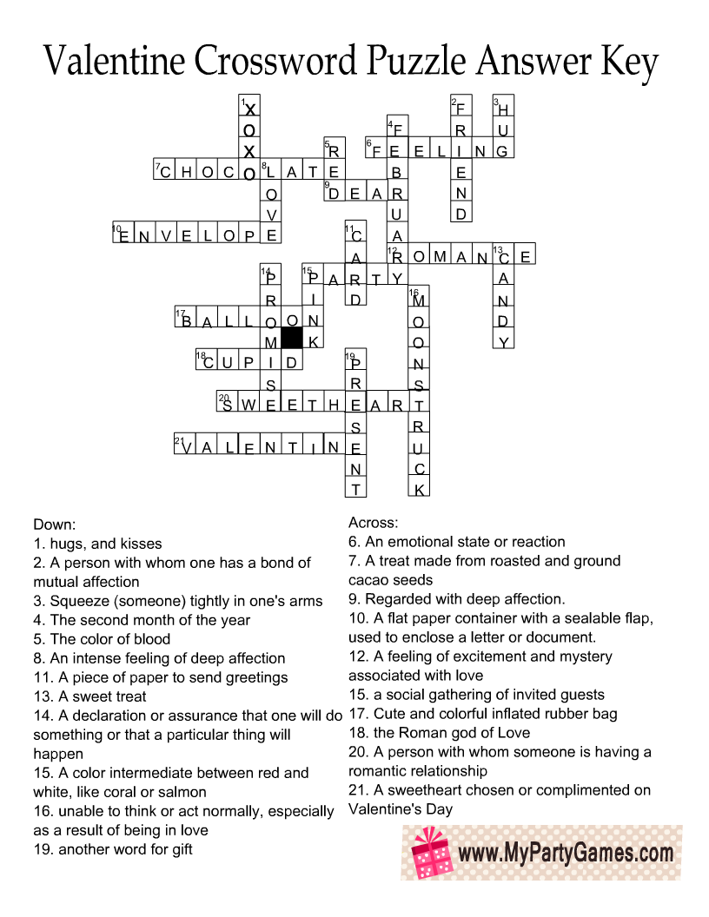

Valentines Pictures to Colour:
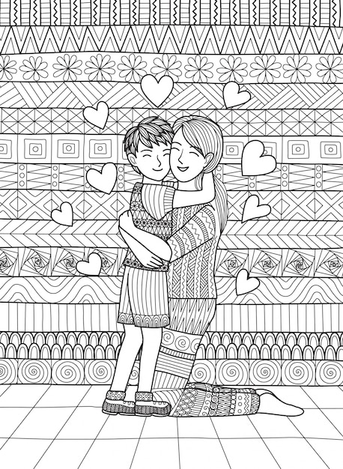

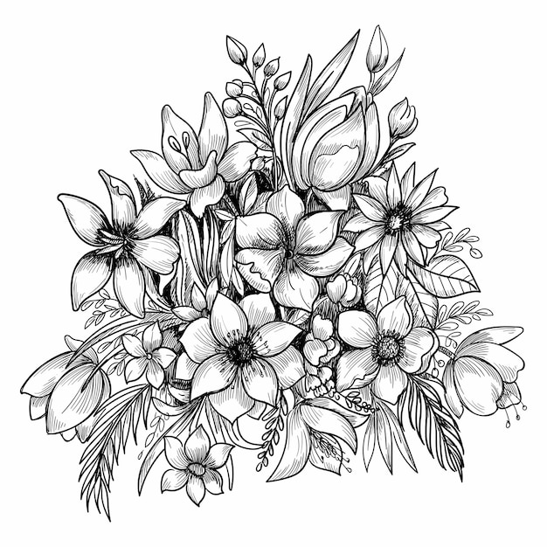

Seanfhocal/Proverbs

‘Seanfhocal’ is the Irish word for proverb, literally meaning ‘old word’. The following proverbs have been around for centuries. The following are some commonly used proverbs and their meanings.

- Hindsight is the best insight to foresight – Learn from your past mistakes to avoid making new ones.
- Every man is sociable until a cow invades his garden – Everybody has their off days!

- Hunger is good sauce – hunger makes any food taste good.

- Experience is the comb that life gives a bald man – A man who has lived long enough to lose his hair will no doubt know a thing or two about life.

- Do not resent growing old, many are denied the privilege – this one of the few self-explanatory proverbs!

- Complain that you have no shoes until you meet a man who has no feet – be thankful for what you have because there will always be someone in a worse situation than you.

- It’s a long road that has no turning – Always doing the same thing is neither beneficial nor entertaining.

- Many a ship is lost within sight of the harbour – don’t let your guard down no matter how safe you think things may be.

- Life is like a cup of tea; it’s all in how you make it – how you live your life is a result of what you do in it.

- It is the quiet pigs that eat the meal – this can be compared to ‘the early bird catches the worm’.

- It’s a lonely washing that has no man’s shirt in it – everybody needs someone to love (and wash clothes for).

- It’s not a delay to stop and sharpen the scythe – take every opportunity to learn.

- No matter how many rooms you have in your house, you’re only able to sleep in one bed – it doesn’t matter how many possessions you have, we all have the same basic needs in life.

- When the drop is inside the sense is outside – alcohol leads to senseless activities!

Facts about Saint Brigid:
- Trailblazing Saint:
  - Did you know that Saint Brigid, also known as Mary of the Gael, is one of Ireland's patron saints alongside Patrick and Columba?
- Powerful Namesake:
  - Did you know that Saint Brigid shares her name with an ancient Celtic goddess, and her feast day on February 1st marks the pagan festival of Imbolc, symbolizing the onset of spring?
- Triple Celebration:
  - Did you know that Saint Brigid is associated with the holy fire of Kildare, which is said to have been kept burning by her nuns for over 1,000 years?
- Nurturing Spirit:
  - Did you know that Saint Brigid is often portrayed with a cow, symbolizing her compassion and generosity? Legend has it that her prayers turned water into milk to feed the hungry.
- Patron of the Arts:
  - Did you know that Saint Brigid is not only revered for her religious contributions but is also considered the patron saint of poets, blacksmiths, and healers?
- Crossing Boundaries:
  - Did you know that Saint Brigid is celebrated not only in Ireland but also in other parts of the world? Churches and places are dedicated to her, and her influence extends beyond her homeland.
- Green Thumb Saint:
  - Did you know that Saint Brigid is connected to agriculture? It is believed that plaited crosses made in her honour were used to bless crops and livestock for a fruitful harvest.
- Compassionate Healer:
  - Did you know that Saint Brigid is attributed with performing miracles, including the healing of the sick and blind? She is remembered for her caring and nurturing nature.
- Protectress of Women:
  - Did you know that Saint Brigid is recognized for her advocacy for women's rights and empowerment? She played a crucial role in challenging societal norms of her time.
- Everlasting Legacy:
  - Did you know that Saint Brigid's influence endures today, with many still observing her feast day and celebrating her legacy in various cultural and religious traditions?

A Birthday by Christina Rossetti

My heart is like a singing bird
Whose nest is in a water’d shoot;
My heart is like an apple-tree
Whose boughs are bent with thickset fruit;
My heart is like a rainbow shell
That paddles in a halcyon sea;
My heart is gladder than all these
Because my love is come to me.

Raise me a dais of silk and down;
Hang it with vair and purple dyes;
Carve it in doves and pomegranates,
And peacocks with a hundred eyes;
Work it in gold and silver grapes,
In leaves and silver fleurs-de-lys;
Because the birthday of my life
Is come, my love is come to me.

How Do I Love Thee? (Sonnet 43)
Elizabeth Barrett Browning

How do I love thee? Let me count the ways.
I love thee to the depth and breadth and height
My soul can reach, when feeling out of sight
For the ends of being and ideal grace.
I love thee to the level of every day's
Most quiet need, by sun and candle-light.

I love thee freely, as men strive for right.
I love thee purely, as they turn from praise.
I love thee with the passion put to use
In my old griefs, and with my childhood's faith.

I love thee with a love I seemed to lose
With my lost saints. I love thee with the breath,
Smiles, tears, of all my life; and, if God choose,
I shall but love thee better after death.

She Walks in Beauty
By Lord Byron

She walks in beauty, like the night
Of cloudless climes and starry skies;
And all that’s best of dark and bright
Meet in her aspect and her eyes;
Thus mellowed to that tender light
Which heaven to gaudy day denies.

One shade the more, one ray the less,
Had half impaired the nameless grace
Which waves in every raven tress,
Or softly lightens o’er her face;
Where thoughts serenely sweet express,
How pure, how dear their dwelling-place.

And on that cheek, and o’er that brow,
So soft, so calm, yet eloquent,
The smiles that win, the tints that glow,
But tell of days in goodness spent,
A mind at peace with all below,
A heart whose love is innocent!

Bucket Of Kindness Mediation
Close your eyes and take a very deep breath.
Keep breathing deeply and feel the cool air
come in through your nose and flow all the way
down to your belly. Feel your belly extend as you breathe in.

Now, listen carefully to all the quiet sounds
outside and around you. You may hear outside
noises, maybe cars, birds or something else…
just listen.
Now, turn your focus within. Listen quietly to what you hear happening within your body.

Can you hear your heart beating? Can you hear
your breath as you breathe slowly in and out?
Maybe your tummy is making noises, or you’re
listening to the sound of your breath, or your
heartbeat. Whatever is going on inside, just take
time to listen.

Imagine now inside of you, there is a big beautiful bucket.
Everyone has one though we can’t see it with our eyes.
When we feel good, our buckets are full.
When we’re feeling bad, our buckets are low… or even empty.
We all want our buckets to be full of love, kindness,
peacefulness, and happiness.
Everyone does. So, we can make a choice each and every day to show loving kindness to others and help fill up their buckets.

If your bucket ever feels low or empty – you can
take in a deep breath and remember how loved
you are. You can choose to be grateful for the
good things and people you have in your life
and focus on that.

Now when you’re ready…. take in a deep breath.
Open your eyes and give you wonderful body a big, wonderful stretch!
You’ve done a great job!

