April
Activity Pack
2

Dear Friends,
As the days lengthen and the sun graces us with its warm embrace in the evenings, we welcome the transition from spring to summer with open arms. It's a time of renewal, of blossoming, and of spending cherished moments with loved ones.

We've curated a special Easter-themed pack for you this month, filled with delightful springtime activities such as crosswords, puzzles, Easter-themed colouring pictures, songs, and much more. But beyond the contents of the pack, we invite you to step outside and embrace nature at its most vibrant.

Take a stroll in your favourite spot, breathe in the fragrant air, and marvel at the signs of life blooming all around you. It's the perfect opportunity to start planting flowers, to connect with the earth, and to revel in the simple joys of being outdoors.

Easter is a time for celebration, for gathering with family and friends, and for savouring the sweetness of life. Whether you're attending mass, indulging in hot cross buns, or embarking on an Easter egg hunt, we hope this April brings you an abundance of joy and renewal.

Let's make the most of these brighter evenings, of the warmth of the sun, and of the company of those dear to us. Here's to a season of growth, of connection, and of embracing the beauty of Ireland under the springtime sun.

"The flowers of late winter and early spring occupy places in our hearts well out of proportion to their size."
Gertrude S. Wister

Useful Resources:

- Our Free Helpline and Dementia Support Line are available at:
Phone: 1800 341 341 and Email: helpline@alzheimer.ie

- Do you know an older person who would like support using their smart phone or tablet?
Age Action Ireland are offering 5 hours free remote tutoring to help people learn to use Apps, email, Zoom, Facetime etc.
Call 01 4756989 or email gettingstarted@ageaction.ie

- We are hosting several Virtual Cafes. They are a place to come together, share a cuppa and listen to our amazing guest speakers. For information on how to attend visit: https://alzheimer.ie/service/alzheimer-cafe/

- The ASI also have a huge library of factsheets and resources available on: https://alzheimer.ie/get-support/resources-and-factsheets/

- The ASI now also has a new online Virtual Dementia Hub where you can go for a full range of activities – you can even listen to some wonderful poetry and songs recorded. Just go www.virtualdementiahub.ie

- For musical videos and resources Music For Dementia are a wonderful
- resource: https://musicfordementia.org.uk/
- Emergency Response Numbers: 999 or 112 9. HSE 24/7 Your Mental Health
- Information Helpline: 1800 111 888

Table of Contents

Activity | Pages
Dyed Easter Eggs Using Shaving Cream | 6
iSpy Garden Birds | 7-8
How to Grow Your Own Garden | 9-11
Easter Trivia Quiz | 12-13
Easter Joys | 14
Irish Carrot Cake | 15-16
Watering Can Maze | 17
Spring and Easter Word Search | 18
Spring Word Search | 19
iSpy and Counting | 20
Spring Maze | 21
Irish Proverbs and Their Meanings | 22-24
How Many Easter Related Items Can You Name? | 25
Spring and Easter Word Scramble | 26
Carrickfergus performed by The Dubliners | 27-28
Morning Has Broken by Cat Stevens | 29
Pictures to Colour | 31-33
Old Irish Folklore and Stories | 34-36
I Wish You Joy | 37
Practising Gratitude | 38

Dyed Easter Eggs Using Shaving Cream
(method and images from marthastewart.com)

What you need
White-shelled, hardboiled eggs
Liquid food colouring
Shaving cream
Containers to dye the eggs in
Tongs
Coffee stirrers or lollipop sticks
Paper towels

- Pour shaving cream into containers. Add drops of the first food colouring, mixing well with coffee stirrer until combined.
- Add a few drops of the second colour; drag stirrer/stick through cream to add swirls and create designs; work over whole container or focus on specific areas.
- Submerge your eggs (hard boiled then cooled) in the coloured cream and let sit for 20 minutes.
- Remove the eggs from the dye with tongs, and gently wipe clean with a paper towel.
- Display your beautiful marble dyed Easter eggs!

iSpy Garden Birds:
How Many Can You Spot
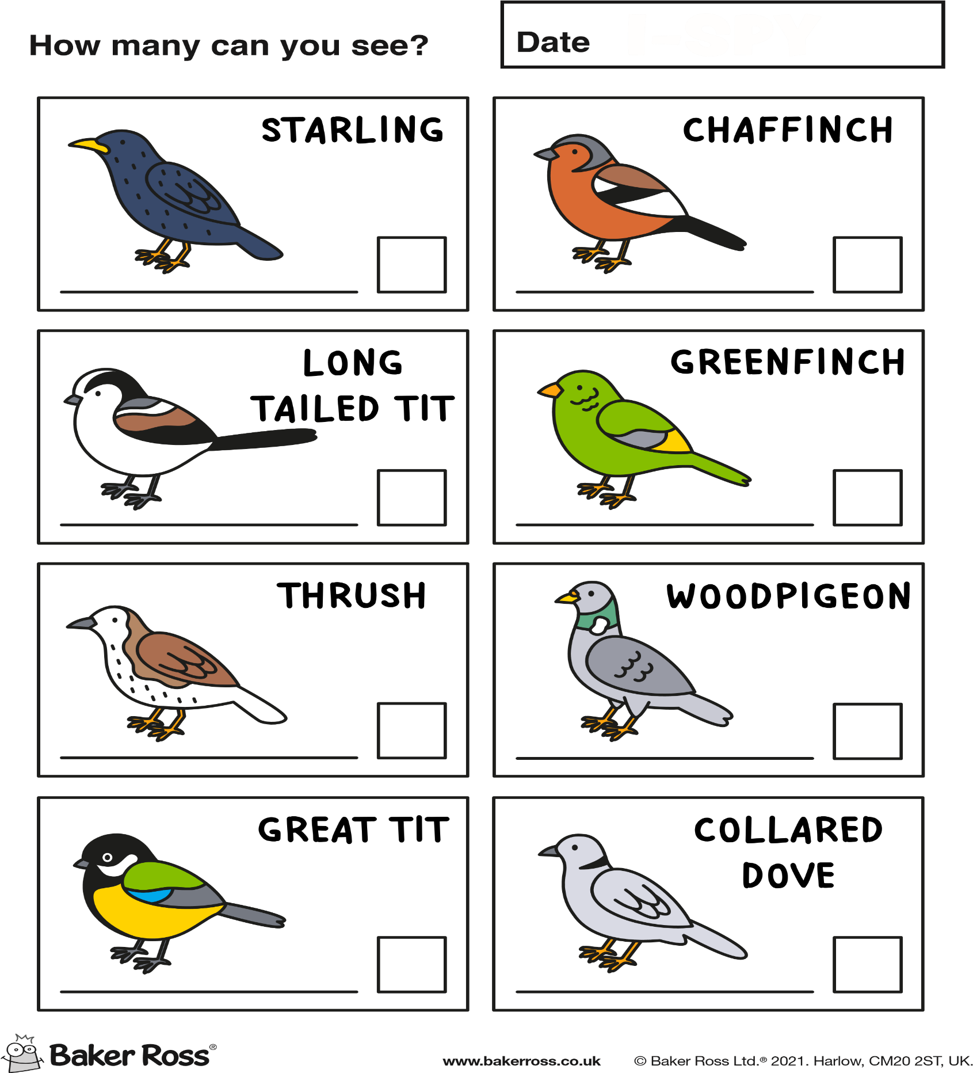

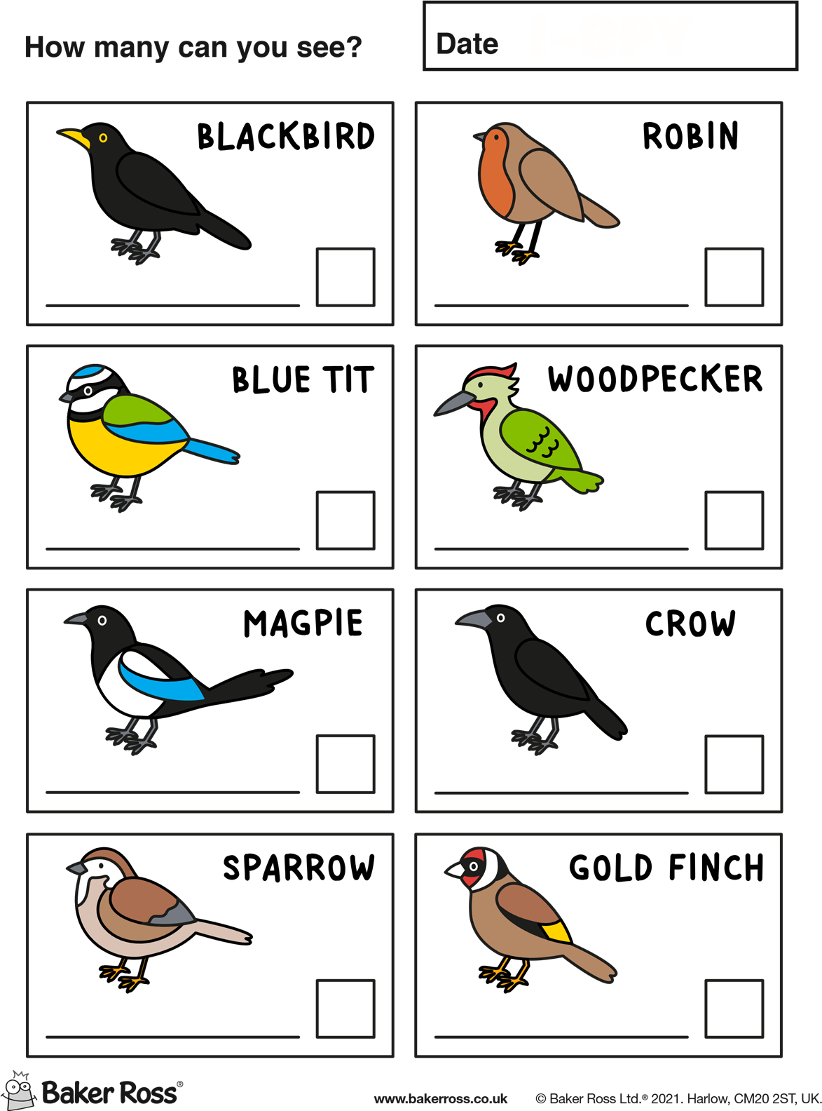

How to Grow Your Own Garden:
What You Need to Grow Your Own Garden:
1. Tools and Equipment:
- Hand Trowel and Fork: These small hand tools are essential for planting, transplanting, and loosening soil.
- Garden Hoe: Use a garden hoe to remove weeds and cultivate the soil.
- Pruning Shears: Pruning shears are handy for trimming and shaping plants, removing dead or diseased branches, and harvesting fruits and vegetables.
- Watering Can or Hose: Ensure your garden receives adequate water with a watering can or hose equipped with a spray nozzle.
- Garden Gloves: Protect your hands from cuts, scratches, and dirt with a sturdy pair of garden gloves.
- Wheelbarrow or Garden Cart: Transport soil, plants, and equipment around your garden with ease using a wheelbarrow or garden cart.
- Plant Labels and Marker: Keep track of your garden plants by labelling them with plant labels and a waterproof marker.
- Mulch: Mulch helps retain moisture, suppress weeds, and regulate soil temperature. Use organic mulch such as shredded leaves, straw, or wood chips.
Tips and Tricks for Starting Your Garden:
- Choose the Right Location: Select a sunny spot for your garden with well-drained soil. Consider factors such as sunlight, water access, and proximity to your home for convenience.
- Start Small: If you're new to gardening, start with a small plot or a few containers. You can always expand your garden as you gain experience.
- Prepare the Soil: Before planting, prepare the soil by loosening it with a garden fork or tiller and adding organic matter such as compost or aged manure to improve soil structure and fertility.
- Plant at the Right Time: Check the planting guidelines for each type of flower, fruit, or vegetable to ensure you plant them at the optimal time for your climate zone.
- Water Regularly: Keep your garden well-watered, especially during dry spells or hot weather. Water plants at the base to avoid wetting the foliage, which can lead to disease.
- Mulch: Apply a layer of mulch around your plants to help retain moisture, suppress weeds, and regulate soil temperature.
- Monitor for Pests and Diseases: Keep an eye out for pests and diseases in your garden and take action promptly to prevent damage to your plants.
- Enjoy the Process: Gardening is a rewarding and therapeutic activity that can bring joy and satisfaction. Take time to appreciate the beauty of your garden and the fruits of your labour.
Best Flowers, Fruits, and Vegetables to Grow in April:
Flowers:
- Daffodils: Daffodils are cheerful spring flowers that come in a variety of colours and sizes. They are easy to grow and can add a burst of colour to any garden.
- Tulips: Tulips are another classic spring flower that comes in a wide range of colours and varieties. Plant them in clusters or rows for a stunning display.
- Pansies: Pansies are hardy annuals that thrive in cool weather. They come in a rainbow of colours and are perfect for adding colour to flower beds, borders, or containers.
Fruits:
- Strawberries: April is the perfect time to plant strawberries. Choose a sunny spot with well-drained soil and enjoy fresh strawberries throughout the summer months.
- Raspberries: Raspberries are another delicious fruit to grow in April. They require a bit more space than strawberries but are well worth the effort for their sweet-tart flavour.
- Blueberries: Blueberries are relatively easy to grow and are packed with antioxidants. Plant them in acidic soil and provide plenty of water for healthy, productive plants.
Vegetables:
- Lettuce: Lettuce is a cool-season crop that can be planted in April for a continuous harvest throughout the spring and early summer. Choose from a variety of leafy greens such as romaine, butterhead, and leaf lettuce.
- Spinach: Spinach is another cool-season crop that thrives in the spring months. Plant spinach seeds directly in the garden or start transplants indoors for an early harvest.
- Radishes: Radishes are quick-growing vegetables that are perfect for beginner gardeners. Plant radish seeds directly in the garden and enjoy crisp, peppery radishes in just a few weeks.

Easter Joys
In the quiet of the morning, When the dawn begins to break, There's a feeling of anticipation, That stirs with every wake.
For Easter brings its promise, Of renewal and of grace, A time to celebrate the blessings, That light up every face.
The earth awakes from slumber, With blossoms bright and fair, As nature's gentle chorus, Fills the sweet and scented air.
The daffodils dance merrily, Their golden heads held high, While robins sing their melodies, Beneath the azure sky.
In every budding blossom, And in every blade of green, There's a whisper of the miracle, That Easter time has seen.
For on this hallowed morning, Long ago and far away, A humble tomb lay empty, As the sun rose on that day.
So let us gather 'round now, With hearts full of delight, And sing of Easter's promise, In the morning's golden light.
For though the years may pass us by, And time may take its toll, The joy of Easter's message, Will live within our soul.
So let us raise our voices high, And sing with one accord, For Easter brings its blessings, And the presence of our Lord.
May this Easter fill your heart, With love that never ends, And may you find in every moment, A joy that always transcends.

Irish Easter Carrot Cake
Ingredients:
- 225g self-raising flour
- 1 teaspoon baking powder
- 1 teaspoon ground cinnamon
- 1/2 teaspoon ground nutmeg
- 1/2 teaspoon ground ginger
- Pinch of salt
- 200g granulated sugar
- 200ml vegetable oil
- 4 large eggs
- 1 teaspoon vanilla extract
- 200g grated carrots (about 2 medium carrots)
- 100g crushed pineapple, drained (optional)
- 100g chopped walnuts or pecans (optional)
Cream Cheese Frosting:
- 200g cream cheese, softened
- 100g unsalted butter, softened
- 250g icing sugar
- 1 teaspoon vanilla extract
Instructions:
- Preheat Oven: Preheat your oven to 180°C (350°F). Grease and line a 20cm (8-inch) round cake tin with parchment paper.
- Prepare Dry Ingredients: In a mixing bowl, sift together the self-raising flour, baking powder, ground cinnamon, ground nutmeg, ground ginger, and a pinch of salt. Set aside.
- Mix Wet Ingredients: In a separate large bowl, whisk together the granulated sugar and vegetable oil until well combined. Add the eggs one at a time, beating well after each addition. Stir in the vanilla extract.
- Combine Batter: Gradually add the dry ingredients to the wet ingredients, mixing until just combined. Fold in the grated carrots, crushed pineapple (if using), and chopped nuts (if using) until evenly distributed throughout the batter.
- Bake: Pour the batter into the prepared cake tin and smooth the top with a spatula. Bake in the preheated oven for 40-45 minutes, or until a skewer inserted into the center of the cake comes out clean. Remove from the oven and allow to cool in the tin for 10 minutes before transferring to a wire rack to cool completely.
- Prepare Frosting: While the cake is cooling, prepare the cream cheese frosting. In a mixing bowl, beat together the softened cream cheese and softened butter until smooth. Gradually add the icing sugar, beating until light and fluffy. Stir in the vanilla extract.
- Assemble Cake: Once the cake is completely cool, spread the cream cheese frosting evenly over the top of the cake.
- Decorate: Decorate the top of the cake with additional grated carrots, chopped nuts, or a sprinkle of cinnamon for a festive touch.
- Serve: Slice and serve your Irish Easter Carrot Cake with a cup of tea or coffee for a delightful Easter treat!

Watering can Maze:

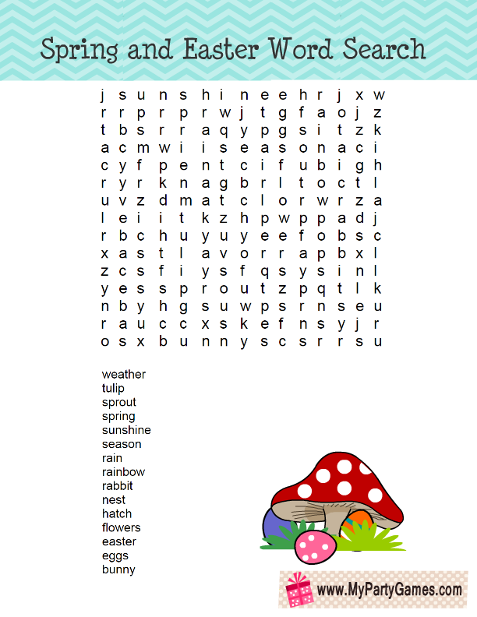

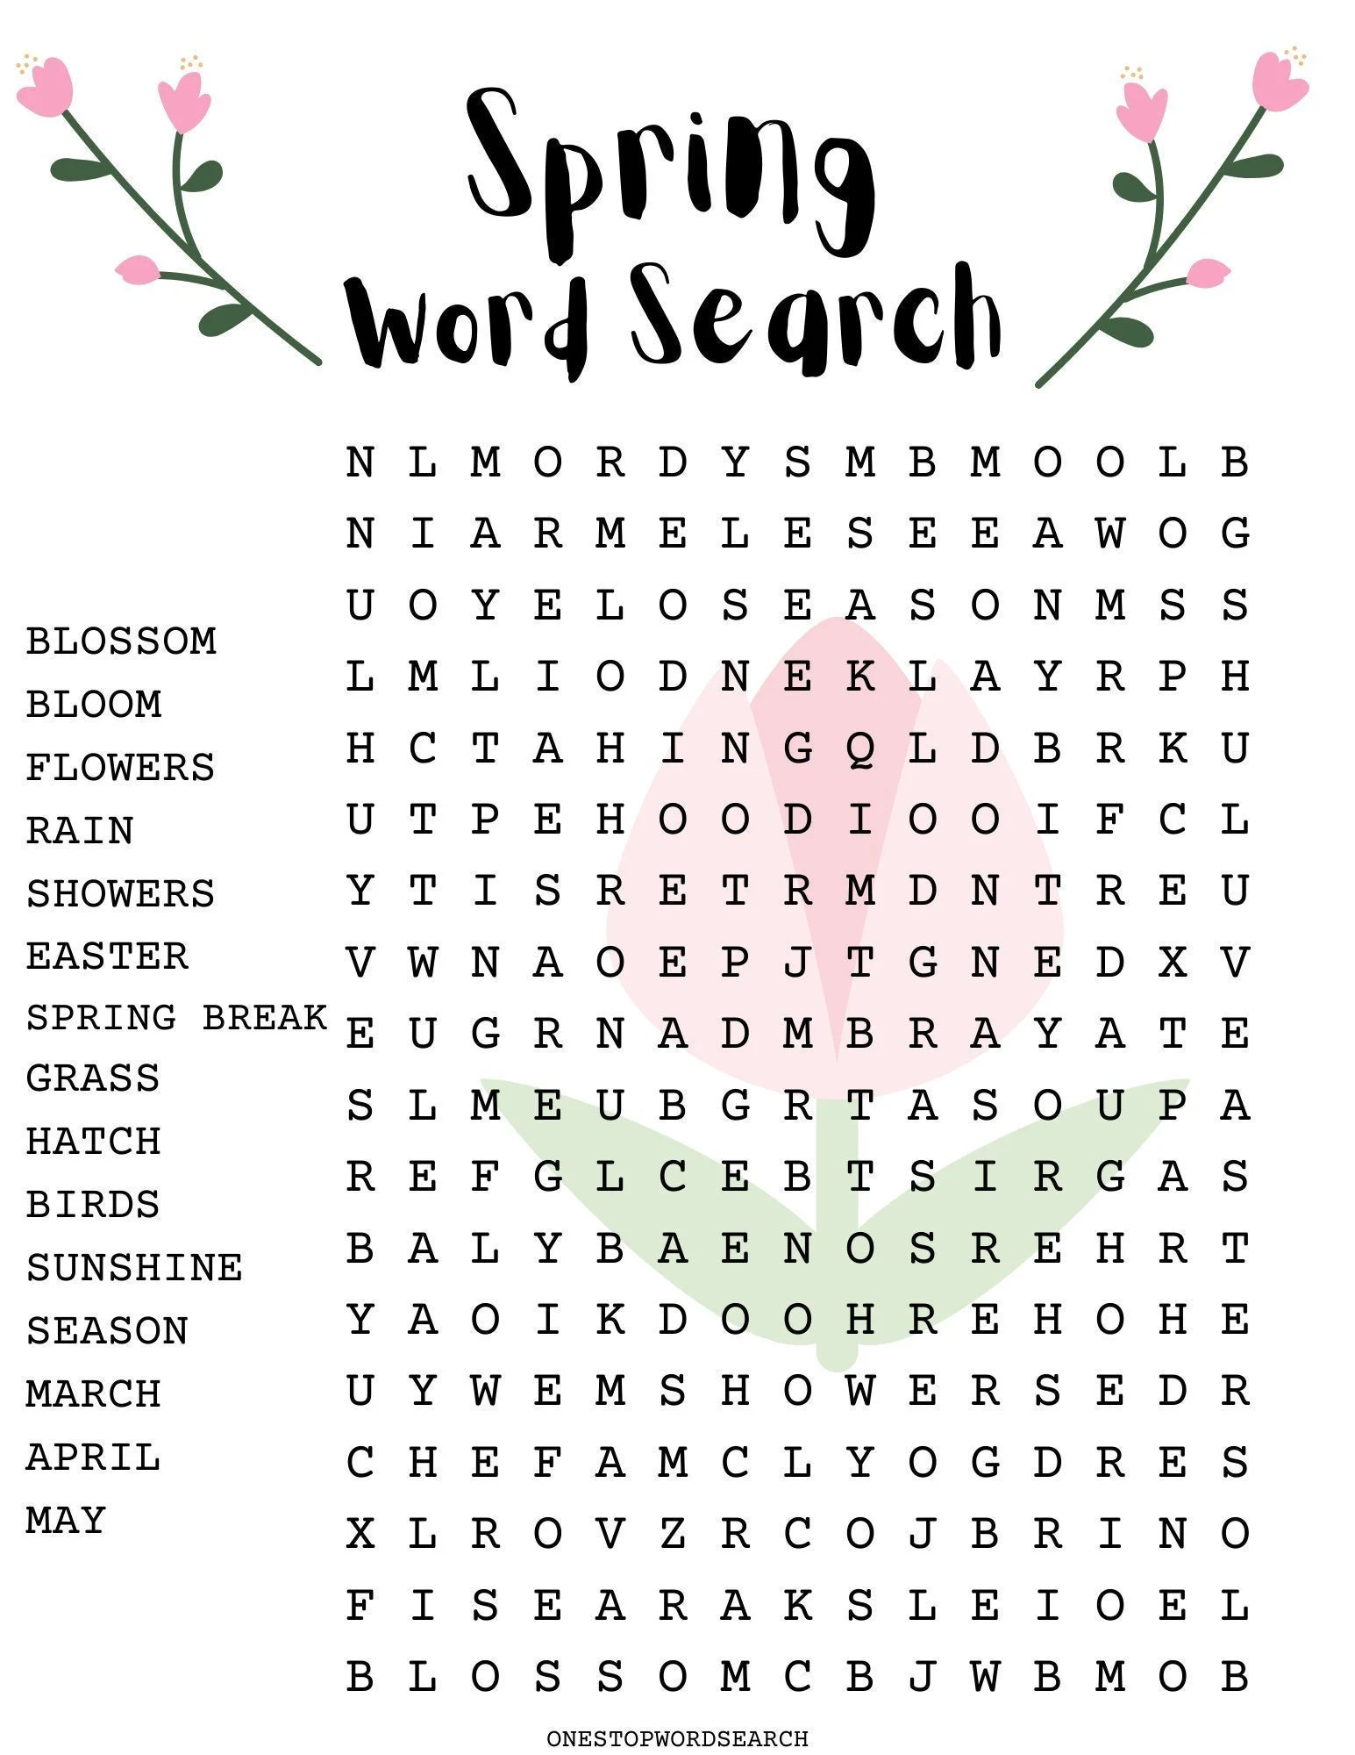
I-Spy and Counting

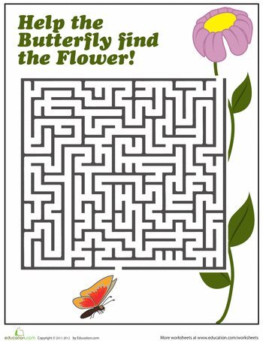
Spring Maze!

Irish Proverbs and Their Meanings

- Don’t fear an ill wind if your haystacks are tied down – There is no need to worry about things if you’re properly prepared.

- The skin of the old sheep is on the rafter no sooner than the skin of the young sheep – nobody is immune to death or bad health no matter what their age.

- It takes time to build castles – hard work and planning will reap rewards eventually.

- A man’s mouth often breaks his nose – if you talk too much you can get in trouble.

- The older the fiddle the sweeter the tune – things improve with age.

- There’s no use boiling your cabbage twice – once something is done, there’s no need to revisit it; leave the past behind.

- A friend’s eye is a good mirror – trust your friends’ opinions.

- A good beginning is half the work – getting things started is the hardest part.

- Sunshine always follows rain – good things come after bad things; there is a light at the end of the tunnel.
- Good luck beats early rising – some people are more fortunate than others for no real reason.

- A wren in the hand is better than a crane out of it – a small success is better than a big failure.

- A blind man is no judge of colours – knowledge is not equal to experience.

- God’s help is nearer than the door – don’t run away from your problems.

- A windy day is not a day for thatching – don’t plan for the future in times of uncertainty.

- Every patient is a doctor after his cure – people who solve their own problems think they are experts in everyone else’s.

- You must crack the nuts before you can eat the kernel – success takes hard work.

- Show the fatted calf but not the thing that fattened him – be wary of giving away the secrets to success.

- If you lie down with dogs you’ll rise with fleas – don’t expect to mingle with bad people and not pick up some bad habits yourself.

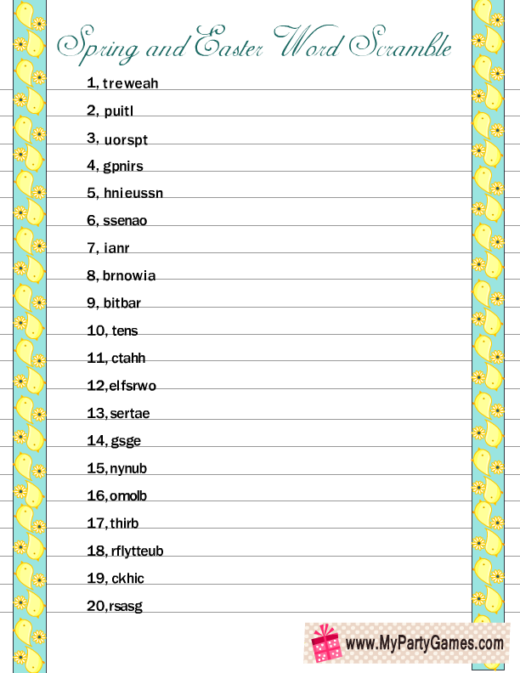
Carrickfergus performed by The Dubliners

I wish I was in Carrickfergus
Only for nights in Ballygrand
I would swim over the deepest ocean
Only for nights in Ballygrand.

But the sea is wide and I cannot swim over
And neither have I the wings to fly
I wish I had a handsome boatsman
To ferry me over my love and I.

My childhood days bring back sad reflections
Of happy times there spent so long ago
My boyhood friends and my own relations
Have all past on now with the melting snow.

So I'll spend my days in this endless roving
Soft is the grass and shore, my bed is free
Oh to be home now in Carrickfergus
On the long rode down to the salty sea.

Now in Kilkenny it is reported
On marble stone there as black as ink
With gold and silver I would support her
But I'll sing no more now til I get a drink.

Cause I'm drunk today and I'm seldom sober
A handsome rover from town to town
Ah but I'm sick now my days are number
Come all me young men and lay me down
Come all me young men and lay me down.

Morning Has Broken by Cat Stevens

Morning has broken like the first morning
Blackbird has spoken like the first bird
Praise for the singing, praise for the morning
Praise for them springing fresh from the world.

Sweet the rains new fall, sunlit from Heaven
Like the first dewfall on the first grass
Praise for the sweetness of the wet garden
Sprung in completeness where His feet pass.

Mine is the sunlight, mine is the morning
Born of the one light, Eden saw play
Praise with elation, praise every morning
God's recreation of the new day.

Pictures To Colour

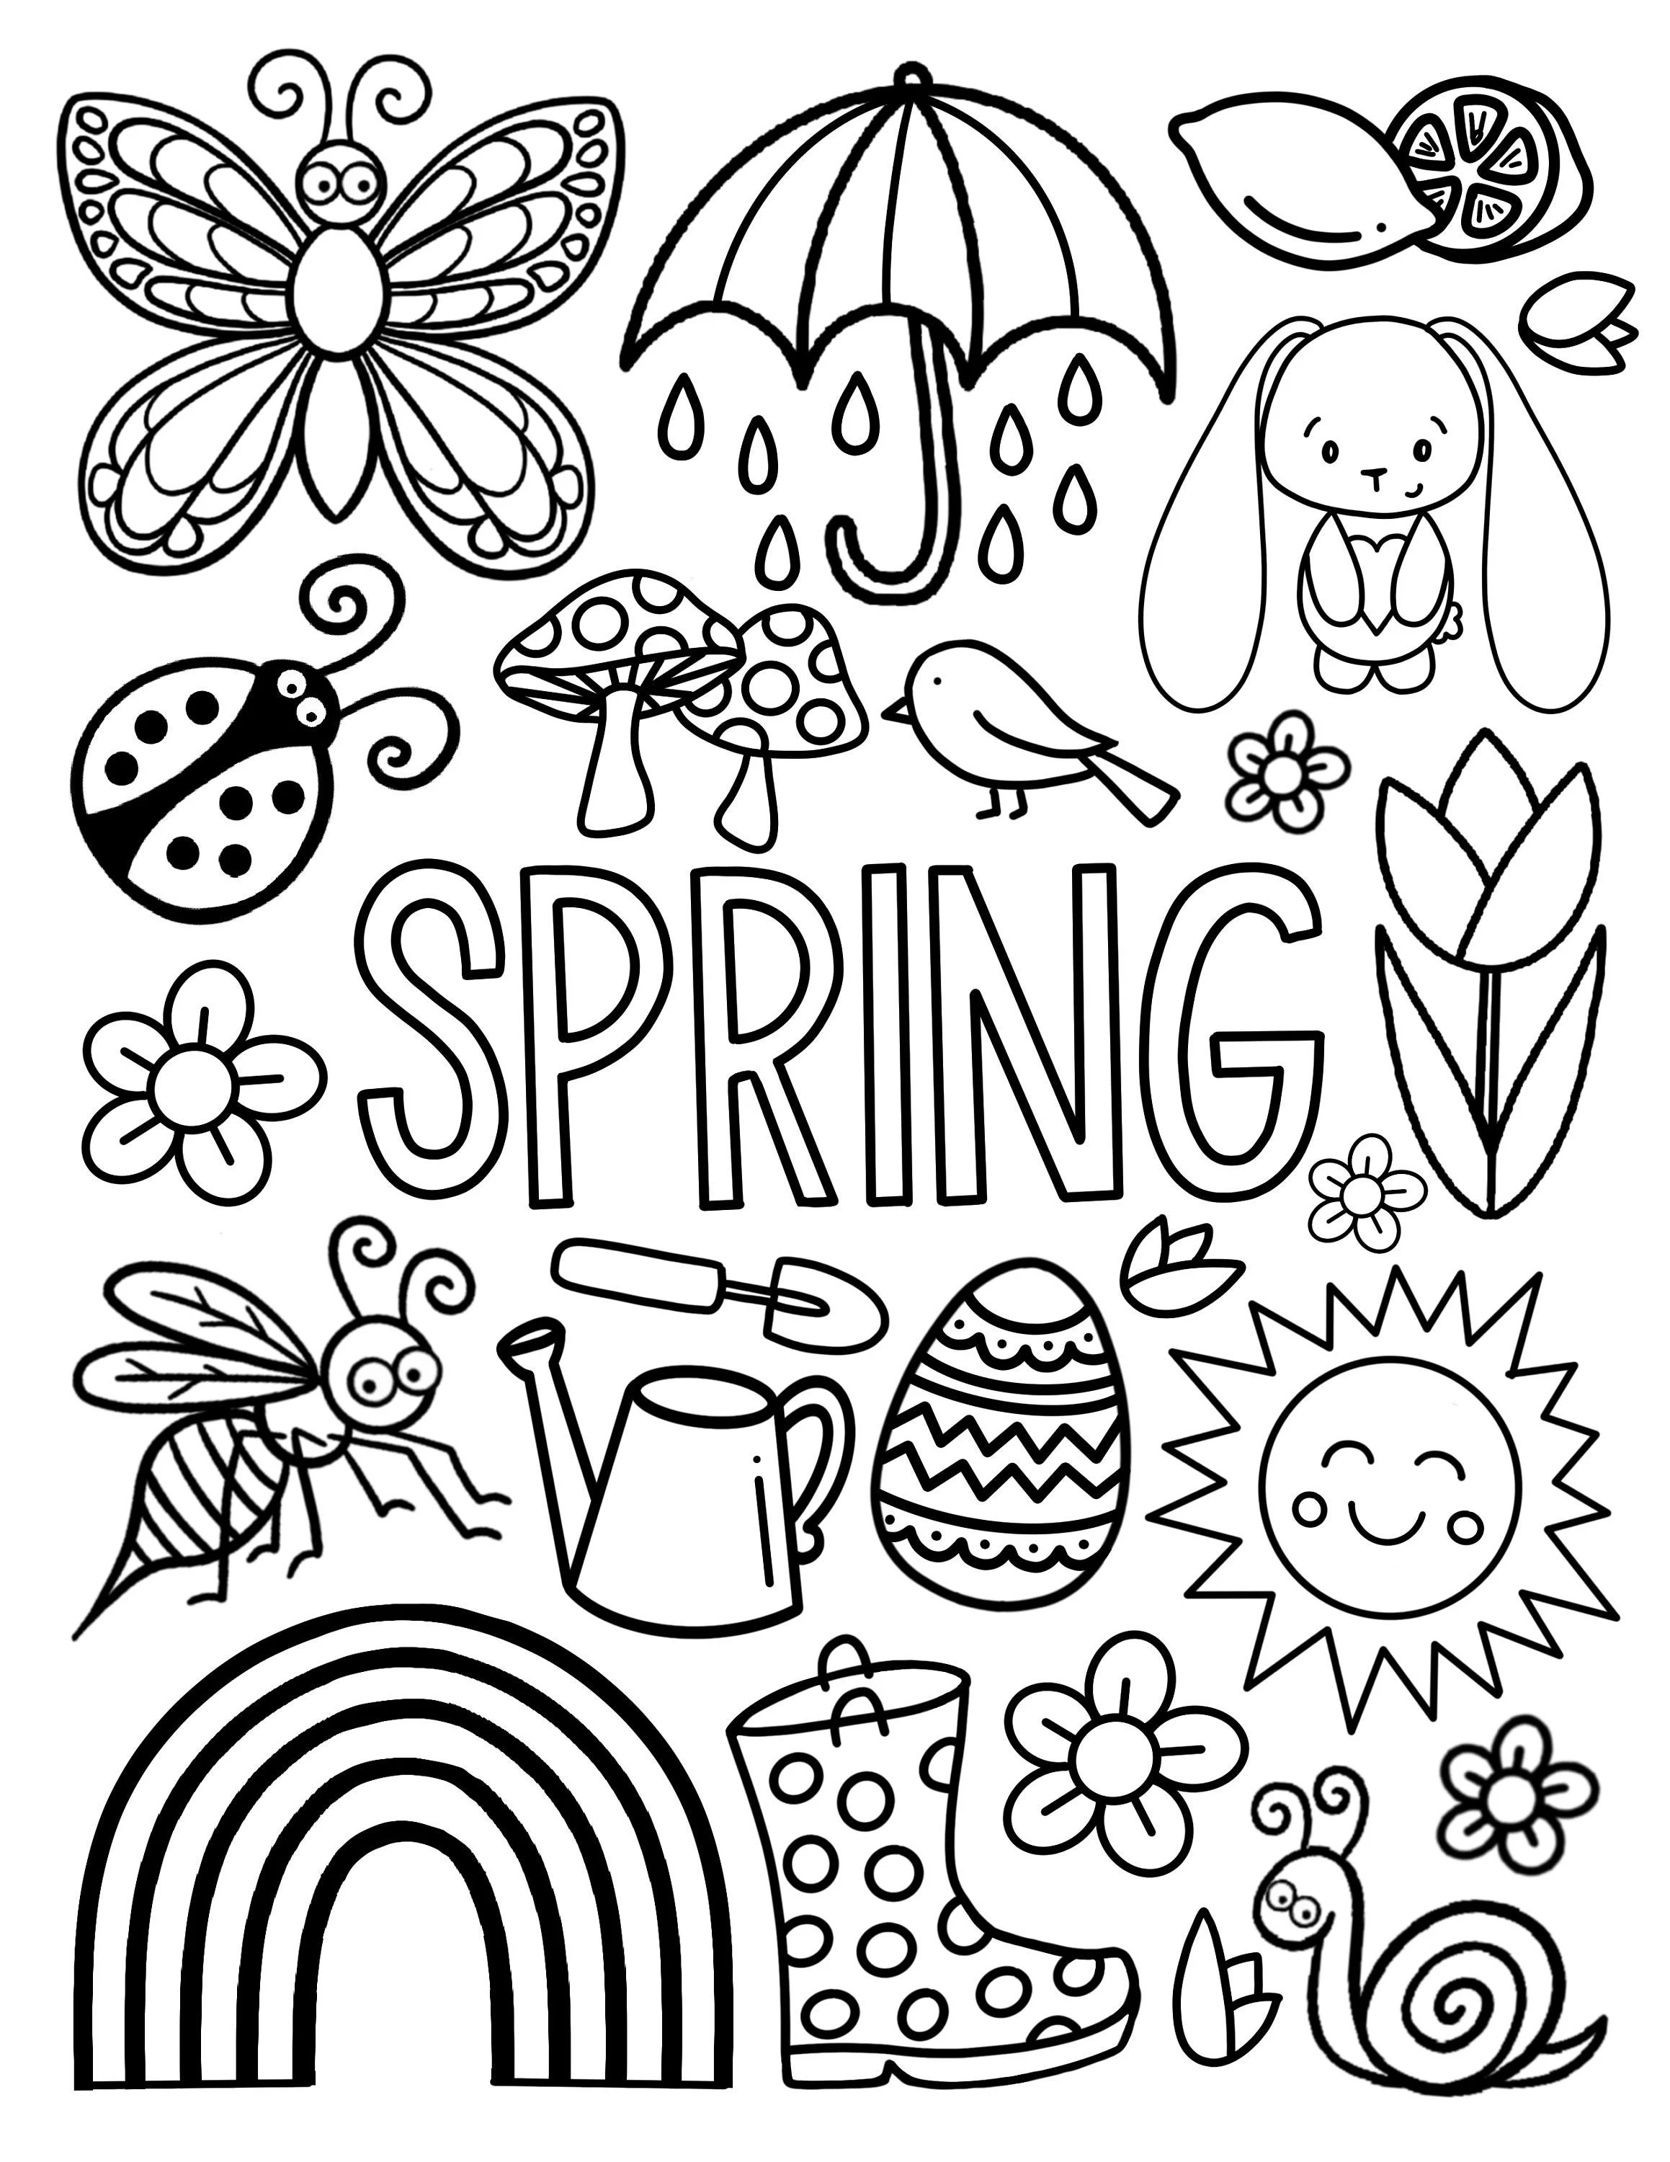

Old Irish Stories and Folklore

Easter Described by Bríghid Ní Ódhra in April 1938
We will have Easter next Sunday. The day before is holy Saturday. The sun dances on Easter Sunday morning and in the evening. We are sure that this Easter will be lovely for the weather is lovely. Easter is celebrated in honour of the death and the resurrection of Our Lord. We are sure that we will get holidays at Easter. The sun dances twice a day with joy for it was on Easter Sunday Our Lord rose from the dead. Easter is the nicest season of the year. Friday will be Good Friday the day Our Lord was crucified. The days are lovely and dry, the sun is lovely and hot. The birds are to be heard singing in the sky morning and evening and many times during the day. Easter will only last two weeks. Easter Sunday everyone will get two eggs in the morning. Easter will have two bank holidays, Friday and Monday.

Old Irish Easter Folklore
Taking three sups of Easter water in name of Holy Trinity.
Easter water sprinkled in house and fields on May Eve.
Drop of Easter water put in first mash of bran given to a cow after calving.
Hair burned from cows udder with blessed candle when first milked after calving.
Easter water put into first churn, into "sciollain". Kept in house for seven years and there is then a cure in it.

Easter Customs in Ireland 1938 by Bridget Claire, Co. Cavan.
There are still some Easter Customs left in this district.
On Easter Sunday morning most people eat two eggs for their breakfast. On that evening children gather together and light a fire outside in the fields. This fire is called cludog. Another custom is that a few days before easter the poor people send their children around through the country gathering eggs for easter. This fire is lighted in honour of Saint Patrick lighting his fire on the hill of slain on Easter Saturday. Also the lighting of the fire on Easter Sunday is held in honour of our Lord from the dead,.
Easter always comes in April or May. It is a great feast day in all countries. On the night before easter several of the people do not go to bed the way they would be able to see the sun and moon dancing.

April Traditions of Yesteryear from Philomena Tighe
Children make a picnic every Easter Sunday round here. They usually make it on a hill or in a liss. Long ago they used to be beating one another out in eating the most eggs at this picnic. Children from about 5 years to seventeen or eighteen years used to go to it. The first of April is called "April Fool Day" in this district because people make April fools of one another. If someone said to a person that there were a lot of parcels in a room for her, and if she did not think of the first of April and she to go to the room and no parcels in it, the other person would say "April fool go to school and kiss the leg of the black stool." Children and grown-up people cod one another for fun. Children make a May-bush on the last day of April for the first of May round here.

I Wish You Joy

Joy in the Springtime,
when life is young and the heart is beating high;
joy in growth, joy in endeavour, joy in expectation.
May the shine of the morning sun be in your smile,
may the sound of the April wind blow through your laughter,
May the fragrance of the first flowers make sacred all your friendships,
may leaf and bud and blossom,
blue sky and golden sun,
combine to make your Springtime a harmony of days.

Practising Gratitude
It is proven to be beneficial to our mood and health to give thanks each day for 3 things we are grateful to have in our lives. Use the memos below to list things you are grateful for and if it’s someone you care about why not let them know?
  - ……………………………………………………………………………………………..
  - ……………………………………………………………………………………………...
  - ………………………………………………………………………………………………
  - …………………………………………………………………………………………….
  - ……………………………………………………………………………………………...

