**March**

**Activity Pack 1**

Dear Friends,

As we step into March 2024, the winds of change sweep across the landscape, marking the arrival of brighter evenings and the blossoming of daffodils. This month beckons us into a time where morning and evening walks become more inviting, offering a promise of warmth and rejuvenation.

In celebration of the Irish spirit and the approaching season, our curated pack embraces all things Ireland. The weather is turning milder, the days are growing longer, and the vibrant Irish culture takes centre stage.

Immerse yourself in the beauty of Irish artwork, poems, and the charm of St. Patrick's Day festivities.

So, let's embrace the changing season, revel in the Irish spirit, and embark on a journey through art and culture. Here's to March – a time when the evenings grow brighter, flowers blooming, chats with friends and the allure of Irish traditions fills the air.

Slán Go Fóill!

Top of Form



**"March winds and April showers bring forth May flowers."**

**Irish Proverb**

**Useful Resources:**

* Our Free Helpline and Dementia Support Line are available at: Phone: 1800 341 341 and Email: helpline@alzheimer.ie
* The ASI now also has a new online Virtual Dementia Hub where you can go for a full range of activities – you can even listen to some wonderful poetry and songs recorded especially. Just go to [www.virtualdementiahub.ie](http://www.virtualdementiahub.ie)
* We are hosting a number of Virtual Cafes. They are a place to come together, share a cuppa and listen to our amazing guest speakers. For information on how to attend visit: <https://alzheimer.ie/service/alzheimer-cafe/>
* The ASI also have a huge library of factsheets and resources available on: <https://alzheimer.ie/get-support/resources-and-factsheets/>
* For musical videos and resources Music For Dementia are a wonderful resource: <https://musicfordementia.org.uk/>
* The Irish Museum of Modern Art (IMMA) have a huge collection available to view online at: <https://imma.ie/collection/>
* Emergency Response Numbers: 999 or 112 9. HSE 24/7 Your Mental Health Information Helpline: 1800 111 888
* Emergency Response Numbers: 999 or 112

**Table of Contents**

|  |  |
| --- | --- |
| *Activity* | *Pages* |
| St Patrick’s Day Crossword | **5** |
| Help the Bird Find Her Nest | **6** |
| Irish Crossword | **7** |
| How Many Words Can You Find? | **8** |
| Irish Trivia Quiz | **9-11** |
| Let’s Play Pictionary | **12** |
| St Patrick’s Day Scavenger Hunt | **13** |
| Irish Proverbs and Their Meanings | **14-15** |
| Oh Danny Boy by the Celtic Woman | **16** |
| Lake Isle of Innisfree by W.B. Yeats | **17** |
| The Children of Lir | **18** |
| Spraying the Potatoes by Patrick Kavangh | **19-20** |
| A Pint of Plain is Your Only Man by Brian O’Neill | **21** |
| What is Pink? By Christina Rossetti | **22** |
| St Patricks Day Pictures to Colour | **23-26** |
| Get to Know Me | **27-28** |
| A Spring Time Meditation | **29-30** |

**Help the Bird to Find Her Nest!**

**Irish Trivia Quiz!**

1. **What is the capital city of Ireland?**
   * Dublin
   * Belfast
   * Cork
   * Galway
2. **Which symbol is associated with St. Patrick's Day?**
   * Shamrock
   * Rose
   * Sunflower
   * Tulip
3. **In Irish folklore, what mythical being is known for hiding its pot of gold at the end of the rainbow?**
   * Goblin
   * Elf
   * Leprechaun
   * Fairy
4. **What is the traditional Irish dance characterized by quick, intricate footwork and an upright upper body?**
   * Jig
   * Tango
   * Salsa
   * Waltz
5. **Which river runs through Dublin?**
   * Thames
   * Seine
   * Liffey
   * Danube
6. **What colour is commonly associated with Ireland and is said to represent luck?**
   * Blue
   * Yellow
   * Green
   * Red
7. **Which famous Irish playwright wrote "The Importance of Being Earnest"?**
   * Samuel Beckett
   * Oscar Wilde
   * George Bernard Shaw
   * James Joyce
8. **What is the traditional Irish stew made with?**
   * Lamb, potatoes, and carrots
   * Chicken and rice
   * Beef and mushrooms
   * Fish and chips
9. **What is the largest island of Ireland?**
   * Isle of Skye
   * Isle of Man
   * Achill Island
   * Inis Mor
10. **Which Irish holiday is celebrated on the 17th of March?**
    * Easter Monday
    * St. George's Day
    * St. Patrick's Day
    * Bloomsday

**Answers:**

1. Dublin
2. Shamrock
3. Leprechaun
4. Jig
5. Liffey
6. Green
7. Oscar Wilde
8. Lamb, potatoes, and carrots
9. Achill Island
10. St. Patrick's Day

**Lets Play Pictionary!**

Two whiteboards or something else to draw on is required. Each team will select a player to draw. When the timer starts, both players will start drawing at the same time and the team to guess the word first wins the point.

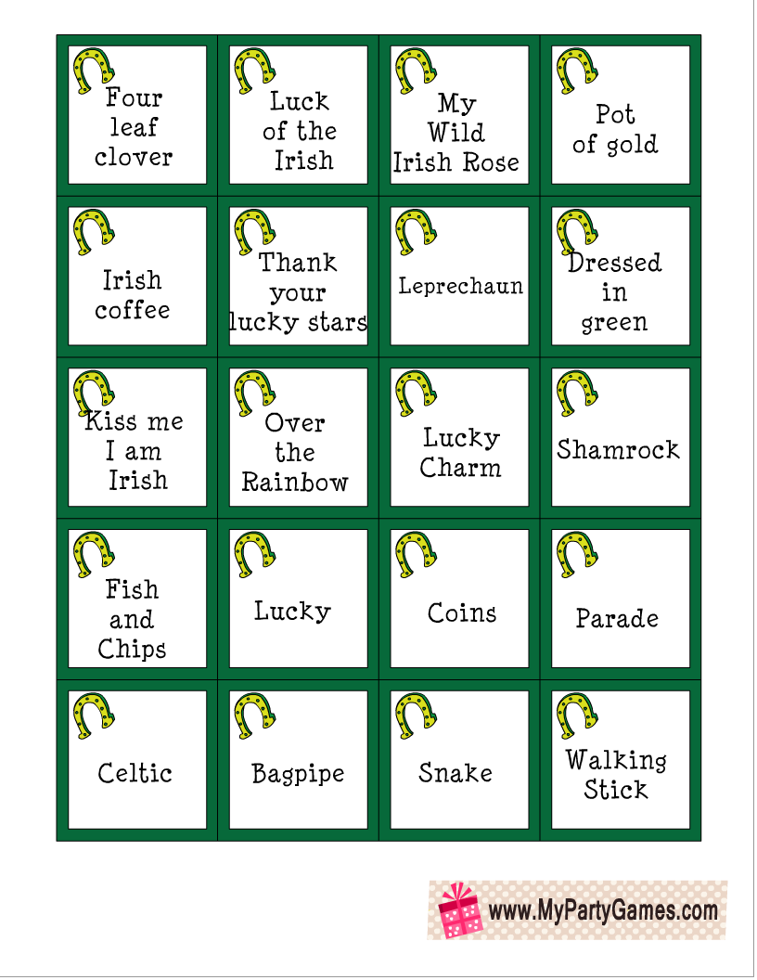

**St Patricks Day Scavenger Hunt!**

**How many can you get?**

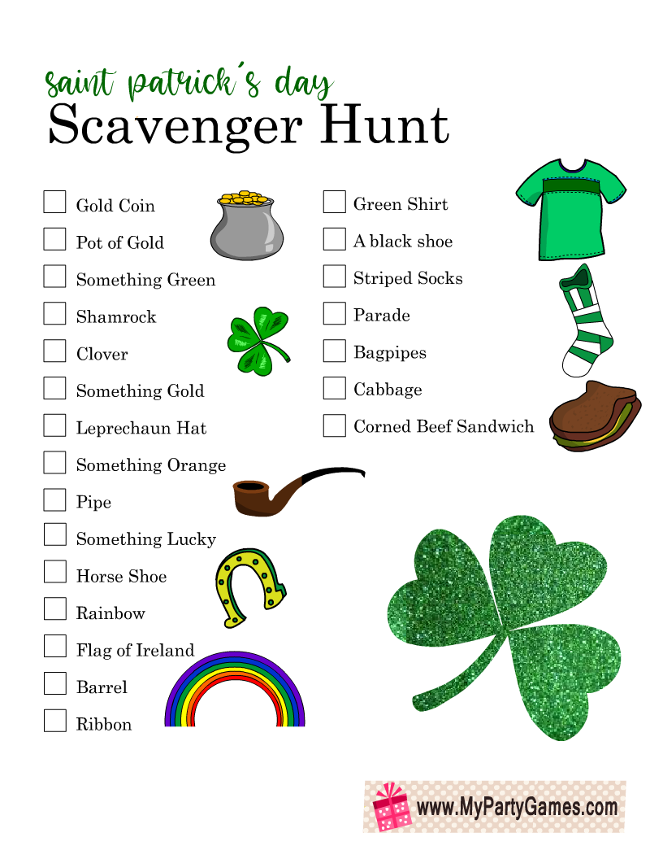

**Irish Proverbs and Their Meanings!**

**Fill in the blanks**

1. **Proverb: "May the road rise up to meet you."**
   * Meaning: Wishing someone a safe and prosperous journey in life.
   * Saying: "May your path always be ______ and filled with good fortune."
2. **Proverb: "There's no need to fear the wind if your haystacks are tied down."**
   * Meaning: Be prepared and secure in your plans, and you won't need to worry about unforeseen challenges.
   * Saying: "With proper preparation, you can face any ______ that comes your way."
3. **Proverb: "A good laugh and a long sleep are the two best cures."**
   * Meaning: Laughter and rest have healing powers.
   * Saying: "Take time for joy and rest; it's the best ______ for the soul."
4. **Proverb: "A watched pot never ______."**
   * Meaning: Time seems to move slower when you're waiting for something.
   * Saying: "Patience is key; things happen in their own ______."
5. **Proverb: "If you want praise, die. If you want blame, ______."**
   * Meaning: Life can bring both praise and criticism, and relationships often come with challenges.
   * Saying: "Every stage of life has its ups and ______; embrace them all."
6. **Proverb: "Your feet will bring you to where your ______ is."**
   * Meaning: Follow your passions; they will guide you to your true destination.
   * Saying: "Listen to your ______; it knows the way."
7. **Proverb: "You'll never plough a field by turning it over in your ______."**
   * Meaning: Action is necessary to achieve your goals; just thinking about it won't get things done.
   * Saying: "Stop ______ and start doing."
8. **Proverb: "It's a long road that has no ______."**
   * Meaning: There is always hope or opportunity, even in difficult situations.
   * Saying: "No matter how tough it gets, there's always a chance for things to ______."
9. **Proverb: "An old broom knows the ______ corners best."**
   * Meaning: Experience brings wisdom and insight.
   * Saying: "Respect the wisdom that comes with ______."
10. **Proverb: "The light heart ______ long."**
    * Meaning: A cheerful and optimistic outlook contributes to a longer, happier life.
    * Saying: "Find joy in the little things; it adds years to your ______."

**Oh Danny Boy!**

**By the Celtic Woman**

Oh, Danny boy, the pipes, the pipes are calling  
From glen to glen, and down the mountain side.  
The summer's gone, and all the roses falling,  
It's you, it's you must go and I must bide.

But come ye back when summer's in the meadow,  
Or when the valley's hushed and white with snow,  
It's I'll be here in sunshine or in shadow,  
Oh, Danny boy, oh Danny boy, I love you so!

But when ye come, and all the flowers are dying,  
If I am dead, as dead I well may be,  
You'll come and find the place where I am lying,  
And kneel and say an Ave there for me.  
And I shall hear, though soft you tread above me,  
And all my grave will warmer, sweeter be,  
For you will bend and tell me that you love me,  
And I shall sleep in peace until you come to me!

**The Lake Isle of Innisfree**

**By W.B Yeates**

I will arise and go now, and go to Innisfree,

And a small cabin build there, of clay and wattles made:

Nine bean-rows will I have there, a hive for the honey-bee;

And live alone in the bee-loud glade.

And I shall have some peace there, for peace comes dropping slow,

Dropping from the veils of the morning to where the cricket sings;

There midnight's all a glimmer, and noon a purple glow,

And evening full of the linnet's wings.

I will arise and go now, for always night and day

I hear lake water lapping with low sounds by the shore;

While I stand on the roadway, or on the pavements gray,

I hear it in the deep heart's core.

**The Children of Lir:**

Once upon a time in ancient Ireland, there lived a king named Lir and his wife, Eva. They had four children – three sons named Aodh, Fiachra, and Conn, and a daughter named Fionnuala. After Eva passed away, Lir married again, but his new wife, Aoife, was jealous of the love he had for his children.

Aoife couldn't bear the sight of the children's happiness, so she cast a spell on them, turning them into swans. The spell would last for 900 years – 300 years on Lough Derravaragh, 300 on the Sea of Moyle, and 300 on the Isle of Glora.

As swans, the children retained their human minds and memories, singing beautiful and haunting songs.

Their father, King Lir, heartbroken by the enchantment on his children, searched for them but could not break the spell.

One day, a saint named Mochaomhóg arrived and blessed the swans, lessening the impact of the spell. The swans regained their human voices while remaining in swan form.

After 900 years, the swans' spell was broken. They transformed back into their human selves but aged instantly, becoming elderly. Fionnuala, the sister, was left alone as her brothers passed away. The story ends with Fionnuala transformed into a swan once more, joining her brothers in the afterlife.

**Spraying the Potatoes by Patrick Kavanagh**

The barrels of blue potato-spray

Stood on a headland in July

Beside an orchard wall where roses

Were young girls hanging from the sky.

The flocks of green potato stalks

Were blossom spread for sudden flight,

The Kerr’s Pinks in frivelled blue,

The Arran Banners wearing white.

And over that potato-field

A lazy veil of woven sun,

Dandelions growing on headlands, showing

Their unloved hearts to everyone.

And I was there with a knapsack sprayer

On the barrel’s edge poised. A wasp was floating

Dead on a sunken briar leaf

Over a copper-poisoned ocean.

The axle-roll of a rut-locked cart

Broke the burnt stick of noon in two.

An old man came through a cornfield

Remembering his youth and some Ruth he knew.

He turned my way. ‘God further the work’.

He echoed an ancient farming prayer.

I thanked him. He eyed the potato drills.

He said: ‘You are bound to have good ones there’.

We talked and our talk was a theme of kings,

A theme for strings. He hunkered down

In the shade of the orchard wall. O roses

The old man dies in the young girl’s frown.

And poet lost to potato-fields,

Remembering the lime and copper smell

Of the spraying barrels he is not lost

Or till blossomed stalks cannot weave a spell.

**A Pint of Plain is Your Only Man by Brian O’Neill**

When things go wrong and will not come right,

Though you do the best you can,

When life looks black as the hour of night –

A pint of plain is your only man.

When money’s tight and hard to get

And your horse has also ran,

When all you have is a heap of debt –

A pint of plain is your only man.

When health is bad and your heart feels strange,

And your face is pale and wan,

When doctors say you need a change,

A pint of plain is your only man.

When food is scarce and your larder bare

And no rashers grease your pan,

When hunger grows as your meals are rare –

A pint of plain is your only man.

In time of trouble and lousey strife,

You have still got a darlint plan

You still can turn to a brighter life –

A pint of plain is your only man.

**What is Pink? By Christina Rossetti**

What is pink? A rose is pink

By the fountain's brink.

What is red? A poppy's red

In its barley bed.

What is blue? The sky is blue

Where the clouds float through.

What is white? A swan is white

Sailing in the light.

What is yellow? Pears are yellow,

Rich and ripe and mellow.

What is green? The grass is green,

With small flowers between.

What is violet? Clouds are violet

In the summer twilight.

What is orange? Why, an orange,

Just an orange!

(take time to look at the items around you – can you find something for each colour mentioned in the poem?

**St. Patricks Day Pictures to Colour**

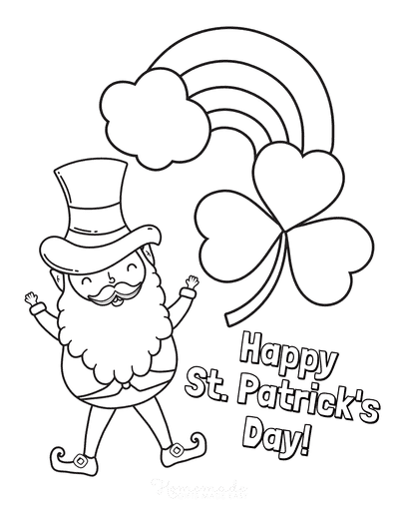

**"Get to Know Me: Irish Edition"**

**Instructions:**

1. Each participant is given a personalized game card with questions related to their interests and memories.
2. Facilitators or fellow participants can ask these questions, sparking conversations and shared memories.
3. Encourage participants to share their thoughts, feelings, and experiences related to each question.
4. Make it a collaborative and supportive atmosphere, focusing on the joy of reminiscing.

**Game Card:**

1. **Place of Birth:**
   * Where were you born, and do you have any fond memories of your hometown?
2. **Favourite Irish Memory:**
   * Share a special memory related to Ireland. It could be a trip, a celebration, or a personal moment.
3. **Favourite Irish Dish:**
   * What is your favourite traditional Irish food? Have you ever tried cooking it?
4. **Irish Music Memories:**
   * Name a favourite Irish song or musician. Does this music bring back any specific memories?
5. **Favourite Irish Landscape:**
   * Do you have a favourite Irish scenery or landmark? Share any stories or experiences related to it.
6. **Irish Family Traditions:**
   * Are there any Irish traditions your family followed or any special customs you remember?
7. **Irish Weather Memories:**
   * What memories do you have of Irish weather? Does a particular season or type of weather stand out?
8. **Favourite Irish Saying:**
   * Share an Irish saying or proverb that you like. What does it mean to you?
9. **Irish Literature or Poetry:**
   * Name a favourite Irish author, book, or poem. What resonates with you about their work?
10. **Irish Dance Memories:**
    * Have you ever participated in or watched traditional Irish dancing? Share any memories.

**A Springtime Meditation**

With Spring right around the corner, we’re focusing

on this season’s sense of renewal and personal improvement.

Lie down and allow your body to become very

comfortable. Close your eyes now and begin to pay

attention to how your breath flows in and out of

your body.

Spring is coming soon. This is a new and fresh season

And is a good time to make room for new wonderful

things to happen in your life. Remember that you

are growing and changing each day! Every season

brings a new you. Think about how during the

winter months certain flowers disappear only to

come back to life stronger during the spring time.

Imagine yourself now being a flower, ready to

sprout from the flower bulb.

As spring approaches, the rains fall from the

heavens and you soak up the water completely. It

renews you and gently wakes you up. Notice how

you look forward to feeling the beautiful warmth

of the sun once again. Now you break through the

bulb and start to grow into the beautiful, bright,

proud flower that you are becoming.

This is much like how it is in life. We choose new

goals or things to strive for, and work towards those

which makes us feel amazing and good each and

every day. We always strive to show the best in ourselves

and to be the best we can possibly be.

Think about something new that you’d like to do or

achieve, or something you’d like to improve upon

in your life right now. What is it that you’d like to be

able to do better? Focus on that for a moment now

and imagine yourself growing and learning and

becoming better at that exact thing.

See yourself being perfect at whatever it is that you

wish to do. See it your mind as already being real

and true.

Feel your heart welling

up because of your achievement. This is what you

set your mind to, what you focused on. Because

of your focus and your effort to improve yourself

each and every day and because you BELIEVE IN

YOURSELF, you have made it happen!

Just as a flower comes back stronger each and every

spring, you do too. When you’re ready,

give your body a big stretch and open your eyes

