**March**

**Activity Pack 2**

Dear Friends,

As we step into March 2024, the winds of change sweep across the landscape, marking the arrival of brighter evenings and the blossoming of daffodils. This month beckons us into a time where morning and evening walks become more inviting, offering a promise of warmth and rejuvenation.

In celebration of the Irish spirit and the approaching season, our curated pack embraces all things Ireland. The weather is turning milder, the days are growing longer, and the vibrant Irish culture takes centre stage.

Immerse yourself in the beauty of Irish artwork, poems, and the charm of St. Patrick's Day festivities.

So, let's embrace the changing season, revel in the Irish spirit, and embark on a journey through art and culture. Here's to March – a time when the evenings grow brighter, flowers blooming, chats with friends and the allure of Irish traditions fills the air.

Slán Go Fóill!

Top of Form



**"March winds and April showers bring forth May flowers."**

**Irish Proverb**

**Useful Resources:**

* Our Free Helpline and Dementia Support Line are available at: Phone: 1800 341 341 and Email: helpline@alzheimer.ie
* The ASI now also has a new online Virtual Dementia Hub where you can go for a full range of activities – you can even listen to some wonderful poetry and songs recorded especially. Just go to [www.virtualdementiahub.ie](http://www.virtualdementiahub.ie)
* We are hosting a number of Virtual Cafes. They are a place to come together, share a cuppa and listen to our amazing guest speakers. For information on how to attend visit: <https://alzheimer.ie/service/alzheimer-cafe/>
* The ASI also have a huge library of factsheets and resources available on: <https://alzheimer.ie/get-support/resources-and-factsheets/>
* For musical videos and resources Music For Dementia are a wonderful resource: <https://musicfordementia.org.uk/>
* The Irish Museum of Modern Art (IMMA) have a huge collection available to view online at: <https://imma.ie/collection/>
* Emergency Response Numbers: 999 or 112 9. HSE 24/7 Your Mental Health Information Helpline: 1800 111 888
* Emergency Response Numbers: 999 or 112

**Table of Contents**

|  |  |
| --- | --- |
| *Activity* | *Pages* |
| All things Green Wordsearch | **5** |
| St Patrick’s Word Search | **6** |
| Help the Bird Find Her Nest | **7** |
| Irish Crossword | **8** |
| Irish Soda Bread Recipe | **9** |
| Irish Short Bread Cookies Recipe | **10** |
| The Legend of St Patrick | **11-12** |
| iSpy | **13** |
| How Many Words Can You Find | **14** |
| Irish Trivia Quiz | **15-17** |
| Let’s Play Pictionary | **18** |
| The Fields of Athenry by The Dubliners | **19** |
| Let’s Make Leprechaun Hats | **20** |
| St Patrick’s Day Scavenger Hunt | **21** |
| Irish Proverbs and Their Meanings | **22-23** |
| Oh Danny Boy by the Celtic Woman | **24** |
| The Lake Isle of Innisfree by W.B Yeats | **25** |
| A Pint of Plain is Your Only Man by Brian O’Neill | **26** |
| What is Pink? By Christina Rossetti | **27** |
| Pictures to Colour | **28-32** |
| Get to Know Me | **33** |
| A Spring Time Meditation | **34-35** |

**All Things Green Wordsearch**

|  |  |  |  |  |  |  |  |  |  |  |  |  |  |  |  |  |  |  |  |  |  |  |  |  |  |  |  |  |  |  |  |  |  |  |  |  |  |  |  |  |  |  |  |  |  |  |  |  |  |  |  |  |  |  |  |  |  |  |  |  |  |  |  |  |  |  |  |  |  |  |  |  |  |  |  |  |  |  |  |  |  |  |  |  |  |  |  |  |  |  |  |  |  |  |  |  |  |  |  |  |  |  |  |  |  |  |  |  |  |  |  |  |  |  |  |  |  |  |  |  |  |  |  |  |  |  |  |  |  |  |  |  |  |  |  |  |  |  |  |  |  |  |  |  |  |  |  |  |  |  |  |  |  |  |  |  |  |  |  |  |  |  |  |  |  |  |  |  |  |  |  |  |  |  |  |  |  |  |  |  |  |  |  |  |  |  |  |  |  |  |  |  |  |  |  |  |  |  |  |  |  |  |  |  |  |  |  |  |  |  |  |  |  |  |  |  |  |  |  |  |  |  |  |  |  |  |  |  |  |  |  |  |  |  |  |  |  |  |  |  |  |  |  |
| --- | --- | --- | --- | --- | --- | --- | --- | --- | --- | --- | --- | --- | --- | --- | --- | --- | --- | --- | --- | --- | --- | --- | --- | --- | --- | --- | --- | --- | --- | --- | --- | --- | --- | --- | --- | --- | --- | --- | --- | --- | --- | --- | --- | --- | --- | --- | --- | --- | --- | --- | --- | --- | --- | --- | --- | --- | --- | --- | --- | --- | --- | --- | --- | --- | --- | --- | --- | --- | --- | --- | --- | --- | --- | --- | --- | --- | --- | --- | --- | --- | --- | --- | --- | --- | --- | --- | --- | --- | --- | --- | --- | --- | --- | --- | --- | --- | --- | --- | --- | --- | --- | --- | --- | --- | --- | --- | --- | --- | --- | --- | --- | --- | --- | --- | --- | --- | --- | --- | --- | --- | --- | --- | --- | --- | --- | --- | --- | --- | --- | --- | --- | --- | --- | --- | --- | --- | --- | --- | --- | --- | --- | --- | --- | --- | --- | --- | --- | --- | --- | --- | --- | --- | --- | --- | --- | --- | --- | --- | --- | --- | --- | --- | --- | --- | --- | --- | --- | --- | --- | --- | --- | --- | --- | --- | --- | --- | --- | --- | --- | --- | --- | --- | --- | --- | --- | --- | --- | --- | --- | --- | --- | --- | --- | --- | --- | --- | --- | --- | --- | --- | --- | --- | --- | --- | --- | --- | --- | --- | --- | --- | --- | --- | --- | --- | --- | --- | --- | --- | --- | --- | --- | --- | --- | --- | --- | --- | --- | --- | --- | --- | --- | --- | --- | --- | --- | --- | --- | --- | --- | --- | --- | --- | --- |
| |  |  |  |  |  |  |  |  |  |  |  |  |  |  |  |  |  |  |  |  |  |  |  |  |  |  |  |  |  |  |  |  |  |  |  |  |  |  |  |  |  |  |  |  |  |  |  |  |  |  |  |  |  |  |  |  |  |  |  |  |  |  |  |  |  |  |  |  |  |  |  |  |  |  |  |  |  |  |  |  |  |  |  |  |  |  |  |  |  |  |  |  |  |  |  |  |  |  |  |  |  |  |  |  |  |  |  |  |  |  |  |  |  |  |  |  |  |  |  |  |  |  |  |  |  |  |  |  |  |  |  |  |  |  |  |  |  |  |  |  |  |  |  |  |  |  |  |  |  |  |  |  |  |  |  |  |  |  |  |  |  |  |  |  |  |  |  |  |  |  |  |  |  |  |  |  |  |  |  |  |  |  |  |  |  |  |  |  |  |  |  |  |  |  |  |  |  |  |  |  |  |  |  |  |  |  |  |  |  |  |  |  |  |  |  |  |  |  |  |  |  |  |  |  |  |  |  |  |  |  |  |  |  |  |  |  |  |  |  |  |  | | --- | --- | --- | --- | --- | --- | --- | --- | --- | --- | --- | --- | --- | --- | --- | --- | --- | --- | --- | --- | --- | --- | --- | --- | --- | --- | --- | --- | --- | --- | --- | --- | --- | --- | --- | --- | --- | --- | --- | --- | --- | --- | --- | --- | --- | --- | --- | --- | --- | --- | --- | --- | --- | --- | --- | --- | --- | --- | --- | --- | --- | --- | --- | --- | --- | --- | --- | --- | --- | --- | --- | --- | --- | --- | --- | --- | --- | --- | --- | --- | --- | --- | --- | --- | --- | --- | --- | --- | --- | --- | --- | --- | --- | --- | --- | --- | --- | --- | --- | --- | --- | --- | --- | --- | --- | --- | --- | --- | --- | --- | --- | --- | --- | --- | --- | --- | --- | --- | --- | --- | --- | --- | --- | --- | --- | --- | --- | --- | --- | --- | --- | --- | --- | --- | --- | --- | --- | --- | --- | --- | --- | --- | --- | --- | --- | --- | --- | --- | --- | --- | --- | --- | --- | --- | --- | --- | --- | --- | --- | --- | --- | --- | --- | --- | --- | --- | --- | --- | --- | --- | --- | --- | --- | --- | --- | --- | --- | --- | --- | --- | --- | --- | --- | --- | --- | --- | --- | --- | --- | --- | --- | --- | --- | --- | --- | --- | --- | --- | --- | --- | --- | --- | --- | --- | --- | --- | --- | --- | --- | --- | --- | --- | --- | --- | --- | --- | --- | --- | --- | --- | --- | --- | --- | --- | --- | --- | --- | --- | --- | --- | --- | --- | --- | --- | --- | --- | --- | --- | --- | --- | --- | | |  |  |  |  |  |  |  |  |  |  |  |  |  |  |  | | --- | --- | --- | --- | --- | --- | --- | --- | --- | --- | --- | --- | --- | --- | --- | | G | I | R | F | B | S | E | A | W | E | E | D | D | P | R | | U | D | Y | C | Z | F | X | T | O | X | Q | C | V | M | T | | I | G | U | A | N | A | P | P | L | E | C | M | T | B | W | | L | U | M | G | N | W | J | H | H | T | W | N | A | N | Q | | V | H | L | C | C | J | A | F | R | O | G | B | R | F | R | | M | M | I | A | U | N | D | L | E | W | O | E | L | O | S | | B | H | M | T | C | E | E | E | L | D | E | T | N | P | C | | U | R | E | E | U | B | Z | A | X | L | A | P | M | E | M | | D | T | Y | R | M | Y | O | V | Y | S | M | A | S | A | Z | | G | C | Z | P | B | I | R | E | L | A | N | D | U | R | L | | I | Z | C | I | E | Y | L | S | Q | W | I | L | Y | N | R | | E | H | G | L | R | L | E | E | E | F | U | O | K | U | Q | | U | S | M | L | C | A | W | E | K | T | E | A | F | T | C | | W | T | S | A | O | M | Y | O | U | L | W | H | F | N | V | | G | L | C | R | Y | P | E | P | P | E | R | M | I | N | T | |  |  |  |  |  |  |  |  |  |  |  |  |  |  |  | | | |  | | --- | | APPLE BUDGIE CATERPILLAR CUCUMBER FROG IGUANA IRELAND JADE LEAVES LIME PEAR PEPPERMINT SEAWEED TEA | | |

**Help the Bird to Find Her Nest!**



**Irish Soda Bread Recipe:**

**Ingredients:**

**1.** 4 cups flour

**2.** 1 1/2 teaspoons baking soda

**3.** 1 teaspoon salt

**4.** 1 3/4 cups buttermilk

**INSTRUCTIONS:**

**1.** Preheat the oven to 425 degrees. Grease and flour a 9-inch round cake pan.

**2.** In a large bowl, combine the flour, baking soda and salt. Gradually stir in the

buttermilk until the dough comes together in a slightly sticky ball.

**3.** Turn dough onto a floured surface and knead gently a few times. Form the

dough into a ball and then press into the prepared pan so that the dough

resembles a large disk. The dough should reach the edges of the pan, but

may spring back slightly.

**4.** Cut an X into the dough with a sharp knife, about 1/4 of an inch deep. Cover

the pan of dough with another round cake pan turned upside down.

**5.** Bake for 25-30 minutes, covered, then remove the top pan and bake

uncovered for about 10 minutes more or until the crust is dark golden brown.

**Irish Shortbread Cookies**

**Ingredients:**

* 1 cup unsalted butter, softened
* 1/2 cup granulated sugar
* 2 cups all-purpose flour
* 1/4 cup cornstarch
* Pinch of salt

**Instructions:**

1. Preheat the oven to 325°F (163°C). Line a baking sheet with parchment paper.
2. In a large bowl, cream together the softened butter and sugar until light and fluffy.
3. Sift the flour, cornstarch, and salt into the bowl. Mix until well combined.
4. Roll the dough into small balls and place them on the prepared baking sheet, leaving space between each.
5. Use a fork to gently press down on each cookie, creating a pattern on the top.
6. Bake in the preheated oven for 12-15 minutes or until the edges are lightly golden.
7. Allow the shortbread cookies to cool on the baking sheet for a few minutes before transferring them to a wire rack to cool completely.

***The Legend of St Patrick:***

*The history of St Patrick, the patron saint of Ireland who was born in the*

*second half of the 4th century, is inevitably sketchy. Even his year of birth*

*is uncertain, with some scholars hitting on 373 while others calculate 390.*

*Similarly, the place where St Patrick was born cannot be confirmed.*

*It is known that he was raised near a village called Banna Vemta Burniae*

*but its location cannot be identified. It may have been lowland Scotland*

*but is equally likely to have been Wales, which was under Roman control*

*at the time.*

*Patrick's real name was probably Maewyn Succat. His father, Calpornius,*

*was a Roman-British army officer and a deacon.*

*Despite this family involvement in the church, the young Patrick was not a*

*believer. His life was ordinary, and completely unexceptional, until the*

*age of 16. But dramatic events then occurred which set the history of St*

*Patrick, and the history of Ireland, on a new course.*

*The young lad was kidnapped, along with many others, by Irish pirates*

*and sold into slavery in Ireland. According to his autobiographical*

*Confessio, which survives, the next six years were spent imprisoned in*

*the north of the island and he worked as a herdsmen of sheep and pigs*

*on Mount Slemish in Co. Antrim.*

*During this period, he became increasingly religious. He considered his*

*kidnapping and imprisonment as a punishment for his lack of faith and*

*spent a lot of time in prayer.*

*After a vision led him to stow away on a boat bound for Britain, Patrick*

*escaped back to his family.*

21

*There he had a dream that the Irish were calling him back to Ireland to*

*tell them about God. This inspired him to return to Ireland as a priest, but*

*not immediately. At this point he didn't feel adequately prepared for a life*

*as a missionary. His studies took him to France where he was trained in a*

*monastery, possibly under St Germain, the bishop of Auxerre, and he*

*dedicated this period of his life to learning. It was some 12 years before*

*he returned to Irish shores as a bishop sent with the Pope's blessing.*

*The next chapter of the history of St Patrick is better known than his*

*earlier life. He landed at Strangford Loch, Co. Down. Although he is often*

*credited with having brought Christianity to Ireland, he was not the first*

*to have done so.*

*An earlier mission had seen Palladius preach to the Irish.*

*Of course, it wasn't all plain sailing. The history of St Patrick is littered*

*with periods of imprisonment when his teachings had upset local*

*chieftains or Celtic Druids, but he always escaped or gained freedom by*

*presenting his captors with gifts.*

*For twenty years he travelled the length and breadth of the island,*

*baptising people and establishing monasteries, schools and churches as*

*he went.*

*By the time he died, on 17 March 461 (or 493, depending on which date*

*you started your calculation), he left behind an organised church, the see*

*of Armagh, and an island of Christians. This date – 17 March – has been*

*commemorated as St Patrick's Day ever since.*

*He was buried either in Downpatrick, Co Down, or in Armagh.*

**iSpy:**

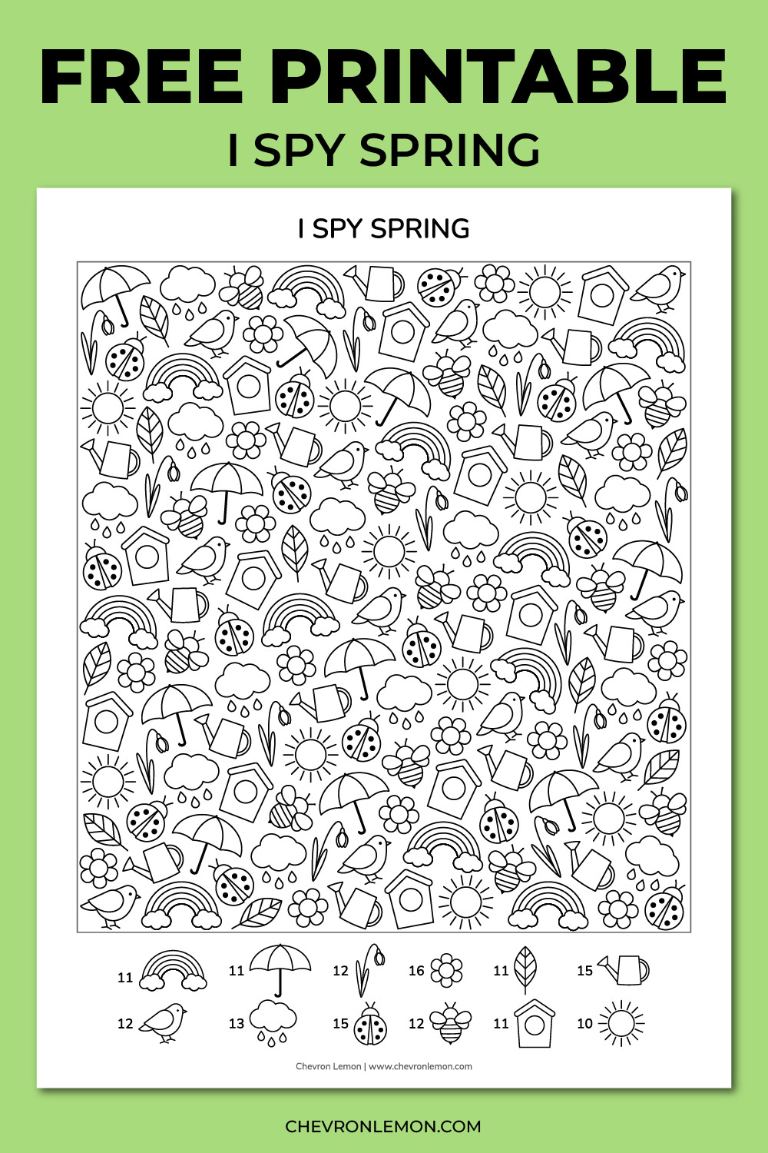

**Irish Trivia Quiz**

1. **Which mythical creature is said to guard the pot of gold at the end of the rainbow in Irish folklore?**
   * A) Elf
   * B) Leprechaun
   * C) Banshee
   * D) Goblin
2. **What is the traditional Irish bread made with buttermilk and baking soda?**
   * A) Baguette
   * B) Brioche
   * C) Soda Bread
   * D) Rye Bread
3. **In Irish mythology, who is the goddess of love and fertility?**
   * A) Morrigan
   * B) Aine
   * C) Brigid
   * D) Danu
4. **Which Irish city is known for its medieval architecture, including the Rock of Cashel?**
   * A) Cork
   * B) Limerick
   * C) Kilkenny
   * D) Galway
5. **What is the traditional Irish instrument known as the "tin whistle" also called?**
   * A) Fiddle
   * B) Bodhrán
   * C) Uilleann Pipes
   * D) Penny Whistle
6. **What is the name of the famous beer that originated in Dublin, Ireland?**
   * A) Guinness
   * B) Smithwick's
   * C) Harp
   * D) Kilkenny
7. **Which Irish poet won the Nobel Prize in Literature in 1923?**
   * A) W.B. Yeats
   * B) Seamus Heaney
   * C) Samuel Beckett
   * D) Oscar Wilde
8. **What is the traditional Irish dance with fast footwork and a rigid upper body posture?**
   * A) Jig
   * B) Hornpipe
   * C) Reel
   * D) Step Dance
9. **In Irish mythology, what is the name of the high king of the Tuatha Dé Danann?**
   * A) Dagda
   * B) Lugh
   * C) Nuada
   * D) Balor
10. **Which famous Irish rock band is known for hits like "With or Without You" and "I Still Haven't Found What I'm Looking For"?**
    * A) The Cranberries
    * B) U2
    * C) Thin Lizzy
    * D) The Script

**Answers:**

1. B) Leprechaun
2. C) Soda Bread
3. B) Aine
4. C) Kilkenny
5. D) Penny Whistle
6. A) Guinness
7. A) W.B. Yeats
8. A) Jig
9. C) Nuada
10. B) U2

**Lets Play Pictionary!**

Two whiteboards or something else to draw on is required. Each team will select a player to draw. When the timer starts, both players will start drawing at the same time and the team to guess the word first wins the point.

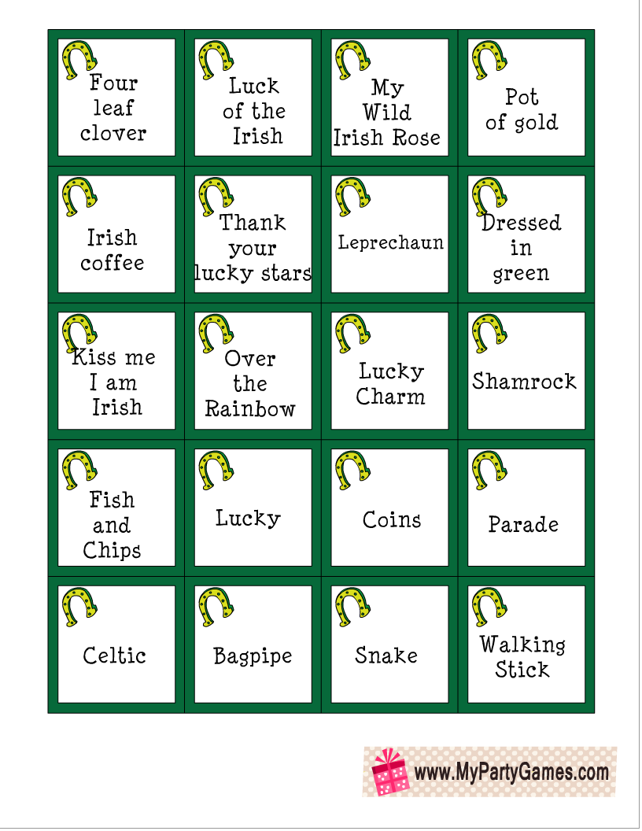

**The Fields of Athenry**

**By The Dubliners:**

By a lonely prison wall  
I heard a young girl calling  
"Michael, they have taken you away  
For you stole Trevelyan's corn  
So the young might see the morn  
Now a prison ship lies waiting in the bay"

Low lie the fields of Athenry  
Where once we watched the small free birds fly  
Our love was on the wing we had dreams and songs to sing  
It's so lonely 'round the fields of Athenry

By a lonely prison wall  
I heard a young man calling  
"Nothing matters, Mary, when you're free  
Against the famine and the crown  
I rebelled, they cut me down  
Now you must raise our child with dignity"

Low lie the fields of Athenry  
Where once we watched the small free birds fly  
Our love was on the wing we had dreams and songs to sing  
It's so lonely 'round the fields of Athenry

By a lonely harbour wall  
She watched the last star falling  
As that prison ship sailed out against the sky  
For she lived in hope and pray  
For her love in Botany Bay  
It's so lonely 'round the fields of Athenry

Low lie the fields of Athenry  
Where once we watched the small free birds fly  
Our love was on the wing we had dreams and songs to sing  
It's so lonely 'round the fields of Athenry

**Let’s Make Leprechaun Hats!**

**Materials:**

1. Construction Paper:
   * Green and black construction paper (or any other colours you prefer).
2. Scissors:
   * Ensure they are safe and easy to handle.
3. Glue Stick:
   * A glue stick is easier to manage than liquid glue.
4. Ruler:
   * A small ruler for measuring and drawing straight lines.
5. Pencil:
   * A pencil for tracing and marking.

**Instructions:**

**Step 1:** Cut the Construction Paper

* Cut a strip of green construction paper, approximately 2 inches in width, and long enough to fit around the person's head comfortably.
* Cut a large circle out of green construction paper for the brim of the hat. You can use a round object as a template to trace the circle.

**Step 2:** Decorate the Hat

* Cut out a black buckle shape from the black construction paper. This will be the leprechaun hat buckle.
* Glue the buckle onto the green strip, near the front, to create the hatband.

**Step 3:** Form the Hat

* Connect the ends of the green strip to form a circle and secure it with glue, creating the main part of the hat.
* Glue the large green circle onto the top of the hat, making sure it's centred.

**Step 4:** Personalize the Hat (Optional)

* Encourage participants to add their own personal touch to the hat. They can use markers to draw additional decorations or write their names.

**Step 5:** Adjust to Fit

* Once the glue is dry, adjust the size of the hat by gently bending or shaping it to comfortably fit the person's head.

**Step 6:** Wear with Pride!

* Invite participants to wear their handmade leprechaun hats with pride, celebrating St. Patrick's Day in style.

**St Patricks Day Scavenger Hunt!**

**How many can you get?**

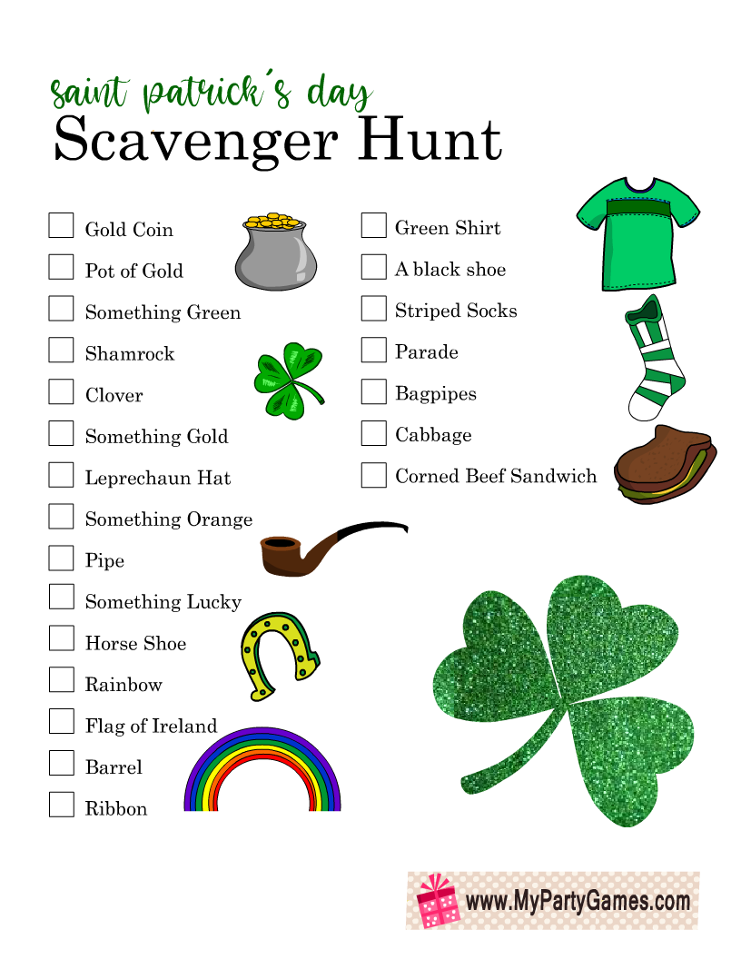

**Irish Proverbs and Their Meanings!**

**Fill in the blanks**

1. **Proverb: "May the road rise up to meet you."**
   * Meaning: Wishing someone a safe and prosperous journey in life.
   * Saying: "May your path always be ______ and filled with good fortune."
2. **Proverb: "There's no need to fear the wind if your haystacks are tied down."**
   * Meaning: Be prepared and secure in your plans, and you won't need to worry about unforeseen challenges.
   * Saying: "With proper preparation, you can face any ______ that comes your way."
3. **Proverb: "A good laugh and a long sleep are the two best cures."**
   * Meaning: Laughter and rest have healing powers.
   * Saying: "Take time for joy and rest; it's the best ______ for the soul."
4. **Proverb: "A watched pot never ______."**
   * Meaning: Time seems to move slower when you're waiting for something.
   * Saying: "Patience is key; things happen in their own ______."
5. **Proverb: "If you want praise, die. If you want blame, ______."**
   * Meaning: Life can bring both praise and criticism, and relationships often come with challenges.
   * Saying: "Every stage of life has its ups and ______; embrace them all."
6. **Proverb: "Your feet will bring you to where your ______ is."**
   * Meaning: Follow your passions; they will guide you to your true destination.
   * Saying: "Listen to your ______; it knows the way."
7. **Proverb: "You'll never plough a field by turning it over in your ______."**
   * Meaning: Action is necessary to achieve your goals; just thinking about it won't get things done.
   * Saying: "Stop ______ and start doing."
8. **Proverb: "It's a long road that has no ______."**
   * Meaning: There is always hope or opportunity, even in difficult situations.
   * Saying: "No matter how tough it gets, there's always a chance for things to ______."
9. **Proverb: "An old broom knows the ______ corners best."**
   * Meaning: Experience brings wisdom and insight.
   * Saying: "Respect the wisdom that comes with ______."
10. **Proverb: "The light heart ______ long."**
    * Meaning: A cheerful and optimistic outlook contributes to a longer, happier life.
    * Saying: "Find joy in the little things; it adds years to your ______."

**Oh Danny Boy!**

**By the Celtic Woman**

Oh, Danny boy, the pipes, the pipes are calling  
From glen to glen, and down the mountain side.  
The summer's gone, and all the roses falling,  
It's you, it's you must go and I must bide.

But come ye back when summer's in the meadow,  
Or when the valley's hushed and white with snow,  
It's I'll be here in sunshine or in shadow,  
Oh, Danny boy, oh Danny boy, I love you so!

But when ye come, and all the flowers are dying,  
If I am dead, as dead I well may be,  
You'll come and find the place where I am lying,  
And kneel and say an Ave there for me.  
And I shall hear, though soft you tread above me,  
And all my grave will warmer, sweeter be,  
For you will bend and tell me that you love me,  
And I shall sleep in peace until you come to me!

**The Lake Isle of Innisfree**

**By W.B Yeates**

I will arise and go now, and go to Innisfree,

And a small cabin build there, of clay and wattles made:

Nine bean-rows will I have there, a hive for the honey-bee;

And live alone in the bee-loud glade.

And I shall have some peace there, for peace comes dropping slow,

Dropping from the veils of the morning to where the cricket sings;

There midnight's all a glimmer, and noon a purple glow,

And evening full of the linnet's wings.

I will arise and go now, for always night and day

I hear lake water lapping with low sounds by the shore;

While I stand on the roadway, or on the pavements gray,

I hear it in the deep heart's core.

**A Pint of Plain is Your Only Man by Brian O’Neill**

When things go wrong and will not come right,

Though you do the best you can,

When life looks black as the hour of night –

A pint of plain is your only man.

When money’s tight and hard to get

And your horse has also ran,

When all you have is a heap of debt –

A pint of plain is your only man.

When health is bad and your heart feels strange,

And your face is pale and wan,

When doctors say you need a change,

A pint of plain is your only man.

When food is scarce and your larder bare

And no rashers grease your pan,

When hunger grows as your meals are rare –

A pint of plain is your only man.

In time of trouble and lousey strife,

You have still got a darlint plan

You still can turn to a brighter life –

A pint of plain is your only man.

**What is Pink? By Christina Rossetti**

What is pink? A rose is pink

By the fountain's brink.

What is red? A poppy's red

In its barley bed.

What is blue? The sky is blue

Where the clouds float through.

What is white? A swan is white

Sailing in the light.

What is yellow? Pears are yellow,

Rich and ripe and mellow.

What is green? The grass is green,

With small flowers between.

What is violet? Clouds are violet

In the summer twilight.

What is orange? Why, an orange,

Just an orange!

(take time to look at the items around you – can you find something for each colour mentioned in the poem?

**St. Patricks Day Pictures to Colour**

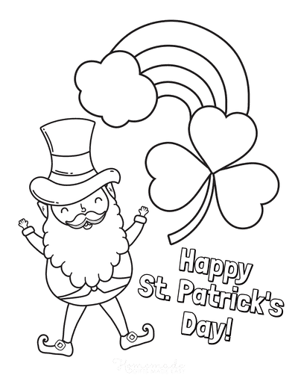

**"Get to Know Me: Irish Edition"**

**Instructions:**

1. Each participant is given a personalized game card with questions related to their interests and memories.
2. Facilitators or fellow participants can ask these questions, sparking conversations and shared memories.
3. Encourage participants to share their thoughts, feelings, and experiences related to each question.
4. Make it a collaborative and supportive atmosphere, focusing on the joy of reminiscing.

**Game Card:**

1. **Place of Birth:**
   * Where were you born, and do you have any fond memories of your hometown?
2. **Favourite Irish Memory:**
   * Share a special memory related to Ireland. It could be a trip, a celebration, or a personal moment.
3. **Favourite Irish Dish:**
   * What is your favourite traditional Irish food? Have you ever tried cooking it?
4. **Irish Music Memories:**
   * Name a favourite Irish song or musician. Does this music bring back any specific memories?
5. **Favourite Irish Landscape:**
   * Do you have a favourite Irish scenery or landmark? Share any stories or experiences related to it.
6. **Irish Family Traditions:**
   * Are there any Irish traditions your family followed or any special customs you remember?
7. **Irish Weather Memories:**
   * What memories do you have of Irish weather? Does a particular season or type of weather stand out?
8. **Favourite Irish Saying:**
   * Share an Irish saying or proverb that you like. What does it mean to you?
9. **Irish Literature or Poetry:**
   * Name a favourite Irish author, book, or poem. What resonates with you about their work?
10. **Irish Dance Memories:**
    * Have you ever participated in or watched traditional Irish dancing? Share any memories.

**A Springtime Meditation**

With Spring right around the corner, we’re focusing

on this season’s sense of renewal and personal improvement.

Lie down and allow your body to become very

comfortable. Close your eyes now and begin to pay

attention to how your breath flows in and out of

your body.

Spring is coming soon. This is a new and fresh season

And is a good time to make room for new wonderful

things to happen in your life. Remember that you

are growing and changing each day! Every season

brings a new you. Think about how during the

winter months certain flowers disappear only to

come back to life stronger during the spring time.

Imagine yourself now being a flower, ready to

sprout from the flower bulb.

As spring approaches, the rains fall from the

heavens and you soak up the water completely. It

renews you and gently wakes you up. Notice how

you look forward to feeling the beautiful warmth

of the sun once again. Now you break through the

bulb and start to grow into the beautiful, bright,

proud flower that you are becoming.

This is much like how it is in life. We choose new

goals or things to strive for, and work towards those

which makes us feel amazing and good each and

every day. We always strive to show the best in ourselves

and to be the best we can possibly be.

Think about something new that you’d like to do or

achieve, or something you’d like to improve upon

in your life right now. What is it that you’d like to be

able to do better? Focus on that for a moment now

and imagine yourself growing and learning and

becoming better at that exact thing.

See yourself being perfect at whatever it is that you

wish to do. See it your mind as already being real

and true.

Feel your heart welling

up because of your achievement. This is what you

set your mind to, what you focused on. Because

of your focus and your effort to improve yourself

each and every day and because you BELIEVE IN

YOURSELF, you have made it happen!

Just as a flower comes back stronger each and every

spring, you do too. When you’re ready,

give your body a big stretch and open your eyes

