June 2024
Activity Pack

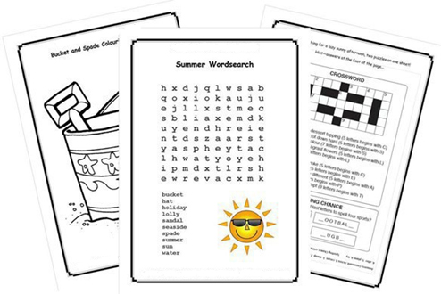

Dear Friends,
We are now in the month of June, and we hope that we will get to enjoy the sunshine soon!

In the month of June, we will celebrate ‘Father’s Day’. We would like to wish all the Fathers, Grandfathers and Great Grandfathers a very special day!!!

We are hosting several Alzheimer Cafés. They are a place to come together, share a cuppa and listen to our amazing guest speakers. For information on how to attend visit: https://alzheimer.ie/service/alzheimer-cafe/.

Our Social Clubs is a social gathering where people can drop in to chat, access information and support, meet other people. Click the link below to find your nearest Social Club.
https://alzheimer.ie/service/socialclub/

Calling all artists and writers among us, we would love to hear from you! We warmly welcome submissions of poems and stories to be featured in the pack. Additionally, if you'd like your artwork from this pack or photos of any local fundraising events showcased on our social media, please send your images via email to communityengagement@alzheimer.ie.

Our Free Helpline is available at
Phone: 1800 341 341 and Email: helpline@alzheimer.ie

Table of Contents

Activity | Pages
Reminiscing Guessing Games | 4 - 8
Pictures to Colour | 9 - 12
Song Lyrics | 13 - 21
Looking Forward to Knock | 21 - 25
Mindfulness and Meditation | 26
Poetry | 27 - 28

Guessing Game – Who Am I?

This is a wonderful reminiscing activity.
Guess the names of these famous people from the clues provided.

Instructions:
- Show a picture to your loved one and read out the clues.
- Ask them to guess the name of the person and reminisce about what else they were famous for.
- Repeat with the next picture.

Extend the activity by asking who else was famous in their time and reminiscing together.

Famous male movie star of the 40s and 50s

He was nominated for an Oscar for his role in the movie Casablanca
in which he co-starred with Ingrid Bergman.

He was also in a movie with Katharine Hepburn called The African Queen.

He was married to Lauren Bacall and had they two children.

Who is he?

Answer: Humphrey Bogart

“Ain’t nothing a man can’t do
if he believes in himself.”
– Humphrey Bogart

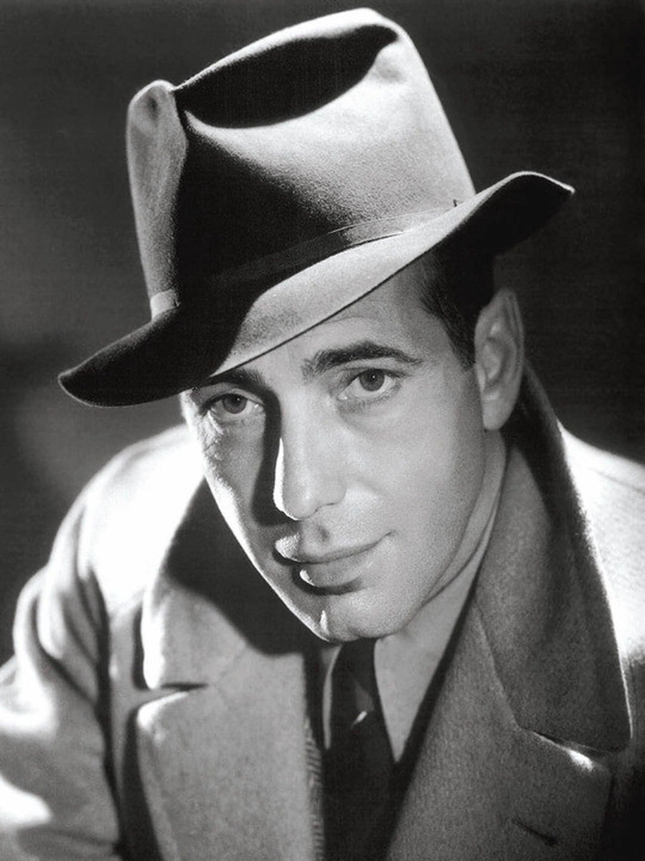

She epitomized feminine beauty and glamour and was admired
for her ground- breaking charity work.

In 1981, she married the Prince of Wales.
Their marriage was regarded as the "wedding of the century".
It was watched by an estimated global TV audience of 750 million people. They divorced in 1992.

She had two sons.

She died tragically in a car crash in 1997.

Who is she?

Answer: Princess Diana

“Carry out a random act of kindness,
with no expectation of reward,
safe in the knowledge that one day
someone might do the same for you”.
- Princess Diana

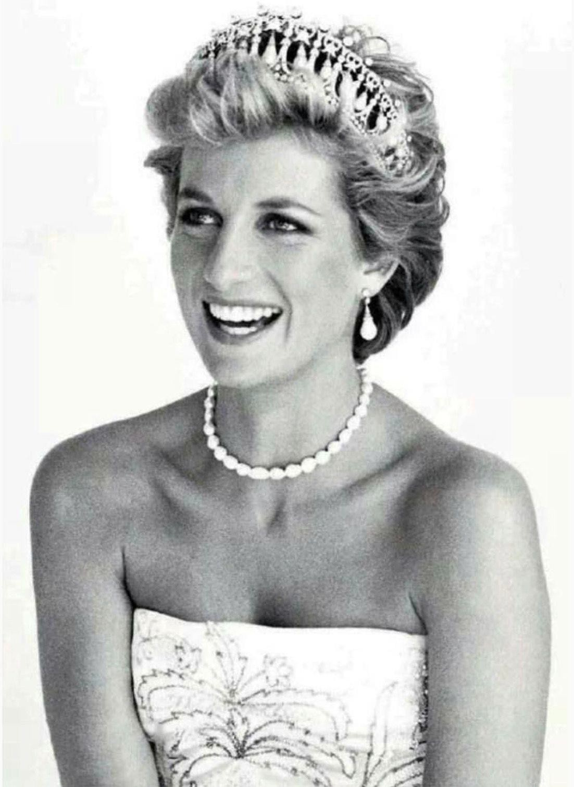

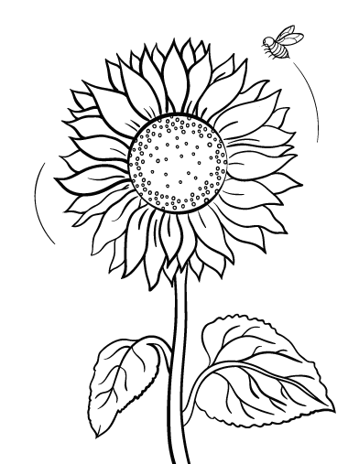

SONG FOR THE MIRA
Out on the Mira on warm afternoons
Old men go fishing with black line and spoons And if they catch nothing they never complain I wish I was with them again
As boys in their boats call to girls on the shore Teasing the one that they dearly adore
And into the evening the courting begins I wish I was with them again
Can you imagine a piece of the universe
More fit for princes and kings?
I'll trade you ten of your cities
For Marion Bridge and the pleasure it brings
Out on the Mira on soft summer nights Bonfires blaze to the children's delight
They dance 'round the flames singing songs with their friends I wish I was with them again

Can you imagine a piece of the universe
More fit for princes and kings?
I'll trade you ten of your cities
For Marion Bridge and the pleasure it brings Out on the Mira the people are kind
They treat you to home-brew and help you unwind And if you come broken, they'll see that you mend I wish I was with them again
Now I'll conclude with a "wish you go well" Sweet be your dreams, and your happiness swell I'll leave you here, for my journey begins
I'm going to be with them Going to be with them
I'm going to be with them again…

Óró, sé do bheatha ‘bhaile

Curfá

Óró, sé do bheatha ‘bhaile, B’fhearr liom tú ná céad bó bhainne!
óró, sé do bheatha bhaile,
Anois ar theacht an tsamhraidh.

Véarsa 1
‘Sé do bheatha, bhean ba léanmhar, B’é ár gcreach tú bheith i ngéibheann,Do dhúiche bhreá i seilbh méirleach, ‘S tú díolta leis na Galla.

Curfá
Óró, sé do bheatha ‘bhaile, B’fhearr liom tú ná céad bó bhainne! óró,
sé do bheatha ‘bhaile,
Anois ar theacht an tsamhraidh.

Tá Gráinne Mhaol a’ trial thar sáile óglaigh armtha léi mar gharda, Gaeil iad féin ní Gaill ná Spáinnigh Is cuirfidh siad ruaig ar Ghalla.

Curfá
Óró, sé do bheatha ‘bhaile, B’fhearr liom tú ná céad bó bhainne! óró,
sé do bheatha ‘bhaile,
Anois ar theacht an tsamhraidh.

Véarsa 3
A bhuí le Dia na bhfeart má dhearcam Mura mbím beo ‘na dhiadh ach seachtain, Gráinne Mhaol is míle gaiscíoch
A’ fógairt fáin ar Ghalla.

Curfá
Óró, sé do bheatha ‘bhaile, B’fhearr liom tú ná céad bó bhainne! óró,
sé do bheatha ‘bhaile,
Anois ar theacht an tsamhraidh.
THE TOWN I LOVED SO WELL

In my memory, I will always see,
The town that I have loved so well,
Where our school played ball by the gas yard wall,
And they laughed through the smoke and the smell,
Going home in the rain, running up the dark lane,
Past the jail, and down behind the fountain,
Those were happy days in so many, many ways,
In the town I loved so well.

Now the music's gone but they carry on,
For their spirits been bruised, never broken,
They will not forget but their hearts are set,
On tomorrow and peace once again,
For what's done is done and what's won is won,
And what's lost is lost and gone forever,
I can only pray for a bright, brand new day,
In the town I love so well.

The Fields of Athenry
The Dubliners
By a lonely prison wall,
I heard a young girl calling
Michael they have taken you away,
For you stole trevelyn's corn
So the young might see the morn,
Now a prison ship lies waiting in the bay

Low lie, The Fields Of Athenry
Where once we watched the small free birds fly
Our love was on the wing
We had dreams and songs to sing,
Its so lonely round the Fields of Athenry

By a lonely prison wall
I heard a young man calling
'Nothing matters Mary, when you're free'
Against the famine and the crown,
I rebelled, they brought me down
Now its lonely round the Fields of Athenry

By a lonely harbour wall
She watched the last star falling
As the prison ship sailed out against the sky
Sure she'll live in hope and pray
For her love in Botney Bay
Its so lonely round the Fields Of Athenry
The Rose of Tralee
John McCormack

The pale moon was rising above the green mountain
The sun was declining beneath the blue sea
When I strayed with my love to the pure crystal fountain
That stands in beautiful vale of Tralee.
She was lovely and fair as the rose of the summer
Yet, 'twas not her beauty alone that won me
Oh no! 'Twas the the truth in her eye ever beaming
That made me love Mary, the Rose of Tralee.
The cool shades of evening their mantle were spreading
And Mary all smiling was listening to me
The moon through the valley her pale rays was shedding
When I won the heart of the Rose of Tralee.
Though lovely and fair as the rose of the summer
Yet, 'twas not her beauty alone that won me
Oh no! 'Twas the the truth in her eye ever beaming
That made me love Mary, the Rose of Tralee.

Molly Malone
The Dubliners
In Dublin's fair city
Where the girls are so pretty
I first set my eyes on sweet Molly Malone
As she wheeled her wheelbarrow
Through the streets broad and narrow
Crying "cockles and mussels, alive, alive, oh"

Alive, alive, oh
Alive, alive, oh
Crying "cockles and mussels, alive, alive, oh"

She was a fishmonger
And sure, t'was no wonder
For so were her mother and father before
And they wheeled their barrow
Through the streets broad and narrow
Crying "cockles and mussels, alive, alive, oh"

Alive, alive, oh
Alive, alive, oh
Crying "cockles and mussels, alive, alive, oh"

She died of a fever
And sure, so one could save her
And that was the end of sweet Molly Malone
Now her ghost wheels her barrow
Through the streets broad and narrow
Crying "cockles and mussels, alive, alive, oh"

Come Back Paddy Reilly

The Garden of Eden has vanished they say
But I know the lie of it still
Just turn to the left at the bridge of Finea
And stop when halfway to Cootehill.
It's there you'll find it I know sure enough
For fortune has come to my call
The grass it is green around Ballyjamesduff
And the blue sky is over it all.
And tones that are tender and tones that are ruff
Come whispering over the sea
Come back, Paddy Reilly to Ballyjamesduff
Come home, Paddy Reilly, to me.

My mother once told me that when I was born
The day that I first saw the light
I looked down the street on that very first morn
And gave a crow of delight.
Now most newborn babies appear in a puff
And start with a sorrowful squall
But I knew I was born in Ballyjamesduff
And that's why I smiled at them all.
The baby's a man now, he's toil-worn and tough
Still, whispers come over the sea
Come back, Paddy Reilly to Ballyjamesduff
Come home, Paddy Reilly, to me.

LOOKING FORWARD TO KNOCK

By Colette Moore, Athy

Old Mrs. Quinn stood in the kitchen. Strands of her dull white hair falling from the bun she neatly placed in it earlier this morning. Her shawl loosely draped from her shoulders. In her hand she held an old envelope, from that envelope she took a note and laid it on the table and into my hand she placed some coins. The note held instructions on what I was to get her in Knock. I listened as she told Mammy, then repeated them to me and waited till I repeated them back to her.
Her purchase was of the utmost importance. Mrs. Quinn was in her 90th year, this was 1974 so she was born in1884, the same year as my Grandfather as she was fond of telling me.
Tomorrow morning my older by one year sister Evelyn and I were going with the Parish of Portarlington on its annual Pilgrimage to Knock, and we were going on the Special Train organised every year just for this occasion.
All day I had examined and re-examined my beautiful clothes I’d be wearing, my mammy had bought me new socks in Goodwin’s drapery store. Oh my, they were so beautiful and I wouldn’t have to hold them up with bands, also I loved my new Aran jumper mammy had knitted with new stitches, it turned out so beautiful. Daddy had polished our shoes to within an inch of life, and they shone. Oh I just couldn’t contain my excitement.

Mrs. Quinn wasn’t the 1st to call that day, there were many others, Hinny McGuiness and her sister Nan and they had left instructions. Granny Burke had called and left us money and we were to buy ourselves something.
Mammy placed all the money belonging to people in a purse and wrote down what I had to get. She said, “keep it separate and don’t spend a penny until you’ve got everything on that list” There was Holy Water, Rosary Beads, and Medals of all different Saints. For Mrs. Quinn a Green Scapular, the instruction was very clear, it had to be green, and for Aunt Maura a red one.
Daddy dragged in the bath to the kitchen floor and mammy had two huge, big saucepans on the range full of hot water. And while she washed us, she kept repeating over and over again “Stay together”. Mr. Connolly was going and he was going to watch over us. If anything happened we were to go to him. Daddy said, “watch where you’re going, stay with the group and Shamie would look after you” (that was Mr. Connolly’s name).
Packing our food for the day was just over the top excitement. Mammy had baked Porter Cake and had boiled a ham and she had bought Lemonade from Emerson’s Shop and custard cream biscuits.
After the Family Rosary it was time for bed , but before we went, Daddy and Mammy gave us our spending money for the next day, oh how I skipped around the kitchen, I’d never had so much money not even for my Communion. It was very hard to sleep that night, my eldest sister Ann told me the “Child of Prague” that Mammy had had put out earlier had fallen and smashed. We were chatting away and Mammy shouted up the stairs, that if we kept it up she’d kill us, in her words “I won’t be responsible for my actions, this day of the Lord!”. That was what Mammy said every single day.
Daddy came up to turn of the light in our room as we weren’t allowed next neigh or near the long wire that held the switch.
I woke the next morning to the sounds of the kitchen, Daddy shaking out the ashes – the kettle starting to boil – mammy putting on the pan for the breakfast. I ran down the stairs – Mammy said “miracles have already started” it was the first time she didn’t have to scream and roar to get us up.
I remember running outside to see if there was any sign of Mr. Connolly stirring- the air was silent almost holy- the most wonderful day of my life.
I’ll never forget the sight of Mr. Connolly as he came out. So smart in his Civil Defence Uniform. Daddy walked with us the mile or more to the train station. All along the way we met other groups and families heading to the station. Everybody greeting each other and laughing, but when we reached the train station I almost ran home, I’d never in my life seen so many people at one place, not even at Sunday Mass. Busses full of people, Groups with Banners, families, Civil Defence, the Priest, the nuns. There was such a large crowd I was almost lost already. Mr. Connolly brought us on to the train as all the people piled on.

I heard the whistle of the train as it slowly pulled out of the station, Daddy wished us a lovely day and made us promise to stay with Mr. Connolly.
I was so excited as the train pulled away until I heard over the speaker the voice of Fr. Byrne as he started the Rosary, Yes, the Rosary was said all the way to Knock. I asked Mrs. Burbage who was sitting near us, why we were saying the Rosary so much, and she snapped “’tis Pilgrimage isn’t it?”. I never said another word to her. I waited and waited for it to be over when suddenly the beautiful voices of the Church Choir started the Hymn
“Oh, Mary we crown thee blossoms today”
Oh, it was just wonderful.

Mindfulness and Meditation
The following links can be copied into your web browser to access online meditation practice:
- 5-Minute Meditation You Can Do Anywhere – 5-Minute Meditation You Can Do Anywhere
- Forgetting Time 10 minute meditation by Calm – https://www.youtube.com/watch?v=YF_P1ZzYgjA
- Rainy Day Antiques Meditation by Headspace – https://www.youtube.com/watch?v=9OHvPNatlBc

Try taking some time for yourself to relax and decompress. This can be done alone or with a loved one. Try the following tips:
- Play some calming music and give yourself permission for 5 or 10 minutes to just sit comfortably, close your eyes, and listen.
- Give your loved one a hand massage. Use soft, slow motions over the skin and a scented hand cream to add an extra sensory element. Think of all the amazing things those hands have done in their lifetime.
- Sit comfortably and think of:
          - 5 things you can see around you
          - 4 things you can feel or touch
          - 3 things you can hear
          - 2 things you can smell
          - 1 thing you can taste
If I Had My Life to Live Over
Lou Rawls
As I review my life with you
Since the days of old
I wouldn't think of changing things
For all the World and its gold
If I had my life to live over
I'd do the same things again
I'd still want to roam
Near the place we called home
Where my happiness never would end
I'd meet you when school days were over
And we'd walk through the lanes we once knew
If I had my life to live over
I'd still fall in love with you
If I had my life to live over
I'd do the same things again
I'd still want to roam
Near that place we called home
Where my happiness never would end
I'd meet you when school days were over
And we'd walk through the lanes we once knew
If I had my life to live over
I'd still fall in love with you

Yes, if I had my life to live over
I'd still fall in love with you

The Daffodils – William Wordsworth

I wandered lonely as a cloud
That floats on high o'er vales and hills,
When all at once I saw a crowd,
A host, of golden daffodils;
Beside the lake, beneath the trees,
Fluttering and dancing in the breeze.

Continuous as the stars that shine
And twinkle on the milky way,
They stretched in never-ending line
Along the margin of a bay:
Ten thousand saw I at a glance,
Tossing their heads in sprightly dance.

The waves beside them danced; but they
Out-did the sparkling waves in glee:
A poet could not but be gay,
In such a jocund company:
I gazed—and gazed—but little thought
What wealth the show to me had brought:

For oft, when on my couch I lie
In vacant or in pensive mood,
They flash upon that inward eye
Which is the bliss of solitude;
And then my heart with pleasure fills,
And dances with the daffodils.

