May 2024
Activity Pack 1
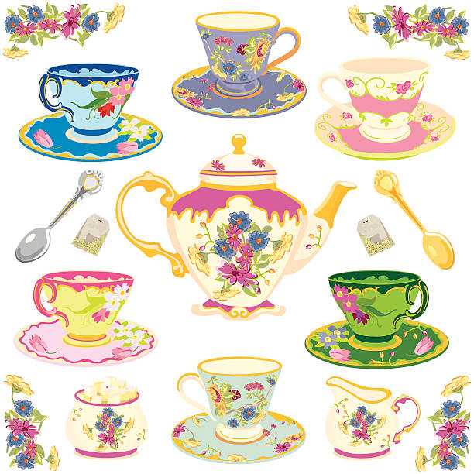

Dear Friends,

We hope you're relishing the splendid weather and taking joy in witnessing nature's vibrant blossoms.
As we eagerly anticipate the ASI’s Alzheimer’s Tea Day on May 2nd, we're delighted to centre this month's pack theme around "Afternoon Tea"! So, why not take a moment to brew a cuppa, indulge in something sweet, and immerse yourself in the myriad of stories and activities awaiting inside.

Calling all artists and writers among us! We warmly welcome submissions of poems and stories to be featured in the pack. Additionally, if you'd like your Tea Day artwork from this pack or photos of any local fundraising events showcased on our social media, please send your images via email to communityengagement@alzheimer.ie

With the delightful weather blessing us, we hope you're finding opportunities to soak up the sunshine and witness the blossoming beauty around you. As we gear up for the 2024 Tea Day, this month's activities are themed around Tea and Ireland! Dive into our fantastic array of games, puzzles, songs, and much more.

“Come and share a pot of tea,
My home is warm and my friendship’s free”
Emilie Barnes

Useful Resources:

- Our Free Helpline and Dementia Support Line are available at:
Phone: 1800 341 341 and Email: helpline@alzheimer.ie

- We are hosting several Virtual Cafes. They are a place to come together, share a cuppa and listen to our amazing guest speakers. For information on how to attend visit: https://alzheimer.ie/service/alzheimer-cafe/

- The ASI also have a huge library of factsheets and resources available on: https://alzheimer.ie/get-support/resources-and-factsheets/

- M4D Radio is a 24/7 online radio station with songs specifically picked to evoke memories and aid reminiscence. To find out more and to listen, please visit: https://m4dradio.com/

- The BBC have curated a remarkable online archive of videos, images and audio clips to aid reminiscence and covers a wide variety of subject matter. Please visit: https://remarc.bbcrewind.co.uk/ to check it out.

- Emergency Response Numbers: 999 or 112

- HSE 24/7 Your Mental Health Information Helpline: 1800 111 888

Table of Contents

Activity | Pages
Spot the Difference | 6-7
Tea for Two Crossword | 8
Summer Crossword | 9
iSpy Tea Party | 10
Get to Know You Game | 11
Irish Proverbs and Their Meanings | 12-13
Summer Maze | 14
Tea Themed Trivia | 15
A Tea Party Like No Other Story | 16-17
Earl Grey Tea Cookies Recipe | 18-19
A Loving Recipe for a Perfect Cup of Tea - by Anonymous | 20
Tea for Two By Doris Day | 21
Pictures to Colour | 22-26
Tea Time Talking Topics | 27
Old Irish Stories and Folklore | 28
Anagram | 29-30
Can You Name Everything Here? | 31

Spot the Difference
See if you can see the 5 differences between these two pictures

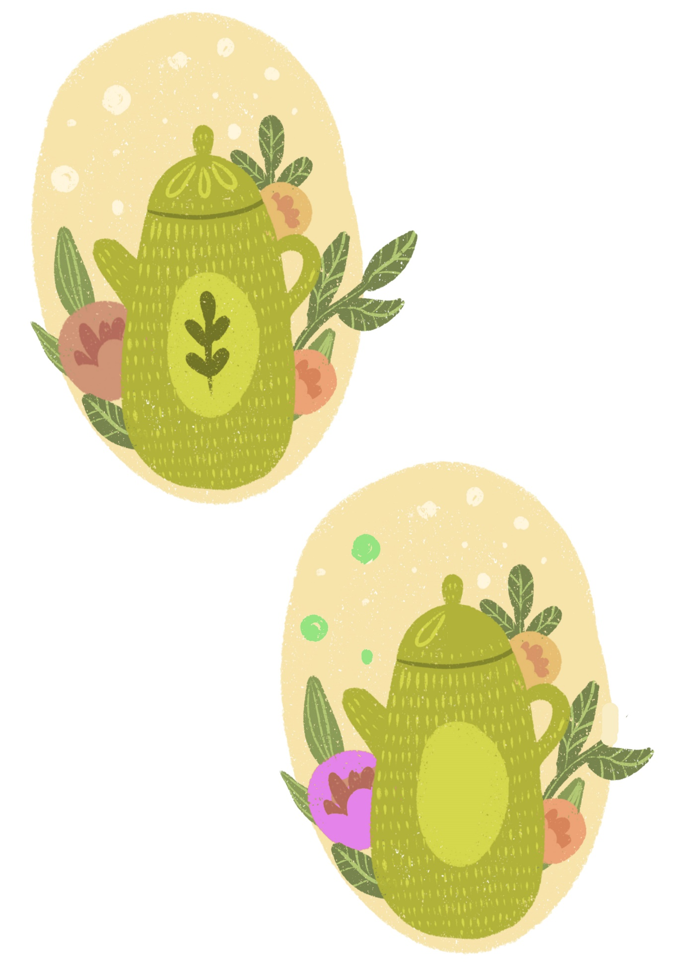

Spot the Difference
See if you can see the 5 differences between these two pictures
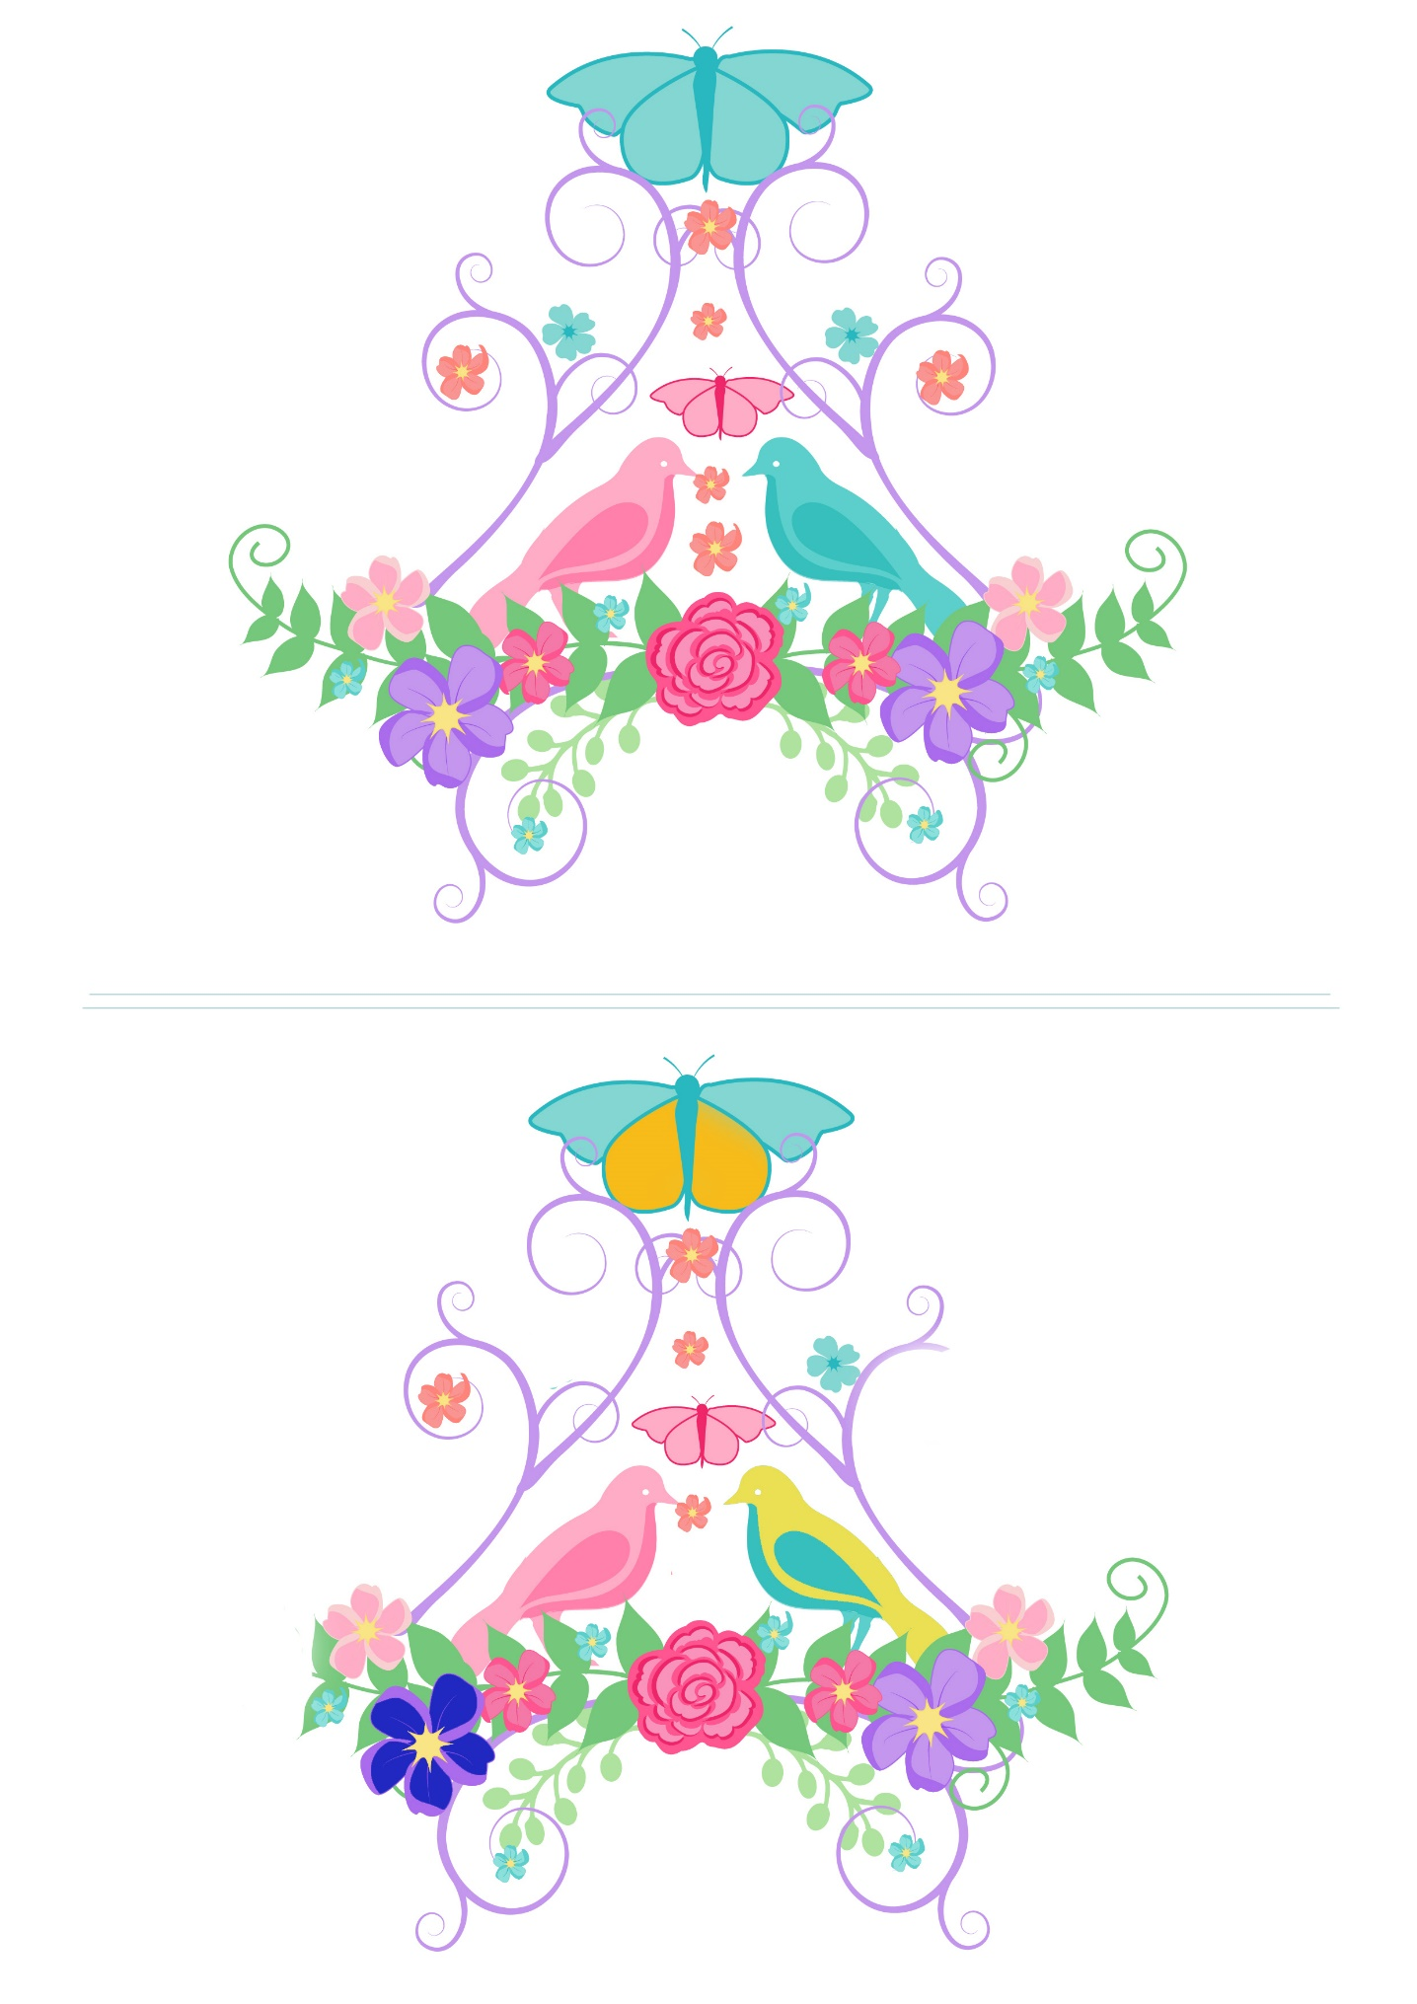
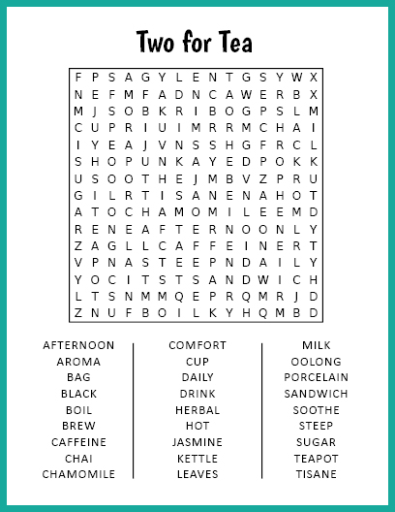
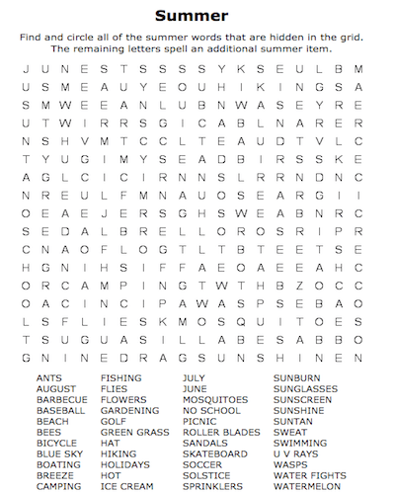

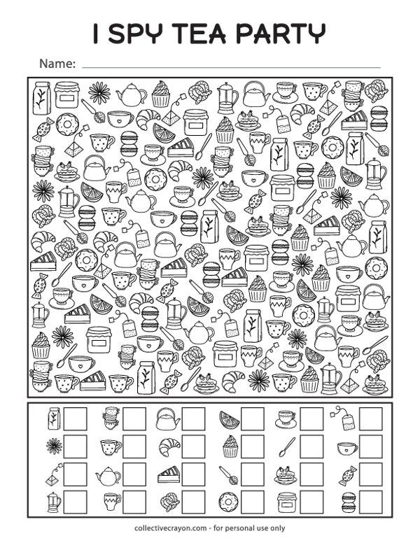
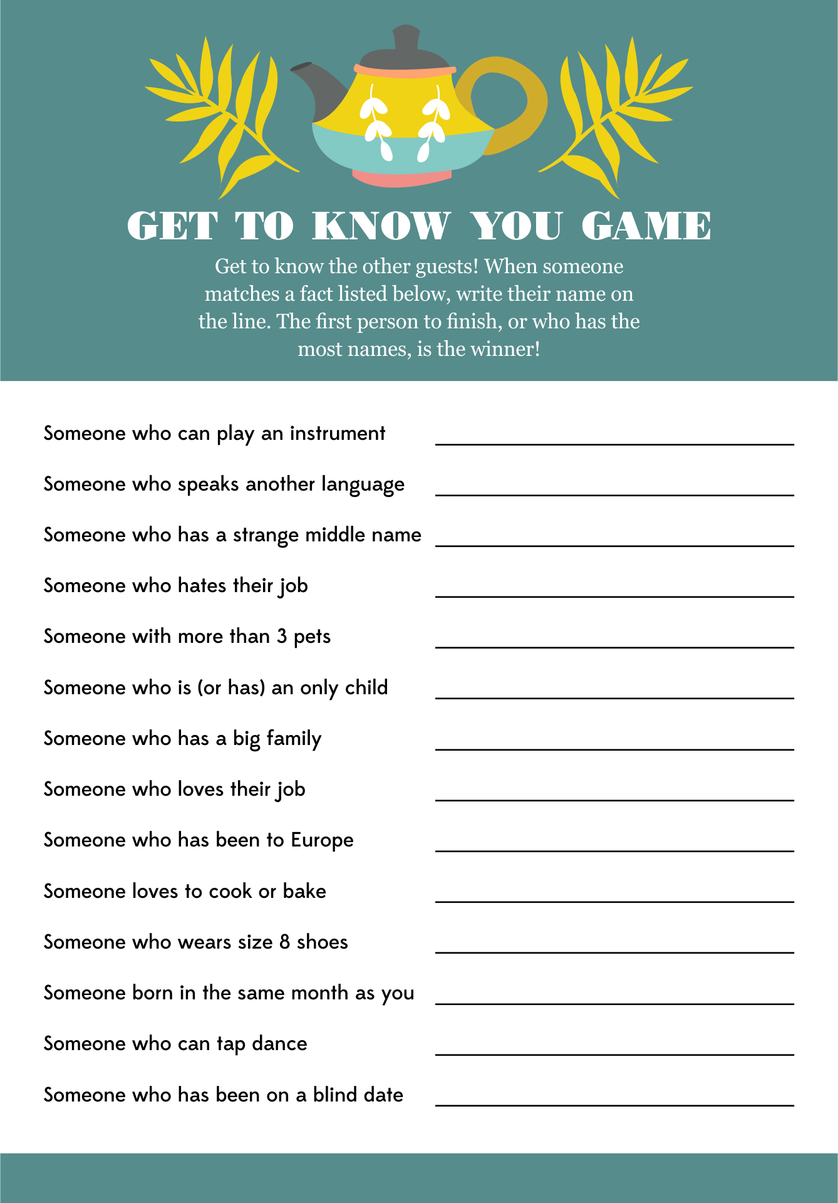

Irish Proverbs and Their Meanings

- An awkward colt often becomes a beautiful horse – everything can be improved.
- A wild goose never reared a tame gosling – children learn by example.
- The best way to keep loyalty in a man’s heart is to keep money in his purse – another self-explanatory one.
- A trout in the pot is better than a salmon in the sea – be thankful for what you have rather than chasing after what you can never get.
- An old broom knows the dirty corners best – wisdom comes with experience.
- Any man can lose his hat in a fairy wind – some things are out of anyone’s control.
- Don’t make little of your dish for it may be an ignorant man who judges it – never undersell yourself.
- The cat is always dignified until the dog comes by – everyone has something or someone that makes them angry.
- Wide is the door of the little cottage – it is often poor people who are most generous.
- Everyone lays a burden on the willing horse – people are quick to take helpful people for granted.
- It is easy to halve the potato where there is love – if you love someone you will share whatever you have without resentment
- Enough and no waste is as good as a feast – Having enough is better than having too much.
- While a person is out, his food goes cold – good things turn bad if left neglected.
- Do not take the thatch from your own roof to buy slates for another man’s house – you can’t help others unless you help yourself first.

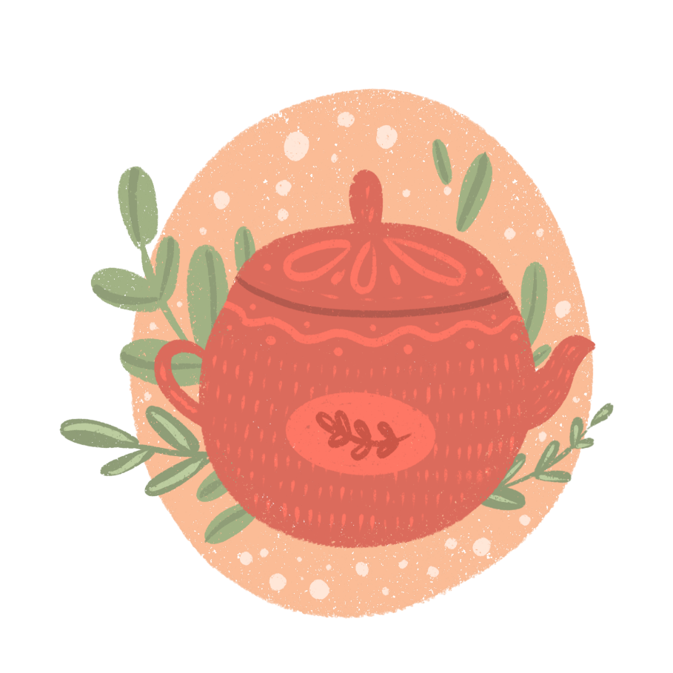

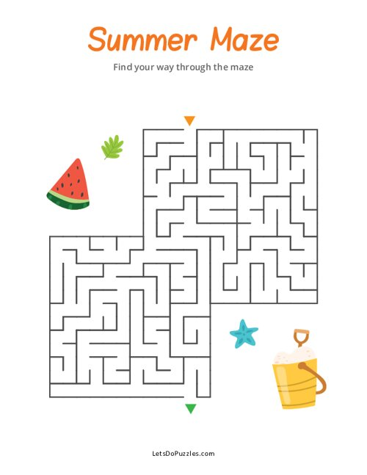

Tea Themed Trivia:
- What is the most widely consumed beverage in the world after water? Answer: Tea
- Which country is famous for its traditional tea ceremony called "chanoyu" or "chado"? Answer: Japan
- What is the name of the plant from which tea leaves are harvested? Answer: Camellia sinensis
- Which British monarch popularized afternoon tea in the 19th century? Answer: Queen Victoria
- What is the term for dried tea leaves wrapped in paper or cloth, ready for steeping? Answer: Tea bag
- Which type of tea undergoes the most oxidation during processing, resulting in a darker colour and stronger flavour? Answer: Black tea
- What is the traditional accompaniment to afternoon tea in England, consisting of small sandwiches, scones, and pastries? Answer: Tea cakes or finger sandwiches
- In which region of China was tea first discovered and cultivated? Answer: Yunnan province
- Which herb, often used for relaxation and sleep, is commonly brewed as a tea? Answer: Chamomile
- What is the name of the Chinese tea ceremony that emphasizes the appreciation of tea's taste, aroma, and appearance? Answer: Gongfu tea ceremony

A Tea Party Like No Other:
A Story
Once upon a time, in a cozy little village nestled in the rolling hills of England, there lived a kind-hearted woman named Mrs. Higgins. Mrs. Higgins was known throughout the village for her love of tea and her legendary tea parties.
Every afternoon, Mrs. Higgins would invite her friends and neighbours over to her charming cottage for tea. Her teapot was always bubbling, and her table was adorned with an array of delicious treats, from freshly baked scones to delicate finger sandwiches.
One sunny afternoon, Mrs. Higgins decided to host a special tea party in her garden. She spent the morning carefully arranging her best china cups and setting up a quaint little gazebo where her guests could relax and enjoy the sunshine.
As the guests arrived, they were greeted with the delightful aroma of freshly brewed tea and the sound of birds chirping in the trees. Mrs. Higgins beamed with joy as she poured steaming cups of tea for her friends, regaling them with stories of her adventures in tea-making.
But just as the party was getting into full swing, disaster struck! A mischievous squirrel, drawn by the scent of Mrs. Higgins' delicious treats, leaped onto the table and knocked over the teapot, sending tea cascading everywhere.
At first, there was a moment of stunned silence, but then Mrs. Higgins burst into laughter, declaring that it was the most exciting tea party she had ever hosted. With the help of her friends, they quickly cleaned up the mess and salvaged what tea they could from the broken pot.
Undeterred, Mrs. Higgins brewed another pot of tea, and soon the party was back in full swing, with laughter and camaraderie filling the garden once more. As the sun began to set and the guests bid their farewells, Mrs. Higgins couldn't help but feel grateful for the simple joys of friendship and a good cup of tea.
And so, in the village of rolling hills, Mrs. Higgins' tea parties became the stuff of legend, remembered fondly by all who attended, and inspiring smiles for years to come.

Earl Grey Tea Cookies
Ingredients:
- 250 grams all-purpose flour
- 2 tablespoons Earl Grey tea leaves (from about 4-5 tea bags)
- 1/2 teaspoon salt
- 225 grams unsalted butter, softened
- 60 grams powdered sugar
- 1 teaspoon vanilla extract
- Zest of 1 lemon (optional, for added flavour)
Instructions:
- Preheat the Oven: Preheat your oven to 180°C (350°F). Line a baking sheet with parchment paper or lightly grease it.
- Prepare the Tea: In a small bowl, crush the Earl Grey tea leaves using a mortar and pestle or the back of a spoon until they are finely ground. Set aside.
- Mix Dry Ingredients: In a medium bowl, whisk together the flour, ground Earl Grey tea leaves, and salt until well combined. Set aside.
- Cream Butter and Sugar: In a large mixing bowl, beat the softened butter and powdered sugar together using a hand mixer or stand mixer until light and fluffy, about 2-3 minutes.
- Add Flavourings: Mix in the vanilla extract and lemon zest (if using) until well incorporated.
- Incorporate Dry Ingredients: Gradually add the dry ingredients to the butter mixture, mixing on low speed until a dough forms. Be careful not to overmix.
- Form Cookies: Shape the dough into small balls, about 2.5 centimetres (1 inch) in diameter, and place them on the prepared baking sheet, spacing them about 5 centimetres (2 inches) apart.
- Flatten Cookies: Gently flatten each cookie ball with the back of a fork or your fingers to create a crisscross pattern on top.
- Bake: Bake the cookies in the preheated oven for 12-15 minutes, or until the edges are lightly golden brown.
- Cool: Allow the cookies to cool on the baking sheet for a few minutes before transferring them to a wire rack to cool completely.
- Enjoy: Once cooled, these Earl Grey Tea Cookies are ready to be enjoyed! Serve them with a hot cup of Earl Grey tea for the perfect tea time treat.

A Loving Recipe for a Perfect Cup of Tea - by Anonymous

1 Willing friend who loves to sit and share
1 Grateful heart to have a friend that cares
1 Beautiful garden to show us God is near
Many wonderful memories of times shared throughout the years.
Lots of smiles and laughter to brighten up our days
Many prayers that we prayed for each other along the way
I’m so blessed to have a friend like you
To share in everything I do.
For one special friend sharing a special cup of tea
Truly makes this a perfect recipe.

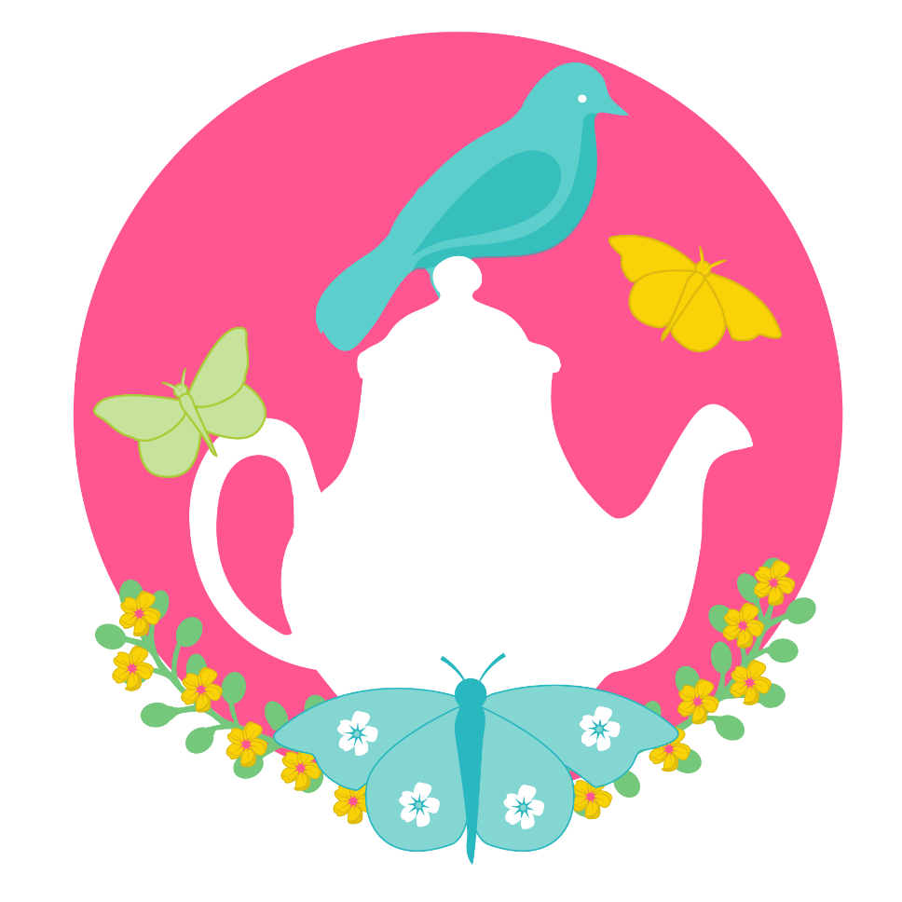

Tea for Two by Doris Day

Picture you upon my knee,
Just tea for two and two for tea,
Just me for you
And you for me alone.

Nobody near us
To see us or hear us,
No friends or relations
On weekend vacations.
We won't have it known, dear,
That we own a telephone, dear;

Day will break and you'll awake
And start to bake a sugar cake,
For me to take
For all the boys to see.

We will raise a family,
A boy for you, a girl for me.
Oh, can't you see
How happy we would be?
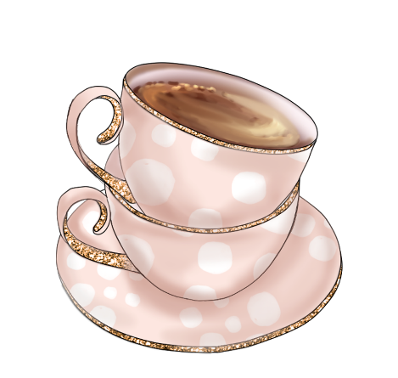

Pictures To Colour

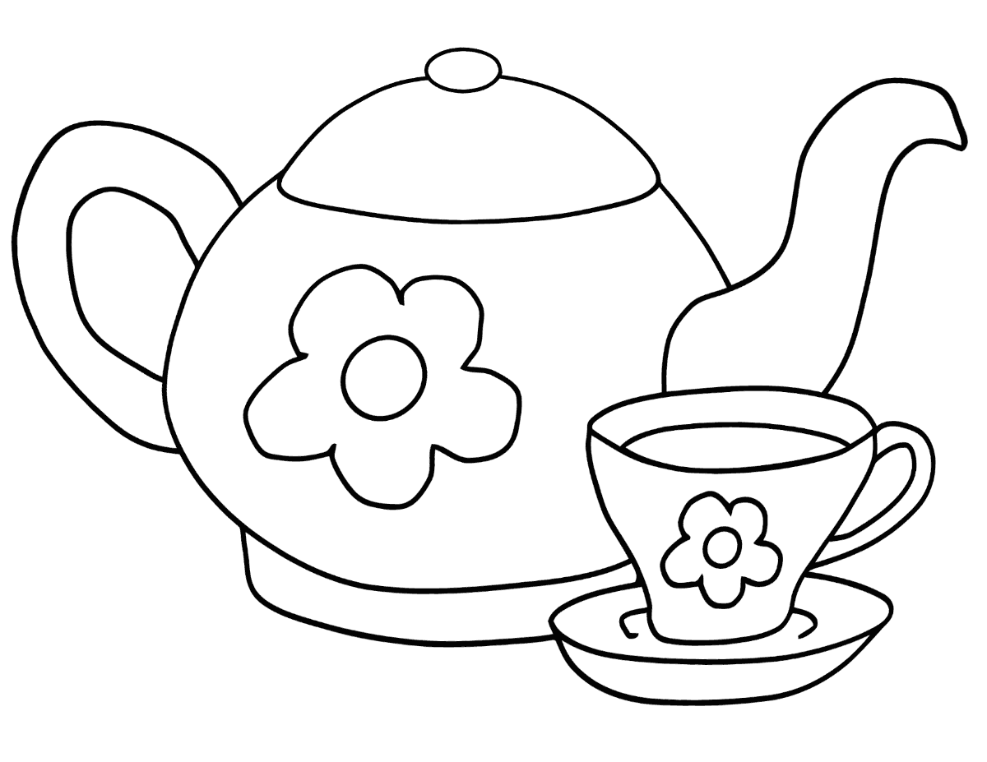

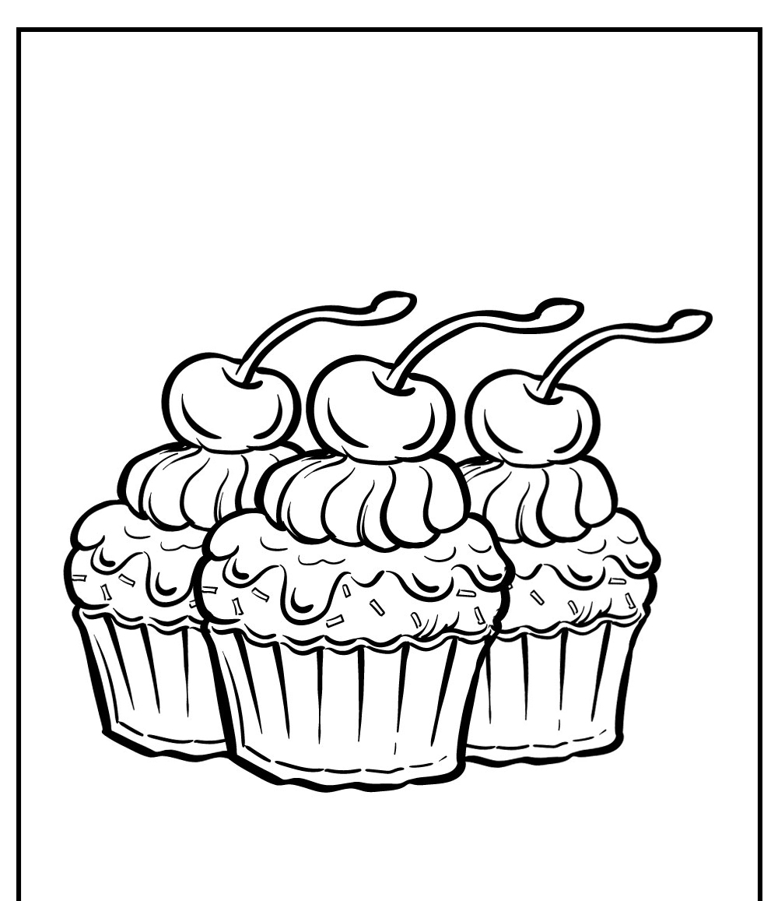

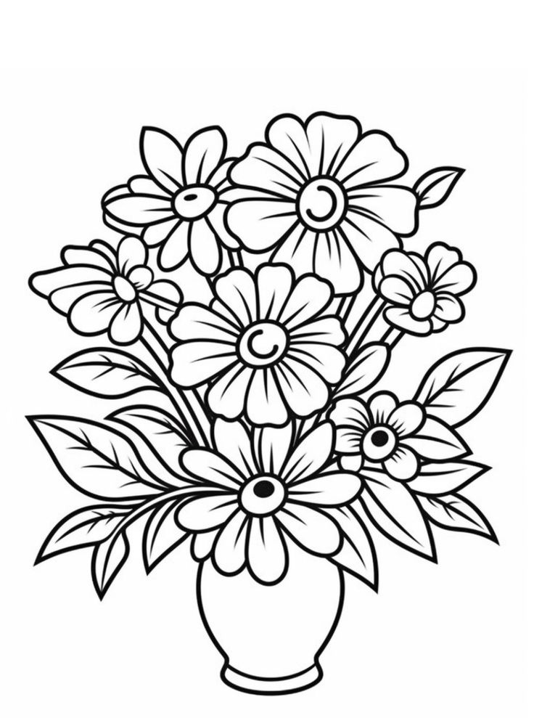

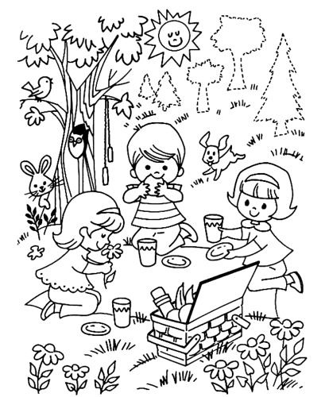

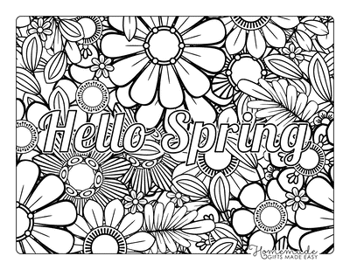

Teatime Talking Topics:

- Memorable Moments: Share a favourite memory from your childhood.
- Tea Memories: Recall a special tea-related memory from your past. Perhaps a cherished teatime with loved ones or a memorable cup of tea enjoyed in a
unique setting.
- Favourite Flavors: What Flavors do you enjoy in your tea? Sweet, fruity, herbal,
or traditional black tea?
- Favourite Season: Which season brings you the most joy and why?
- Favourite Sweets: Describe your favourite dessert or treat to enjoy with tea.
- Favourite Hobby: What activities do you enjoy the most? Whether it's gardening, painting, or listening to music, share what brings you happiness.
- Dream Destinations: If you could travel anywhere in the world, where would you go? Describe your dream destination and why it's special to you.
- Favourite Songs: What songs or music do you enjoy listening to? Share a favourite melody or memory associated with a song.
- Family Traditions: Share a cherished family tradition or holiday memory.
- Favourite Scents: What scents bring back fond memories for you? Is it the smell of freshly baked cookies, blooming flowers, or a favourite perfume?
- Favourite Childhood Toys: Discuss your favourite toys or games from when you were younger.
- Favourite Seasonal Activities: What activities do you enjoy during different seasons? Whether it's building snowmen in winter or picnicking in spring, share your seasonal joys.

Old Irish Stories and Folklore

A Tall Tea Tale
Once upon a time before people used to drink tea a man went to Cork one day to pay his rent. After travelling around the city he felt very hungry. He went into a hotel and asked for a plate of porridge. The waitress told him that she had no porridge and she asked him would he have a cup of tea. The man said he never heard of tea before and asked what kind was it. The waitress gave him a cup of tea and she had milk and sugar put in it, when she was giving it to him she said "That’s the best Congo tea and I hope you will like it". He drank it and he said it was lovely, and he asked for a second cup and she gave it to him, but she did not put the sugar or milk in it, instead she put the milk and sugar on the table and said, "Sweeten it to your liking", he did not know what she meant, he drank some of the tea and it burned him, and he threw the rest of it away. He went to pay for the tea and when he was paying the waitress she asked him how did he like the tea, and he said that the "Congo tea" was lovely, but the "Sweeten to Your Liking tea” was just horrible!

Anagram
Unscramble the letters below to make words relating to all things Irish.

- satin tackrip

- rockhams

- nilbud

- genre

- unclehaper

- hisir canding

- pubrelic

- phar

- topato fineam

- icelag

- rouf feal colver

- top fo glod

- iownbar

- ricemilk

- elderam elsi

Anagram Solutions
Solutions to: Words relating to all things Irish.

  - Saint Patrick

  - Shamrock

  - Dublin

  - Green

  - Leprechaun

  - Irish dancing

  - Republic

  - Harp

  - Potato famine

  - Gaelic

  - Four leaf clover

  - Pot of gold

  - Rainbow

  - Limerick

  - Emerald Isle

Can you name everything on the menu?
