May 2024
Activity Pack 2
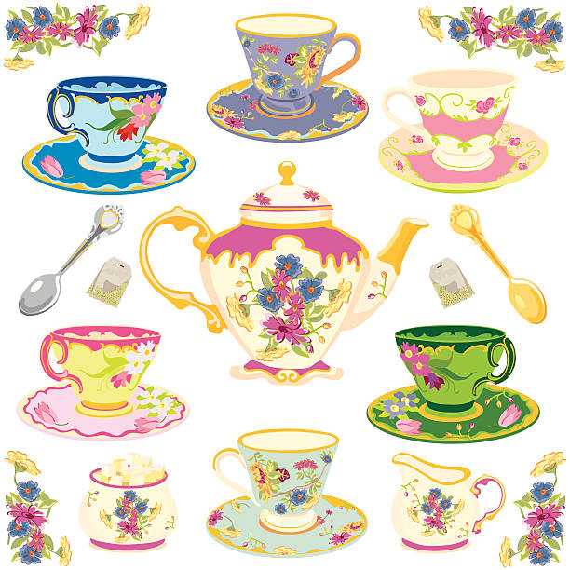

Dear Friends,

We hope you're relishing the splendid weather and taking joy in witnessing nature's vibrant blossoms.
As we eagerly anticipate the ASI’s Alzheimer’s Tea Day on May 2nd, we're delighted to centre this month's pack theme around "Afternoon Tea"! So, why not take a moment to brew a cuppa, indulge in something sweet, and immerse yourself in the myriad of stories and activities awaiting inside.

Calling all artists and writers among us! We warmly welcome submissions of poems and stories to be featured in the pack. Additionally, if you'd like your Tea Day artwork from this pack or photos of any local fundraising events showcased on our social media, please send your images via email to communityengagement@alzheimer.ie

With the delightful weather blessing us, we hope you're finding opportunities to soak up the sunshine and witness the blossoming beauty around you. As we gear up for the 2024 Tea Day, this month's activities are themed around Tea and Ireland! Dive into our fantastic array of games, puzzles, songs, and much more.

“Come and share a pot of tea,
My home is warm and my friendship’s free”
Emilie Barnes

Useful Resources:

- Our Free Helpline and Dementia Support Line are available at:
Phone: 1800 341 341 and Email: helpline@alzheimer.ie

- We are hosting several Virtual Cafes. They are a place to come together, share a cuppa and listen to our amazing guest speakers. For information on how to attend visit: https://alzheimer.ie/service/alzheimer-cafe/

- The ASI also have a huge library of factsheets and resources available on: https://alzheimer.ie/get-support/resources-and-factsheets/

- M4D Radio is a 24/7 online radio station with songs specifically picked to evoke memories and aid reminiscence. To find out more and to listen, please visit: https://m4dradio.com/

- The BBC have curated a remarkable online archive of videos, images and audio clips to aid reminiscence and covers a wide variety of subject matter. Please visit: https://remarc.bbcrewind.co.uk/ to check it out.

- Emergency Response Numbers: 999 or 112

- HSE 24/7 Your Mental Health Information Helpline: 1800 111 888

Table of Contents

Activity | Pages
Spot the Difference | 6-7
Tea for Two Crossword | 8
Summer Crossword | 9
Short Story Buddy Holly, Richie Valens and Big Bopper Remembered | 10-14
Let’s Make Teacups! | 15-16
Tea Party iSpy | 17
High Tea Word Find | 18
Get To Know You Game | 19
Irish Proverbs and Their Meanings | 20-21
Summer Maze | 22
Spring Maze | 23
Tea Themed Trivia | 24
A Tea Party Like No Other A Story | 25-26
Classic Scones with Clotted Cream and Jam Recipe | 27-28
A Loving Recipe for a Perfect Cup of Tea - by Anonymous | 29
Friendship by O.Clarke | 30
Tea for Two by Doris Day | 31
Pictures to Colour | 32-36
Old Irish Stories and Folklore | 37

Spot the Difference
See if you can see the 5 differences between these two pictures

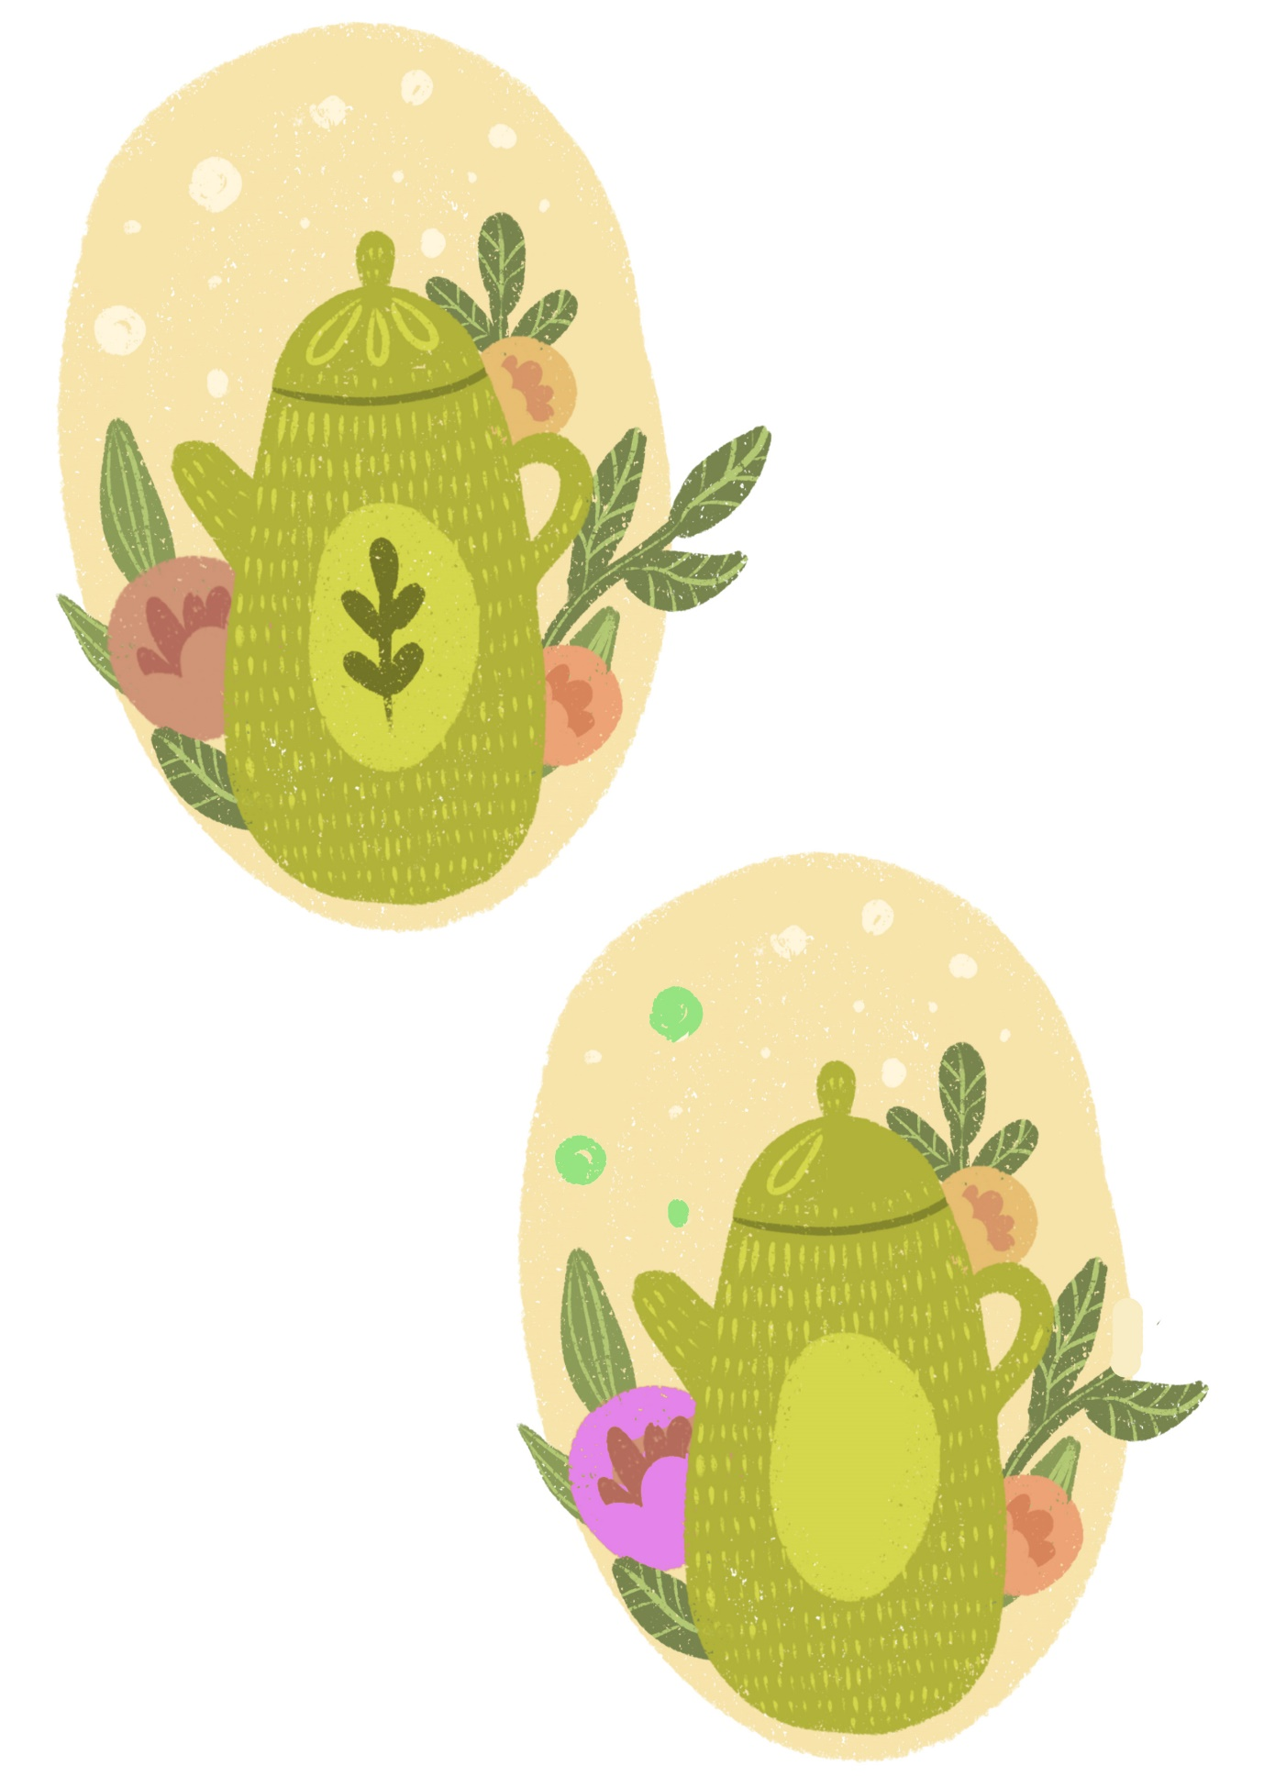

Spot the Difference
See if you can see the 5 differences between these two pictures
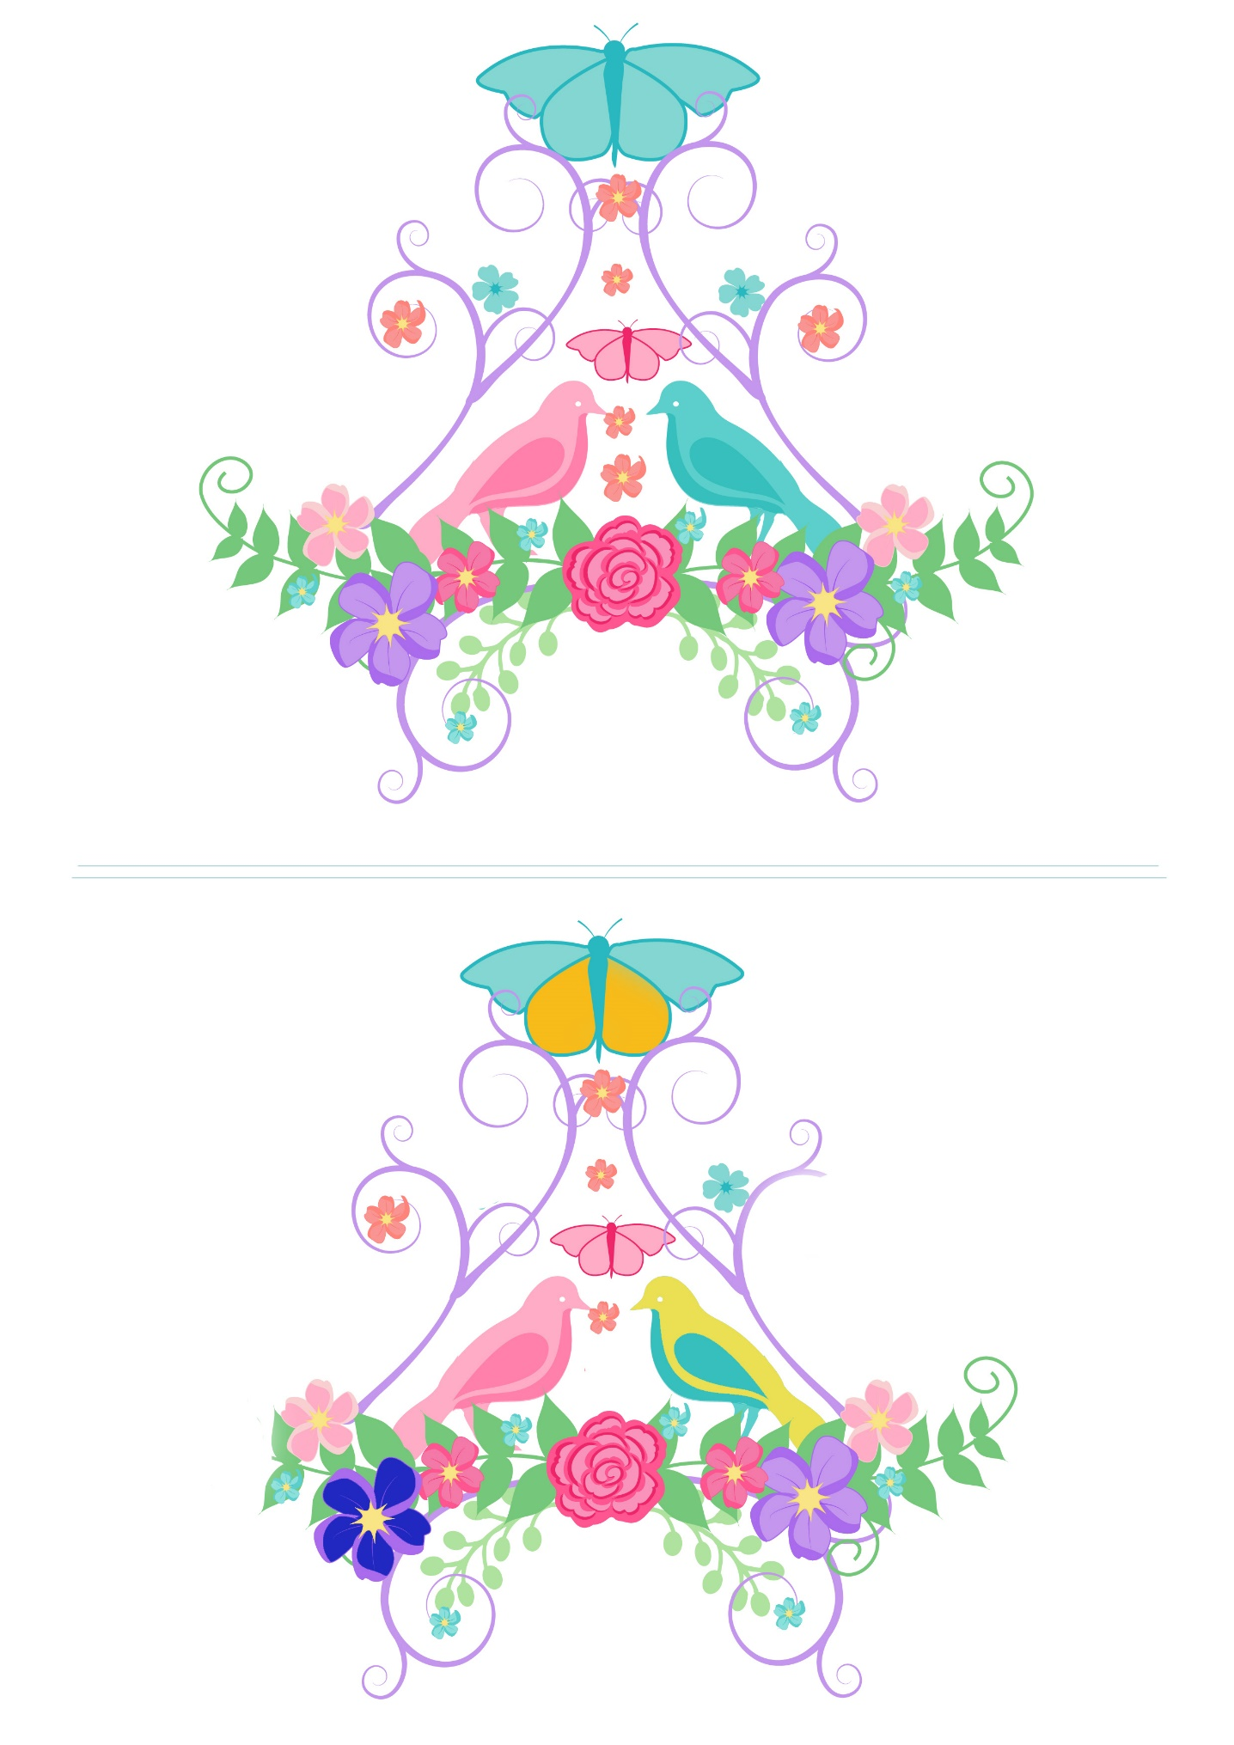

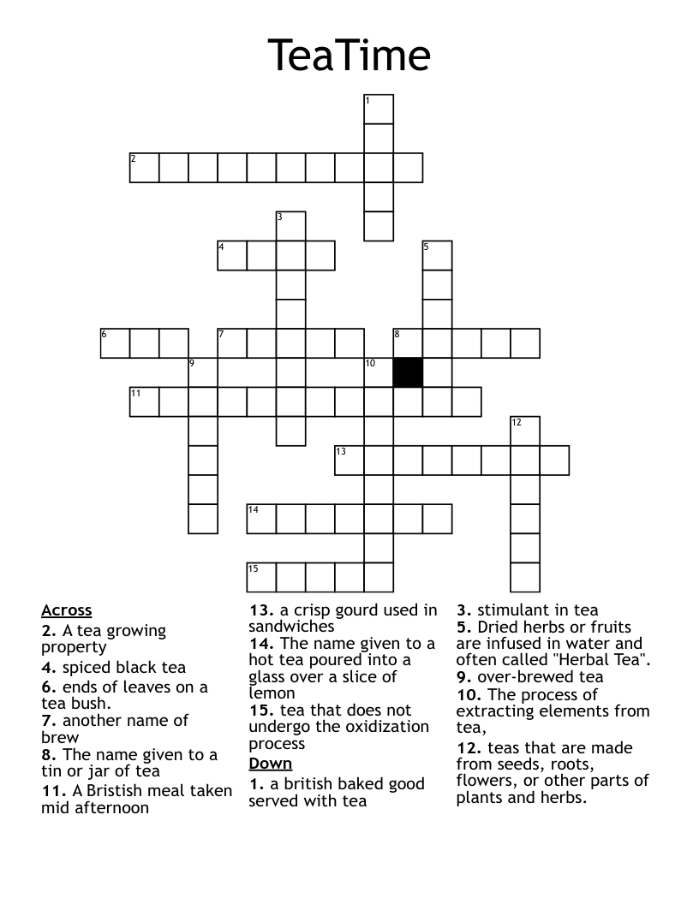
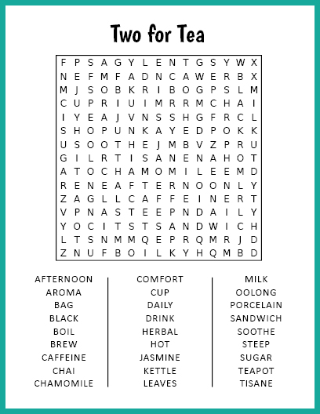
Short Story
Buddy Holly, Richie Valens and Big Bopper Remembered

On February 3, 1959 three young rock & roll musicians died in a plane crash in Iowa, USA. The date is often dubbed as 'The day the music died' in reference to the lyrics of Don McLean's 'American Pie' song of 1971.

Buddy Holly was 23 years old, Richie Valens 17 years old and Big Hopper 29 years old. They were to appear in a 'Winter Dance Party' tour across 24 Mid-Western cities over the course of three weeks. The tour was to promote their recent recordings.

It was winter and the roads were covered with snow; buses poorly equipped and the ﬂu was going around. One of Buddy's band members ended up in hospital with frostbite. Frustrated by the conditions, Holly decided to charter a plane to take them from Iowa to Minnesota. Among his companions were Big Bopper and Richie Valens, who was not one of the original passengers as he was afraid of ﬂying. As fate would have it, he asked another passenger for his seat on the plane. They tossed a coin and Richie won.
The plane took oﬀ and soon disappeared. Later they discovered that the plane came down only ﬁve miles from the airport, no one saw or heard the crash. The investigation determined that it was the harsh weather which caused spatial disorientation and caused the pilot to lose control of the plane.

In the morning, when the owner of the plane and the ﬂight service company was unable to establish contact by radio with the plane, he reported it missing. He then took oﬀ in his own Cessna 180 to search the area and spotted the wreckage in a corn ﬁeld.

Buddy Holly left behind his pregnant wife Maria Elena but she miscarried soon after. Big Bopper (J.P. Richardson) had recently hit the big time with 'Chantilly Lace'.
Richie had just started his career; and was pioneering Spanish-language rock and roll.
It is hard to believe these three young men had only had 5 top hits between them and none of them had a hit album before their deaths. Buddy's hit songs were 'That'll Be the Day', 'Peggy Sue' and 'Oh Boy', Ritchie had 'Donna' and Big Bopper 'Chantilly Lace'.
Ritchie had a previous hit with a Mexican folk song 'La Bamba' in 1958. Richie's version of 'La Bamba' is ranked number 354 on Rolling Stone Magazine's list of 500 Greatest Hits of All Time and it is the only song on the list sung in a language other than English.

Celebrate the lives of the young musicians by:
- Hiring the biographical movies:
La Bamba (biographical movie about Ritchie Valens) The Buddy Holly Story
- Download the music of all three tragic rock musicians and have a sing-along.

Let’s Make Teacups!
Materials Needed:
- Colorful construction paper or cardstock
- Scissors
- Glue or tape
- Markers, crayons, or stickers for decoration
- Optional: Ribbon, buttons, or other embellishments
Step 1: Gather Materials and Prepare Workspace
- Set up a comfortable and well-lit workspace with all the materials within easy reach.
- Choose a variety of vibrant colors for the paper teacups to make them visually appealing.
Step 2: Create Teacup Template
- Draw or print out a teacup template onto the construction paper or cardstock. You can find templates online or draw your own simple teacup shape.
- Ensure that the template is large enough to hold a small treat or trinket inside, making the paper teacup functional as well as decorative.
Step 3: Cut Out Teacup Shapes
- Carefully cut out the teacup shapes from the construction paper or cardstock using scissors. You'll need two identical teacup shapes for each paper teacup.
Step 4: Decorate Teacups
- Encourage participants to decorate their teacups using markers, crayons, or stickers. They can add colorful patterns, designs, or even draw their favorite tea-related images such as teapots, teabags, or flowers.
- Share interesting facts or stories about tea as they decorate, such as the history of tea drinking or different tea traditions around the world.
Step 5: Assemble Teacups
- Once the teacups are decorated, fold each teacup shape in half along the top edge to create a crease.
- Apply glue or tape along the straight edges of one teacup shape, leaving the curved edge open.
- Carefully place the other teacup shape on top, aligning the edges, and press down firmly to seal them together. This creates a pocket-like structure for the teacup.

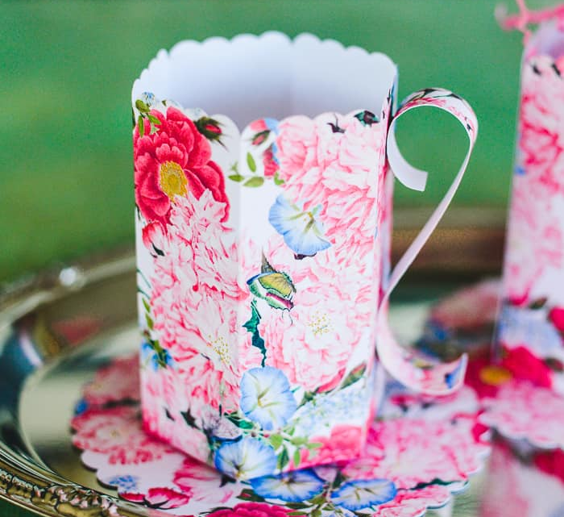

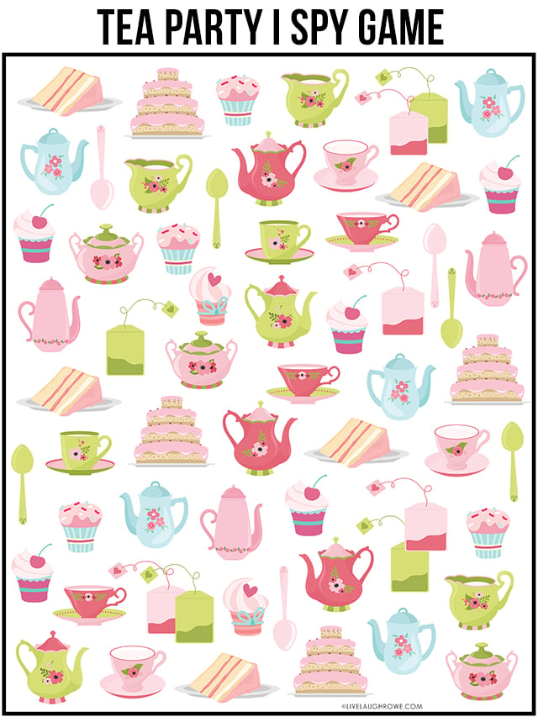
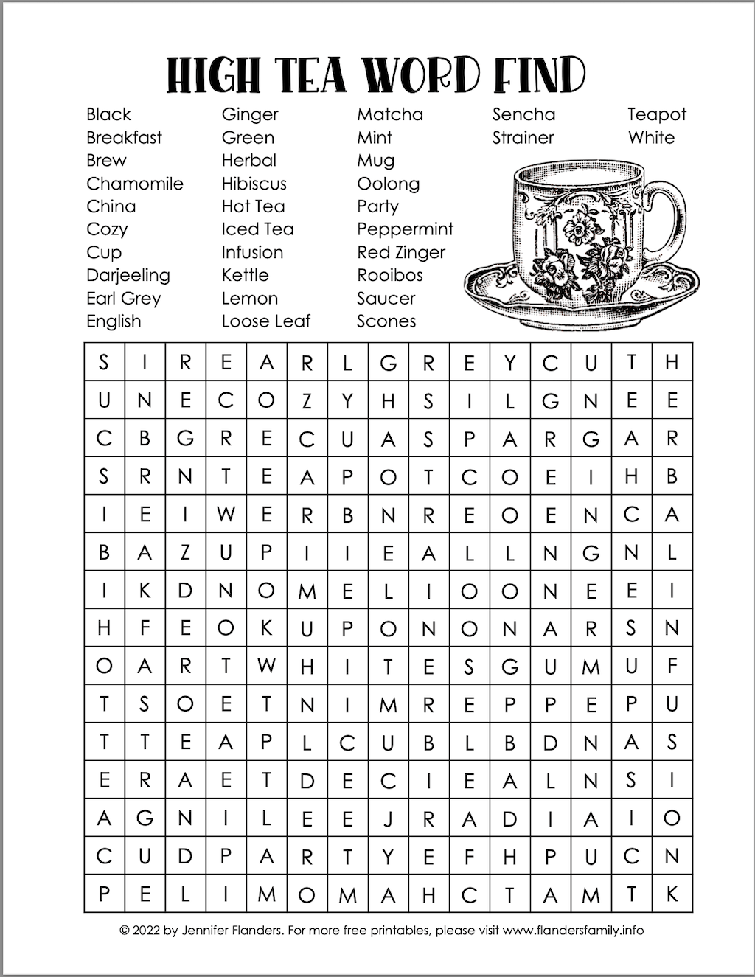
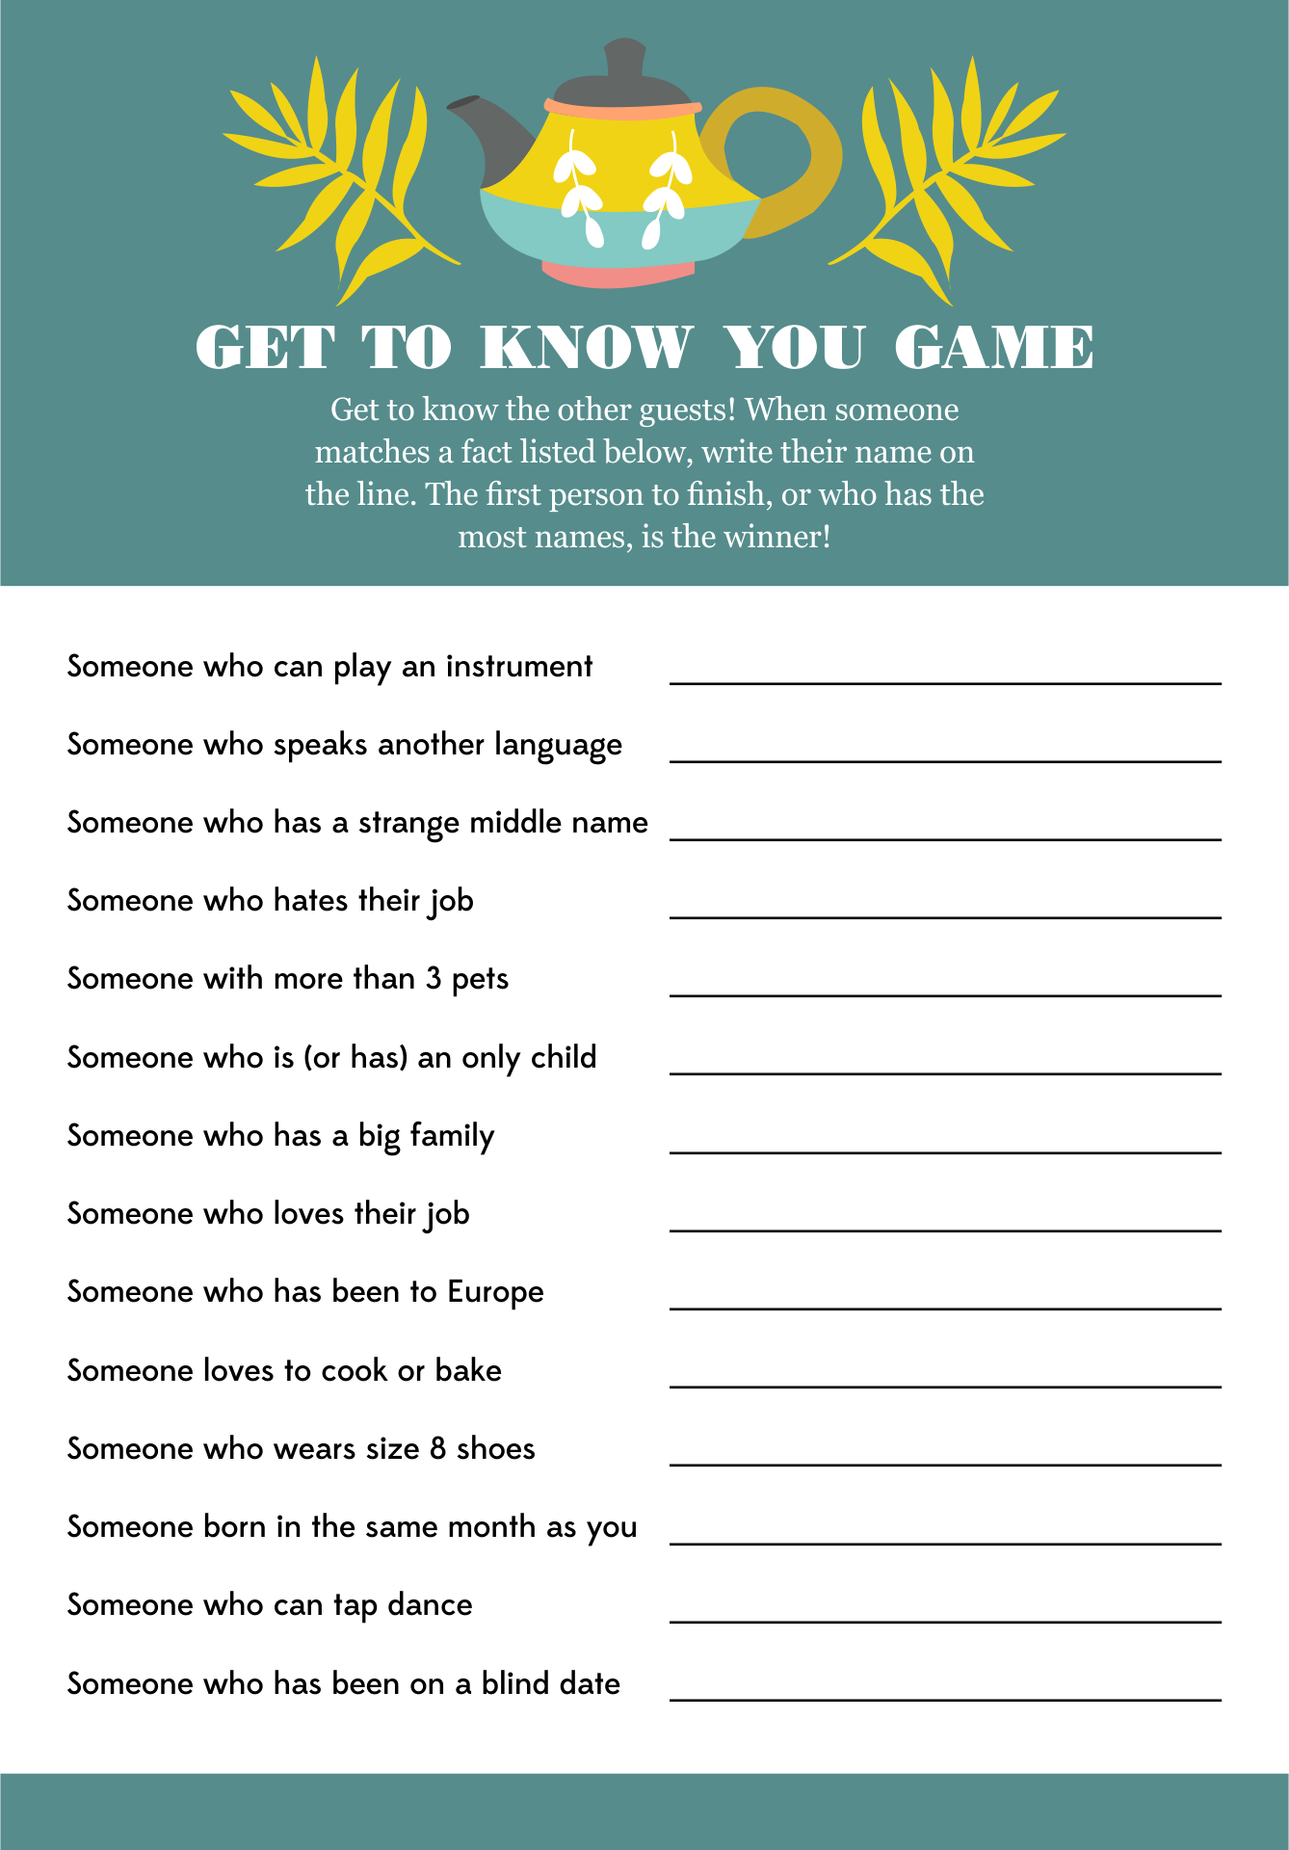
Irish Proverbs and Their Meanings

- An awkward colt often becomes a beautiful horse – everything can be improved.
- A wild goose never reared a tame gosling – children learn by example.
- The best way to keep loyalty in a man’s heart is to keep money in his purse – another self-explanatory one.
- A trout in the pot is better than a salmon in the sea – be thankful for what you have rather than chasing after what you can never get.
- An old broom knows the dirty corners best – wisdom comes with experience.
- Any man can lose his hat in a fairy wind – some things are out of anyone’s control.
- Don’t make little of your dish for it may be an ignorant man who judges it – never undersell yourself.
- The cat is always dignified until the dog comes by – everyone has something or someone that makes them angry.
- Wide is the door of the little cottage – it is often poor people who are most generous.
- Everyone lays a burden on the willing horse – people are quick to take helpful people for granted.
- It is easy to halve the potato where there is love – if you love someone you will share whatever you have without resentment
- Enough and no waste is as good as a feast – Having enough is better than having too much.
- While a person is out, his food goes cold – good things turn bad if left neglected.
- Do not take the thatch from your own roof to buy slates for another man’s house – you can’t help others unless you help yourself first.

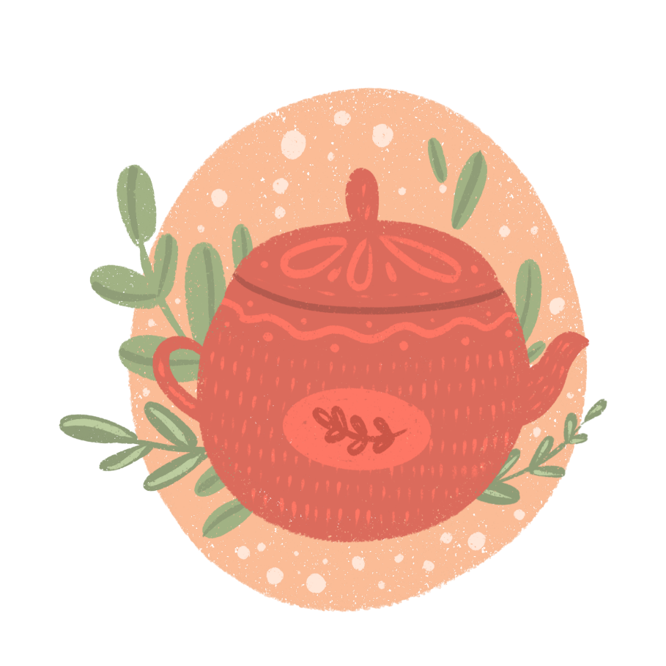

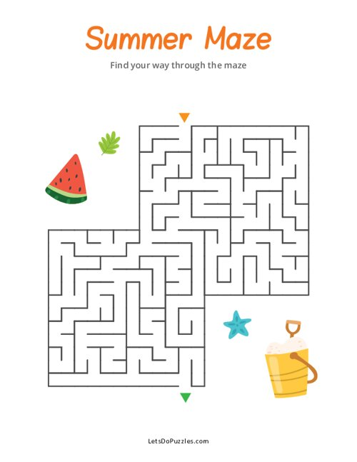

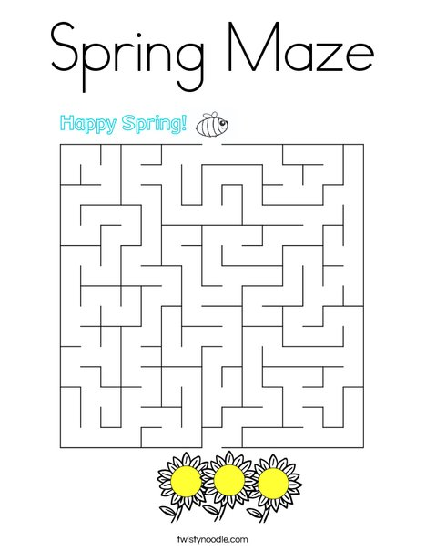
Tea Themed Trivia:
- What is the most widely consumed beverage in the world after water? Answer: Tea
- Which country is famous for its traditional tea ceremony called "chanoyu" or "chado"? Answer: Japan
- What is the name of the plant from which tea leaves are harvested? Answer: Camellia sinensis
- Which British monarch popularized afternoon tea in the 19th century? Answer: Queen Victoria
- What is the term for dried tea leaves wrapped in paper or cloth, ready for steeping? Answer: Tea bag
- Which type of tea undergoes the most oxidation during processing, resulting in a darker colour and stronger flavour? Answer: Black tea
- What is the traditional accompaniment to afternoon tea in England, consisting of small sandwiches, scones, and pastries? Answer: Tea cakes or finger sandwiches
- In which region of China was tea first discovered and cultivated? Answer: Yunnan province
- Which herb, often used for relaxation and sleep, is commonly brewed as a tea? Answer: Chamomile
- What is the name of the Chinese tea ceremony that emphasizes the appreciation of tea's taste, aroma, and appearance? Answer: Gongfu tea ceremony

A Tea Party Like No Other:
A Story
Once upon a time, in a cozy little village nestled in the rolling hills of England, there lived a kind-hearted woman named Mrs. Higgins. Mrs. Higgins was known throughout the village for her love of tea and her legendary tea parties.
Every afternoon, Mrs. Higgins would invite her friends and neighbours over to her charming cottage for tea. Her teapot was always bubbling, and her table was adorned with an array of delicious treats, from freshly baked scones to delicate finger sandwiches.
One sunny afternoon, Mrs. Higgins decided to host a special tea party in her garden. She spent the morning carefully arranging her best china cups and setting up a quaint little gazebo where her guests could relax and enjoy the sunshine.
As the guests arrived, they were greeted with the delightful aroma of freshly brewed tea and the sound of birds chirping in the trees. Mrs. Higgins beamed with joy as she poured steaming cups of tea for her friends, regaling them with stories of her adventures in tea-making.
But just as the party was getting into full swing, disaster struck! A mischievous squirrel, drawn by the scent of Mrs. Higgins' delicious treats, leaped onto the table and knocked over the teapot, sending tea cascading everywhere.
At first, there was a moment of stunned silence, but then Mrs. Higgins burst into laughter, declaring that it was the most exciting tea party she had ever hosted. With the help of her friends, they quickly cleaned up the mess and salvaged what tea they could from the broken pot.
Undeterred, Mrs. Higgins brewed another pot of tea, and soon the party was back in full swing, with laughter and camaraderie filling the garden once more. As the sun began to set and the guests bid their farewells, Mrs. Higgins couldn't help but feel grateful for the simple joys of friendship and a good cup of tea.
And so, in the village of rolling hills, Mrs. Higgins' tea parties became the stuff of legend, remembered fondly by all who attended, and inspiring smiles for years to come.

Classic scones with jam & clotted cream
Ingredients
- 350g self-raising flour, plus more for dusting
- 1 tsp baking powder
- 85g butter, cut into cubes
- 3 tbsp caster sugar
- 175ml milk
- 1 tsp vanilla extract
- squeeze lemon juice (see tips below)
- beaten egg, to glaze
- jam and clotted cream, to serve

Method
- STEP 1
Heat the oven to 220C/200C fan/gas 7. Tip the self-raising flour into a large bowl with ¼ tsp salt and the baking powder, then mix.
- STEP 2
Add the butter, then rub in with your fingers until the mix looks like fine crumbs. Stir in the caster sugar.
- STEP 3
Put the milk into a jug and heat in the microwave for about 30 secs until warm, but not hot. Add the vanilla extract and a squeeze of lemon juice, then set aside for a moment.
- STEP 4
Put a baking tray in the oven. Make a well in the dry mix, then add the liquid and combine it quickly with a cutlery knife – it will seem pretty wet at first.
- STEP 5
Scatter some flour onto the work surface and tip the dough out. Dredge the dough and your hands with a little more flour, then fold the dough over 2-3 times until it’s a little smoother. Pat into a round about 4cm deep. Take a 5cm cutter (smooth-edged cutters tend to cut more cleanly, giving a better rise) and dip it into some flour. Plunge into the dough, then repeat until you have four scones. You may need to press what’s left of the dough back into a round to cut out another four.
- STEP 6
Brush the tops with a beaten egg, then carefully arrange on the hot baking tray. Bake for 10 mins until risen and golden on the top. Eat just warm or cold on the day of baking, generously topped with jam and clotted cream. If freezing, freeze once cool. Defrost, then put in a low oven (about 160C/140C fan/gas 3) for a few minutes to refresh.
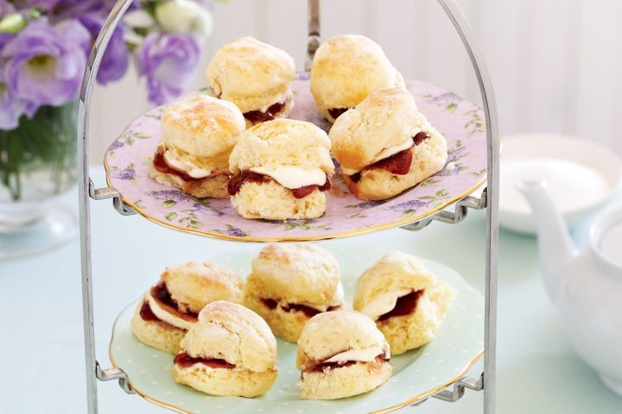

A Loving Recipe for a Perfect Cup of Tea - by Anonymous

1 Willing friend who loves to sit and share
1 Grateful heart to have a friend that cares
1 Beautiful garden to show us God is near
Many wonderful memories of times shared throughout the years.
Lots of smiles and laughter to brighten up our days
Many prayers that we prayed for each other along the way
I’m so blessed to have a friend like you
To share in everything I do.
For one special friend sharing a special cup of tea
Truly makes this a perfect recipe.

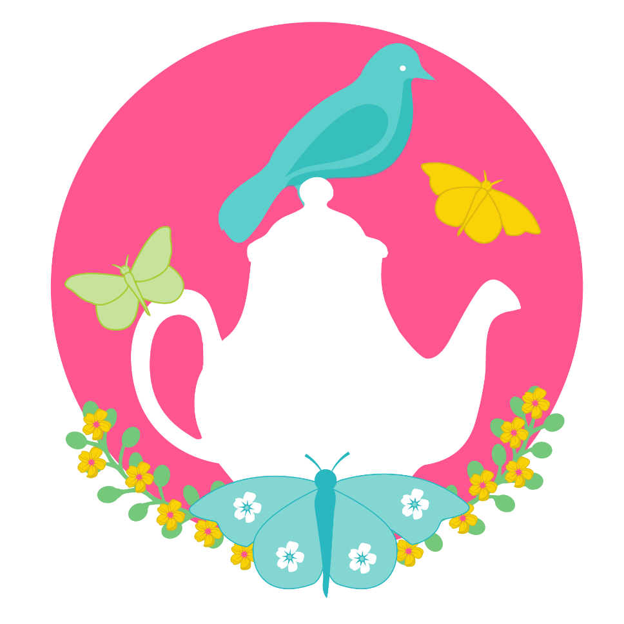
Friendship
By O.Clarke
A cup of tea, a friend so dear
Together we chase away the fear
The warmth that spreads through every vein
Reminds us that we're not alone again
The steam that rises from the brew
Filled with aroma, sweet and true
A symphony of flavours blend
With every sip, our hearts extend
We talk of life, we talk of dreams
We laugh, we cry, or so it seems
A bond so pure, a bond so true
A friendship that will always brew
So here's to you, my dear friend
May our cups never come to an end
May the tea we share bring us cheer
And keep our friendship ever dear.

Tea for Two by Doris Day

Picture you upon my knee,
Just tea for two and two for tea,
Just me for you
And you for me alone.

Nobody near us
To see us or hear us,
No friends or relations
On weekend vacations.
We won't have it known, dear,
That we own a telephone, dear;

Day will break and you'll awake
And start to bake a sugar cake,
For me to take
For all the boys to see.

We will raise a family,
A boy for you, a girl for me.
Oh, can't you see
How happy we would be?
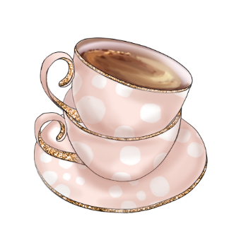
Pictures To Colour

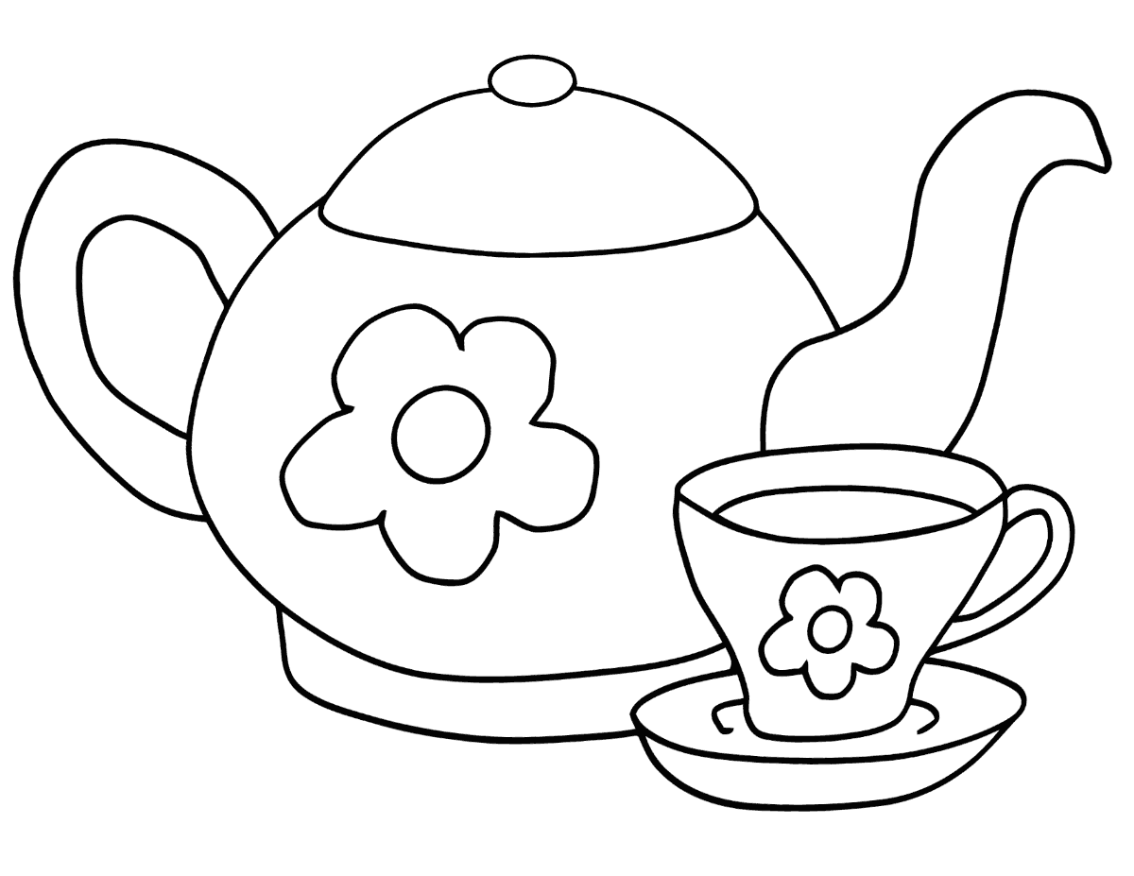

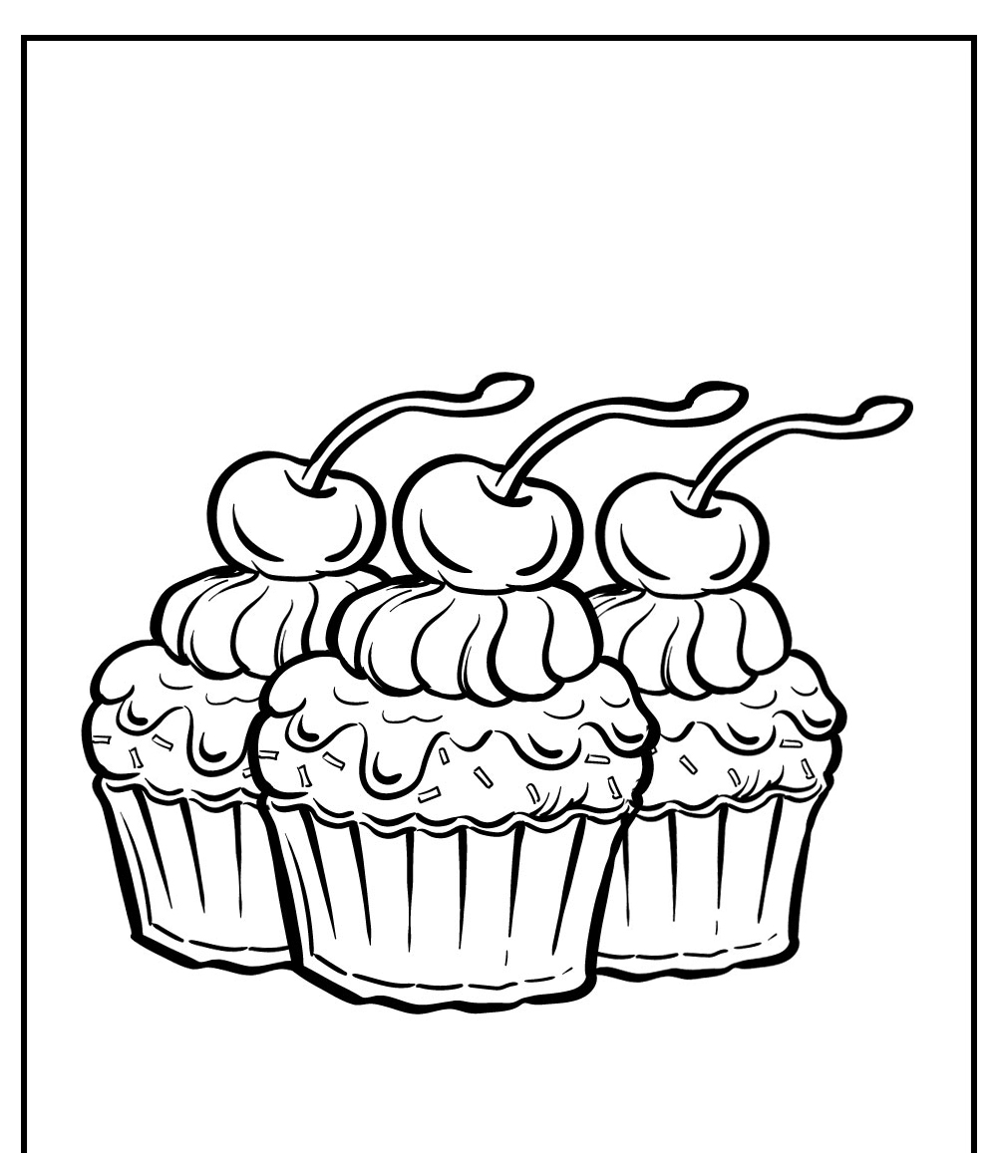

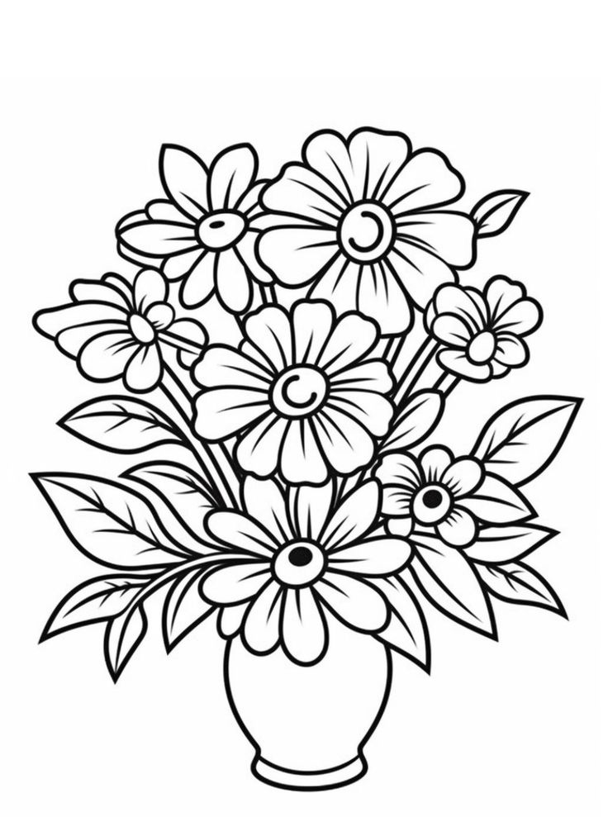
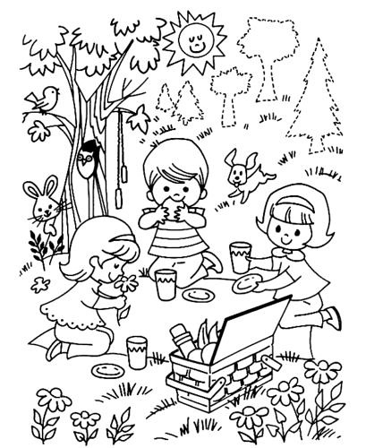

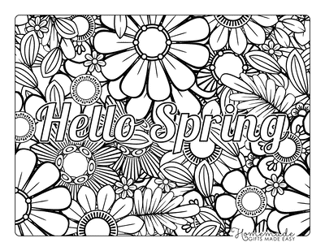

Old Irish Stories and Folklore

A Tall Tea Tale
Once upon a time before people used to drink tea a man went to Cork one day to pay his rent. After travelling around the city he felt very hungry. He went into a hotel and asked for a plate of porridge. The waitress told him that she had no porridge and she asked him would he have a cup of tea. The man said he never heard of tea before and asked what kind was it. The waitress gave him a cup of tea and she had milk and sugar put in it, when she was giving it to him she said "That’s the best Congo tea and I hope you will like it". He drank it and he said it was lovely, and he asked for a second cup and she gave it to him, but she did not put the sugar or milk in it, instead she put the milk and sugar on the table and said, "Sweeten it to your liking", he did not know what she meant, he drank some of the tea and it burned him, and he threw the rest of it away. He went to pay for the tea and when he was paying the waitress she asked him how did he like the tea, and he said that the "Congo tea" was lovely, but the "Sweeten to Your Liking tea” was just horrible!

