July 2024
Activity Pack

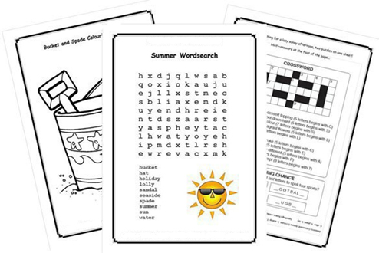

Dear Friends,

We are now in the month of July; the birds are singing and the sun is shining (some of the time!). We are looking forward to enjoying the lovely warm weather.

Excitement is building for the 2024 Summer Olympics, scheduled to take place from 26 July to 11 August 2024 in France. Paris will be the main host city and 16 other cities spread across Metropolitan France and Tahiti!

Calling all artists and writers among us, we would love to hear from you! We warmly welcome submissions of poems and stories to be featured in the pack.

Additionally, if you'd like your artwork from this pack or photos of any local fundraising events showcased on our social media, please send your images via email to communityengagement@alzheimer.ie.

Our Free Helpline is available at Phone: 1800 341 341 and Email: helpline@alzheimer.ie.

We hope you all enjoy this month’s pack.

Table of Contents

Activity | Pages
Summer Olympics Quiz | 4,5
Elvis Presley Crossword | 6 - 8
Sing The Next Line | 9,10
Wordsearch | 11,12
Great Grandmother’s Wish (Short Story) | 13,14
Famous Olympic Athletes | 15 - 18
Pictures to Colour | 19 - 21
Match the Objects | 22, 23
Chocolate Pudding Recipe | 24
Remembering the Clothesline | 25
Inniskeen Road: July Evening (Poem) | 26
The Lake Isle Of Innisfree (Poem) | 27
The Four Farrellys (Poem) | 28 - 30
Match the Shadows | 31,32
Find the Object | 33,34
Math is Fun | 35,36
Mindfulness Session | 37
Useful Resources | 38,39

Summer Olympics Quiz
Pit your wits against our Olympics-themed quiz.
1. In which year were the first modern Olympic Games held?
a) 1896 b) 1902 c) 1936

2. Which city hosted the 1936 Summer Olympics?
a) Dublin b) Paris c) Berlin

3. In which city were the 1972 Summer Olympics held?
a) Los Angeles b) Munich c) London

4. In which year were women allowed to participate in athletics events for the first time?
a) 1925 b) 1936 c) 1928

5. Which country will host the 2024 Olympic Games?
a) Spain b) France c) Itay

6. The movie ‘Chariots of Fire’ is based on which Olympian?
a) Eric Liddle b) Mungo Jerry c) Mohammed Ali

7. Who was the first Irish woman to win an Olympic medal?
a) Katie Taylor b) Sonia O’ Sullivan c) Beatrice Hill-Lowe

8. How many Olympic Gold medals does Ireland have?
a) 9 b) 11 c) 13

9. In what year did Michael Carruth win gold in Boxing for Ireland?
a) 1988 b) 1990 c) 1992

10. Daley Thompson won his gold medals in what event?
a) Boxing b) Decathlon c) Swimming

Answers:
1. 1896
2. Berlin
3. Munich
4. 1928
5. France
6. Eric Liddle
7. Beatrice Hill-Lowe
8. 11
9. 1992
10. Decathlon
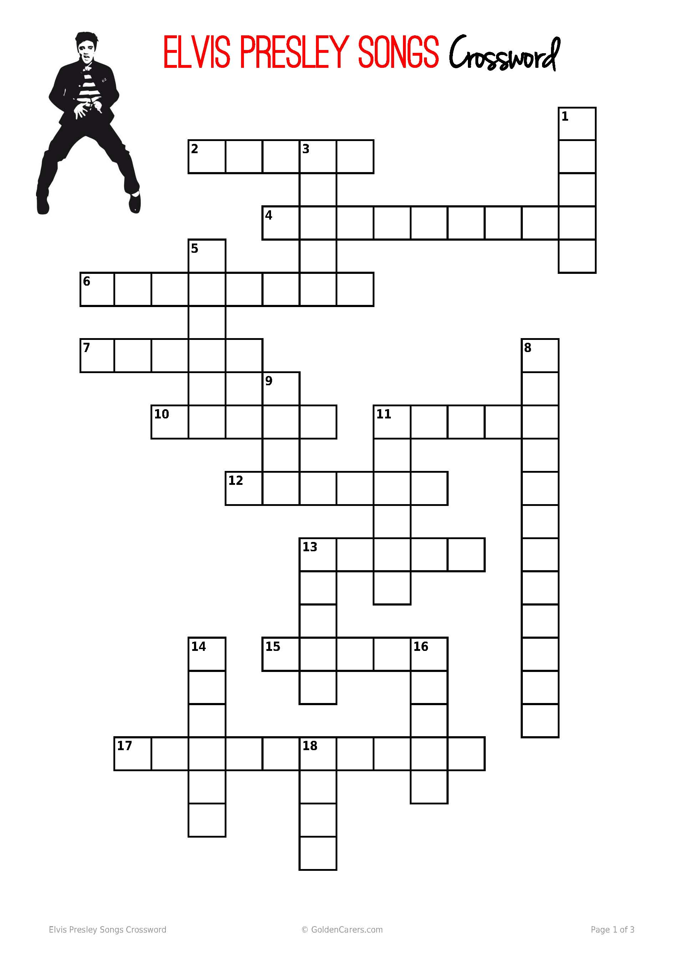
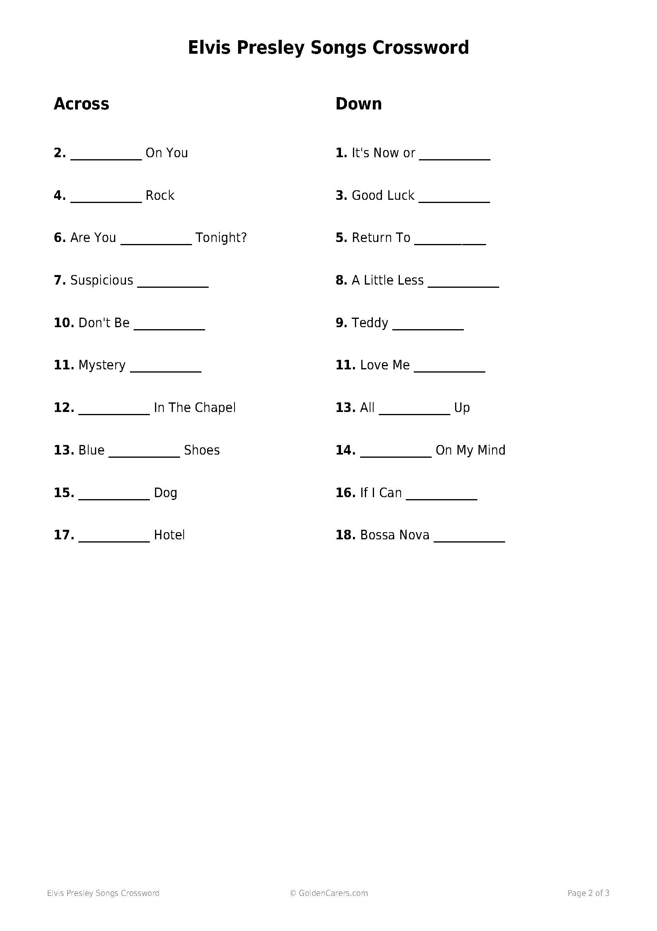

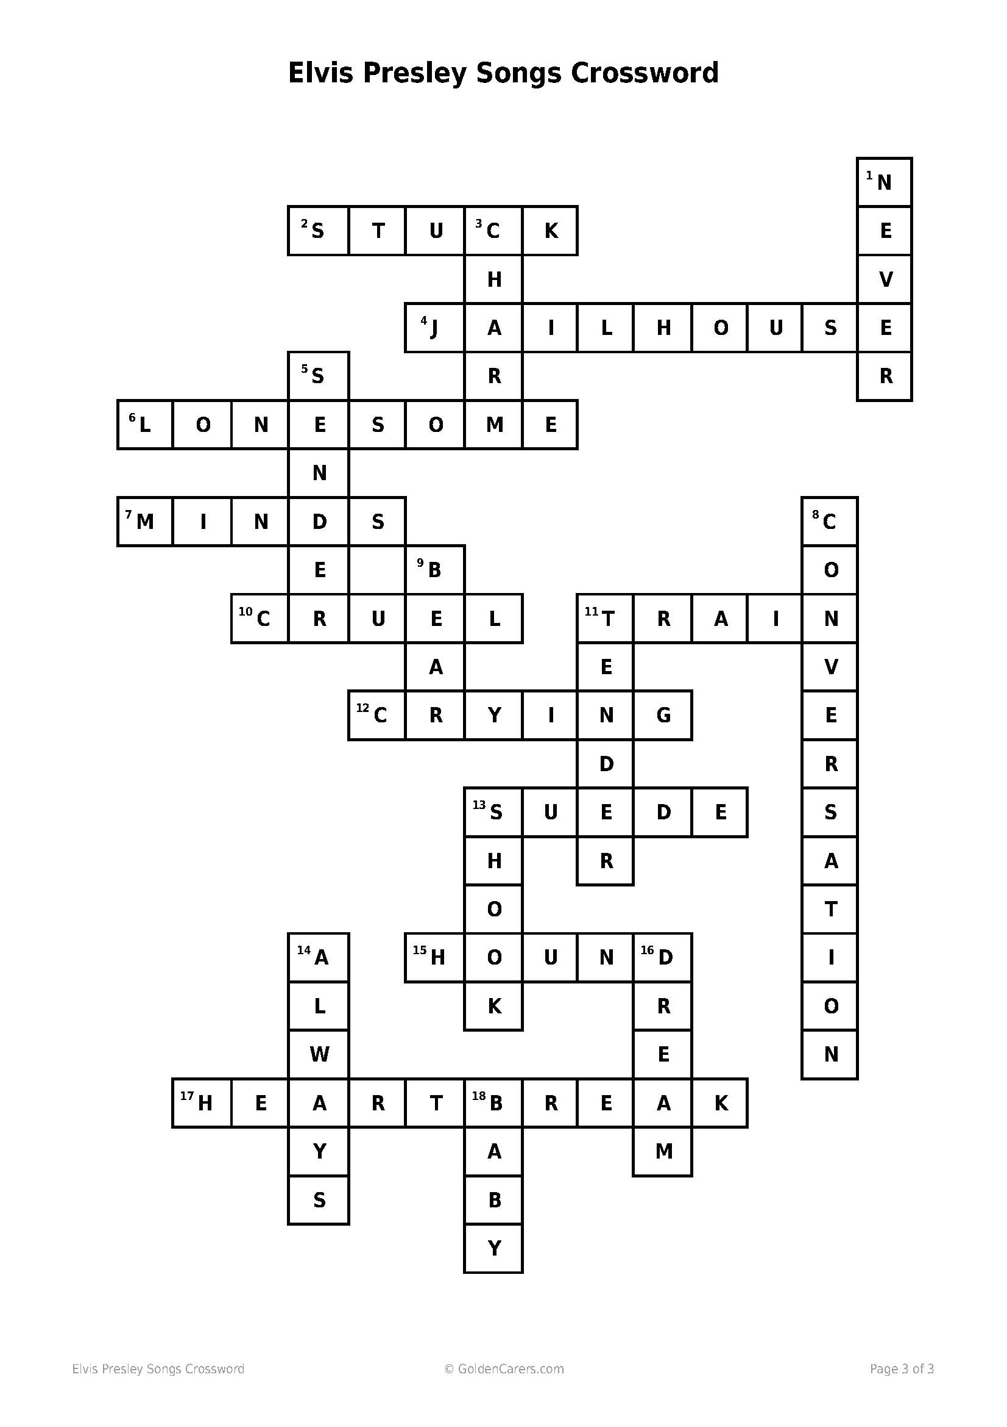

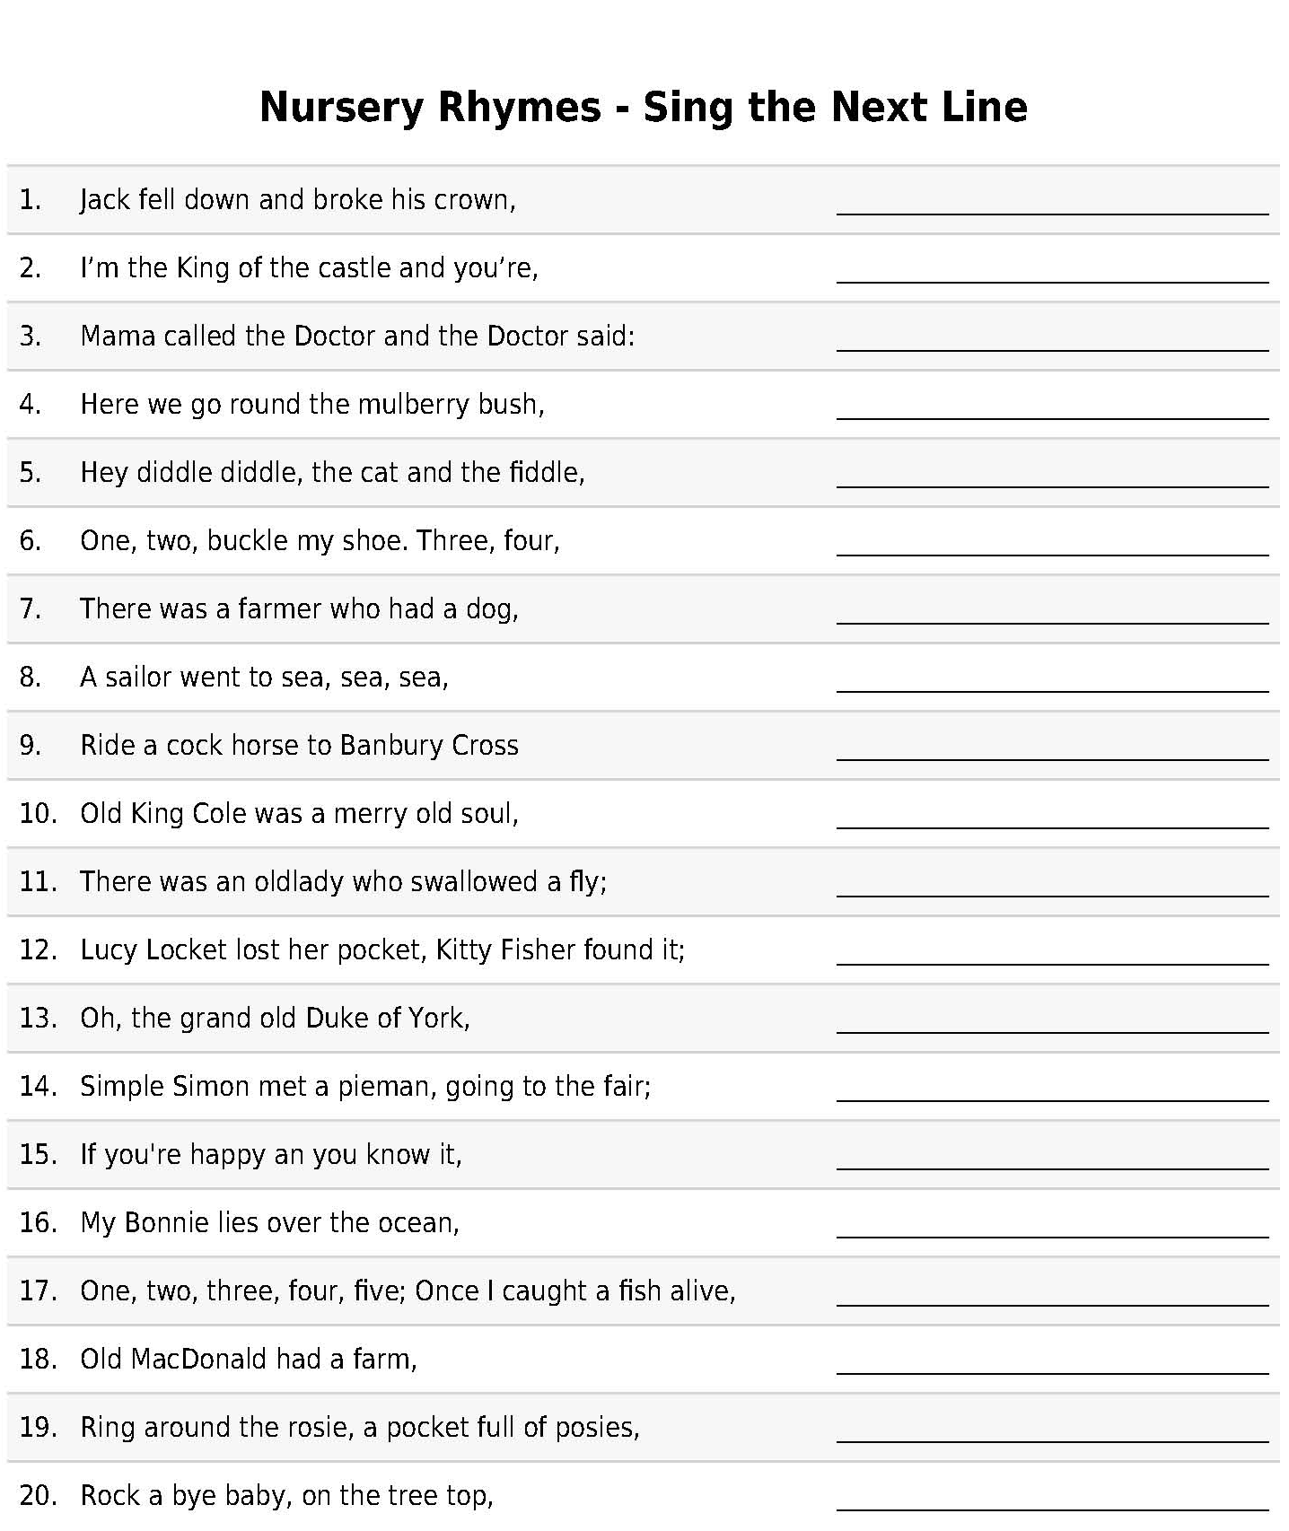

Answers:
1 - and Jill came tumbling after
2 - the dirty rascal
3 - No more monkeys jumping on the bed!
4 - on a cold and frosty morning
5 - the cow jumped over the moon
6 - knock at the door
7 - And Bingo was his name-O
8 - To see what he could see, see, see
9 - To see a fine lady upon a white horse
10 - and a merry old soul was he
11 - I don't know why she swallowed a fly – perhaps she'll die!
12 - Not a penny was there in it, Only ribbon round it.
13 - He had ten thousand men; he marched them up to the top of the hill and he marched them down again.
14 - Says Simple Simon to the pie man, let me taste your ware.
15 - clap your hands
16 - Oh, bring back my Bonnie to me
17- Six, seven, eight, nine, ten; Then I let them go again.
18 - E I E I O
19 - Atishoo, atishoo, we all fall down!
20 - When the wind blows the cradle will rock
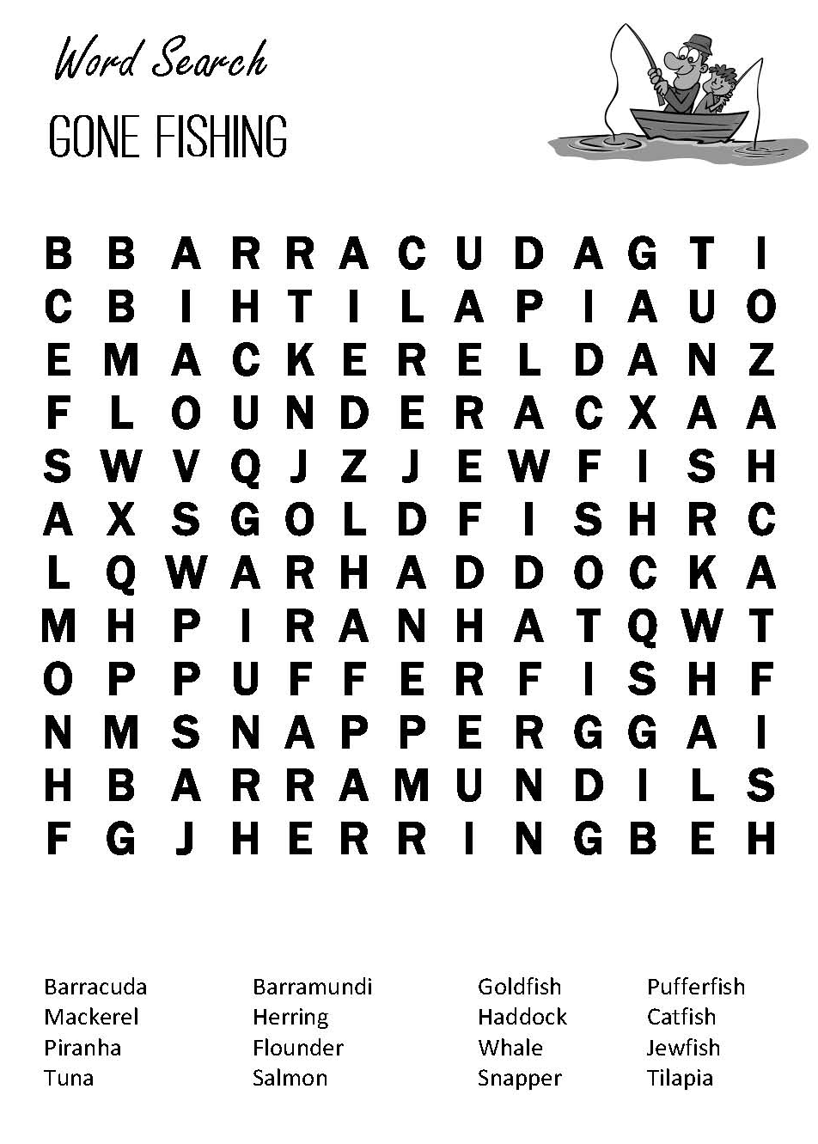

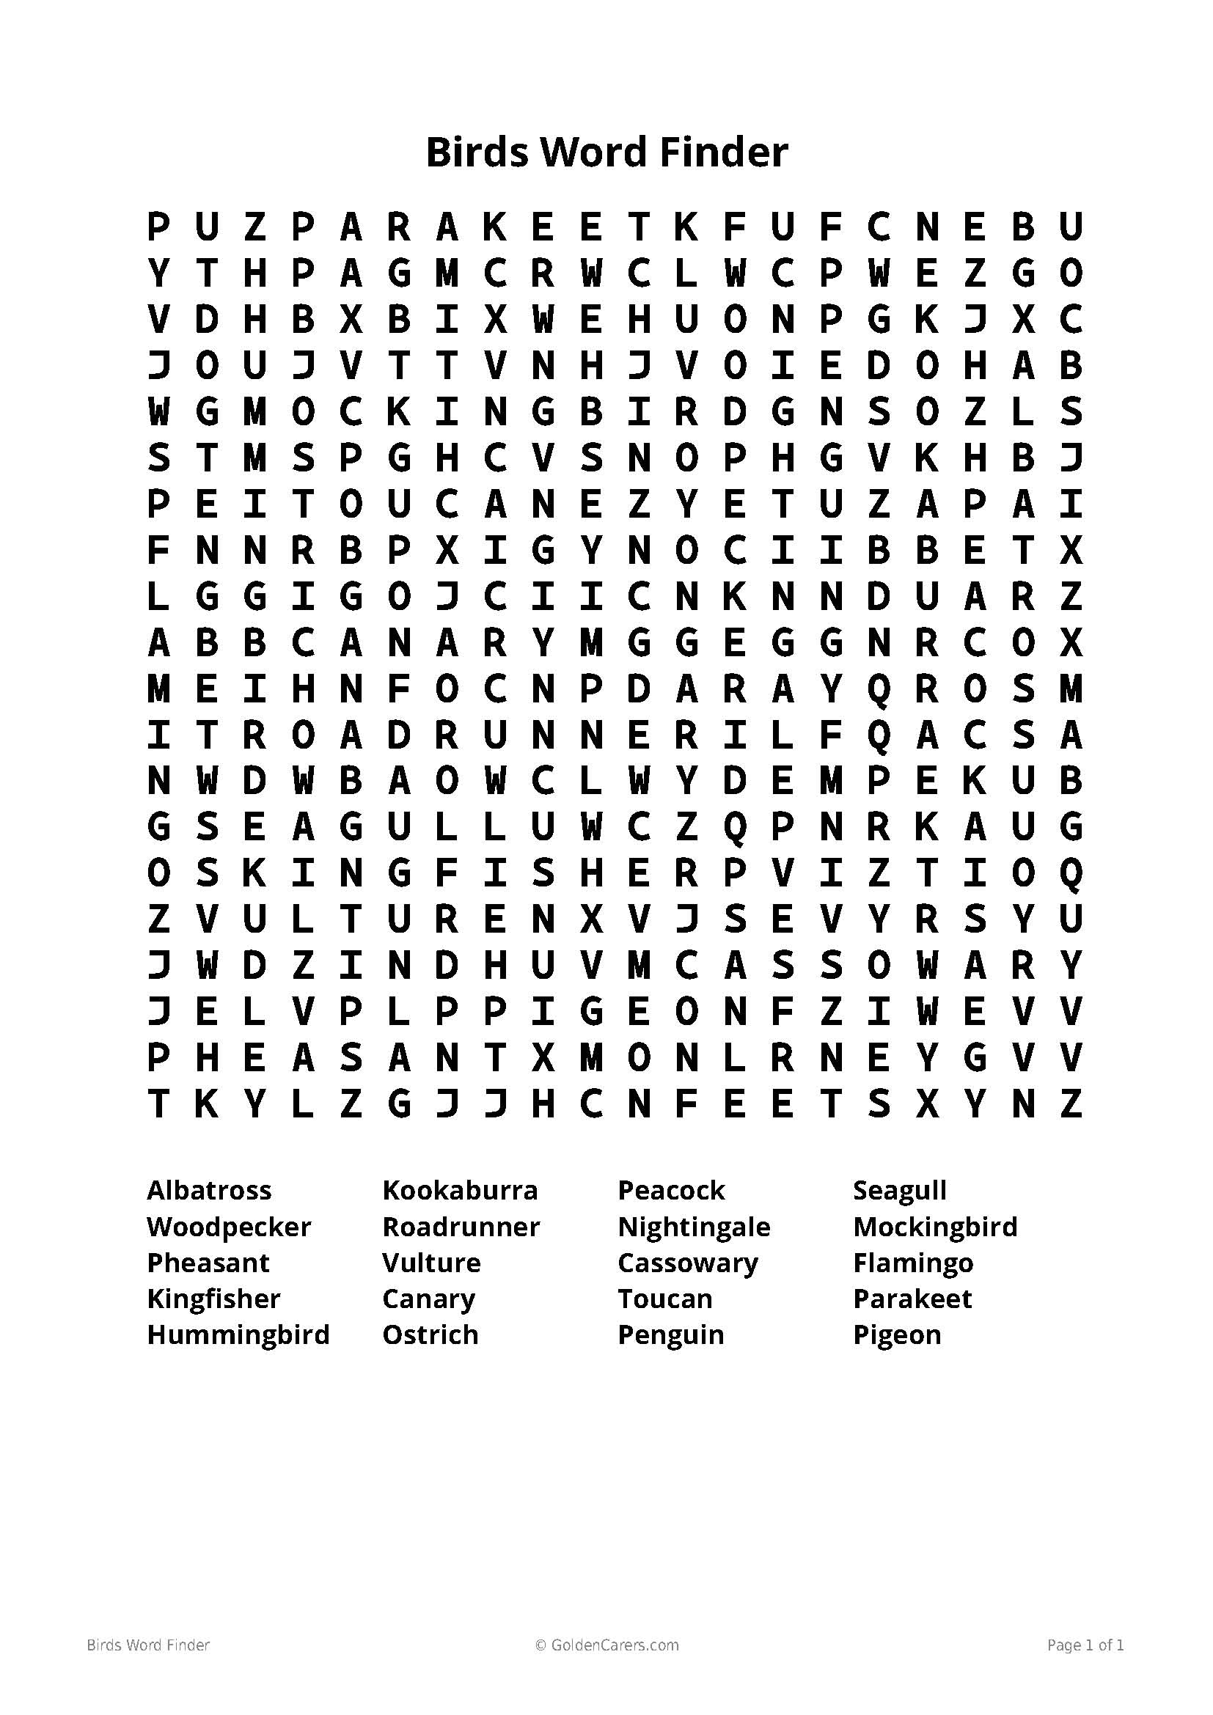
Great-Grandmother’s Wish

“Did you ever see a fairy, grannie?” said Tots.

“No,” she said, “but my great-grandmother did.”

“Oh, do tell me!” cried Tots.

“Well, once upon a time, as she was carrying her butter to market, she picked up a crooked sixpence. And with it, and what she sold her butter for, she bought a little black pig. Now, coming home, she had to cross the brook; so she picked piggy up in her arms and carried her over the brook. And, lo, instead of a pig, there was a little fairy in her arms!”

“Oh!” cried Tots, “what was it like?”

“Well, it had a red cap on its head, and a green frock, and it had gauzy wings, and it wanted to fly away, but great-grandmother held it tight.

“‘Please let me go,’ said the fairy.

“‘What will you give me?’ said great-grandmother.

“‘I will give you one wish,’” answered the fairy.

So great-grandmother thought and thought what was the best thing to wish for, and at last she said,—

“‘Give to me and to my daughters to the eleventh generation the lucky finger and the loving heart.’

“‘You have wished a big wish,’ said the fairy, ‘but you shall have it.’” So she kissed great-grandmother’s eyes and mouth, and then she flew away.

“And did the wish come true?” asked Tots.

“Always—always,” answered grannie. “We have been since then the best spinners and knitters in all the countryside, and the best wives and daughters.”

“But,” said Tots, “what will the eleventh generation do when the wish stops and the good-luck?”

“I don’t know,” said grannie, shaking her head. “I suppose they’ll have to catch a fairy of their own.”

Famous Olympic Athletes

He was born in Arklow, Co. Wicklow.

He is an Irish former athlete who specialised in middle-distance running.

He won a gold medal in the 1500 metres event at the 1956 Summer Olympics in Melbourne.

He later earned a bronze medal in the 1500 metres event at the 1958 European Athletics Championships in Stockholm.

He retired from Athletics in 1962.

He is married to Joan Riordan.

Who is he?

Answer: Ronnie Delany

“I knew I was as good as anyone in the world so my expectation was that I would win!”
– Ronnie Delany

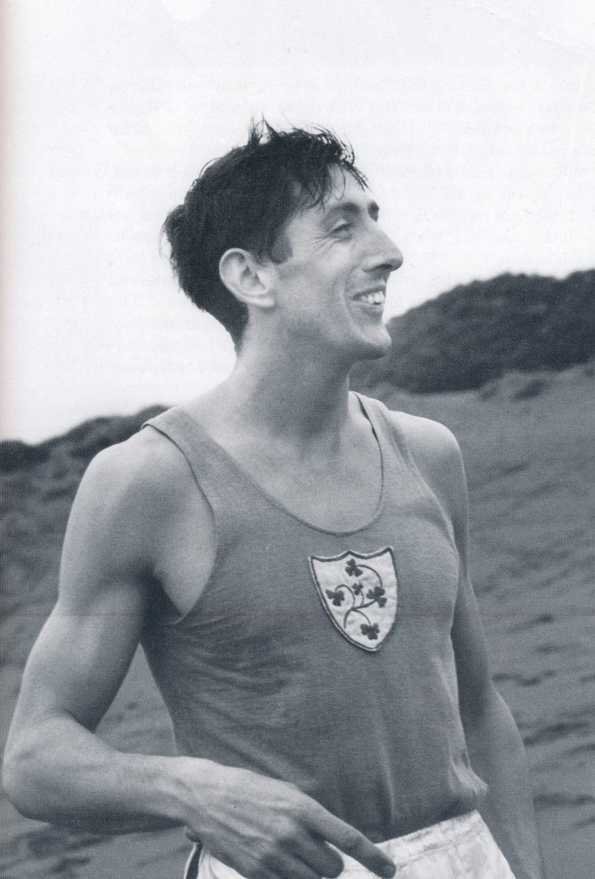

She was born on 2nd July 1986 in Bray, Co. Wicklow.

She has three siblings – Lee, Peter and Sarah.

Her parents are Pete and Bridget.

She won Gold in the 2012 London Olympic Games.

She turned professional in 2016.

Who is she?

Answer: Katie Taylor

“I want to go down in the history books as one of the greatest female boxers of all time and I think I am on the right track”.
- Katie Taylor

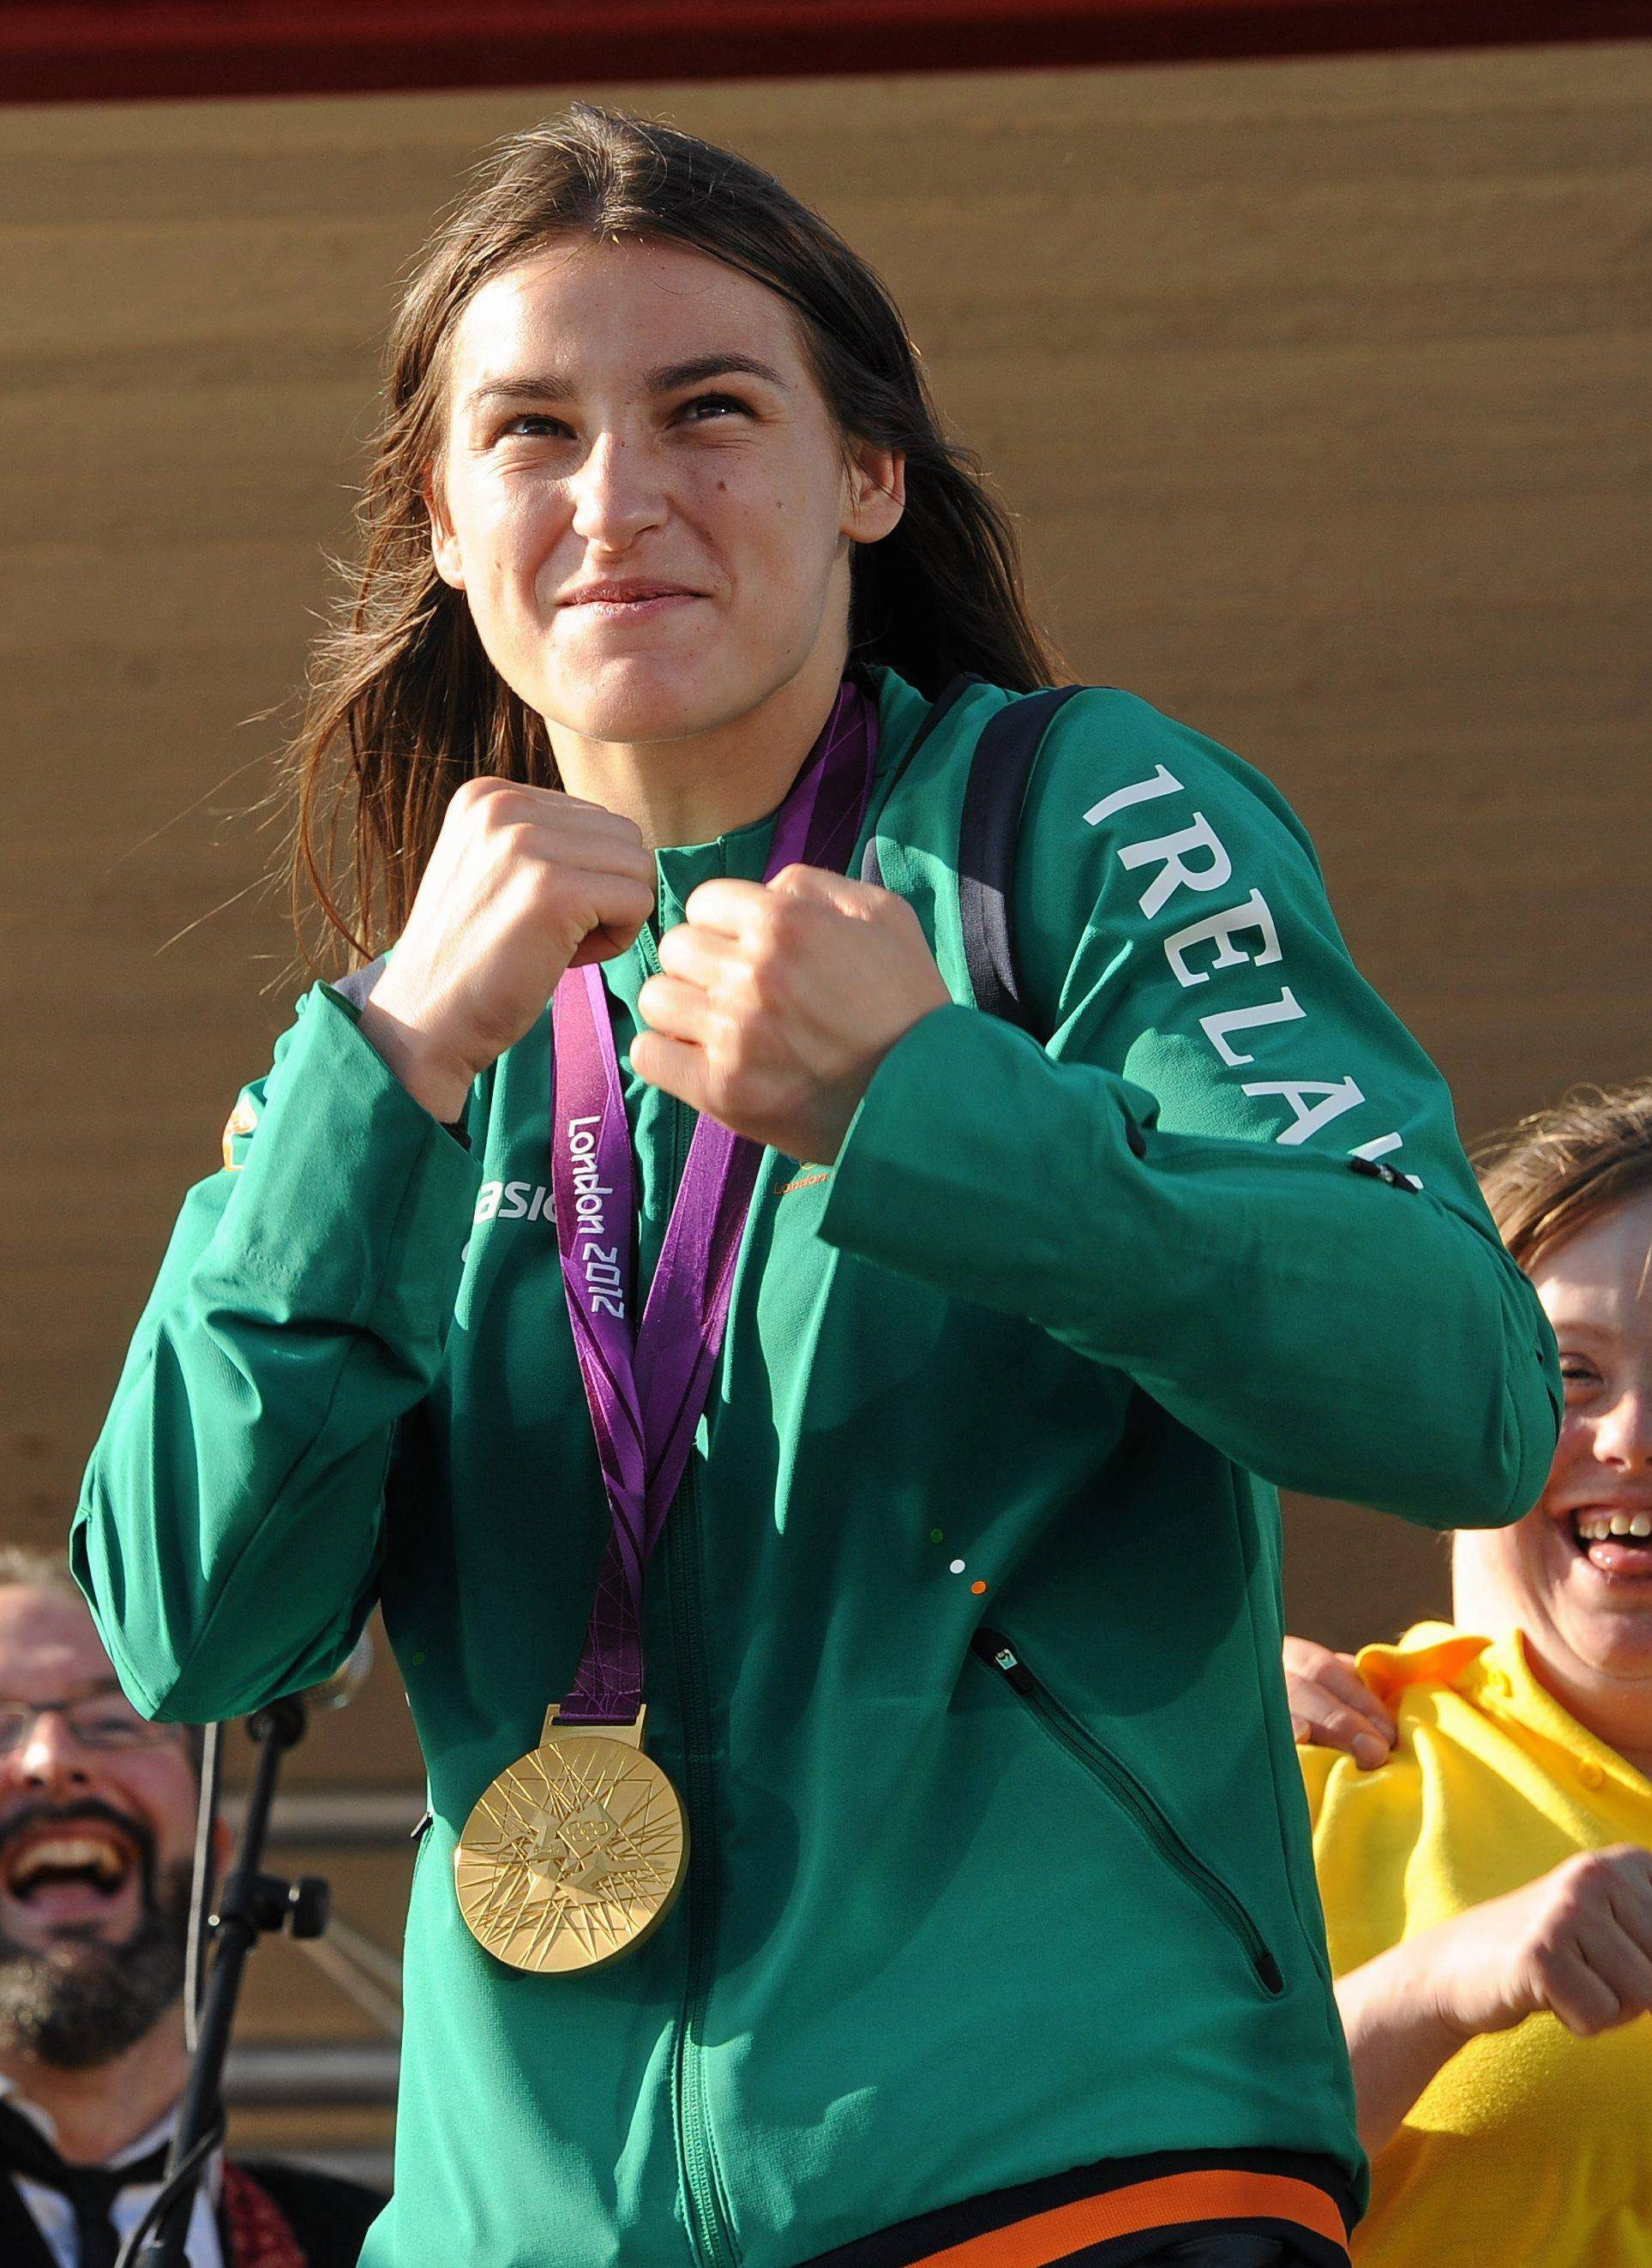

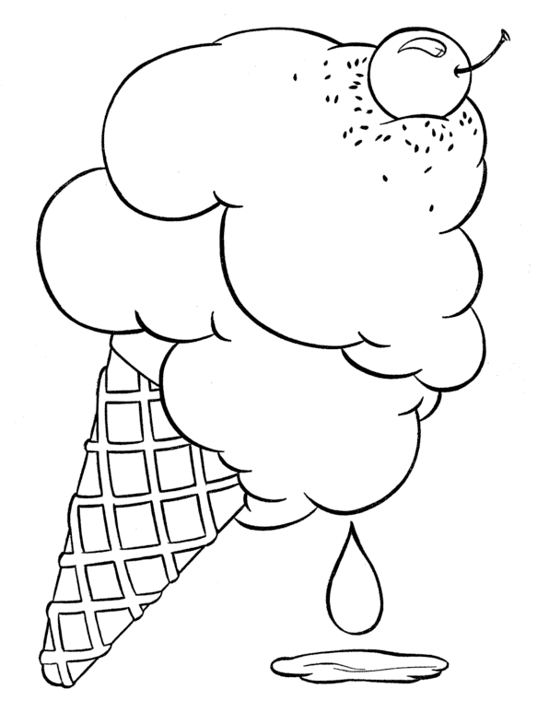

Match The Objects
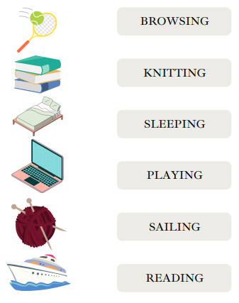

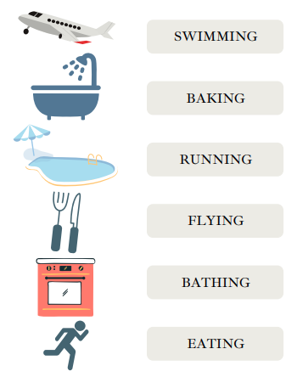

Chocolate Pudding Recipe
Serves: 6
Ingredients
- 425ml whole milk (14½oz)
- 150ml cream (5oz)
- 3 large eggs, lightly beaten
- 30g cornflour (1oz)
- 150g sugar (5oz)
- 3 tablespoons cocoa powder
- pinch salt
- 70g dark chocolate, finely diced (2 ½oz)

Directions
- Heat the milk and cream in a metal bowl over a saucepan of simmering water, making sure the water does not touch the base of the bowl. Do not boil the milk.
- In a separate bowl, beat the eggs, cornflour, sugar, cocoa, salt, and diced chocolate.
- Add hot milk one ladleful at a time while whisking, so the chocolate melts but the eggs don't cook.
- Pour mixture into a large saucepan and heat very slowly, stirring, until just below boiling point.
- Blend in a blender until very smooth or beat 5 minutes with a wooden spoon.
- Transfer to a bowl, cover with plastic wrap and chill 2-3 hours in the fridge.

Enjoy!
Remembering the Clothesline
You have to be a "certain age" to appreciate this one!
I can hear my mother saying...

THE BASIC RULES FOR CLOTHESLINES:
1. You had to hang the socks by the toes... NOT the top.
2. You hung pants by the BOTTOM/cuffs... NOT the waistbands.
3. You had to WASH the clothesline(s) before hanging any clothes - walk the entire length of each line with a damp cloth around the lines, because the lines might have been dirty, and leave marks on the clean clothes you pegged there.
4. You had to hang the clothes in a certain order, and always hang "whites" with "whites," and hang them first.
5. You NEVER hung a shirt by the shoulders - always by the tail! What would the neighbours think?
6. Wash day on a Monday! NEVER hang clothes on the weekend, or on Sunday, for Heaven's sake!
7. Hang the sheets and towels on the OUTSIDE lines so you could hide your "unmentionables" in the middle.
8. It didn't matter if it was sub-zero weather... clothes would "freeze-dry."
9. ALWAYS gather the clothes pins when taking down dry clothes! Pins left on the lines were "tacky"!
10. If you were efficient, you would line the clothes up so that each item did not need two clothes pins, but shared one of the clothes pins with the next washed item.
11. Clothes off of the line before dinner time, neatly folded in the clothes basket, and ready to be ironed.
12. IRONED???!! Well, that's a whole OTHER subject!
Inniskeen Road: July Evening
Patrick Kavanagh

The bicycles go by in twos and threes -
There's a dance in Billy Brennan's barn to-night,
And there's the half-talk code of mysteries
And the wink-and-elbow language of delight.
Half-past eight and there is not a spot
Upon a mile of road, no shadow thrown
That might turn out a man or woman, not
A footfall tapping secrecies of stone.

I have what every poet hates in spite
Of all the solemn talk of contemplation.
Oh, Alexander Selkirk knew the plight
Of being king and government and nation.
A road, a mile of kingdom, I am king
Of banks and stones and every blooming thing.
The Lake Isle Of Innisfree
William Butler Yeats

I will arise and go now, and go to Innisfree,
And a small cabin build there, of clay and wattles made:
Nine bean-rows will I have there, a hive for the honey-bee,
And live alone in the bee-loud glade.

And I shall have some peace there, for peace comes dropping slow,
Dropping from the veils of the morning to where the cricket sings;
There midnight's all a glimmer, and noon a purple glow,
And evening full of the linnet's wings.

I will arise and go now, for always night and day
I hear lake water lapping with low sounds by the shore;
While I stand on the roadway, or on the pavements grey,
I hear it in the deep heart's core.
The Four Farrellys
Percy French

In a small hotel in London I was sitting down to dine.
When the waiter brought the register and asked me if I'd sign.
And as I signed I saw a name that set my heart astir —
A certain "Francis Farrelly" had signed the register
I knew a lot of Farrellys and out of all the crew
I kept on "sort of wonderin' " which Farrelly were you.
And when I'd finished dinner I sat back in my chair,
Going round my native land to find, what Farrelly you were.
SOUTH
Were you the keen-eyed Kerryman I met below Kenmare,
Who told me that when Ireland fought "the odds were never fair?"
If Cromwell had met Sarsfield, or Owen Roe O'Neill,
It's not to Mister Gladstone we'd be lookin' for repeal.
Would have Ireland for the Irish, not a Saxon to be seen,
And only Gaelic spoken in that House in College Green. Told me landlords wor the Divil! their agints ten times worst,.
And iv'ry sort of government for Ireland was a curse!
Oh! if you're that Francis Farrelly, your dreams have not come true,
Still, Slainthe! Slainthe! Fransheen! for I like a man like you!
NORTH
Or were you the Francis Farrelly that often used to say
He'd like to blow them Papishes from Derry walls away?
The boy who used to bother me that Orange Lodge to join,
And thought that history started with the Battle o' the Boyne —
I was not all with ye, Francis, the Pope is not ma friend,
But still I hope, poor man, he'll die without that bloody end. -
And when yer quit for care yerself, and get to Kingdom Come,
It's not use teachin' you the harp — you'll play the Orange drum!
Och! man, ye wor a fighter, of that I had no doubt.
For I see ye in Belfast one night when the Antrim Road was out!
And many a time that evenin' I thought that ye wor dead,
The way them Papish pavin' stones was hoppin' off yer head.
Oh! if you're the Francis Farrelly who came from North Tyrone -
Here's lookin' to ye, Francis, but do leave the Pope alone!
EAST
Or were you the Francis Farrelly that in my college days
For strollin on the Kingstown Pier had such a curious craze?
D'y mind them lovely sisters — the blonde and the brunette?
I know I've not forgotten, and I don't think you forget!
That picnic at the Dargle —' and the others at the Scalp —
How my heart was palpitatin' — hers wasn't — not a palp!
Someone said ye married money — any maybe ye were wise,
But the gold you loved was in her hair, and the d'monds in her eyes!
So I like to think ye married her and that you're with her yet,
'Twas some "meleesha" officer that married the brunette;
But the blonde one always loved ye, and I knew you loved her too,
So me blessin's on ye, Francis, and the blue sky over you!
WEST
Or were you the Francis Farrelly I met so long ago,
In the bog below Belmullet, in the County of Mayo?
That long-legged, freckled Francis with the deep-set, wistful eyes,
That seemed to take their colour from those ever-changing skies,
That put his flute together as I sketched the distant scene,
And played me "Planxy Kelly and the "Wakes of Inniskeen."
That told me in the Autumn he'd be Bailin' to the West
To try and make his fortune and send money to the rest.
And would I draw a picture of the place where he was born,
And he'd hang it up, and look at it, and not feel so forlorn.
And when I had it finished, you got up from where you sat,
And you said, "Well, you're the Divil, and I can't say more than that."
Oh' if you're that Francis Farrelly, your fortune may be small,
But I'm thinking — thinking —Francis, that I love you best of all;
And I never can forget you — though it's years and years ago -
In the bog below BeImullet, in the County of Mayo.

Match the Shadows

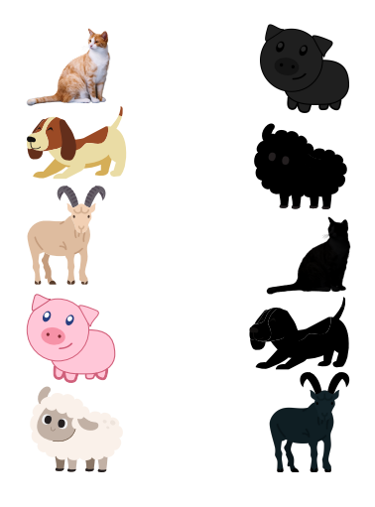

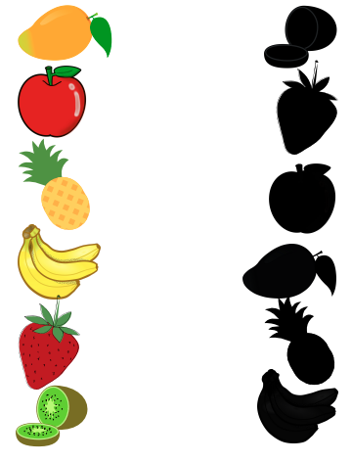
Find the Object

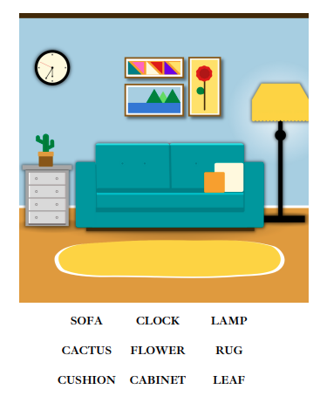

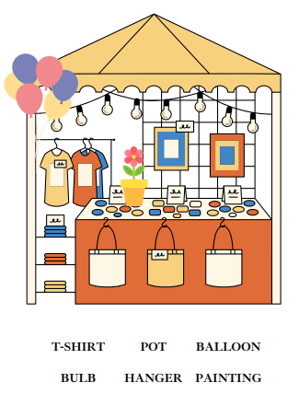
Math is Fun!

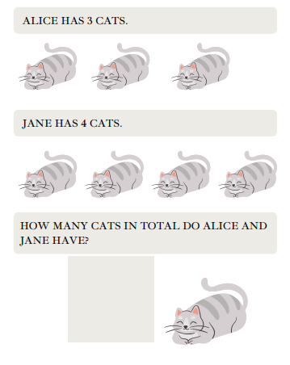
Mindfulness and Meditation

Although you cannot always control the mind, you can encourage it to be more at ease. Learning to do this will help you respond rather than react to your thoughts and emotions.

This practice gives you the opportunity to train the mind to slow down when it becomes overactive, and helps you practice ease and relaxation instead of perpetuating those difficult mental states.
You can sit upright or lie down for this practice.
Take a few deep breaths. Inhaling, fill the lungs completely.
Hold the breath for just a second or two, and exhale slowly.
As you let the breath go, try to empty the lungs slowly and completely.
If thoughts are present, just leave them be.
Offer yourself two simple phrases of kindness toward the mind:
May my mind be at ease.
May I be at ease with my mind.
Synchronize these phrases with your exhale, offering one phrase every time you breathe out.
Hear each word and try to connect with your own intention to care for the mind. Even if you can say only one phrase before the mind wanders, you are still moving toward relaxation by continuing to practice.
Helpful Resources
Cafés
We are hosting several Alzheimer Cafés in July. They are a place to come together, share a cuppa and listen to our amazing guest speakers. For information on how to attend visit: https://alzheimer.ie/service/alzheimer-cafe/.

There is a Cabin Café meeting / Social Coffee morning for those living with Dementia and their carers in Carlow on July 2nd. Located at The Old School House, Barracks St., Carlow, R93YW10. Booking essential: Margaret 087 8380018.

The Court House Café in Roscrea is scheduled for July 31st from 10.30am to 12.30pm. It will be taking a break for the month of August.

The Bookwork Café in Thurles is scheduled for September 4th. It will be taking a break for July and August.

The Deise Memories Café is scheduled for July 10th and August 14th at 10.30am to 12pm. Located in the Sacred Heart Centre, Ballytruckle, Waterford.

Ballincollig, Macroom and Kenmare are not hosting cafés in July and August.

Social Clubs
Some of our Social Clubs will be running in July. These are a social gathering where people can drop in to chat, access information and support, meet other people. Click the link below to find your nearest Social Club https://alzheimer.ie/service/socialclub/.
The Castlebar Dementia Inclusive Social Club will be on Friday, July 12th and Friday, July 26th from 11am – 1pm. The venue is the Castlebar Social Services Building, Castle St., Castlebar, F23CY67. Contact Catherine Mc Lellan on 087 6942491 for more information.

A new Social club is starting in Bethany House, Barracks Street, Carlow, R93 F8K3 on Friday July 19th for People living with Dementia and their family members. RSVP to friendsofasi@alzheimer.ie.

There will be no Social Club in Ennis, North Meath and Macroom during July and August.

Support Groups
The Le Cairde Support Group (Clonmel) will be meeting on Tuesday, 16th July from 2pm – 3pm. It will be taking a break for August.

The Roscommon Support Group will be meeting in the Roscommon Library (F42 RP49) on Thursday, 18th July from 4.30pm – 5.30pm.

Music
The VIRTUAL ASI National Choir is taking a break for the summer and will return on September 19th.

Mindful Melodies virtual choir will be held every Wednesday in July except Wednesday 31st from 1.30pm, for a little over an hour.

Helpful links

• Let’s Sing Together: https://youtu.be/KEFAxePeZ18
• Playlist for Life: https://www.playlistforlife.org.uk/
• The Story of Playlist for Life: https://www.youtube.com/watch?v=eWgBlmVQXoM

