July 2024
Activity Pack

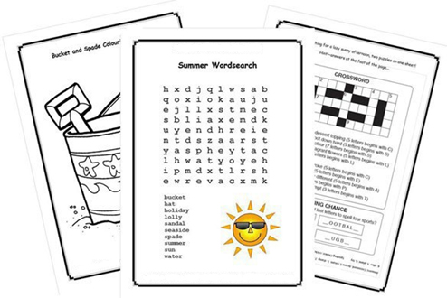

Dear Friends,

We are now in the month of July; the birds are singing and the sun is shining (some of the time!). We are looking forward to enjoying the lovely warm weather.

Excitement is building for the 2024 Summer Olympics, scheduled to take place from 26 July to 11 August 2024 in France. Paris will be the main host city and 16 other cities spread across Metropolitan France and Tahiti!

Calling all artists and writers among us, we would love to hear from you! We warmly welcome submissions of poems and stories to be featured in the pack.

Additionally, if you'd like your artwork from this pack or photos of any local fundraising events showcased on our social media, please send your images via email to communityengagement@alzheimer.ie.

Our Free Helpline is available at Phone: 1800 341 341 and Email: helpline@alzheimer.ie.

We hope you all enjoy this month’s pack.

Table of Contents

Activity | Pages
Reminiscing Guessing Games | 4 - 8
Pictures to Colour | 9 - 13
Song Lyrics | 14 - 21
A Story About Churning from Co. Mayo | 22
Mindfulness and Meditation | 23
Poetry | 24 – 28
Helpful Resources | 29 - 31

Guessing Game – Who Am I?

This is a wonderful reminiscing activity.
Guess the names of these famous people from the clues provided.

Instructions:
- Show a picture to your loved one and read out the clues.
- Ask them to guess the name of the person and reminisce about what they were famous for.
- Repeat with the next picture.

Extend the activity by asking who else was famous in their time and reminiscing together.

Famous Olympic Athletes

He was born in Arklow, Co. Wicklow.

He is an Irish former athlete who specialised in middle-distance running.

He won a gold medal in the 1500 metres event at the 1956 Summer Olympics in Melbourne.

He later earned a bronze medal in the 1500 metres event at the 1958 European Athletics Championships in Stockholm.

He retired from Athletics in 1962.

He is married to Joan Riordan.

Who is he?

Answer: Ronnie Delany

“I knew I was as good as anyone in the world so my expectation was that I would win!”
– Ronnie Delany

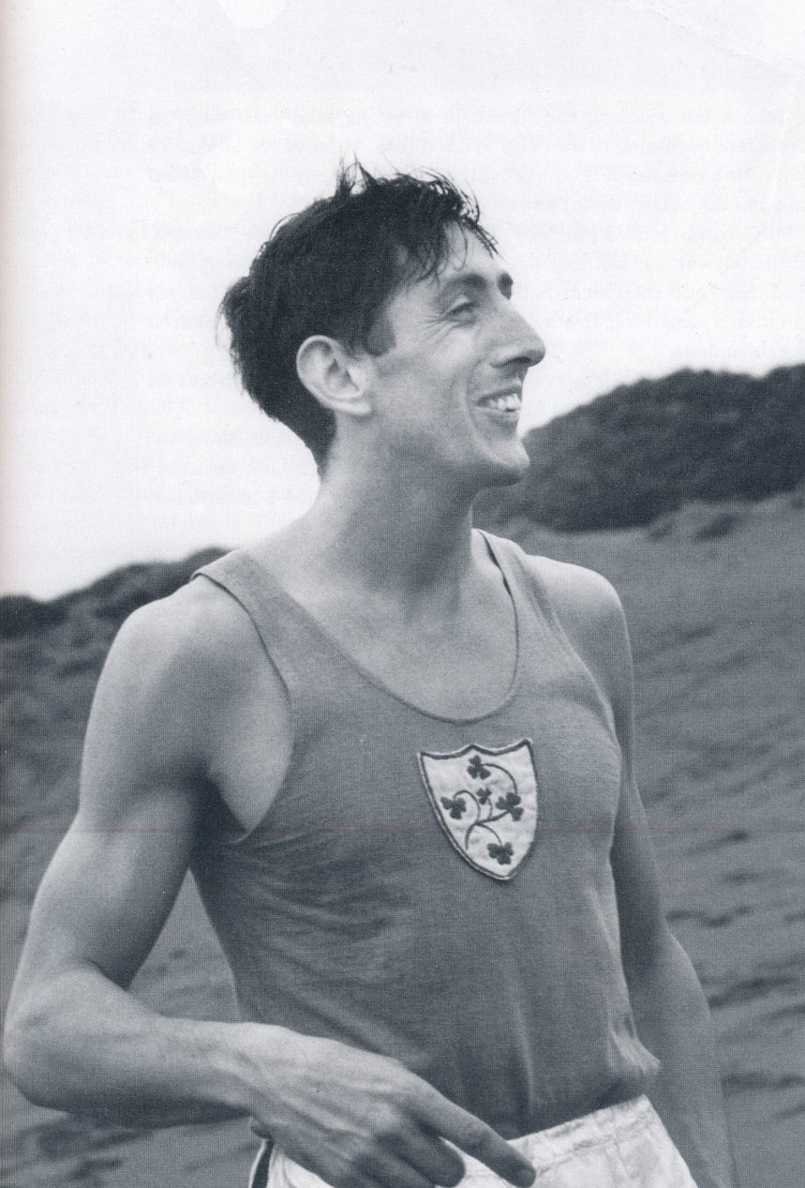

She was born on 2nd July 1986 in Bray, Co. Wicklow.

She has three siblings – Lee, Peter and Sarah.

Her parents are Pete and Bridget.

She won Gold in the 2012 London Olympic Games.

She turned professional in 2016.

Who is she?

Answer: Katie Taylor

“I want to go down in the history books as one of the greatest female boxers of all time and I think I am on the right track”.
- Katie Taylor

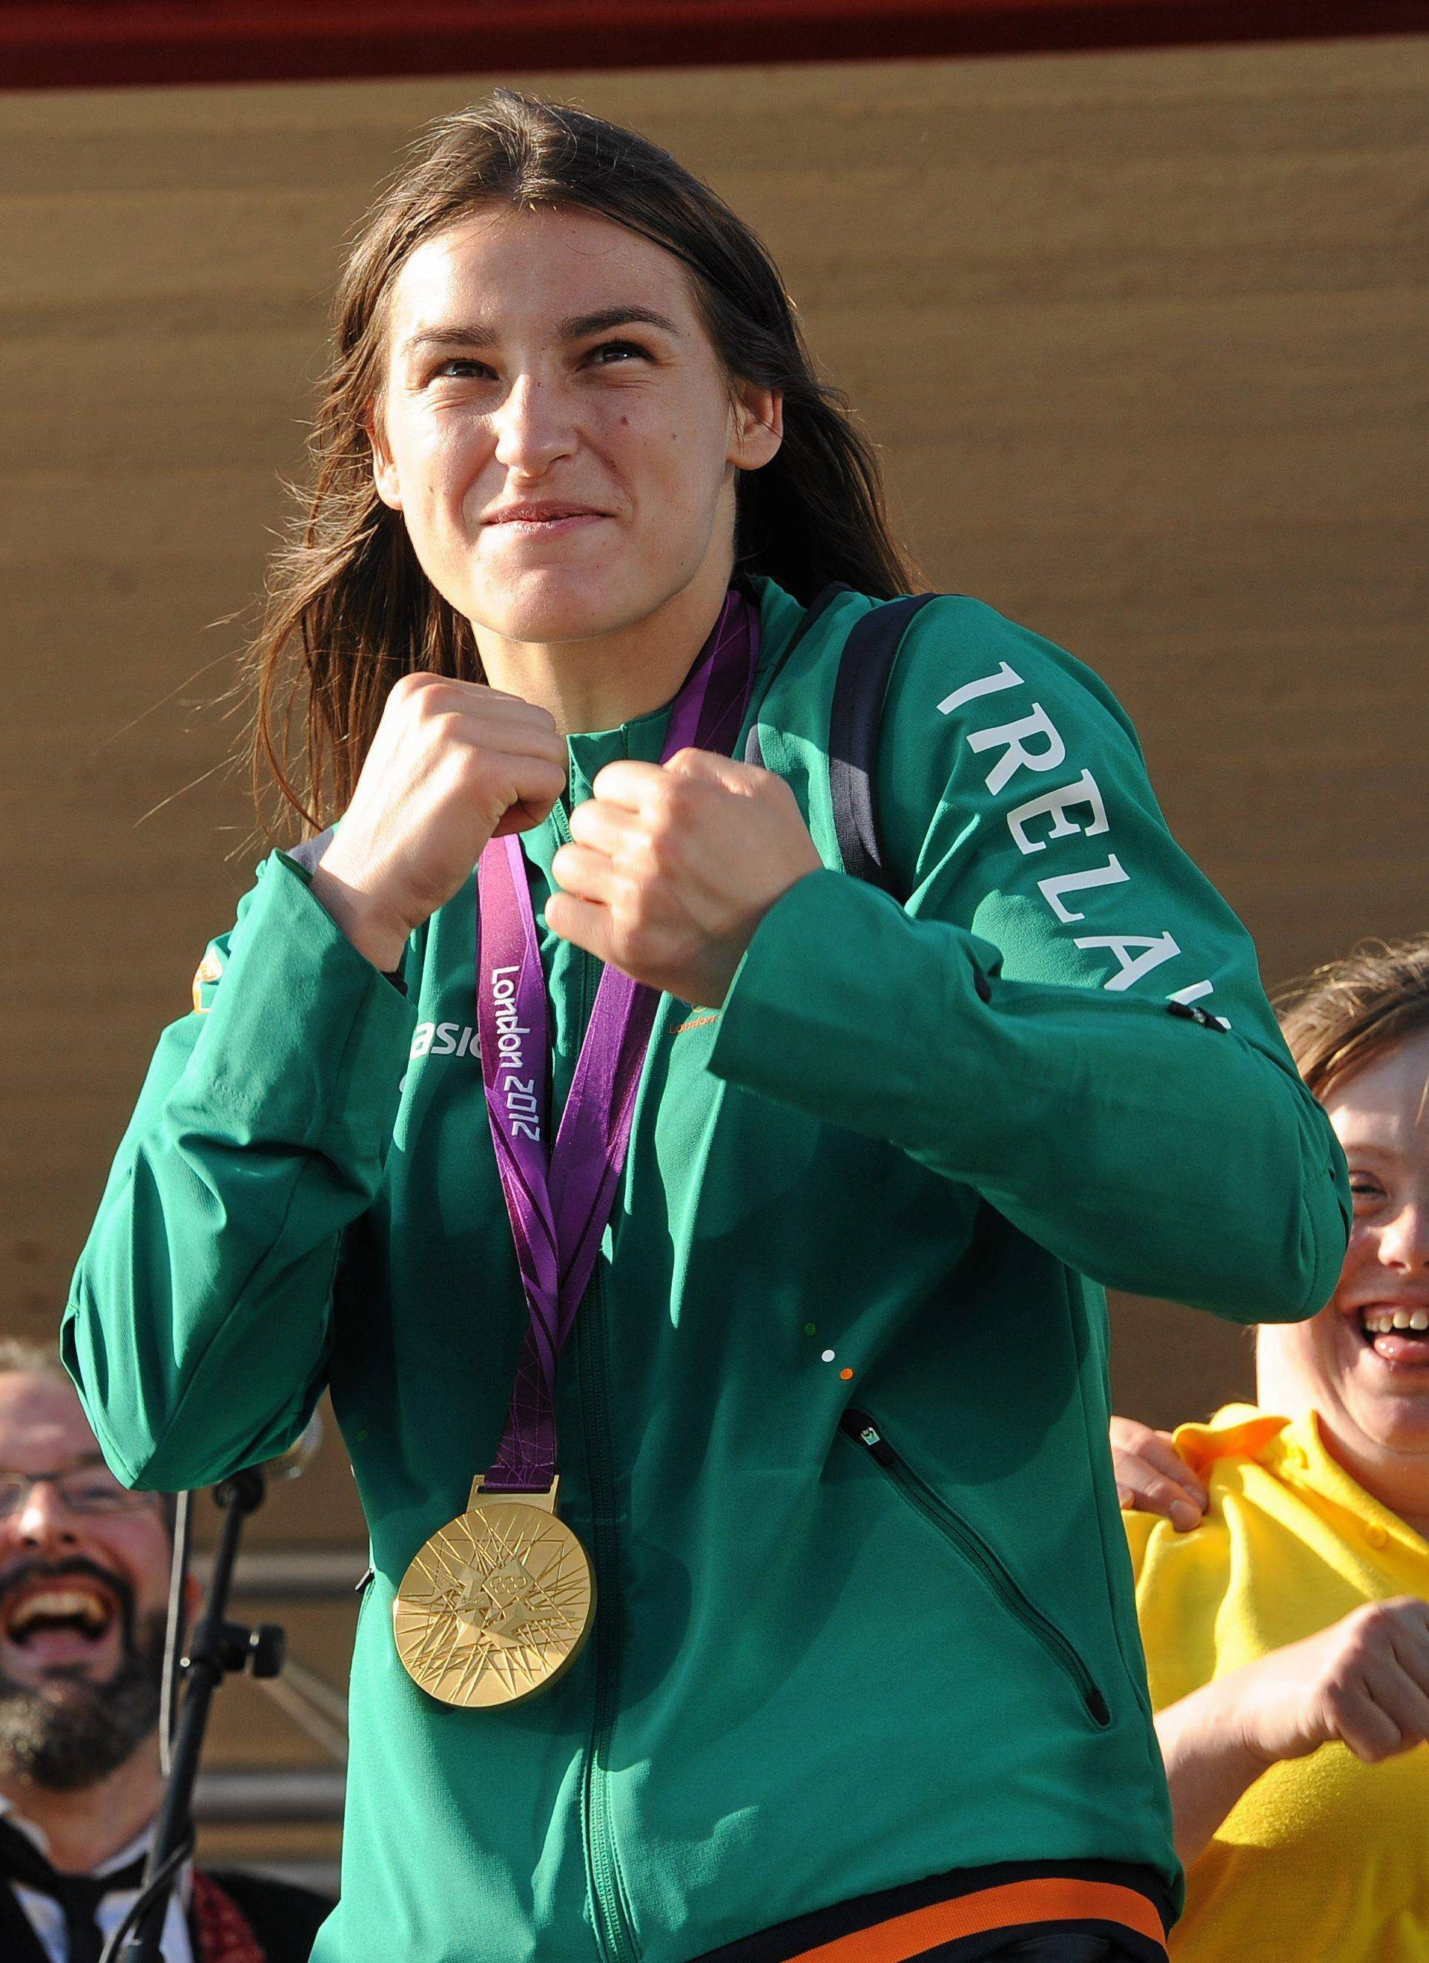

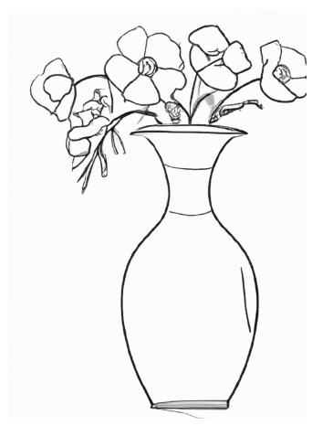
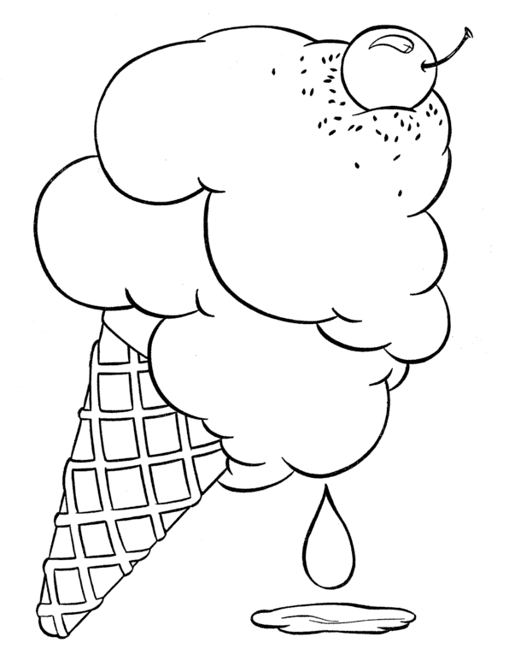
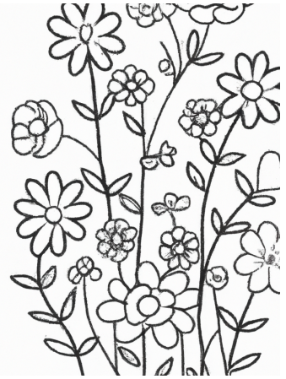

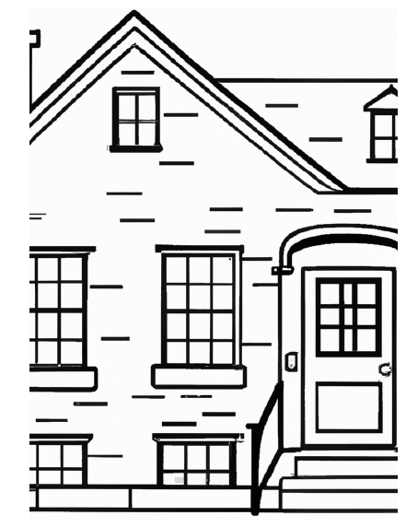

Wooden Heart

[Verse 1]
Can't you see I love you
Please don't break my heart in two
That's not hard to do
'Cause I don't have a wooden heart

And if you say goodbye
Then I know that I would cry
Maybe I would die
'Cause I don't have a wooden heart

There's no strings upon this love of mine
It was always you from the start

Treat me nice, treat me good
Treat me like you really should
'Cause I'm not made of wood
And I don't have a wooden heart

[Verse 2]
Muss i denn, muss i denn
Zum Stadtele hinaus
Stadtele hinaus
Und du, mein Schatz, bleibst hier?

There's no strings upon this love of mine
It was always you from the start
See upcoming pop shows

[Verse 3]
Sei mir gut, sei mir gut
Sei mir wie du wirklich sollst
Wie du wirklich sollst
'Cause I don't have a wooden heart

The Boys from The County Armagh

There's one fair county in Ireland
With memories so glorious and grand
Where nature has lavished it's bounty
It's the orchard of Ireland's green land
I love it's cathedral and city
Was founded by Patrick so true
And it bears in the heart of it's bosom
The ashes of Brian Boru
It's my own Irish home
Far across the foam
And though I've often left it
In foreign lands to roam
No matter where I wander
Through cities near or far
Sure me heart is at home in old Ireland
In the county of Armagh

I travelled that part of the county
Through Newport, Forkhill, Crossmaglenn
Around by the gap of Mount Norris
Then home by Blackwater again
Where the girls are so gay and so hearty
None fairer in Eireann go brath
Ah but where are the boys that can court them
Like the boys from the County Armagh

It's my own Irish home
Far across the foam
And though I've often left it
In foreign lands to roam
No matter where I wander
Through cities near or far
Sure me heart is at home in old Ireland
In the county of Armagh

There’s a Bridle Hanging on the Wall

There's a bridle hanging on the wall.
And a saddle in an empty stall.
You ask me why the teardrops fall.
It's that bridle hanging on the wall.

There's a horseshoe nailed above the door.
It's the shoe that my old pony wore.
A faded blanket in the hall.
And that bridle hanging on the wall.

With that pony for my guide.
I used to ride down the trail.
Watching the moon swing low.
But now that faithful friend.
Has found the end of that trail.
He's gone wherever good ponies go,

And his bridle's hanging on the wall.
And his saddle's in his empty stall.
No more he'll answer to my call.
There's a bridle hanging on the wall.

And his bridle's hanging on the wall.
And his saddle's in his empty stall.
No more he'll answer to my call.
There's a bridle hanging on the wall.

Annie's Song by John Denver

You fill up my senses
Like a night in a forest
Like the mountains in springtime
Like a walk in the rain
Like a storm in the desert
Like a sleepy blue ocean
You fill up my senses, Come fill me again

Come, let me love you
Let me give my life to you
Let me drown in your laughter
Let me die in your arms
Let me lay down beside you
Let me always be with you
Come, let me love you, Come love me again

Let me give my life to you
Come, let me love you, Come love me again

You fill up my senses
Like a night in a forest
Like the mountains in springtime
Like a walk in the rain
Like a storm in the desert
Like a sleepy blue ocean
You fill up my senses, Come fill me again

Beautiful City Lyrics by John Fitzgerald

I have sought to discover a haven of rest
Where the sun sinks by night in the land of the West
I have dwelt with the red man in green forest bowers
O’er the wild rolling prairie bespangled with flowers
I have hived to the north, where the hardy pine grows
‘Mid the wolf and the bear, and the bleak winter snows
I have roamed through all climates, but none could I see
Like the green hills of Cork and my home by the Lee

Beautiful city, charming and pretty
Beautiful city, my home by the Lee

I have slumbered in palm groves by clear running streams
And the wild groves of Blarney come haunting my dreams
I have listened to bells on the soft summer wind
But the sweet bells of Shandon were dear to my mind
I have mixed in gay dances my sorrows to hide
But there’s none like the maiden that’s now by my side
There is nought in the land of the slave or the free
Like the green hills of Cork and my home by the Lee

Beautiful city, charming and pretty
Beautiful city, my home by the Lee

The bold feudal castles look down on the Rhine
That flows through the land of the olive and vine
There is freedom and health in the fresh mountain breeze
That careers round the home of the brave Tyrolese
There is beauty and love in all spots of the earth
To the heart that can call it the land of its birth
But of all the fair countries, the dearest to me
Are the green hills of Cork and my home by the Lee

Beautiful city, charming and pretty
Beautiful city, my home by the Lee

A Story About Churning from Co. Mayo
We have a churn at home. It is two feet and six inches in height. It was made about fifteen years ago, by a cooper named Edward Nicholoson of Ballygarris but he lives in Castlebar now.

It is composed of the bottom which is made of oak. The hoops are made of steel, and the lid is made of white deal. The handle of the churn dash is made of ash. The butter hands and the dish are made of deal.

We churn twice a week in Summer and once a week in Winter. My Mother makes the churning. When a stranger comes into a house where there is a churning being made, he takes a hold of the churn dash and gives a few blows and says, "God bless the cows."

It is said, that's if that was not done that the butter would be stolen.

It is said that it is not right to let out a man smoking a pipe whilst churning unless he takes the churn and says, "God bless the work".

There are various kneads kinds of churns namely "the barrel churn" and the "machine churns". When the butter gathers in small lumps the churning is made. Some people take out the butter with their hands and other people take it out with a butter cup. If the people have too much butter, they sell some of it. People make bread with the buttermilk.
Mindfulness and Meditation
Although you cannot always control the mind, you can encourage it to be more at ease. Learning to do this will help you respond rather than react to your thoughts and emotions.

This practice gives you the opportunity to train the mind to slow down when it becomes overactive, and helps you practice ease and relaxation instead of perpetuating those difficult mental states.
You can sit upright or lie down for this practice.
Take a few deep breaths. Inhaling, fill the lungs completely.
Hold the breath for just a second or two, and exhale slowly.
As you let the breath go, try to empty the lungs slowly and completely.
If thoughts are present, just leave them be.
Offer yourself two simple phrases of kindness toward the mind:
May my mind be at ease.
May I be at ease with my mind.
Synchronize these phrases with your exhale, offering one phrase every time you breathe out.
Hear each word and try to connect with your own intention to care for the mind. Even if you can say only one phrase before the mind wanders, you are still moving toward relaxation by continuing to practice.

Inniskeen Road: July Evening
Patrick Kavanagh

The bicycles go by in twos and threes -
There's a dance in Billy Brennan's barn to-night,
And there's the half-talk code of mysteries
And the wink-and-elbow language of delight.
Half-past eight and there is not a spot
Upon a mile of road, no shadow thrown
That might turn out a man or woman, not
A footfall tapping secrecies of stone.

I have what every poet hates in spite
Of all the solemn talk of contemplation.
Oh, Alexander Selkirk knew the plight
Of being king and government and nation.
A road, a mile of kingdom, I am king
Of banks and stones and every blooming thing.
The Lake Isle Of Innisfree
William Butler Yeats

I will arise and go now, and go to Innisfree,
And a small cabin build there, of clay and wattles made:
Nine bean-rows will I have there, a hive for the honey-bee,
And live alone in the bee-loud glade.

And I shall have some peace there, for peace comes dropping slow,
Dropping from the veils of the morning to where the cricket sings;
There midnight's all a glimmer, and noon a purple glow,
And evening full of the linnet's wings.

I will arise and go now, for always night and day
I hear lake water lapping with low sounds by the shore;
While I stand on the roadway, or on the pavements grey,
I hear it in the deep heart's core.
The Four Farrellys
Percy French

In a small hotel in London I was sitting down to dine.
When the waiter brought the register and asked me if I'd sign.
And as I signed I saw a name that set my heart astir —
A certain "Francis Farrelly" had signed the register
I knew a lot of Farrellys and out of all the crew
I kept on "sort of wonderin' " which Farrelly were you.
And when I'd finished dinner I sat back in my chair,
Going round my native land to find, what Farrelly you were.
SOUTH
Were you the keen-eyed Kerryman I met below Kenmare,
Who told me that when Ireland fought "the odds were never fair?"
If Cromwell had met Sarsfield, or Owen Roe O'Neill,
It's not to Mister Gladstone we'd be lookin' for repeal.
Would have Ireland for the Irish, not a Saxon to be seen,
And only Gaelic spoken in that House in College Green. Told me landlords wor the Divil! their agints ten times worst,.
And iv'ry sort of government for Ireland was a curse!
Oh! if you're that Francis Farrelly, your dreams have not come true,
Still, Slainthe! Slainthe! Fransheen! for I like a man like you!
NORTH
Or were you the Francis Farrelly that often used to say
He'd like to blow them Papishes from Derry walls away?
The boy who used to bother me that Orange Lodge to join,
And thought that history started with the Battle o' the Boyne —
I was not all with ye, Francis, the Pope is not ma friend,
But still I hope, poor man, he'll die without that bloody end. -
And when yer quit for care yerself, and get to Kingdom Come,
It's not use teachin' you the harp — you'll play the Orange drum!
Och! man, ye wor a fighter, of that I had no doubt.
For I see ye in Belfast one night when the Antrim Road was out!
And many a time that evenin' I thought that ye wor dead,
The way them Papish pavin' stones was hoppin' off yer head.
Oh! if you're the Francis Farrelly who came from North Tyrone -
Here's lookin' to ye, Francis, but do leave the Pope alone!
EAST
Or were you the Francis Farrelly that in my college days
For strollin on the Kingstown Pier had such a curious craze?
D'y mind them lovely sisters — the blonde and the brunette?
I know I've not forgotten, and I don't think you forget!
That picnic at the Dargle —' and the others at the Scalp —
How my heart was palpitatin' — hers wasn't — not a palp!
Someone said ye married money — any maybe ye were wise,
But the gold you loved was in her hair, and the d'monds in her eyes!
So I like to think ye married her and that you're with her yet,
'Twas some "meleesha" officer that married the brunette;
But the blonde one always loved ye, and I knew you loved her too,
So me blessin's on ye, Francis, and the blue sky over you!
WEST
Or were you the Francis Farrelly I met so long ago,
In the bog below Belmullet, in the County of Mayo?
That long-legged, freckled Francis with the deep-set, wistful eyes,
That seemed to take their colour from those ever-changing skies,
That put his flute together as I sketched the distant scene,
And played me "Planxy Kelly and the "Wakes of Inniskeen."
That told me in the Autumn he'd be Bailin' to the West
To try and make his fortune and send money to the rest.
And would I draw a picture of the place where he was born,
And he'd hang it up, and look at it, and not feel so forlorn.
And when I had it finished, you got up from where you sat,
And you said, "Well, you're the Divil, and I can't say more than that."
Oh' if you're that Francis Farrelly, your fortune may be small,
But I'm thinking — thinking —Francis, that I love you best of all;
And I never can forget you — though it's years and years ago -
In the bog below BeImullet, in the County of Mayo.

Helpful Resources
Cafés
We are hosting several Alzheimer Cafés in July. They are a place to come together, share a cuppa and listen to our amazing guest speakers. For information on how to attend visit: https://alzheimer.ie/service/alzheimer-cafe/.

There is a Cabin Café meeting / Social Coffee morning for those living with Dementia and their carers in Carlow on July 2nd. Located at The Old School House, Barracks St., Carlow, R93YW10. Booking essential: Margaret 087 8380018.

The Court House Café in Roscrea is scheduled for July 31st from 10.30am to 12.30pm. It will be taking a break for the month of August.

The Bookwork Café in Thurles is scheduled for September 4th. It will be taking a break for July and August.

The Deise Memories Café is scheduled for July 10th and August 14th at 10.30am to 12pm. Located in the Sacred Heart Centre, Ballytruckle, Waterford.

Ballincollig, Macroom and Kenmare are not hosting cafés in July and August.

Social Clubs
Some of our Social Clubs will be running in July. These are a social gathering where people can drop in to chat, access information and support, meet other people. Click the link below to find your nearest Social Club https://alzheimer.ie/service/socialclub/.
The Castlebar Dementia Inclusive Social Club will be on Friday, July 12th and Friday, July 26th from 11am – 1pm. The venue is the Castlebar Social Services Building, Castle St., Castlebar, F23CY67. Contact Catherine Mc Lellan on 087 6942491 for more information.

A new Social club is starting in Bethany House, Barracks Street, Carlow, R93 F8K3 on Friday July 19th for People living with Dementia and their family members. RSVP to friendsofasi@alzheimer.ie.

There will be no Social Club in Ennis, North Meath and Macroom during July and August.

Support Groups
The Le Cairde Support Group (Clonmel) will be meeting on Tuesday, 16th July from 2pm – 3pm. It will be taking a break for August.

The Roscommon Support Group will be meeting in the Roscommon Library (F42 RP49) on Thursday, 18th July from 4.30pm – 5.30pm.

Music
The VIRTUAL ASI National Choir is taking a break for the summer and will return on September 19th.

Mindful Melodies virtual choir will be held every Wednesday in July except Wednesday 31st from 1.30pm, for a little over an hour.

Helpful links

• Let’s Sing Together: https://youtu.be/KEFAxePeZ18
• Playlist for Life: https://www.playlistforlife.org.uk/
• The Story of Playlist for Life: https://www.youtube.com/watch?v=eWgBlmVQXoM

